Supplementary materials
Table S1 Comparison of Co-morbidities and Disease symptoms in 283 Patients
Immune status | Immunocompeten(n=238) | Immunocompromised(n=45) | P value
Co-morbidities
Hypertension | 72（30.25%） | 10(22.22%) | 0.276
Diabetes mellitus | 32（13.45%） | 8(17.78%) | 0.444
Cerebral infarction | 18（7.56%） | 1（2.22%） | 0.323
Coronary heart disease | 18（7.56%） | 3(6.67%) | 1.000
Chronic gastritis | 16（6.72%） | 2（4.44%） | 0.809
Pulmonary tuberculosis | 16（6.72%） | 3(6.67%) | 1.000
Cervical spondylosis | 11（4.62%） | 1（2.22%） | 0.742
Benign prostatic hyperplasia | 8（3.36%） | 1（2.22%） | 1.00
Hepatitis B virus | 7（2.94%） | 1（2.22%） | 1.00
Malignant tumor | 1（0.42%） | 7（15.56%） | <0.001
Disease symptoms
Cough | 162(68.07%) | 19(42.22%) | 0.001
Expectoration | 128(53.78%) | 13(28.89%) | 0.002
Fever | 84(35.29%) | 6(13.33%) | <0.001
Asthma | 68（28.57%) | 5(11.11%) | 0.014
Chilly | 37(15.55%) | 3(6.67%) | 0.182
Fatigue | 35(14.71%) | 5(11.11%) | 0.526
Chest pain | 33(13.87%) | 4(8.89%) | 0.505
Chest distress | 32(13.45%) | 8(17.78%) | 0.444
Dizziness | 20(8.40%) | 3(6.67%) | 0.925
Headache | 19(7.98%) | 2(4.44%) | 0.603
Note：*.Percent is in （）/%.

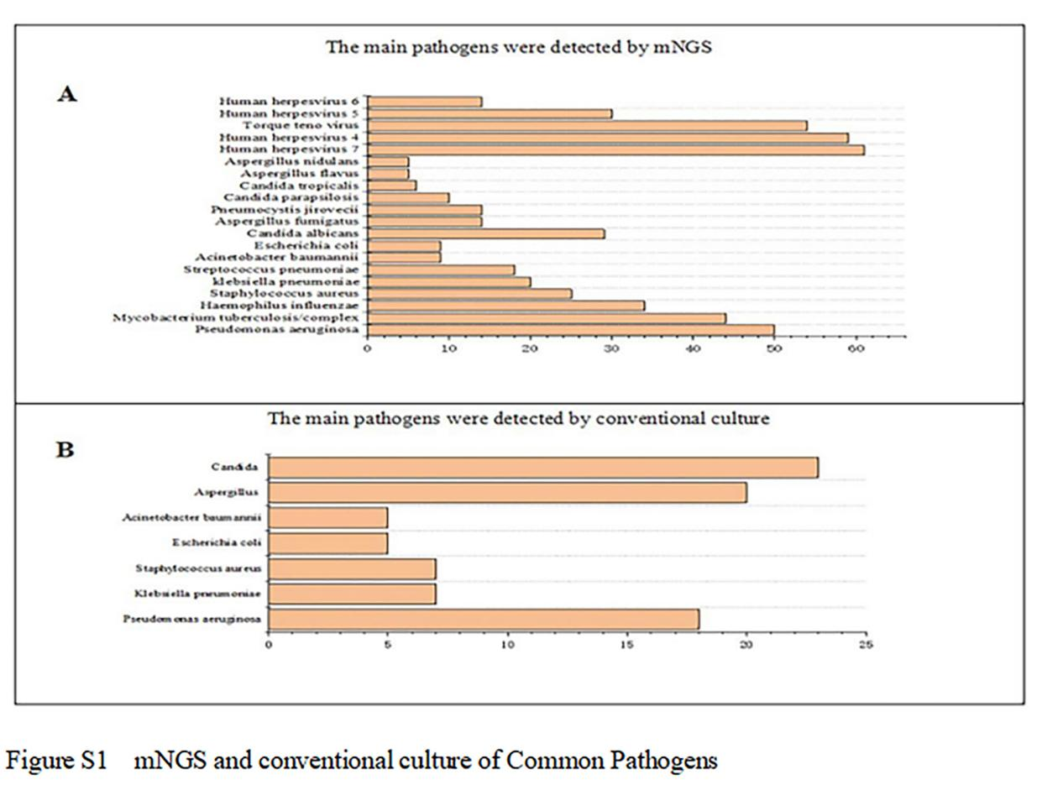
Among the 252 cases positive for mNGS analysis, accounting for 89.05% of the total cohort, Pseudomonas aeruginosa (50 cases, 19.84%), Mycobacterium tuberculosis/complex (44 cases, 17.46%) and Haemophilus influenzae (34 cases, 13.50%) emerged as the predominant microorganisms identified.The three most prevalent fungi identified were Candida albicans (29 cases, 11.51%), Aspergillus fumigatus (14 cases, 5.56%) and Pneumocystis jirovecii (14 cases, 5.56%). Among the viruses detected, Human Herpesvirus-7 accounted for the highest number of cases (61 cases, 24.21%), followed by Human Herpesvirus-4 (59 cases, 23.41%) and Torque teno virus (54 cases, 21.43%) (Figure S1A). Out of the total number of cases, 82 cases (34.45% of the total) were positive by conventional culture, Pseudomonas aeruginosa (18 cases, 40.00%), Klebsiella pneumoniae (7 cases, 15.56%) and Staphylococcus aureus (7 cases, 15.56%). For fungi, Candida (23 cases, 51.11%) and Aspergillus (20cases,44.44%) (Figure S1B). The aforementioned components constitute the primary constituents of both detection methodologies employed for comprehensive pathogen identification.
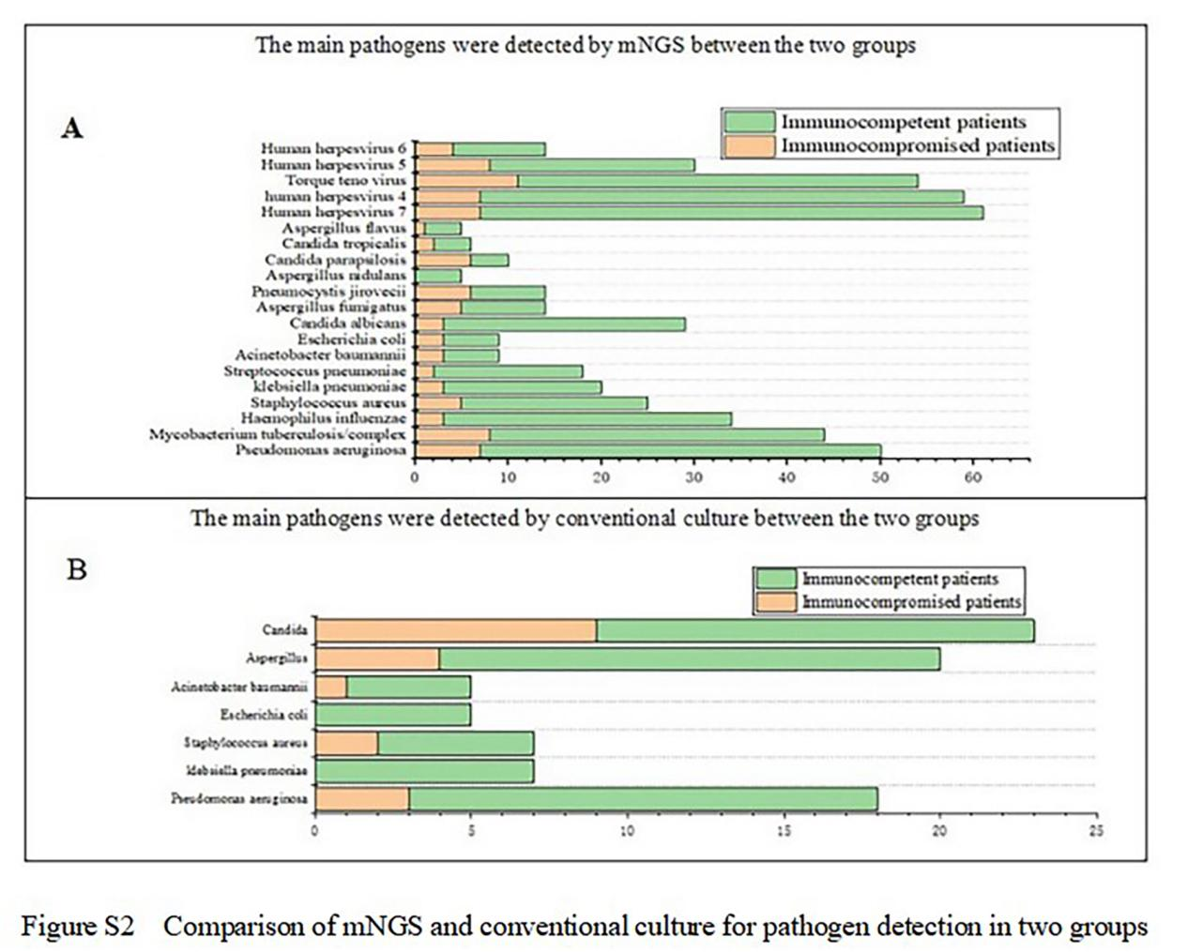
Following data grouping, the pathogen detection ratio of mNGS and traditional culture in both groups was elucidated. In the immunocompetent group, 214 cases (89.92% out of 238 cases) exhibited positive results for mNGS. The predominant bacterial species identified were Pseudomonas aeruginosa (43 cases, 20.10%), Mycobacterium tuberculosis/complex (36 cases, 16.82%) and Haemophilus influenzae (31 cases, 14.50%). Among fungi, Candida albicans (26 cases, 12.15%) was the most prevalent, followed by Aspergillus fumigatus (9 cases, 4.21%) and Pneumocystis jirovecii (8 cases, 3.74%). In terms of viral infections, Human Herpesvirus-7 (54 cases, 25.23%), Human Herpesvirus-4 (52 cases, 24.30%) and Torque teno virus (43 cases, 20.10%) exhibited dominance. In the immunocompromised group, 38 out of 45 cases (84.44%) tested positive for mNGS. The predominant bacteria identified were Mycobacterium tuberculosis/complex (8 cases, 21.10%), Pseudomonas aeruginosa (7 cases, 18.42%) and Staphylococcus aureus (5 cases, 13.20%), two of which overlapped with the immunocompetent group. The most prevalent fungi detected were Pneumocystis jirovecii (6 cases, 16.00%), Candida parapsilosis (6 cases, 16.00%) and Aspergillus fumigatus (5 cases, 13%). Among the viral pathogens identified, Torque teno virus was the most common (11 cases, 29.00%), followed by Human Herpesvirus-5 (8 cases, 21.10%), Human Herpesvirus-4 (7 cases, 18.42%) and Human Herpesvirus-7 (7cases，18．42%) (Figure S2A). For the immunocompetent group, the three most commonly detected bacteria in conventional culture were Pseudomonas aeruginosa (15 cases, 22.40%), Klebsiella pneumoniae (7 cases, 10.45%) and Staphylococcus aureus (5 cases, 7.46%). As for fungi, Aspergillus (16 cases, 24.00%) and Candida (14 cases, 21.00%) were the predominant species identified. The bacteria identified in the immunocompromised group included Pseudomonas aeruginosa (3 cases, 20%), Staphylococcus aureus (2 cases, 13.33%), and Acinetobacter baumannii (1 case, 6.67%). Most frequently isolated fungi were Candida (9 cases, 60%) and Aspergillus (4 cases, 27%) (Figure S2B).

Antibiotic utilization associated with pre- or post- mNGS testing
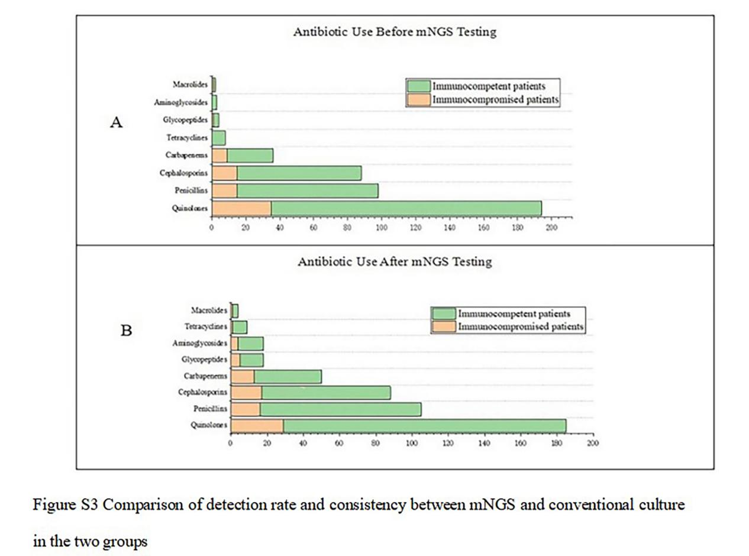
The empirical antimicrobial treatment scheme commonly employed quinolones, penicillins, cephalosporins and carbapenems as the predominant antibiotics both prior to and subsequent to the mNGS test. In the immunocompetent group, quinolones were predominantly utilized (159 cases, 74.30%), followed by penicillins accounting for 38.80% (83 cases), cephalosporins comprising 34.11% (73 cases) and carbapenems representing 12.62% (27 cases), respectively (Figure S3A). It is similar in the immunocompromised group, quinolones accounted for 92.11% (35 cases), penicillins for 39.47% (15 cases), cephalosporins for 39.47% (15 cases) and carbapenems for 23.68% (9 cases) (Figure S3A). In the adjusted antimicrobial treatment regimen based on mNGS results, quinolones were the most frequently used antimicrobial agents (72.90%, 156 cases), followed by penicillins (41.60%, 89 cases), cephalosporins (33.20%, 71 cases) and carbapenems (17.30%, 37 cases) in the immunocompetent group (Figure S3B), which was consistent with the empirical antimicrobial agents used prior to mNGS testing. It is also similar in the immunocompromised group, quinolones accounted for 76.32% (29 cases), cephalosporins for 44.74% (17 cases), penicillins for 42.11% (16 cases) and carbapenems for 34.21% (13 cases) (Figure S3B). Moreover, compared to immunocompetent patients, immunocompromised patients had fewer full pathogen covered empirical antibiotic therapy (11/38 = 28.95% vs. 130/214 = 60.75%, p<0.001(Figure S3).

