Supporting Information of
“Magmatic fluids uprise through ring faults at Campi Flegrei caldera”
Genny Giacomuzzi^{1*}, Rossella Fonzetti ^{1,2}, Aladino Govoni¹, Pasquale De Gori¹, and Claudio Chiarabba¹
¹ Istituto Nazionale di Geofisica e Vulcanologia (INGV), Rome, Italy
² Università degli Studi Roma Tre, Rome, Italy
*Corresponding author: genny.giacomuzzi@ingv.it

Content of this file

The following Supportal Information includes 3 figures (S1-S3) and 1 table (Table S1).

Fig. S1:Map view and cross-sections of the 1D-locations obtained through Hypoellipse.
Fig. S2: Map view and cross-sections of the DD-relocations obtained through HypoDD.
Fig S3: MD-derived ML vs GaMMA-derived ML plots
Table S1: 1D velocity model used for 1D and DD relocations.

Supporting Figures and Tables

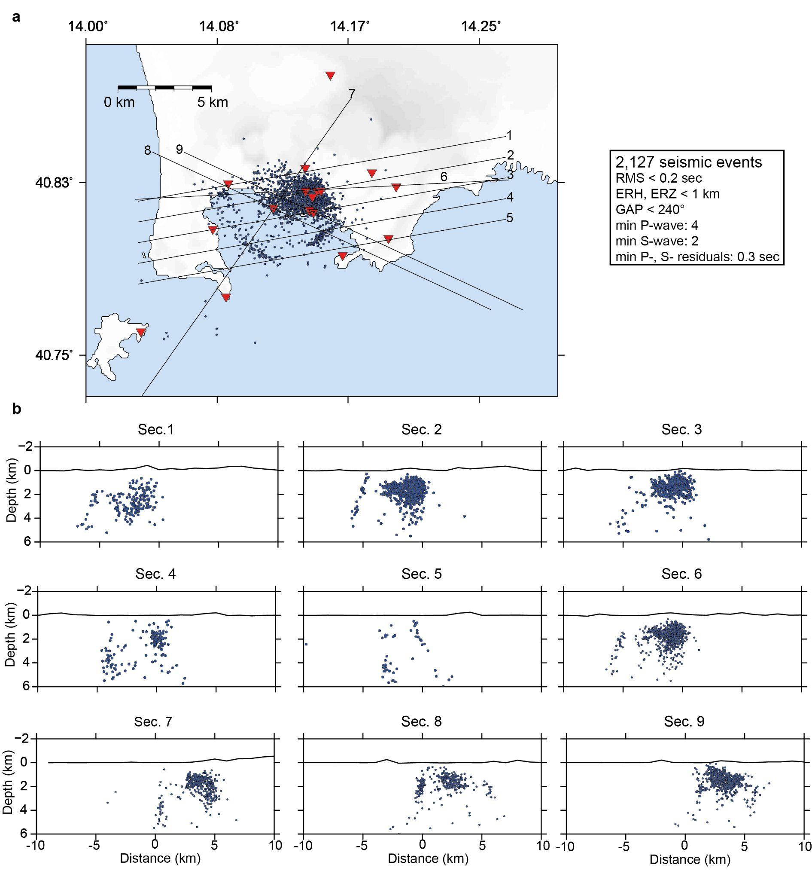
Figure S1 1D relocations. (a) Map view of the best 1D-locations (blue dots) obtained through Hypoellipse. The red triangles are the seismic stations. Black lines are the cross-sections shown in panel b; The inset shows the filters used to select the best relocations from the overall catalog (about 8,400 events). (b) cross-sections plotting seismic event with a distance of +/- 0.5 km from sections: 1-5 have a strike of N80°, section 6 has a strike of N87°, section 7 has a strike of N35°, section 8-9 have a strike of N(-65)°.

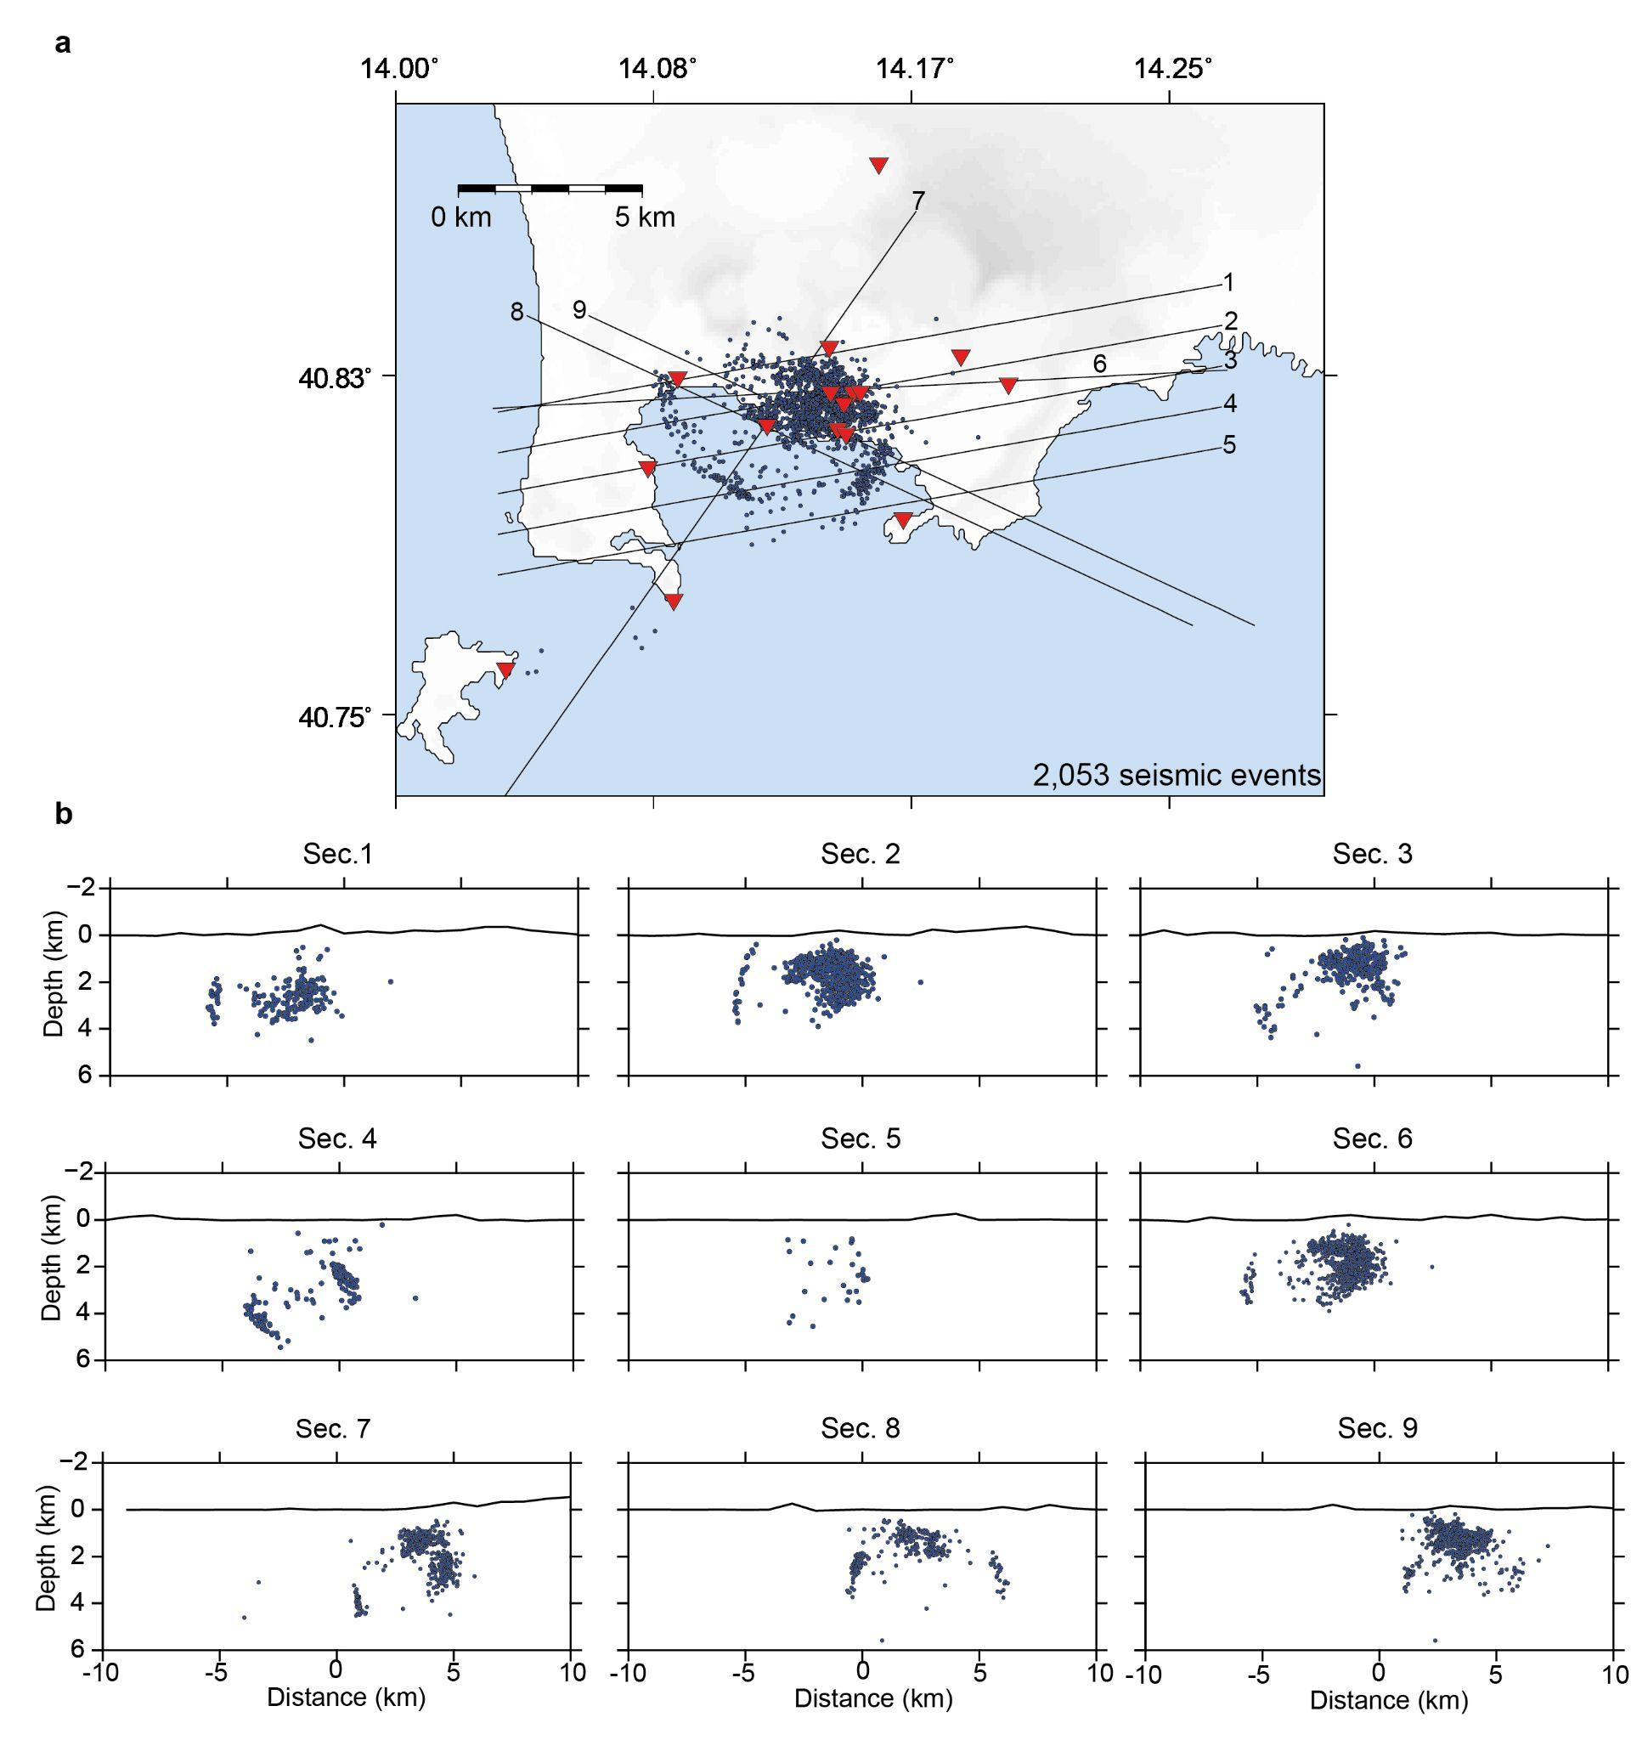
Figure S2 DD-relocations. (a) Map view of the best DD-locations (blue dots) obtained through HypoDD. The red triangles are the seismic stations. Black lines are the cross-sections shown in panel b; (b) cross-sections plotting seismic event with a distance of +/- 0.5 km from sections: 1-5 have a strike of N80°, section 6 has a strike of N87°, section 7 has a strike of N35°, section 8-9 have a strike of N(-65)°.

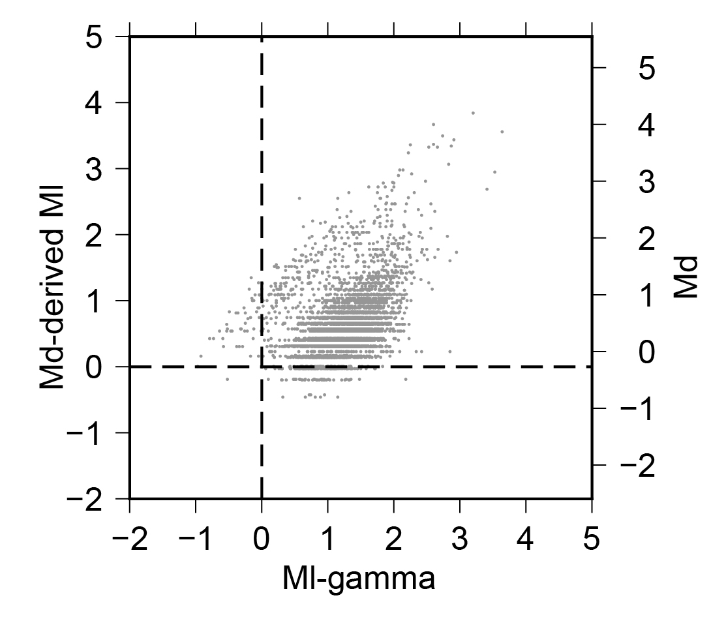

Figure S3 Local magnitude. Comparison between local magnitude estimated from the GaMMA parameters (Ml-gamma) and local magnitude (Md-derived Ml) computed from the official magnitude Md based on duration and reported by the OV Bulletin. The Md-derived Ml are computed from the linear fit¹ ml=0.23+0.86Md.

Depth (km) | Vp (km/s) | Vp/Vs
0 | 1.45 | 1.96
1 | 2.73 | 1.86
2 | 3.81 | 1.62
3 | 3.67 | 1.40
4 | 3.64 | 1.34
5 | 4.50 | 1.53
6 | 4.80 | 1.72
7 | 4.97 | 1.82

Table S1 1D models used to relocate earthquakes. The models were computed from the 3D tomographic models² (5-th epoch) by considering a squared region of 8km x 8km centered on Pozzuoli.

References

1 Tramelli, A., Convertito, V. & Godano, C. b value enlightens different rheological behaviour in Campi Flegrei caldera. Commun. Earth. Environ. 5, 275, https://doi.org/10.1038/s43247-024-01447-y (2024).

2 Giacomuzzi, G., Chiarabba, C., Bianco, F., De Gori, P., & Agostinetti, N. P. Tracking transient changes in the plumbing system at Campi Flegrei Caldera. Earth Planet. Sci. Lett. 637, 118744 (2024).

