Association of school social status with Covid pandemic related changes and post-pandemic rebounds of children’s physical fitness

Paula Teich, Fabian Arntz, Toni Wöhrl, Florian Bähr, Kathleen Golle, Reinhold Kliegl

Supplementary Material

The following tables show the mean test scores grouped by physical fitness test, cohort (pre-covid: 2016–19, covid: 2020–22, post-covid: 2023), and school social status category. Scores of the 6-min run are shown in meters, star-run and 20m sprint test scores in meters/second, standing long jump test scores in centimeters, ball-push test scores in meters, and score of the one-legged-stance test are shown in seconds. For analysis, one-legged-stance test scores were converted to log(seconds).

Table S1.1 School social status category 1: Physical fitness by physical fitness component and cohort
Cohorts | N Children | N Schools | Age in years  Mean (SD) | Test score  Mean (SD)
Cardiorespiratory endurance (6-min run)
cohorts 2016–19 | 13365 | 103 | 8.61 (0.28) | 1009.1 (156.2)
cohorts 2020–22 | 10801 | 105 | 8.55 (0.27) | 997.5 (156.9)
cohort 2023 | 3847 | 103 | 8.60 (0.28) | 992.7 (152.2)
Coordination under time pressure (star-run)
cohorts 2016–19 | 13410 | 104 | 8.61 (0.28) | 2.06 (0.28)
cohorts 2020–22 | 10644 | 105 | 8.55 (0.27) | 2.01 (0.30)
cohort 2023 | 3877 | 103 | 8.60 (0.28) | 2.05 (0.31)
Speed (20m sprint)
cohorts 2016–19 | 13064 | 102 | 8.61 (0.28) | 4.59 (0.43)
cohorts 2020–22 | 10825 | 105 | 8.55 (0.27) | 4.54 (0.43)
cohort 2023 | 3916 | 103 | 8.60 (0.28) | 4.56 (0.44)
PowerLOW (standing-long-jump)
cohorts 2016–19 | 13674 | 104 | 8.61 (0.28) | 127.8 (19.2)
cohorts 2020–22 | 10934 | 105 | 8.55 (0.27) | 127.0 (19.5)
cohort 2023 | 3937 | 103 | 8.60 (0.28) | 127.1 (19.4)
PowerUP (ball-push test)
cohorts 2016–19 | 13772 | 104 | 8.61 (0.28) | 3.78 (0.73)
cohorts 2020–22 | 10903 | 105 | 8.55 (0.27) | 3.68 (0.72)
cohort 2023 | 3929 | 103 | 8.60 (0.28) | 3.70 (0.71)
Static balance (one-legged-stance test)
cohorts 2016–19 | 13585 | 104 | 8.61 (0.28) | 19.6 (17.3)
cohorts 2020–22 | 10829 | 105 | 8.55 (0.27) | 22.0 (18.6)
cohort 2023 | 3929 | 103 | 8.60 (0.28) | 20.8 (17.6)
Table S1.2 School social category 2: Physical fitness by physical fitness component and cohort
Cohorts | N Children | N Schools | Age in years  Mean (SD) | Test score  Mean (SD)
Cardiorespiratory endurance (6-min run)
cohorts 2016–19 | 12334 | 110 | 8.61 (0.28) | 1009.8 (147.1)
cohorts 2020–22 | 10143 | 110 | 8.55 (0.28) | 991.3 (150.6)
cohort 2023 | 3566 | 110 | 8.60 (0.28) | 994.9 (145.8)
Coordination under time pressure (star-run)
cohorts 2016–19 | 12310 | 110 | 8.61 (0.28) | 2.06 (0.28)
cohorts 2020–22 | 10285 | 110 | 8.55 (0.28) | 2.00 (0.29)
cohort 2023 | 3653 | 112 | 8.60 (0.28) | 2.04 (0.29)
Speed (20m sprint)
cohorts 2016–19 | 12514 | 110 | 8.61 (0.28) | 4.58 (0.41)
cohorts 2020–22 | 10467 | 110 | 8.55 (0.28) | 4.55 (0.43)
cohort 2023 | 3680 | 112 | 8.60 (0.28) | 4.55 (0.41)
PowerLOW (standing long jump)
cohorts 2016–19 | 12489 | 110 | 8.61 (0.28) | 125.9 (19.4)
cohorts 2020–22 | 10433 | 110 | 8.55 (0.28) | 126.2 (19.2)
cohort 2023 | 3681 | 112 | 8.60 (0.28) | 127.4 (20.0)
PowerUP (ball-push test)
cohorts 2016–19 | 12592 | 110 | 8.61 (0.28) | 3.81 (0.72)
cohorts 2020–22 | 10521 | 110 | 8.55 (0.28) | 3.71 (0.71)
cohort 2023 | 3698 | 112 | 8.60 (0.28) | 3.74 (0.71)
Static balance (one-legged-stance test)
cohorts 2016–19 | 12354 | 110 | 8.61 (0.28) | 19.0 (17.0)
cohorts 2020–22 | 10496 | 110 | 8.55 (0.28) | 19.9 (17.6)
cohort 2023 | 3691 | 112 | 8.60 (0.28) | 18.6 (16.6)

Table S1.3 School social category 3: Physical fitness by physical fitness component and cohort
Cohorts | N Children | N Schools | Age in years  Mean (SD) | Test score  Mean (SD)
Cardiorespiratory endurance (6-min run)
cohorts 2016–19 | 11860 | 110 | 8.62 (0.28) | 991.5 (157.3)
cohorts 2020–22 | 9397 | 111 | 8.56 (0.28) | 979.4 (155.4)
cohort 2023 | 3366 | 107 | 8.61 (0.27) | 975.8 (154.0)
Coordination under time pressure (star-run)
cohorts 2016–19 | 11746 | 110 | 8.62 (0.28) | 2.06 (0.30)
cohorts 2020–22 | 9365 | 111 | 8.56 (0.28) | 2.01 (0.30)
cohort 2023 | 3393 | 108 | 8.61 (0.27) | 2.01 (0.31)
Speed (20m sprint)
cohorts 2016–19 | 11967 | 110 | 8.62 (0.28) | 4.54 (0.42)
cohorts 2020–22 | 9572 | 111 | 8.56 (0.28) | 4.53 (0.43)
cohort 2023 | 3468 | 109 | 8.61 (0.27) | 4.53 (0.43)
PowerLOW (standing long jump)
cohorts 2016–19 | 12007 | 110 | 8.62 (0.28) | 124.7 (19.5)
cohorts 2020–22 | 9544 | 111 | 8.56 (0.28) | 125.1 (20.2)
cohort 2023 | 3479 | 109 | 8.61 (0.27) | 125.8 (20.0)
PowerUP (ball-push test)
cohorts 2016–19 | 12087 | 110 | 8.62 (0.28) | 3.77 (0.73)
cohorts 2020–22 | 9612 | 111 | 8.56 (0.28) | 3.65 (0.73)
cohort 2023 | 3510 | 109 | 8.61 (0.27) | 3.68 (0.73)
Static balance (one-legged-stance test)
cohorts 2016–19 | 12067 | 110 | 8.62 (0.28) | 20.3 (17.5)
cohorts 2020–22 | 9509 | 111 | 8.56 (0.28) | 22.3 (18.9)
cohort 2023 | 3421 | 109 | 8.61 (0.27) | 20.9 (17.7)

Table S1.4 School social category 4: Physical fitness by physical fitness component and cohort
Cohorts | N Children | N Schools | Age in years  Mean (score) | Test score  Mean (SD)
Cardiorespiratory endurance (6-min run)
cohorts 2016–19 | 12215 | 111 | 8.63 (0.28) | 974.7 (158.2)
cohorts 2020–22 | 9509 | 110 | 8.57 (0.28) | 961.2 (161.1)
cohort 2023 | 3241 | 108 | 8.62 (0.27) | 955.5 (155.6)
Coordination under time pressure (star-run)
cohorts 2016–19 | 12133 | 111 | 8.63 (0.28) | 2.02 (0.30)
cohorts 2020–22 | 9477 | 110 | 8.57 (0.28) | 1.99 (0.30)
cohort 2023 | 3190 | 108 | 8.62 (0.28) | 1.99 (0.30)
Speed (20m sprint)
cohorts 2016–19 | 12297 | 111 | 8.62 (0.28) | 4.50 (0.43)
cohorts 2020–22 | 9675 | 109 | 8.57 (0.28) | 4.49 (0.44)
cohort 2023 | 3239 | 107 | 8.62 (0.27) | 4.47 (0.43)
PowerLOW (standing long jump)
cohorts 2016–19 | 12261 | 111 | 8.62 (0.28) | 122.3 (19.6)
cohorts 2020–22 | 9729 | 110 | 8.57 (0.28) | 123.2 (20.1)
cohort 2023 | 3268 | 108 | 8.62 (0.27) | 123.8 (20.1)
PowerUP (ball-push test)
cohorts 2016–19 | 12449 | 111 | 8.63 (0.28) | 3.73 (0.71)
cohorts 2020–22 | 9787 | 110 | 8.57 (0.28) | 3.67 (0.73)
cohort 2023 | 3306 | 108 | 8.62 (0.27) | 3.72 (0.73)
Static balance (one-legged-stance test)
cohorts 2016–19 | 12226 | 111 | 8.63 (0.27) | 19.0 (16.9)
cohorts 2020–22 | 9616 | 110 | 8.57 (0.28) | 20.9 (17.9)
cohort 2023 | 3263 | 108 | 8.62 (0.27) | 18.9 (16.8)

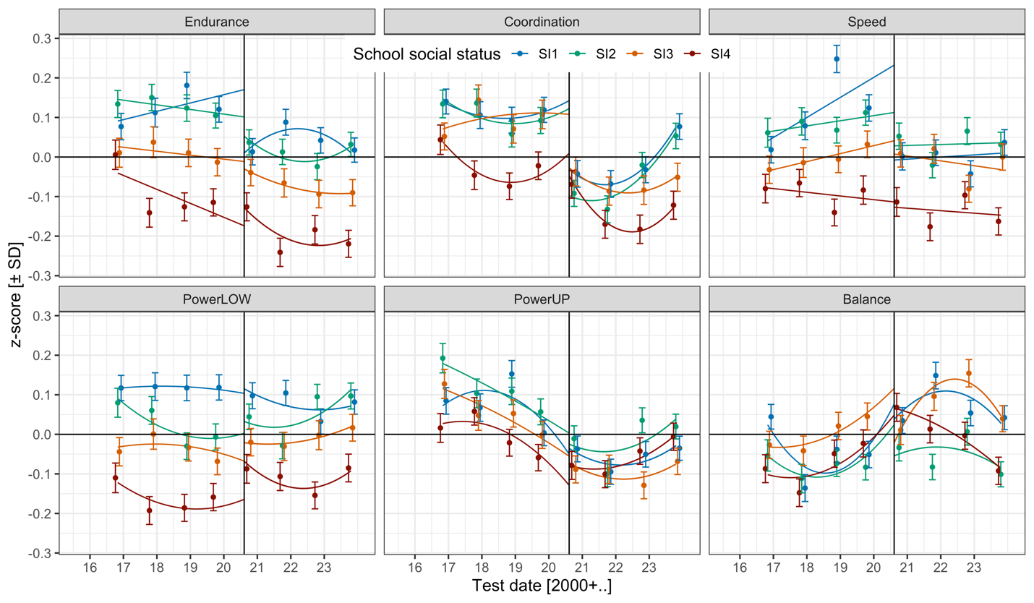
Figure S1. Physical fitness by fitness component, school social status, and cohort (means and 95% CIs). The vertical line marks the critical date (first day of school in school year 2020/21). Endurance = cardiorespiratory endurance (i.e., 6-min run), Coordination = star-run, Speed = 20-m linear sprint, PowerLOW = lower limbs muscle power (i.e., standing long jump), PowerUP = upper limbs muscle power (i.e., ball-push test), Balance = one-legged-stance with eyes closed. SI1, SI2, SI3, SI4 = school social index categories 1 (highest social status) through 1 (lowest social status).

Random effect structure of reparameterized linear mixed model (LMM) for keyage children in cohorts 2016 until 2023 with physical fitness component levels instead of contrasts
The reparameterized version of the LMM includes physical fitness component levels instead of physical fitness component contrasts in the random effect structure for school. Table S2 shows the fixed effect estimates, standard errors and z-values of this LMM. Code is provided in script keyage_lmm_16_23.qmd in the OSF repository.

Table S2. Variance components (VC) and correlation parameters (CP) of reparameterized LMM

 | VC | CP
 |  |  |  |  |  |  |  | Covid @ crit. date
 |  | E | C | S | pL | pU | B | E | C | S | pL | pU
Child
E | 0.474
C | 0.494 | +0.62
S | 0.501 | +0.69 | +0.73
pL | 0.549 | +0.66 | +0.73 | +0.85
pU | 0.449 | +0.27 | +0.51 | +0.48 | +0.56
B | 0.510 | +0.28 | +0.30 | +0.29 | +0.32 | +0.16
School
E | 0.128
C | 0.165 | +0.32
S | 0.125 | +0.29 | +0.32
pL | 0.066 | +0.38 | +0.40 | +0.39
pU | 0.071 | +0.17 | +0.23 | +0.26 | +0.23
B | 0.123 | -0.02 | +0.23 | +0.09 | +0.13 | +0.10
Covid @ crit. date
E | 0.088 | -0.50 | -0.11 | -0.12 | -0.06 | -0.04 | +0.06
C | 0.172 | -0.14 | -0.49 | -0.03 | -0.15 | -0.15 | -0.10 | +0.13
S | 0.122 | -0.13 | -0.03 | -0.44 | -0.02 | -0.09 | -0.02 | +0.21 | +0.15
pL | 0.054 | -0.19 | -0.16 | -0.16 | -0.44 | -0.12 | -0.02 | +0.07 | +0.16 | +0.21
pU | 0.075 | -0.04 | -0.05 | -0.06 | -0.04 | -0.53 | -0.19 | +0.07 | +0.18 | +0.11 | +0.08
B | 0.151 | -0.01 | -0.06 | -0.04 | -0.01 | -0.06 | -0.45 | -0.11 | +0.14 | +0.02 | +0.04 | +0.03
Age | <0.001 | - | - | - | - | - | - | - | - | - | - | -
Int = Intercept, E = cardiorespiratory endurance (i.e., 6-min run), C = coordination (i.e., star-run), S = speed (i.e., 20-m linear sprint), pL = lower limbs muscle power (i.e., powerLOW, standing long jump), pU = upper limbs muscle power (i.e., powerUP, ball-push test), B = static balance (i.e., one-legged-stance test). Covid @ crit. date = Covid pandemic effect estimated at first day of school in school year 2020/21. Age = linear age trend. VC = variance component, CP = correlation parameter. Theoretically relevant correlations are set in bold. LMM random factors: schools (444) and children (108,308), observations = 628,399. VC for Residual = 0.340.

Regional differences (close to vs. far from Berlin) in children’s physical fitness
LMMs testing regional differences in physical fitness are reported in the OSF repository. LMMs without the inclusion of school social status indicated that regions close to Berlin exhibited better performances in the 6-min run (cardiorespiratory endurance), 20m sprint (speed) and standing long jump (powerLOW) than regions far from Berlin. When adding school social status to the LMMs, regional differences remained significant for the 6-min run and 20m sprint.
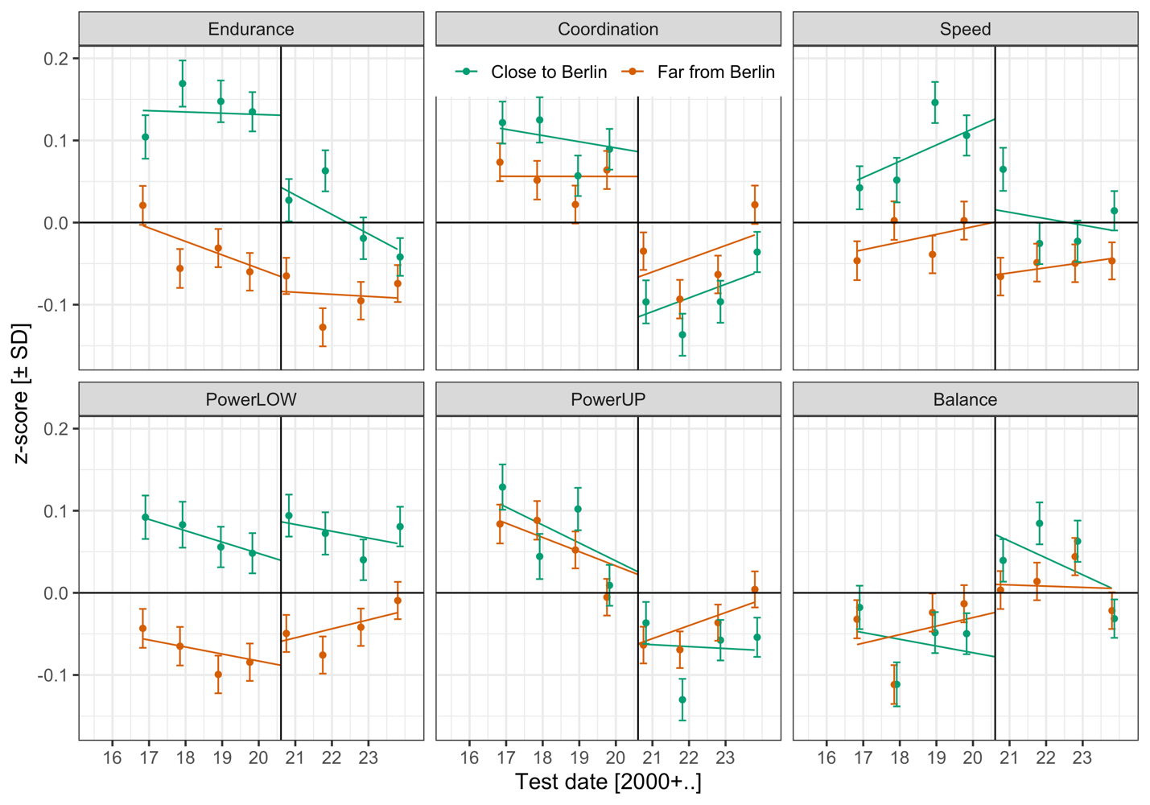
Figure S2. Physical fitness by fitness component, region (close vs. far from Berlin), and cohort (with means and 95% CIs). The vertical line marks the critical date (first day of school in school year 2020/21). Endurance = cardiorespiratory endurance (i.e., 6-min run), Coordination = star-run, Speed = 20-m linear sprint, PowerLOW = lower limbs muscle power (i.e., standing long jump), PowerUP = upper limbs muscle power (i.e., ball-push test), Balance = one-legged-stance with eyes closed. Allocation of areas to close vs. far from Berlin was determined based on official structural classification (“Landesentwicklungsplan”) of the Federal State of Brandenburg, Germany (Gemeinsame Landesplanungsabteilung Berlin-Brandenburg, 2019).

