Discovery of novel non-retroviral endogenous viral elements reveals their long-term co-evolution with spiders
Hengrui Hu¹, Just M. Vlak², Zhihong Hu¹*, Manli Wang¹*
1. State Key Laboratory of Virology, Wuhan Institute of Virology, Chinese Academy of Science, Wuhan, China.
2. Laboratory of Virology, Wageningen University, Binnenhaven 11, 6709 PD, Wageningen, The Netherlands.

*Corresponding authors

Zhihong Hu, Dr., Prof.
Mailing address: Wuhan Institute of Virology, Chinese Academy of Sciences, Wuhan 430071, P.R. China. Email: huzh@wh.iov.cn. Tel/Fax: +86-27-87998916

Manli Wang, Dr. Prof.
Mailing address: Wuhan Institute of Virology, Chinese Academy of Sciences, Wuhan 430071, P.R. China. Email: wangml@wh.iov.cn Tel/Fax: +86-27-87998086

Supplementary Figures
Fig. S1. Baculoviral homologs found in spider TSA database and T. clavata sequencing data
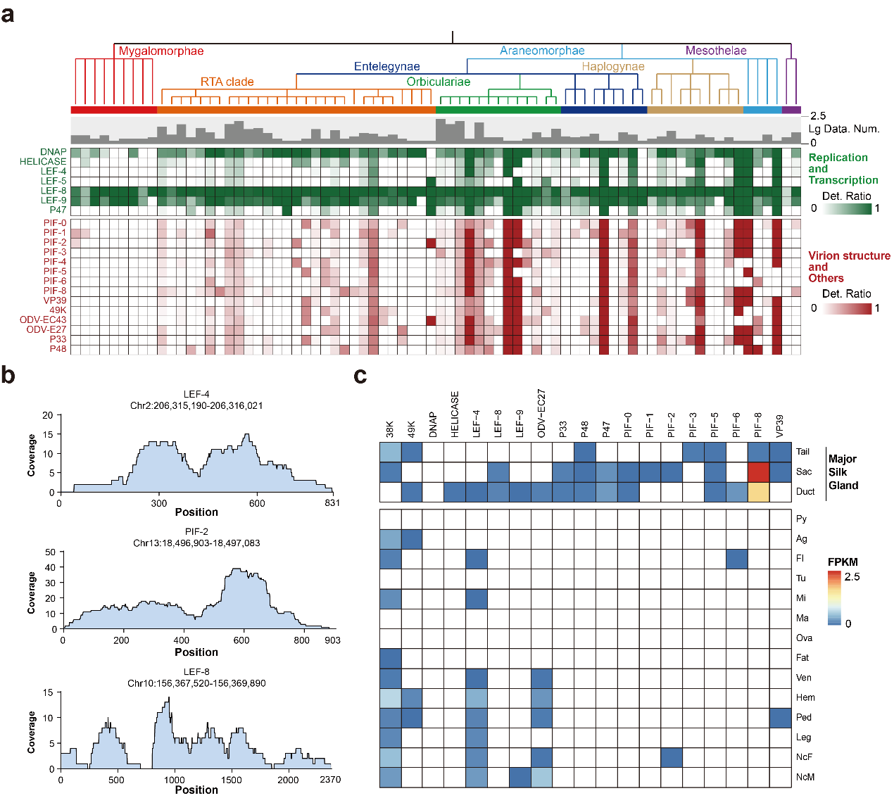
a. A heatmap of the baculoviral homologs (BHs) detection ratio in different spider families, the corresponding common tree, and the dataset number for each family are plotted above the heatmap. b. mRNA read coverage of three baculoviral homologs (BHs) in T. clavata transcriptome sequence data. c. Heatmap of BHs’ FPKM values from different tissues in T. clavata transcriptome sequence data. Py: Pyriform gland; Ag: Aggregate gland; Fl: Flagelliform gland; Tu: Tubuliform gland; Mi: Minor ampullate gland; Ma: Major ampullate gland; Ova: Ovary Fat: Fat body; Ven: Venom gland; Hem: Hemolymph; Ped: Pedipalp; NcF: Female whole body; NcM: Male whole body.

Fig. S2. PCR results demonstrate the presence of spider nrEVEs in different individuals of A. ventricosus
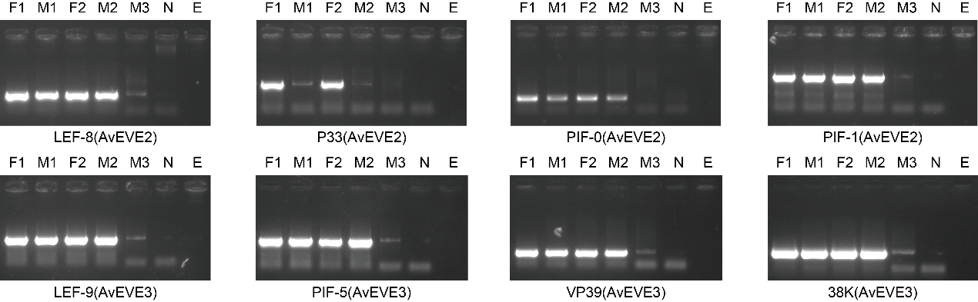
PCR results of baculoviral homologs in A. ventricosus samples from two female (F1 and F2) and three males (M1, M2, and M3). Lane NC represents the negative control, and Lane E represents the blank control.

Fig. S3. Co-phylogenetic tree of spider nrEVEs and their spider hosts
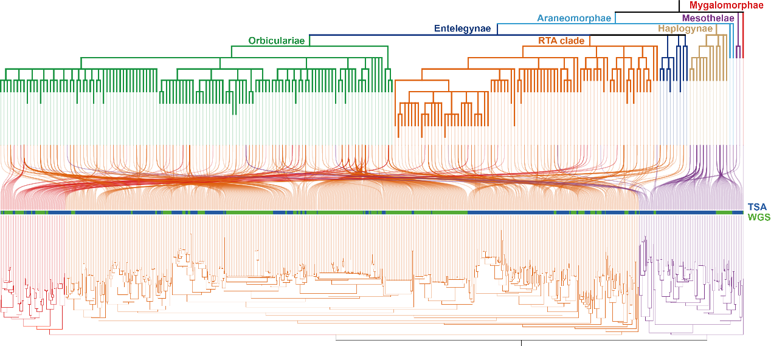
The phylogenetic tree of spider nrEVEs was a maximum-likelihood phylogenetic tree built using PIF-0 sequences from the WGS and TSA databases. The phylogenetic tree of the spiders was based on the common tree from the NCBI taxonomy. The co-phylogenetic analysis was conducted by R package ‘phytools’ (v2.1-1).

Supplementary Tables
Table S1. Baculoviral homologs founded in Araneus ventricosus by querying predicted baculoviral protein structures in AFDB50 via Foldseek
Table S2. Baculoviral homologs founded in A. ventricosus by querying predicted protein structures of selected scaffolds in predicted baculoviral protein structures via Foldseek
Table S3. Information of Arachnida WGS data used in this study
Table S4. Baculoviral homologs found in genomes of Arachnida by querying baculoviral homologs in A. ventricosus in Arachnida WGS database via mmseqs2
Table S5. Information of Araneae scaffolds containing baculoviral homologs
Table S6. Baculoviral homologs found in T. clavata by querying baculoviral homologs in A. ventricosus in SpiderDB via mmseqs2
Table S7. Information of the Araneae TSA data used in this study
Table S8. Baculoviral homologs found in transcripts of Araneae by querying baculoviral homologs in A. ventricosus in Araneae TSA database via mmseqs2
Table S9. Accession number and classfication of typical NALDVs and spider nrEVEs
Table S10. All againist all comparison of predicted protein structures of typical NALDVs and spider nrEVEs via Foldseek
Table S11. Conserved proteins shared in spider nrEVEs and NALDVs
Table S12. Primers used in this study

