Neural stemness contributes to cell tumorigenicity
Liyang Xu^{1,#}, Min Zhang^{1,#}, Lihua Shi¹, Xiaoli Yang¹, Lu Chen¹, Ning Cao¹, Anhua Lei¹, and Ying Cao^{1,*}
¹MOE Key Laboratory of Model Animals for Disease Study and Model Animal Research Center of the Medical School, Nanjing University, 12 Xuefu Road, Pukou High-Tech Zone, Nanjing 210061, China
#These authors contributed equally to the study
*Correspondence
Ying Cao, Model Animal Research Center of the Medical School, Nanjing University, 12 Xuefu Road, Pukou High-Tech Zone, Nanjing 210061, China. Email: caoying@nju.edu.cn

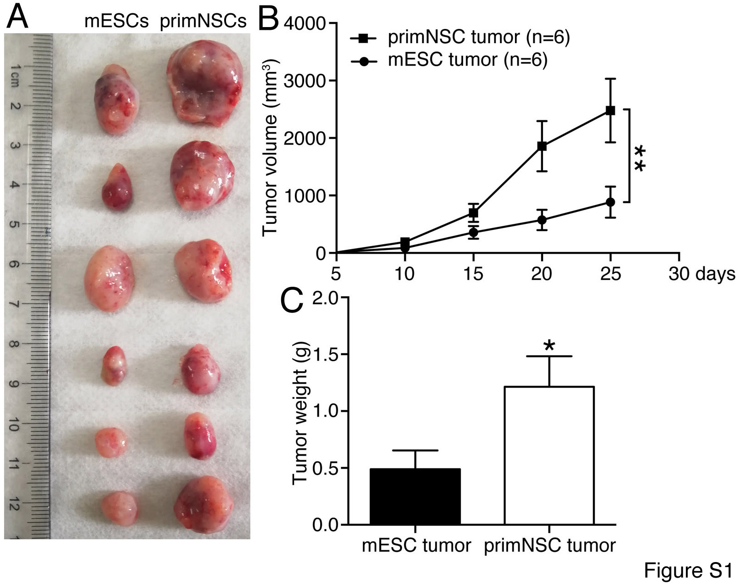
Fig. S1 Difference in tumor formation by mESCs and mESC-derived primNSCs in nude mice. (A) Tumors formed by mESCs and primNSCs in nude mice, which were injected at the same number (1×10⁶ cells each mouse). (B-C) Difference in volumes (B) and weight (C) between tumors formed by mESCs and primNSCs. In (B) and (C), data are shown as mean±SEM. Significance of difference in tumor volume between two groups was calculated using two-way ANOVA-Bonferroni/Dunn test, and significance of difference in weight was calculated using two-tailed Student’s t-test. *p<0.05, **p<0.01.

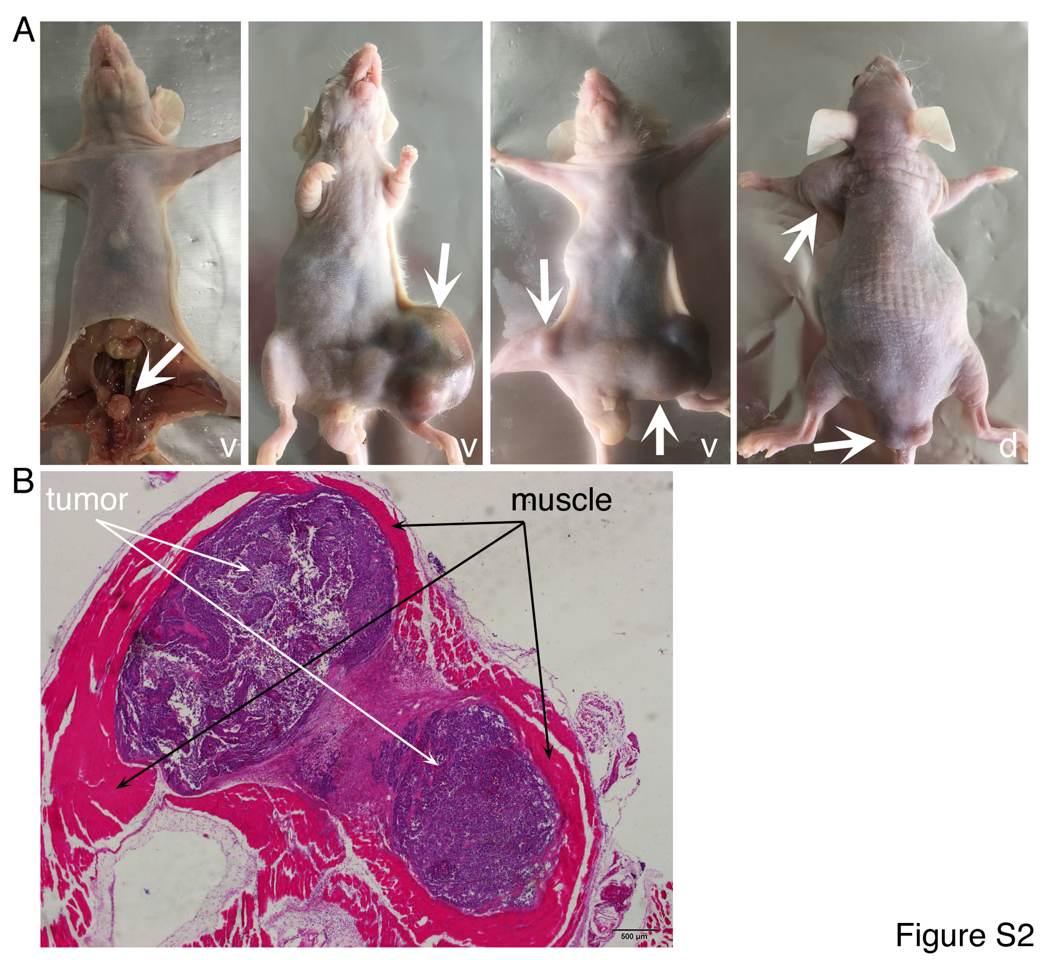
Fig. S2 Tumor formation in nude mice by NE-4C cells injected via tail vein. (A) Tumor formation occurred in different parts of the body, as indicated by arrows. v, ventral view; d, dorsal view. (B) An HE stained section of a tumor dissected from the hind leg, showing the tumor was surrounded by muscle tissue. Objective magnification: 2×.
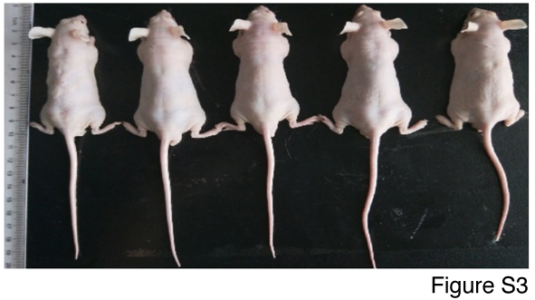
Fig. S3 Detection of tumorigenicity of MSCs via subcutaneous injection of cells into nude mice. No tumor formation could be observed in the mice in 114 days after injection.
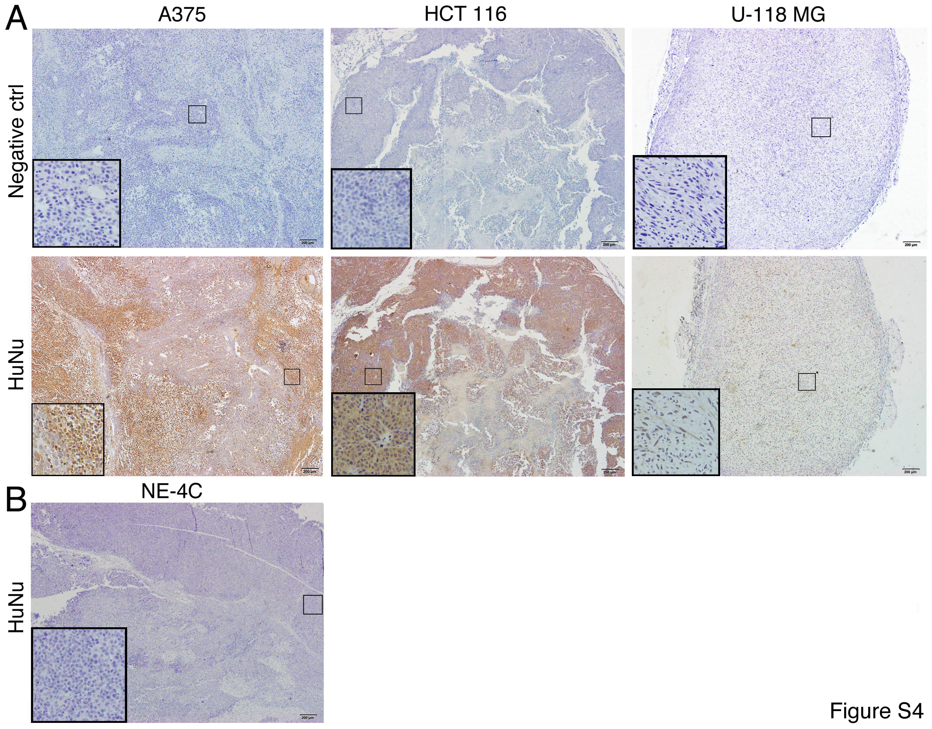
Fig. S4 Detection of tissue origin in xenograft tumors using an antibody specific for human cell nuclei (HuNu). (A) IHC detection of HuNu in sections of tumors derived from different cancer cells. IHC without addition of HuNu antibody was used as negative controls. (B) IHC detection of HuNu in a section of the tumor derived from mouse NE-4C cells. Objective magnification: 4×; insets: 20×.

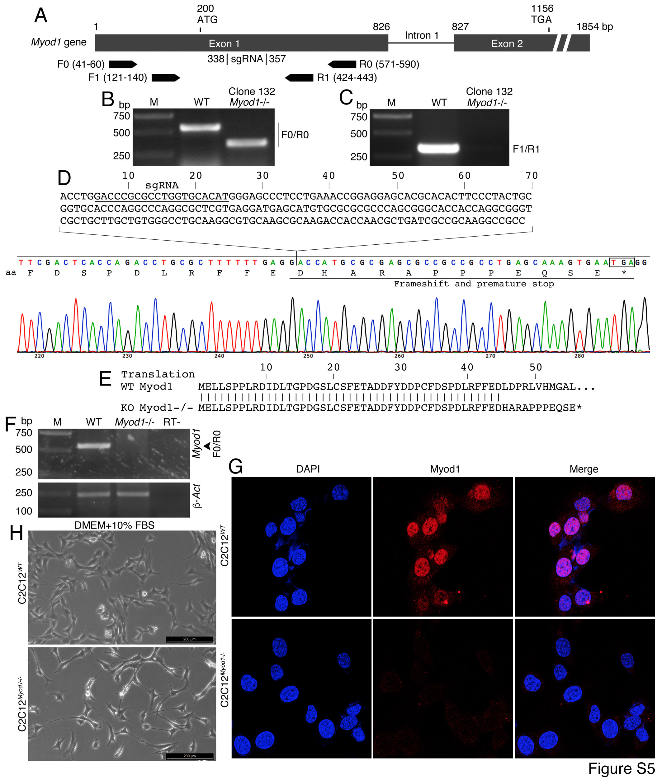
Fig. S5 Myod1 gene knockout in C2C12 cells using CRISPR/Cas9 and genotyping. (A) Diagram showing mouse Myod1 gene structure, sgRNA, and primer pairs used for genotyping. Numbers indicate position of bases, with the first base of transcription start site being assigned as +1. (B-C) PCR amplification of genomic DNA from a selected clone No. 132 and wild type (WT) C2C12 cells using primer pairs F0/R0 (B) and F1/R1 (C). M: DNA molecular size marker. (D) Sequencing electropherogram showing a deletion of 209 bp in Myod1 gene in the cells of selected clone, which led to a frameshift and premature translational stop. Underlined in the deleted region is the sequence matching sgRNA. (E) Conceptual translation of the truncated Myod1 gene and comparison with the wild type Myod1. (F) RT-PCR detection of Myod1 transcription in wild type and knockout cells using primer pair F0/R0. β-Act was detected as a loading control. RT-: Reverse transcription without transcriptase. M: DNA molecular size marker. (G) IF detection of Myod1 in wild type and knockout cells. Nuclei were counterstained with DAPI. (H) Morphological difference between wild type and knockout cells in C2C12 normal culture medium.

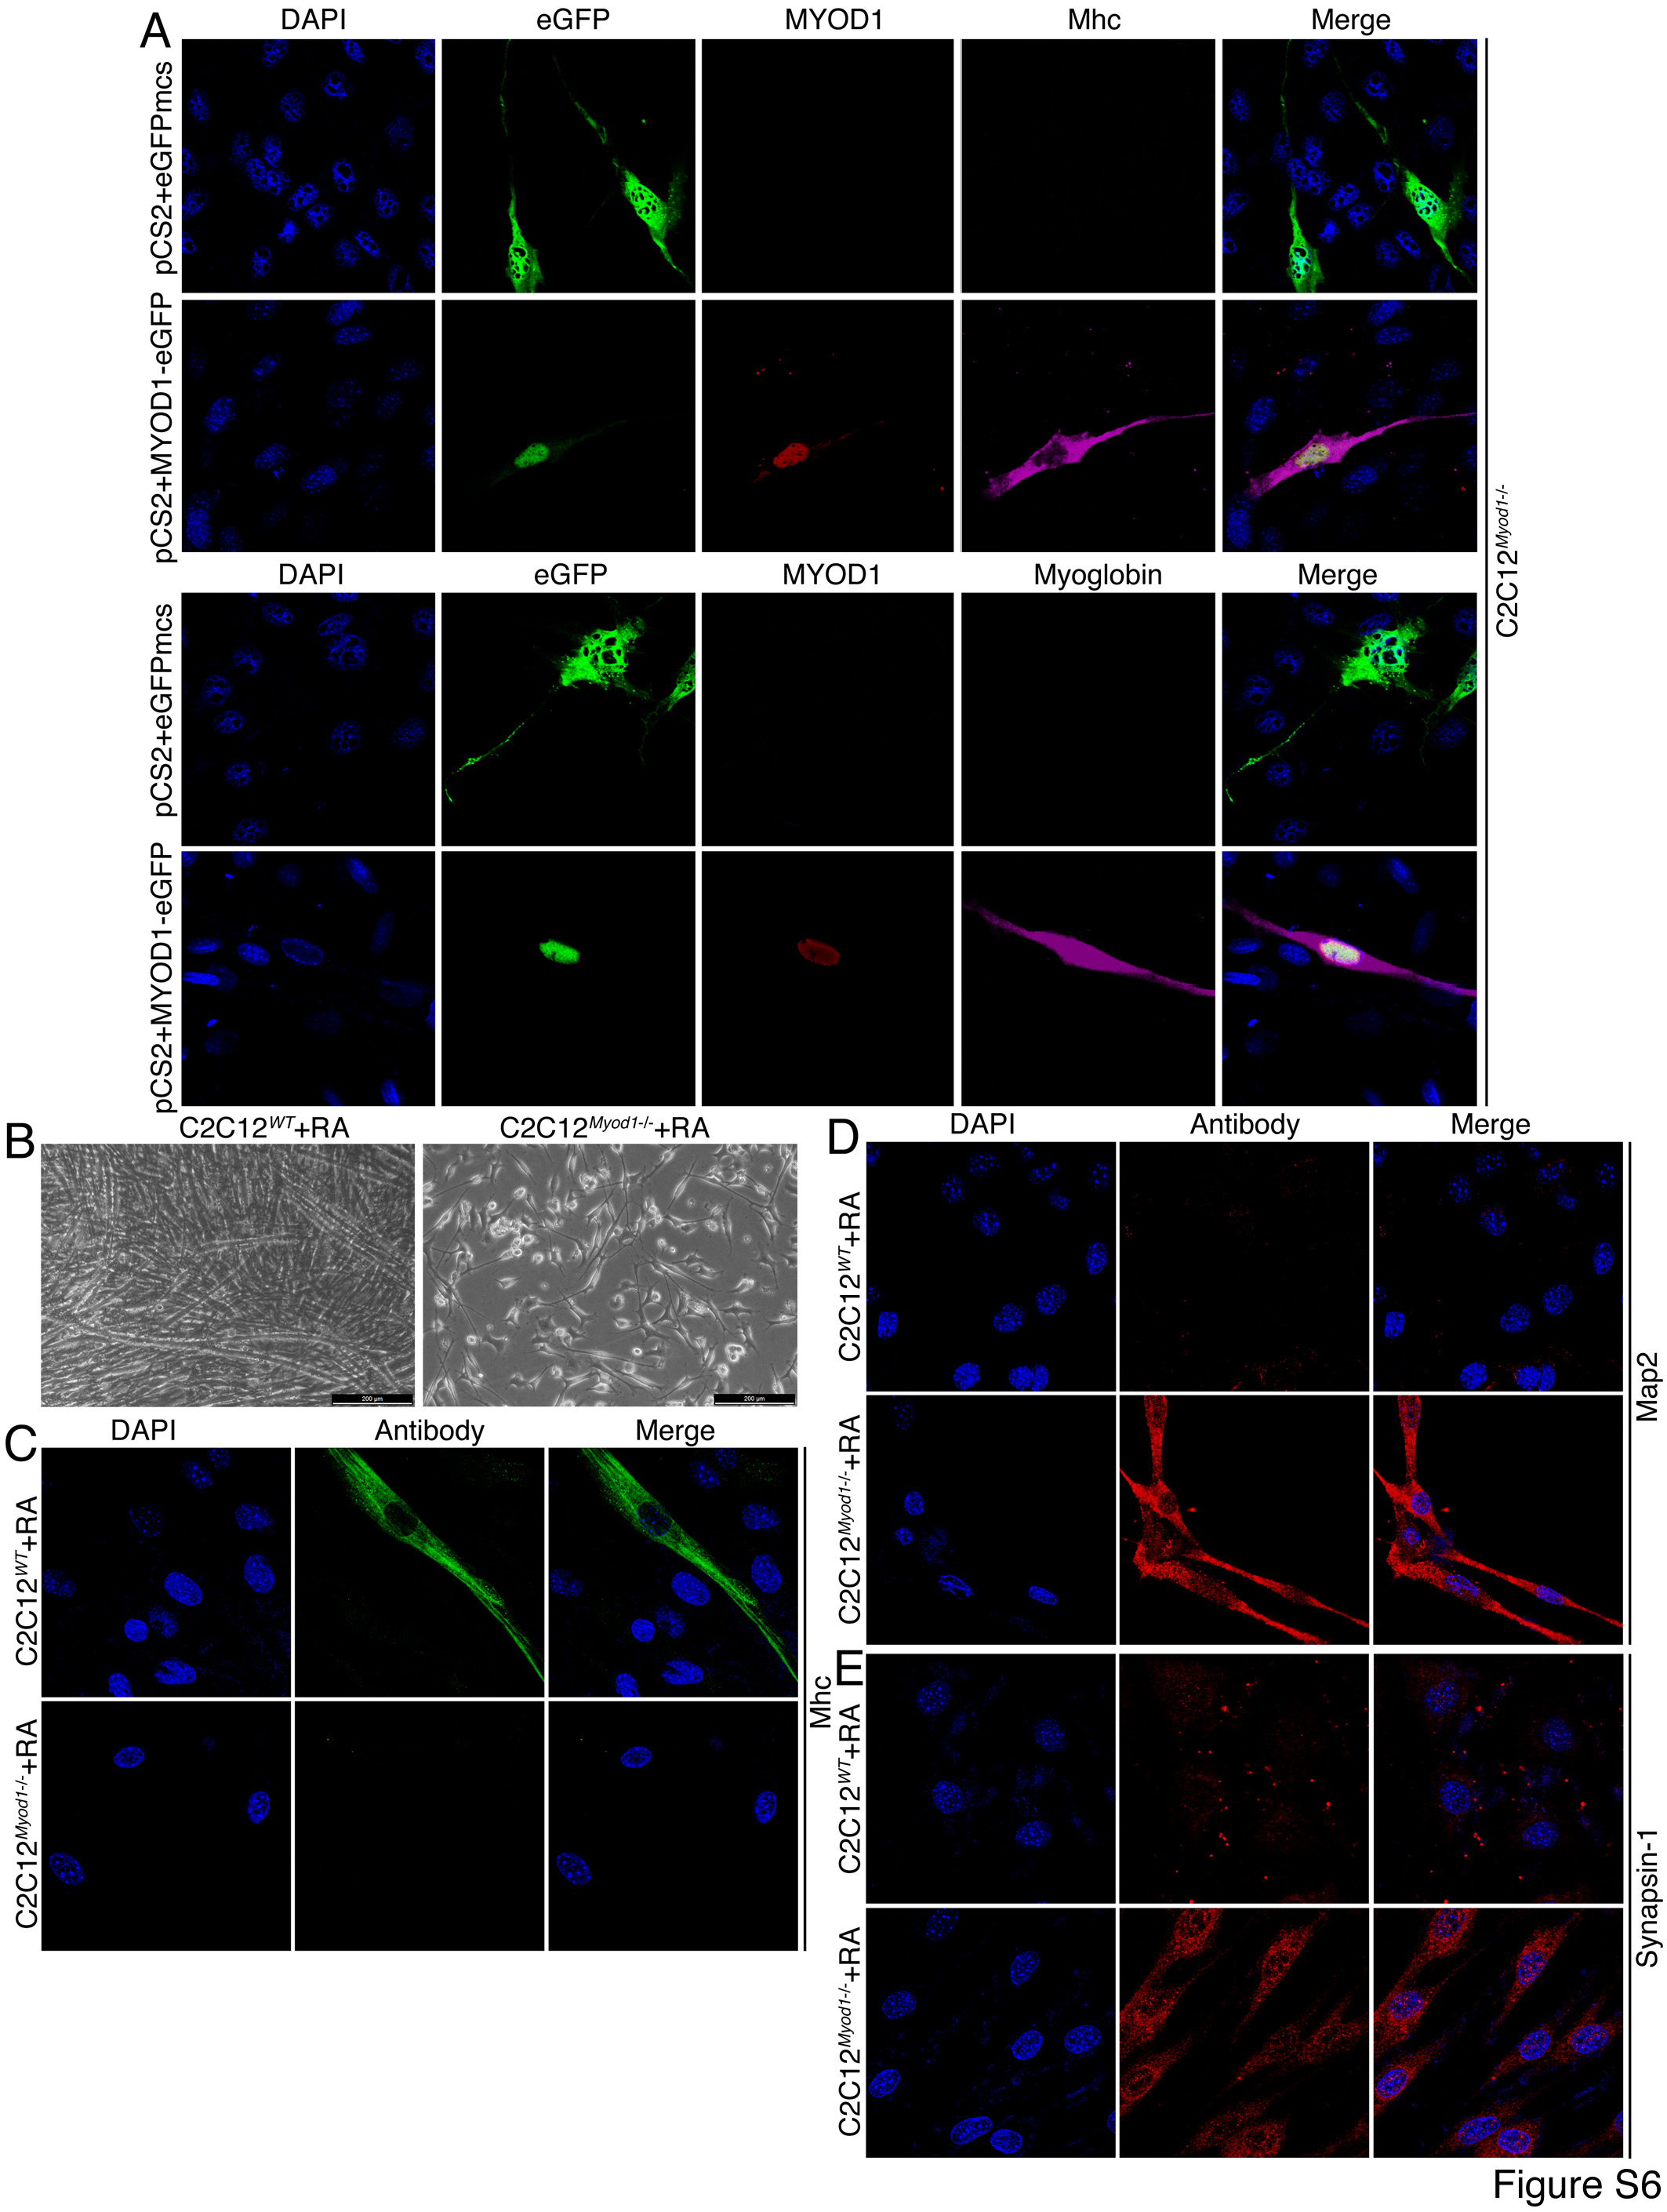
Fig. S6 Rescue of KO phenotype and characterization of neuronal differentiation potential of KO cells. (A) Rescuing effect of electroporation of a plasmid coding for MYOD1-eGFP fusion protein into KO cells. Electroporation of the empty vector pCS2+eGFPmcs was used as a control. Expression of MYOD1 and muscle cell markers was detected with IF. (B) Phenotypic difference of WT and KO cells cultured in serum-free medium for 6 days followed by RA treatment. (C-E) IF assays of muscle-specific (C) and neuron-specific marker (D and E) expression in WT and KO cells, as treated in (B). In (A) and (C-E), nuclei were counterstained with DAPI.
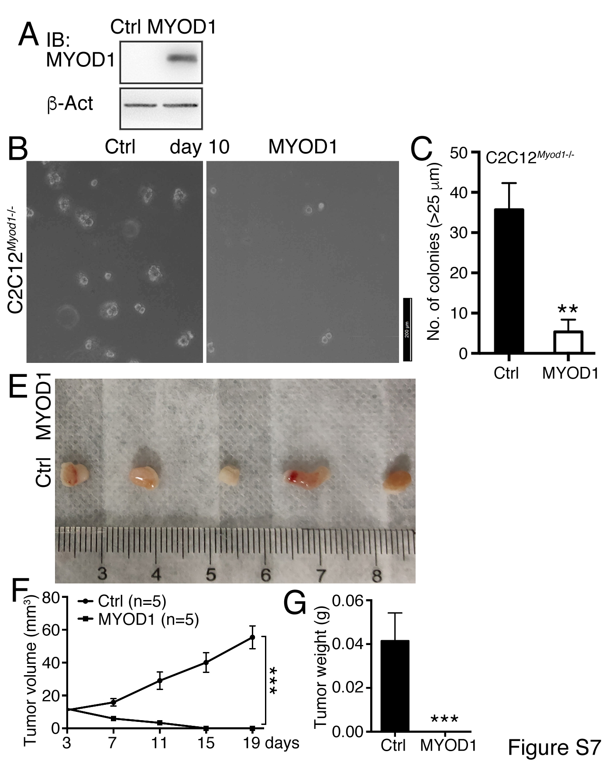
Fig. S7 The effect of re-introduction of MYOD1 on tumorigenicity of C2C12 KO cells. (A) IB detection of forced expression of MYOD1 in C2C12 KO cells. (B and C) The effect of forced expression of MYOD1 on the ability of colony formation in soft agar in a 10-day period. Significance in difference of colony formation (C) was calculated based on experiments in triplicate using two-tailed Student’s t-test. ***p<0.01. Colonies larger than 25 μm in diameter were counted. (E-G) shows the difference in tumor formation between control C2C12 KO cells and cells with forced MYOD1 expression in nude mice. (E) shows tumors in five of five mice injected with control cells but no tumor formation by cells with forced MYOD1 expression, and (F) and (G) show difference in tumor volume (F) and weight (G) between the two groups. In (F), significance of difference in tumor volume between two groups of mice was calculated using two-way ANOVA-Bonferroni/Dunn test. In (G), significance of difference in tumor weight was calculated using two-tailed Student’s t-test. Data are shown as mean±SEM. ***p<0.001.
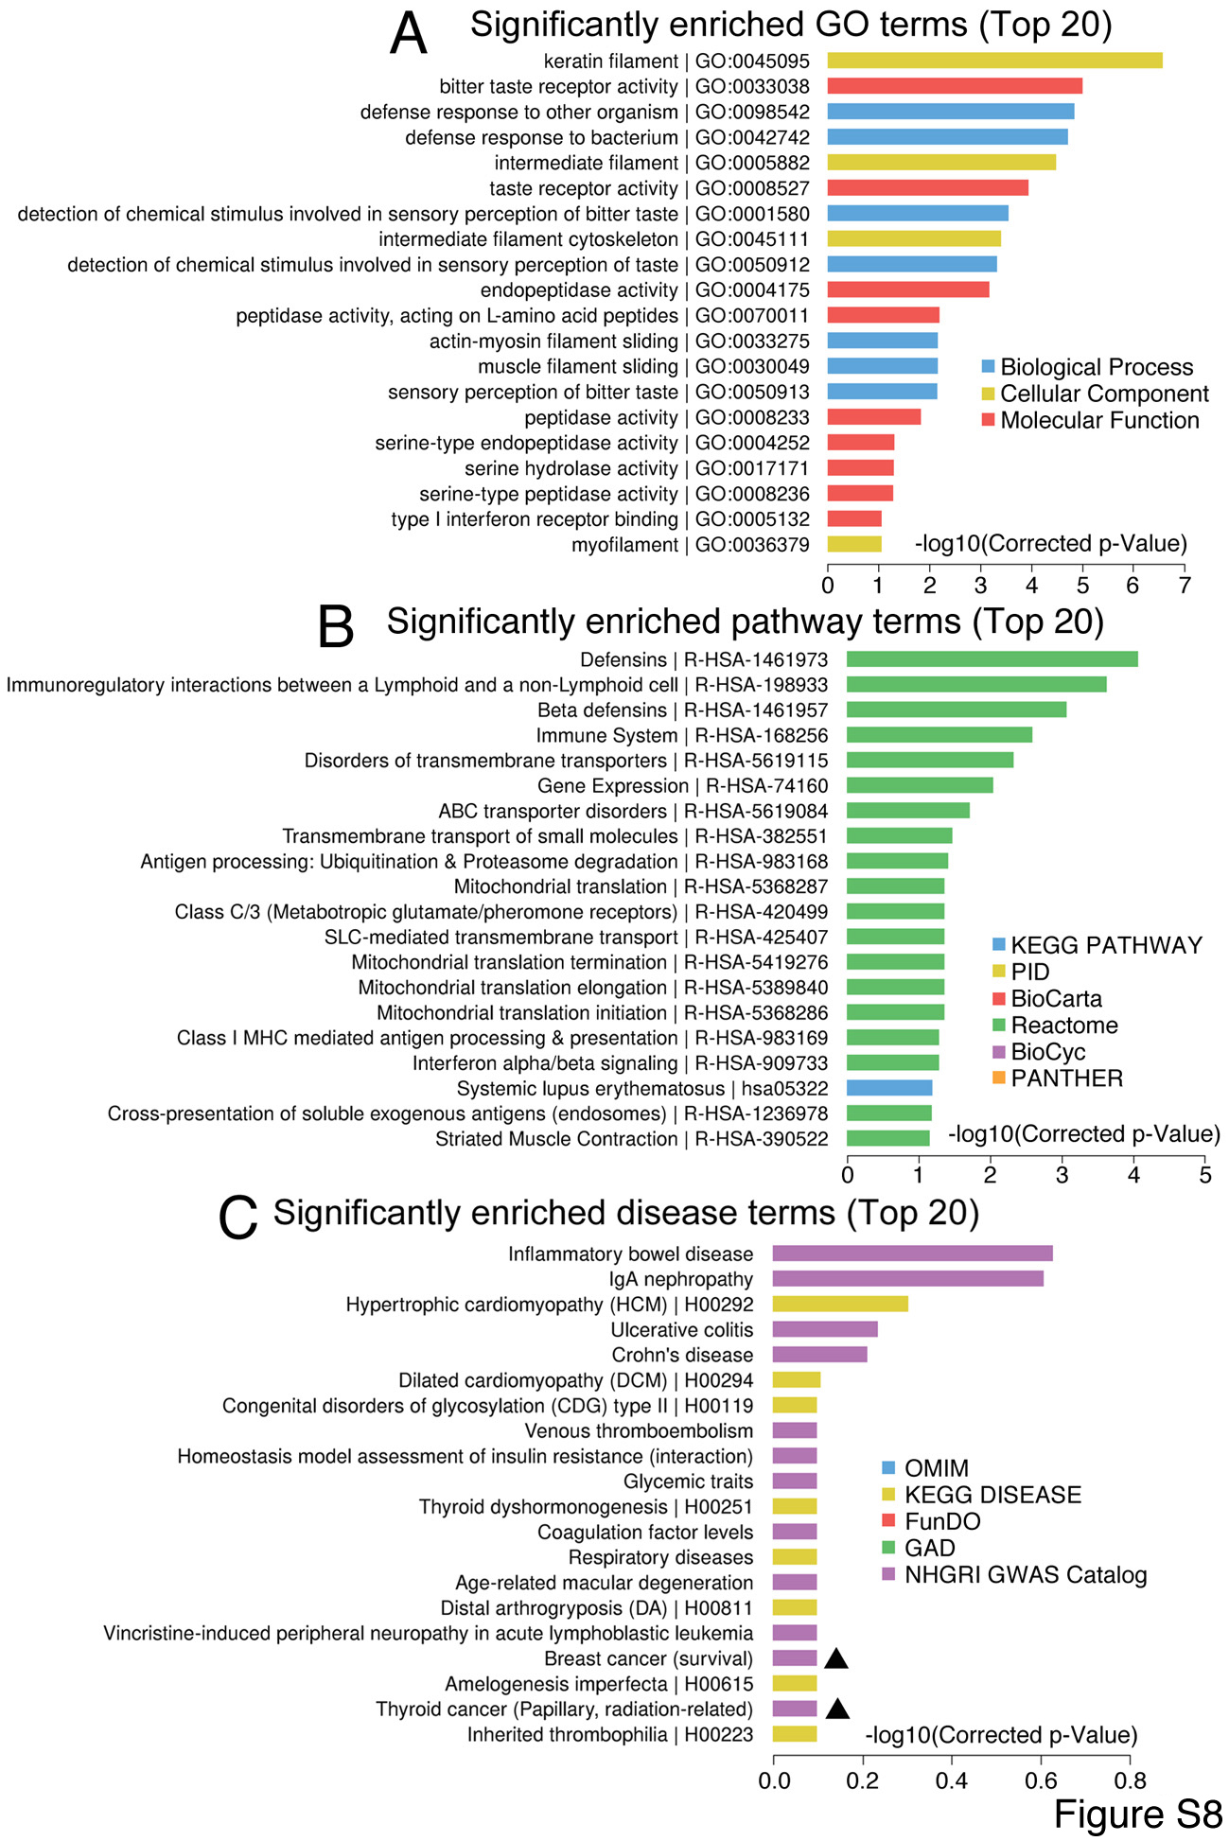
Fig. S8 Association between the genes that are not expressed in vertebrate neural tissues with GO (A), pathway (B) and human diseases (C). Cancer is highlighted with a triangle.
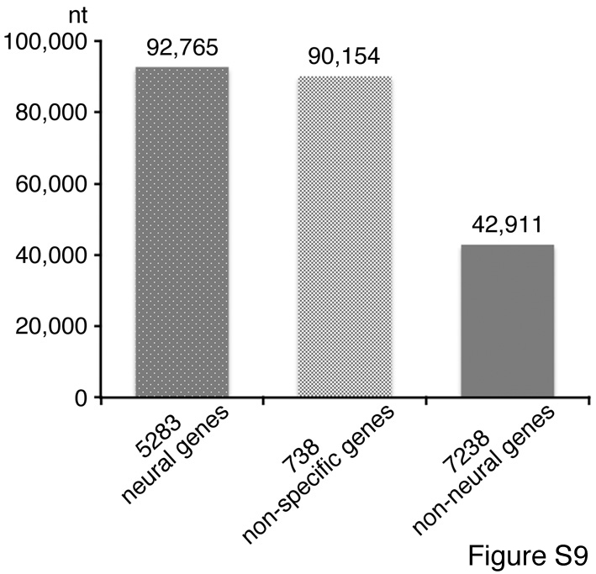
Fig. S9 Average gene length of three groups of human genes.

Table S1. Xenograft analysis on different types of cells
Cell type | Cells injected per mouse | Days after injection | Tumors/Injection
mESCs | 1×10⁶ | 25 | 6/6
primNSCs derived from mESCs | 1×10⁶ | 25 | 6/6
NE-4C | 2×10⁶ | 35 | 8/8
NE-4C+DMSO | 4×10⁶ | 19 | 5/5
NE-4C+RA | 4×10⁶ | 19 | 2/5
Cortical cells from E13.5 mouse embryos | 5×10⁶ | 47 | 6/8
MEFs from E13.5 mouse embryos | 5×10⁶ | 86 | 0/5
MSC | 2×10⁶ | 114 | 0/5
A375 | 3×10⁶ | 40 | 6/6
HCT 116 | 5×10⁶ | 29 | 6/6
U-118 MG | 4×10⁶ | 34 | 5/5
NCI-H460 | 3×10⁶ | 28 | 6/6
SW480 | 3×10⁶ | 28 | 6/6
U-2OS | 3×10⁶ | 28 | 0/6
HepG2 | 3×10⁶ | 28 | 0/6
C2C12^{WT} | 5×10⁶ | 44 | 0/5
C2C12^{Myod1-/-} | 5×10⁶ | 44 | 5/5
C2C12^{Myod1-/-}+DMSO | 6×10⁶ | 19 | 5/5
C2C12^{Myod1-/-}+RA | 6×10⁶ | 19 | 0/5
C2C12^{Myod1-/-} | 6×10⁶ | 19 | 5/5
C2C12^{Myod1-/-}+MYOD1 | 6×10⁶ | 19 | 0/5

Table S2. Comparison of tumorigenicity between mESCs and primNSCs by injecting different numbers of cells in mice, as measured 36 days after injection.
Cells injected per mouse | mESCs (Tumors/Injection) | primNSCs derived from mESCs (Tumors/Injection)
1×10⁶ | 10/10 | 10/10
0.5×10⁶ | 1/12 | 10/12
1×10⁵ | 0/10 | 4/10
1×10⁴ | 0/10 | 0/10
1×10³ | 0/10 | 0/10

Table S3. Primers for RT-qPCR
Mouse genes | Primers (5’-3’)
Acta2 (alpha-Sma) | Forward: aatggctctgggctctgtaa  Reverse: tctcttgctctgggcttcat
β-Act | Forward: ccctgaagtaccccattgaa  Reverse: cttttcacggttggccttag
Afp | Forward: atgaagcaagccctgtgaac  Reverse: agcttggcacagatccttgt
Ascl1 | Forward: gccaacaagaagatgagcaag  Reverse: gaacccgccatagagttcaa
T | Forward: ctccaacctatgcggacaat  Reverse: accattgctcacagaccaga
Cdh1 | Forward: actttggtgtgggtcaggaa  Reverse: ttcacatgctcagcgtcttc
Cdh2 | Forward: cggtttcacttgagagcaca  Reverse: catacgtcccaggctttgat
Myc | Forward: acgactccgtacagccctatt  Reverse: acgtagcgaccgcaacata
Desmin | Forward: gtgaagatggccttggatgt  Reverse: cgggtctcaatggtcttgat
Foxa2 | Forward: taagcgagctaaagggagca  Reverse: gtggttgaaggcgtaatggt
Gata4 | Forward: ggaagcccaagaacctgaat  Reverse: tgctgtgcccatagtgagat
Gata6 | Forward: aagatgaatggcctcagcag  Reverse: catatagagcccgcaagcat
Gdnf | Forward: gacttgggtttgggctatga  Reverse: aacatgcctggcctactttg
Kdr | Forward: agctctccgtggatctgaaa  Reverse: agatgctccaaggtcaggaa
Krt8 | Forward: tctgggatgcagaacatgag  Reverse: tcttcacaaccacagccttg
Krt20 | Forward: tccagacttgaagcccagat  Reverse: cagccagcttagcattgtca
Map2 | Forward: agcagccgaagaaacagcta  Reverse: aaggtcttgggagggaagaa
Mturn | Forward: agcgcaggatggacttctac  Reverse: ttcatggagggtcttcttgc
Myf5 | Forward: gccatccgctacattgaga  Reverse: tgctgtcaaagctgctgttc
Myh1 | Forward: catgtccaaagccaacagtg  Reverse: acttggcgttcacagcttct
Myh3 | Forward: tggaagacgaagtgtgagga  Reverse: tctcggcaatctgttcagtg
Myh4 | Forward: acattattggctggctggac  Reverse: acccttcttcttgccacctt
Myh6 | Forward: gggcattgagtgggagttta  Reverse: tgtcatacagcttggccttg
Myod1 | Forward: tcgtgaggatgagcatgtg (Within the deleted region of Myod1 gene in KO cells)  Reverse: tctcgaaggcctcattcact (Outside the deleted region)
Myog | Forward: tccagtacattgagcgccta  Reverse: caaatgatctcctgggttgg
Nestin | Forward: ttccctgatgatccaacctc  Reverse: acctctgtggctgcttcttt
Neurod1 | Forward: ctctggagcccttctttgaa  Reverse: tgcagggtagtgcatggtaa
NeuN | Forward: agcagcccaaacgactacat  Reverse: tcggtcagcatctgagctagt
Notch1 | Forward: tcgtgctcctgttctttgtg  Reverse: agcaccatctgaggcattct
Patched | Forward: tacgtggaggtggttcatca  Reverse: aggcataggcaagcatcagt
Pax5 | Forward: aacttgcccatcaaggtgtc  Reverse: ggcgtttgtactcagcgatt
Pax6 | Forward: cacatcaggttccatgttgg  Reverse: cataactccgcccattcact
Pdgfra | Forward: ctcccatccatcaaactggt  Reverse: caatctcgacgaagcctttc
Robo2 | Forward: attccgttgtcaggtccaag  Reverse: acttttcccacccgattctc
Sox1 | Forward: cacaactcggagatcagcaa  Reverse: tccttcttgagcagcgtctt
Sox2 | Forward: gcggagtggaaacttttgtc  Reverse: tccgggaagcgtgtacttat
Sox9 | Forward: gctggcaaagttgatctgaag  Reverse: gttgggtggcaagtattggt
Sox11 | Forward: cttcatggtgtggtccaaga  Reverse: gtcgggataatcagccatgt
Sox17 | Forward: taaaggtgaaaggcgaggtg  Reverse: tagctctgcgttgtgcagat
Stat3 | Forward: caaaaccctcaagagccaag  Reverse: ttctgcacgtactccattgc
Synj1 | Forward: gagctgaatgctgggaacat  Reverse: gcgtgctgtggtctgataaa
Tubb3 | Forward: ttctggtggacttggaacct  Reverse: actctttccgcacgacatct
Vim | Forward: gaccttgaacggaaagtgga  Reverse: agccacgctttcatactgct
Zeb2 | Forward: gggacagatcagcaccaaat  Reverse: gcagtttgggcattcgtaag
Zic1 | Forward: tggagccttcttccgctat  Reverse: actcctcccagaagcagatgt
Zic2 | Forward: tccgagaacctcaagatcca  Reverse: tgggatgcgtgtaggactt
Human genes | Primers (5’-3’)
ACP5 | Forward: ttccaggagacctttgagga  Reverse: tgtgggatcttgaagtgcag
ACTA2 (alpha-SMA) | Forward: ctgttccagccatccttcat  Reverse: ccgtgatctccttctgcatt
β-ACT | Forward: agaaaatctggcaccacacc  Reverse: tagcacagcctggatagcaa
AFP | Forward: agcttggtggtggatgaaac  Reverse: tctgcaatgacagcctcaag
ASCL1 | Forward: gtgcgaatggactttggaag  Reverse: gggttggttgactgttttcg
BDNF | Forward: tgttggatgaggaccagaaag  Reverse: cctcatggacatgtttgcag
BGLAP | Forward: cctttgtgtccaagcagga  Reverse: tgaaagccgatgtggtcag
T | Forward: aagtacgtgaacggggaatg  Reverse: tgagcttgttggtgagcttg
CALCR | Forward: ggcctgcaactatttctgga  Reverse: aatgggtttccacactcagc
CDH1 | Forward: tggacagggaggattttgag  Reverse: acctgaggctttggattcct
CDH2 | Forward: ccatcactcggcttaatggt  Reverse: acccacaatcctgtccacat
MYC | Forward: tcaagaggcgaacacacaac  Reverse: atgagcttttgctcctctgc
CTSK | Forward: tgtggtgagctttgctctgt  Reverse: gcctcaaggttatggatgga
DESMIN | Forward: tatgagaccatcgcggcta  Reverse: ggaatcgttagtgcccttca
FOXA2 | Forward: cccacaaaatggacctcaag  Reverse: ataatgggccgggagtaca
FGF5 | Forward: agtcaatggatcccacgaag  Reverse: cttgaaaacgctccctgaac
GAPDH | Forward: tcaagaaggtggtgaagcag  Reverse: tgacaaagtggtcgttgagg
GATA4 | Forward: taagacaccagcagctccttc  Reverse: atcgcactgactgagaacgtc
GATA6 | Forward: gtgtgcaatgcttgtggact  Reverse: agttggagtcatgggaatgg
GFAP | Forward: aggaagattgagtcgctgga  Reverse: atactgcgtgcggatctctt
HNF1A | Forward: cctcaaagagctggagaacct  Reverse: ttgttgaggtgttgggacag
HNF4A | Forward: gtgtccatacgcatccttga  Reverse: tactggcggtcgttgatgta
KDR | Forward: atccctgtggatctgaaacg  Reverse: agatgctccaaggtcaggaa
KRT8 | Forward: caagaaggatgtggatgaagc  Reverse: caatgatgctgtccatgtcc
KRT20 | Forward: atgaagtcatggcccagaag  Reverse: ttcatgctgagatgggactg
NCAM1 | Forward: cagatgggagaggatggaaa  Reverse: ttcagcatgacgtggtcact
NEUN | Forward: gagaagctgaatgggacgat  Reverse: aaccccgtcactgcatagaa
MAP2 | Forward: cagggaggaatttgtggaga  Reverse: atggtctcctttccacctca
MSI1 | Forward: accaagagatccaggggttt  Reverse: tcgttcgagtcaccatcttg
MTURN | Forward: acgcaggatggatttctacg  Reverse: acttcgtggagcgtcttctt
OCT4 | Forward: tgagaggcaacctggagaat  Reverse: cagcagcctcaaaatcctct
PAX6 | Forward: aagggccaaatggagaagag  Reverse: gccagatgtgaaggaggaaa
PDGFRA | Forward: ggccccatttacatcatcac  Reverse: catagctccgtgtgctttca
ROBO2 | Forward: acccttccagcaagtgcata  Reverse: gttgatcgctctgaccatga
SOX1 | Forward: aagtcaaaacgaggcgagag  Reverse: aagtgcttggacctgcctta
SOX2 | Forward: catcacccacagcaaatgac  Reverse: cctccccaggttttctctgta
SOX9 | Forward: ccgaagaaagagaggaccaa  Reverse: gcgcttggataggtcatgtt
SYN1 | Forward: aatactggctctgcgatgct  Reverse: tgtcttcatcctggtggtca
SYNJ1 | Forward: tggcttctgaacagttggtg  Reverse: agcaaaggctggttgtatgg
SYT1 | Forward: gccatagtcgcagtcctttt  Reverse: tgagggcctgatctttcatc
TUBB3 | Forward: gtgcggaaggagtgtgaaa  Reverse: acgacgctgaaggtgttcat
VIM | Forward: tgttgacaatgcgtctctgg  Reverse: ggcttggaaacatccacatc
ZEB2 | Forward: caccaaatgctaacccaagg  Reverse: tgtgcgaactgtaggaacca
ZIC1 | Forward: acaaaaggacgcacacagg  Reverse: ggattcgtggaccttcatgt
ZIC2 | Forward: gtacggccccatgaatatga  Reverse: cttgggattgctcagttgct

