Supporting Information
A hydrophobic and degradable straw based on the ethyl cellulose-coated bacterial cellulose
Ronghui Zhang¹, Luyu Yang¹, Bianjing Sun ¹, and Dongping Sun¹*

¹Institute of Chemicobiology and Functional Materials, School of Chemistry and Chemical Engineering, Nanjing University of Science and Technology, 200 Xiao Ling Wei, Nanjing 210094, China.

*Corresponding author, E-mail:
sundpe301@163.com (Dongping Sun).

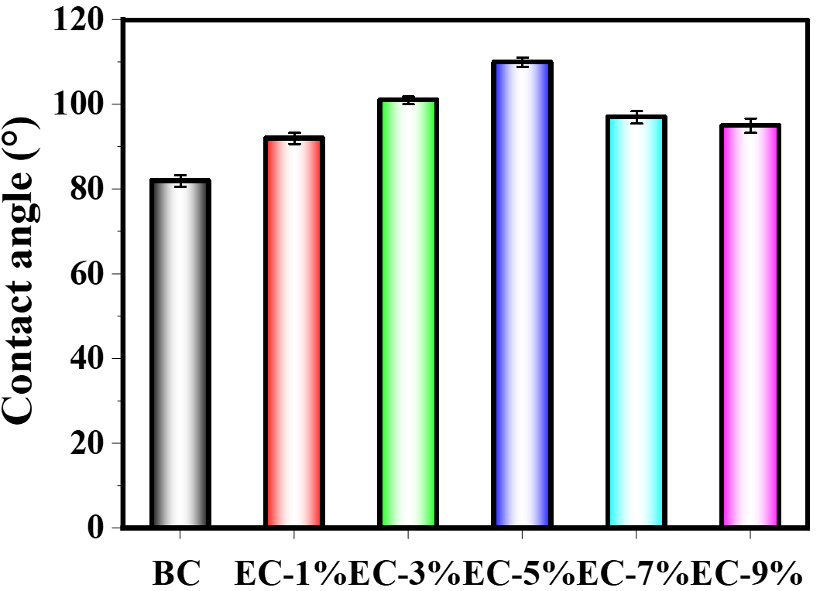
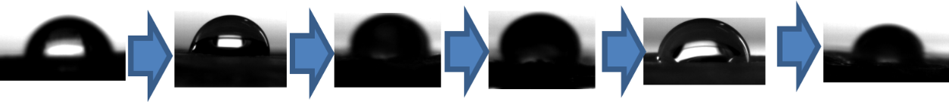
Fig. S1. Contact angle and Schematic diagram of BC and EC-BC with different EC contents.
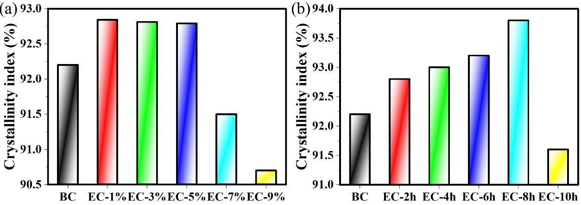
Fig. S2. (a-b) Crystallinity index of BC and EC-BC with different EC contents and soaking time

Table S1.1. Comparison between the initial decomposition temperature, fastest decomposition temperature, and residual mass of five types of straws

Sample | Initial  decomposition  temperature (℃) | Fastest decomposition temperature (℃) | Residual mass  (%)
BC | 302 | 327 | 23.0
PP | 433 | 453 | 0.724
PLA | 288 | 327 | 22.1
EC-BC | 308 | 347 | 16.7
paper | 317 | 354 | 15.3

Table S1.2. Comparison between the initial decomposition temperature, fastest decomposition temperature, and residual mass of BC and EC-BC straws with different EC soaking time

Sample | Initial  decomposition  temperature (℃) | Fastest decomposition temperature (℃) | Residual mass  (%)
BC/EC-2h | 298 | 329 | 21.1
BC/EC-4h | 297 | 329 | 21.5
BC/EC-6h | 300 | 331 | 22.2
BC/EC-8h | 313 | 344 | 47.4
BC/EC-10h | 307 | 338 | 53.0
BC | 297 | 329 | 23.1

Table S1.3. Comparison between the initial decomposition temperature, fastest decomposition temperature, and residual mass of BC and EC-BC straws with different EC contents

Sample | Initial  decomposition  temperature (℃) | Fastest decomposition temperature (℃) | Residual mass  (%)
BC/EC-1% | 304 | 335 | 21.8
BC/EC-3% | 307 | 337 | 20.8
BC/EC-5% | 308 | 339 | 21.0
BC/EC-7% | 311 | 342 | 20.5
BC/EC-9% | 317 | 349 | 20.6
BC | 300 | 331 | 23.1

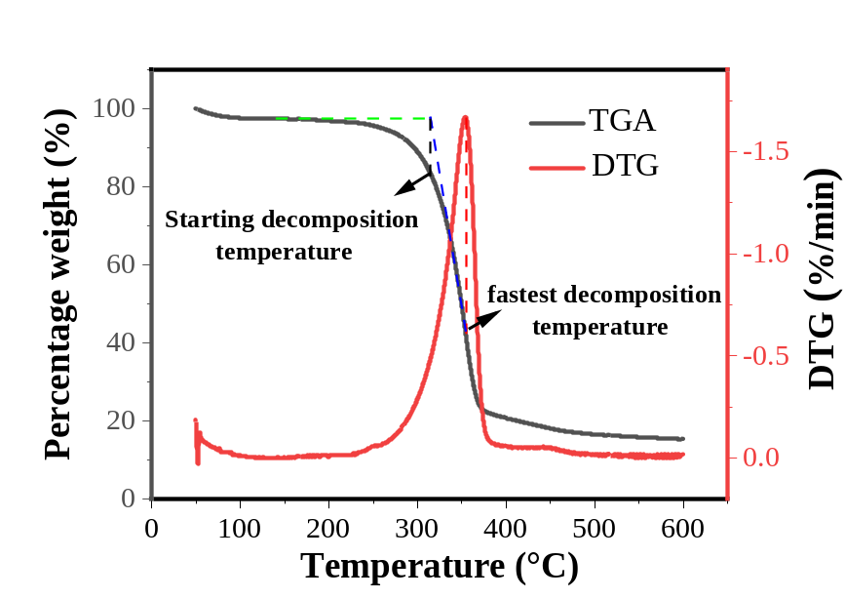
Fig S3. The determination of the starting decomposition temperature and the fastest decomposition temperature for the straw.

Table S2.1. The calculation of the atomic percentage of BC and EC-BC straw atoms in the XPS full spectrum

Sample | Atomic (%)
Sample | C | O
BC | 68.5 | 31.5
EC-BC | 75.6 | 24.4
(b)
(c)
(a)
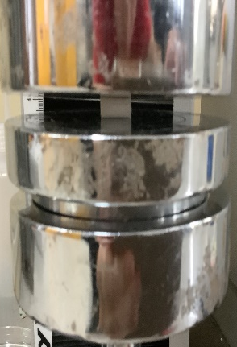
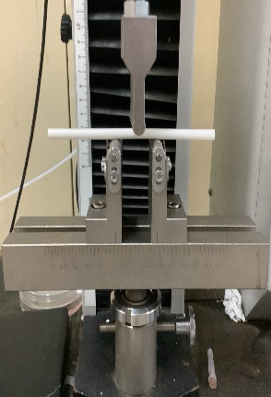
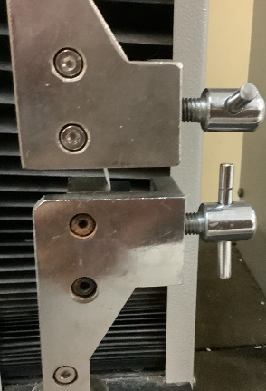

Fig. S4. (a-c) Schematic diagrams of the straw's tensile, compression, and bending tests.

Table S3.1. Comparisons between the bending strength of the straw in this research and those in previous research

Ref. | Samples | Flexural strength (MPa) | Instructions
This  work | EC-BC | 66.82 ± 0.72 | Ethyl cellulose-bacterial cellulose(EC-BC)
[1] | LCS | 62.22 ± 5.73 | Lignose cellulose straw (LCS)
[1] | LFCS | 20.60 ± 2.19 | Lignin-free cellulose straw (LFCS)
[2] | BC/alginate | 35.3 ± 3.9 | Alginate-coated bacterial cellulose (BC)-based straws
[3] | 4.86% PLA starch/cellulose | 0.38 | Polylactic Acid (PLA) reinforced starch  /cellulose composite foam straws
[4] | Paper-based | 7.12 ± 0.19 | Cellulose fiber composite with ethyl cellulose and SiO2 nanoparticles
[5] | Cellulose hybrid | 6.9 ± 0.8 | Cellulose microscale and nanoscale fibers hybrid
[6] | Cellulose-lignin film | 10.6 ± 1.0 | Cellulose-lignin composite
[7] | Nanochitin | 19.7 ± 0.45 | Chitin straws
[8] | PBS/CNC composites | 23.0 ± 0.85 | Polybutylene succinate cellulose  nanocrystal (PBS/CNC )
[9] | CFS | 13.4 ± 0.75 | All-natural superhydrophobic straw made of a composite of cellulose nanofibers and stearic acid

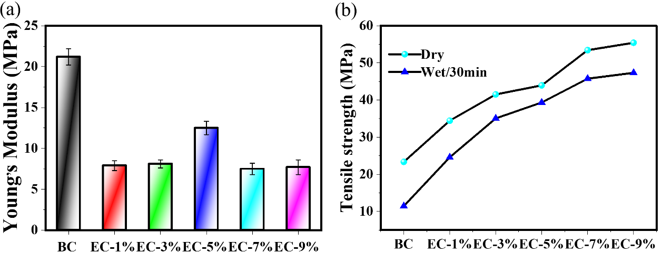
Fig. S5. (a) The column graph of Young's modulus. (b) The alteration of tensile strength of EC-BC straws in dry state and after being immersed in deionized water for 30 minutes.

Table S3.2. The comparison of the tensile strength of the straw in this study with thoaw in previous research

Ref. | Samples | Tensile strength (MPa) | Instructions
This  work | EC-BC | 55.43±1.42 | Ethyl cellulose-bacterial cellulose(EC-BC)
[1] | LCS | 127.00 ± 9.21 | Lignose cellulose straw (LCS)
[1] | LFCS | 82.54 ± 9.57 | Lignin-free cellulose straw (LFCS)
[2] | BC/alginate | 408.23 ± 12.9 | Alginate-coated bacterial cellulose (BC)-based straws
[10] | molded pulp  tableware | 35.0 | The slender bamboo fibers mixed with stubby bagasse fibers
[4] | Paper-based | ~ 23 | Cellulose fiber composite with ethyl cellulose and SiO2 nanoparticles
[11] | PBAT/PLA/CNC  films | 44.7 ± 2.3 | adipate-co-terephthalate (PBAT) and cellulose nanocrystalline (CNC) composites
[12] | Paper-CNF | 45 ± 3.8 | Paper surface coated with CNF
[12] | Paper-LCNF | 41 ± 1.8 | Paper surface coated with lignin-CNF (LCNF)
[8] | PBS/CNC composites | 14.43 ± 0.85 | Polybutylene succinate cellulose  nanocrystal (PBS/CNC )
[9] | CFS | 67.15±1.75 | All-natural superhydrophobic straw made of a composite Of cellulose nanofibers and stearic acid
[13] | PP-straw | 14.11 ~ 47.98 | Commercial polypropylene (PP)
[13] | Paper straw | ~ 17 | Commercial paper straws
[14] | PLA-straw | 39 ~ 65 | Commercial Polylactic acid (PLA) straw
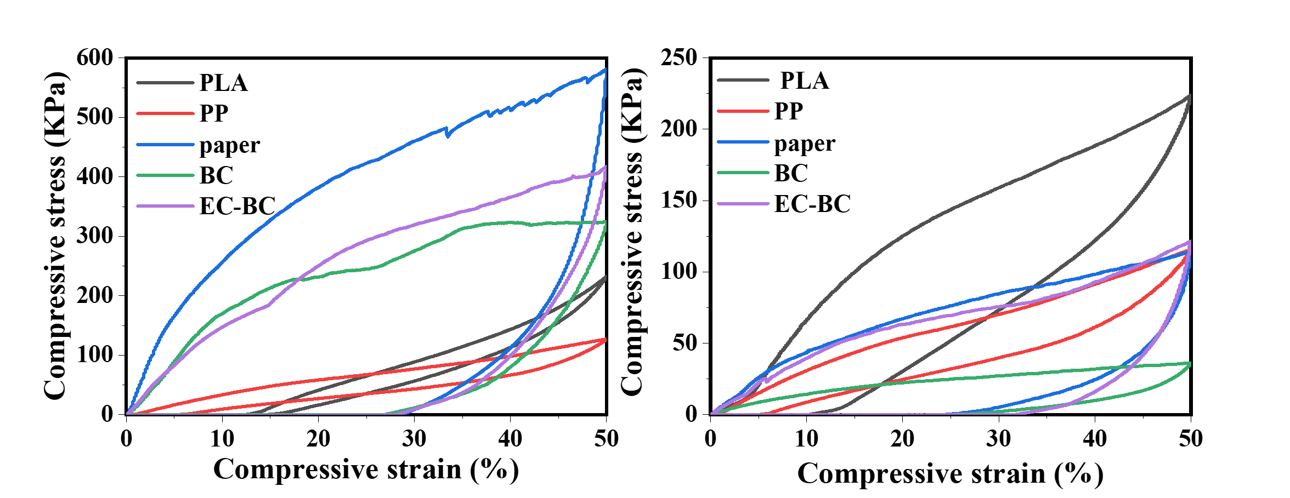
(b)
(a)
Fig. S6. Comparison of the compression performance of five different types of straws. (a) Under dry conditions. (b) after soaking for 30 minutes

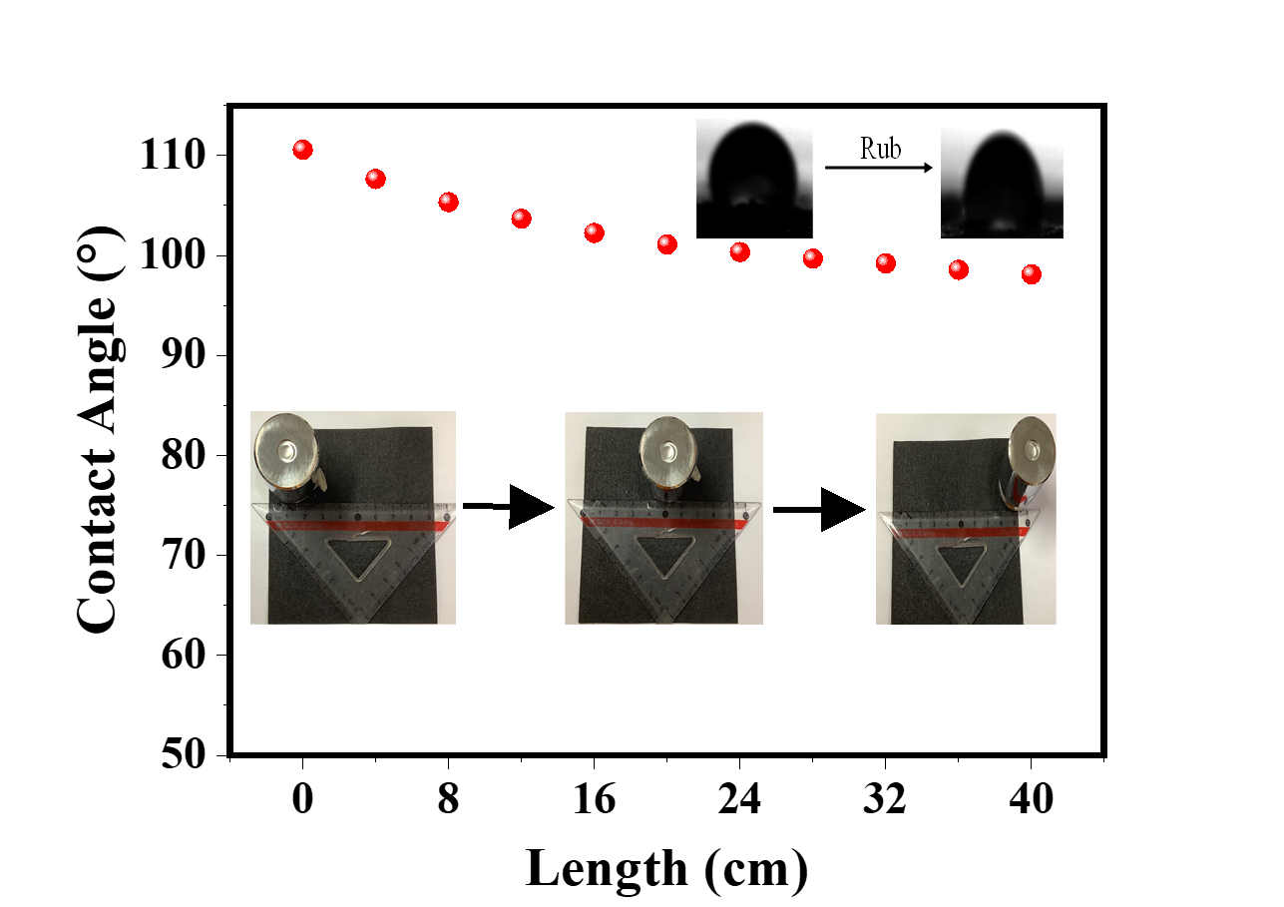
(a)
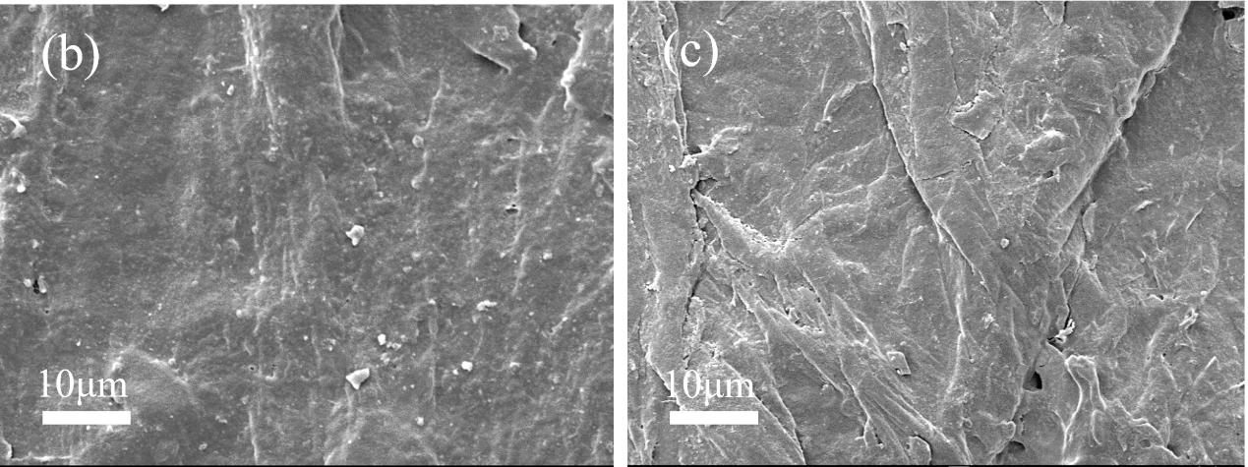
Fig. S7. (a) Abrasion test of EC(5%,8h)-BC straw. (b-c) The SEM images obtained after rubbing the straw on the sandpaper for 20cm and 40cm.
(c)
(b)

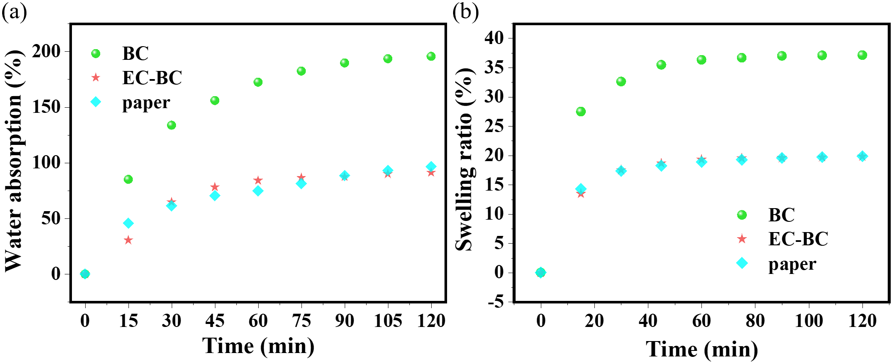
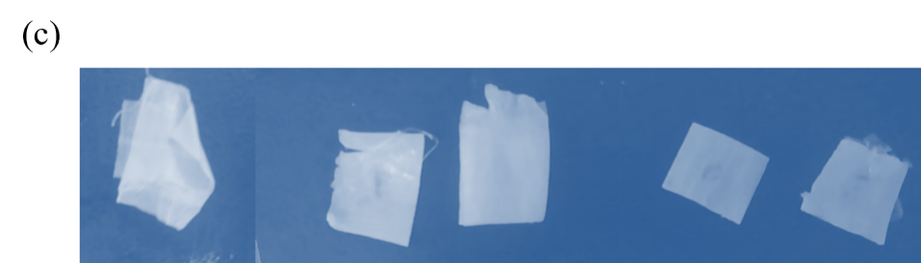
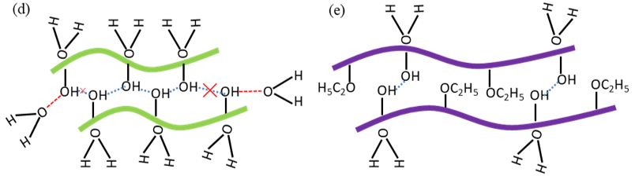
Fig. S8. (a-b) Water absorption and swelling ratio variation for EC(5%,8h)-BC, BC and paper straws. (c) Optical digital photos of BC and EC-BC straws (after the straws were immersed in deionized water for 2 hours). Schematic diagram of hydrogen bond erosion by water in the hydrogen bond network of (d) BC and (e) EC-BC straw

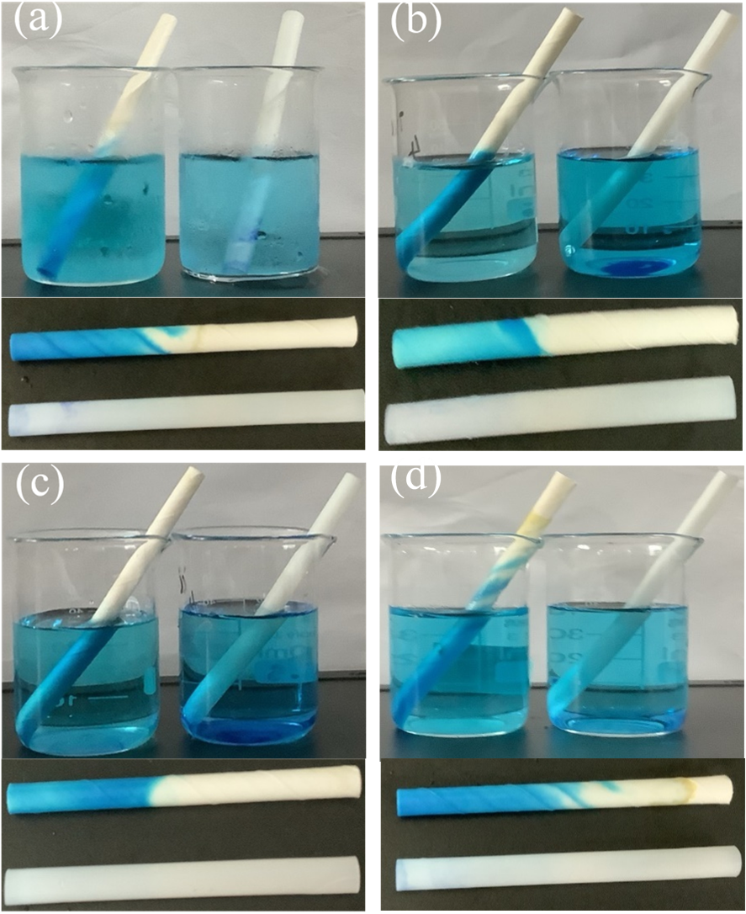
Fig. S9. (a-d) Soaking in water of different temperatures for 120 minutes and the morphological changes of the straw after soaking.

Table S4. The evaluation level of each index for Paper、PLA、PP、BC and EC-BC straws
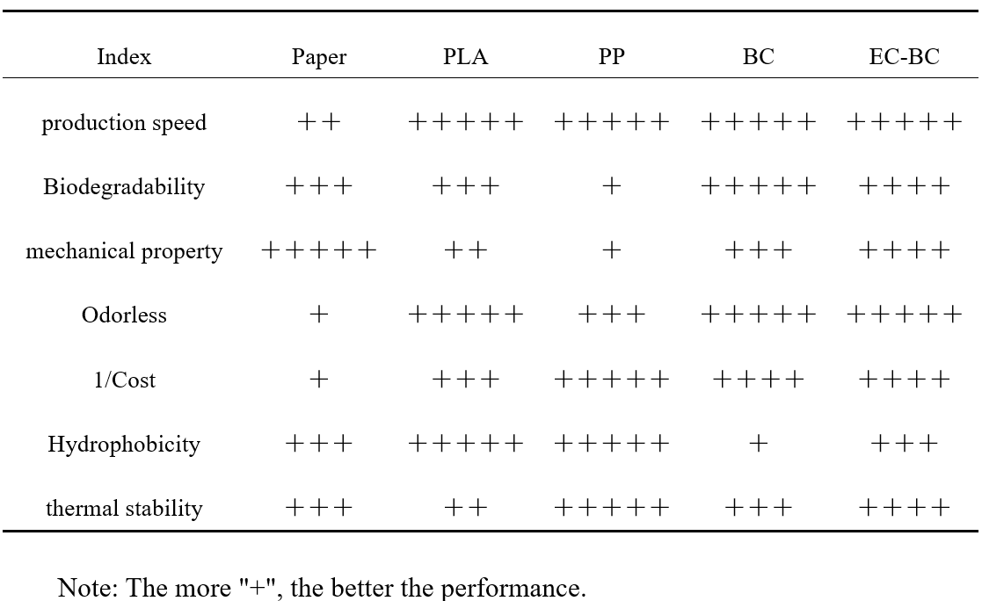
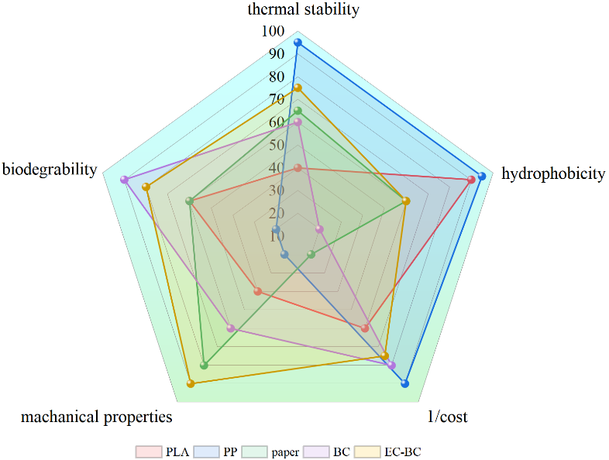Fig. S10. Radar chart of the performance of CFS, plastic, and paper straws.

References

[1] T. Dong, W. Chen, C. Cai, F. Bai, Z. Zhou, J. Wang, X. Li, Water-stable, strong, biodegradable lignocellulose straws replacement for plastic straws, Chemical Engineering Journal 451 (2023) 138970.
[2] H.-B. Yang, Z.X. Liu, C.H. Yin, Z.-M. Han, Q.-F. Guan, Y.-X. Zhao, Z.C. Ling, H.C. Liu, K.-P. Yang, W.-B. Sun, S.-H. Yu, Edible, Ultrastrong, and Microplastic‐Free Bacterial Cellulose‐Based Straws by Biosynthesis, Advanced Functional Materials 32 (2022) 2111713.
[3] M.M. Hassan, M.J.L. Guen, N. Tucker, K. Parker, Thermo-mechanical, morphological and water 1 absorption properties of thermoplastic 2 starch/cellulose foam composites reinforced with 3 PLA, 2021.
[4] J. Liu, C. Wang, C.M. Ewulonu, X. Chen, M. Wu, Y. Huang, Fabrication of superhydrophobic and degradable cellulose paper materials for straw application, Cellulose 29(1) (2022) 527-540.
[5] X. Wang, P. Zhenqian, C. Chaoji, Q. Xia, Y. Zhou, S. Jing, R. Wang, U. Ray, W. Gan, C. Li, G. Chen, B. Foster, T. Li, L. Hu, All‐Natural, Degradable, Rolled‐Up Straws Based on Cellulose Micro‐ and Nano‐Hybrid Fibers, Advanced Functional Materials 30 (2020).
[6] X. Wang, Q. Xia, S. Jing, C. Li, Q. Chen, B. Chen, P. Zhenqian, B. Jiang, W. Gan, G. Chen, C. Mingjin, L. Hu, T. Li, Strong, Hydrostable, and Degradable Straws Based on Cellulose‐Lignin Reinforced Composites, Small 17 (2021) 2008011.
[7] C. Chen, Q. Wu, Z. Wan, Q. Yang, Z. Xu, D. Li, Y. Jin, O.J. Rojas, Mildly processed chitin used in one-component drinking straws and single use materials: Strength, biodegradability and recyclability, Chemical Engineering Journal 442 (2022) 136173.
[8] H. Kwak, H. Kim, S.A. Park, M. Lee, M. Jang, S.B. Park, S.Y. Hwang, H.J. Kim, H. Jeon, J.M. Koo, J. Park, D.X. Oh, Biodegradable, Water-Resistant, Anti-Fizzing, Polyester Nanocellulose Composite Paper Straws, Adv Sci (Weinh) 10(1) (2022) e2205554.
[9] L. Qin, Z. Liu, T. Liu, S. Liu, J. Zhang, J. Wu, X. Liang, A bioinspired, strong, all-natural, superhydrophobic cellulose-based straw, International Journal of Biological Macromolecules 220 (2022) 910-919.
[10] C. Liu, P. Luan, Q. Li, Z. Cheng, X. Sun, D. Cao, H. Zhu, Biodegradable, Hygienic, and Compostable Tableware from Hybrid Sugarcane and Bamboo Fibers as Plastic Alternative, Matter 3(6) (2020) 2066-2079.
[11] A. Sayed, G. Safwat, M. Abdel-raouf, G.A. Mahmoud, Alkali-cellulose/ Polyvinyl alcohol biofilms fabricated with essential clove oil as a novel scented antimicrobial packaging material, Carbohydrate Polymer Technologies and Applications 5 (2023) 100273.
[12] H.T. A, M. Tajvidi, D. Bousfield, Paper-Based Oil Barrier Packaging using Lignin-Containing Cellulose Nanofibrils, Molecules 25(6) (2020).
[13] J.N. Gutierrez, A.W. Royals, H. Jameel, R.A. Venditti, L. Pal, Evaluation of paper straws versus plastic straws: Development of a methodology for testing and understanding challenges for paper straws, BioResources (2019).
[14] R.G. Sinclair, The Case for Polylactic Acid as a Commodity Packaging Plastic, Journal of Macromolecular Science, Part A 33 (1996) 585-597.

