Table S1
18 SNPs satisfying the three hypotheses were associated with HSCR
SNP | CHR | POS | EA | OA | BETA | SE | PVAL | F
rs113052371 | 1 | 95011853 | A | C | 1.1356 | 0.2253 | 4.66E-07 | 25.40
rs75026391 | 2 | 39442135 | A | T | 1.1196 | 0.2258 | 7.08E-07 | 24.59
rs349279 | 4 | 132884220 | T | C | 0.6371 | 0.1174 | 5.64E-08 | 29.45
rs1845717 | 5 | 83974660 | G | A | 0.8611 | 0.1574 | 4.48E-08 | 29.93
rs2935063 | 6 | 170451098 | T | C | 0.5229 | 0.1137 | 4.24E-06 | 21.15
rs117617821 | 7 | 84322189 | C | T | 1.1899 | 0.1773 | 1.95E-11 | 45.04
rs12534941 | 7 | 16890982 | T | C | -0.7857 | 0.1682 | 2.98E-06 | 21.82
rs77417070 | 7 | 150504451 | T | C | 1.3548 | 0.2779 | 1.09E-06 | 23.77
rs2505994 | 10 | 43568887 | T | C | 1.7690 | 0.1207 | 1.31E-48 | 214.81
rs702376 | 10 | 43431173 | A | G | -1.0877 | 0.1655 | 5.03E-11 | 43.19
rs7909373 | 10 | 37793177 | C | T | 0.5432 | 0.1166 | 3.16E-06 | 21.70
rs142851613 | 11 | 22182386 | T | C | 1.3067 | 0.2825 | 3.74E-06 | 21.39
rs60140646 | 12 | 20864629 | C | T | 1.1620 | 0.25 | 3.35E-06 | 21.60
rs12428625 | 13 | 86708779 | T | A | 1.7756 | 0.2334 | 2.76E-14 | 57.88
rs34796483 | 13 | 31228668 | A | G | 1.2383 | 0.2579 | 1.58E-06 | 23.05
rs77165025 | 14 | 90604400 | G | A | 0.7867 | 0.1523 | 2.41E-07 | 26.68
rs12459191 | 19 | 3938782 | T | C | -0.9437 | 0.2001 | 2.41E-06 | 22.24
rs6032951 | 20 | 10769074 | T | G | 0.5358 | 0.116 | 3.83E-06 | 21.34
SNP, single nucleotide polymorphism. CHR, chromosome. POS, position. EA, effect allele. OA; other allele. Beta: beta-coefficient. Se: standard error. Pval: p-value. F: F-statistic

Fig.S1
Funnel plots of MR analyses. (A) Funnel plot for analyzing the causal association between HSCR and depression; (B) Funnel plot for analyzing the causal association between HSCR and anxiety; (C) Funnel plot for analyzing the causal association between HSCR and ADHD; (D) Funnel plot for analyzing the causal association between HSCR and ASD
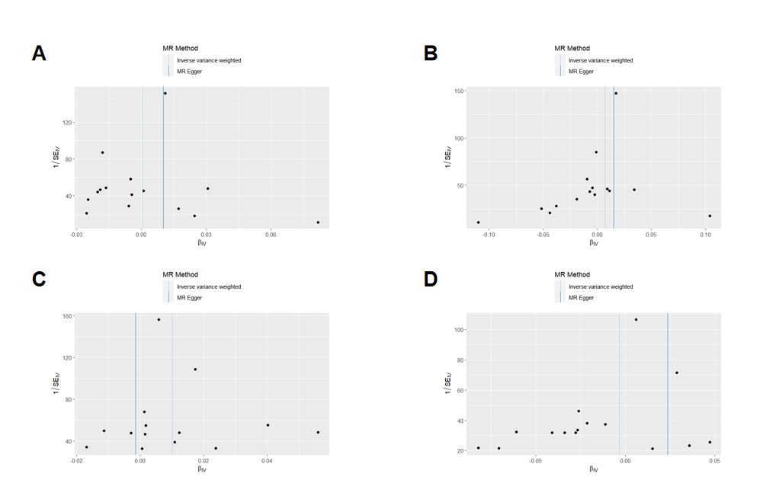
HSCR, Hirschsprung disease. ADHD, attention deficit hyperactivity disorder. ASD, autism spectrum disorder.

Fig.S2
Results of leave-one-out analysis. (A) Leave-one-out analysis for analyzing the causal association between HSCR and depression; (B) Leave-one-out analysis for analyzing the causal association between HSCR and anxiety; (C) Leave-one-out analysis for analyzing the causal association between HSCR and ADHD; (D) Leave-one-out analysis for analyzing the causal association between HSCR and ASD
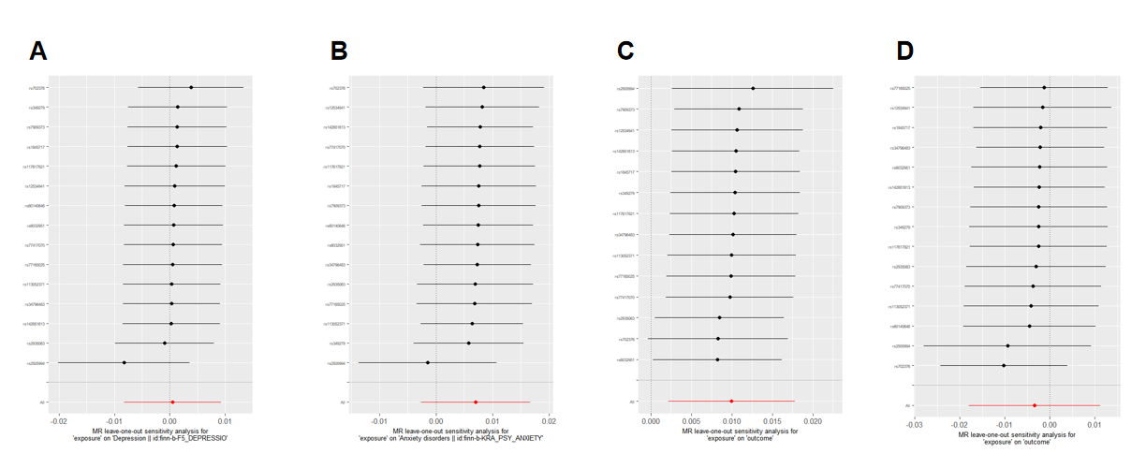
HSCR, Hirschsprung disease. ADHD, attention deficit hyperactivity disorder. ASD, autism spectrum disorder.

Fig.S3
Forest plots of MR analyses. (A) Forest plot for analyzing the causal association between HSCR and depression; (B) Forest plot for analyzing the causal association between HSCR and anxiety; (C) Forest plot for analyzing the causal association between HSCR and ADHD; (D) Forest plot for analyzing the causal association between HSCR and ASD
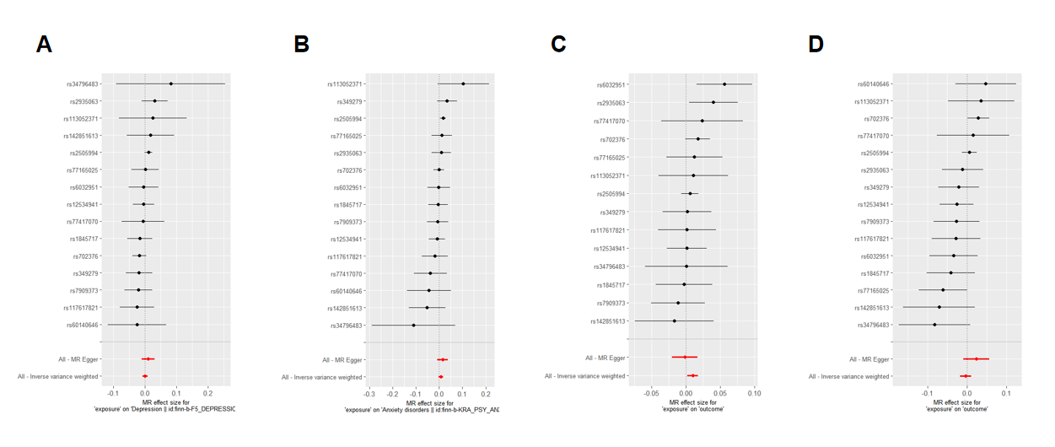
HSCR, Hirschsprung disease. ADHD, attention deficit hyperactivity disorder. ASD, autism spectrum disorder.

