Table. 1Chemical profile of N. nucifera crude extract screened through GC-MS. were Peak Area (PA) & Retention Time (RT).
Peak No. | Retention indices | PA | Height (%) | Name of Compound
1 | 4.224 | 68510 | 1.56 | Hydrazinecarbothioamide
2 | 16.554 | 104273 | 1.55 | Phenol,4,4'-methylenebis[2,6-dimethyl-
3 | 19.122 | 86928 | 1.78 | Hexadecane
4 | 21.913 | 70895 | 1.38 | Neophytadiene
5 | 22.841 | 481666 | 8.30 | Hexadecanoicacid,methyl ester
6 | 23.213 | 1572532 | 24.97 | n-Hexadecanoicacid
7 | 24.555 | 381505 | 6.69 | Methyl 10-trans,12-cis-octadecadienoate
8 | 24.611 | 239384 | 3.79 | E,E,Z-1,3,12-Nonadecatriene-5,14-diol
9 | 24.927 | 609781 | 9.10 | 9,12-Octadecadienoicacid(Z,Z)-
10 | 24.977 | 506484 | 6.20 | Z,Z-8,10-Hexadecadien-1-ol
11 | 25.170 | 371842 | 3.72 | Octadecanoic acid
12 | 27.186 | 107436 | 1.81 | Silane,diethyl(2,4,6-trichlorophenoxy)pentyloxy-
13 | 28.121 | 103310 | 1.51 | 1,3,5-Trisilacyclohexane
14 | 28.403 | 221417 | 2.49 | 1,4,5,8-Tetrahydroxyanthraquinone
15 | 28.665 | 2514266 | 25.13 | 6a-.beta.-Aporphine,1,2-dimethoxy-

Table. 2. Toxicity of herbal extract N. nucifera major metabolites using the free Bee-Tox web server in against to the honeybee Apis mellifera. The fragment contributions to toxicity are shown on the color-coded maps, which are derived from (BeeTox AI: http://beetoxai.labmol.com.br/).

Name of Ligand | SMILES | Acute oral toxicity | Acute oral toxicity (LD₅₀) | Contribution mapping
Hydrazinecarbothioamide | C(=S)(N)NN | Non-toxic | - | 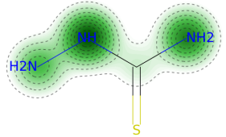
Phenol,4,4'-methylenebis[2,6-dimethyl- | CC1=CC(=CC(=C1O)C)  CC2=CC(=C(C(=C2)C)O)C | Non-toxic | - | 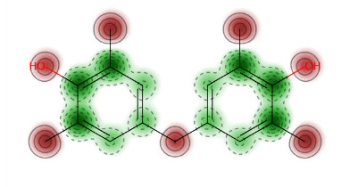
Hexadecane | CCCCCCCCCCCCCCCC | Non-toxic | - | 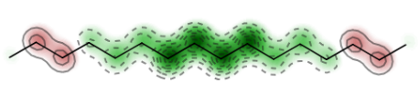
Neophytadiene | CC(C)CCCC(C)CCCC(C)  CCCC(=C)C=C | Toxic | 28.9011 μg/bee | 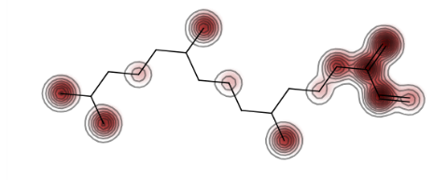
Hexadecanoicacid, methyl ester | CCC(C)CCCCCCCCC  CCCC(=O)OC | Toxic | 16.0763 μg/bee | 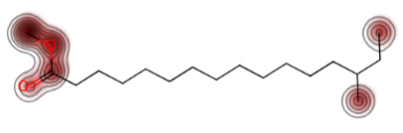
n-Hexadecanoic acid | CCCCCCCCCCCCC  CCC(=O)O | Non-toxic | - | 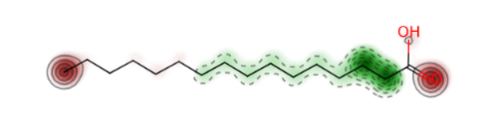
Methyl 10-trans,12-cis-octadecadienoate | CCCCC/C=C\C=C\  CCCCCCCCC(=O)OC | Toxic | 53.419 μg/bee | 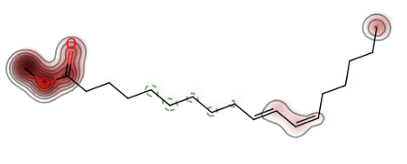
E,E,Z-1,3,12-Nonadecatriene-5,14-diol | CCCCCC(/C=C\CCCC  CCC(/C=C/C=C)O)O | Non-toxic | - | 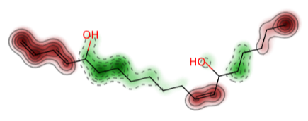
9,12-Octadecadienoic acid(Z,Z)- | CCCCC/C=C\C/C=C\  CCCCCCCC(=O)O | Toxic | 276.2561 μg/bee | 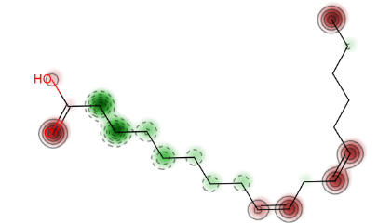
Z,Z-8,10-Hexadecadien-1-ol | CCCCC/C=C\C=  C/CCCCCCCO | Non-toxic | - | 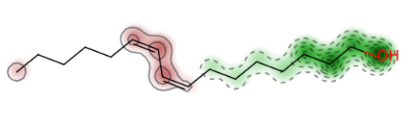
Octadecanoic acid | CCCCCCCCCCC  CCCCCCC(=O)O | Non-toxic | - | 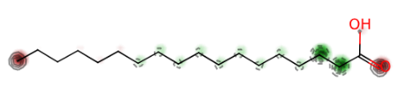
Silane,diethyl(2,4,6-trichlorophenoxy)pentyloxy- | CCCCCO[Si](CC)(CC)  OCC1=C(C=C(C=C1Cl)Cl)Cl | Non-toxic | - | 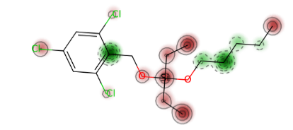
1,3,5-Trisilacyclohexane | C1[Si]C[Si]C[Si]1 | Non-toxic | - | 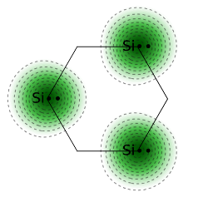
1,4,5,8-Tetrahydroxyanthraquinone | C1=CC(=C2C(=C1O)C  (=O)C3=C(C=CC  (=C3C2=O)O)O)O | Non-toxic | - | 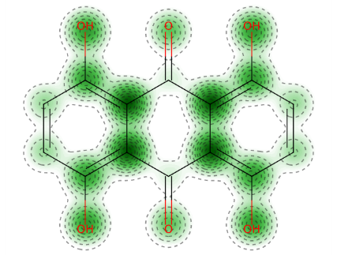
6a-.beta.-Aporphine,1,2-dimethoxy- | CN1CCC2=CC(=C(C3=C2  [C@H]1CC4=CC=  CC=C43)OC)OC | Non-toxic | - | 