1.Normalization: The morphological characteristics of the extracted features are standardized, and the features are normalized, which eliminates the unit constraints of each feature’s data and converts it into dimensionless pure values. This allows for the comparison and weighting of indices with different units or orders. We use z-score normalization to make the image intensity conform to the standard normal distribution, where μ is the mean of the image and σ is the standard deviation. The normalized value (also known as the z-score) of the image intensity (x) is calculated as follows：

2.Lasso Regression Details
Lasso regression (Least Absolute Shrinkage and Selection Operator) is a linear regression analysis method that achieves variable selection and dimensionality reduction by adding an L1 regularization term to the loss function. The objective function of Lasso regression adds a penalty term to the ordinary least squares loss function, which is the sum of the absolute values of the regression coefficients.：
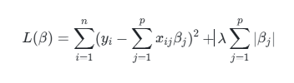

β is the regression coefficient, yi is the dependent variable for the ith observation, xij is the value of the jth feature for the ith observation, n is the number of observations, p is the number of features, and λ is the regularization strength parameter.
Table 1 shows all lambda values and their degrees of freedom and residuals. As lambda increases, the degrees of freedom and residuals decrease. Table 2 shows the lambda value with the smallest mean squared error and the largest lambda value within one standard deviation of the mean error. Table 3 presents information such as lambda values, the logarithm of lambda, mean squared error, the standard error of the mean squared error, and the error interval. Note that CL_2.5 and CL_97.5 represent the left tail (2.5%) and the right tail plus the confidence interval (2.5% and 95%) at the 95% confidence level. Table 4 is the regression coefficient table, also known as the variable selection table. For two lambda cases, it shows the selection of independent variables, with zero indicating no selection.
Table 1: Lasso Binomial Regression Lambda Values Table
Df | ratio_Dev | Lambda
0 | 0.0000 | 0.3289
1 | 0.0287 | 0.3140
1 | 0.0549 | 0.2997
1 | 0.0789 | 0.2861
3 | 0.1043 | 0.2731
4 | 0.1313 | 0.2607
3 | 0.1563 | 0.2488
4 | 0.1820 | 0.2375
5 | 0.2067 | 0.2267
5 | 0.2299 | 0.2164
5 | 0.2517 | 0.2066
5 | 0.2721 | 0.1972
5 | 0.2913 | 0.1882
5 | 0.3095 | 0.1797
6 | 0.3285 | 0.1715
6 | 0.3490 | 0.1637
6 | 0.3685 | 0.1563
6 | 0.3869 | 0.1492
6 | 0.4044 | 0.1424
6 | 0.4210 | 0.1359
6 | 0.4368 | 0.1297
Table 2: Lasso Binomial Regression Minimum Lambda Values Table
lambda_min | lambda_1se
0.0076 | 0.0369
表3.Lasso二项式回归Lambda值均方误差表格
lambda | LogLambda | CVM | cvsd | cvup | cvlo | VariableNum
0.3289 | -1.1119 | 1.3701 | 0.0170 | 1.3872 | 1.3531 | 0
0.3140 | -1.1584 | 1.3321 | 0.0176 | 1.3498 | 1.3145 | 1
0.2997 | -1.2050 | 1.2953 | 0.0183 | 1.3136 | 1.2769 | 1
0.2861 | -1.2515 | 1.2615 | 0.0191 | 1.2806 | 1.2424 | 1
0.2731 | -1.2980 | 1.2287 | 0.0200 | 1.2487 | 1.2087 | 3
0.2607 | -1.3445 | 1.1958 | 0.0207 | 1.2165 | 1.1752 | 4
0.2488 | -1.3910 | 1.1622 | 0.0204 | 1.1825 | 1.1418 | 3
0.2375 | -1.4375 | 1.1298 | 0.0199 | 1.1498 | 1.1099 | 4
0.2267 | -1.4841 | 1.0982 | 0.0194 | 1.1176 | 1.0788 | 5
0.2164 | -1.5306 | 1.0685 | 0.0189 | 1.0874 | 1.0495 | 5
0.2066 | -1.5771 | 1.0405 | 0.0186 | 1.0590 | 1.0219 | 5
0.1972 | -1.6236 | 1.0134 | 0.0180 | 1.0315 | 0.9954 | 5
0.1882 | -1.6701 | 0.9875 | 0.0174 | 1.0049 | 0.9701 | 5
0.1797 | -1.7166 | 0.9624 | 0.0168 | 0.9793 | 0.9456 | 5
0.1715 | -1.7632 | 0.9381 | 0.0164 | 0.9545 | 0.9218 | 6
0.1637 | -1.8097 | 0.9135 | 0.0162 | 0.9297 | 0.8972 | 6
0.1563 | -1.8562 | 0.8884 | 0.0163 | 0.9046 | 0.8721 | 6
0.1492 | -1.9027 | 0.8638 | 0.0159 | 0.8797 | 0.8479 | 6
0.1424 | -1.9492 | 0.8398 | 0.0151 | 0.8549 | 0.8246 | 6
0.1359 | -1.9957 | 0.8170 | 0.0145 | 0.8315 | 0.8025 | 6
0.1297 | -2.0423 | 0.7954 | 0.0140 | 0.8093 | 0.7814 | 6

表4.Lasso二项式回归最小Lambda值系数表格
CoefName | coeff_min_lamda | coeff_se_lamda
(Intercept) | -34.9846 | -27.0276
shape_Elongation | 0 | 0
shape_Flatness | 12.3471 | 3.1059
shape_LeastAxisLength | 0 | 0
shape_MajorAxisLength | 0 | 0
shape_Maximum2DDiameterColumn | 0 | 0
shape_Maximum2DDiameterRow | 0 | 0
shape_Maximum2DDiameterSlice | 0 | 0
shape_Maximum3DDiameter | 0 | 0
shape_MeshVolume | 0 | 0
shape_MinorAxisLength | 0 | 0
shape_Sphericity | 0 | 0
shape_SurfaceArea | 0 | 0
shape_SurfaceVolumeRatio | 0 | 0
shape_VoxelVolume | 0 | 0
firstorder_shape0Percentile | 0 | -0.0247
firstorder_90Percentile | 0 | 0
firstorder_Energy | 0 | 0
firstorder_Entropy | 0 | 0
firstorder_InterquartileRange | 0 | 0
firstorder_Kurtosis | 0 | 0

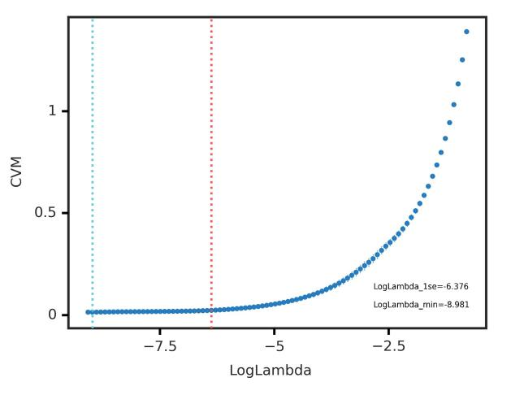
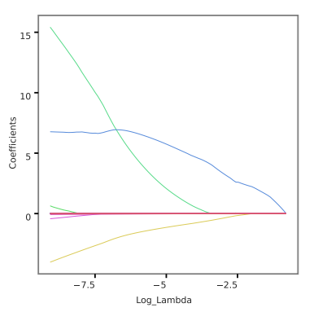

Fig. A Fig. B

A
B
图A.Lasso二项式回归Lambda值均方误差图；Lasso回归lambda值均方误差图。此图横轴是lambda的对数，纵轴是均方误差，两条虚线分别是最小lambda值和平均误差在一个标准差以内的最大的lambda值。随着lambda值增加，均方误差增大。图B.Lasso二项式回归Lambda值系数图Lasso回归lambda值系数图。此图横轴是lambda的对数，纵轴是变量系数。随着lambda增加，变量系数不断减小，部分变量系数变为0。

4. Machine Learning Details
In our study, we used SVM machine-learning classifiers. SVM classifiers were implemented using R package caret [1], which provides a nice interface to access many machine-learning algorithms in R. Furthermore, it also provides a user-friendly framework for training different machine-learning models. We used parameter configurations of machine learning that were previously defined by Fernandez-Delgado et al [2], and we have listed the classification methods along with their parameters and corresponding R packages.
Support vector machine (SVM)
SVM, with Gaussian kernel function was implemented using a caret interface and R package kernlab. Cost parameter C was varied with values {2⁻², 2⁻¹ ,1, 2¹ , 2² } and the parameter kernel spread was varied with values in {10⁻² , 10⁻¹ , 1, 10¹ ,10²}.
References
- Kuhn M. Building predictive models in R using the caret package. J Stat Softw. 2008, 28(5):1–26.
- Fernández-Delgado, Cernadas, Barro, et al. Do we need hundreds of classifiers to solve real world classification problems? J. Mach. Learn. Res. 2014, 15:3133–3181.

