Three-arm polyrotaxanes with multidirectional molecular motions as the nanocarrier for nitric oxide-enhanced photodynamic therapy against bacterial biofilms in septic arthritis
Shixin Liuª, Yuanfang Jiang^{b}, Yu Zhang^{c}, Kai Lv^{d}, Jiaxin Zhu^{d}, Mei Liu^{d}, Hao Xu^{b}, Genlong Jiao^{e}, Wanyong Yang^{f,*}, Guodong Sun^{a,g,*}, Dong Ma^{a,d,,*}
ª Guangdong Provincial Key Laboratory of Spine and Spinal Cord Reconstruction, The Fifth Affiliated Hospital (Heyuan Shenhe People’s Hospital), Jinan University, Heyuan 517000, China
^{b} Department of Nuclear Medicine, PET/CT-MRI Center, The First Affiliated Hospital of Jinan University, Guangzhou 510630, China
^{c} Department of Ultrasound Medicine, Zhucheng People's Hospital, Zhucheng 262200, China
^{d} Key Laboratory of Biomaterials of Guangdong Higher Education Institutes, Department of Biomedical Engineering, Jinan University, Guangzhou 510632, China
^{e} Dongguan Key Laboratory of Central Nervous System Injury and Repair / Department of Orthopedic Surgery, The Sixth Affiliated Hospital of Jinan University (Dongguan), Dongguan, 523573, China
^{f} The Fifth Affiliated Hospital, Jinan University, Heyuan 517000, China
^{g} The First Affiliated Hospital, Jinan University, Guangzhou 510630, China

* Corresponding authors.
E-mail addresses: tmadong@jnu.edu.cn (Dong Ma), sgd96@jnu.edu.cn (Guodong Sun), kfyang_1973@163.com (Wanyong Yang)

This file includes:
Experimental Section
Results and Discussions
Supplementary Figure 1 to Figure 8

- Experimental Section
  - Synthesis of diamino poly(ethylene glycol) (NH₂-PEG-NH₂)
PEG (5 g, Mn = 4000, 1.25 mmol) was dissolved in anhydrous CH₂Cl₂ (30 mL) containing CDI (0.2 g, 1.25 mmol), followed by adding triethylamine (200 μL). After stirring under a nitrogen atmosphere for 3 h, ethanediamine (7.5 g, 12.5 mmol) dissolved in CH₂Cl₂ (20 mL) was added into the solution dropwise. The mixture was stirred overnight and the resultant solution was washed successively by the saturated solution of NaHCO₃, NaCl, NaHCO₃, and NaCl. Finally, the product was obtained by rotary evaporation and vacuum drying as white powder (yielded, 85%). ¹H NMR (600 MHz, DMSO-d₆, δ): 2.85-4.20 (m, 90H, -CH₂CH₂O-), 4.25 (m, 4H, -CH₂-OCONH-), 2.76 (m, 4H, -CONHCH₂CH₂-).

1.2 Synthesis of Three-arm Ce6-(PEG)₃
Ce6 (10 mg, 0.016 mmol), PEG-(NH2)2 (0.67 g, 0.16 mmol), NHydroxybenzotrizole (HOBT) (11.3 mg, 0.08 mmol), and 1-(3-Dimethylaminopropyl)-3-ethylcarbodiimide hydrochloride (EDC) (16 mg, 0.08 mmol) was dissolved and mixed in 7 mL of N,N-Dimethylformamide (DMF) for the reaction at room temperature for 24 h. After that, extraction was carried out using CH₂Cl₂ (50 mL) as the solvent, following successive washing by the saturated solution of NaCl, NaHCO₃, NaHSO₄, and NaCl. Finally, the product Ce6-(PEG)₃ was obtained as dark green and sticky powder by rotary evaporation, column chromatography isolation, and another rotary evaporation (yielded, 65%).
1.3 Synthesis of Three-arm Poly(pseudo)rotaxanes Ce6-PPR
The poly(pseudo)rotaxanes Ce6-PPR were prepared through the host-guest interaction between α-CD and Ce6-(PEG)_{3.} Briefly, 8.4 mL of α-CD aqueous solution (0.145 g/mL) and 0.7 mL of Ce6-(PEG)₃ aqueous solution (0.109 g/mL) were mixed for a 15-min ultrasound treatment and stirred at room temperature overnight. After the reaction, Ce6-PPR was obtained as pale green powder by centrifugation and lyophilization.

- Results and Discussions
  - Characterization of NH₂-PEG-NH₂
The obtained polymer NH₂-PEG-NH₂ was characterized by ¹H NMR (Supplementary Figure 2A) and FT-IR spectra (Supplementary Figure 5A). In the ¹H NMR spectrum of NH₂-PEG-NH_{2,} except for the characteristic proton peaks (3.5 ppm) of PEG, the characteristic peaks of ethanediamine at 2.76 ppm, and the methylene proton peak at 4.25 formed from the dehydrated condensation between ethylenediamine and PEG were found, confirming the successful modification on PEG copolymer by ethanediamine. By analyzing the integral areas of proton absorption peaks of the PEG at 3.5 (a) and ethanediamine at 2.76 ppm (c), it could be confirmed that the ends of PEG were completely aminated. As presented in the FT-IR spectrum in Supplementary Figure 5A, characteristic bands of amide groups at 1650cm⁻¹ and 1560cm⁻¹, which are amide Ⅰ and amide Ⅱ bands respectively, and the former is caused by the stretching vibration of carboxyl group, while the latter is caused by the bending deformation vibration of N-H bond and the stretching vibration of C-N bond in -CONH-, fully confirmed the successful preparation of NH₂-PEG-NH₂.

  - Characterization of Three-arm Ce6-(PEG)₃
The obtained Ce6-(PEG)₃ was characterized by ¹H NMR (Supplementary Figure 2B). In the spectrum, except for the characteristic peaks of PEG (b), proton peaks of Ce6 at 2.0 ~ 3.0 ppm and 6.5 ppm (a) were shown. By analyzing the area ratio of the proton peak of a and b, it was confirmed that carboxyl groups in Ce6 were fully occupied by NH₂-PEG-NH₂ and the successful formation of a three-arm structure. In addition, FT-IR spectrum of Ce6-(PEG)₃ (Supplementary Figure 5B) showed the stretching vibration absorption peaks of secondary amines and carbonyl groups at 3265 cm⁻¹ and 1650cm⁻¹, further confirming the successful preparation of Ce6-(PEG)₃.

  - Characterization of Three-arm Poly(pseudo)rotaxanes Ce6-PR
The obtained Ce6-PR was characterized by ¹H NMR (Supplementary Figure 3). As presented in the ¹H NMR spectrum of Ce6-PR, except for the characteristic peaks of PEG, the characteristic peaks of hydroxyl and glycocyclic protons of α-CD at 5.78, 5.6 4.8 ppm and 4.5, 3 ~ 4 ppm was found, suggesting that an interlocking supramolecule Ce6-PR was formed through the self-assembly between α-CD and PEG. Meanwhile, the appearance of the proton peaks of Ada in the ¹H NMR spectrum of Ce6-PR confirmed that Ada has successfully end-capped Ce6-PR to prevent α-CD from falling off. In addition, the FT-IR spectrum of Ce6-PR in Supplementary Figure 5B presented the vibration peak of carbon-oxygen stretching of alcohol hydroxyl on α-CD further confirming the successful self-assembly between Ce6-(PEG)₃ and α-CD.

2.4 Characterization of NO-Loaded Polyrotaxane Ce6-PRP/NO
PEHA was used to modify Ce6-PR to prepare the cationic polyrotaxane Ce6-PRP. From the ¹H NMR spectrum of Ce6-PRP (Supplementary Figure 4), the appearance of the proton peaks of PEHA at 2 ~ 3 ppm (a) confirmed that PEHA was successfully modified on α-CD in Ce6-PR. Further, as shown in the FT-IR spectrum in Supplementary Figure 5A, the characteristic peaks of -NH₂ and -CONH- at 3265 cm⁻¹, 1650cm⁻¹, 1560cm⁻¹, 1120cm⁻¹, and 1035cm⁻¹ also confirmed the coupling between PEHA and α-CD, suggesting the successful preparation of cationic polyrotaxane Ce6-PRP.
Under the high-pressure NO atmosphere, the secondary amine groups in Ce6-PRP would be oxidated into NONOates to obtain NO-loaded polyrotaxane Ce6-PRP/NO. the ¹H NMR spectrum of Ce6-PRP/NO (Supplementary Figure 4) showed a chemical shift of the peak of protons of methylene next to the secondary amine in Ce6-PRP from 2.57 ppm to 3.01 ppm. In the FT-IR spectrum of Ce6-PRP/NO (Supplementary Figure 5C), the vibration absorption peak at 1450 cm⁻¹ of νN=N in the NONOate group appeared compared with the spectrum of Ce6-PR. Therefore, it was confirmed that NO-loaded polyrotaxane Ce6-PRP/NO was successfully prepared.

Supplementary Figure 1. Synthetic route of Ce6-PRP/NO.
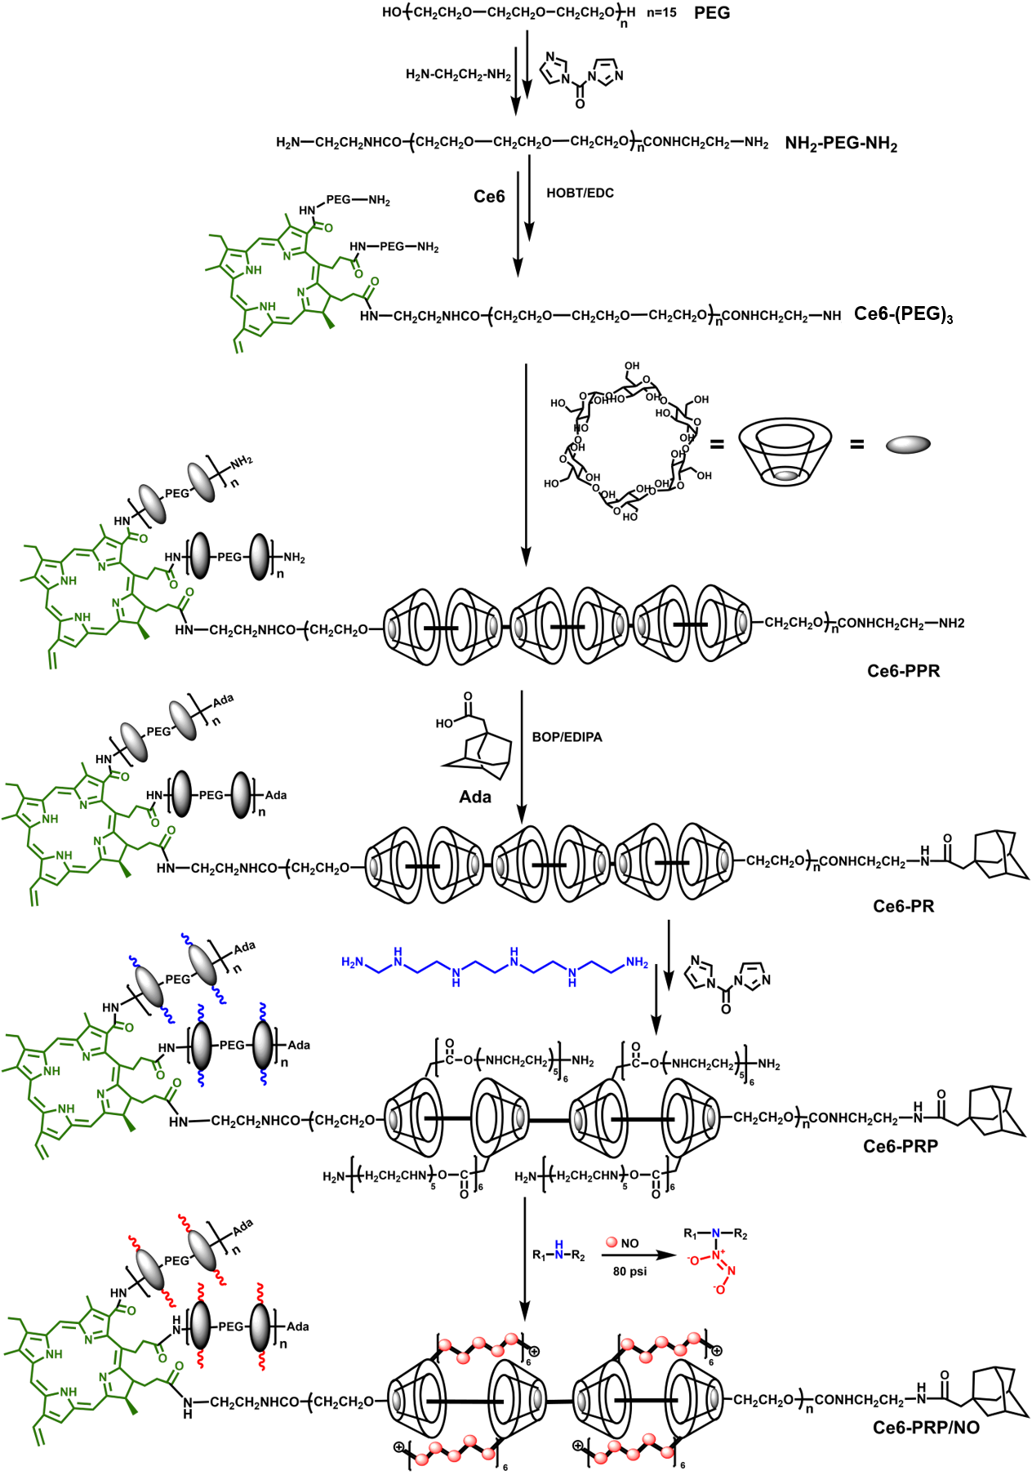

Figure S2. (A) ¹H NMR spectrum of NH₂-PEG-NH₂ in DMSO at 25 °C. (B) ¹H NMR spectrum of Ce6-(PEG)₃ in CDCl₃ at 25 °C.
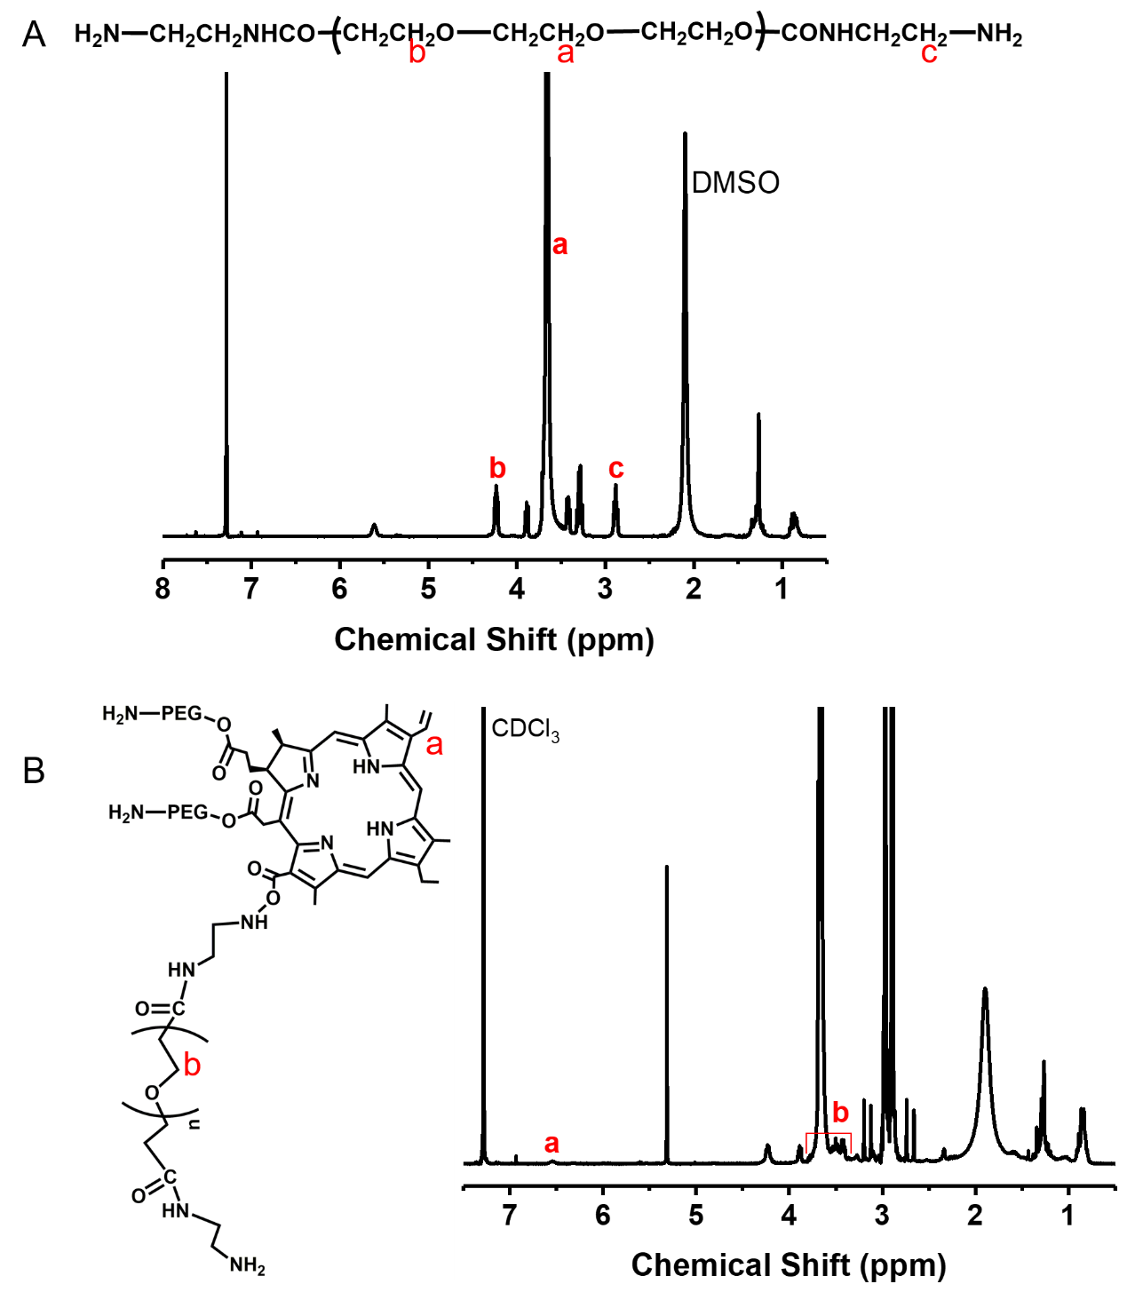

Supplementary Figure 3. ¹H NMR spectrum of α-CD and Ce6-PR in DMSO at 25 °C.
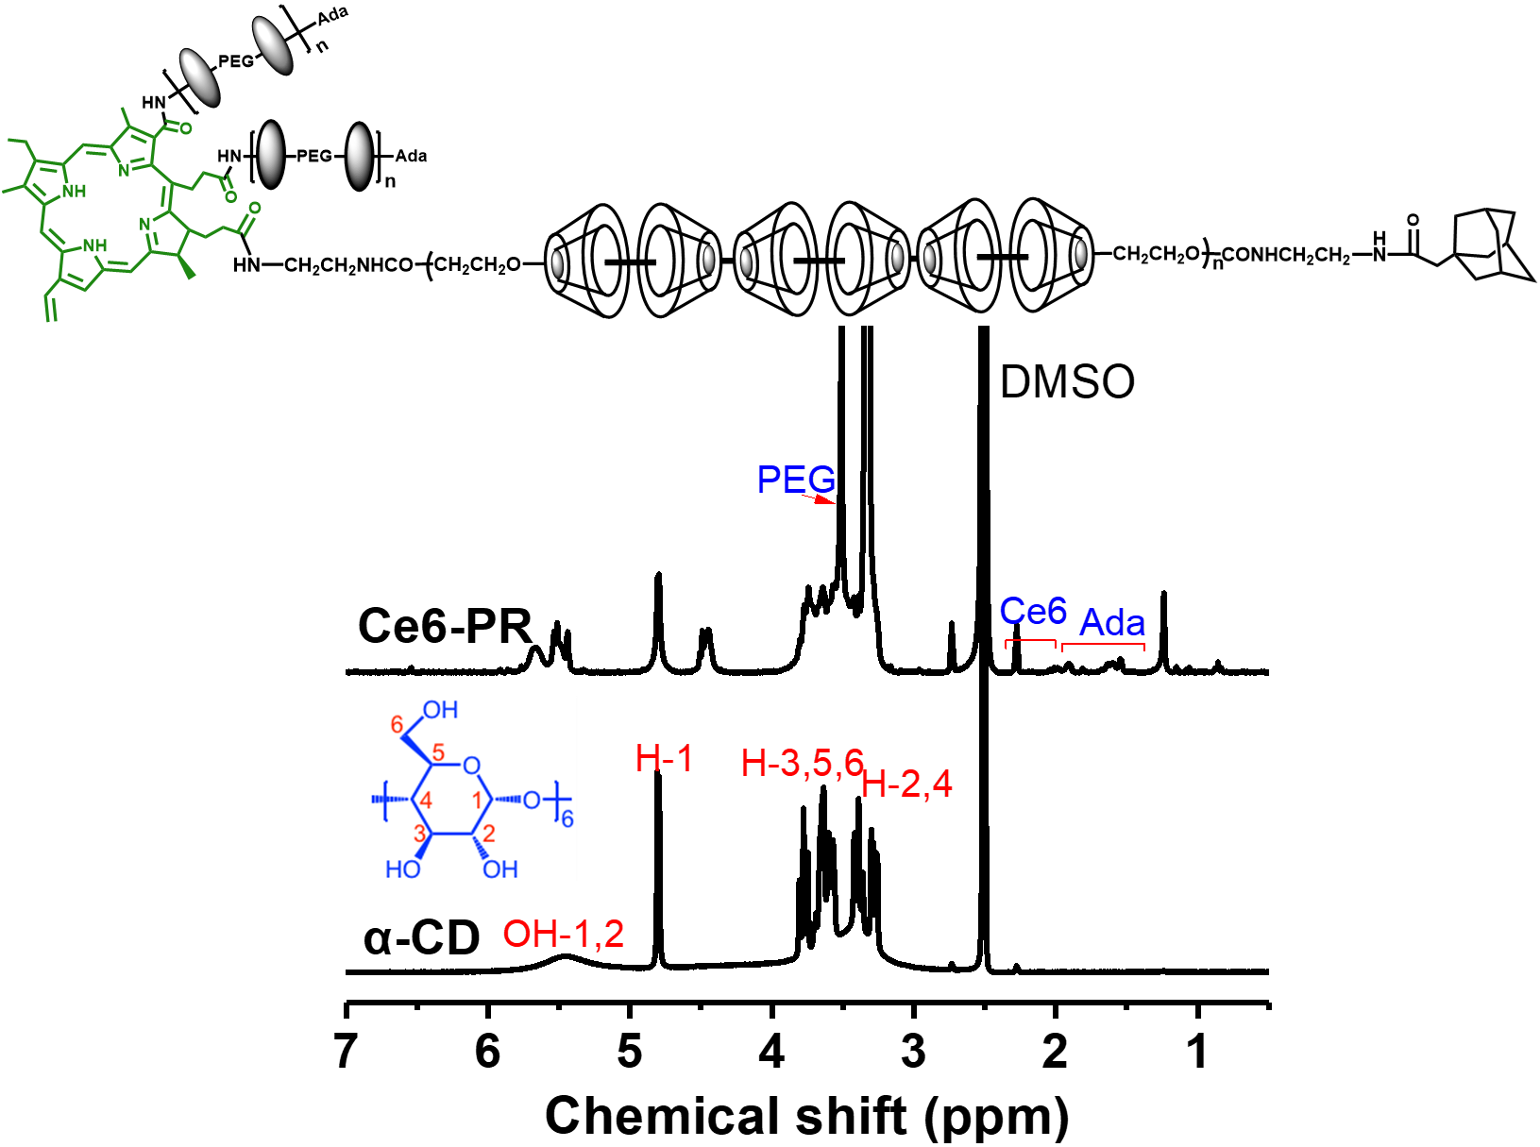

Supplementary Figure 4. (A) ¹H NMR spectra of Ce6-PRP and Ce6-PRP/NO in D₂O at 25 °C.
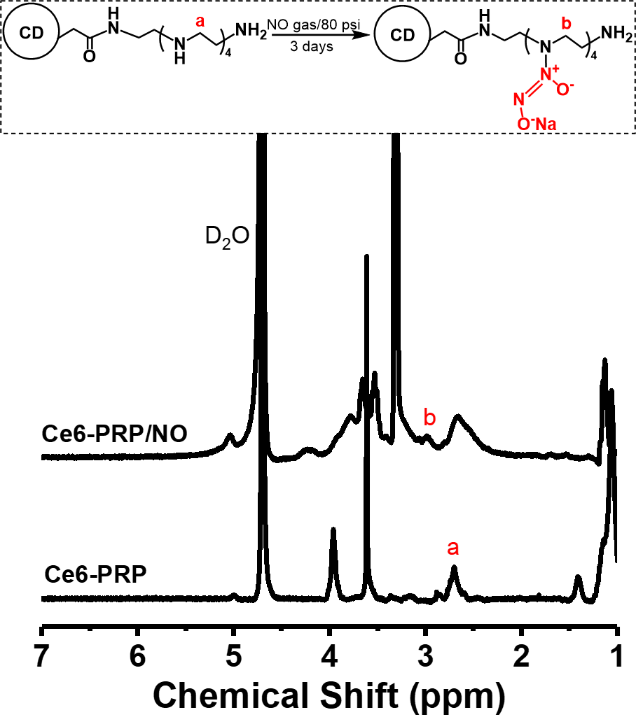

Supplementary Figure 5. (A) FT-IR spectra of Ce6, NH₂-PEG-NH_{2,} and Ce6-(PEG)₃. (B) FT-IR spectra of α-CD, Ce6-PRP, and Ce6-PR. (C) FT-IR spectra of Ce6-PRP and Ce6-PRP/NO.
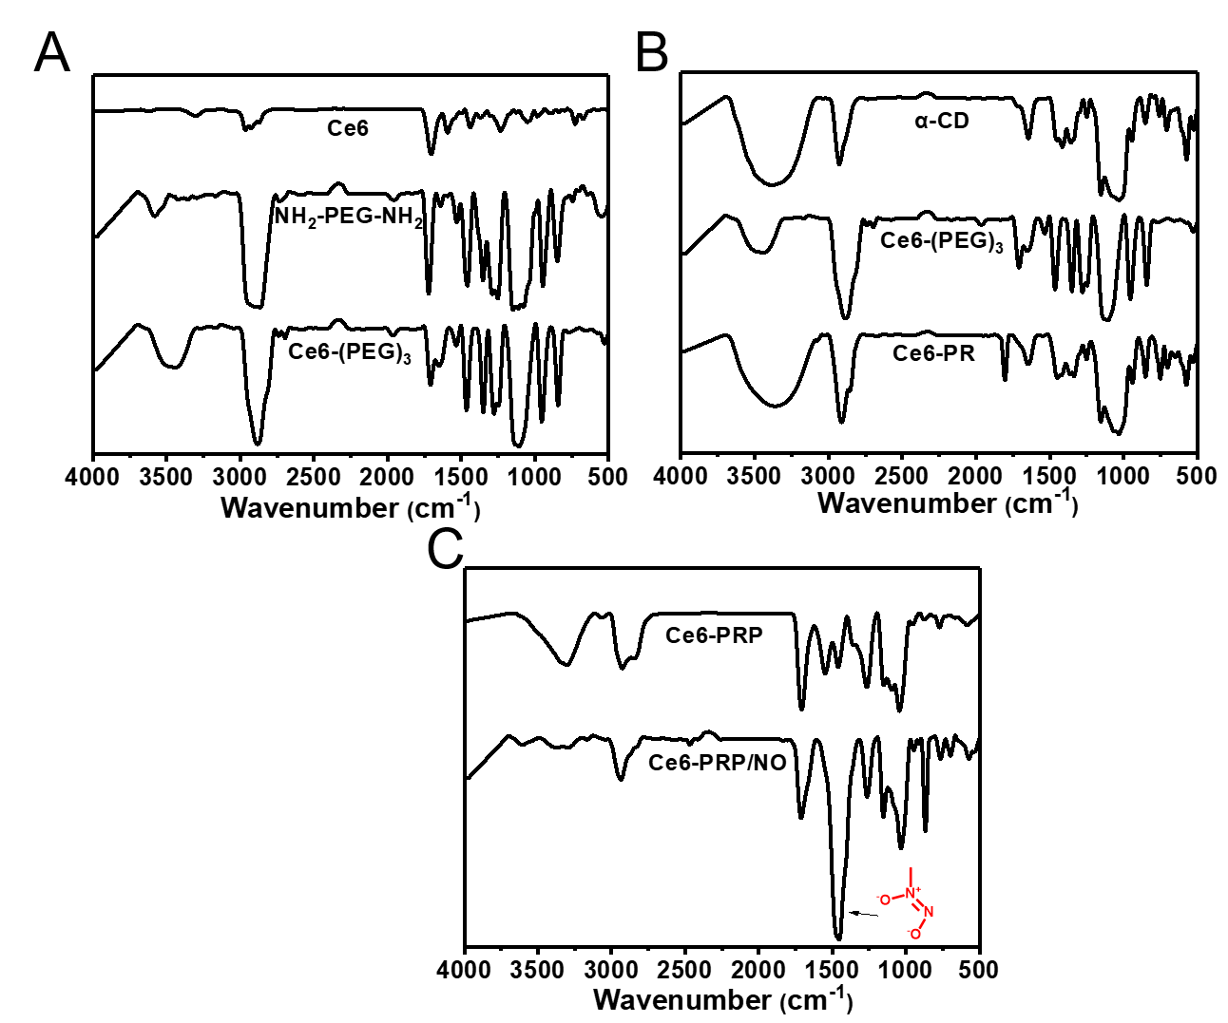

Supplementary Figure 6. Absorbance decreases percentage at 415 nm in Figure 1G and 1H.
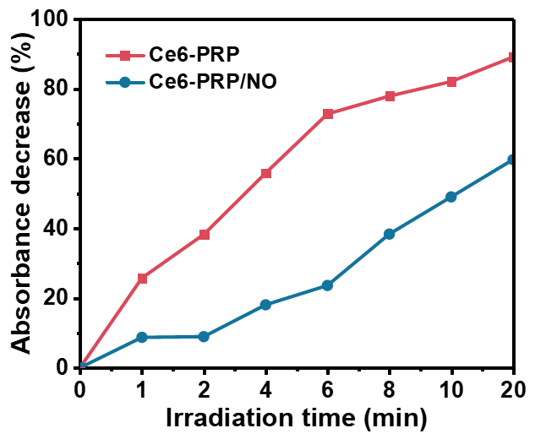

Supplementary Figure 7. Fluorescence intensity of Ce6, Ce6-PRP, and Ce6-PRP/NO used in Figure 3.
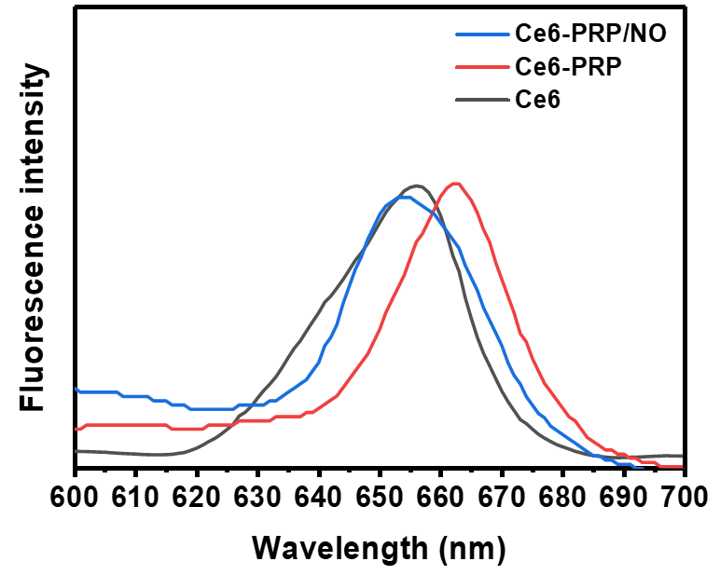

Supplementary Figure 8. Digital photos of knees during different treatments.
