Title page
Titles: Exosomes Derived from liver failure patients’ plasma stimulated Mesenchymal Stem Cells alleviate acute liver failure

Authors: Zhuoran Wang¹ Jun Ling¹ Shaoli You^{1*} Bing Zhu^{1*}
Affiliations:
¹The Fifth Medical Center of Chinese PLA General Hospital Beijing 10039, China
*Corresponding author
Bing Zhu, Doctoral degree
Address:The Fifth Medical Center of Chinese PLA General Hospital Beijing 10039, China
E-mail: zhubing302@163.com
Mailing address: No. 100, Xisi Huanzhong Road, Beijing 10039, China
Telephone number: +86 138 1163 3607

Shaoli You, Master degree
Address:The Fifth Medical Center of Chinese PLA General Hospital Beijing 10039, China
E-mail: youshaoli1972@163.com
Mailing address: No. 100, Xisi Huanzhong Road, Beijing 10039, China
Telephone number: +86 136 5118 9002

Fig S1 to S4 for multiple supplementary figures
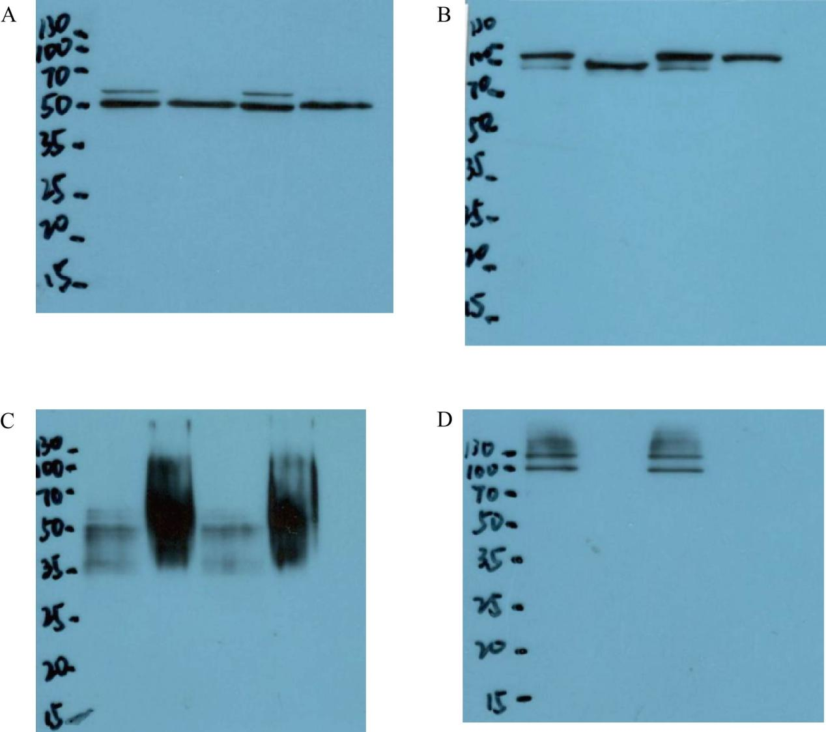
Supplementary Fig.1. Full-length blots of Figure 2C. A. Full-length blots of TSG101; B. Full-length blots of Alix; C. Full-length blots of CD63; D. Full-length blots of Calnexin.

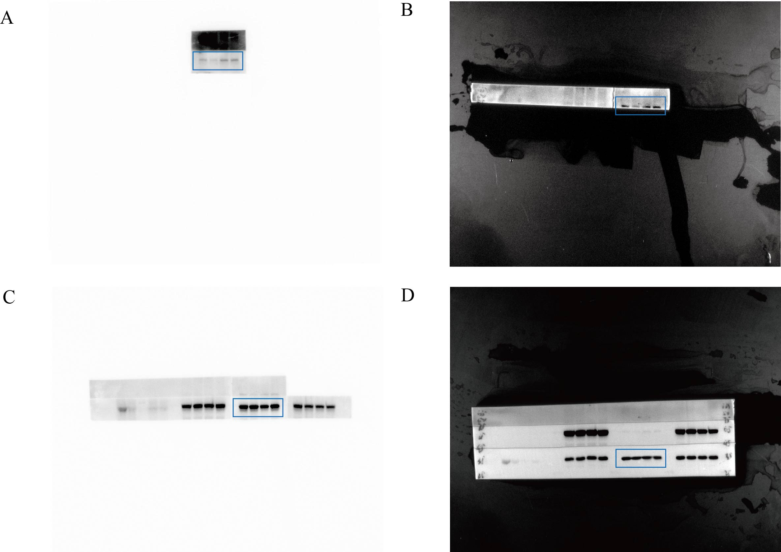
Supplementary Fig.2. Full-length blots of Figure 6A. A. Full-length blots of p-AKT; B. Full-length blots of PI3K; C. Full-length blots of AKT; D. Full-length blots of GAPDH.

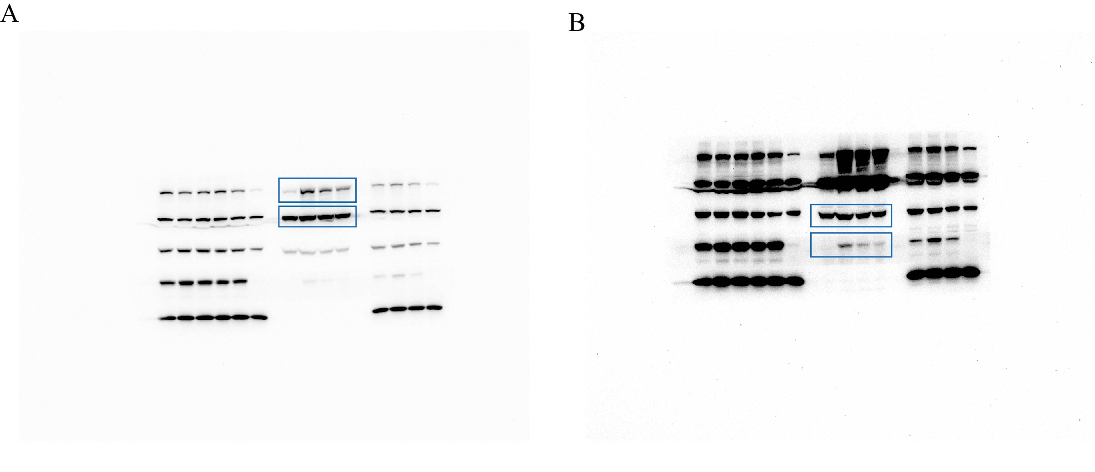
Supplementary Fig.3. Full-length blots of Figure 6B. A. Full-length blots of NLRP3 and Lamin B; B. Full-length blots of caspase-1 and IL-1β.

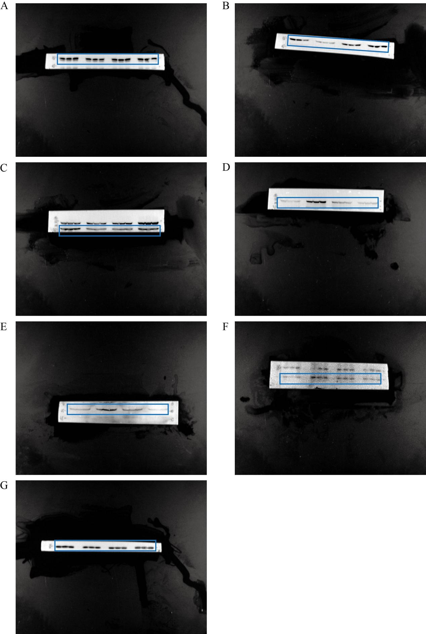
Supplementary Fig.4. Full-length blots of Figure 6C. A. Full-length blots of AKT; B. Full-length blots of p-AKT; C. Full-length blots of PI3K; D. Full-length blots of NLRP3; E. Full-length blots of caspase-1; F. Full-length blots of ASC; G. Full-length blots of GAPDH.

