Online Supplement

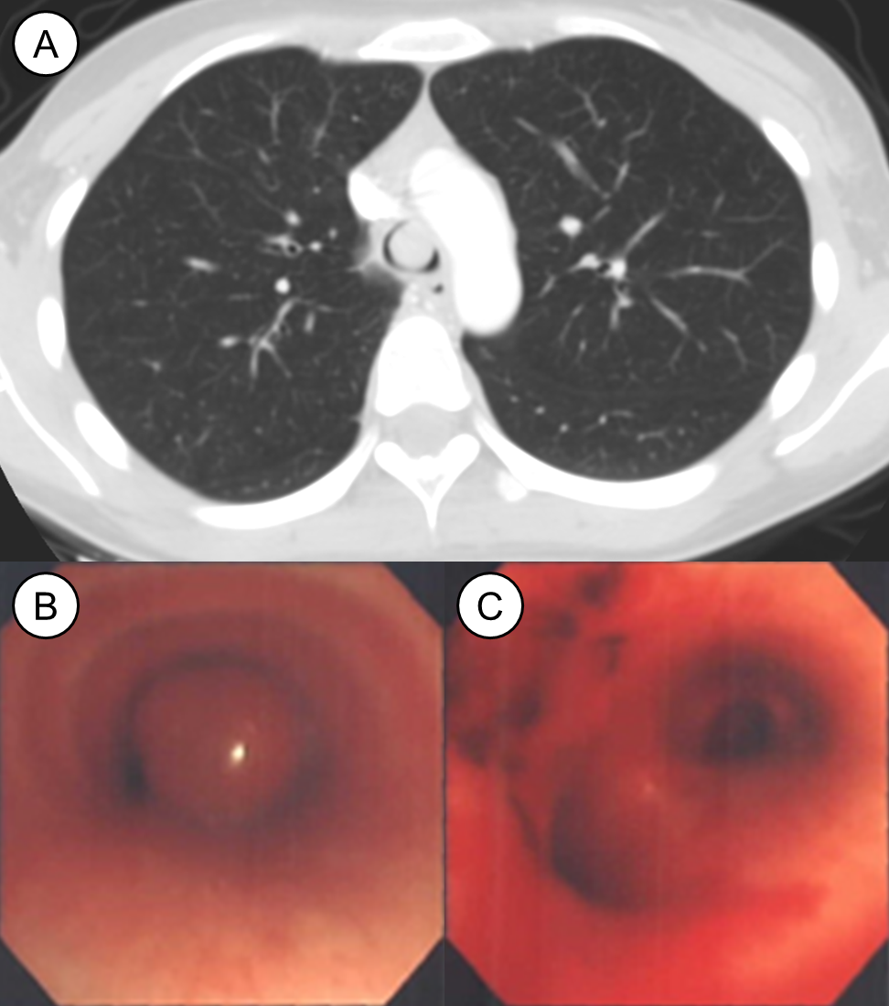
Supplementary Figure 1. Case No. 1. (A) A 21-year-old woman underwent a CT scan due to progressive dyspnea. A 13-mm-sized, well-enhanced, round nodule was seen at the lower trachea without tracheal wall invasion. (B) Bronchoscopic gross findings showed a round mass with a stalk hanging from the anterior wall of the trachea. (C) After cutting the stalk using a rigid bronchoscope, the tumor base was cauterized using a diode laser.
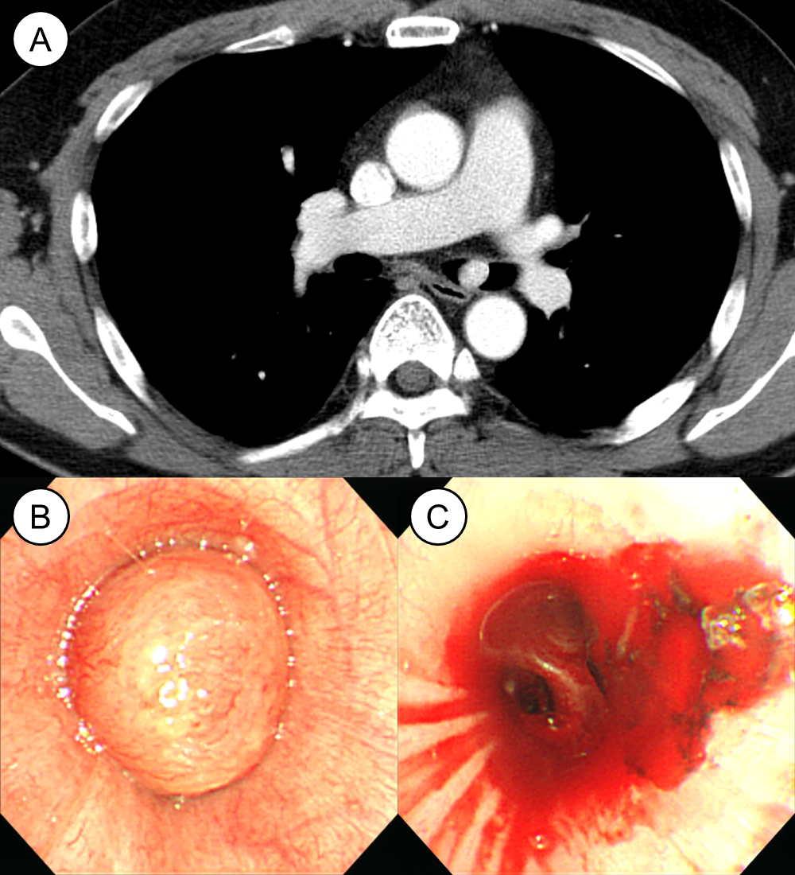
Supplementary Figure 2. Case No. 2. (A) A 40-year-old man underwent a CT scan due to progressive dyspnea. A 13-mm-sized, highly-enhanced, round nodule was seen in the left main bronchus without bronchial wall invasion. (B) Bronchoscopic gross findings showed a round mass with a stalk hanging from the anterior wall of the bronchus. (C) After mechanical removal of the tumor mass using a rigid bronchoscope, the tumor base was cauterized using a diode laser.
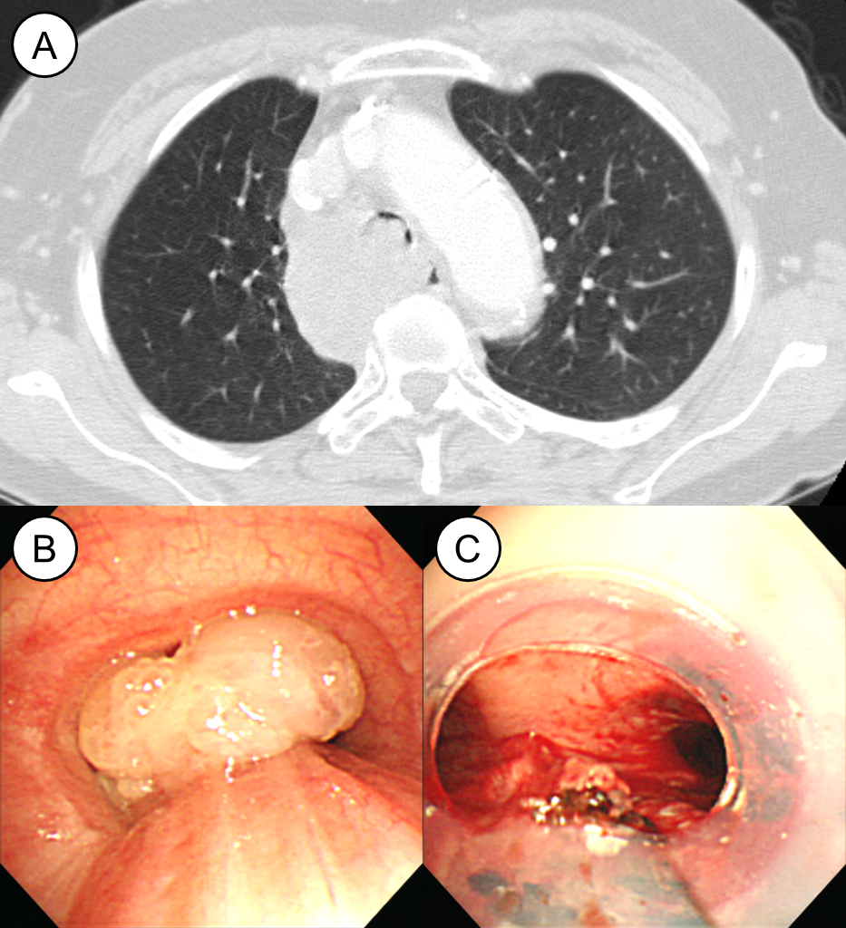
Supplement Figure 3. Case No. 3. (A) A 74-year-old woman underwent a CT scan due to progressive dyspnea. Huge lymphadenopathies at the right lower paratracheal area and endotracheal mass were found. (B) Bronchoscopic gross findings showed lobulated masses arising from the posterior wall of the trachea and the right upper lobar bronchus. (C) After mechanical removal of the tumor masses using a rigid bronchoscope, the tumor bases were cauterized using a diode laser. Then, a silicone stent insertion was needed to maintain airway patency due to extrinsic compression of the metastatic lymphadenopathy.
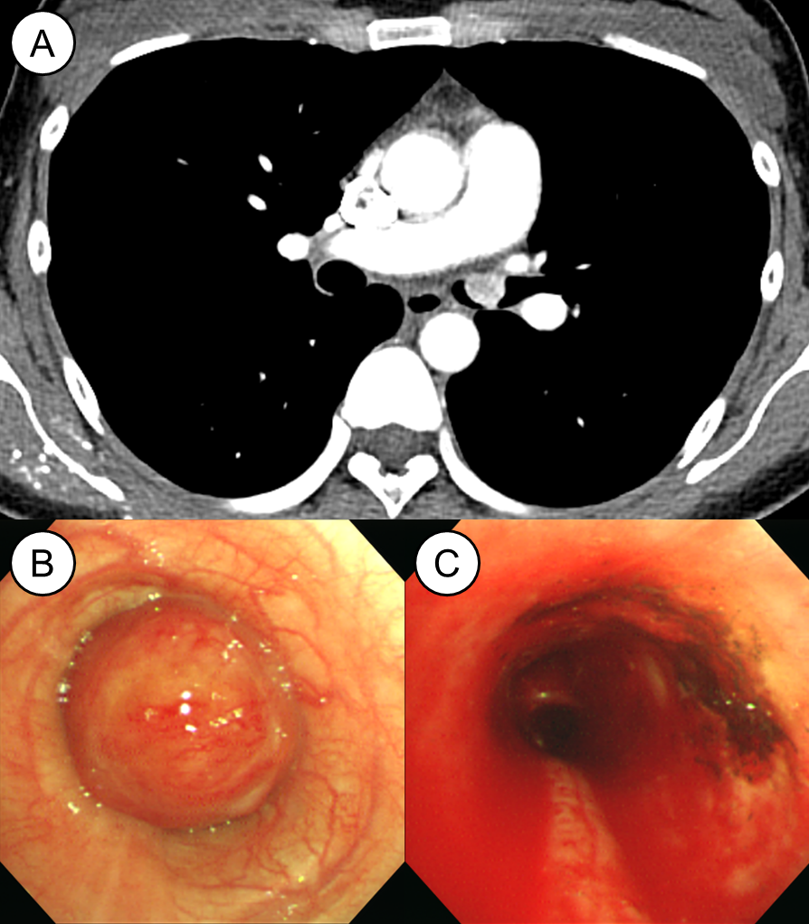
Supplementary Figure 4. Case No. 4. (A) A 29-year-old woman underwent a CT scan due to progressive dyspnea. A 13-mm-sized, highly-enhanced, round nodule was seen in the left main bronchus without bronchial wall invasion. (B) Bronchoscopic gross findings showed a round mass with a stalk hanging from the anterior wall of the bronchus. (C) After mechanical removal of the tumor mass using a rigid bronchoscope, the tumor base was cauterized using a diode laser.
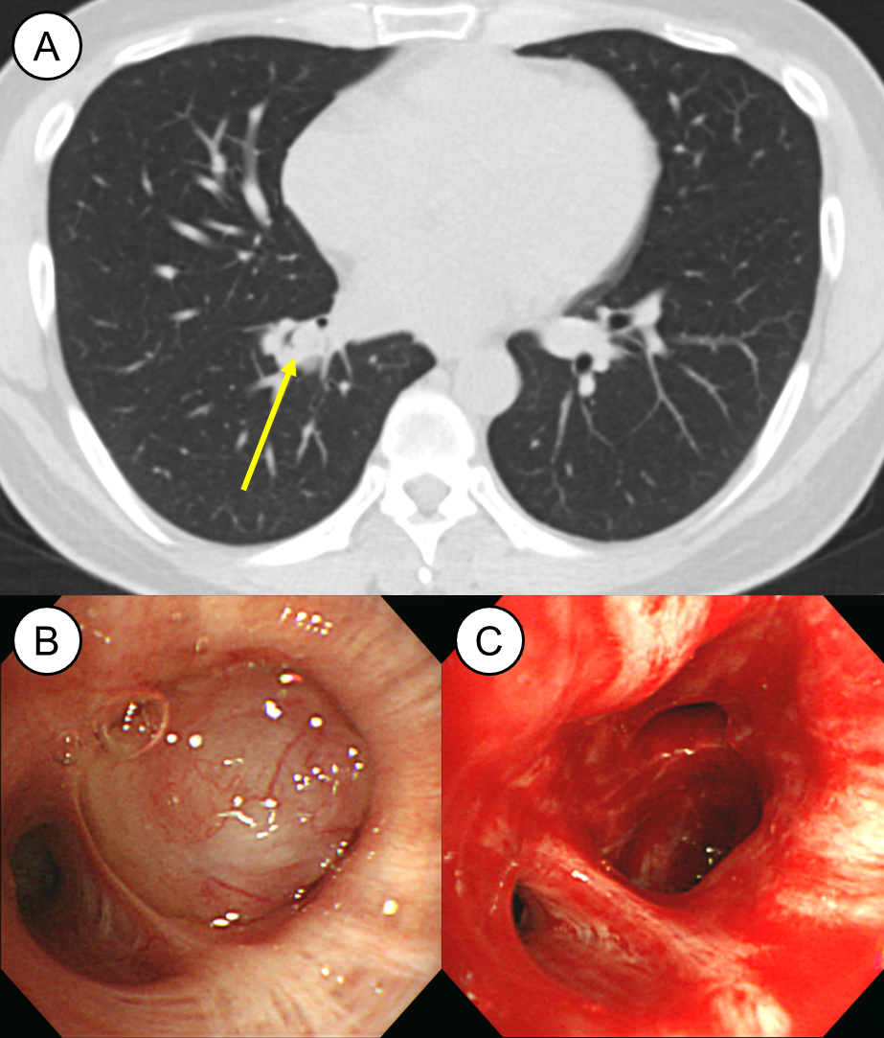
Supplementary Figure 5. Case No. 6. (A) A 45-year-old man underwent a CT scan due to blood-tinged sputum. An endobronchial nodule was seen in the segmental bronchus of the right lower lobe. Because there was no contrast-enhanced computed tomography scan, the size of the tumor could not be determined. (B) Bronchoscopic gross findings showed a round mass. The tumor tightly adhered to the segmental bronchus, and the base was not identified. (C) The tumor mass was removed using a snare. One year after the procedure, progression was confirmed, and the patient underwent surgical resection (lobectomy).
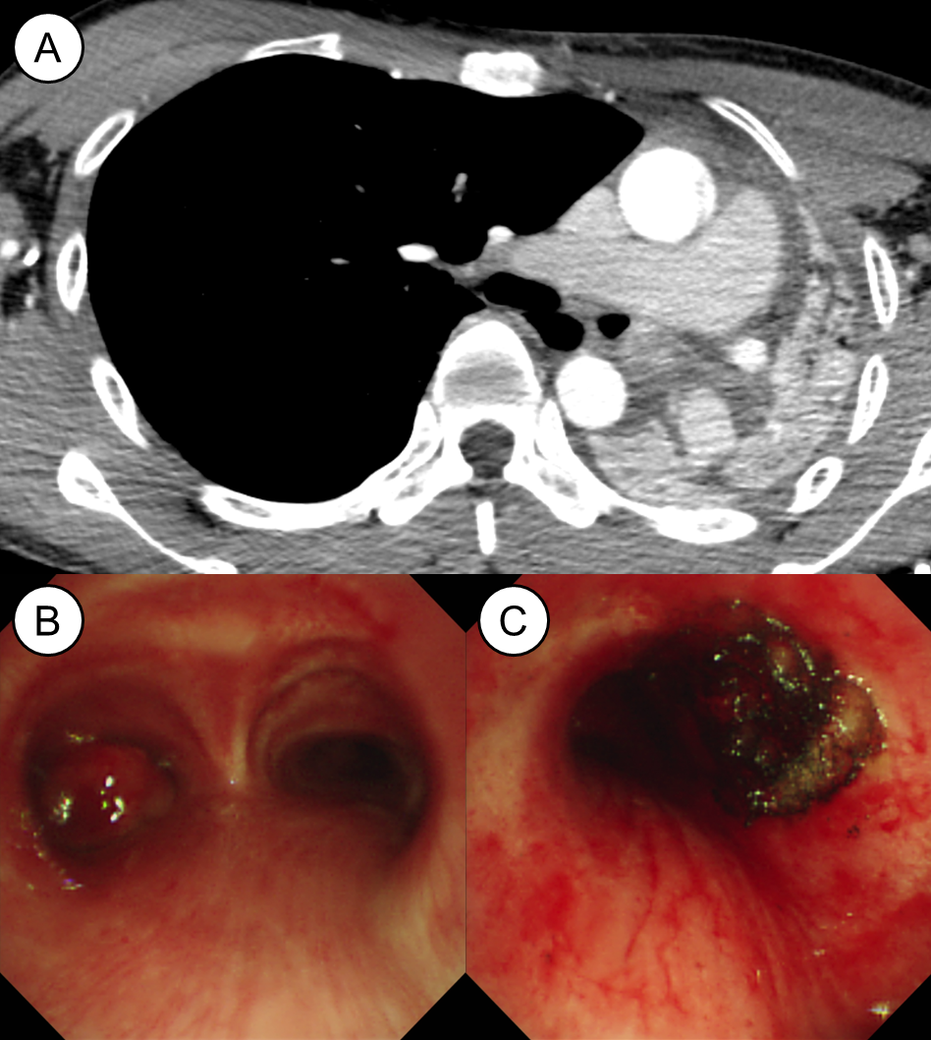
Supplementary Figure 6. Case No. 7. (A) A 23-year-old man underwent a CT scan due to progressive dyspnea and sudden left pleuritic pain. A 19-mm-sized, highly-enhanced, round nodule was seen in the left main bronchus without bronchial wall invasion. (B) Bronchoscopic gross findings showed a round mass with a stalk hanging from the anterior wall of the bronchus. (C) After mechanical removal of the tumor mass using a rigid bronchoscope, the tumor base was cauterized using a diode laser.
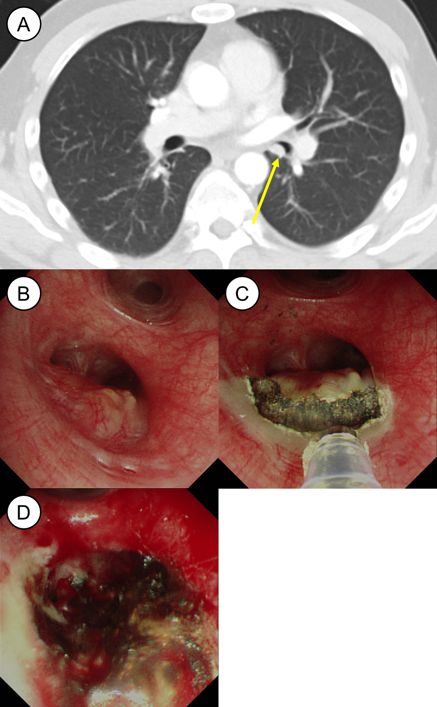
Supplementary Figure 7. Case No. 8. (A) A 38-year-old man underwent a CT scan due to blood-tinged sputum. A 9-mm-sized, well-enhanced, round nodule was seen in the left lower bronchus without bronchial wall invasion. (B) Bronchoscopic gross findings showed a slightly raised lesion without a stalk. (C) The border between the normal mucosa and tumor tissue was cauterized with a laser. (D) After mechanical removal of the tumor mass using a rigid bronchoscope, the tumor base was cauterized using a diode laser.

