Healthcare utilization among community members reporting respiratory, diarrheal or febrile syndromic illness in the Western Highlands of Guatemala

Lucas F. Santos¹, Laura Grajeda¹, Carmen Castillo¹, Juan Carlos Romero¹, Maria Renee Lopez¹, Guy H. Palmer², Douglas R. Call², Celia Cordon-Rosales^{1,2,*}, Brooke M. Ramay^{1,2,*,**}
¹Center for Health Studies, Universidad del Valle de Guatemala, Guatemala City,
²Paul G. Allen School for Global Health, Washington State University, Pullman, WA, USA
Running title: Healthcare utilization in Guatemala

*co-senior authors
**corresponding author
Brooke Ramay
8 av 11-95 zona 15 VHIII
Universidad del Valle
Guatemala City, Guatemala
+502 2364 0336

Table S1. Components included in the wealth index. A principal component analysis (PCA) factor score was generated for each wealth asset and the scores were standardized in relation to a normal distribution according to our sample values and whether the household had the assets. The wealth index for community participants included 10 components and 68 factors within each component. In the community, the final scores were based on rural or urban location of the household. Bold values indicate relevant variables of each component
Components and factors | RC1 | RC2 | RC3
Household ownership
House ownership | 0.029375377 | -0.179579585 | -0.007656557
Household staff
Household has housekeeper | 0.054844406 | 0.020289095 | -0.015234334
Household wall materials
Adobe | -0.080178829 | -0.055908593 | 0.040061838
Clay | 0.033191769 | -0.011153624 | -0.01253752
Sheet | -0.060921049 | 0.047150015 | 0.052213454
Sawn timber | 0.000174411 | -0.144442224 | -0.005639692
Recycling material | -0.012898572 | -0.004688589 | 0.005319314
Cement | -0.017441131 | 0.194103786 | 0.011426779
Stone cement | 0.006772722 | 0.025449667 | -0.016117895
Bricks | 0.012130348 | -0.00345129 | -0.00332639
Cement block | 0.088784609 | 0.102816389 | -0.040428167
Plastered adobe | -0.018260256 | 0.007043361 | -0.01704905
Household roof materials
Wood plank | 0.00211171 | 0.023464877 | -0.014786379
Clay ceramic | -0.065638276 | -0.018965425 | 0.01851988
Concrete tile | -0.10750589 | 0.05600958 | 0.035194871
Zinc sheet | -0.006051431 | 0.017612815 | 0.020569445
Energy source
Electric energy | 0.041353291 | 0.114382912 | -0.020802269
Drinking water source
Pipeline water piped into the household | -0.021049861 | 0.0671924 | 0.043398175
Pipeline water piped into the patio | 0.049263998 | -0.027307531 | 0.030518949
Pipe water, public faucet | -0.022180897 | -0.021095795 | 0.023051866
Other pipe source | 0.007268865 | 0.061653584 | 0.009454329
Mechanical or manual well (curb) | -0.000460344 | -0.002648065 | 0.043060163
Protected spring water | -0.040447224 | 0.057417836 | 0.074705676
Water from truck or water tank | -0.024598139 | 0.009592573 | 0.022010981
Bottled water | -0.080983215 | -0.026802887 | -0.019452995
Other | -0.002701918 | 0.019436531 | 0.004339746
Sanitation facilities
Toilet connected sewer | 0.088157773 | 0.039057867 | 0.034833613
Toilet connected septic tank | -0.04944264 | 0.045265015 | 0.038661506
Improved latrine | 0.038649924 | -0.098895934 | 0.020128889
Open latrine | 0.072054551 | -0.027335169 | -0.015342759
Shared toilet connected sewer | -0.038054835 | -0.011915419 | 0.016435967
Shared toilet connected to septic tank | -0.010474306 | -0.033860784 | 0.002841119
Shared improved latrine | 0.021572503 | 0.010104629 | -0.004782328
Shared open latrine | 0.035652881 | -0.013674481 | -0.004333857
Household doesn’t have sanitation facilities | 0.007570686 | 0.138730783 | -0.001455457
Household assets
Radio | 0.089207259 | 0.024452141 | -0.054832503
TV | 0.11849422 | 0.037457686 | -0.0228221
Fridge | 0.152764986 | -0.007091663 | -0.014543417
Mobile phone | 0.104538731 | 0.01188839 | -0.036399851
Bicycle | 0.079231623 | 0.009362711 | -0.047335794
Motorcycle | 0.063942552 | 0.019277394 | -0.015714374
Car | 0.123021626 | -0.009160038 | -0.073002835
Internet-connection | -0.120951931 | 0.017437874 | 0.003436013
Hand watch | 0.084728451 | -0.001318576 | 0.018021833
Cloth dryer | -0.029695954 | 0.011015151 | -9.65559E-05
Computer | -0.123745626 | 0.020796381 | 0.017940727
Washing machine | -0.120469137 | 0.017213504 | 0.006557753
Cooking fuel
Liquid propane | -0.086472477 | -0.019640089 | -0.106350957
Electricity | -0.00753922 | -0.020060354 | 0.00181029
Wood | 0.085525782 | 0.018588389 | 0.109454903
Farm animal ownership
No cattle | -0.041642562 | 0.079241466 | -0.029437316
Cattle: 1-4 | -0.061763387 | 0.071435274 | 0.110107572
Cattle:5-9 | 0.004266945 | -0.00760479 | -0.015341957
Pigs none | -0.052761121 | 0.028118443 | 0.231614096
Pigs:1-4 | -0.049362855 | 0.029125407 | 0.226800493
Pigs:5-9 | -0.020804226 | 0.006455689 | 0.02601798
Pigs: >10 | 0.017010218 | -0.00057998 | -0.027946946
Horses, donkeys, or mules: none | -0.020751002 | -0.035131448 | 0.120330429
Horses, donkeys, or mules:1-4 | -0.02286437 | -0.018140638 | 0.124544707
Goats, pelibuey-sheep, or sheep in household: none | 0.045536611 | -0.05888985 | 0.100185171
Goats, pelibuey-sheep, or sheep in household: 1-4 | 0.037787391 | -0.0652314 | 0.059920875
Goats, pelibuey-sheep, or sheep in household: 5-9 | 0.02639216 | -0.020150167 | 0.071182026
Goats, pelibuey-sheep, or sheep in household: >10 | 0.010099413 | -0.002153389 | 0.011543098
Poultry: none | 0.013081511 | 0.004442108 | -0.174674312
Poultry: 1-4 | 0.007674118 | 0.051456019 | 0.044391347
Poultry: 5-9 | -0.048706643 | 0.065144531 | 0.098906151
Poultry: >10 | 0.008619588 | 0.081441001 | -0.071881644
ª Variables with no variation were discarded (SD=0.00)

Figure S1. Standardized wealth score for households enrolled in the community settings and participants who sought healthcare.
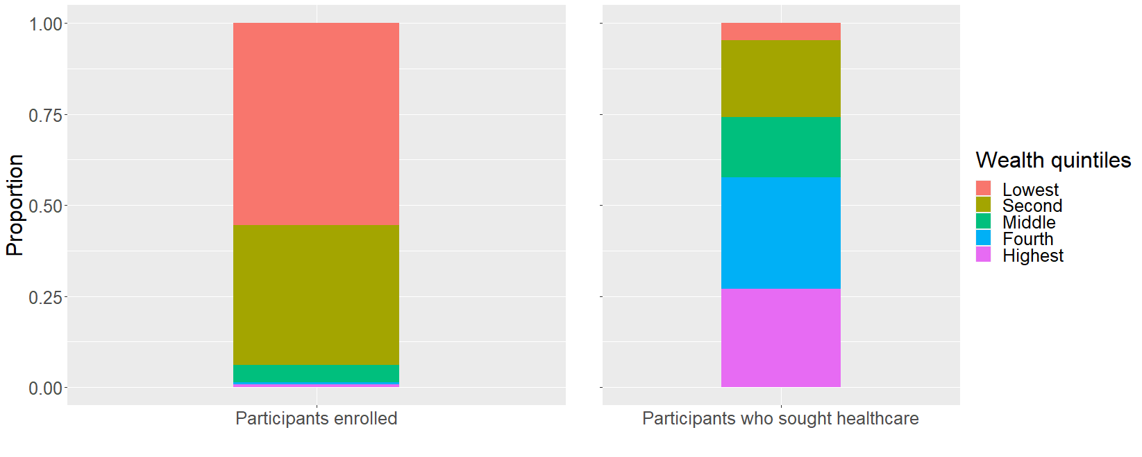

Table S2. Unweighted prevalence of syndromic illness and participants who sought healthcare within 30 days of study enrollment.
 | Unweighted prevalence | Std. error
Community population, N=964
Any syndrome | 17 (14-20) | 0.02
Reported fever | 6 (5-8) | 0.01
Reported diarrhea | 10 (8-12) | 0.01
Reported influenza-like illness | 8 (6-11) | 0.01
Syndromic participants in community settings and sought healthcare | 54 (46-63) | 0.04

Table S3. Participants with syndromes 30 days prior to enrollment who did not seek healthcare at a clinic or hospital (N = 100).
Responses | n (%)
How participant manage symptoms
Did not seek healthcare | 72 (72.0)
Sought advice at pharmacy | 25 (25.0)
Sought advice at convenience store | 3 (3.0)
Reasons for not seeking healthcare in clinic or hospital, pharmacy, or convenience store (n=72 participants, 74 responsesª)
Was not sick enough | 51 (69.0)
Clinic was too far from home | 2 (3.0)
Did not have money | 1 (1.35)
Unable to neglect household chores | 1 (1.35)
Unable to miss work | 1 (1.35)
Other reasons^{b} | 18 (24.0)
Self-medication with antibiotics to treat illness | 20 (28.0)
Antibiotic type (n=20)
Amoxicillin | 8 (40.0)
Tetracycline (or Santemycin) | 9 (45.0)
Amoxicillin + Clavulanic Acid | 1 (5.0)
Trimethoprim Sulfamethoxazole | 1 (5.0)
Cefadroxil | 1 (5.0)
Place where antibiotic was obtained (n=20)
Convenience store | 10 (50.0)
Pharmacy | 9 (45.0)
Already had it | 1 (5.0)
Antibiotic alleviated the illness (n=20) | 18 (90.0)
Second antibiotic obtained to alleviate the illness (n=20) | 2 (10.0)
Second antibiotic used (n=2)
Ampicillin/sulbactam | 1 (50.0)
Tetracycline (or Santemycin) | 1 (50.0)
ª Participants may have listed multiple reasons for not seeking healthcare.
^{b} Consulted with health personal (family member/school) n=2 (11%), did not want to use health services n= 5 (28%), no access to health services n=3 (17%), general self-medication n=8 (44).

