Supporting Information for:
How tidal properties influence the future duration of coastal flooding
Stefan Talke¹
¹Department of Civil and Environmental Engineering, California Polytechnic State University, San Luis Obispo, CA 93407.

Synopsis:
Figures S1-S2: Duration of flooding for an inundation depth s= 0.1m and s = 0.3m
Figures S3: (a) Relative sea-level rise rate (RSLR) over 30 years (1990-2019) and (b) time (in years) to go from 0 to 1 hours of inundation time, using RSLR from (a). An acceleration of 0.1 mm/yr² is assumed.
Figures S4: (a) Relative sea-level rise rate over 30 years (1990-2019) and (b) time (in years) to go from 0 to 3 hours of inundation time, using RSLR from (a).. An acceleration of 0.1 mm/yr² is assumed.
Figures S5: (a) Relative sea-level rise rate over 20 years (2000-2019) and (b) time (in years) to go from 0 to 2 hours of inundation time, using RSLR from (a). An acceleration of 0.1 mm/yr² is assumed.
Figures S6: (a) Relative sea-level rise rate over 40 years (1980-2019) and (b) time (in years) to go from 0 to 2 hours of inundation time, using RSLR from (a). An acceleration of 0.1 mm/yr² is assumed.
Figures S7-S26: Examples of sinusoidal waves (red curve) fit to the largest predicted high-water stand (black curve) for each location analyzed (311 total) using a nonlinear least squares fit. Location names from the GESLA-3 data set are used (Haigh et al., 2023), but truncated after the 25th character to fit onto the graph. Each subplot includes the ratio of root-mean-square error (RMSE) and the tidal amplitude (RA). An RA< 0.03 was considered an adequate fit. The amplitude and period of each wave fit is tabulated.

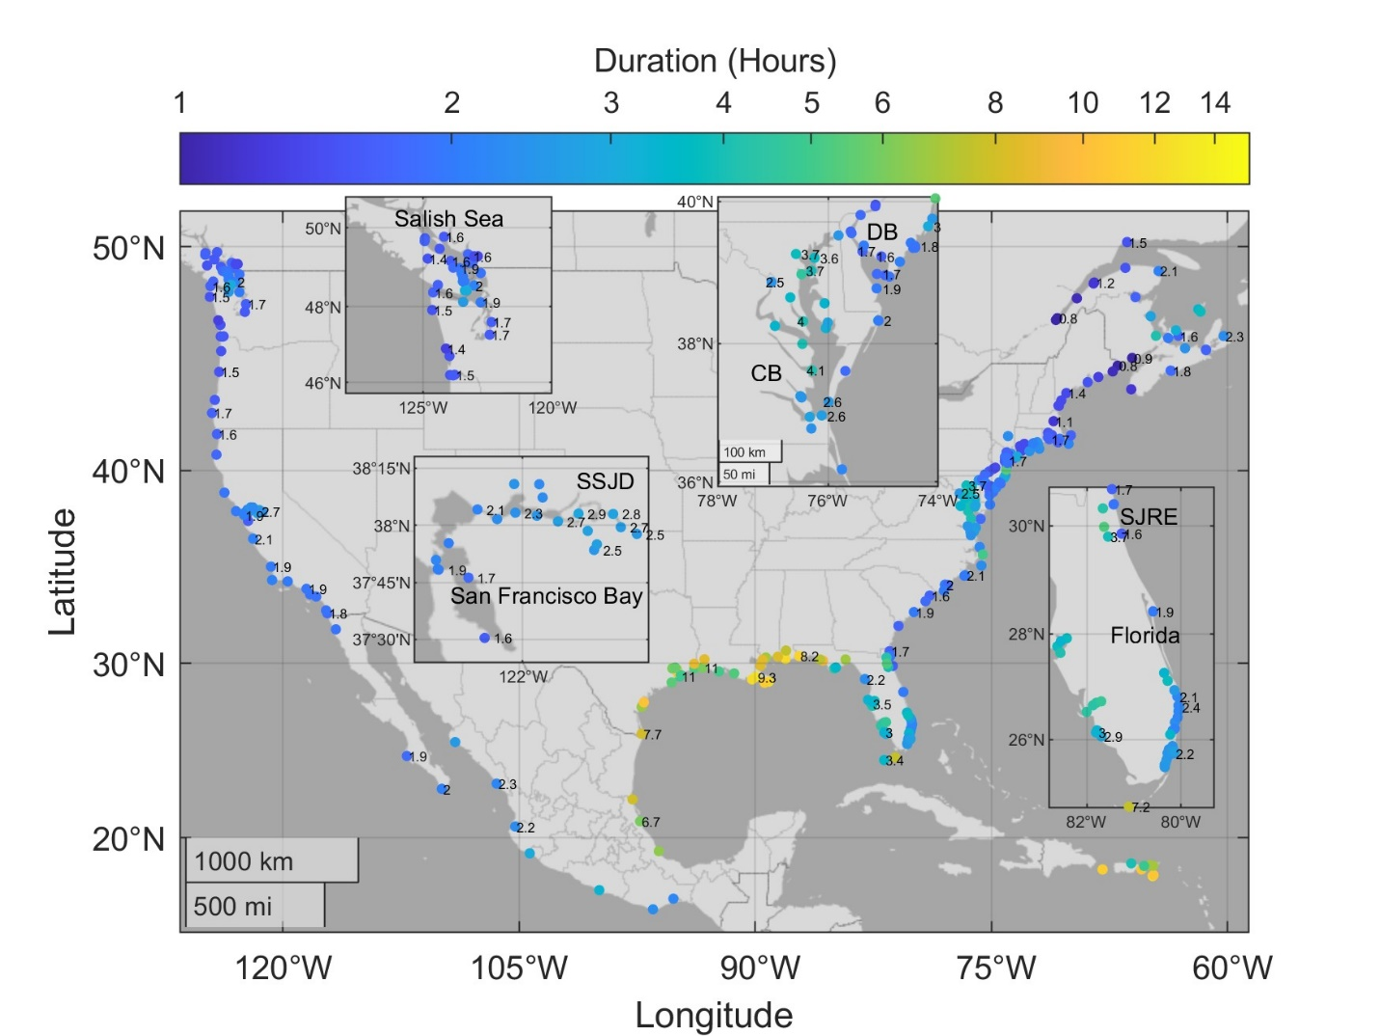
Figure S1: Median duration of flooding for an inundation depth of s= 0.1m for the top 30 high water periods from a typical year (see main paper for details). Abbreviations: SSJD = Sacramento-San Joaquin Delta; CB = Chesapeake Bay; DB = Delaware Bay; SJRE = Saint Johns River Estuary

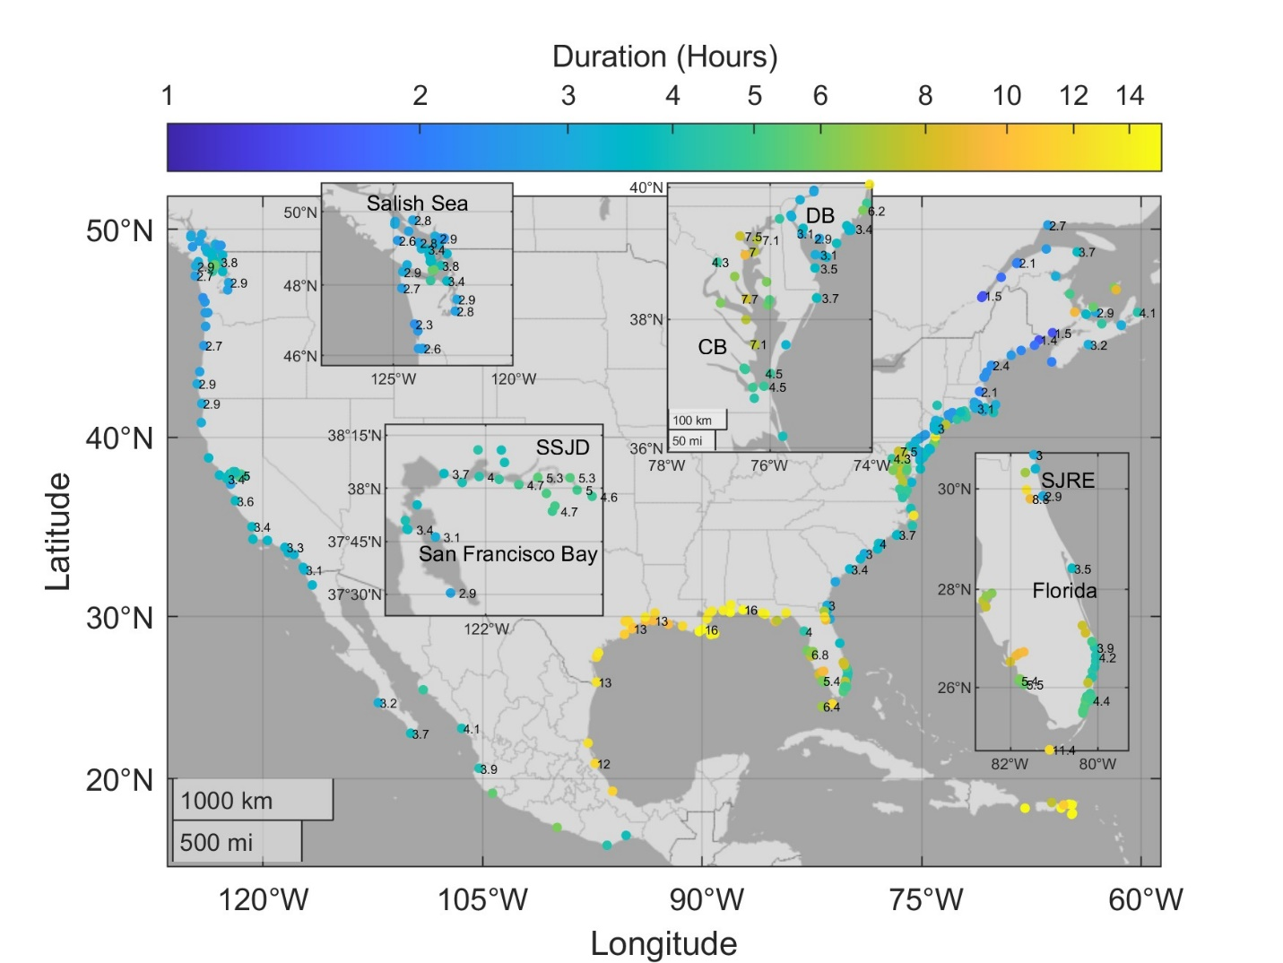
Figure S2: Duration of flooding for an inundation depth of s= 0.3m for the top 30 high water periods from a typical year (see main paper for details). Abbreviations: SSJD = Sacramento-San Joaquin Delta; CB = Chesapeake Bay; DB = Delaware Bay; SJRE = Saint Johns River Estuary
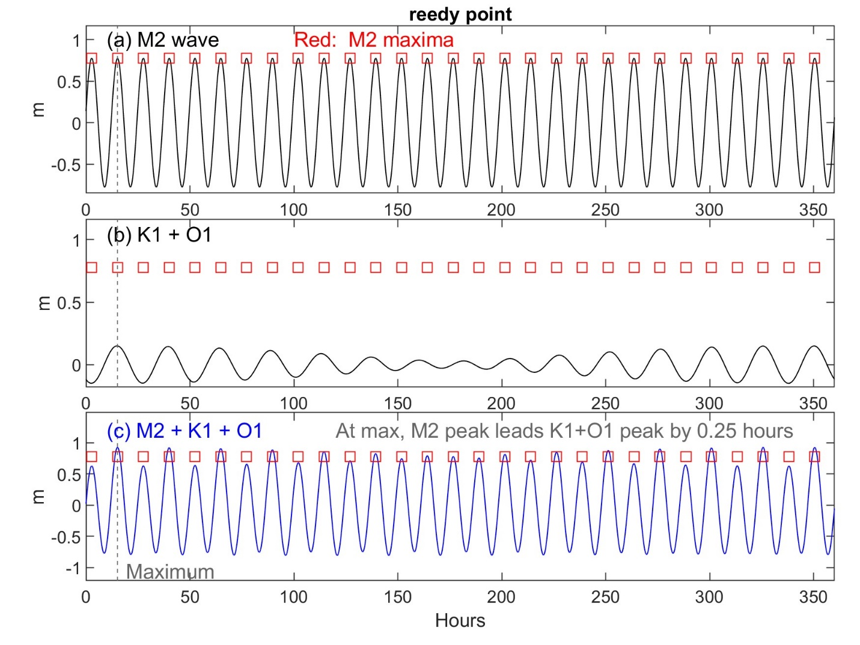
Figure S3: (a) M2 wave (b) K1+O1 wave and (c) sum of the M2+K1+O1 wave at Reedy Point, Delaware. Constituent amplitudes and phases obtained via harmonic analysis (see Supporting Data File). The time of the maximum over the 13.66 day repeating cycle is shown by a vertical dashed line. The M2 peak and the K1+O1 peak are nearly in phase.

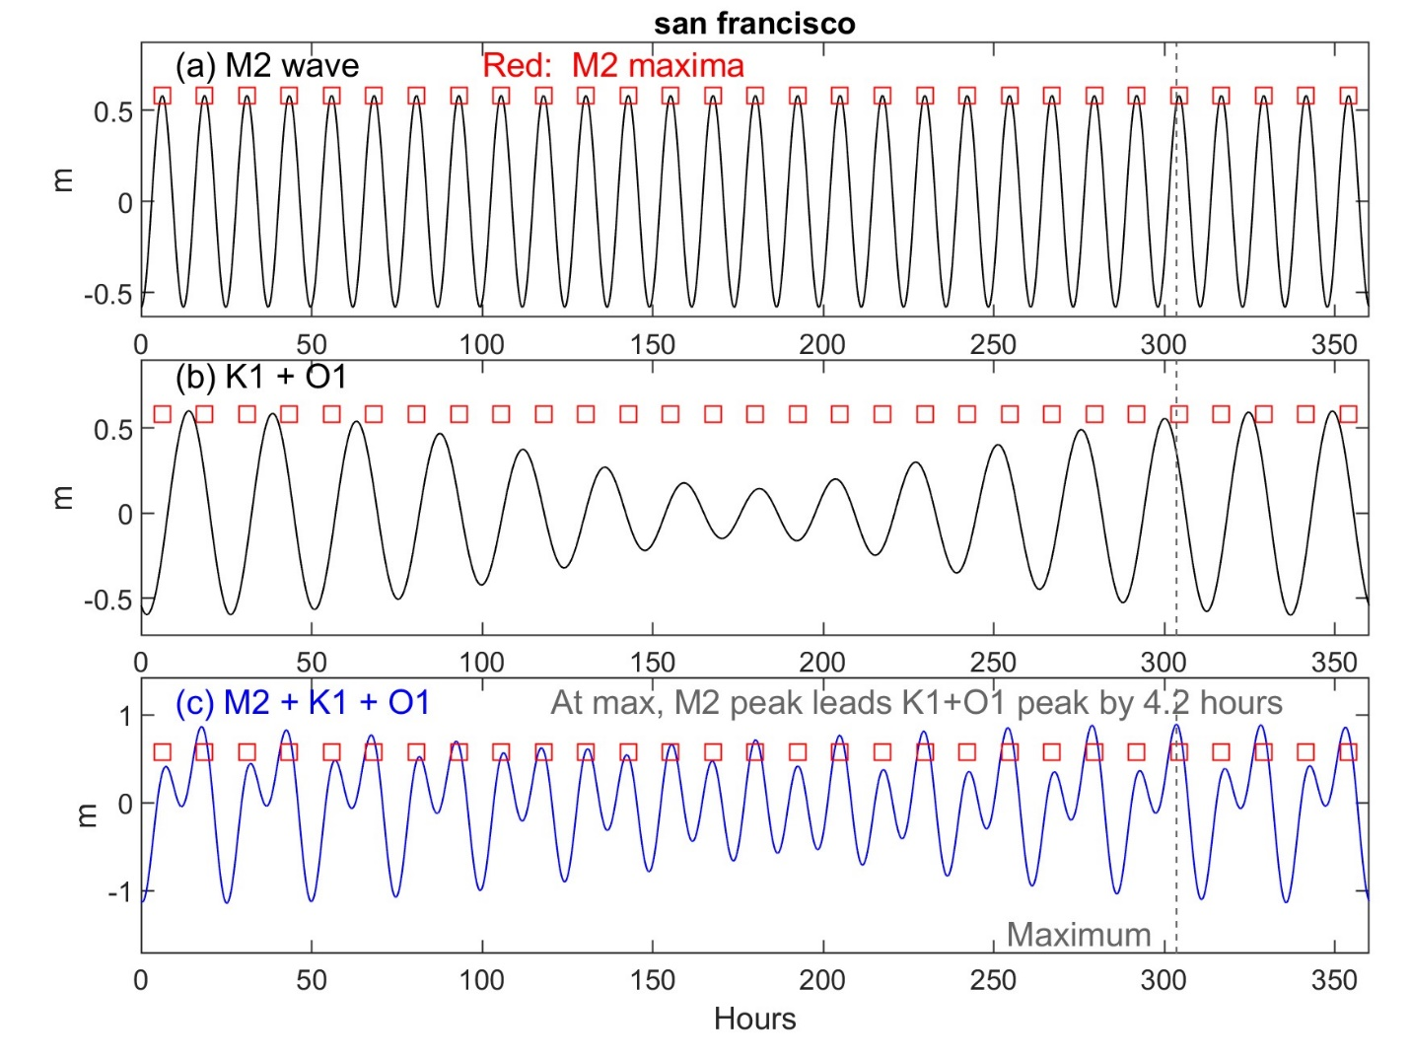
Figure S4: (a) M2 wave (b) K1+O1 wave and (c) sum of the M2+K1+O1 wave at San Francisco, California. Constituent amplitudes and phases obtained via harmonic analysis (see Supporting Data File). The time of the maximum over the 13.66 day repeating cycle is shown by a vertical dashed line. The M2 peak and the K1+O1 peak are separated by 4.2 hours at the time of peak water level in (c). This phase shift reduces the influence of the diurnal wave on the high-water stand. Thus, though the form factor is much smaller at Reedy Point (Figure S3) than San Francisco (0.17 vs 0.84), the duration time-scales are similar (e.g., t_{d} = 2.7 vs. 2.8 hours, for s = 0.2 m). Similarly, the great diurnal tidal range (GT) is similar at the two locations (1.76 m vs. 1.78 m), even though the sum of major constituents (M2+S2+N2+O1+K1) is much smaller at Reedy Point than at San Francisco (1.18m vs. 1.44 m). See Supporting Data File.

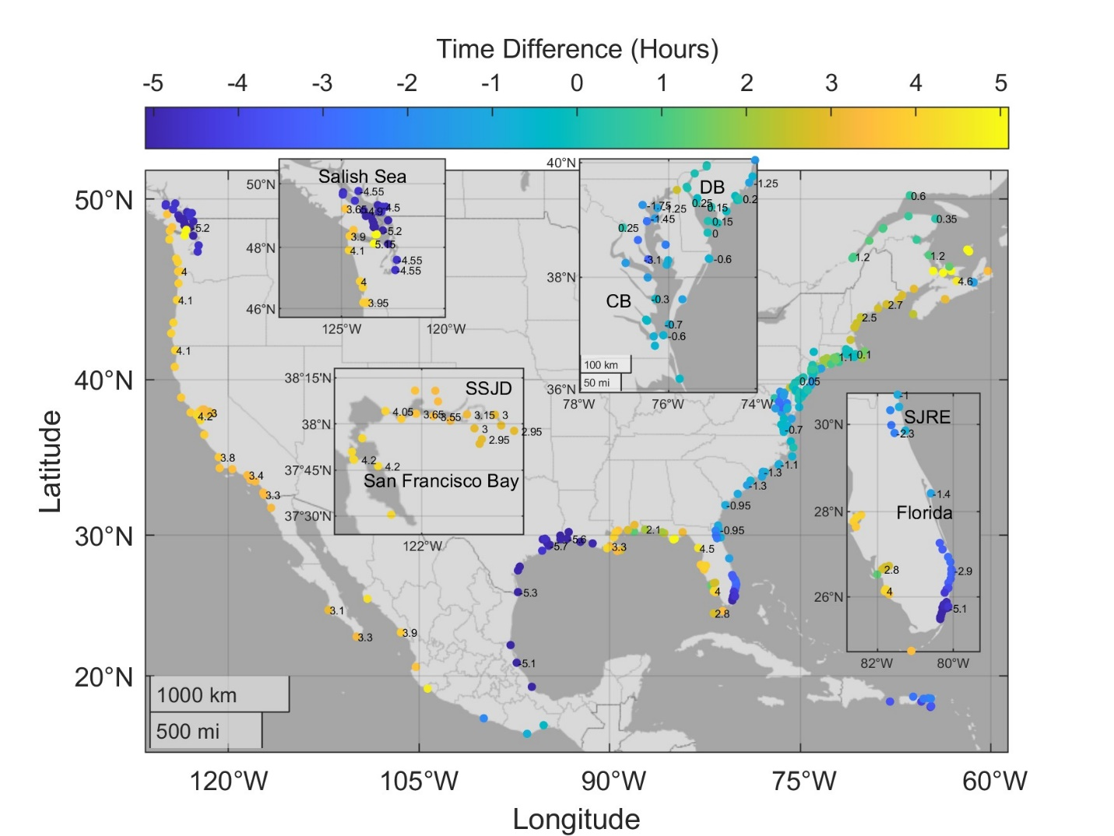
Figure S5. Time Difference between the closest M2 peak and K1+O1 peak at the time of the maximum water level in the M2+K1+O1 triad. See Figure S3 and S4 for examples of the triad and the time lag between M2 and K1+O1 at the maximum water level elevation. Abbreviations: SSJD = Sacramento-San Joaquin Delta; CB = Chesapeake Bay; DB = Delaware Bay; SJRE = Saint Johns River Estuary

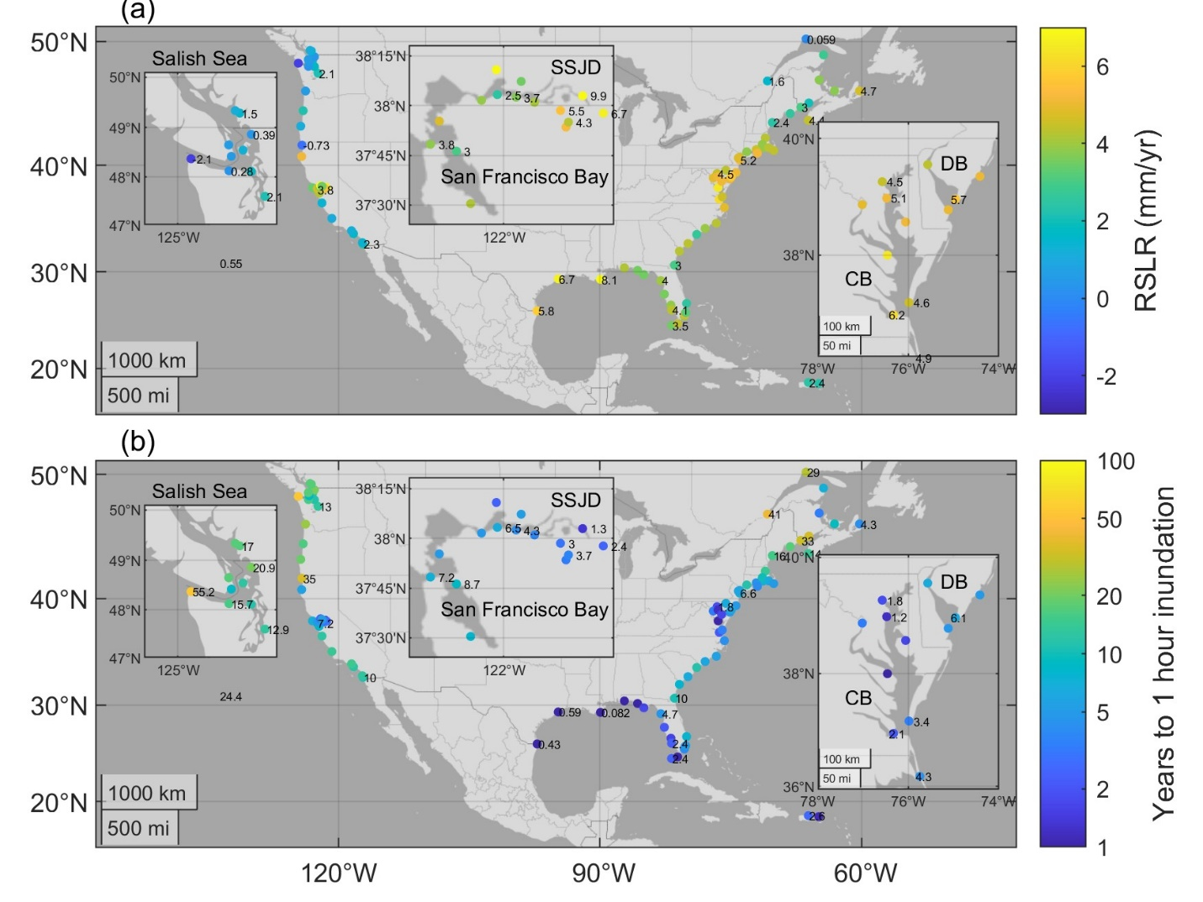
Figure S6: (a) Relative sea-level rise rate (RSLR) over 30 years (1990-2019) and (b) time (in years) to go from 0 to 1 hours of inundation time, using RSLR from (a). An acceleration of 0.1 mm/yr² is assumed. Abbreviations: SSJD = Sacramento-San Joaquin Delta; CB = Chesapeake Bay; DB = Delaware Bay.

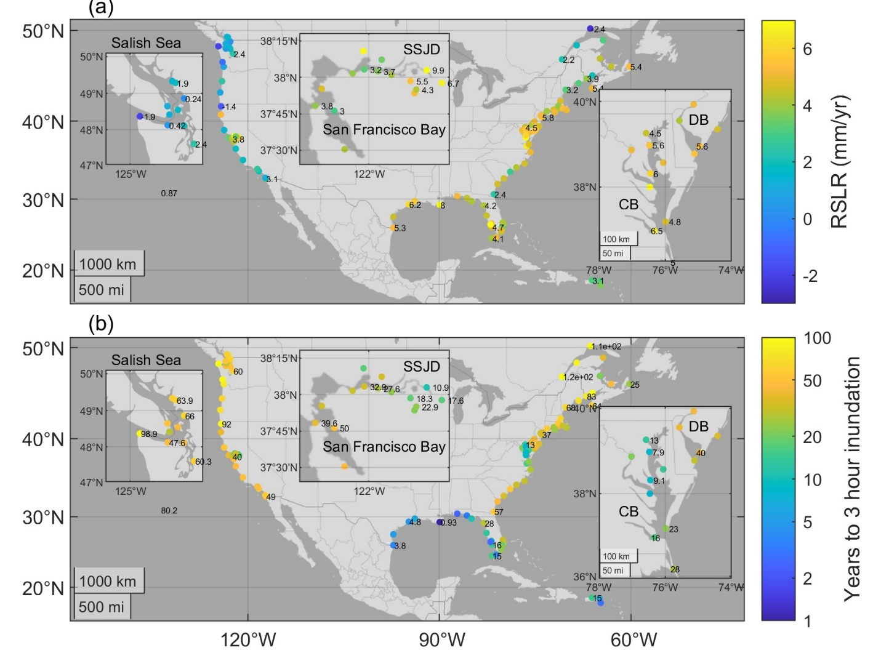
Figure S7: (a) Relative sea-level rise rate over 30 years (1990-2019) and (b) time (in years) to go from 0 to 3 hours of inundation time, using RSLR from (a). An acceleration of 0.1 mm/yr² is assumed. Abbreviations: SSJD = Sacramento-San Joaquin Delta; CB = Chesapeake Bay; DB = Delaware Bay.
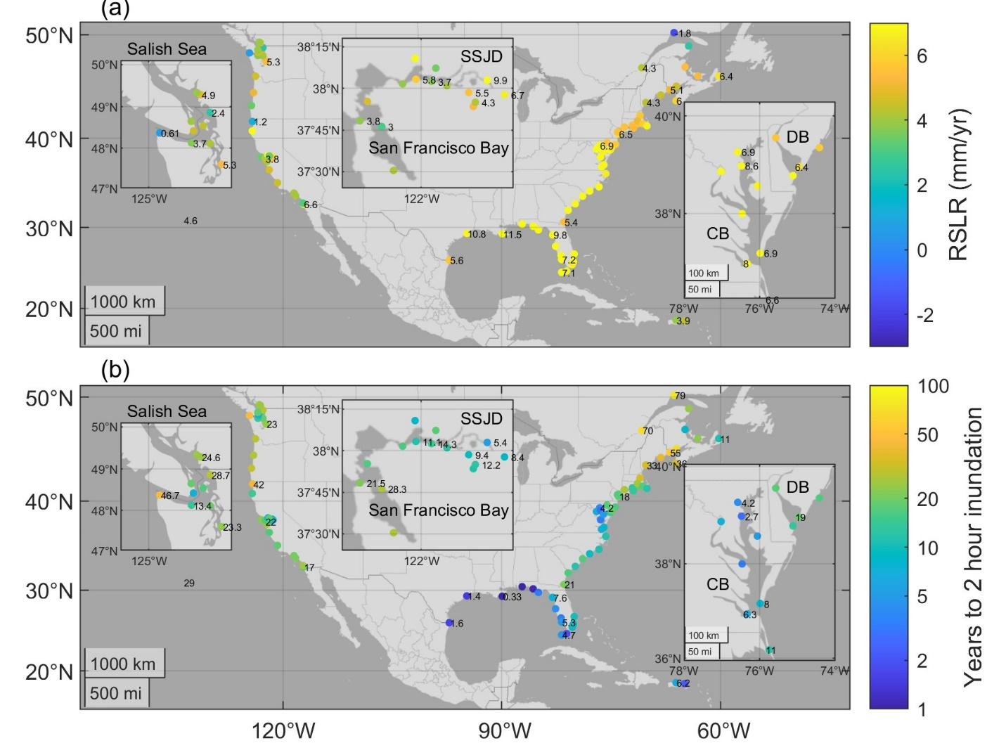
Figure S8: (a) Relative sea-level rise rate over 20 years (2000-2019) and (b) time (in years) to go from 0 to 2 hours of inundation time, using RSLR from (a). An acceleration of 0.1 mm/yr² is assumed. Abbreviations: SSJD = Sacramento-San Joaquin Delta; CB = Chesapeake Bay; DB = Delaware Bay.
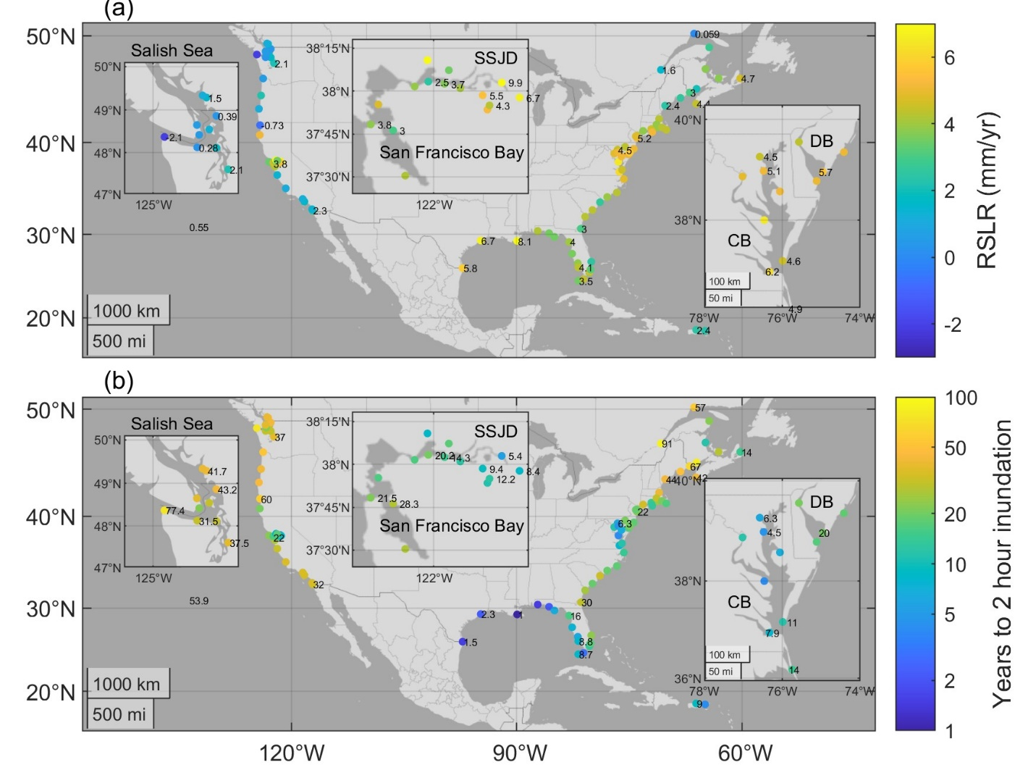
Figure S9: (a) Relative sea-level rise rate over 40 years (1980-2019) and (b) time (in years) to go from 0 to 2 hours of inundation time, using RSLR from (a). An acceleration of 0.1 mm/yr² is assumed. Abbreviations: SSJD = Sacramento-San Joaquin Delta; CB = Chesapeake Bay; DB = Delaware Bay.

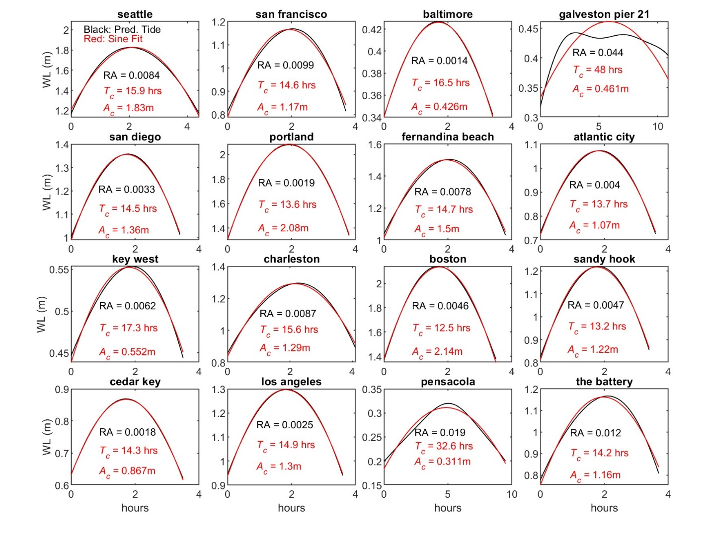
Figure S10: Examples of sinusoidal waves (red curve) fit to the largest predicted high-water stand (black curve) at 16 tide gauge locations. See the GESLA-3 data set for additional location information and meta-data (Haigh et al., 2023).
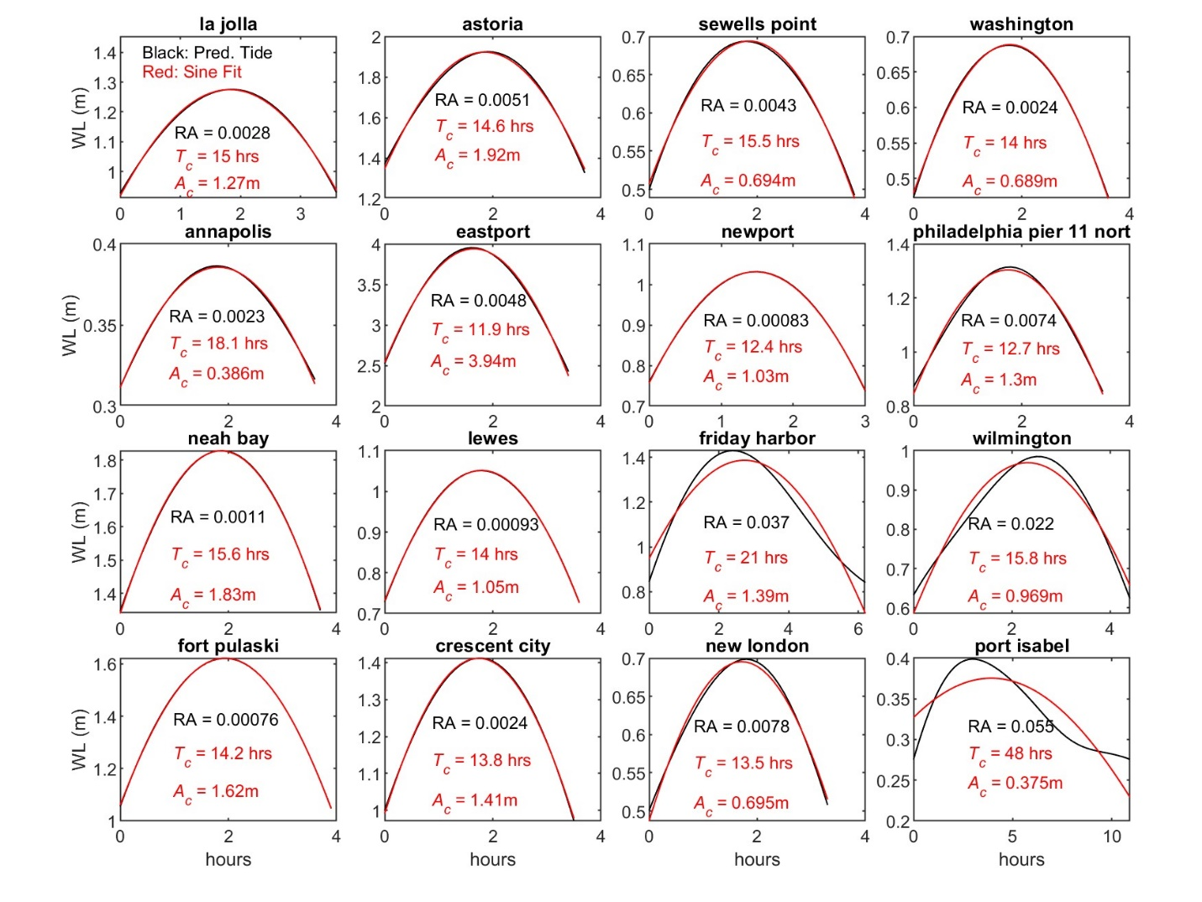
Figure S11: Examples of sinusoidal waves (red curve) fit to the largest predicted high-water stand (black curve) at 16 tide gauge locations. See the GESLA-3 data set for additional location information and meta-data (Haigh et al., 2023).

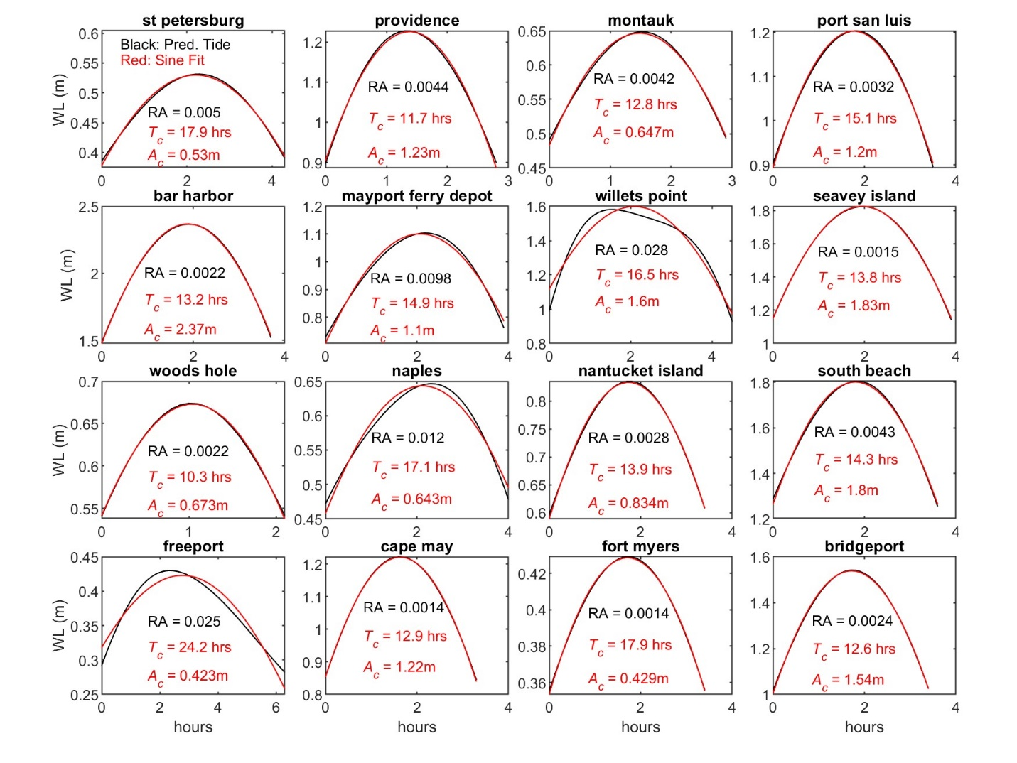
Figure S12: Examples of sinusoidal waves (red curve) fit to the largest predicted high-water stand (black curve) at 16 tide gauge locations. See the GESLA-3 data set for additional location information and meta-data (Haigh et al., 2023).
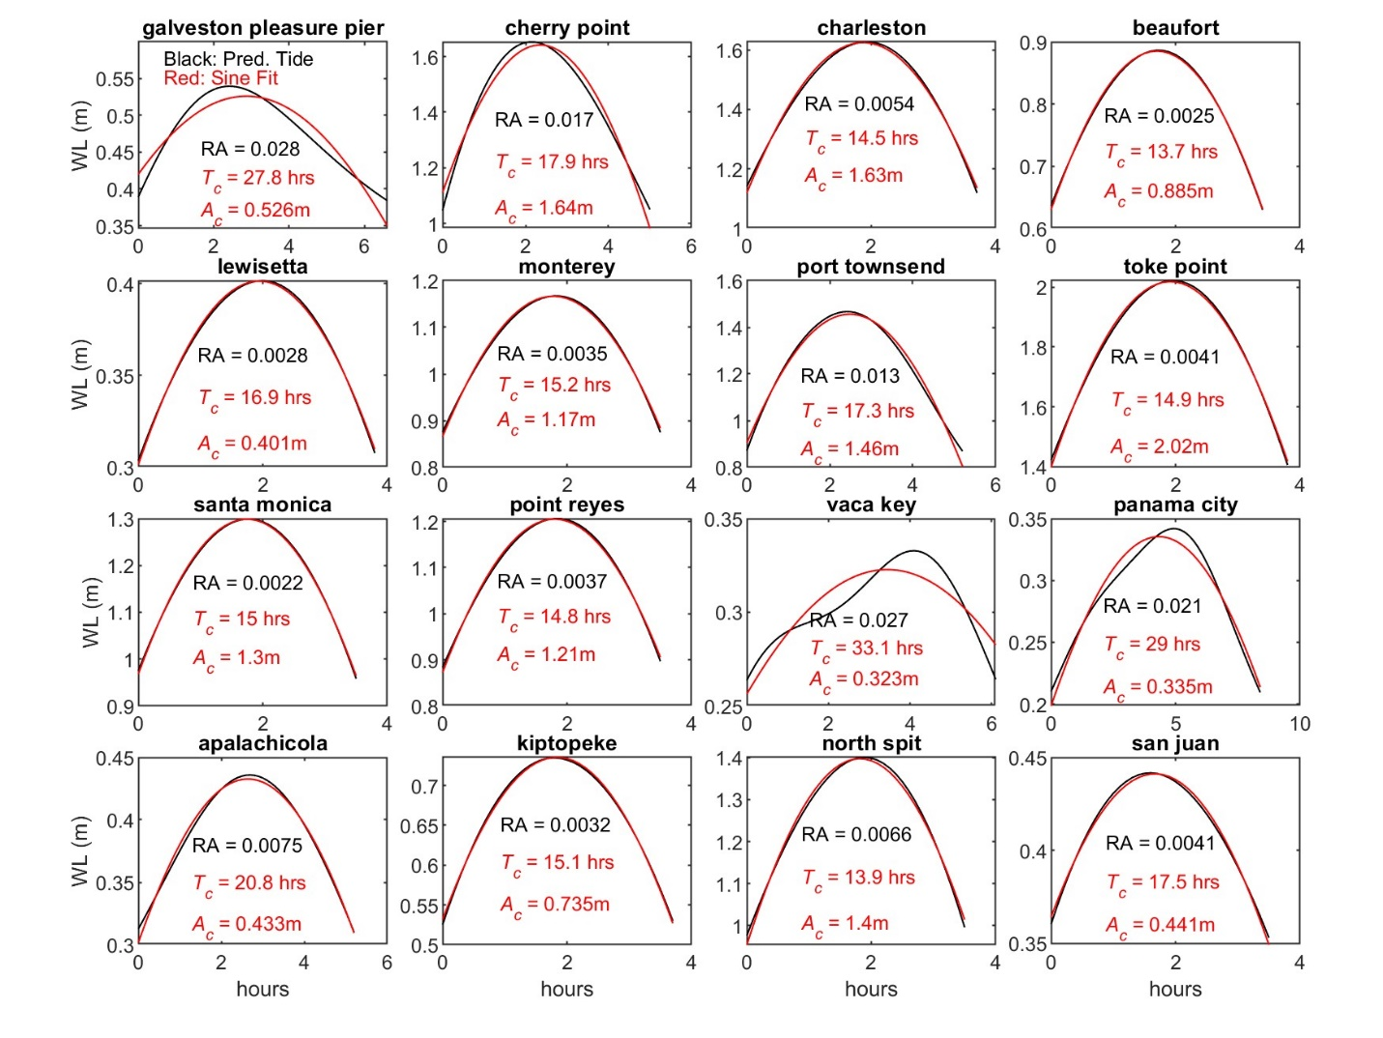
Figure S13: Examples of sinusoidal waves (red curve) fit to the largest predicted high-water stand (black curve) at 16 tide gauge locations. See the GESLA-3 data set for additional location information and meta-data (Haigh et al., 2023).
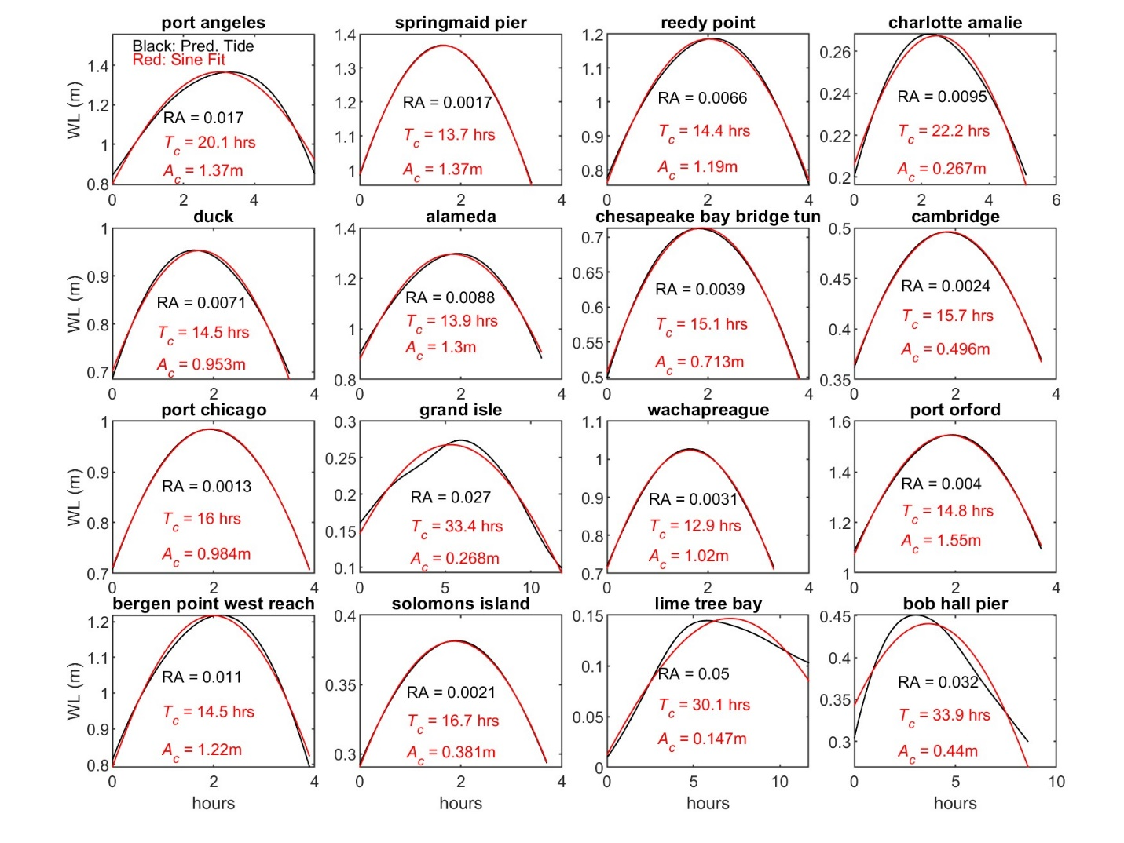 Figure S14: Examples of sinusoidal waves (red curve) fit to the largest predicted high-water stand (black curve) at 16 tide gauge locations. See the GESLA-3 data set for additional location information and meta-data (Haigh et al., 2023).
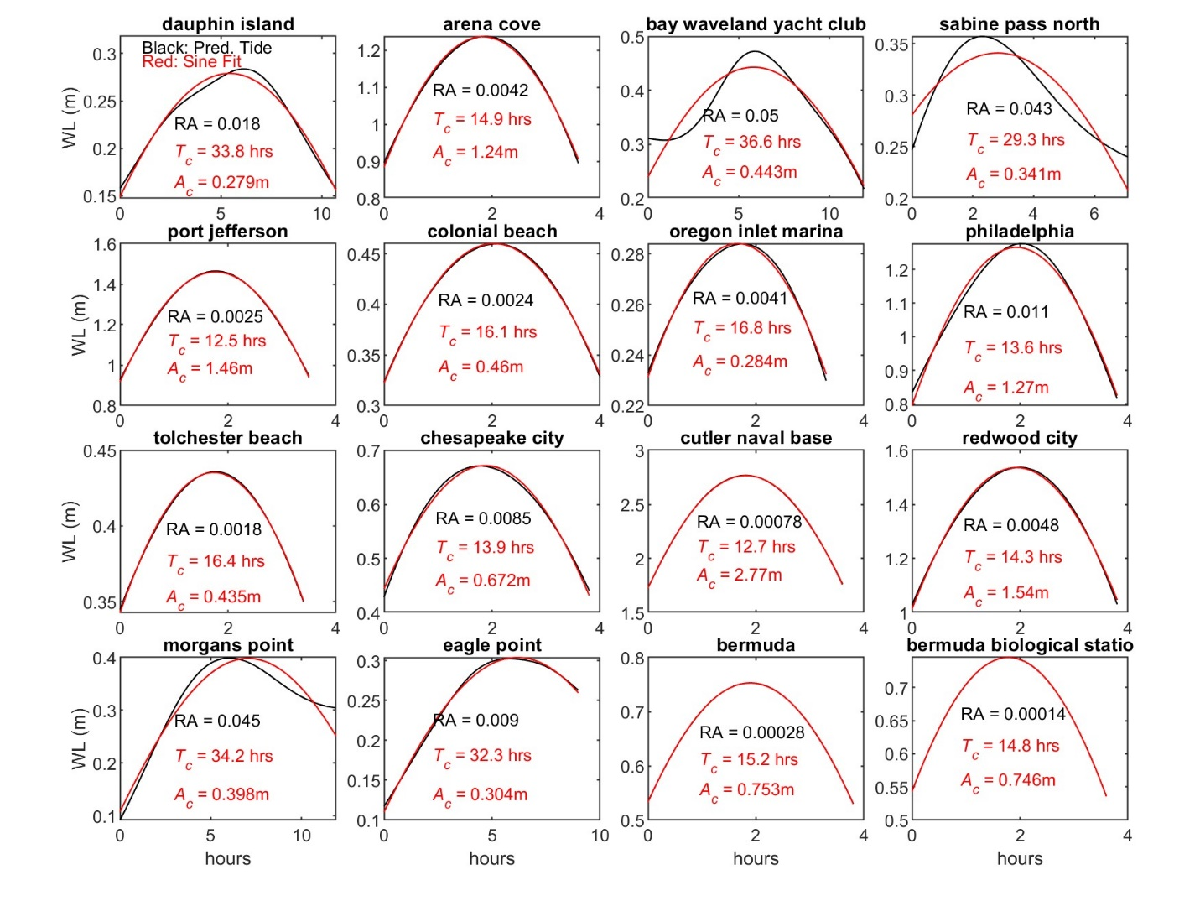 Figure S15: Examples of sinusoidal waves (red curve) fit to the largest predicted high-water stand (black curve) at 16 tide gauge locations. See the GESLA-3 data set for additional location information and meta-data (Haigh et al., 2023).
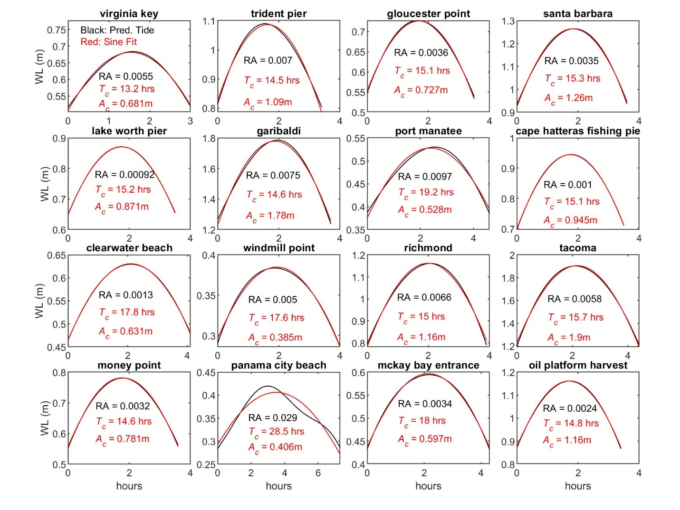 Figure S16: Examples of sinusoidal waves (red curve) fit to the largest predicted high-water stand (black curve) at 16 tide gauge locations. See the GESLA-3 data set for additional location information and meta-data (Haigh et al., 2023).
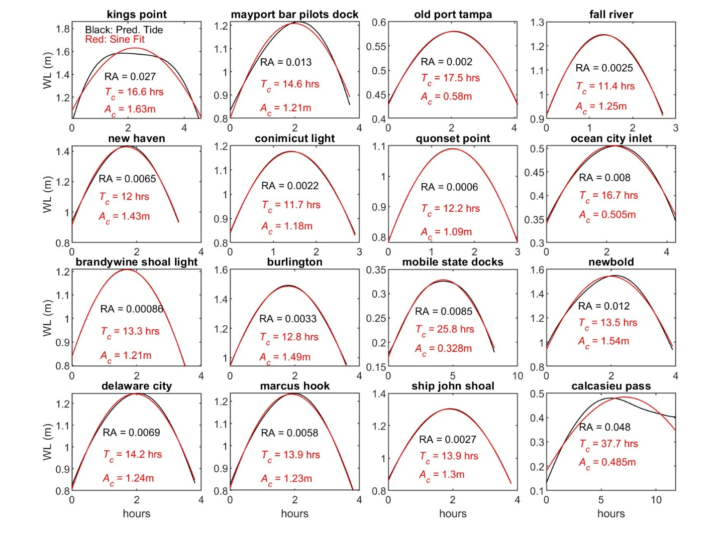 Figure S17: Examples of sinusoidal waves (red curve) fit to the largest predicted high-water stand (black curve) at 16 tide gauge locations. See the GESLA-3 data set for additional location information and meta-data (Haigh et al., 2023).
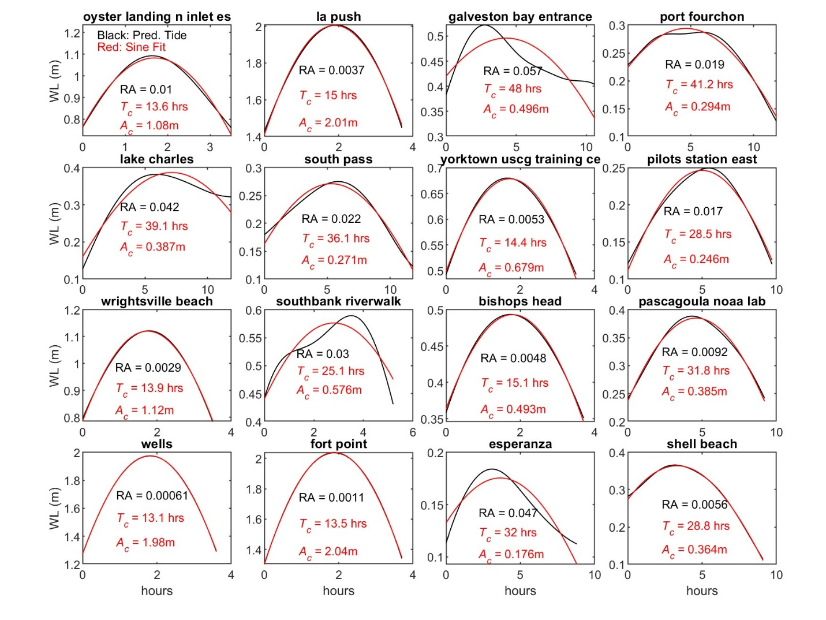 Figure S18: Examples of sinusoidal waves (red curve) fit to the largest predicted high-water stand (black curve) at 16 tide gauge locations. See the GESLA-3 data set for additional location information and meta-data (Haigh et al., 2023).
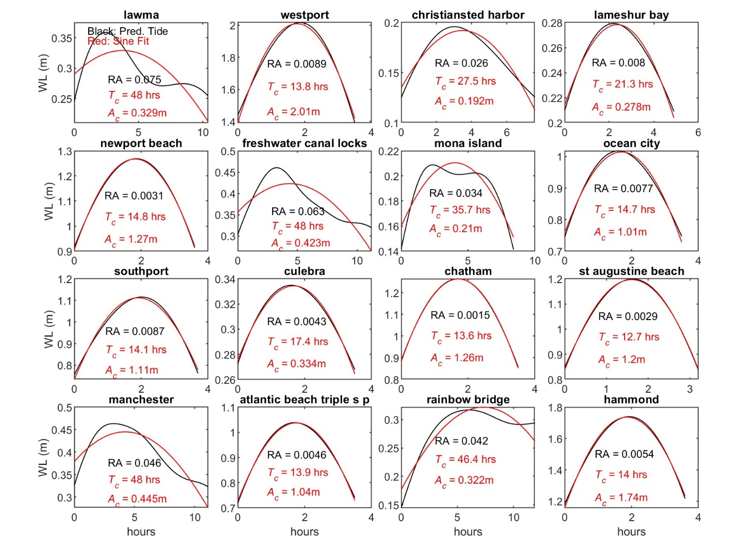 Figure S19: Examples of sinusoidal waves (red curve) fit to the largest predicted high-water stand (black curve) at 16 tide gauge locations. See the GESLA-3 data set for additional location information and meta-data (Haigh et al., 2023).
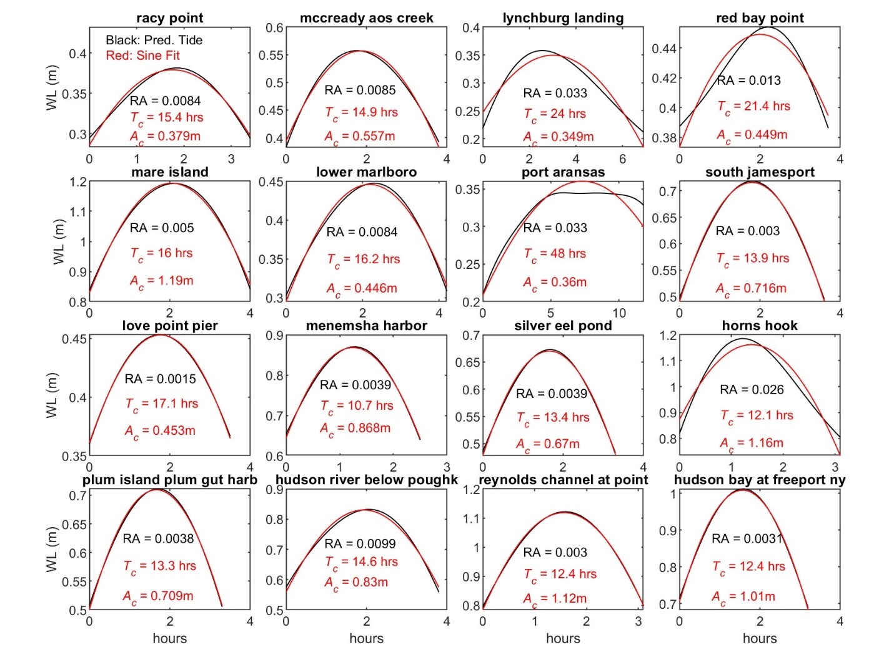 Figure S20: Examples of sinusoidal waves (red curve) fit to the largest predicted high-water stand (black curve) at 16 tide gauge locations. See the GESLA-3 data set for additional location information and meta-data (Haigh et al., 2023).
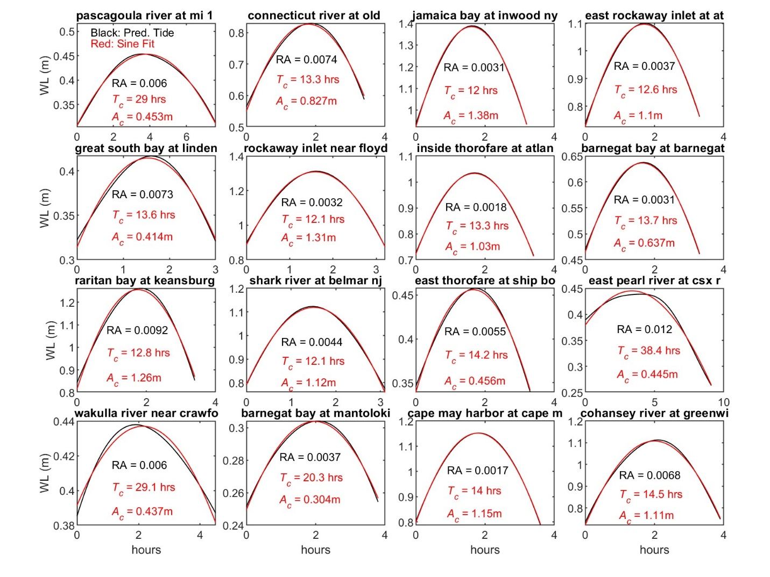 Figure S21: Examples of sinusoidal waves (red curve) fit to the largest predicted high-water stand (black curve) at 16 tide gauge locations. See the GESLA-3 data set for additional location information and meta-data (Haigh et al., 2023).
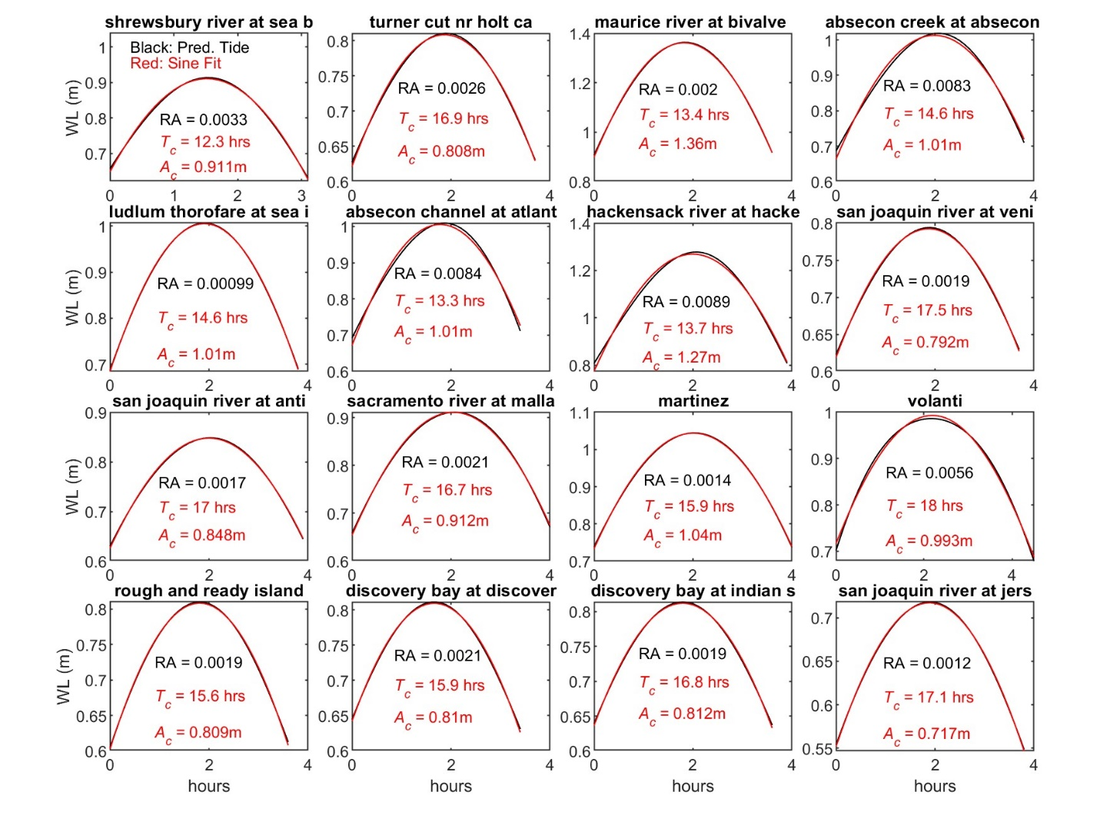 Figure S22: Examples of sinusoidal waves (red curve) fit to the largest predicted high-water stand (black curve) at 16 tide gauge locations. See the GESLA-3 data set for additional location information and meta-data (Haigh et al., 2023).
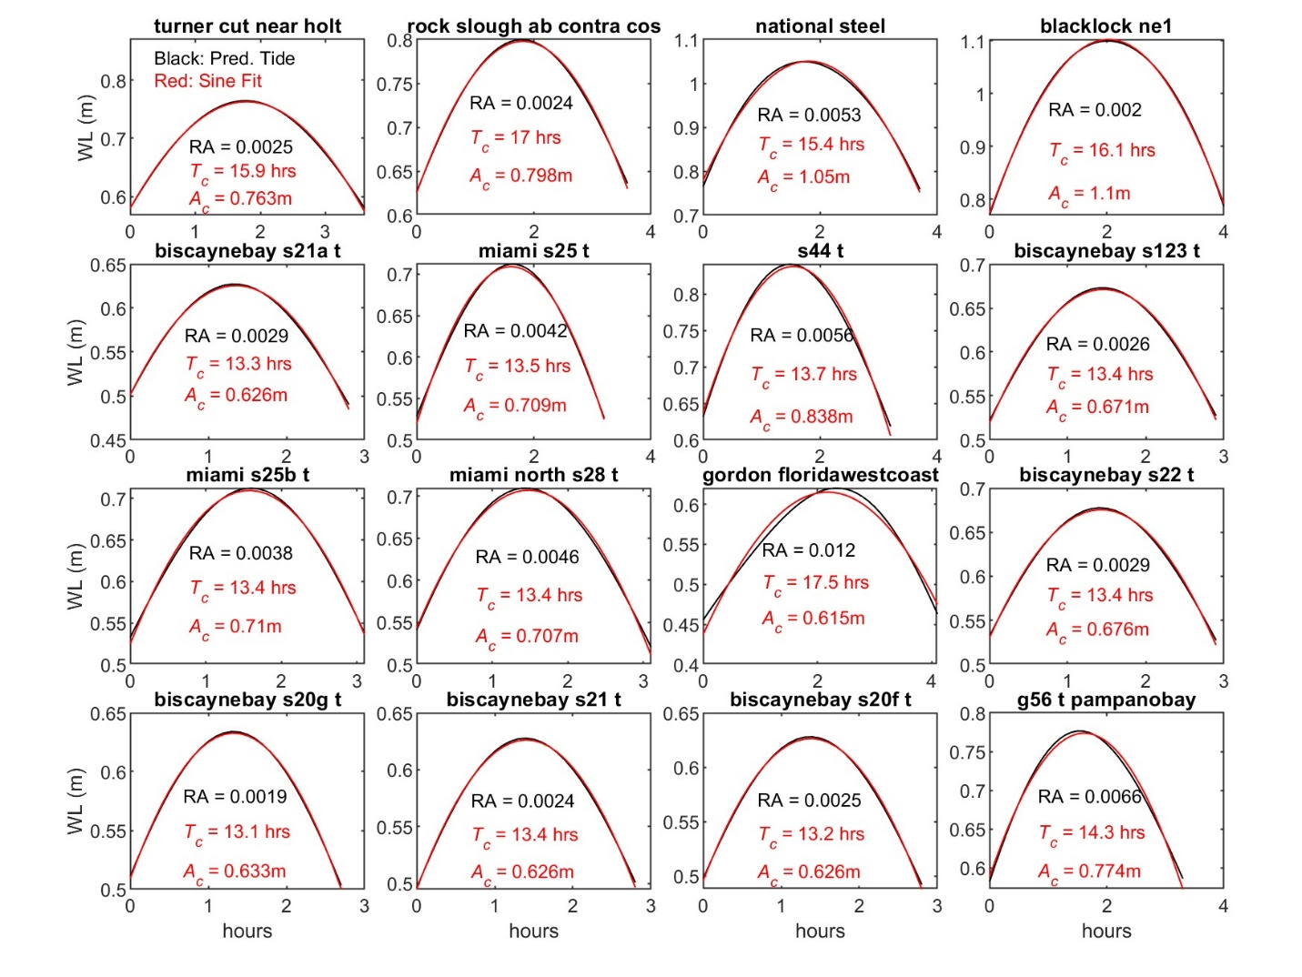 Figure S23: Examples of sinusoidal waves (red curve) fit to the largest predicted high-water stand (black curve) at 16 tide gauge locations. See the GESLA-3 data set for additional location information and meta-data (Haigh et al., 2023).
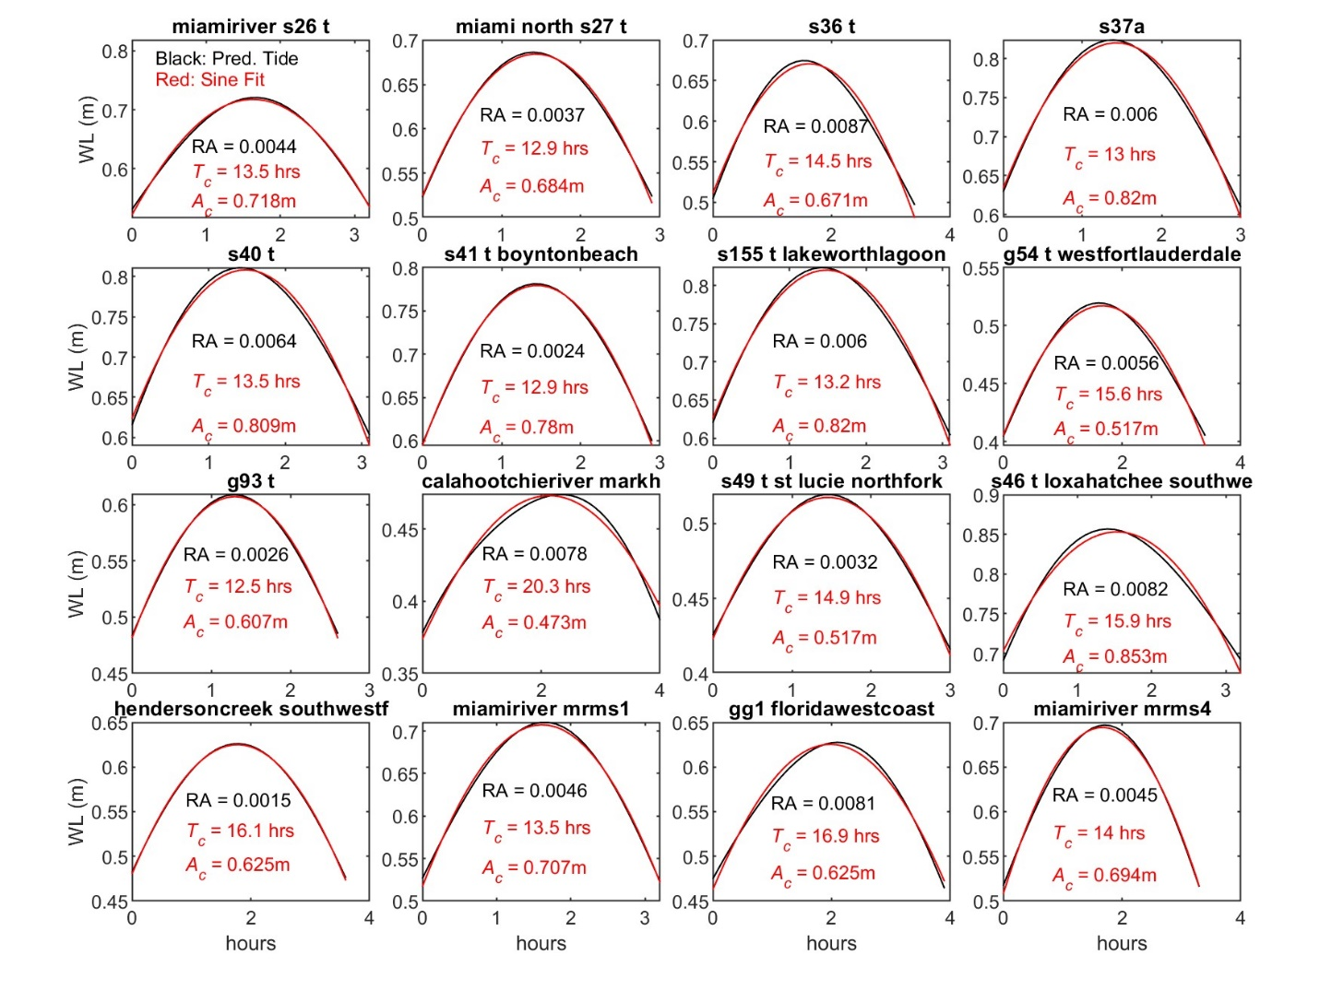 Figure S24: Examples of sinusoidal waves (red curve) fit to the largest predicted high-water stand (black curve) at 16 tide gauge locations. See the GESLA-3 data set for additional location information and meta-data (Haigh et al., 2023).
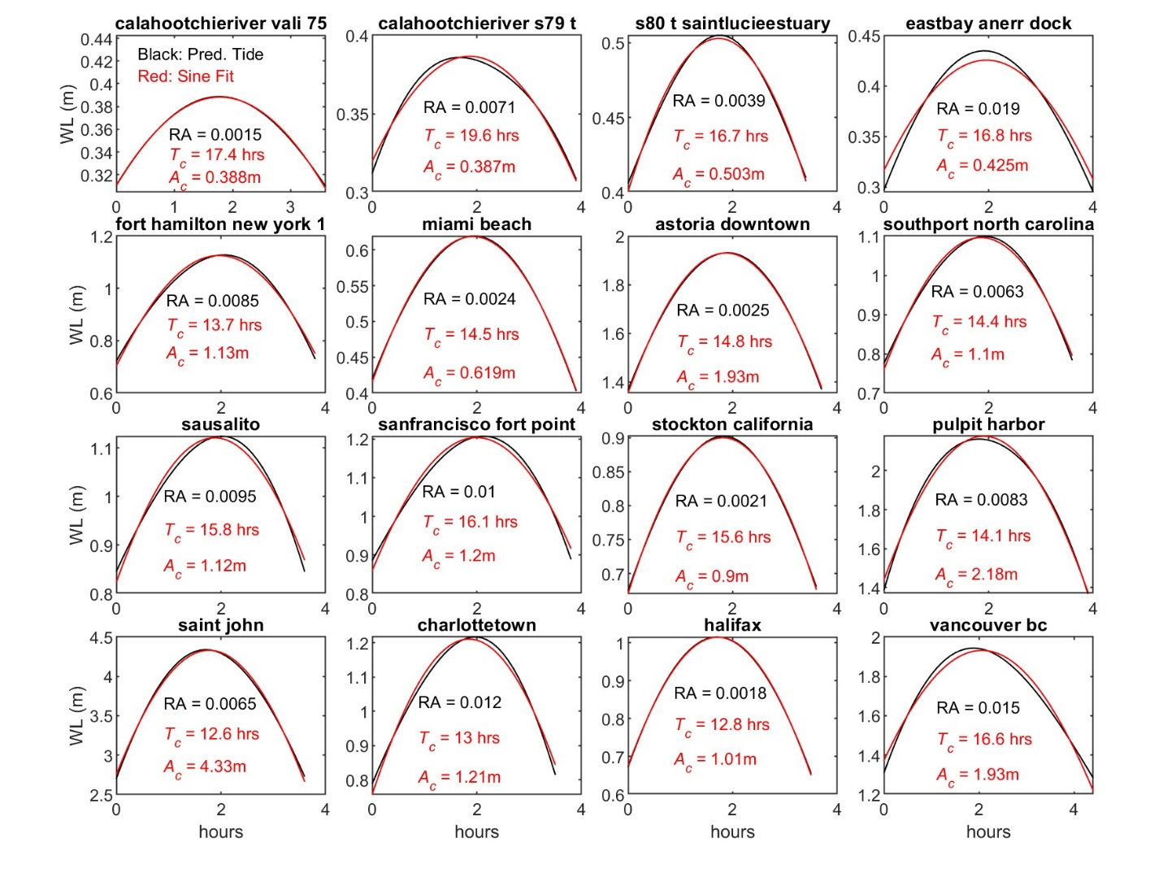 Figure S25: Examples of sinusoidal waves (red curve) fit to the largest predicted high-water stand (black curve) at 16 tide gauge locations. See the GESLA-3 data set for additional location information and meta-data (Haigh et al., 2023).
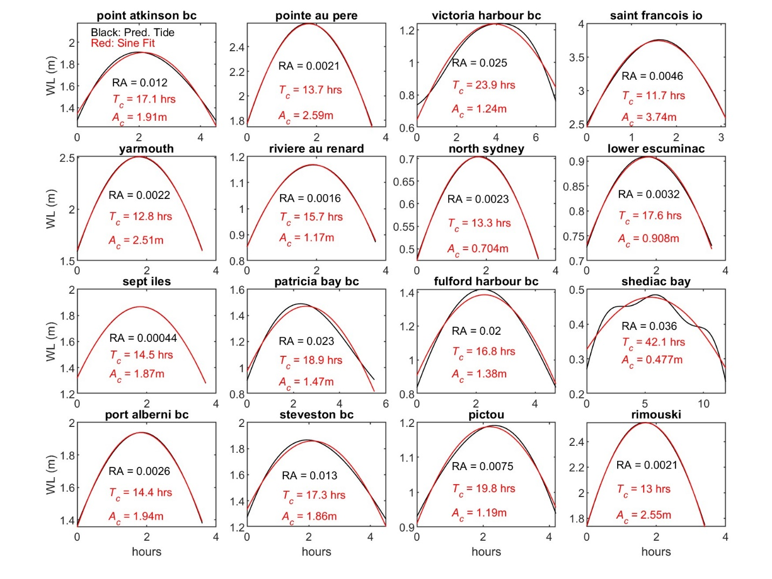 Figure S26: Examples of sinusoidal waves (red curve) fit to the largest predicted high-water stand (black curve) at 16 tide gauge locations. See the GESLA-3 data set for additional location information and meta-data (Haigh et al., 2023).
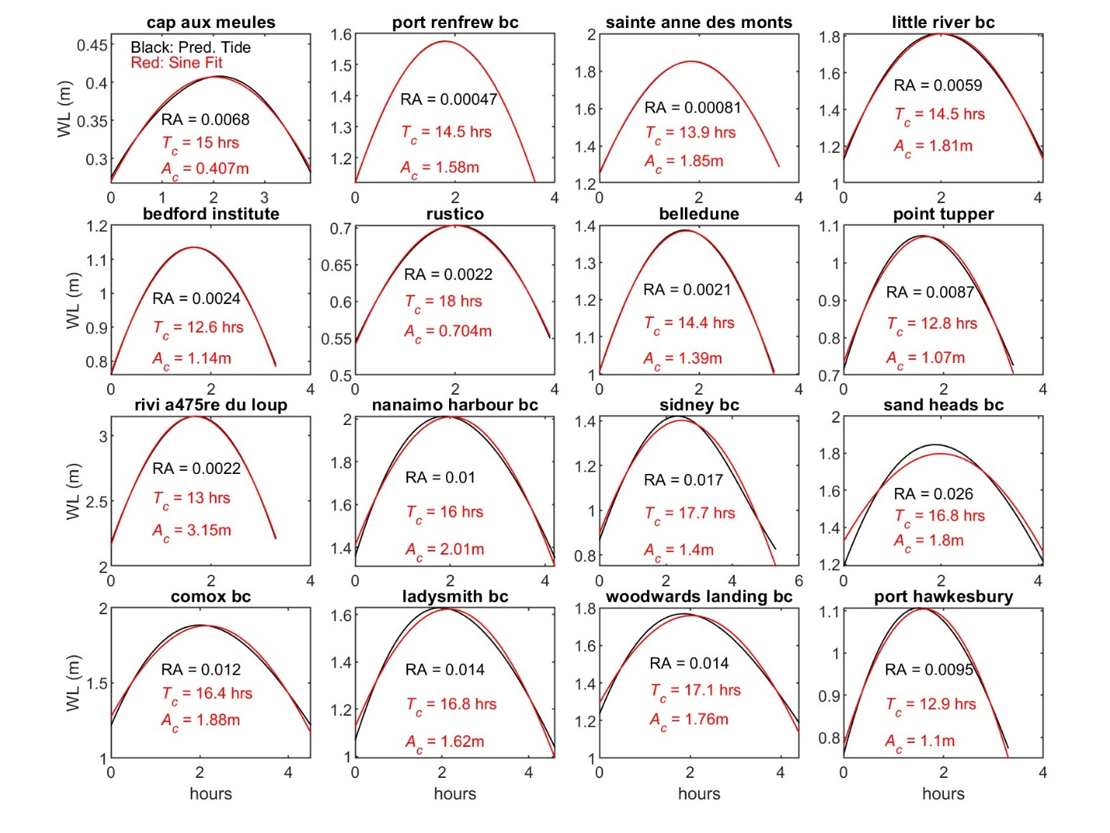 Figure S27: Examples of sinusoidal waves (red curve) fit to the largest predicted high-water stand (black curve) at 16 tide gauge locations. See the GESLA-3 data set for additional location information and meta-data (Haigh et al., 2023).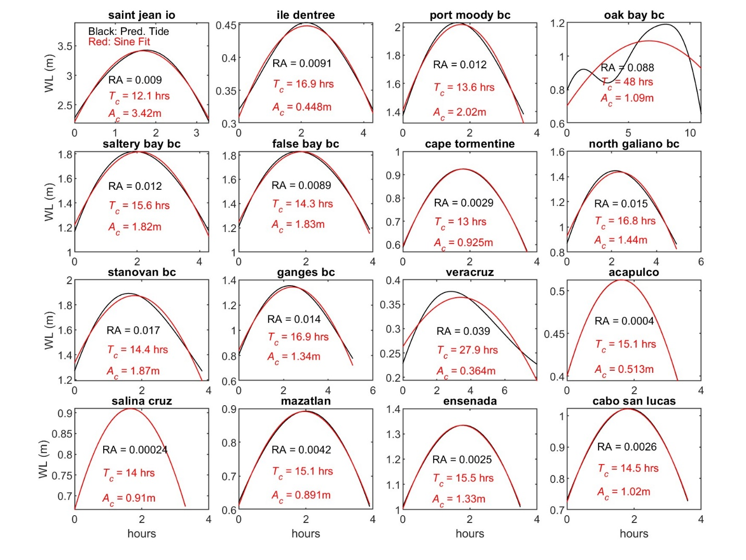 Figure S28: Examples of sinusoidal waves (red curve) fit to the largest predicted high-water stand (black curve) at 16 tide gauge locations. See the GESLA-3 data set for additional location information and meta-data (Haigh et al., 2023).
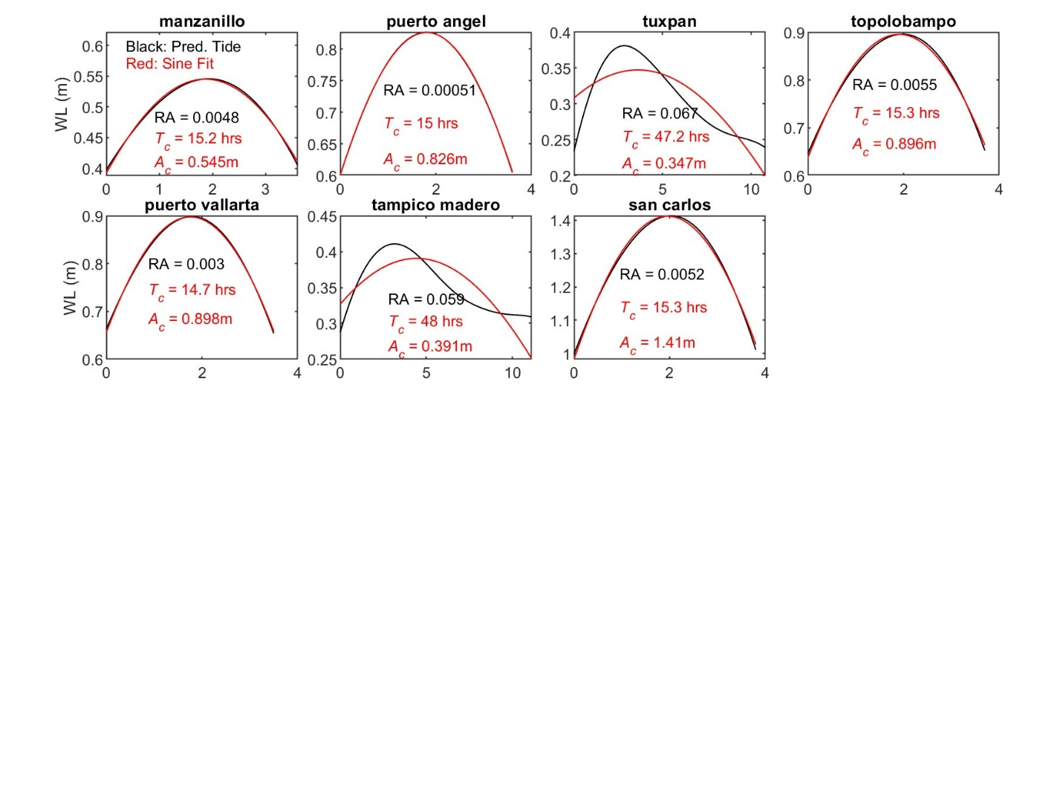
Figure S29: Examples of sinusoidal waves (red curve) fit to the largest predicted high-water stand (black curve) at 7 tide gauge stations. See the GESLA-3 data set for additional location information and meta-data (Haigh et al., 2023).

