Dose escalation biodistribution, positron emission tomography/computed tomography imaging and dosimetry of a highly specific radionuclide-labeled non-blocking nanobody

Authors
Yanling Yang, Chao Wang, Yan Sun, Tao Xu, Xing Huang , HuiXu, Huaying Fan, Daquan Chen*, Feng Zhao*

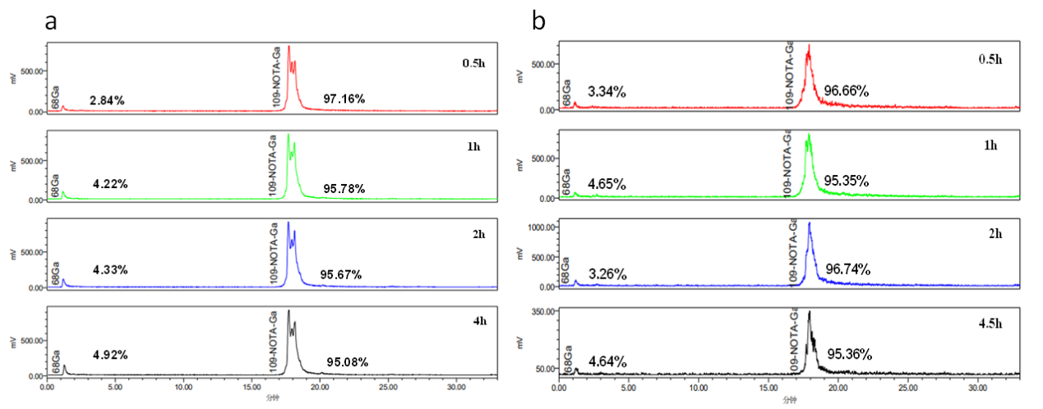
Supplemental Figure 1 In vitro stability determined by radio HPLC of ⁶⁸Ga-NOTA-Nb109. (a) In human serum (in vitro); (b) In 0.9% NaCl solution.

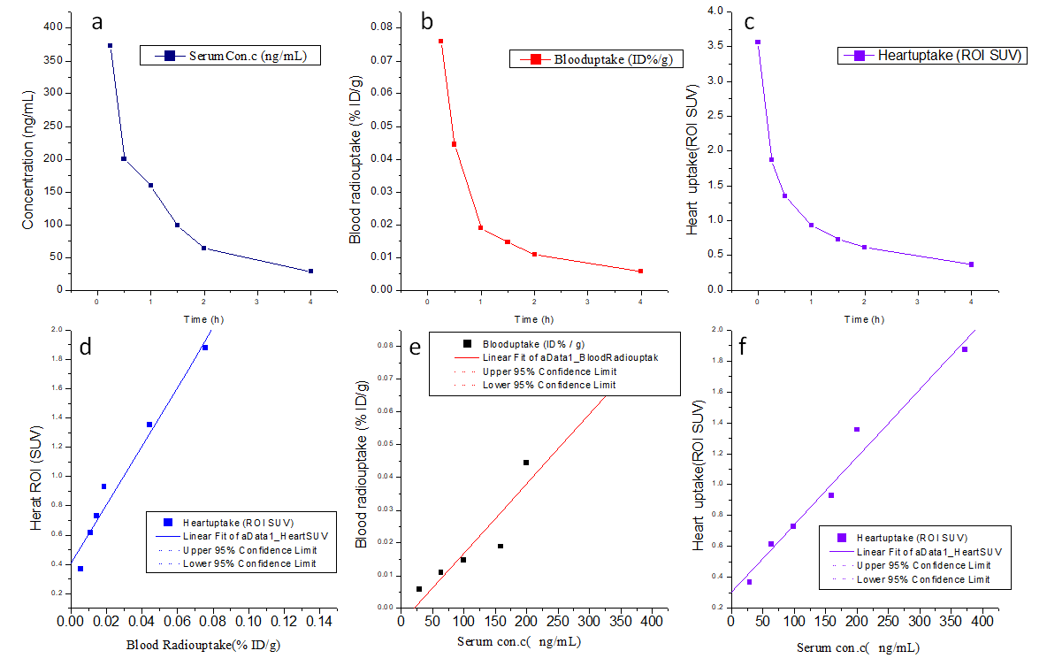
Supplemental Figure 2 Pharmacokinetic analysis in cynomolgus monkey. (a-c) Curves show the serum concentration, blood and heart uptake over time analyzed by ELISA, gamma counter, and PET/CT imaging, respectively. (d-f) Pearson correlation analysis showed linear correlations among the above three indexes.
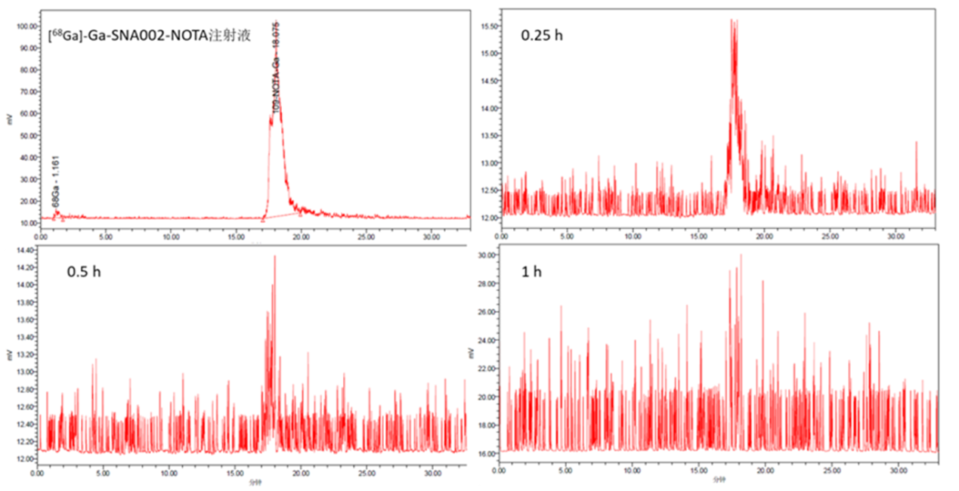
Supplemental Figure 3 Serum radio-HPLC and radio-TLC analysis of cynomolgus monkeys after a single intravenous injection of ⁶⁸Ga-NOTA-Nb109.

Supplemental Table 1 Pharmacokinetics parameters for cynomolgus monkeys
Parameters | t1/2 (h) | C₀ | AUC_{0–last} | AUC_{0–inf} | MRT_{last}
Protein concentration (ng/mL) | 1.24 | 693.16 | 493.23 | 544.96 | 1.00
Blood (ID%/g) | 1.81 | 0.13 | 0.09 | 0.10 | 0.95
Heart (SUV) | 2.57 | 3.56 | 3.39 | 4.75 | 1.30
Note: apparent terminal elimination half-life (t1/2); Initial concentration (C₀), the area under the concentration–time curve (AUC) from time 0 to the time when the final concentration was measured (AUC_{0–last}), and AUC was extrapolated to infinity (AUC_{0–inf}), mean residence time from time 0 to the time at which the lowest serum drug concentration can be detected (MRT_{last})

