Supplementary figure 1. Tetrachoric correlation plot of SEP indicators as binary variables
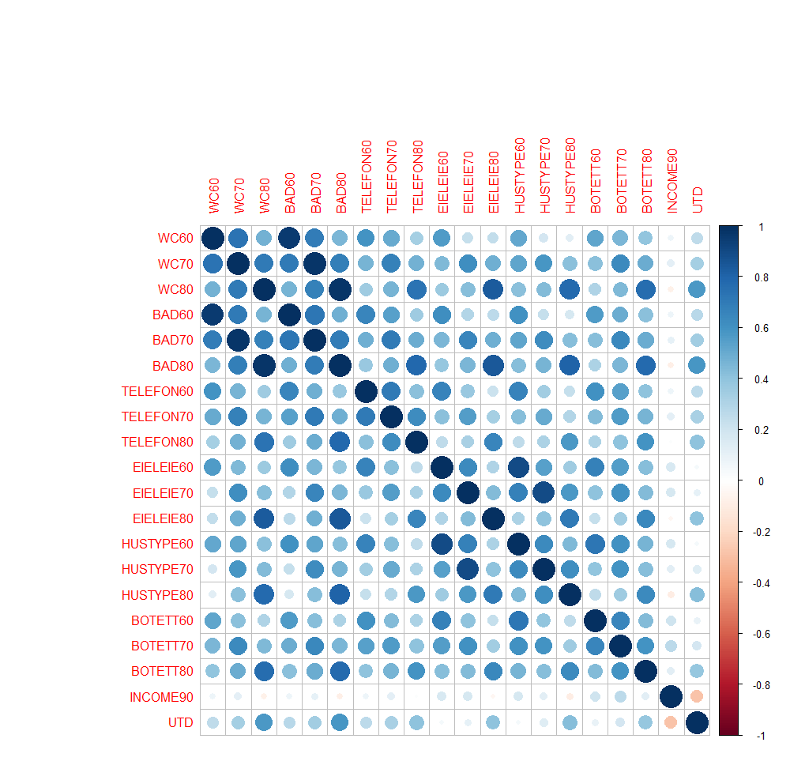

Supplementary figure 2. Figures for Item Response Theory modeling of SEP. Boundary Characteristic curves for indicators of SEP continuum.
Questionnaire 1-3
Did you have bathroom or WC in 1960s?  Yes (WCBAD60 =1) | Did you have bathroom or WC in 1970s?  Yes (WCBAD70 =1) |  |  | Did you have bathroom or WC in 1980s?  Yes (WCBAD80=1)

Questionnaire 4-6
Did you have a telephone in 1960s?  Yes (TELEFON60 =1) | Did you have a telephone in 1970s?  Yes (TELEFON70 =1) |  |  | Did you have a telephone in 1980s?  Yes (TELEFON80 =1)

Questionnaire 7-9
Did you own a property in 1960s?  Yes (EIELEIE 60 =1) | Did you own a property in 1970s?  Yes (EIELEIE 70 =1) |  |  | Did you own a property in 1980s?  Yes (EIELEIE 80 =1)

Questionnaire 10-12
Was the ratio room per person ≥1 in 1960s?  Yes (BOTETT60=1) | Was the ratio room per person ≥1 in 1970s?  Yes (BOTETT70=1) |  |  | Was the ratio room per person ≥1 in 1980s?  Yes (BOTETT80=1)

Questionnaire 13-15
Did you own a house in 1960s?  Yes (HUSTYPE60 =1) | Did you own a house in 1970s?  Yes (HUSTYPE70 =1) |  |  | Did you own a house in 1980s?  Yes (HUSTYPE80 =1)

Questionnaire 16-17
Was the income in the lowest group (lowest tertile)?  Yes (INCOME90=1) | Did you have an education level higher than high school?  Yes (UTD=1)

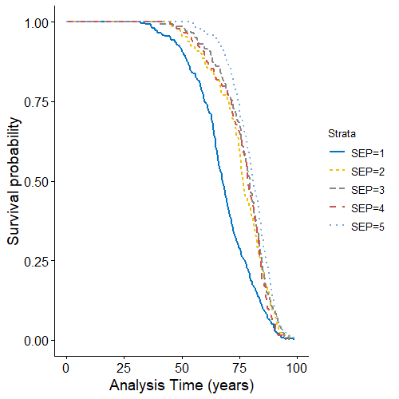  A | 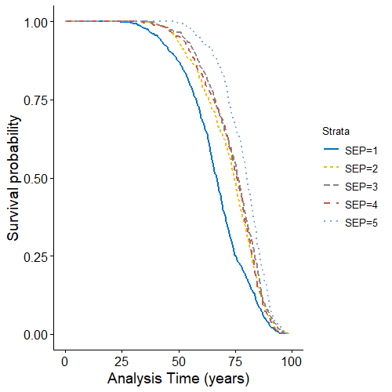  B

Supplementary figure 3. Kaplan-Meier failure estimates for CVD events (A) and for all-cause mortality (B) according to five categories of life-course SEP in monozygotic twins
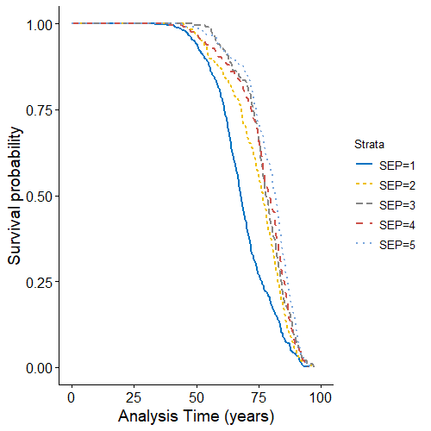  A | 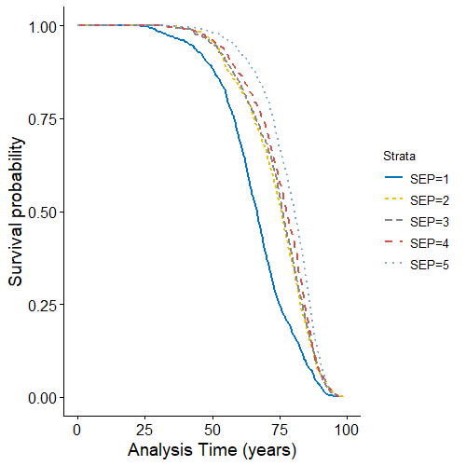  B

Supplementary figure 4. Kaplan-Meier failure estimates for CVD events (A) and for all-cause mortality (B) according to five categories of life-course SEP in dizygotic twins

Supplementary table 1. Item response theory model parameters.
Description | Label | Discriminability | 95% CI | Difficulty | 95% CI
Did you have bathroom or WC in 1960s? | WCBAD60 | 1.28 | (1.21 - 1.35) | −0.02 | (−0.05 - 0.01)
Did you have bathroom or WC in 1970s? | WCBAD70 | 1.75 | (1.66 - 1.85) | −0.92 | (−0.97 - −0.88)
Did you have bathroom or WC in 1980s? | WCBAD80 | 1.89 | (1.78 - 1.99) | −1.46 | (−1.52 - −1.40)
Did you have telephone in 1960s? | TELEFON60 | 1.39 | (1.31 - 1.47) | 0.40 | (0.37 - 0.44)
Did you have telephone in 1970s? | TELEFON70 | 1.99 | (1.87 - 2.11) | 0.05 | (0.02 - 0.07)
Did you have telephone in 1980s? | TELEFON80 | 1.35 | (1.27 - 1.43) | −0.50 | (−0.54 - −0.46)
Did you own a property in 1960s (ownership status)? | EIELEIE60 | 0.25 | (0.20 - 0.30) | −2.77 | (−3.34 - −2.20)
Did you own a flat in 1970s? | EIELEIE70 | 0.39 | (0.34 - 0.45) | −1.16 | (−1.34 - −0.97)
Did you own a flat in 1980s? | EIELEIE80 | 0.54 | (0.20 - 0.30) | −2.47 | (−2.74 - −2.19)
Did you own a house in 1960s (house type)? | HUSTYPE60 | −0.14 | (−0.21 - −0.08) | 11.25 | (6.27 - 16.23)
Did you own a house in 1970s? | HUSTYPE70 | 0.32 | (0.27 - 0.37) | −1.90 | (−2.22 - −1.57)
Did you own a house in 1980s? | HUSTYPE80 | 0.34 | (0.28 - 0.41) | −4.11 | (−4.87 - −3.36)
Was the ratio room per person ≥1 in 1960s? | BOTETT60 | 0.77 | (0.71 - 0.83) | 1.26 | (1.17 - 1.36)
Was the ratio room per person ≥1 in 1970s? | BOTETT70 | 0.79 | (0.73 - 0.84) | −0.17 | (−0.21 - −0.12)
Was the ratio room per person ≥1 in 1980s? | BOTETT80 | 0.68 | (0.61 - 0.75) | −2.15 | (−2.35 - −1.95)
Was the income in the lowest group (lowest tertile)? | INCOME90 | −0.23 | (−0.28 - −0.18) | −3.59 | (−4.35 - −2.83)
Did you have education level higher than high school? | UTD | 0.89 | (0.83 - 0.95) | −0.66 | (−0.72 - −0.61)

