Supplementary Appendix

Figure S1. Flow diagram of participants.

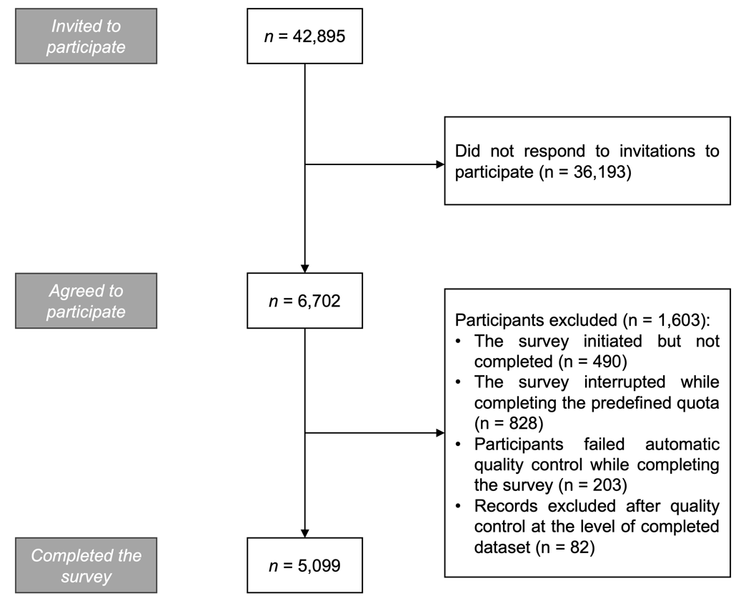

Figure S2. Communities of nodes identified in the network. Note: A, age; ANX, anxiety symptoms; ATB, attributional biases; DEP, depressive symptoms; EDU, education level; EMP, employment status; G, gender; INC, monthly income; LON, loneliness; PER, ideas of persecution; REF, ideas of reference; RS, rejection sensitivity; SA, social anhedonia; SB, safety behaviors; SI, social isolation; SIA, social isolation anxiety; SoC; social cognition problems; SU, substance use (other than alcohol and nicotine, preceding month); SubC, subjective cognitive problems; T, lifetime history of psychiatric treatment; URB, place of residence.

Figure S2. Stability of the bridge expected influence centrality index while dropping various proportions of data. Average correlation with data from the original sample is plotted against the percentage of sampled cases.

Figure S3. Results of non-parametric bootstrapping that show confidence intervals of estimated edge-weights. Horizontal lines refer to specific edges. The red line shows the sample values, the grey bar indicates the 95% bootstrapped CIs, and the black line refers to the bootstrap mean.

Table S1. The matrix of edge weights. Note: A, age; ANX, anxiety symptoms; ATB, attributional biases; DEP, depressive symptoms; EDU, education level; EMP, employment status; G, gender; INC, monthly income; LON, loneliness; PER, ideas of persecution; REF, ideas of reference; RS, rejection sensitivity; SA, social anhedonia; SB, safety behaviors; SI, social isolation; SIA, social isolation anxiety; SoC; social cognition problems; SU, substance use (other than alcohol and nicotine, preceding month); SubC, subjective cognitive problems; T, lifetime history of psychiatric treatment; URB, place of residence.

