Appendix.1
The appendix is the data of other 24 volunteers in the process of squatting and climbing stairs. These data are processed by MATLAB software in this paper, and finally the values of relative rotation (represented by rotate X, rotate Y, rotate Z) and relative translation (represented by translate Y, translate Z) of the femur and tibiofemoral of the human knee joint are obtained. The data of six degrees of freedom (DOF) of squatting and climbing stairs for each volunteer are listed below.

- Volunteer: 415lfj (date and name abbreviation)
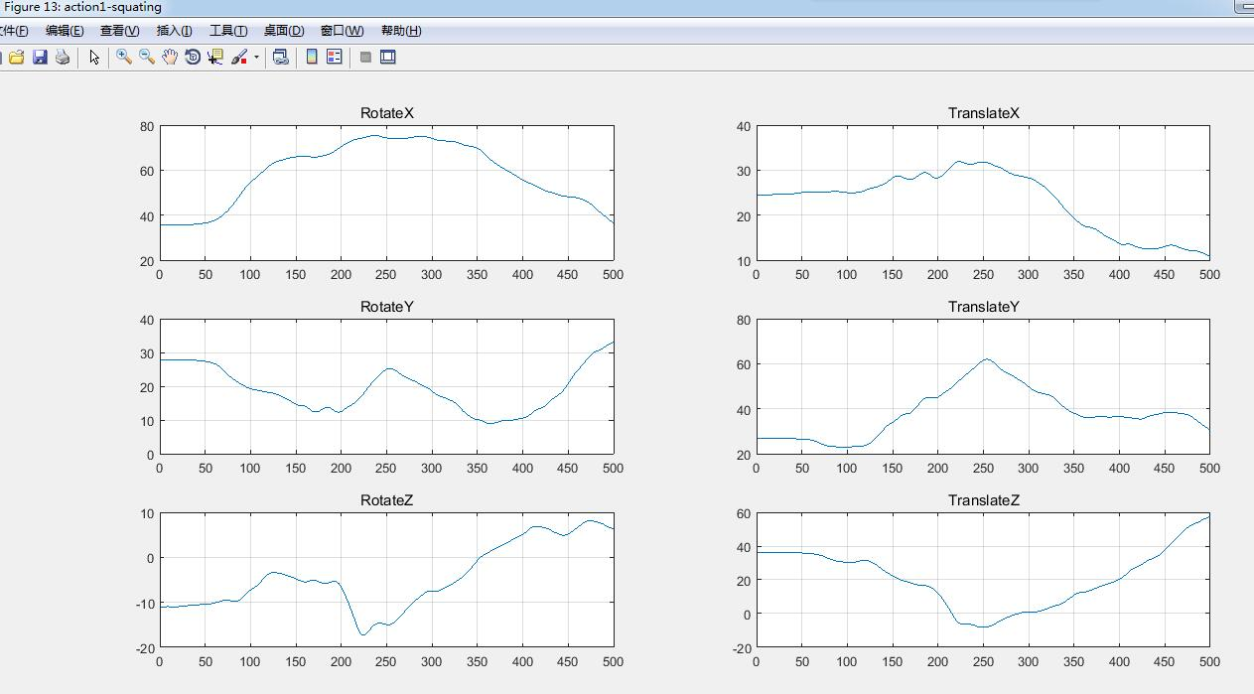
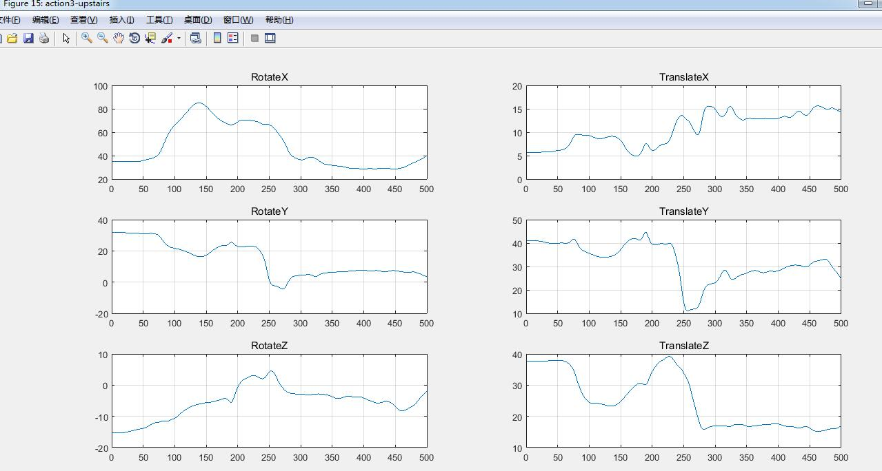
- Volunteer: 416cl (date and name abbreviation)

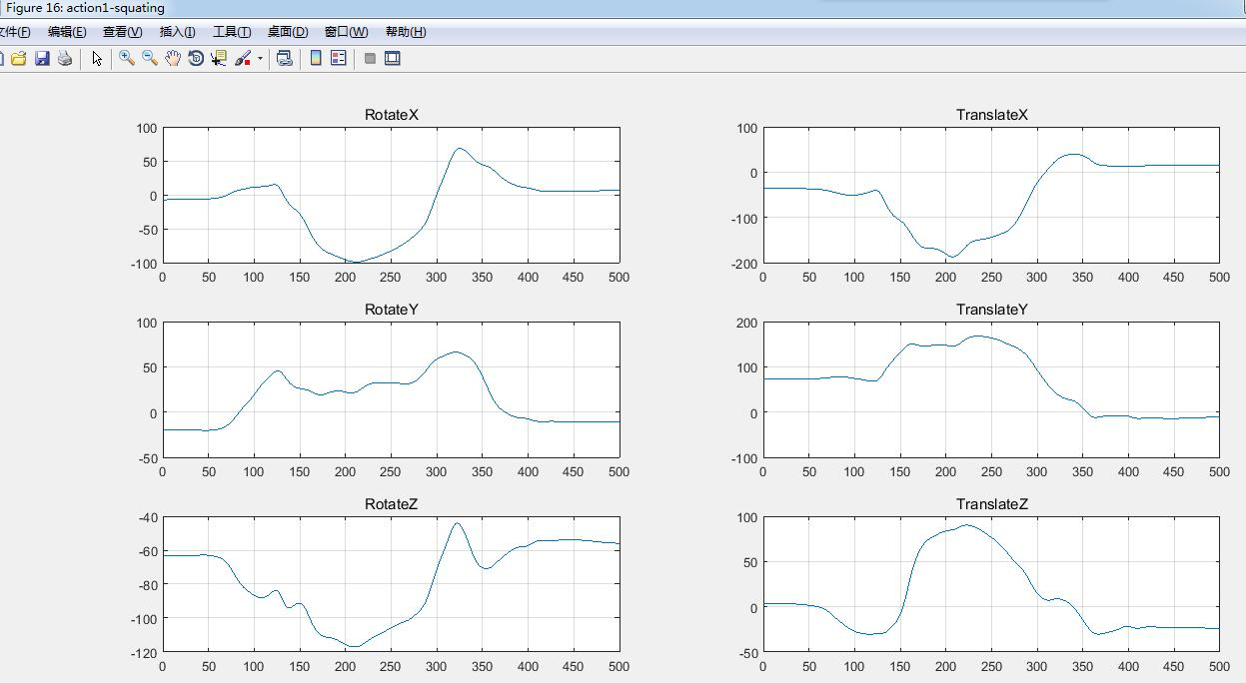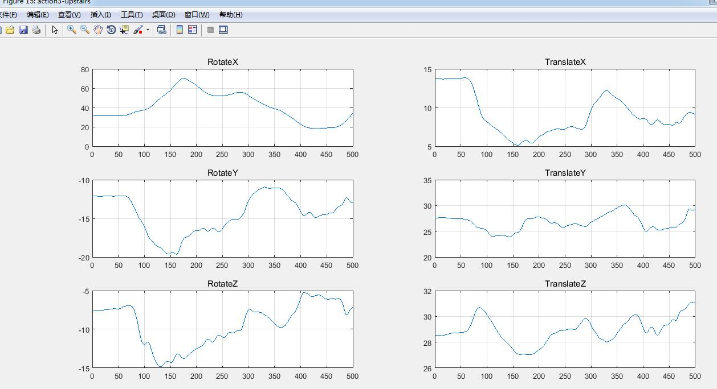
- Volunteer: 416lw (date and name abbreviation)
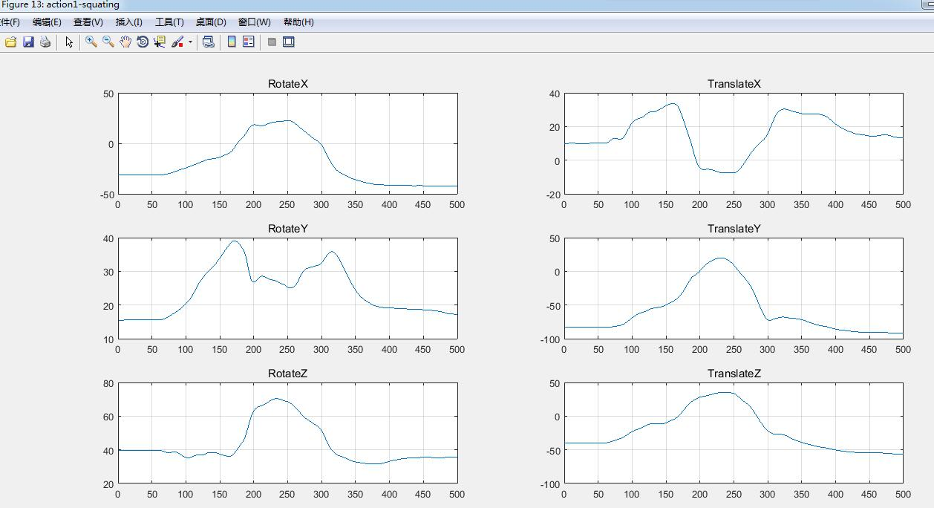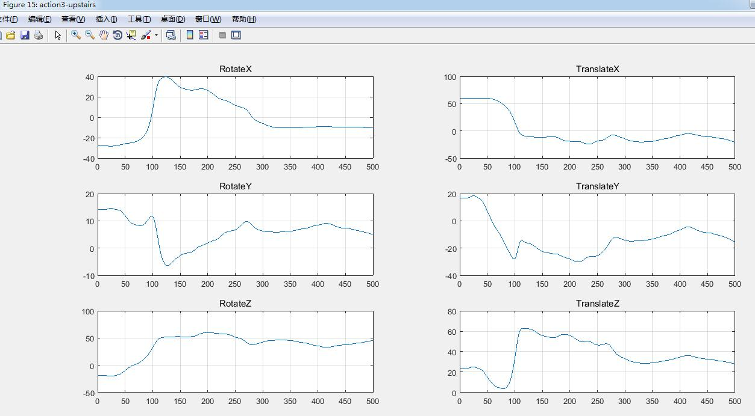
- Volunteer: 416mj(date and name abbreviation)
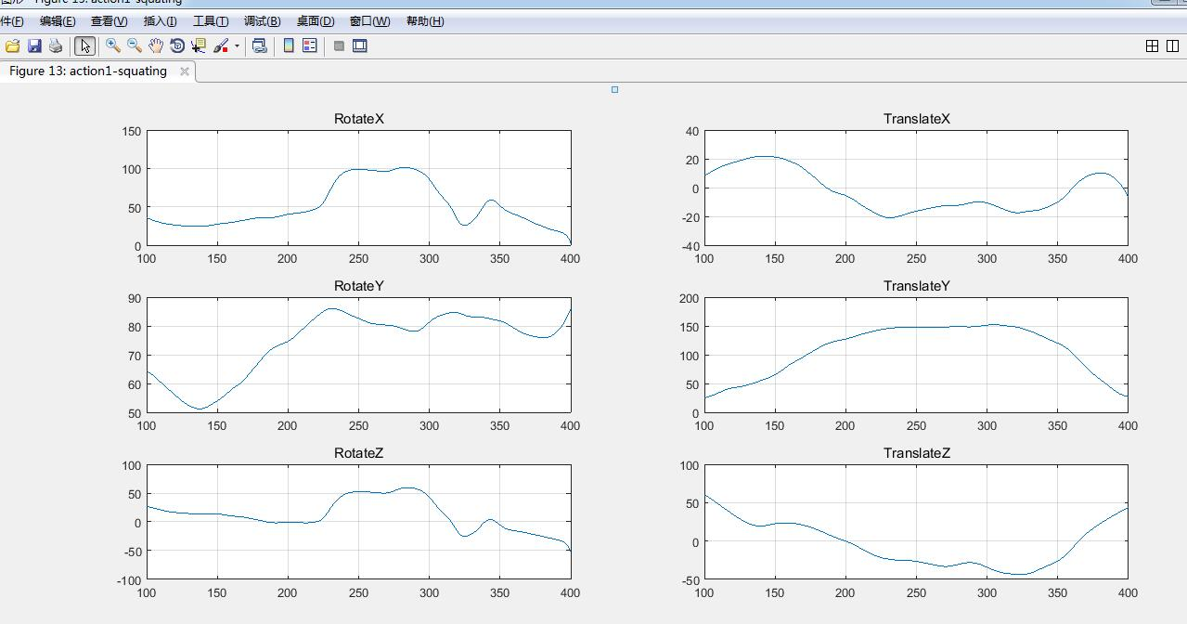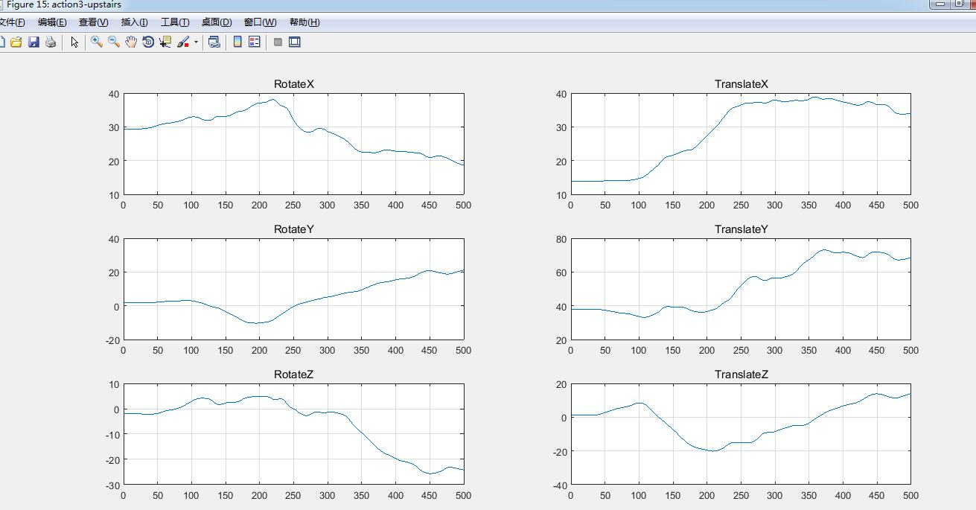
- Volunteer: 416www(date and name abbreviation)
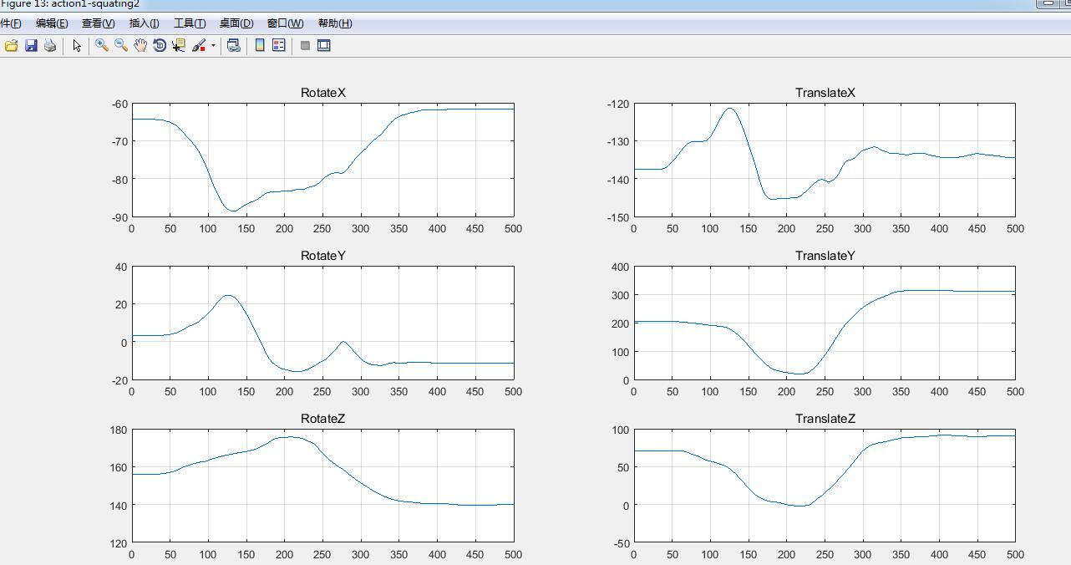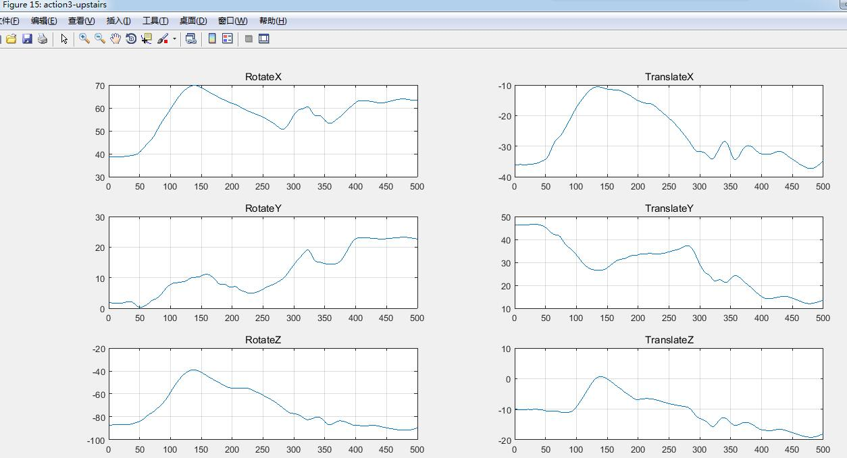
- Volunteer: 417zl(date and name abbreviation)
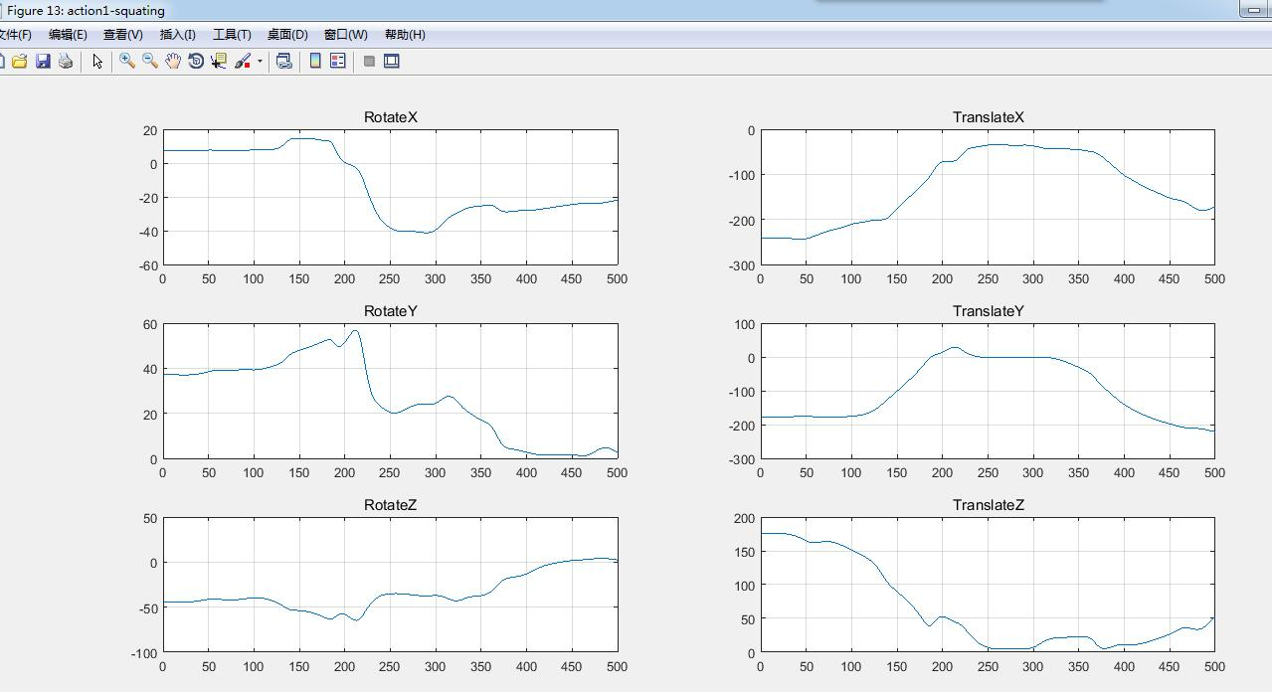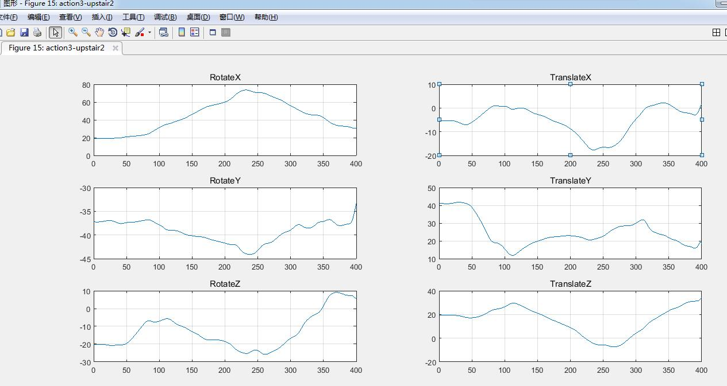
- Volunteer: 420fl(date and name abbreviation)
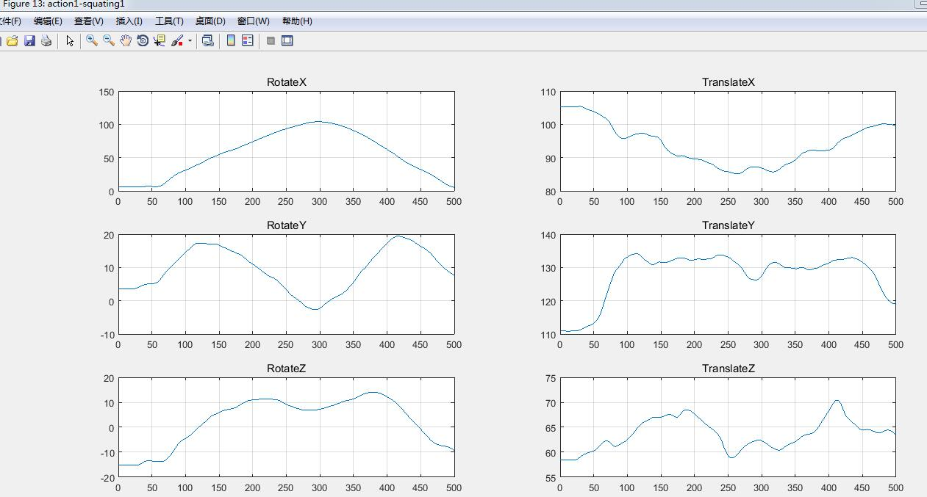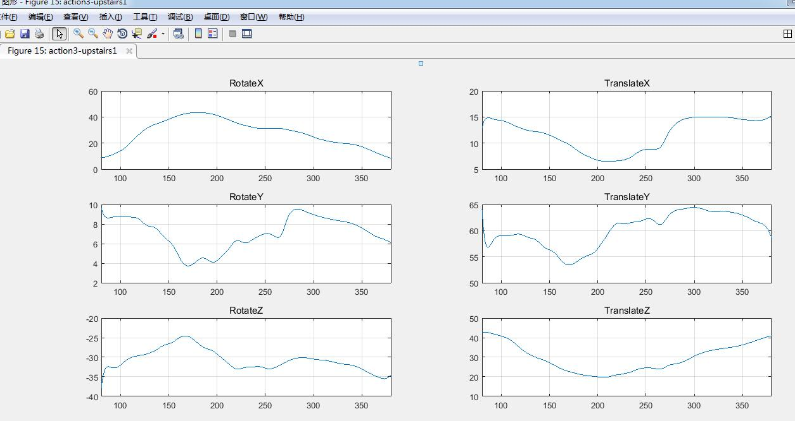
- Volunteer: 420wyf(date and name abbreviation)
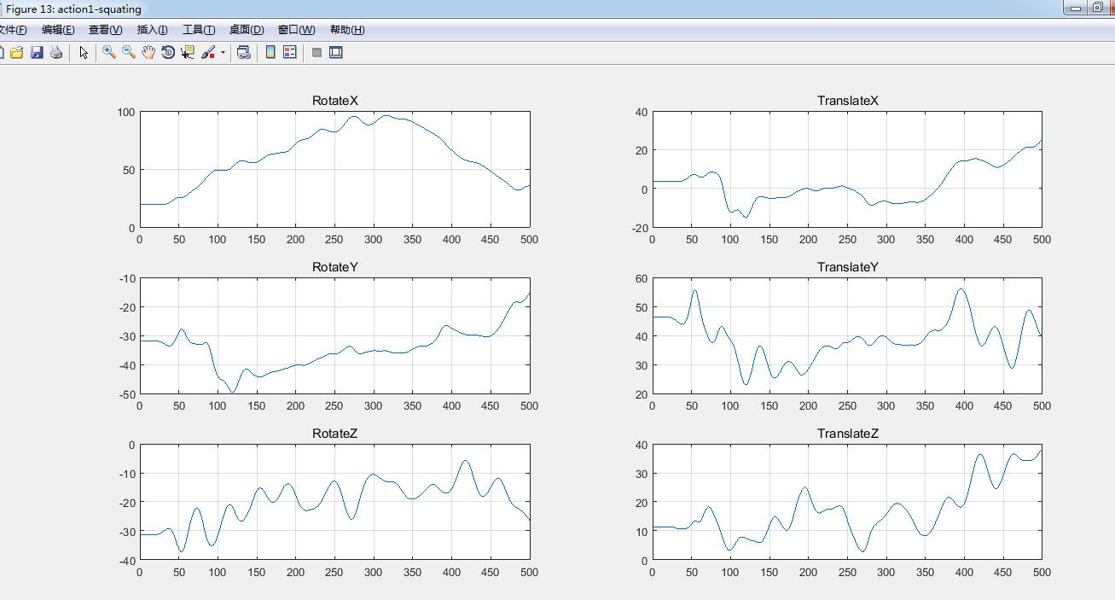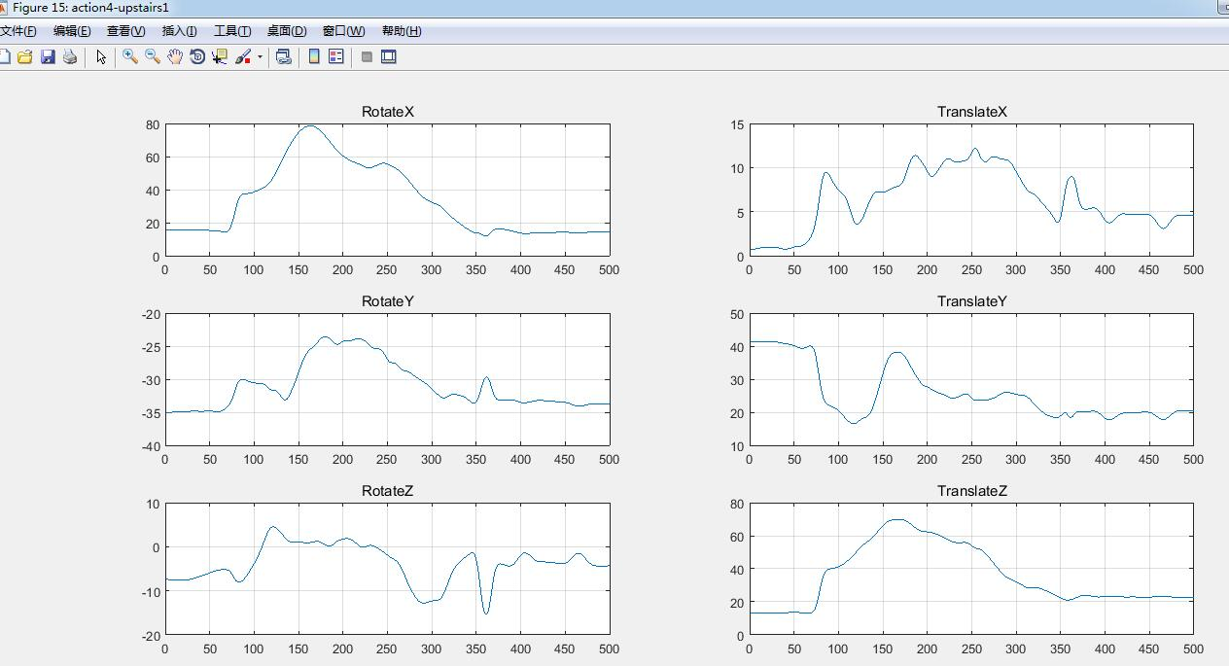
- Volunteer: 420xsl(date and name abbreviation)
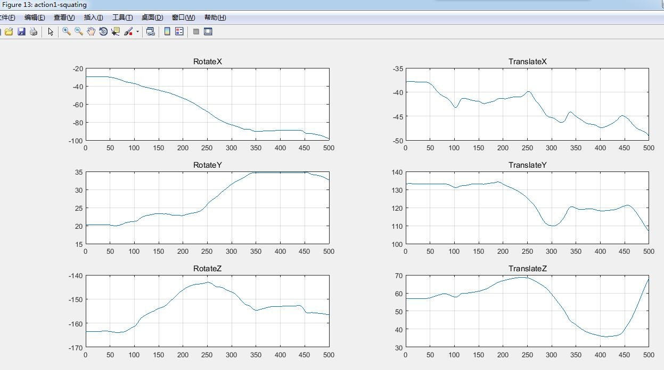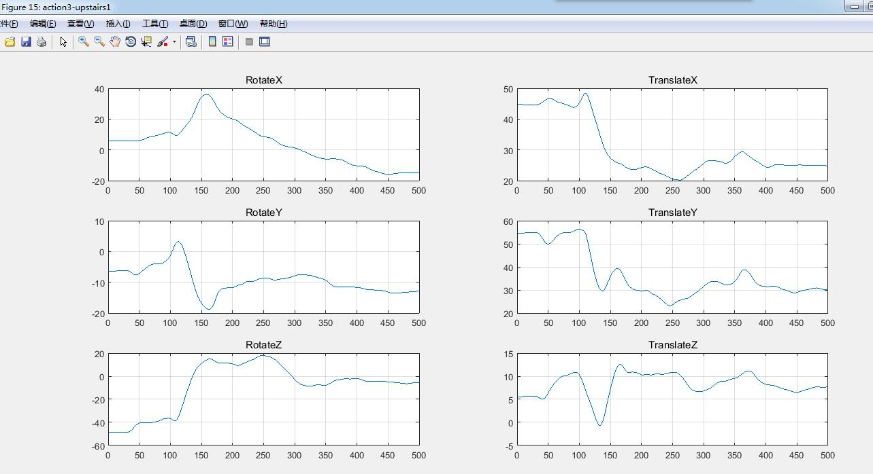
- Volunteer: ych (name abbreviation)
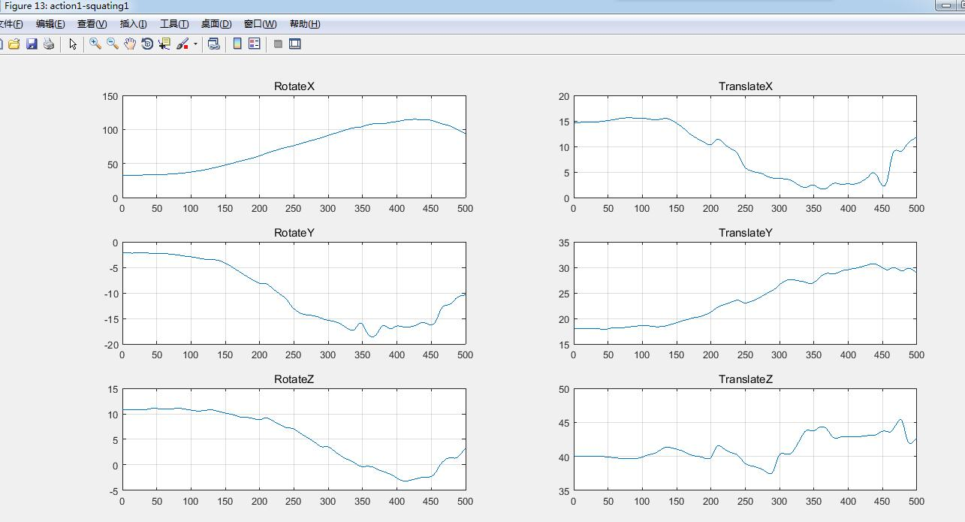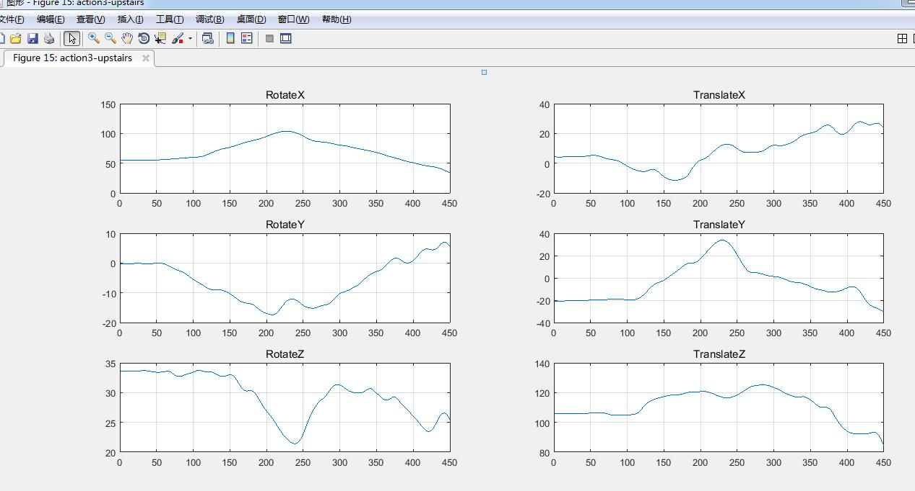
- Volunteer: 414txs(date and name abbreviation)
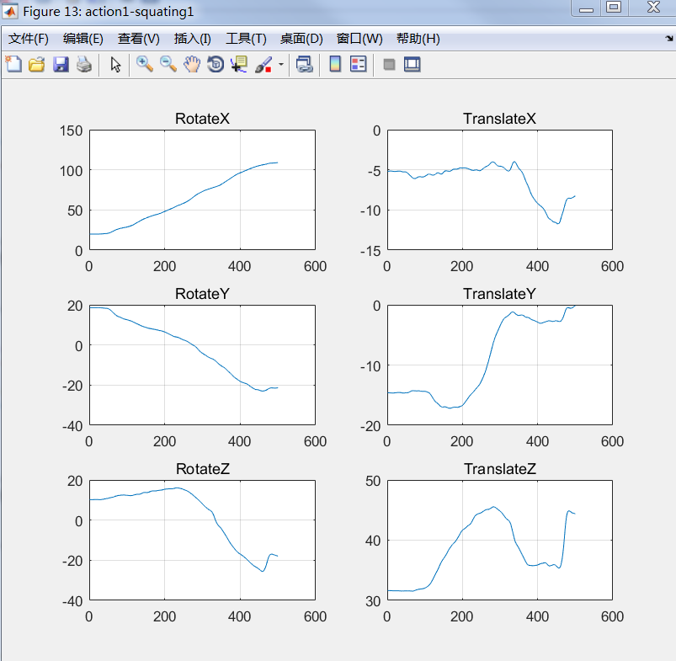
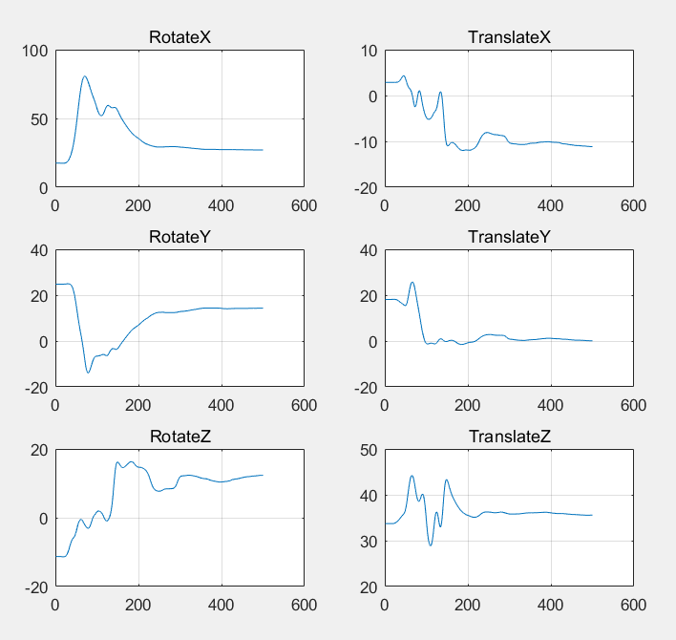
- Volunteer: 414tyr (date and name abbreviation)
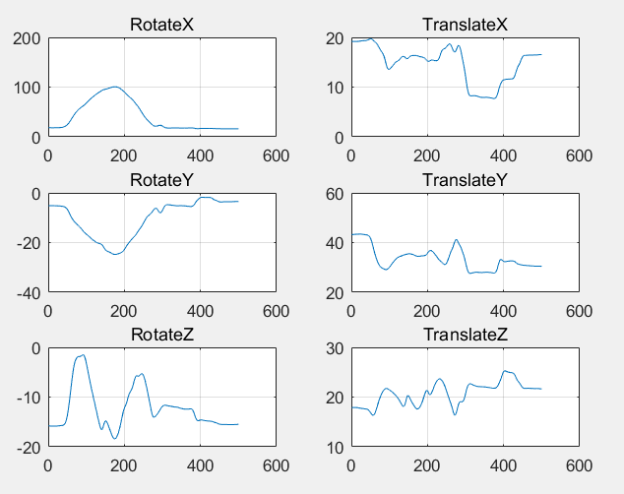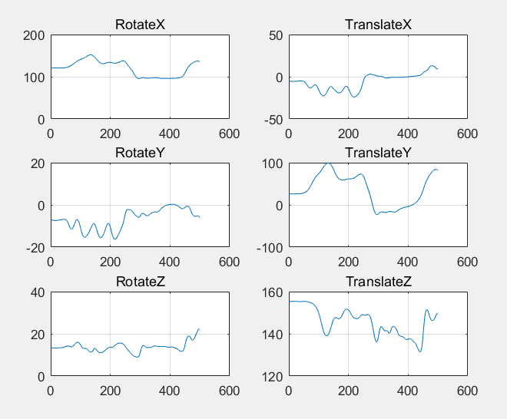
- Volunteer: 414zsf (date and name abbreviation)
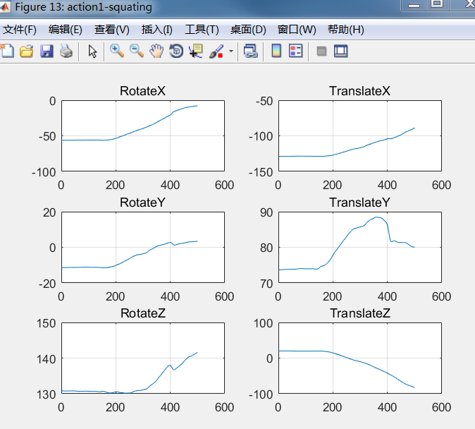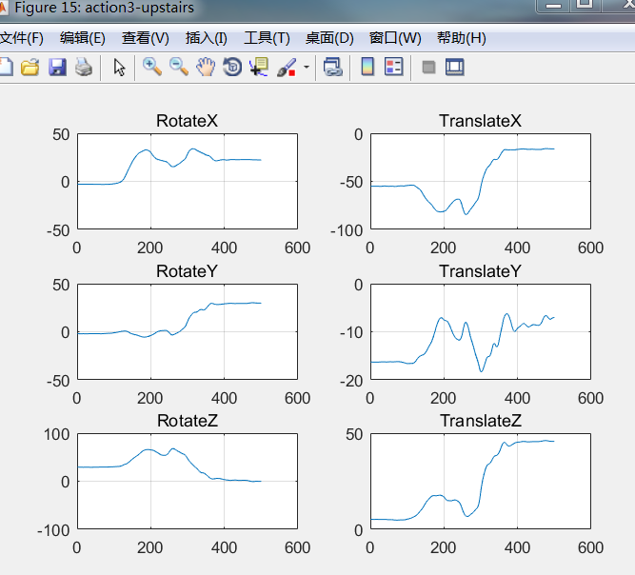
- Volunteer: 419wzh (date and name abbreviation)
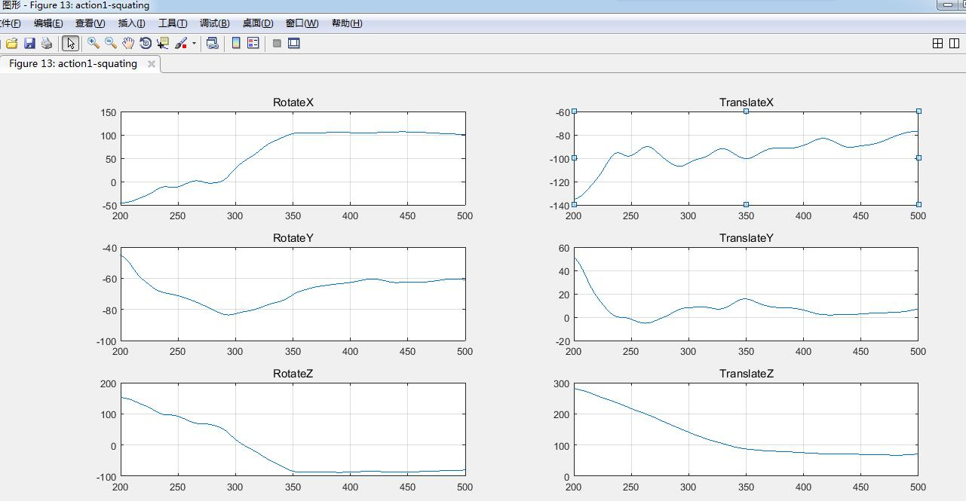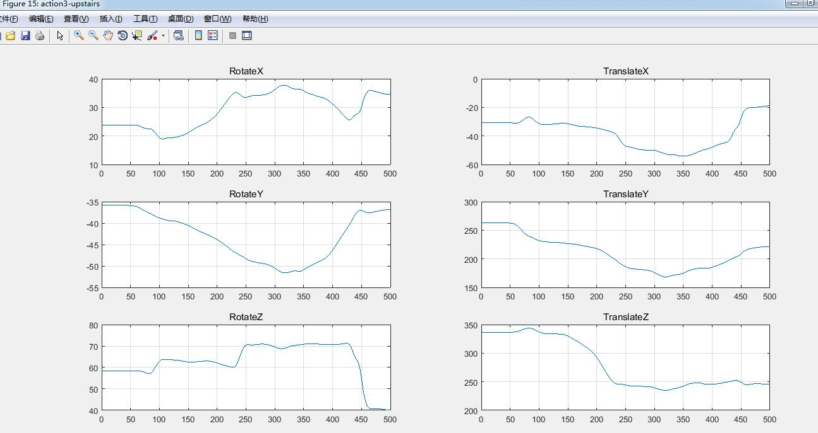
- Volunteer: duxiaobin (name abbreviation)
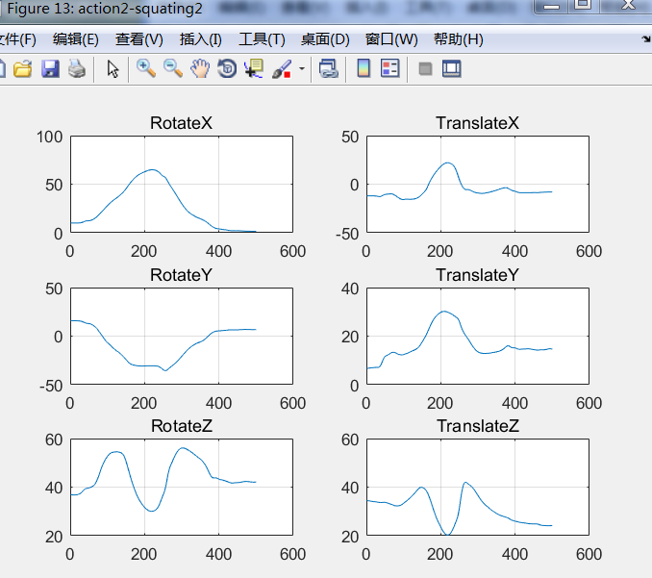
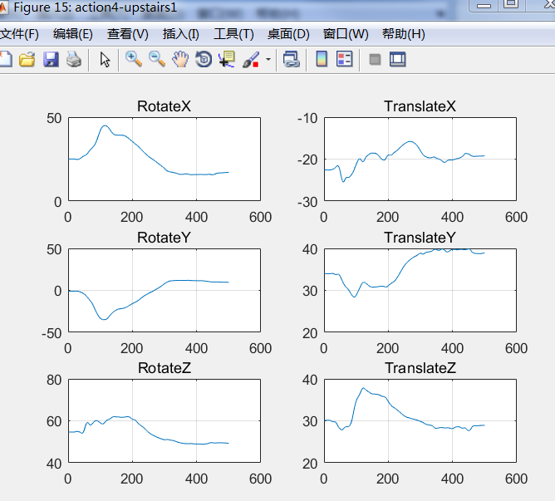
- Volunteer: lijuehong (name abbreviation)
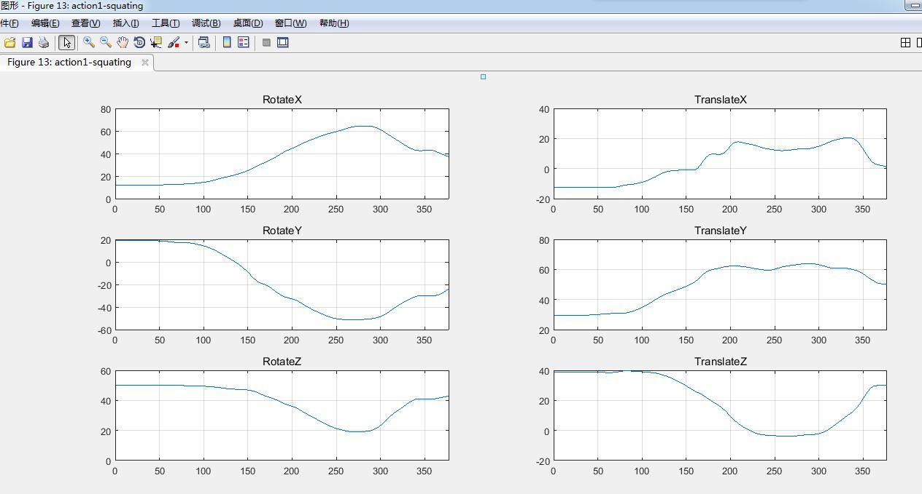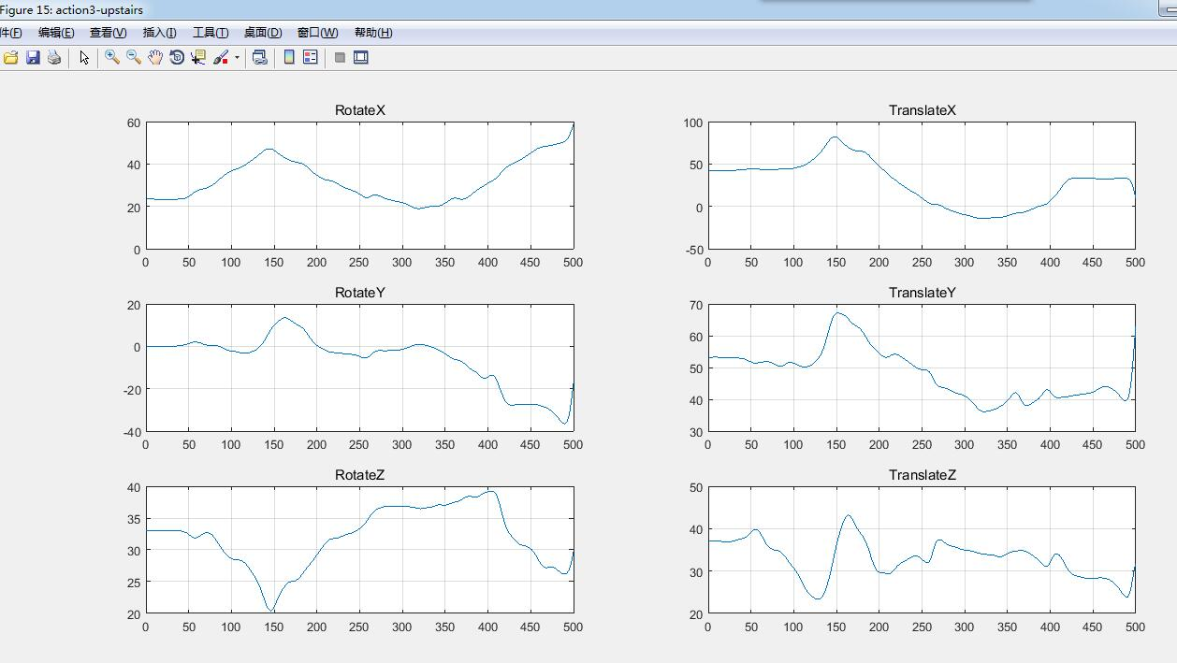
- Volunteer: 415gjz (date and name abbreviation)
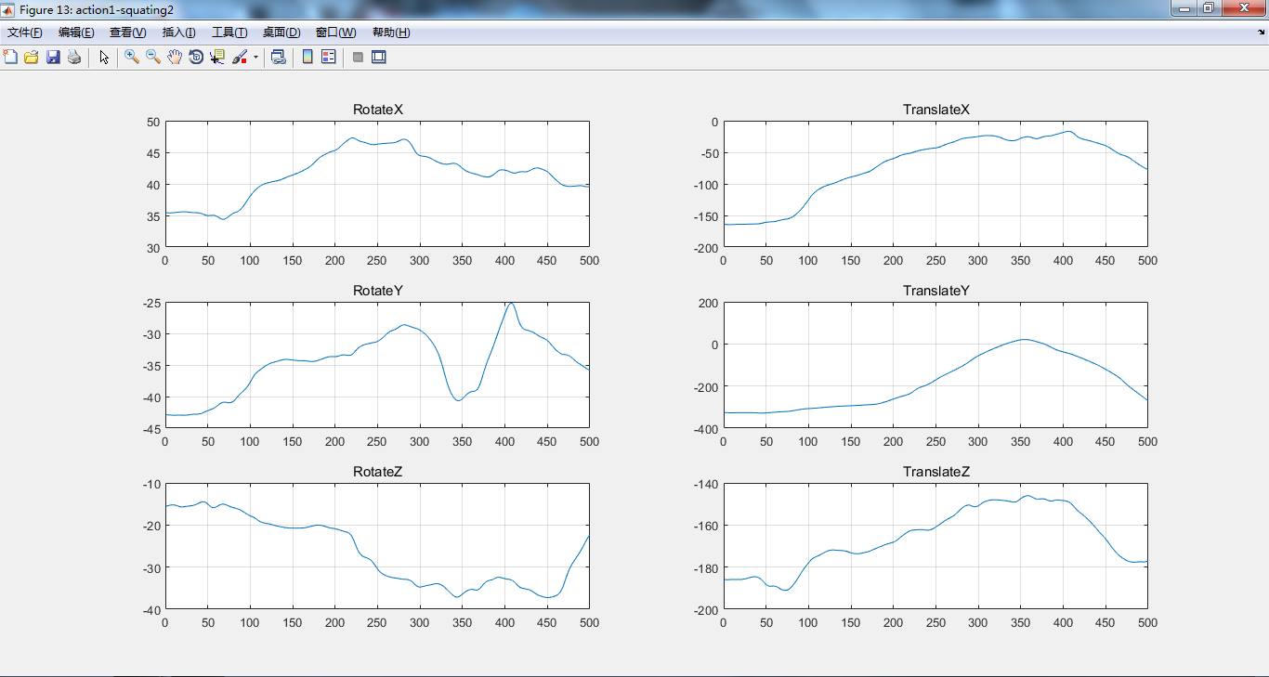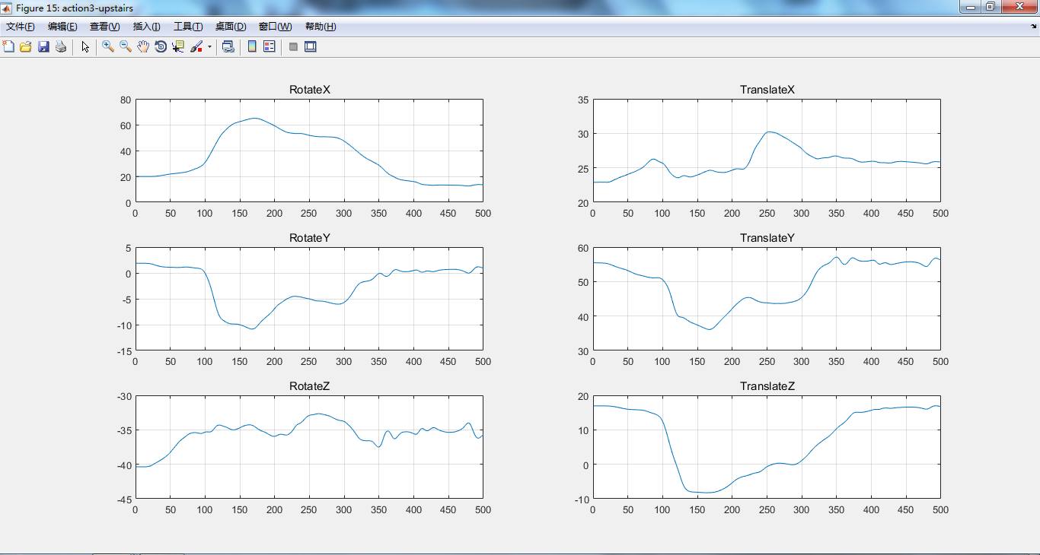
- Volunteer: 415qgb (date and name abbreviation)
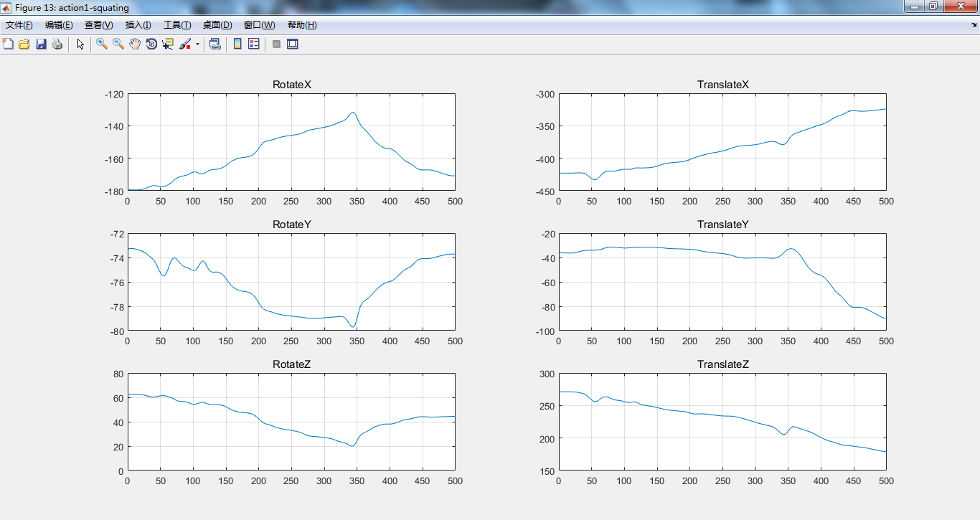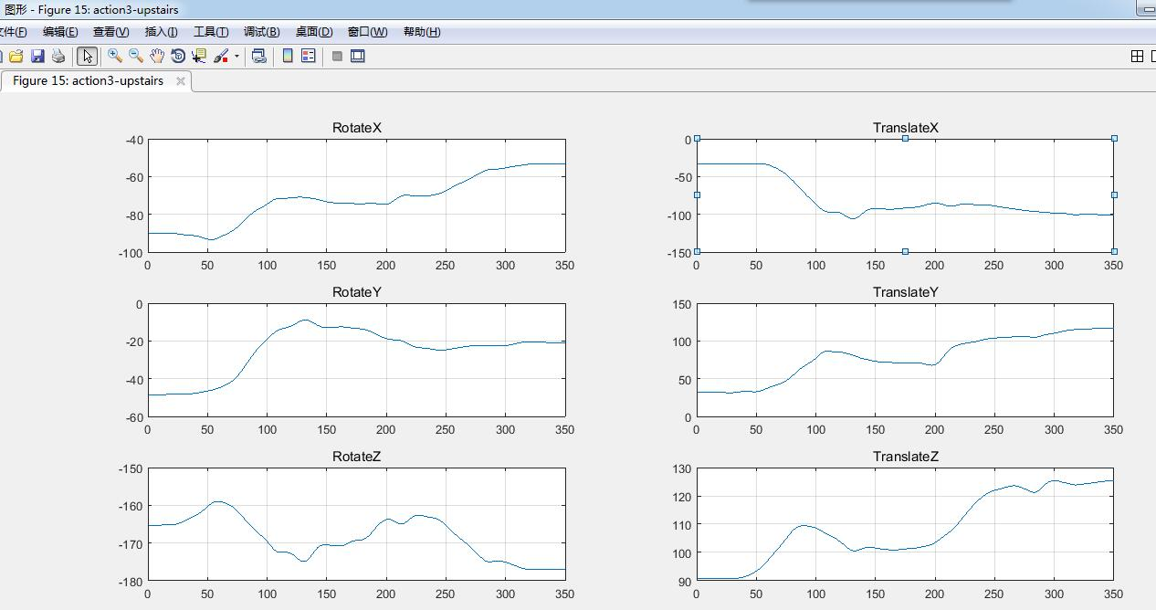
- Volunteer: 415wxy(date and name abbreviation)
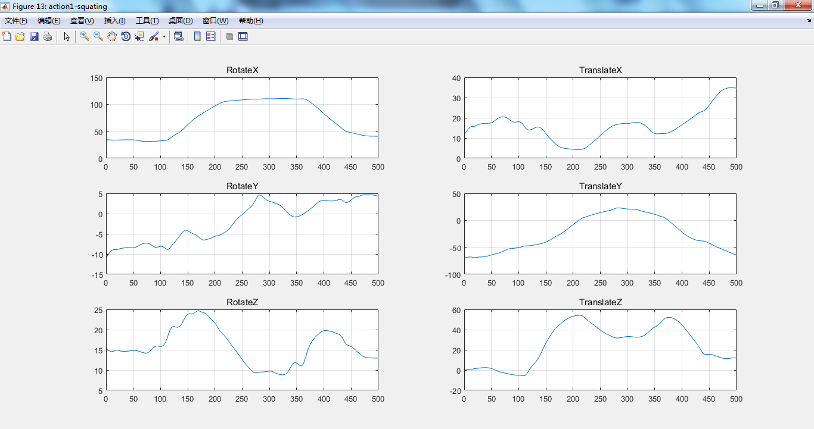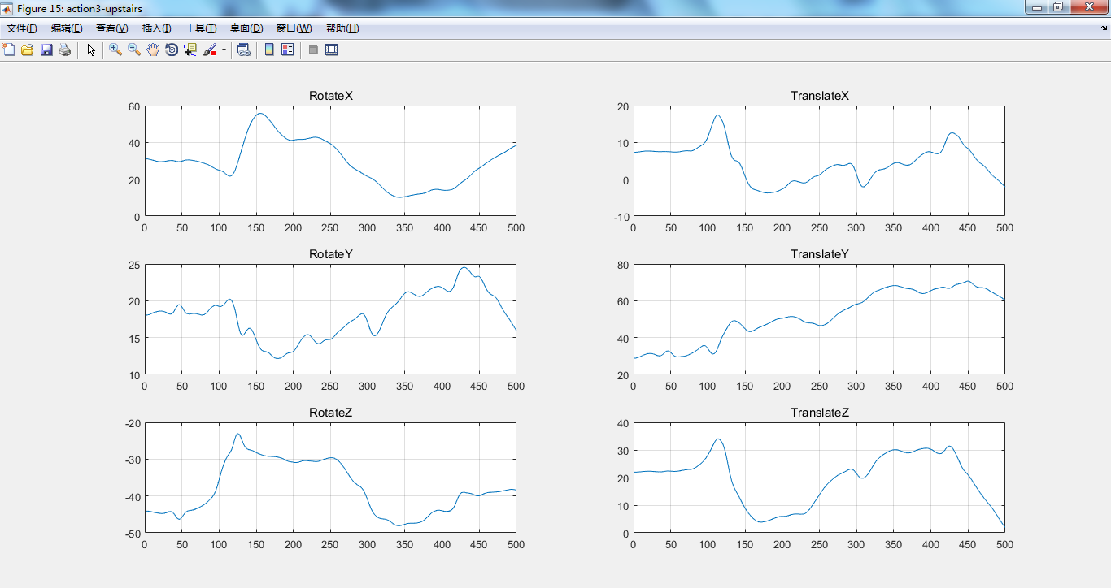
- Volunteer: 415zpp(date and name abbreviation)
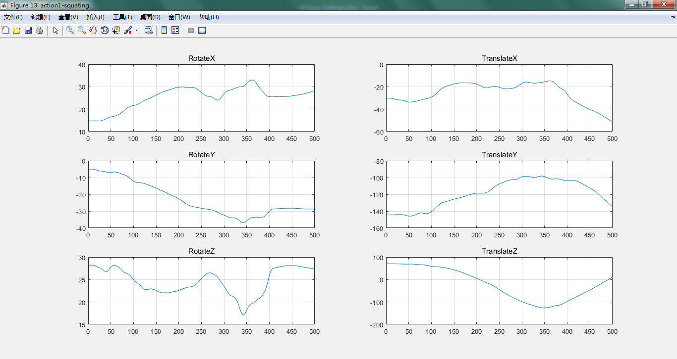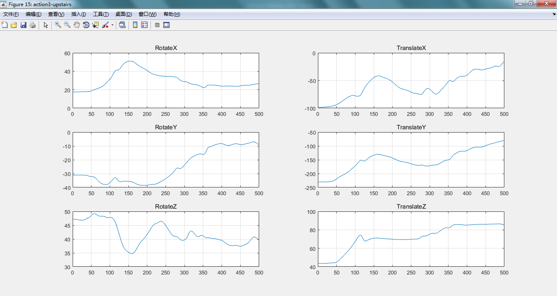
- Volunteer: 415zzq(date and name abbreviation)
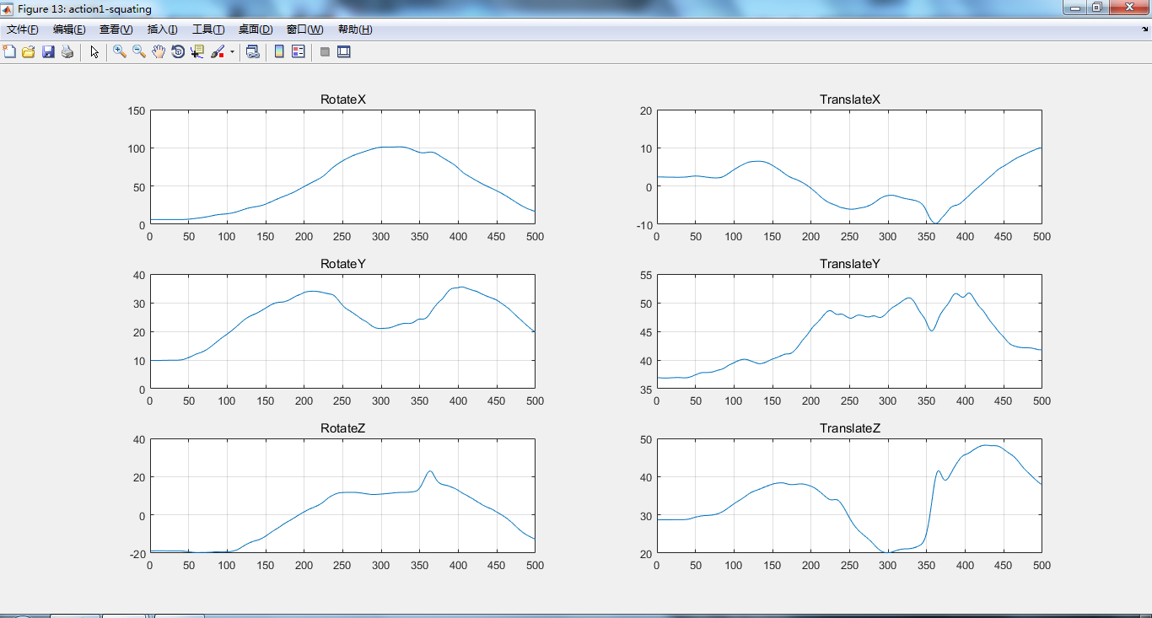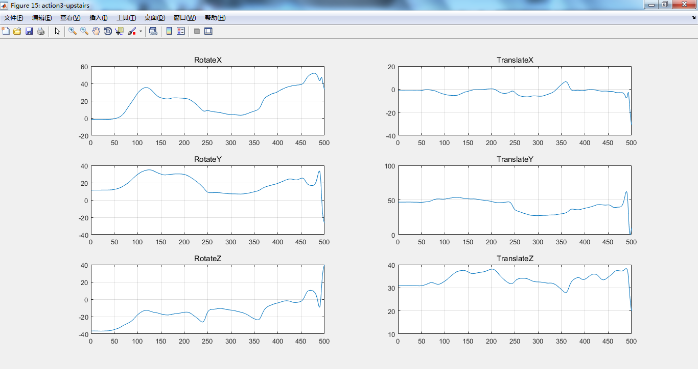
- Volunteer: 417wys(date and name abbreviation)
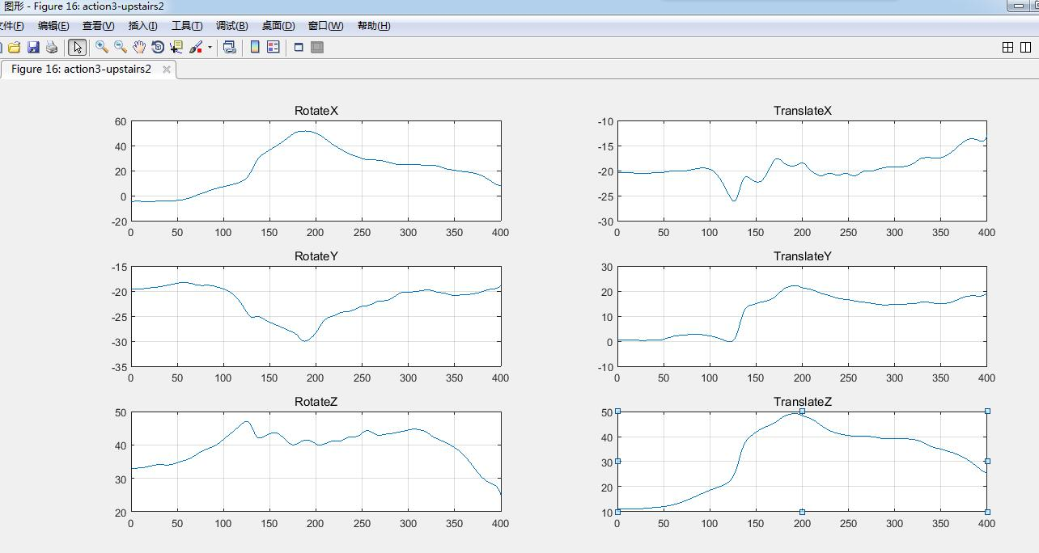
Note：the volunteer was missing data while doing the squats.
- Volunteer: 419zxj(date and name abbreviation)
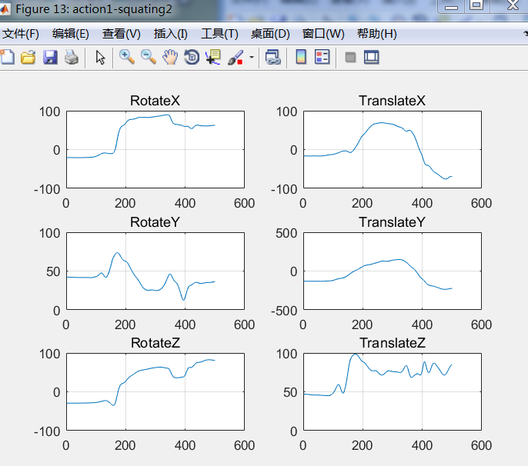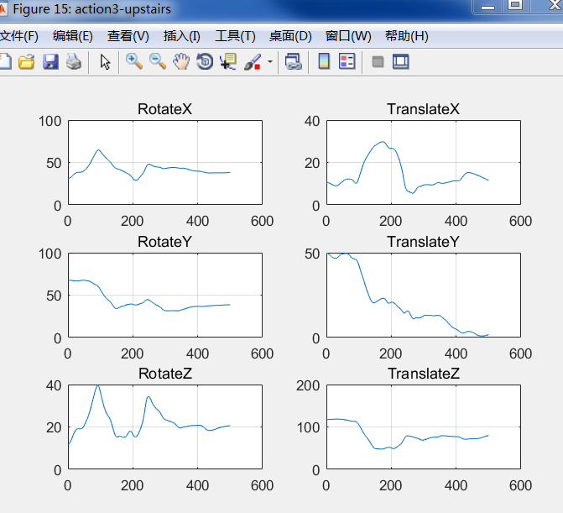

- Volunteer: 420hxl(date and name abbreviation)
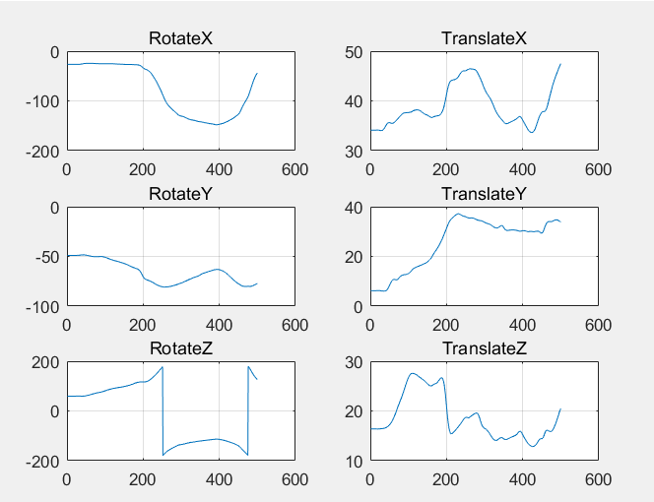
Note：the volunteer was missing data while climbing stairs.

