Direct visualization of orbital electron occupancy

Tongtong Shang^{1,2}†, Dongdong Xiao^{1,3}†, Fanqi Meng⁴†, Xiaohui Rong¹, Xiaozhi Liu^{1,2}, Xinyan Li^{1,2}, Qinghua Zhang¹, Yuren Wen⁵, Xuefeng Wang^{1,2}, Dong Su^{1,2}, Yong-sheng Hu^{1,2}, Hong Li^{1,2}, Qian Yu⁶, Ze Zhang⁶, Vaclav Petricek⁷, Lijun Wu⁸*, Lin Gu^{1,2,3}*, Jian-Min Zuo⁹, Yimei Zhu⁸, Ce-Wen Nan⁴, Jing Zhu¹⁰

Affiliations:
¹Beijing National Laboratory for Condensed Matter Physics, Institute of Physics, Chinese Academy of Sciences, Beijing 100190, P. R. China
²School of Physical Sciences, University of Chinese Academy of Sciences, Beijing 100049, China
³Songshan Lake Materials Laboratory, Dongguan, Guangdong 523808, P. R. China
⁴State Key Lab of New Ceramics and Fine Processing, School of Materials Science and Engineering, Tsinghua University, 100084 Beijing, P. R. China
⁵School of Materials Science and Engineering, University of Science and Technology Beijing, Beijing 100083, P. R. China
⁶Department of Materials Science and Engineering, Center of Electron Microscopy and State Key Laboratory of Silicon Materials, Zhejiang University, 310027, Hangzhou, P. R. China
⁷Institute of Physics, Academy of Sciences of the Czech Republic, 2, 180 40 Praha 8, Czech Republic
⁸Condensed Matter Physics and Materials Science Division, Brookhaven National Laboratory, Upton, New York 11973, USA
⁹Department of Materials Science and Engineering, University of Illinois at Urbana Champaign, 1304 W Green St, Urbana, IL 61801, USA
¹⁰Beijing National Center for Electron Microscopy, Laboratory of Advanced Materials, Department of Materials Science and Engineering, Tsinghua University, Beijing 100084, P. R. China
*Email: ljwu@bnl.gov; l.gu@iphy.ac.cn

Supplementary Text
Mapping the electron density
The refinement and extraction of low-order structure factors were performed using the Program Wu¹. The refined parameters are electron-beam incident direction, sample thickness, and structure factors. To avoid very large matrices and a reasonable accuracy for the Bloch wave theory, beams were selected according to certain criteria². We chose 2.6 for g_{max}, 3.0 for 2KS_{gmax}, 0.005 for $\left|\frac{U_{max}}{{2KS}_{g}}\right|$.
Using the Mott-Bethe formula we can convert electron structure factors to X-ray structure factors, and replace the corresponding structure factors to perform a multipole refinement. The refined low-order electron and x-ray structure factors are listed in Table S1-S4 of Li_{1-x}CoO₂. The high-order X-ray structure factors are mainly determined by the atomic position, atomic displacement parameters, and core electrons. It can be refined and extracted using Rietveld refinement from SPXRD.
All Rietveld refinement and multipole refinement were performed in JANA2006³ with scattering factors derived from Slater-type orbitals (STO) atomic relativistic wavefunctions. The Rietveld refinements are shown in Fig. S5-S8. To accurately extract the high-order structure factors, the resolution of the data was cut off from 1.67 Å⁻¹ to 1.2 Å⁻¹, where the overlap between diffraction peaks was severe. Since the multipole model⁴ is based on spherical harmonic density functions centered around each atomic nucleus, the limit l_{max} = 4 was used for truncation of the multipole expansion at the hexadecapole level. The functions allowed for a particular site are symmetrically restricted. The coordinate systems used for both Co ($\overline{3}m$) and O ($3m$) are that the z-axis is parallel to the 3-fold axis [001] direction, and the y axis is perpendicular to the mirror plane, i.e. alone [010] direction. Several constraints were imposed on the multipole refinement: the valence population of Li ion was fixed at P_{v} = 0, κ_{[Li]} = 1 and the electron deformation density of Li was not refined. For Co, only the seven 3d electrons were considered as valence electrons. The two 4s electrons were treated as core electrons, since the 4s electrons contribute very little to the scattering factors⁵. The topological electron density analysis of the obtained total electron densities based on Bader’s quantum theory of atoms in molecules was also calculated using JANA2006. The results for the bond critical points are shown in Table 1.

Co 3d-orbital populations
In Li_{1-x}CoO₂, the CoO₆ octahedra is within a trigonally distorted field. The 3d electron density can be expressed by⁵
$ρ_{3d}={[R(r)]}^{2}\left\{P_{1}{(a_{1})}^{2}+(1/2)P_{2}[{\left(e_{g-}\right)}^{2}+{\left(e_{g+}\right)}^{2}]+(1/2)P_{3}[{\left(e_{g-}^{'}\right)}^{2}+{(e_{g+}^{'})}^{2}]\right\}$, (S1)
where $R(r)$ is the radial function, $(a_{1})$, ${(e}_{g-})$ and $\left(e_{g+}\right)$ correspond to the three t_{2g} orbitals, ${\left(e_{g-}\right)}^{'}$ and ${\left(e_{g+}\right)}^{'}$ correspond to the two e_{g} orbitals. P₁, P₂ and P₃ are the occupancies of the $(a_{1})$, ${(e}_{g})$ and ${\left(e_{g}\right)}^{'}$, respectively.
The relationship between the occupancies of 3d orbital and the populations of spherical density functions, which are refined from multipole modelling, is given by
$$P_{1}=\left(1/3\right)P_{00}+{\left(1/7\right)[{(196π/5)}^{1/2}/M_{20}]P}_{20}+(3/35)[{(196π)}^{1/2}/M_{40}]P_{40}$$
$$P_{2}=\left(2/3\right)P_{00}-{\left(5/7\right)[{(196π/5)}^{1/2}/M_{20}]P}_{20}+(6/35)[{(196π)}^{1/2}/M_{40}]P_{40}-\sqrt{2}P_{4}$$
$P_{3}=\left(1/3\right)P_{00}+{\left(4/7\right)[{(196π/5)}^{1/2}/M_{20}]P}_{20}-(9/35)[{(196π)}^{1/2}/M_{40}]P_{40}+\sqrt{2}P_{4}$ (S2)
$P_{4}=3/(6\sqrt{2}+1)\left\{{-\left(9/7\right)[{(196π/5)}^{1/2}/M_{20}]P}_{20}+\left(3/7\right)[{\left(196π\right)}^{\frac{1}{2}}/M_{40}]P_{40}+[{(63π/5)}^{1/2}/M_{43}]P_{43+}\right\}$,
where the P₀₀, P₂₀, P₄₀, P₄₃₊ are the refined populations of spherical harmonic density functions, respectively. M_{lm} denotes the ratio of normalization factors for wave functions and density functions. The Co 3d-orbital occupancies can be calculated according to Eq. S2.

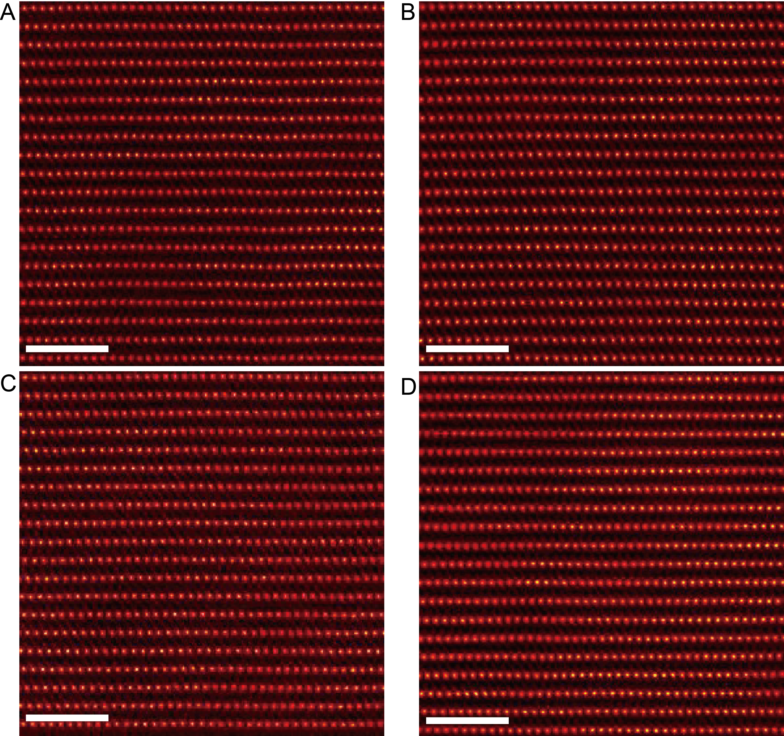

Fig. S1. STEM-HAADF images of Li_{1-x}CoO₂ along the [100] zone axis.
(A) pristine LiCoO₂, (B) Li_{0.6}CoO₂, (C) Li_{0.4}CoO₂, (D) Li_{0.3}CoO₂. Scale bar: 2 nm

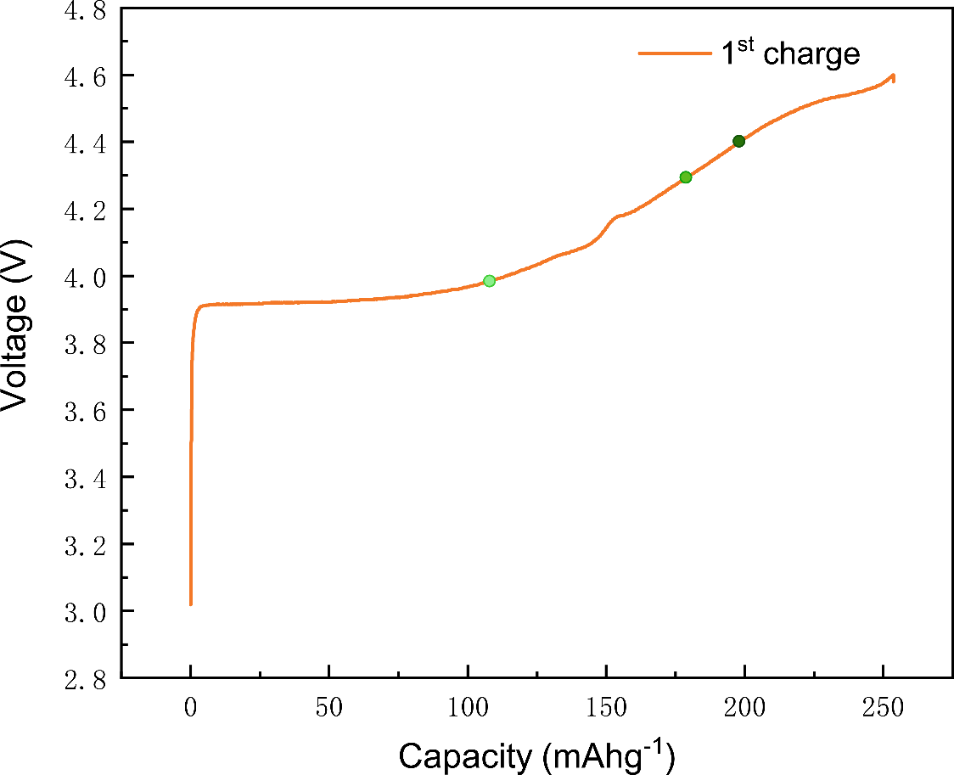

Fig. S2. Initial charge-discharge curves of LiCoO₂, charge to 4.6 V and then discharge to 3.0 V versus Li/Li⁺.
The green circles from the left to the right correspond to x=0.4, 0.6, 0.7, respectively.

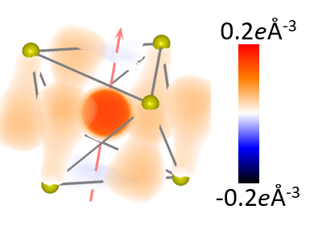

Fig. S3. 3D rendering of the static deformation density map of the CoO₆ octahedra for Li_{0.3}CoO₂.
In this map, the color scheme ranges from -0.2 to 0.2 $e Å^{-3}$ and can offer more information compared to Fig. 3I.

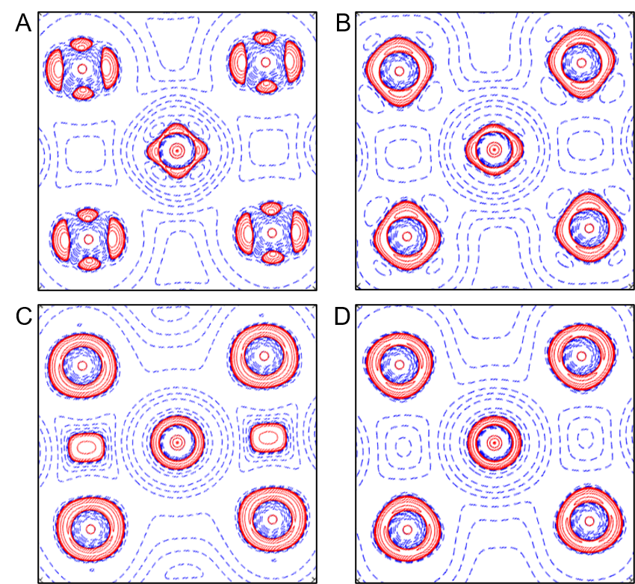

Fig. S4. Laplacian maps in the ($01\overline{4}$) plane.
(A) LiCoO₂ (B) Li_{0.6}CoO₂, (C) Li_{0.4}CoO₂, (D) Li_{0.3}CoO₂. contours are drawn at ± 2×10^{n}, ± 4×10^{n} and ± 8×10^{n} $e Å^{-5}$ (n = ± 3, ± 2, ± 1, 0), with solid red and dotted blue lines for positive and negative values, respectively.

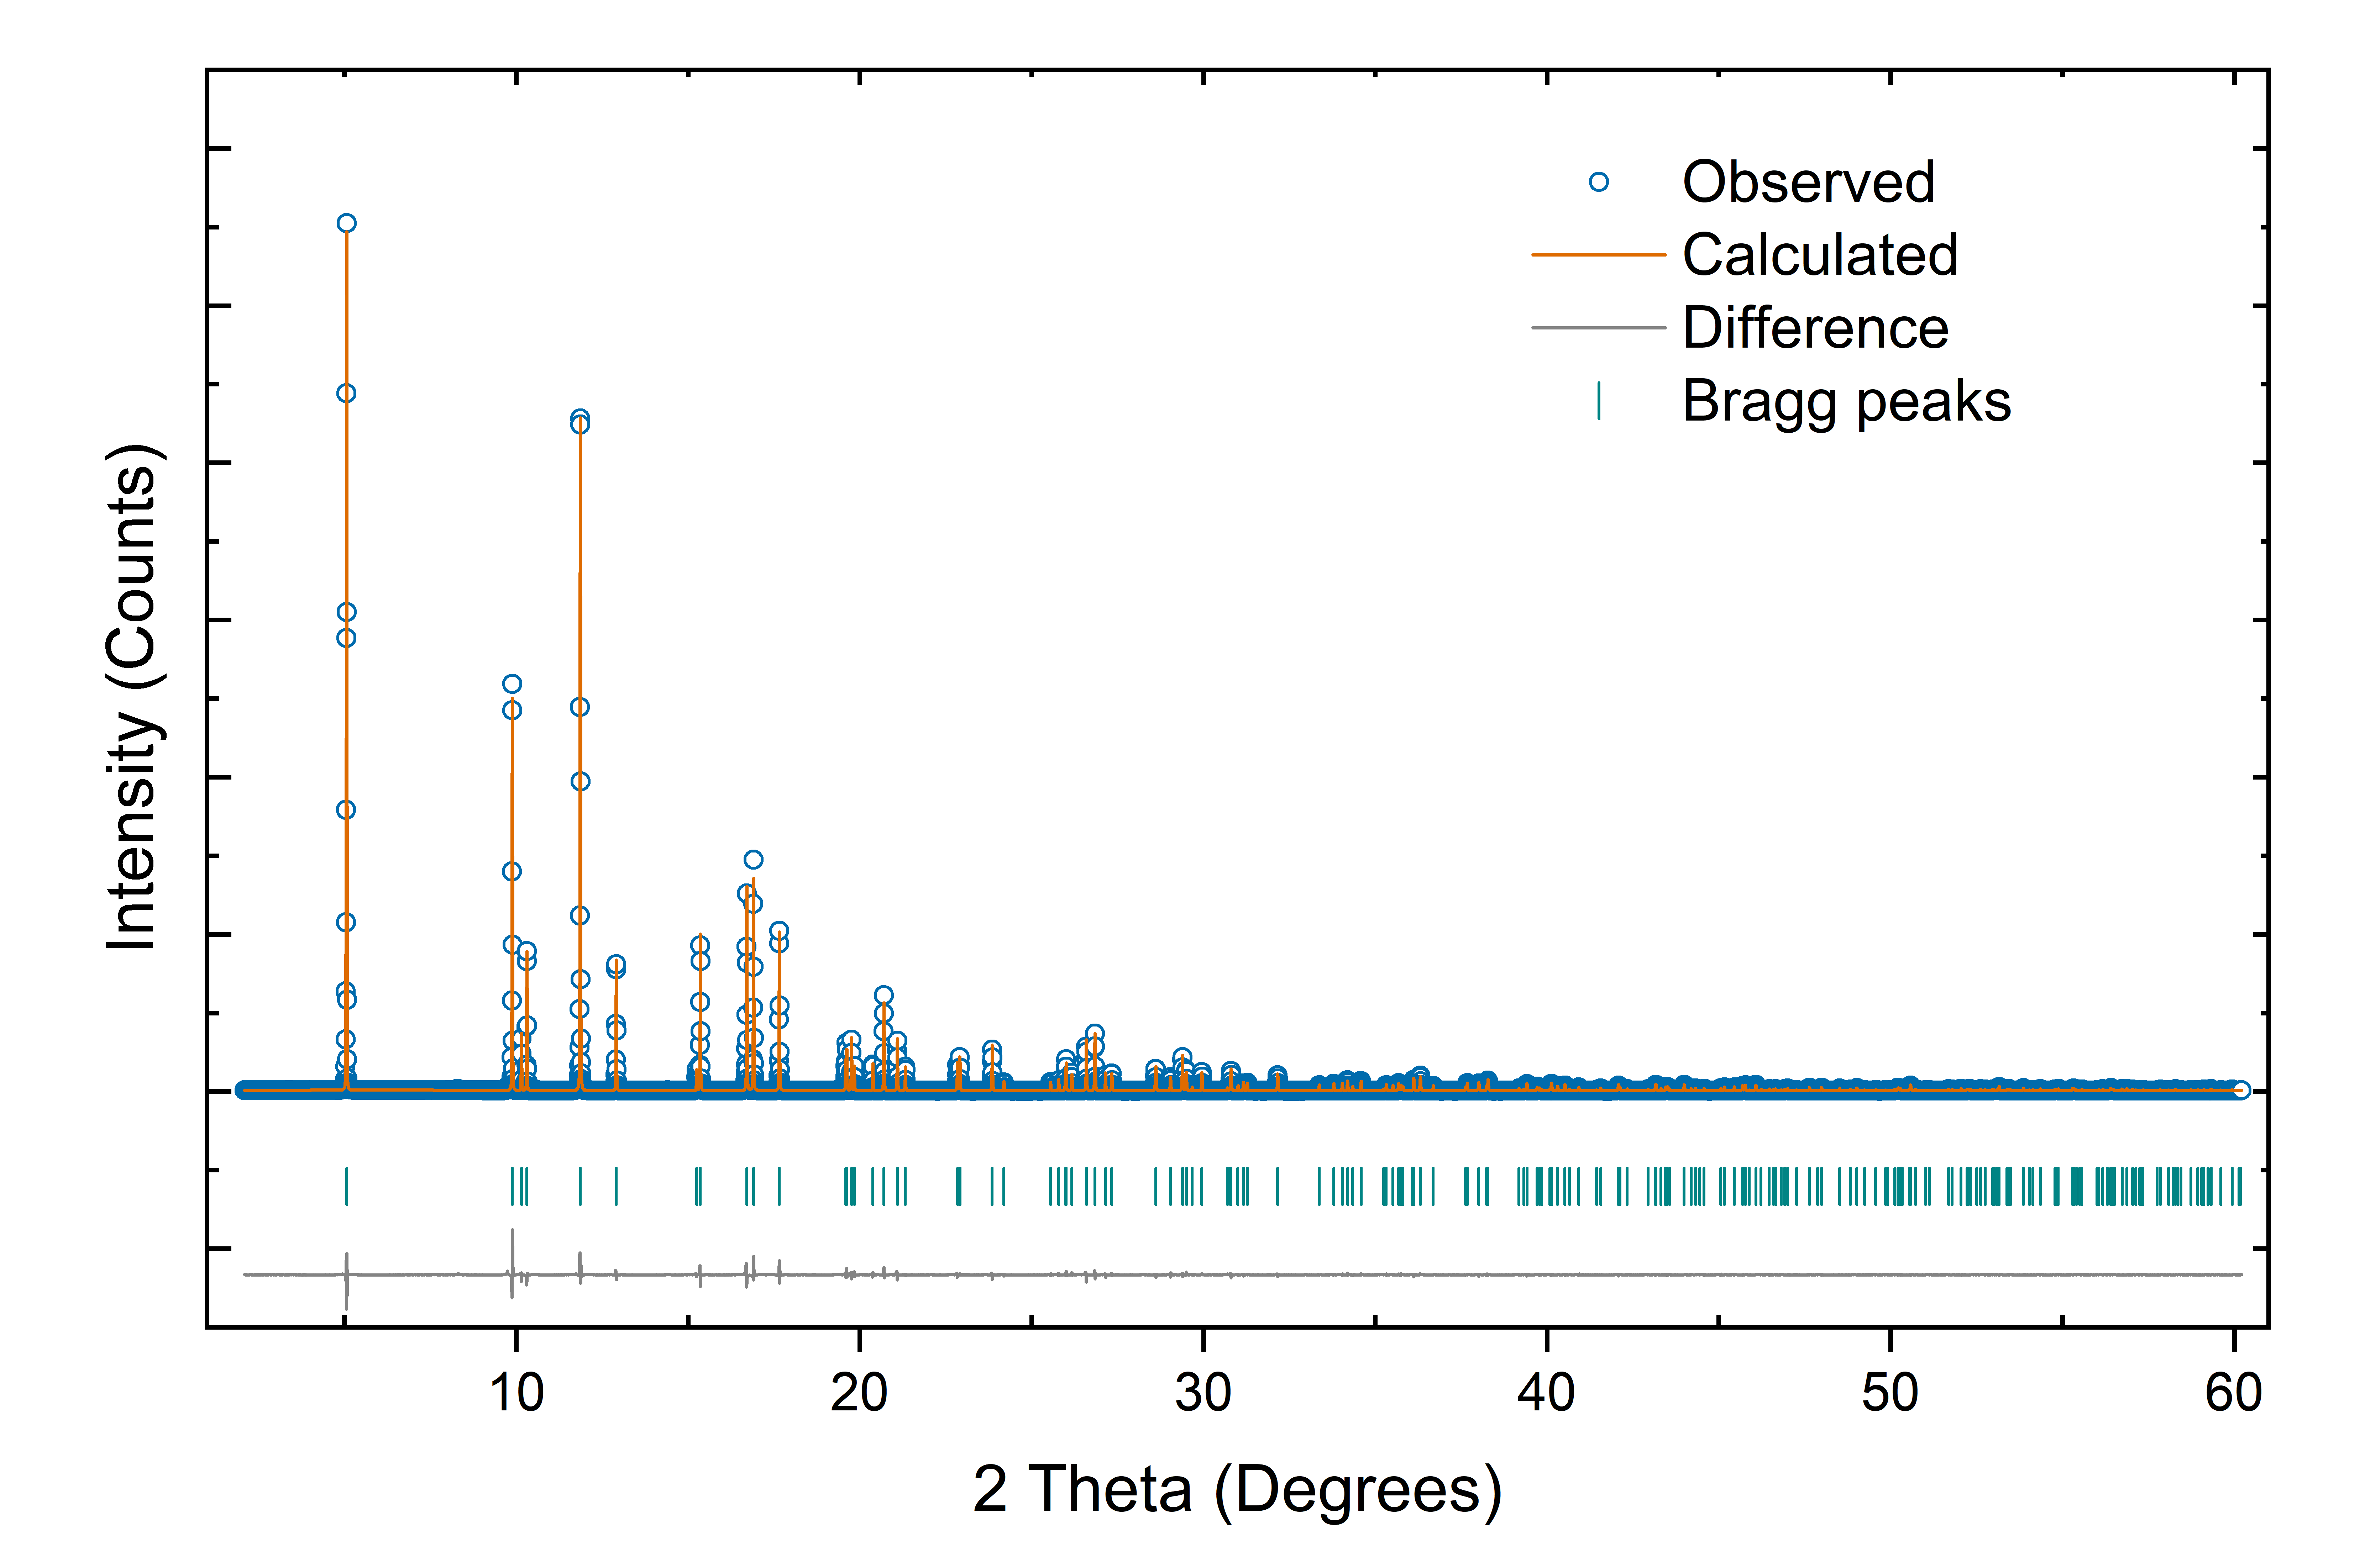

Fig. S5. Rietveld refinement for the SPXRD pattern of LiCoO₂.

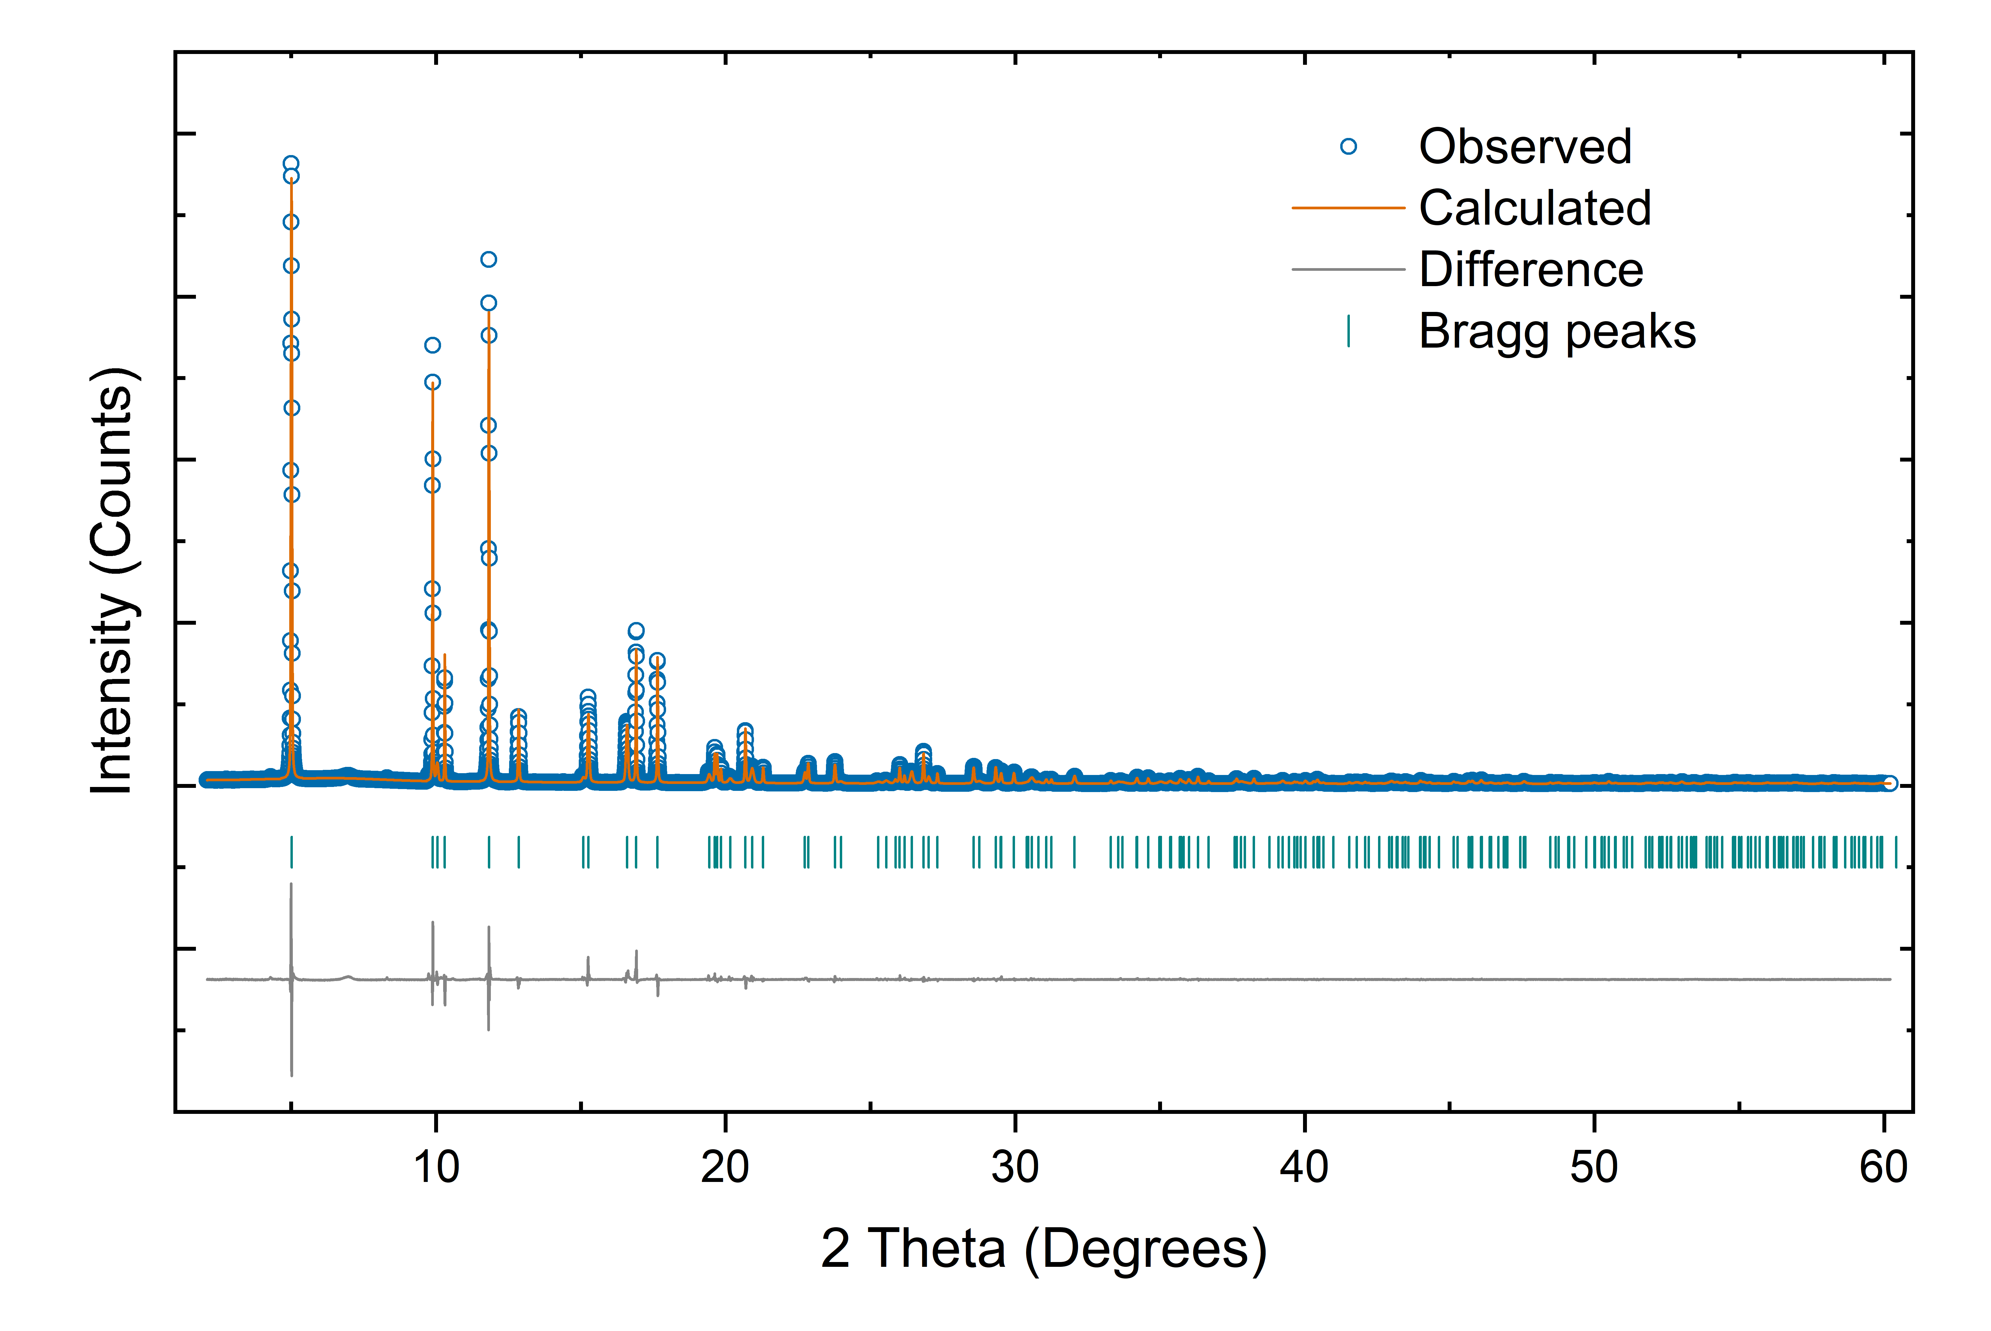

Fig. S6. Rietveld refinement for the SPXRD pattern of Li_{0.6}CoO₂.

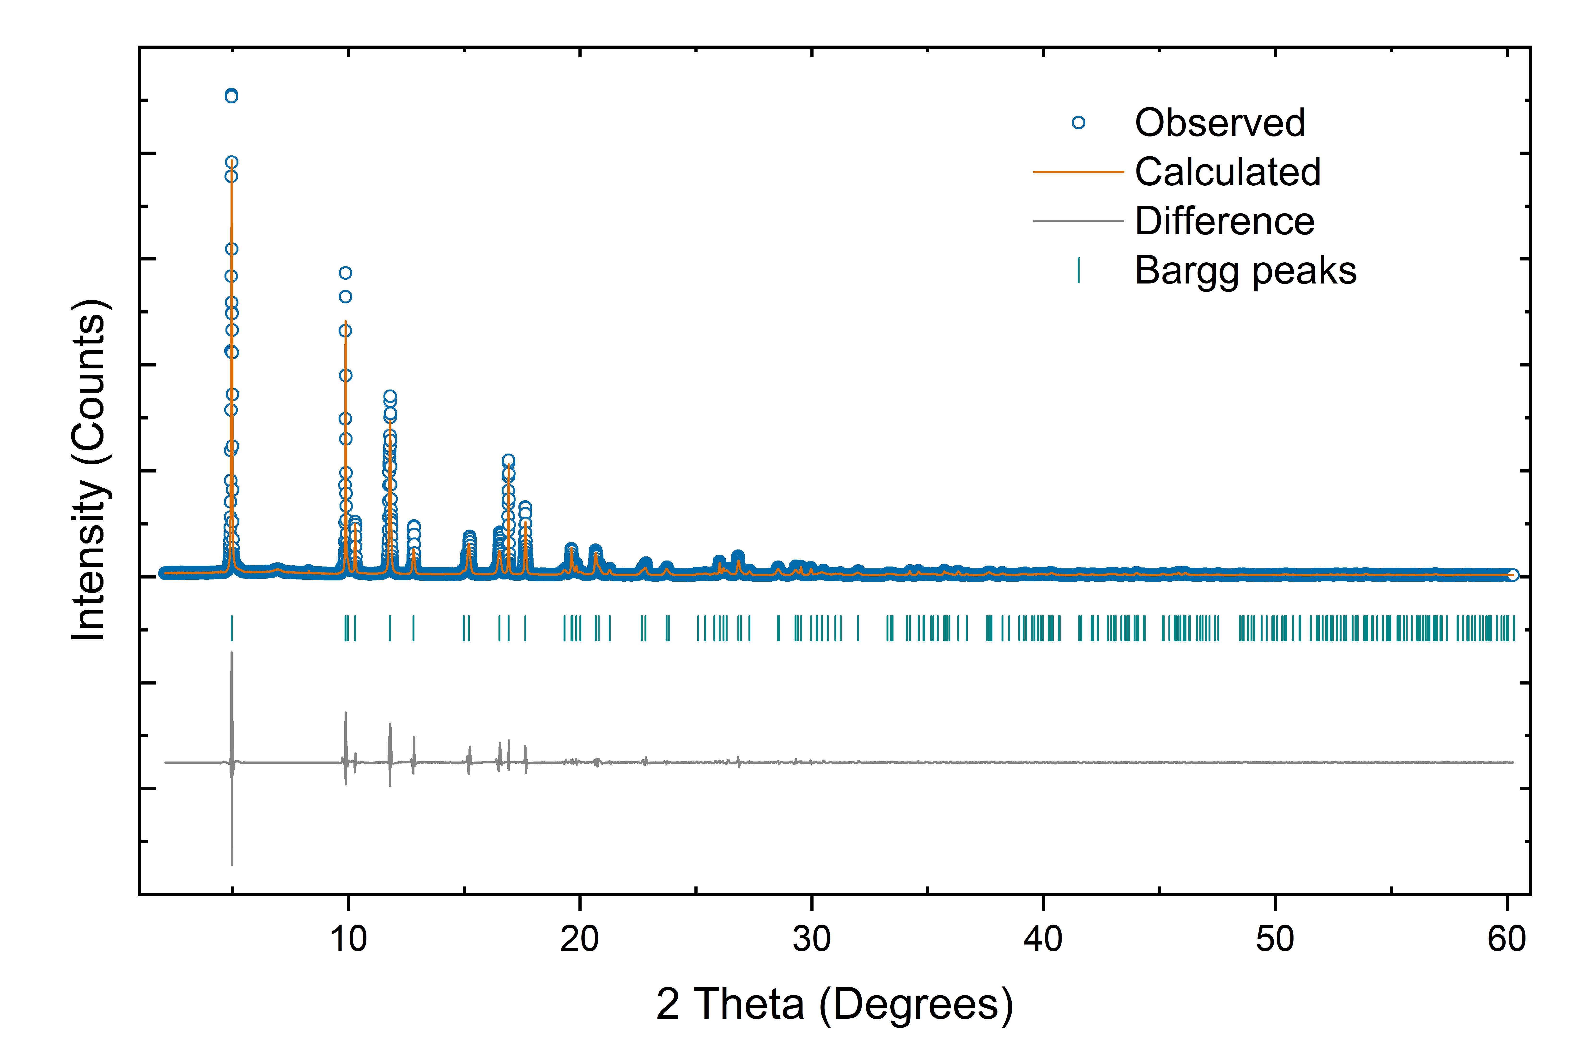

Fig. S7. Rietveld refinement for the SPXRD pattern of Li_{0.4}CoO₂.

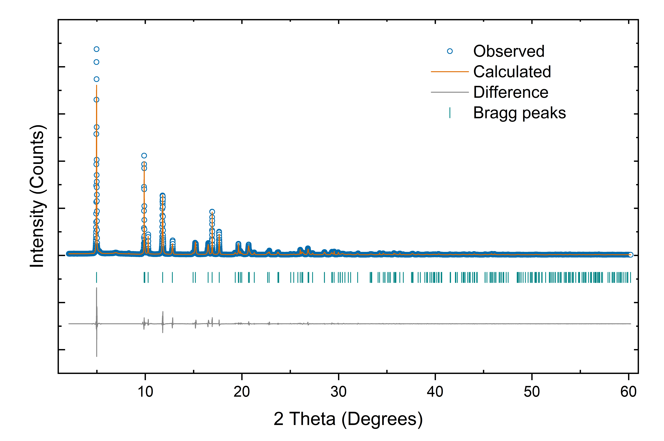

Fig. S8. Rietveld refinement for the SPXRD pattern of Li_{0.3}CoO₂.

Table S1. Low-order structure factors measurement using CBED of LiCoO₂.
Reflection | $$F_{E}^{CBED}$$ | $$χ^{2}$$ | $$F_{X}^{Con}$$ | $$F_{X}^{Obs}$$
$$003$$ | -12.0281 | 0.128 | -75.2026 | -74.7950
$$0\overline{1}1$$ | -7.7820 | 8.255 | -54.8774 | -54.9590
$$006$$ | 5.2031 | 0.128 | 35.0276 | 35.3030
$$012$$ | 4.6897 | 2.640 | 32.9610 | 33.7800
$$0\overline{1}4$$ | 17.6667 | 5.131 | 88.8956 | 90.5540
$F_{E}^{CBED}$ denotes the refined electron-structure-factors from CBED. $χ^{2}$ is the goodness of fit. $F_{X}^{Con}$ represents the X-ray structure factors converted from electron-structure factors using the Mott-Bethe formula. $F_{X}^{Obs}$ stands for the X-ray structure factors obtained using the synchrotron powder XRD.

Table S2. Low-order structure factors measurement using CBED of Li_{0.6}CoO₂.
Reflection | $$F_{E}^{CBED}$$ | $$χ^{2}$$ | $$F_{X}^{Con}$$ | $$F_{X}^{Obs}$$
$$003$$ | -15.2838 | 2.447 | -80.4759 | -80.0610
$$0\overline{1}1$$ | -8.2820 | 1.235 | -56.2763 | -57.5079
$$006$$ | 4.0447 | 2.447 | 36.9176 | 35.1539
$$012$$ | 4.8031 | 4.154 | 29.4540 | 30.1469
$$0\overline{1}4$$ | 17.6636 | 2.345 | 84.4921 | 86.3889
$F_{E}^{CBED}$ denotes the refined electron-structure-factors from CBED. $χ^{2}$ is the goodness of fit. $F_{X}^{Con}$ stands for the X-ray structure factors converted from electron-structure factors using the Mott-Bethe formula. $F_{X}^{Obs}$ represents the X-ray structure factors obtained using synchrotron powder XRD.

Table S3. Low-order structure factors measurement using CBED of Li_{0.4}CoO₂.
Reflection | $$F_{E}^{CBED}$$ | $$χ^{2}$$ | $$F_{X}^{Con}$$ | $$F_{X}^{Obs}$$
$$003$$ | -19.0487 | 0.439 | -82.2019 | -81.8140
$$0\overline{1}1$$ | -7.8576 | 0.483 | -58.3635 | -57.0550
$$006$$ | 4.8761 | 0.439 | 36.2501 | 37.2120
$$012$$ | 3.2848 | 2.107 | 30.9666 | 31.0820
$$0\overline{1}4$$ | 16.6159 | 0.976 | 84.6782 | 87.9260
$F_{E}^{CBED}$ denotes the refined electron-structure-factors from CBED. $χ^{2}$ is the goodness of fit. $F_{X}^{Con}$ represents the X-ray structure factors converted from electron-structure factors using the Mott-Bethe formula. $F_{X}^{Obs}$ stands for the X-ray structure factors obtained using synchrotron powder XRD.

Table S4. Low-order structure factors measurement using CBED of Li_{0.3}CoO₂.
Reflection | $$F_{E}^{CBED}$$ | $$χ^{2}$$ | $$F_{X}^{Con}$$ | $$F_{X}^{Obs}$$
$$003$$ | -17.0316 | 0.463 | -83.3051 | -82.5350
$$0\overline{1}1$$ | -8.5585 | 1.364 | -58.1658 | -57.2490
$$006$$ | 3.6727 | 0.463 | 36.4529 | 35.9679
$$012$$ | 3.3336 | 0.414 | 29.9553 | 31.4750
$$0\overline{1}4$$ | 15.7307 | 1.372 | 86.4530 | 86.9929
$F_{E}^{CBED}$ denotes the refined electron-structure-factors from CBED. $χ^{2}$ is the goodness of fit. $F_{X}^{Con}$ stands for the X-ray structure factors converted from electron-structure factors using the Mott-Bethe formula. $F_{X}^{Obs}$ represents the X-ray structure factors obtained using synchrotron powder XRD.

Table S5. Lattice parameters, atomic coordinates, bond length, and bond angle of Li_{1-x}CoO₂.
Parameters | LiCoO₂ | Li_{0.6}CoO₂ | Li_{0.4}CoO₂ | Li_{0.3}CoO₂
$$a (Å)$$ | 2.812792(4) | 2.812155(14) | 2.80962(4) | 2.808697(16)
$$c (Å)$$ | 14.02096(3) | 14.17254(18) | 14.2662(6) | 14.2924(2)
z(O) | 0.23989(5) | 0.23646(8) | 0.23501(15) | 0.23541(13)
Co-O bond length ($Å$) | 1.9213(4) | 1.9012(6) | 1.8927(12) | 1.8960(10)
O-O spacing ($Å$) | 2.6179(12) | 2.5592(18) | 2.537(4) | 2.548(3)
CoO₆ angle ($°$) | 85.89(3) | 84.61(4) | 84.16(8) | 84.42(7)

Table S6. Results from multipole refinement of the experimental data.
Parameters | LiCoO₂ | Li_{0.6}CoO₂ | Li_{0.4}CoO₂ | Li_{0.3}CoO₂
$${(sinθ/λ)}_{max} (Å^{-1})$$ | 1.2 | 1.2 | 1.2 | 1.2
R(F²) (%) | 1.39 | 1.86 | 1.49 | 1.04
wR(F²) (%) | 2.10 | 2.12 | 2.20 | 1.58
N_{refl} | 222 | 217 | 219 | 220
U₁₁, U₃₃(Li) ($Å^{2}$) | 0.006246 (1125) 0.010248 (1818) | 0.012628 (2809) 0.005017 (2961) | 0.00933 (3309) 0.004931 (3561) | 0.007591 (2780) 0.004703 (3253)
U₁₁, U₃₃(Co) ($Å^{2}$) | 0.001333 (172) 0.002367 (186) | 0.001842 (204) 0.001596 (231) | 0.000883 (191) 0.002034 (192) | 0.001166 (156) 0.001885 (156)
U₁₁, U₃₃(O) ($Å^{2}$) | 0.003567 (612) 0.000403 (1269) | 0.002885 (275) 0.003163 (374) | 0.000839 274) 0.008891 (385) | 0.001729 (212) 0.006926 (248)
P_{v}(Co) | 6.50(22) | 6.44(27) | 6.66 (33) | 7.24 (29)
P_{v}(O) | 6.75(11) | 6.58 (13) | 6.37(16) | 6.03(14)
P₂₀, P₄₀, P₄₃₊(Co) | 0.291(57)  0.367(46)  -0.296(42) | 0.103 (69)  0.228 (39)  -0.040 (32) | 0.763 (216)  1.698 (371)  0.790 (364) | 0.449 (273)  0.893 (502)  1.256 (423)
P₁₀, P₂₀, P₃₀, P₃₃₊, P₄₀, P₄₃₊(O) | -0.003(40)  0.295(97)  -0.032(24)  -0.003(25)  0.075(30)  -0.063(31) | -0.056 (83)  0.228 (103)  0.031 (95)  0.153 (98)  0.220 (104)  -0.139 (87) | 0.016 (85)  0.117 (101)  0.064 (101)  0.001 (89)  0.173 (156)  0.120 (134) | -0.225 (123)  0.115 (132)  -0.094 (131)  0.267 (200)  0.514 (182)  0.014 (187)
$κ$, $κ^{'}$(Co) | 1.03(4), 1.95(9) | 1.06(5), 2.20(25) | 1.05(5), 0.62(4) | 1.04(3), 0.55(5)
$κ$, $κ^{'}$(O) | 1.00(2), 2.12(4) | 1.00 (2), 0.79 (14) | 1.00(2), 0.82(24) | 1.02(2), 0.56(10)

Reference
1. Ma C, Wu L, Yin W-G, Yang H, Shi H, Wang Z, et al. Strong Coupling of the Iron-Quadrupole and Anion-Dipole Polarizations in Ba(Fe1-xCox)(2)As-2. Physical Review Letters 2014, 112(7).

2. Zuo JM, Weickenmeier AL. ON THE BEAM SELECTION AND CONVERGENCE IN THE BLOCH-WAVE METHOD. Ultramicroscopy 1995, 57(4): 375-383.

3. Václav P, Michal D, Lukáš P. Crystallographic Computing System JANA2006: General features. Zeitschrift für Kristallographie - Crystalline Materials 2014, 229(5): 345-352.

4. Hansen NK, Coppens P. Testing aspherical atom refinements on small-molecule data sets. Acta Crystallographica Section A 1978, 34(6): 909-921.

5. Stevens ED, Coppens P. Refinement of metal d-orbital occupancies from X-ray diffraction data. Acta Crystallographica Section A 1979, 35(4): 536-539.

