Supplemental Material
This appendix presents additional information
Supplement to: Heterogeneity in Treatment Response for Patent Ductus Arteriosus: A Meta-Analysis

Corresponding author

Felipe Yu Matsushita, MD – felipe.matsushita@hc.fm.usp.br
Department of Pediatrics,
Instituto da Criança, Faculty of Medicine, University of São Paulo
Av. Dr. Enéas Carvalho de Aguiar, 647
São Paulo, São Paulo, Brazil, 05403901
ORCID: 0000-0002-5106-7497

eFigure 1. PRISMA flowchart
eTable 1. Meta-regression of Mixed-Effect Models Results for Mortality
eTable 2. Meta-regression of Mixed-Effect Models Results for PDA closure
eFigure 2. Meta-analysis of pharmacological interventions and mortality
eFigure 3. Meta-analysis of pharmacological interventions and PDA closure
eFigure 4. Meta-analysis of standard dose vs higher dose and mortality
eFigure 5. Meta-analysis of standard dose vs higher dose and PDA closure
eFigure 6. Meta-analysis of ibuprofen route of administration and mortality
eFigure 7. Meta-analysis of ibuprofen route of administration and PDA closure
eTable 3. Characteristics of included studies

eFigure 1. PRISMA flowchart
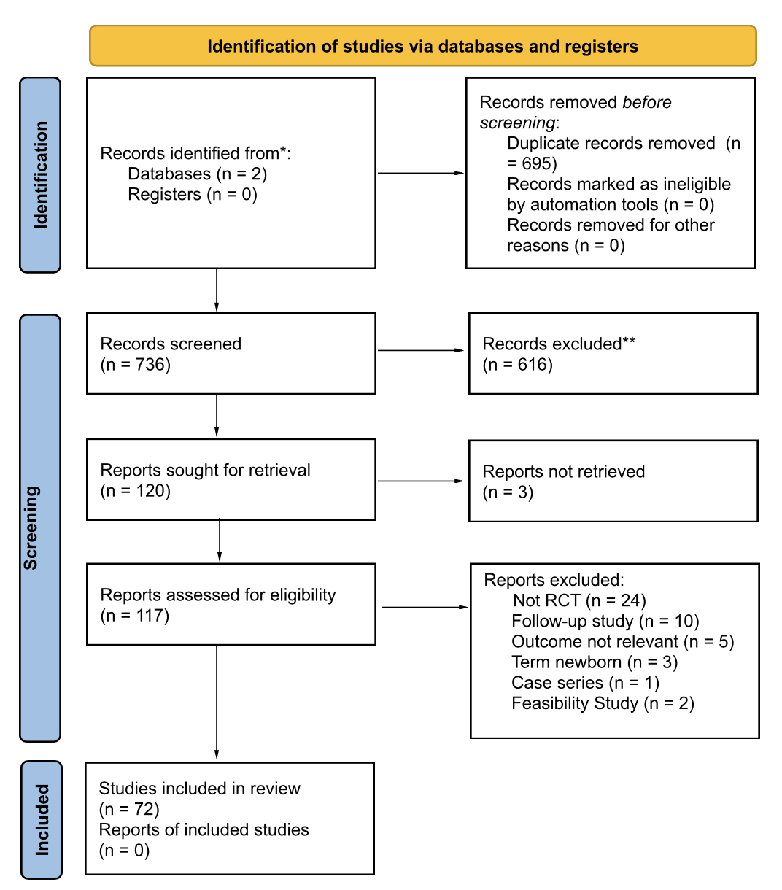

eTable 1. Meta-regression of Mixed-Effect Models Results for Mortality

Term | Estimate | SE | z-value | p-value | CI (95%)
Intercept | -3.8410 | 16.9859 | -0.2261 | 0.8211 | -37.13 to 29.45
Multicenter (yes) | -0.4822 | 0.6130 | -0.7866 | 0.4315 | -1.68 to 0.71
Trial Site (europe) | -1.0405 | 3.9632 | -0.2625 | 0.7929 | -8.81 to 6.73
Intervention (Ibuprofen) | -2.0593 | 3.9022 | -0.5277 | 0.5977 | -9.71 to 5.59
Route (Oral) | 1.99 | 4.01 | 0.4957 | 0.6201 | -5.88 to 9.86
hsPDA (yes) | -1.2114 | 4.8599 | -0.2493 | 0.8032 | -10.74 to 8.31
JADAD score | 0.2198 | 0.4700 | 0.4677 | 0.64 | -0.70 to 1.14
Mean gestational age | 0.3391 | 0.9428 | 0.3597 | 0.7191 | -1.50 to 2.18
Mean Birth Weight | -0.0064 | 0.0168 | -0.3812 | 0.70 | -0.03 to 0.02
Mean days of life | -0.3682 | 0.7449 | -0.4943 | 0.62 | -1.82 to 1.09
Female gender | -0.08 | 0.1519 | -0.5834 | 0.55 | -0.38 to 0.20
Antenatal corticoid | 0.11 | 0.3031 | 0.3677 | 0.71 | -0.48 to 0.70
5th minute mean APGAR | -0.1767 | 0.7466 | -0.2367 | 0.81 | -1.64 to 1.28
CI: Confidence Interval; SE: Standard Error; hsPDA: hemodynamically significant patent ductus arteriosus

eTable 2. Meta-regression of Mixed-Effect Models Results for PDA closure

Term | Estimate | SE | z-value | p-value | CI (95%)
Intercept | 6.9920 | 9.0146 | 0.7756 | 0.4380 | [-10.68, 24.66]
Multicenter (yes) | -0.9043 | 0.6545 | -1.3815 | 0.1671 | [-2.19, 0.38]
Intervention (ibuprofen) | 0.0598 | 1.1625 | 0.0514 | 0.9590 | [-2.22, 2.34]
Route (Oral) | -0.5633 | 1.0541 | -0.5344 | 0.5931 | [-2.63, 1.50]
hsPDA (yes) | -0.0114 | 0.8566 | -0.0133 | 0.9894 | [-1.69, 1.67]
JADAD score | -0.2671 | 0.2404 | -1.1109 | 0.2666 | [-0.74, 0.20]
Mean gestational age | -0.2034 | 0.3207 | -0.6342 | 0.5260 | [-0.83, 0.43]
Mean birth weight | 0.0010 | 0.0019 | 0.5491 | 0.5829 | [-0.003, 0.005]
Mean days of life | 0.0511 | 0.1157 | 0.4421 | 0.6584 | [-0.18, 0.28]
Female gender | 0.0304 | 0.0738 | 0.4122 | 0.6802 | [-0.11, 0.17]
Antenatal corticoid | -0.0106 | 0.0499 | -0.2130 | 0.8313 | -0.11 to 0.09

eFigure 2. Meta-analysis of pharmacological interventions and mortality
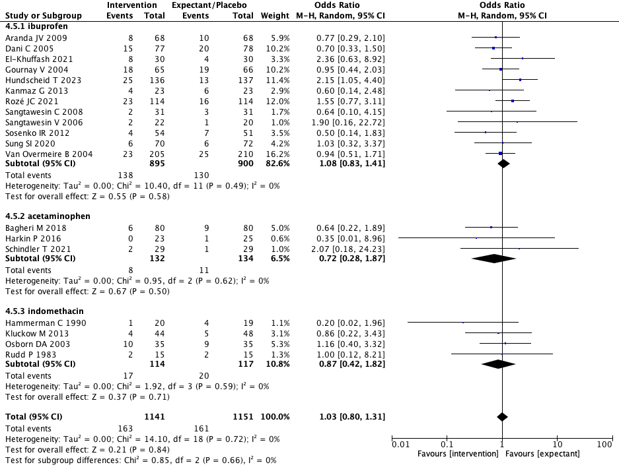

eFigure 3. Meta-analysis of pharmacological interventions and PDA closure
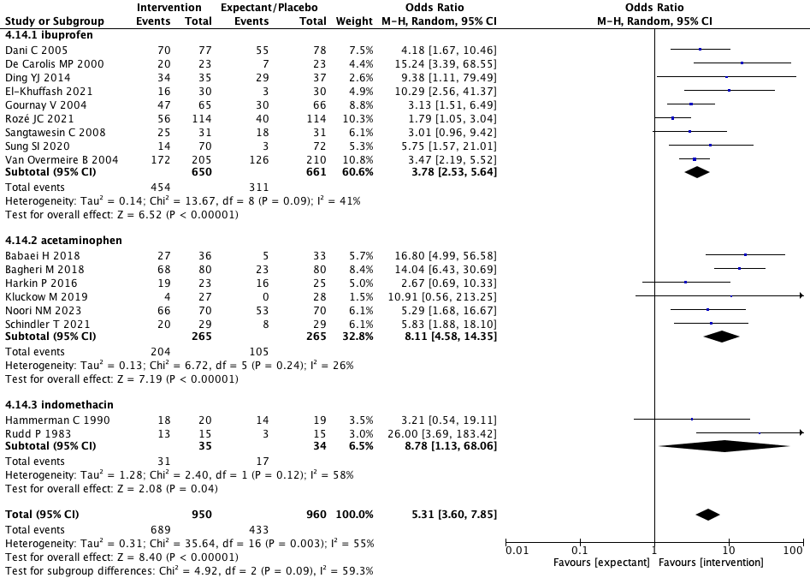

eFigure 4. Meta-analysis of standard dose vs higher dose and mortality
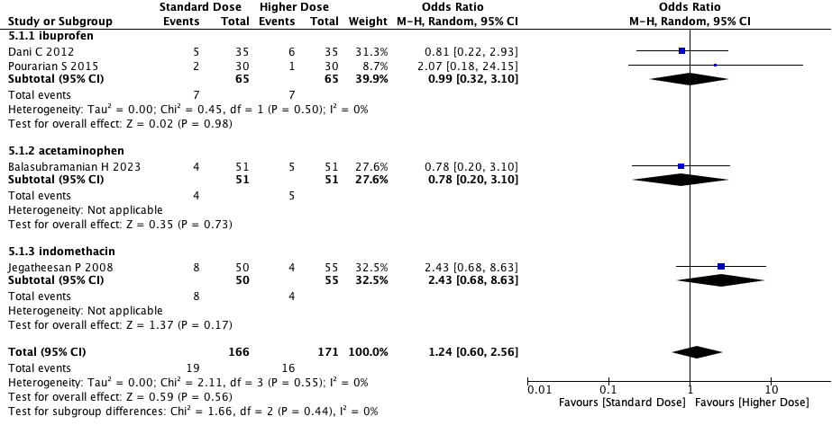

eFigure 5. Meta-analysis of standard dose vs higher dose and PDA closure
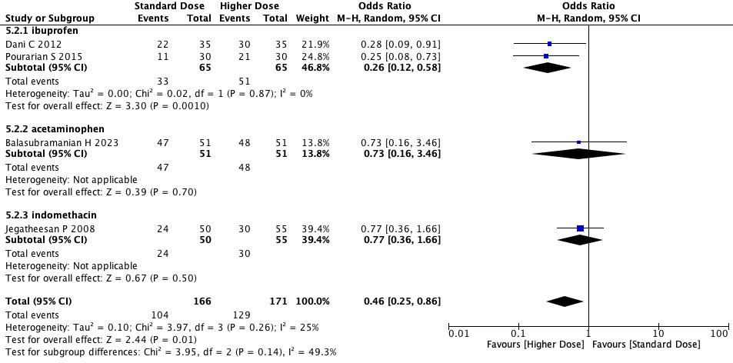

eFigure 6. Meta-analysis of ibuprofen route of administration and mortality
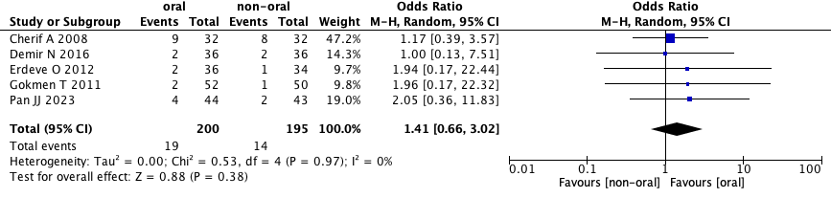

eFigure 7. Meta-analysis of ibuprofen route of administration and PDA closure
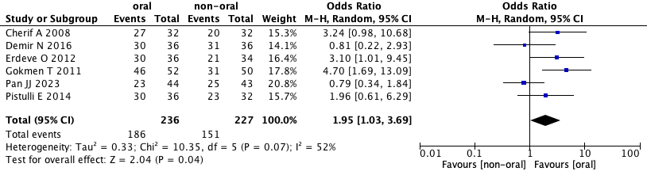

eTable 3. Characteristics of included studies
Trial | Multicenter | Trial Site | Intervention | Comparison | Power Analysis | GA inclusion | Mortality as outcome | PDA Closure as outcome
Hundscheid T. 2023 | yes | europe | expectant | ibuprofen | yes | < 28 weeks | yes | yes
Dani C 2021 | yes | europe | paracetamol | ibuprofen | yes | 25 - 31+6 | yes | yes
El-Mashad AE 2017 | no | egypt | paracetamol | ibuprofen | yes | < 28 weeks | no | yes
El-Khuffash 2021 | no | europe | ibuprofen | placebo | yes | < 29 weeks | yes | yes
Schindler T 2021 | no | australia | paracetamol | placebo | yes | < 29 weeks | yes | yes
Balasubramanian H 2023 | no | india | paracetamol | paracetamol | yes | < 30 weeks | yes | yes
Al-Lawama M 2018 | yes | india | paracetamol | ibuprofen | yes | < 32 weeks | yes | yes
Van Overmeire B 2000 | yes | europe | indomethacin | ibuprofen | yes | < 32 weeks | yes | yes
Su PH 2003 | no | taiwan | ibuprofen | indomethacin | no | < 32 weeks | yes | yes
Farkhraee SH 2007 | no | iran | ibuprofen | indomethacin | no | < 34 weeks | yes | yes
Sosenko IR 2012 | no | us | ibuprofen | placebo | yes | 23 - 32 weeks | yes | yes
Sung SI 2020 | no | south korea | ibuprofen | expectant | yes | 23 - 30 weeks | yes | yes
Kluckow M 2013 | yes | australia | indomethacin | placebo | yes | < 29 weeks | yes | no
Khuwuthyakorn V 2018 | no | thailand | indomethacin | ibuprofen | yes | 24-32 weeks | yes | yes
Gokmen T 2011 | no | turkey | ibuprofen | ibuprofen | yes | < 32 weeks | yes | yes
Van Overmeire B 1997 | no | europe | indomethacin | ibuprofen | yes | < 33 weeks | yes | yes
Harkin P 2016 | no | europe | paracetamol | placebo | yes | < 32 weeks | yes | yes
Pan JJ 2023 | no | china | ibuprofen | ibuprofen | yes | < 34 weeks | yes | yes
Pourarian SH 2008 | no | iran | indomethacin | ibuprofen | no | < 37 weeks | no | yes
Sangtawesin 2008 | no | thailand | ibuprofen | placebo | yes | - | yes | yes
Rozé JC 2021 | yes | europe | placebo | ibuprofen | yes | 24 - 28 weeks | yes | yes
Dang D 2013 | no | china | paracetamol | ibuprofen | yes | < 34 weeks | yes | yes
De Carolis 2000 | no | europe | ibuprofen | expectant | yes | < 31 weeks | no | yes
Rudd P 1983 | no | europe | indomethacin | placebo | no | no | yes | yes
Kanmaz G 2013 | no | turkey | ibuprofen | expectant | yes | < 28 weeks | yes | no
Lago P 2002 | no | europe | indomethacin | ibuprofen | yes | < 34 weeks | yes | yes
Su BH 2008 | no | taiwan | ibuprofen | indomethacin | yes | < 28 weeks | yes | yes
Dash SK 2015 | no | india | paracetamol | indomethacin | yes | - | yes | yes
Lago P 2014 | no | europe | ibuprofen | ibuprofen | yes | < 32 weeks | yes | yes
Dani C 2012 | yes | europe | ibuprofen | ibuprofen | yes | < 29 weeks | yes | yes
Sangtawesin 2006 | no | thailand | ibuprofen | placebo | yes | 28-32 weeks | yes | no
Hammerman C 2008 | no | israel | indomethacin | ibuprofen | yes | < 33 weeks | yes | yes
Pourarian 2015 | no | iran | ibuprofen | ibuprofen | yes | < 37 weeks | yes | yes
Van Overmeire B 2004 | yes | europe | ibuprofen | placebo | yes | 24 - 30 weeks | yes | yes
Van Overmeire B 1995 | yes | europe | indomethacin | aspirin | no | < 34 weeks | yes | yes
Cherif A 2008 | no | tunisia | ibuprofen | ibuprofen | yes | < 32 weeks | yes | yes
Gournay V 2004 | yes | europe | ibuprofen | placebo | yes | < 28 weeks | yes | yes
Kluckow M 2019 | no | australia | paracetamol | placebo | yes | < 33 weeks | no | yes
Aranda JV 2009 | yes | us | ibuprofen | placebo | yes | < 30 weeks | yes | yes
Erdeve O 2012 | no | turkey | ibuprofen | ibuprofen | yes | < 28 weeks | yes | yes
Osborn DA 2003 | yes | australia | indomethacin | placebo | yes | < 30 weeks | yes | no
Tammela O 1999 | yes | europe | indomethacin | indomethacin | yes | < 33 weeks | yes | yes
Jegatheesan 2008 | yes | us | indomethacin | indomethacin | yes | < 28 weeks | yes | yes
Oncel MY 2014 | no | turkey | paracetamol | ibuprofen | yes | < 30 weeks | yes | yes
Dani C 2005 | yes | europe | ibuprofen | placebo | yes | < 28 weeks | yes | yes
Hammerman C 1990 | no | us | indomethacin | placebo | yes | - | yes | yes
Lee J 2003 | no | singapore | indomethacin | indomethacin | yes | - | yes | yes
Lin YJ 2017 | yes | us + taiwan | indomethacin | ibuprofen | yes | - | yes | yes
Yadav S 2014 | no | india | ibuprofen | indomethacin | yes | < 37 weeks | yes | yes
Davidson JM 2021 | yes | us | acetaminophen | indomethacin | yes | 22 - 32 weeks | yes | yes
Noori NM 2023 | no | iran | expectant | acetaminophen | yes | < 32 weeks | no | yes
Samadi 2022 | no | iran | ibuprofen | paracetamol | yes | < 32 weeks | yes | yes
Bravo MC 2022 | yes | europe | ibuprofen | ibuprofen | yes | < 28 weeks | yes | yes
Arif M 2021 | no | pakistan | paracetamol | ibuprofen | no | - | yes | yes
El-Khuffash 2021 | no | europe | ibuprofen | placebo | yes | < 29 weeks | yes | yes
Kumar A 2020 | yes | india | paracetamol | ibuprofen | yes | < 32 weeks | yes | yes
Balachander 2020 | no | india | paracetamol | ibuprofen | yes | < 37 weeks | yes | yes
Meena V 2020 | no | india | indomethacin | ibuprofen | no | < 37 weeks | no | yes
Oboodi R 2020 | no | iran | acetaminophen | ibuprofen | no | < 37 weeks | no | yes
Ghaderian M 2019 | no | iran | ibuprofen | acetaminophen | no | < 34 weeks | no | yes
Asadpour 2018 | no | iran | acetaminophen | ibuprofen | no | < 37 weeks | no | yes
Bagheri 2018 | no | iran | paracetamol | placebo | no | < 34 weeks | no | yes
Babaei 2018 | no | iran | acetaminophen | expectant | no | < 34 weeks | no | yes
Sadeghi-Moghaddam 2017 | no | iran | indomethacin | ibuprofen | yes | < 32 weeks | yes | yes
Yang B 2016 | no | china | ibuprofen | acetaminophen | yes | < 37 weeks | no | yes
Bagheri 2016 | no | iran | acetaminophen | ibuprofen | yes | < 37 weeks | no | yes
Demir N 2016 | no | turkey | ibuprofen | ibuprofen | yes | < 32 weeks | yes | yes
Pistulli E 2014 | no | europe | ibuprofen | ibuprofen | no | 28 - 32 weeks | no | yes
Ding YJ 2014 | no | china | ibuprofen | placebo | no | < 37 weeks | no | yes
Aly H 2007 | no | egypt | ibuprofen | indomethacin | no | 27-35 weeks | no | yes
Gimeno Navarro 2005 | no | europe | indomethacin | ibuprofen | yes | < 34 weeks | yes | yes
Patel J 2000 | yes | europe | indomethacin | ibuprofen | no | - | no | yes

