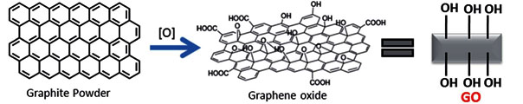

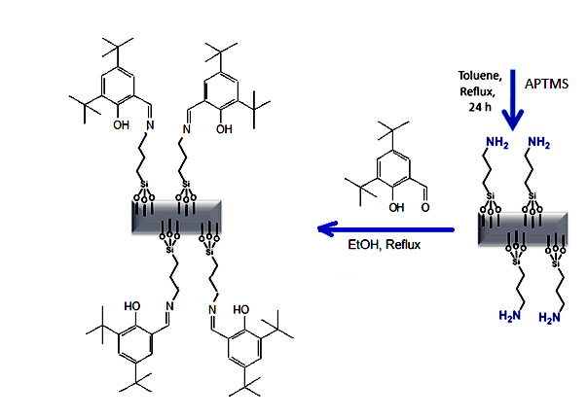
Hybrid material (HB) GO-APTMS

Schema.Preparation of the hybrid material from the graphite powder.

