Table 1. List of Tuberose Cultivars with their characteristics

Sr. No. | Genotypes | Images | Parental Cross | Characteristics | References
1 | Arka Nirantara | 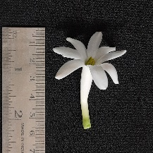 | cross of Single x Double, (developed by IIHR) | Single-flower type with prolonged blooming, Single rows of petals, and Flower Spike curvature present | Khandagale et al. 2014
2 | Mexican single | 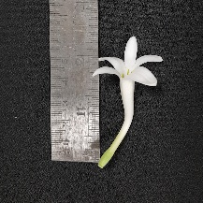 | NA | Single-flower type, Pure white Florets bearing single segment of corolla | Khandagale et al. 2014
3 | Phule Rajani | 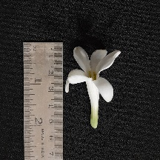 | NA | Single-flower type, with single rows of corolla segments, (developed by MPKV) | Sarkar et al. 2010
4 | Local single | 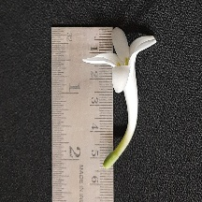 | NA | Single-flower type | Sadhukhan et al. 2021
5 | Bidhan Ujjwal | 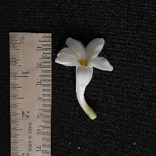 | Sikkim selection x Phule Rajani | Single-flower type, developed at BCKV through hybridization | Sadhukhan et al. 2021
6 | Arka Suvasini | 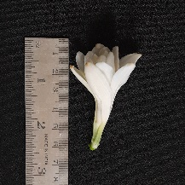 | Single x Double, (developed by IIHR) | A multi-whorled variety | Khandagale et al. 2014
7 | Arka Vaibhav | 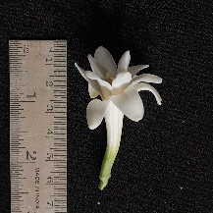 | Cross of Mexican Single x IIHR-2, (developed by IIHR) | Semi-double flowers on medium spike | Khandagale et al. 2014
8 | Sikkim Selection | 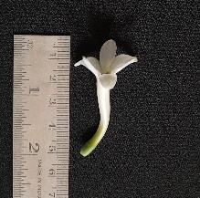 | NA | Flowers are single but leaves are of variegated type | Sarkar et al. 2010
9 | GKTC-4 | 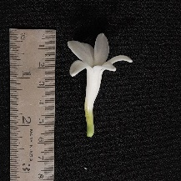 | NA | Single rows of petals, Flower Spike curvature Absent | Sirohi et al. 2017
10 | Local double | 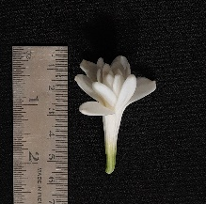 | NA | Double-flower type | Sadhukhan et al. 2021
11 | Hyderabad single | 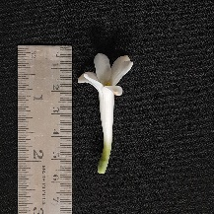 | NA | Single flower type with Single rows of corolla segments, (developed by APAU) | Sarkar et al. 2010
12 | Arka Prajwal | 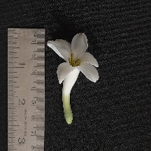 | Cross of Shringar x Mexican Single (developed by IIHR) | Single flowers on tall, stiff spikes; | Khandagale et al. 2014
13 | Arka Sugandhi | 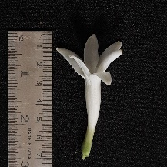 | NA | Small size spike with more number of single florets (developed by IIHR) | Sirohi et al. 2017

NA: Not Available

Table 2. List of primers used in the present study for molecular profiling of Tuberose cultivars

Primers | Sequence | Primers | Sequence
Me1 | 5'- TGA GTC CAA ACC GGA TA-3' | Em1 | 5'- GAC TGC GTA CGA ATT AAT-3'
Me2 | 5'-TGA GTC CAA ACC GGA GC-3' | Em2 | 5'- GAC TGC GTA CGA ATT TGC-3'
Me3 | 5'- TGA GTC CAA ACC GGA AT-3' | Em3 | 5'- GAC TGC GTA CGA ATT GAC-3'
Me4 | 5'- TGA GTC CAA ACC GGA CC-3' | Em4 | 5'- GAC TGC GTA CGA ATT TGA-3'
Me5 | 5'-TGA GTC CAA ACC GGA AG-3' | Em6 | 5'- GAC TGC GTA CGA ATT GCA-3'
 |  | Em7 | 5′- GAC TGC GTA CGA ATT CAA-3′
 |  | Em12 | 5′- GAC TGC GTA CGA ATT GTC -3′
 |  | Em15 | 5′- GAC TGC GTA CGA ATT CTG -3′

Table 3. Growth attributes of Tuberose genotypes

Sr. No. | Genotypes | Plant Height (cm) | Spike Length (cm) | Rachis Length (cm) | Leaf Length (cm) | Leaf Width (cm) | No. of Leaves | Flower Length (cm) | Flower Diameter (cm) | Total No. of Flowers | Total No. of Spikes | Inter-Floret Length (cm)
1 | Arka Nirantara | 81.33 | 68.48 | 36.21 | 58.42 | 2.38 | 15.20 | 5.55 | 4.83 | 35.50 | 5.50 | 5.06
2 | Mexican single | 99.11 | 86.91 | 19.22 | 42.75 | 1.85 | 12.40 | 6.83 | 4.27 | 24.80 | 5.80 | 4.67
3 | Phule Rajani | 88.56 | 76.35 | 31.42 | 56.41 | 2.52 | 15.80 | 5.99 | 4.26 | 37.40 | 4.80 | 4.98
4 | Local single | 104.60 | 91.45 | 18.55 | 40.60 | 1.80 | 4.00 | 6.50 | 4.55 | 30.00 | 2.50 | 4.70
5 | Bidhan Ujjwal | 57.10 | 45.53 | 25.03 | 30.55 | 2.85 | 12.25 | 6.25 | 4.48 | 22.50 | 6.10 | 5.28
6 | Suvasini | 100.07 | 87.43 | 39.20 | 42.24 | 2.29 | 12.20 | 7.00 | 4.73 | 43.90 | 7.50 | 4.78
7 | Arka Vaibhav | 89.42 | 76.96 | 38.98 | 58.20 | 2.42 | 13.60 | 5.10 | 4.20 | 36.80 | 6.60 | 6.92
8 | Sikkim Selection | 99.76 | 86.64 | 21.54 | 44.95 | 1.94 | 11.80 | 6.08 | 4.33 | 23.20 | 5.67 | 4.34
9 | GKTC-4 | 70.60 | 55.75 | 34.45 | 35.00 | 4.35 | 11.00 | 6.45 | 5.40 | 40.00 | 4.00 | 5.40
10 | Local double | 80.90 | 68.70 | 40.90 | 50.70 | 2.80 | 12.00 | 4.90 | 4.10 | 36.00 | 4.00 | 6.80
11 | Hyderabad single | 75.55 | 63.69 | 22.86 | 53.09 | 2.60 | 13.80 | 5.65 | 4.00 | 34.80 | 3.80 | 3.96
12 | Arka Prajwal | 121.65 | 109.33 | 23.74 | 74.34 | 2.33 | 16.60 | 7.93 | 4.61 | 39.80 | 7.20 | 5.13
13 | Arka Sugandhi | 85.15 | 72.10 | 37.15 | 40.00 | 2.60 | 15.00 | 5.70 | 4.05 | 39.00 | 4.50 | 5.30

Table 4. Details of SRAP marker profiling of Tuberose cultivars

Sr. No. | Primer combinations | Amplicon range (bp) | Total no. of bands | Total no. of polymorphic bands | Fraction polymorphism | PIC value | EMR | MI | RP
1 | m1-e1 | 50-500bp | 3 | 3 | 1.00 | 0.696 | 3 | 2.088 | 10.66
2 | m1-e2 | 50-700bp | 5 | 5 | 1.00 | 0.722 | 5 | 3.609 | 12.4
3 | m1-em3 | 75-350bp | 4 | 4 | 1.00 | 0.808 | 4 | 3.230 | 10
4 | m1-e6 | 50-1200bp | 7 | 6 | 0.85 | 0.555 | 5.14 | 2.851 | 15.14
5 | m1-em7 | 50-500 | 4 | 4 | 1.00 | 0.926 | 4 | 3.704 | 6
6 | m1-em12 | 50-500 | 4 | 1 | 0.25 | 0.130 | 0.25 | 0.032 | 24
7 | m2-e2 | 50-100 | 2 | 1 | 0.5 | 0.073 | 0.5 | 0.036 | 25
8 | m2-em12 | 50-500 | 6 | 6 | 1.00 | 0.497 | 6 | 2.982 | 16.66
9 | m3-e7 | 50-1200 | 8 | 8 | 1.00 | 0.774 | 8 | 6.195 | 10.75
10 | m1-em7 | 150-600 | 6 | 6 | 1.00 | 0.771 | 6 | 4.627 | 9.33
11 | m4-e7 | 50-500 | 4 | 3 | 0.75 | 0.498 | 2.25 | 1.121 | 15.5
12 | m5-e1 | 100-400 | 3 | 2 | 0.66 | 0.461 | 1.33 | 0.615 | 16.66
13 | m5-e4 | 150-450 | 5 | 4 | 0.8 | 0.349 | 3.2 | 1.117 | 20
14 | m5-e15 | 50bp-400bp | 2 | 1 | 0.5 | 0.142 | 0.5 | 0.071 | 24
Total |  |  | 63 | 54 | 11.31 | 7.402 | 49.17 | 32.278 | 216.1
Mean |  |  | 4.5 | 3.85 | 0.81 | 0.528 | 3.51 | 2.305 | 15.43

Table 5. Jaccard's similarity coefficient based on SRAP markers analysis of Tuberose Cultivars

 | Arka Nirantara | Mexican Single | Phule Rajani | Local Single | Bidhan Ujjwal | Suvasini | Arka Vaibhav | Sikkim Selection | GKTC-4 | Local Double | Hyderabad Single | Arka Prajwal | Arka Sugandhi
Arka Nirantara | 1
Mexican Single | 0.578125 | 1
Phule Rajani | 0.796875 | 0.6875 | 1
Local Single | 0.71875 | 0.765625 | 0.796875 | 1
Bidhan Ujjwal | 0.5625 | 0.828125 | 0.734375 | 0.71875 | 1
Suvasini | 0.78125 | 0.578125 | 0.796875 | 0.6875 | 0.5625 | 1
Arka Vaibhav | 0.515625 | 0.75 | 0.71875 | 0.703125 | 0.890625 | 0.515625 | 1
Sikkim Selection | 0.5625 | 0.765625 | 0.734375 | 0.625 | 0.84375 | 0.59375 | 0.765625 | 1
GKTC-4 | 0.671875 | 0.625 | 0.75 | 0.671875 | 0.640625 | 0.671875 | 0.65625 | 0.640625 | 1
Local Double | 0.78125 | 0.640625 | 0.828125 | 0.6875 | 0.65625 | 0.8125 | 0.609375 | 0.71875 | 0.671875 | 1
Hyderabad Single | 0.765625 | 0.71875 | 0.8125 | 0.734375 | 0.765625 | 0.703125 | 0.6875 | 0.734375 | 0.75 | 0.734375 | 1
Arka Prajwal | 0.84375 | 0.671875 | 0.828125 | 0.78125 | 0.6875 | 0.78125 | 0.640625 | 0.65625 | 0.734375 | 0.8125 | 0.859375 | 1
Arka Sugandhi | 0.78125 | 0.640625 | 0.734375 | 0.75 | 0.625 | 0.6875 | 0.640625 | 0.59375 | 0.765625 | 0.6875 | 0.859375 | 0.84375 | 1
Table 6. Descriptive Statistics of the Morphological Traits measured

Variable | Observations | Obs. with missing data | Obs. without missing data | Minimum | Maximum | Mean | Std. deviation
Plant Height 1 | 13 | 0 | 13 | 57.100 | 121.650 | 88.754 | 16.648
Plant Height 2 | 13 | 0 | 13 | 46.251 | 99.753 | 75.502 | 14.394
Plant Height 3 | 13 | 0 | 13 | 67.949 | 143.547 | 102.006 | 19.211
Spike Length 1 | 13 | 0 | 13 | 45.530 | 109.330 | 76.102 | 16.654
Spike Length 2 | 13 | 0 | 13 | 36.879 | 89.651 | 64.737 | 14.274
Spike Length 3 | 13 | 0 | 13 | 54.181 | 129.009 | 87.466 | 19.267
Rachis Length 1 | 13 | 0 | 13 | 18.550 | 40.900 | 29.942 | 8.313
Rachis Length 2 | 13 | 0 | 13 | 16.337 | 35.174 | 25.522 | 7.432
Rachis Length 3 | 13 | 0 | 13 | 20.591 | 46.626 | 34.363 | 9.236
Leaf Length 1 | 13 | 0 | 13 | 30.550 | 74.340 | 48.250 | 11.803
Leaf Length 2 | 13 | 0 | 13 | 24.746 | 60.959 | 40.931 | 9.543
Leaf Length 3 | 13 | 0 | 13 | 36.355 | 87.721 | 55.569 | 14.152
Leaf Width 1 | 13 | 0 | 13 | 1.800 | 4.350 | 2.518 | 0.644
Leaf Width 2 | 13 | 0 | 13 | 1.573 | 3.785 | 2.141 | 0.563
Leaf Width 3 | 13 | 0 | 13 | 1.998 | 4.916 | 2.895 | 0.730
No. of Leaves 1 | 13 | 0 | 13 | 4.000 | 16.600 | 12.742 | 3.146
No. of Leaves 2 | 13 | 0 | 13 | 3.560 | 13.612 | 10.791 | 2.583
No. of Leaves 3 | 13 | 0 | 13 | 4.440 | 19.588 | 14.693 | 3.734
Flower Length 1 | 13 | 0 | 13 | 4.900 | 7.930 | 6.148 | 0.821
Flower Length 2 | 13 | 0 | 13 | 4.214 | 6.503 | 5.224 | 0.693
Flower Length 3 | 13 | 0 | 13 | 5.586 | 9.357 | 7.073 | 0.979
Flower Diameter 1 | 13 | 0 | 13 | 4.000 | 5.400 | 4.447 | 0.386
Flower Diameter 2 | 13 | 0 | 13 | 3.320 | 4.698 | 3.782 | 0.374
Flower Diameter 3 | 13 | 0 | 13 | 4.577 | 6.102 | 5.112 | 0.428
Total No. of Flowers 1 | 13 | 0 | 13 | 22.500 | 43.900 | 34.131 | 6.881
Total No. of Flowers 2 | 13 | 0 | 13 | 18.225 | 38.632 | 29.074 | 6.187
Total No. of Flowers 3 | 13 | 0 | 13 | 26.775 | 49.168 | 39.187 | 7.663
Total No. of Spikes 1 | 13 | 0 | 13 | 2.500 | 7.500 | 5.228 | 1.458
Total No. of Spikes 2 | 13 | 0 | 13 | 2.225 | 6.600 | 4.433 | 1.222
Total No. of Spikes 3 | 13 | 0 | 13 | 2.775 | 8.496 | 6.024 | 1.706
Inter-Floret Length 1 | 13 | 0 | 13 | 3.960 | 6.920 | 5.178 | 0.848
Inter-Floret Length 2 | 13 | 0 | 13 | 3.287 | 5.951 | 4.406 | 0.759
Inter-Floret Length 3 | 13 | 0 | 13 | 4.633 | 7.889 | 5.951 | 0.953

Table 7. Results of Eigen Roots, Variability, and Cumulative from Multiple Factor Analysis

 | Eigenvalue | Variability (%) | Cumulative %
F1 | 3.577 | 32.086 | 32.086
F2 | 2.731 | 24.496 | 56.583
F3 | 1.816 | 16.295 | 72.878
F4 | 1.251 | 11.225 | 84.103
F5 | 0.811 | 7.278 | 91.381
F6 | 0.502 | 4.500 | 95.881
F7 | 0.275 | 2.466 | 98.347
F8 | 0.108 | 0.966 | 99.313
F9 | 0.055 | 0.494 | 99.807
F10 | 0.018 | 0.165 | 99.972
F11 | 0.003 | 0.027 | 99.999
F12 | 0.000 | 0.001 | 100.000

Table 8. Correlations between variables and factors for quantitative traits of 13 Tuberose genotypes

 | F1 | F2 | F3 | F4 | F5
Plant Height 1 | 0.910 | 0.209 | 0.061 | -0.323 | 0.029
Plant Height 2 | 0.861 | 0.187 | 0.092 | -0.439 | 0.059
Plant Height 3 | 0.932 | 0.222 | 0.037 | -0.231 | 0.005
Spike Length 1 | 0.921 | 0.211 | 0.030 | -0.303 | 0.033
Spike Length 2 | 0.883 | 0.191 | 0.055 | -0.406 | 0.062
Spike Length 3 | 0.937 | 0.224 | 0.010 | -0.224 | 0.012
Rachis Length 1 | -0.558 | 0.729 | 0.001 | -0.215 | 0.160
Rachis Length 2 | -0.548 | 0.706 | 0.026 | -0.271 | 0.169
Rachis Length 3 | -0.564 | 0.744 | -0.020 | -0.169 | 0.151
Leaf Length 1 | 0.482 | 0.656 | -0.237 | 0.019 | -0.326
Leaf Length 2 | 0.472 | 0.679 | -0.231 | -0.069 | -0.310
Leaf Length 3 | 0.487 | 0.637 | -0.239 | 0.078 | -0.335
Leaf Width 1 | -0.745 | 0.178 | 0.515 | 0.097 | -0.189
Leaf Width 2 | -0.747 | 0.183 | 0.538 | 0.010 | -0.174
Leaf Width 3 | -0.738 | 0.173 | 0.492 | 0.164 | -0.199
No. of Leaves 1 | 0.029 | 0.697 | -0.191 | 0.625 | -0.225
No. of Leaves 2 | -0.002 | 0.737 | -0.177 | 0.572 | -0.210
No. of Leaves 3 | 0.050 | 0.664 | -0.199 | 0.658 | -0.235
Flower Length 1 | 0.673 | -0.070 | 0.648 | 0.205 | 0.049
Flower Length 2 | 0.640 | -0.079 | 0.710 | 0.023 | 0.079
Flower Length 3 | 0.675 | -0.061 | 0.584 | 0.328 | 0.027
Flower Diameter 1 | -0.133 | 0.028 | 0.916 | -0.017 | 0.090
Flower Diameter 2 | -0.161 | 0.025 | 0.890 | -0.256 | 0.113
Flower Diameter 3 | -0.099 | 0.029 | 0.877 | 0.193 | 0.064
Total No. of Flowers 1 | -0.099 | 0.768 | 0.339 | -0.307 | -0.316
Total No. of Flowers 2 | -0.124 | 0.722 | 0.358 | -0.387 | -0.266
Total No. of Flowers 3 | -0.077 | 0.795 | 0.320 | -0.238 | -0.354
Total No. of Spikes 1 | 0.363 | 0.522 | 0.104 | 0.519 | 0.535
Total No. of Spikes 2 | 0.348 | 0.546 | 0.127 | 0.451 | 0.557
Total No. of Spikes 3 | 0.371 | 0.501 | 0.087 | 0.563 | 0.515
Inter-Floret Length 1 | -0.446 | 0.536 | -0.225 | -0.335 | 0.437
Inter-Floret Length 2 | -0.450 | 0.516 | -0.180 | -0.452 | 0.433
Inter-Floret Length 3 | -0.435 | 0.543 | -0.257 | -0.236 | 0.433

