Figure 5. Curcumin improved hippocampal neurogenesis and synaptic plasticity in mice subjected to hypoxia stress. (A) Fluorogram of BrdU-positive (newborn) cells in the subgranular zone-granule cell layer of the hippocampus in mice. (B) Histograms showing the number of BrdU-positive cells as shown in BrdU staining. (C-D) Representative dendritic segments of CA1 pyramidal neurons (AO = apical oblique dendrite) in each group of Thy-l-YFP mice. (E) Dendritic spine density expressed as the number of spines normalized to 15 μm of dendritic length. (F-G) Western blots of PSD95, Homer1 and BDNF in the hippocampus. Histograms on the right show relative protein band density. All data are expressed as mean ± SEM, n = 3, *p < 0.05, **p < 0.01 versus Con group, #p < 0.05 versus H14d group.

The original image of BrdU in Figure 5
- The picture marked in the red box is the Con group BrdU in Figure 5 which we captured and displayed in the manuscript.
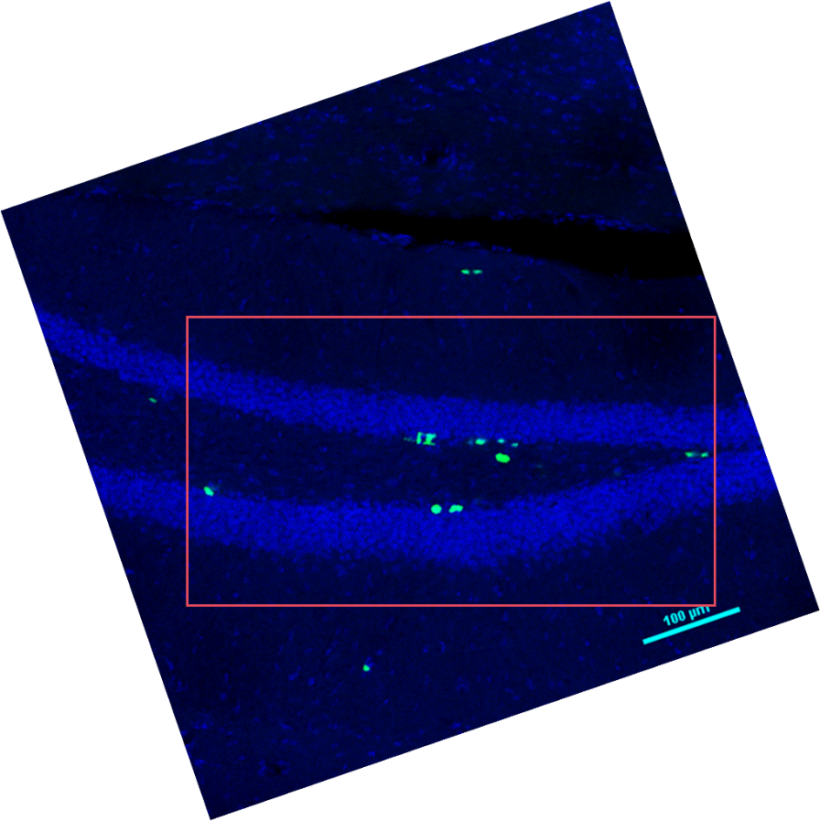
- The picture marked in the red box is the H14d group BrdU in Figure 5 which we captured and displayed in the manuscript.
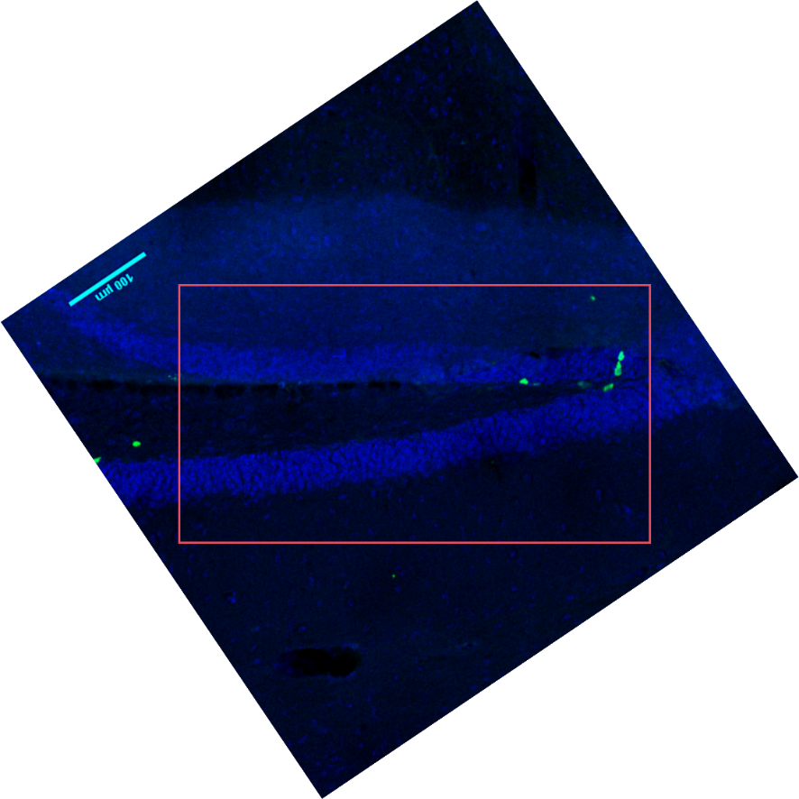
- The picture marked in the red box is the Cur group BrdU in Figure 5 which we captured and displayed in the manuscript.
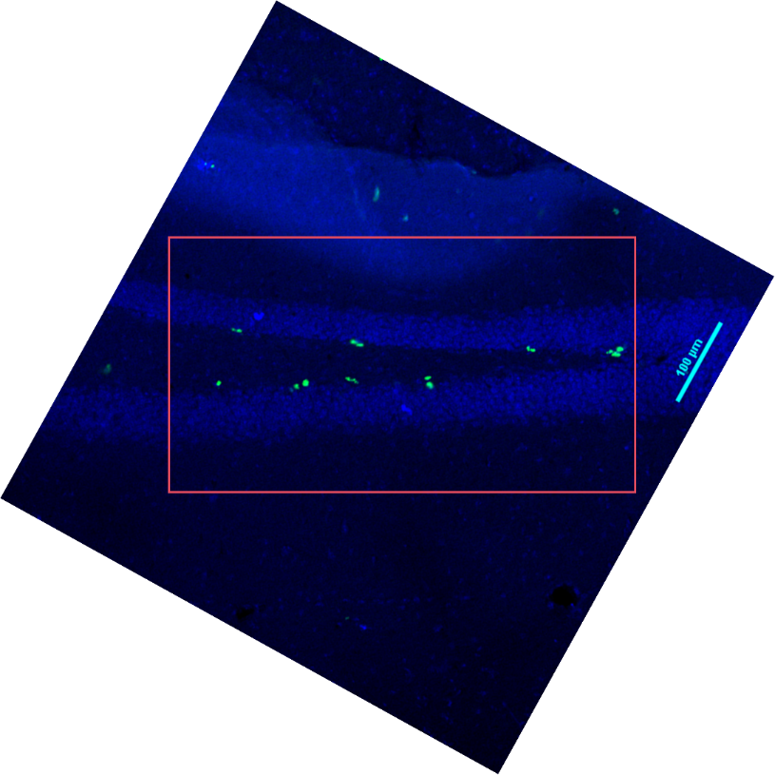

- The picture marked in the red box is the H14d+Cur group BrdU in Figure 5 which we captured and displayed in the manuscript.
