Figure 4. Curcumin improved hypoxic-induced hippocampal neurodegeneration.
- FJC staining was used to evaluate the neurodegeneration of the CA1 and DG regions in the mice hippocampus of each group. (B-C) Histograms showing the number of FJC-positive cells as shown in (A). Data are expressed as mean ± SEM, n = 3, ***p < 0.001 versus Con group, ##p < 0.01, ###p < 0.01 versus H14d group.

The original image of FJC-CA1 in Figure 4
- The picture marked in the red box is the Con group FJC-CA1 in Figure 4 which we captured and displayed in the manuscript.
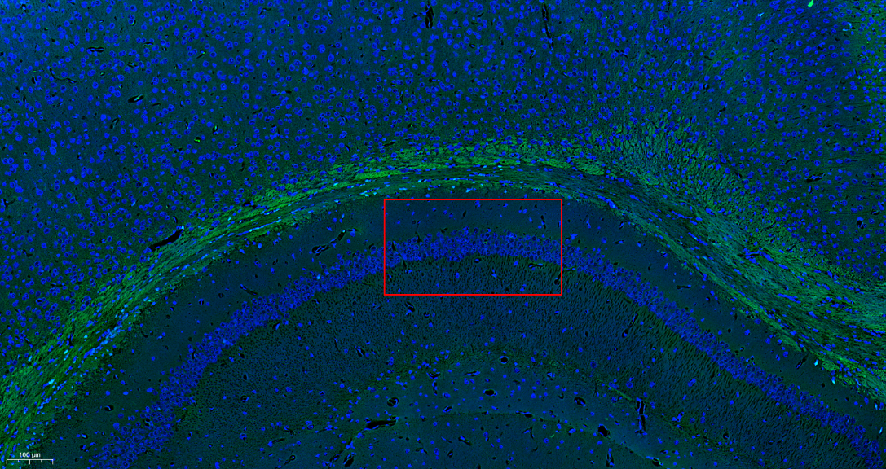
- The picture marked in the red box is the H14d group FJC-CA1 in Figure 4 which we captured and displayed in the manuscript.
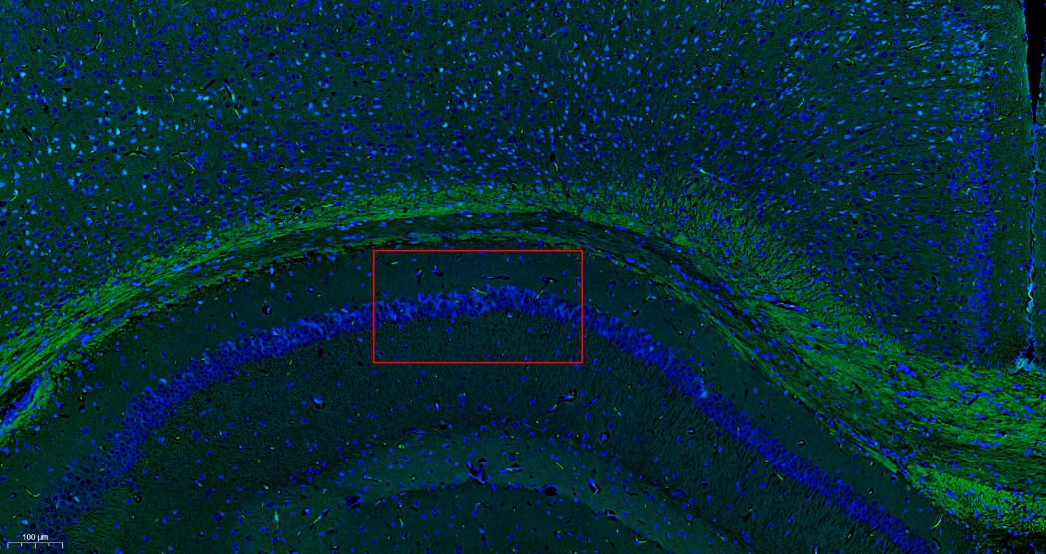

- The picture marked in the red box is the Cur group FJC-CA1 in Figure 4 which we captured and displayed in the manuscript.
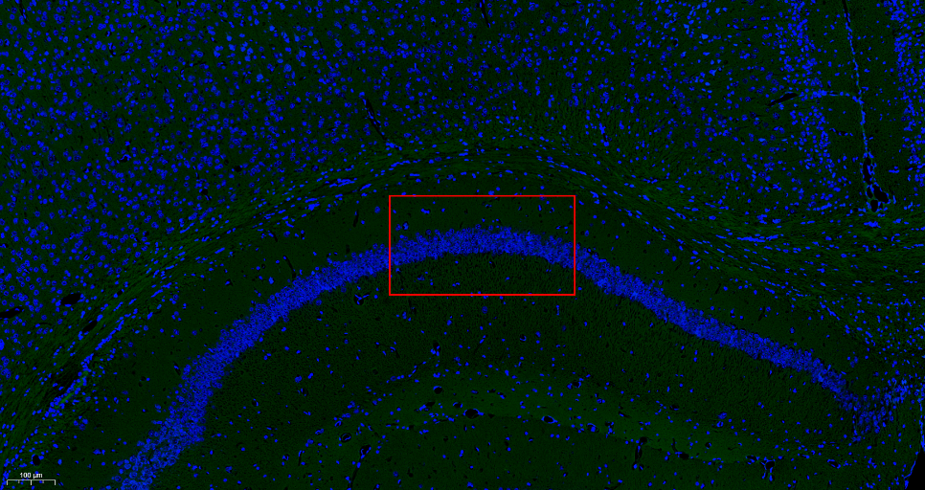

- The picture marked in the red box is the H14d+Cur group FJC-CA1 in Figure 4 which we captured and displayed in the manuscript.
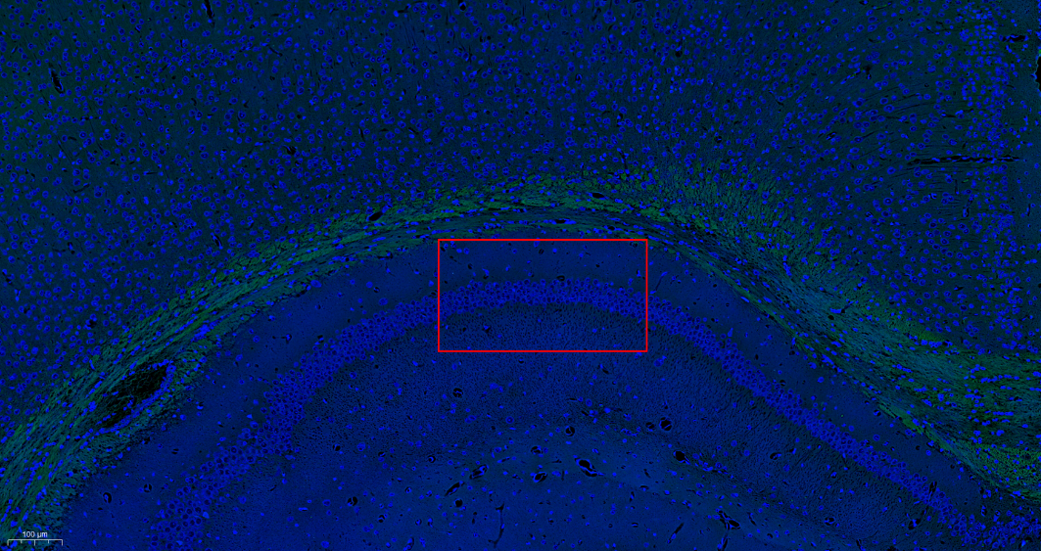

The original image of FJC-DG in Figure 4
- The picture marked in the red box is the CON group FJC-DG in Figure 4 which we captured and displayed in the manuscript.

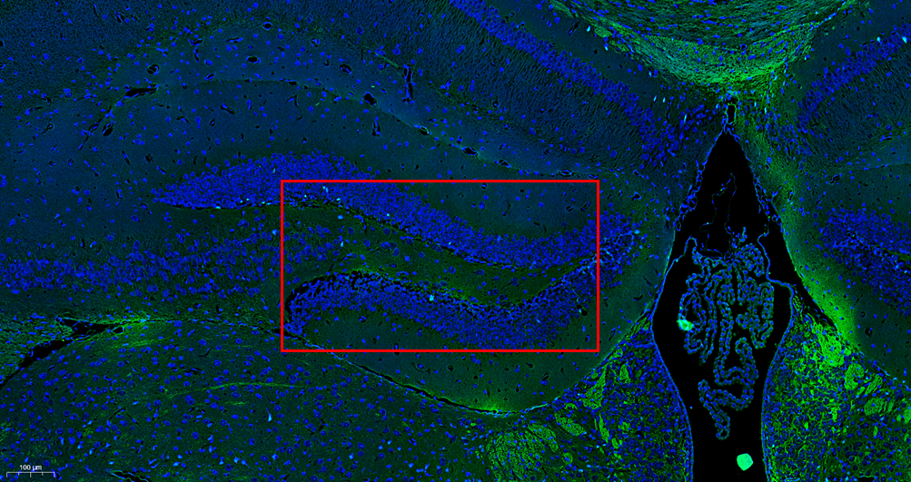

- The picture marked in the red box is the H14d group FJC-DG in Figure 4 which we captured and displayed in the manuscript.
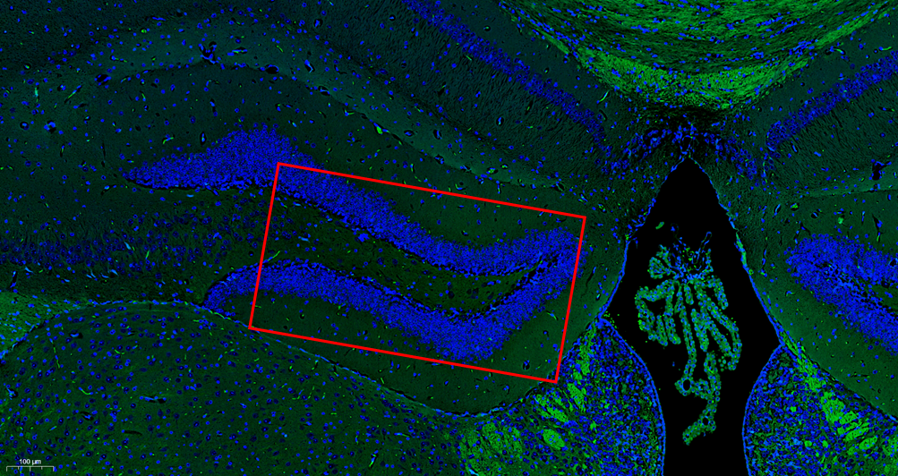

- The picture marked in the red box is the Cur group FJC-DG in Figure 4 which we captured and displayed in the manuscript.
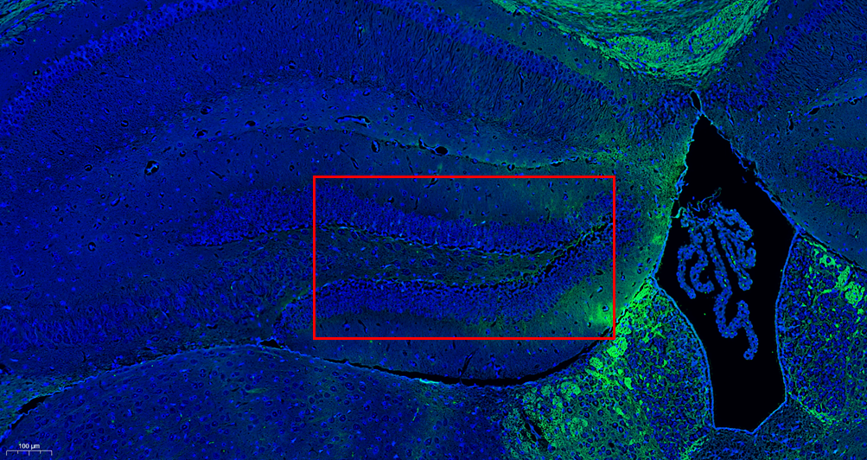

- The picture marked in the red box is the H14d+Cur group FJC-DG in Figure 4 which we captured and displayed in the manuscript.
