Figure 6. Curcumin promoted dendritic growth of primary hippocampal neurons subjected to hypoxia stress in vitro. (A-B) Effects of curcumin on cell viability and cytotoxicity of primary neurons subjected to hypoxia stress. (C) Representative images of MAP2 staining. (D-E) Quantification of total cultured neuron numbers and total dendritic length. (F-G) Western blot of PSD95 and BDNF in the hippocampus neurons. The histogram below shows the relative protein band density. Con = control group; H4h = neurons treated with 0-0.1% O₂ for 4 h group; cur-1/2/3/4/5 = curcumin (1, 5, 10, 20, 25 μM) groups; H14d+Cur = H14d+curcumin group. All data are expressed as mean ± SEM, n = 3, *p < 0.05, **p < 0.01 versus Con group, #p < 0.05, ##p < 0.01 versus H4h group.

The original image of MAP2 in Figure 6
- The picture marked in the red box is the Con group MAP2 in Figure 6 which we captured and displayed in the manuscript.
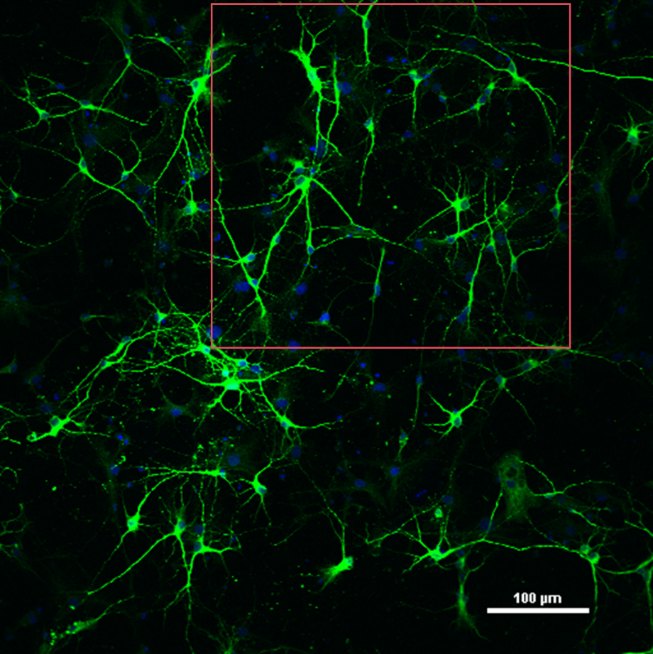

- The picture marked in the red box is the H4h group MAP2 in Figure 6 which we captured and displayed in the manuscript.
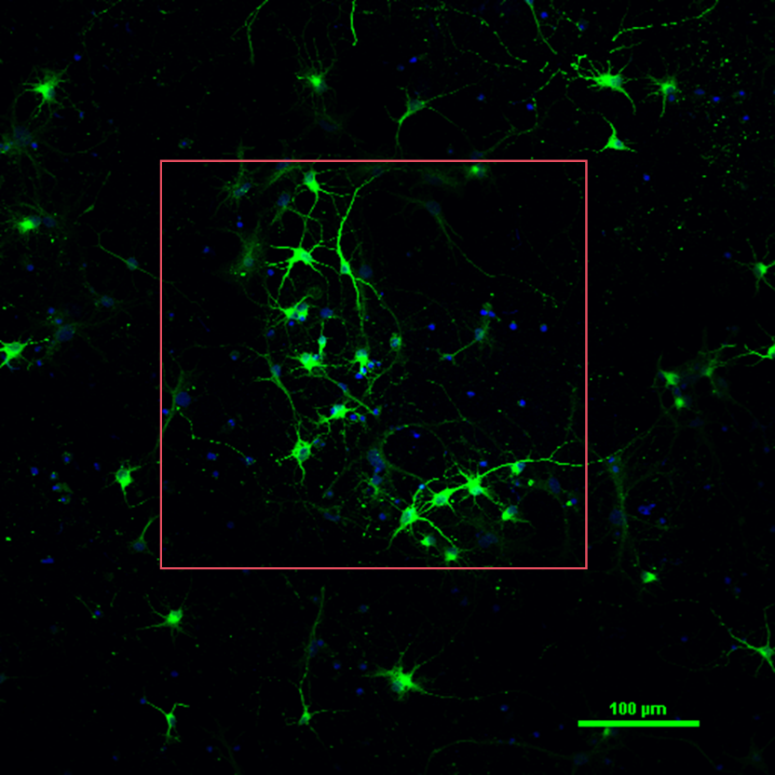
- The picture marked in the red box is the H4h+Cur group MAP2 in Figure 6 which we captured and displayed in the manuscript.
