Supplementary Figures.

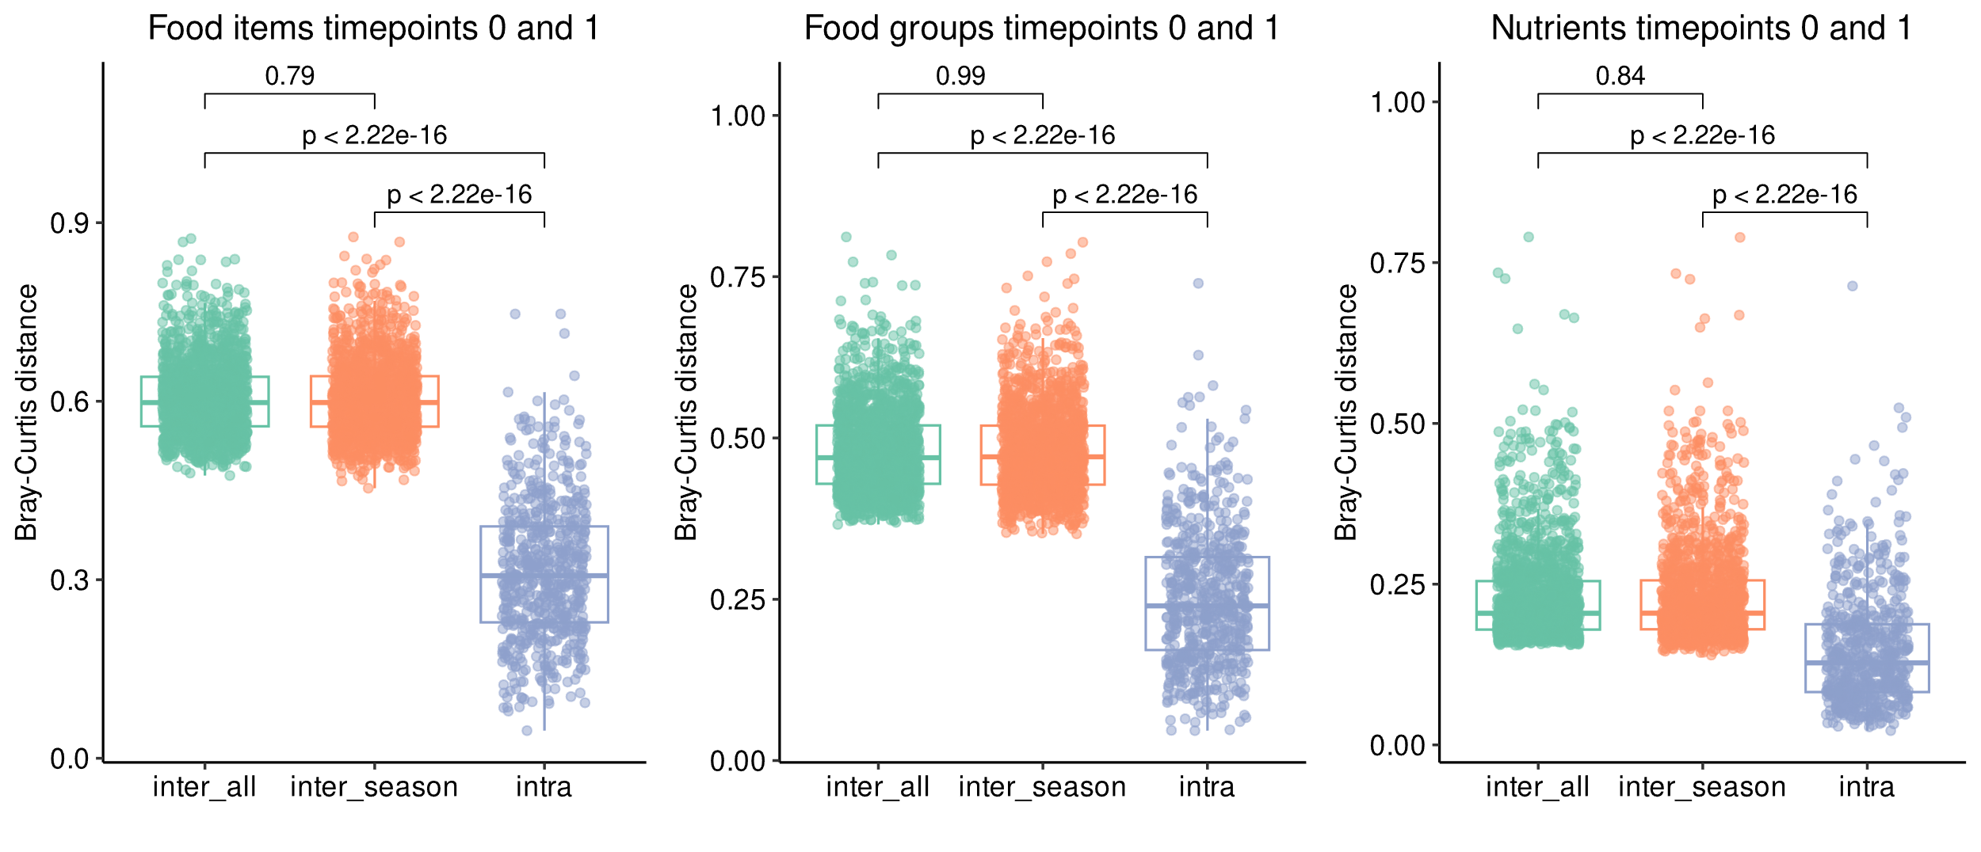
Figure S1. Intra- and Inter-individual variability of dietary intake across timepoints 0 and 1. We computed the Bray-Curtis dissimilarity index between samples, taking into account A) food items, B) food groups, and C) nutrients. Inter_all shows, for each sample, the median of distances between the samples and all the other samples. Inter_season shows, for each sample, the median of distances between the sample and other samples taken on the same season. Intra shows for each participant the distance between timepoint 0 and timepoint 1, which are 6-month apart and thus in different seasons. Differences were tested for significance using Mann-Whitney test.

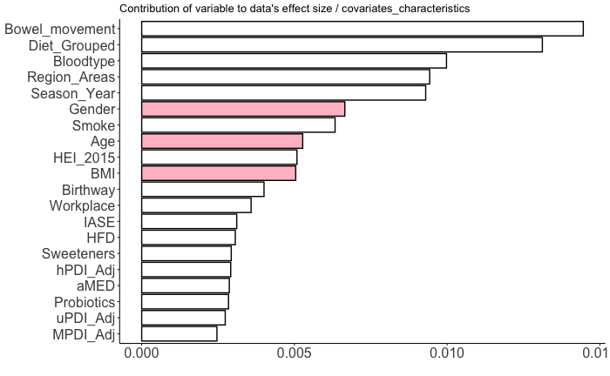
Figure S2. Effect size of the dietary data on the microbiome data. The magnitude of the influence of dietary intake on the microbiome was calculated using permutational analysis of variance (PERMANOVA), as implemented in the adonis2 function of the vegan R and using the Bray-Curtis method (n = 500).

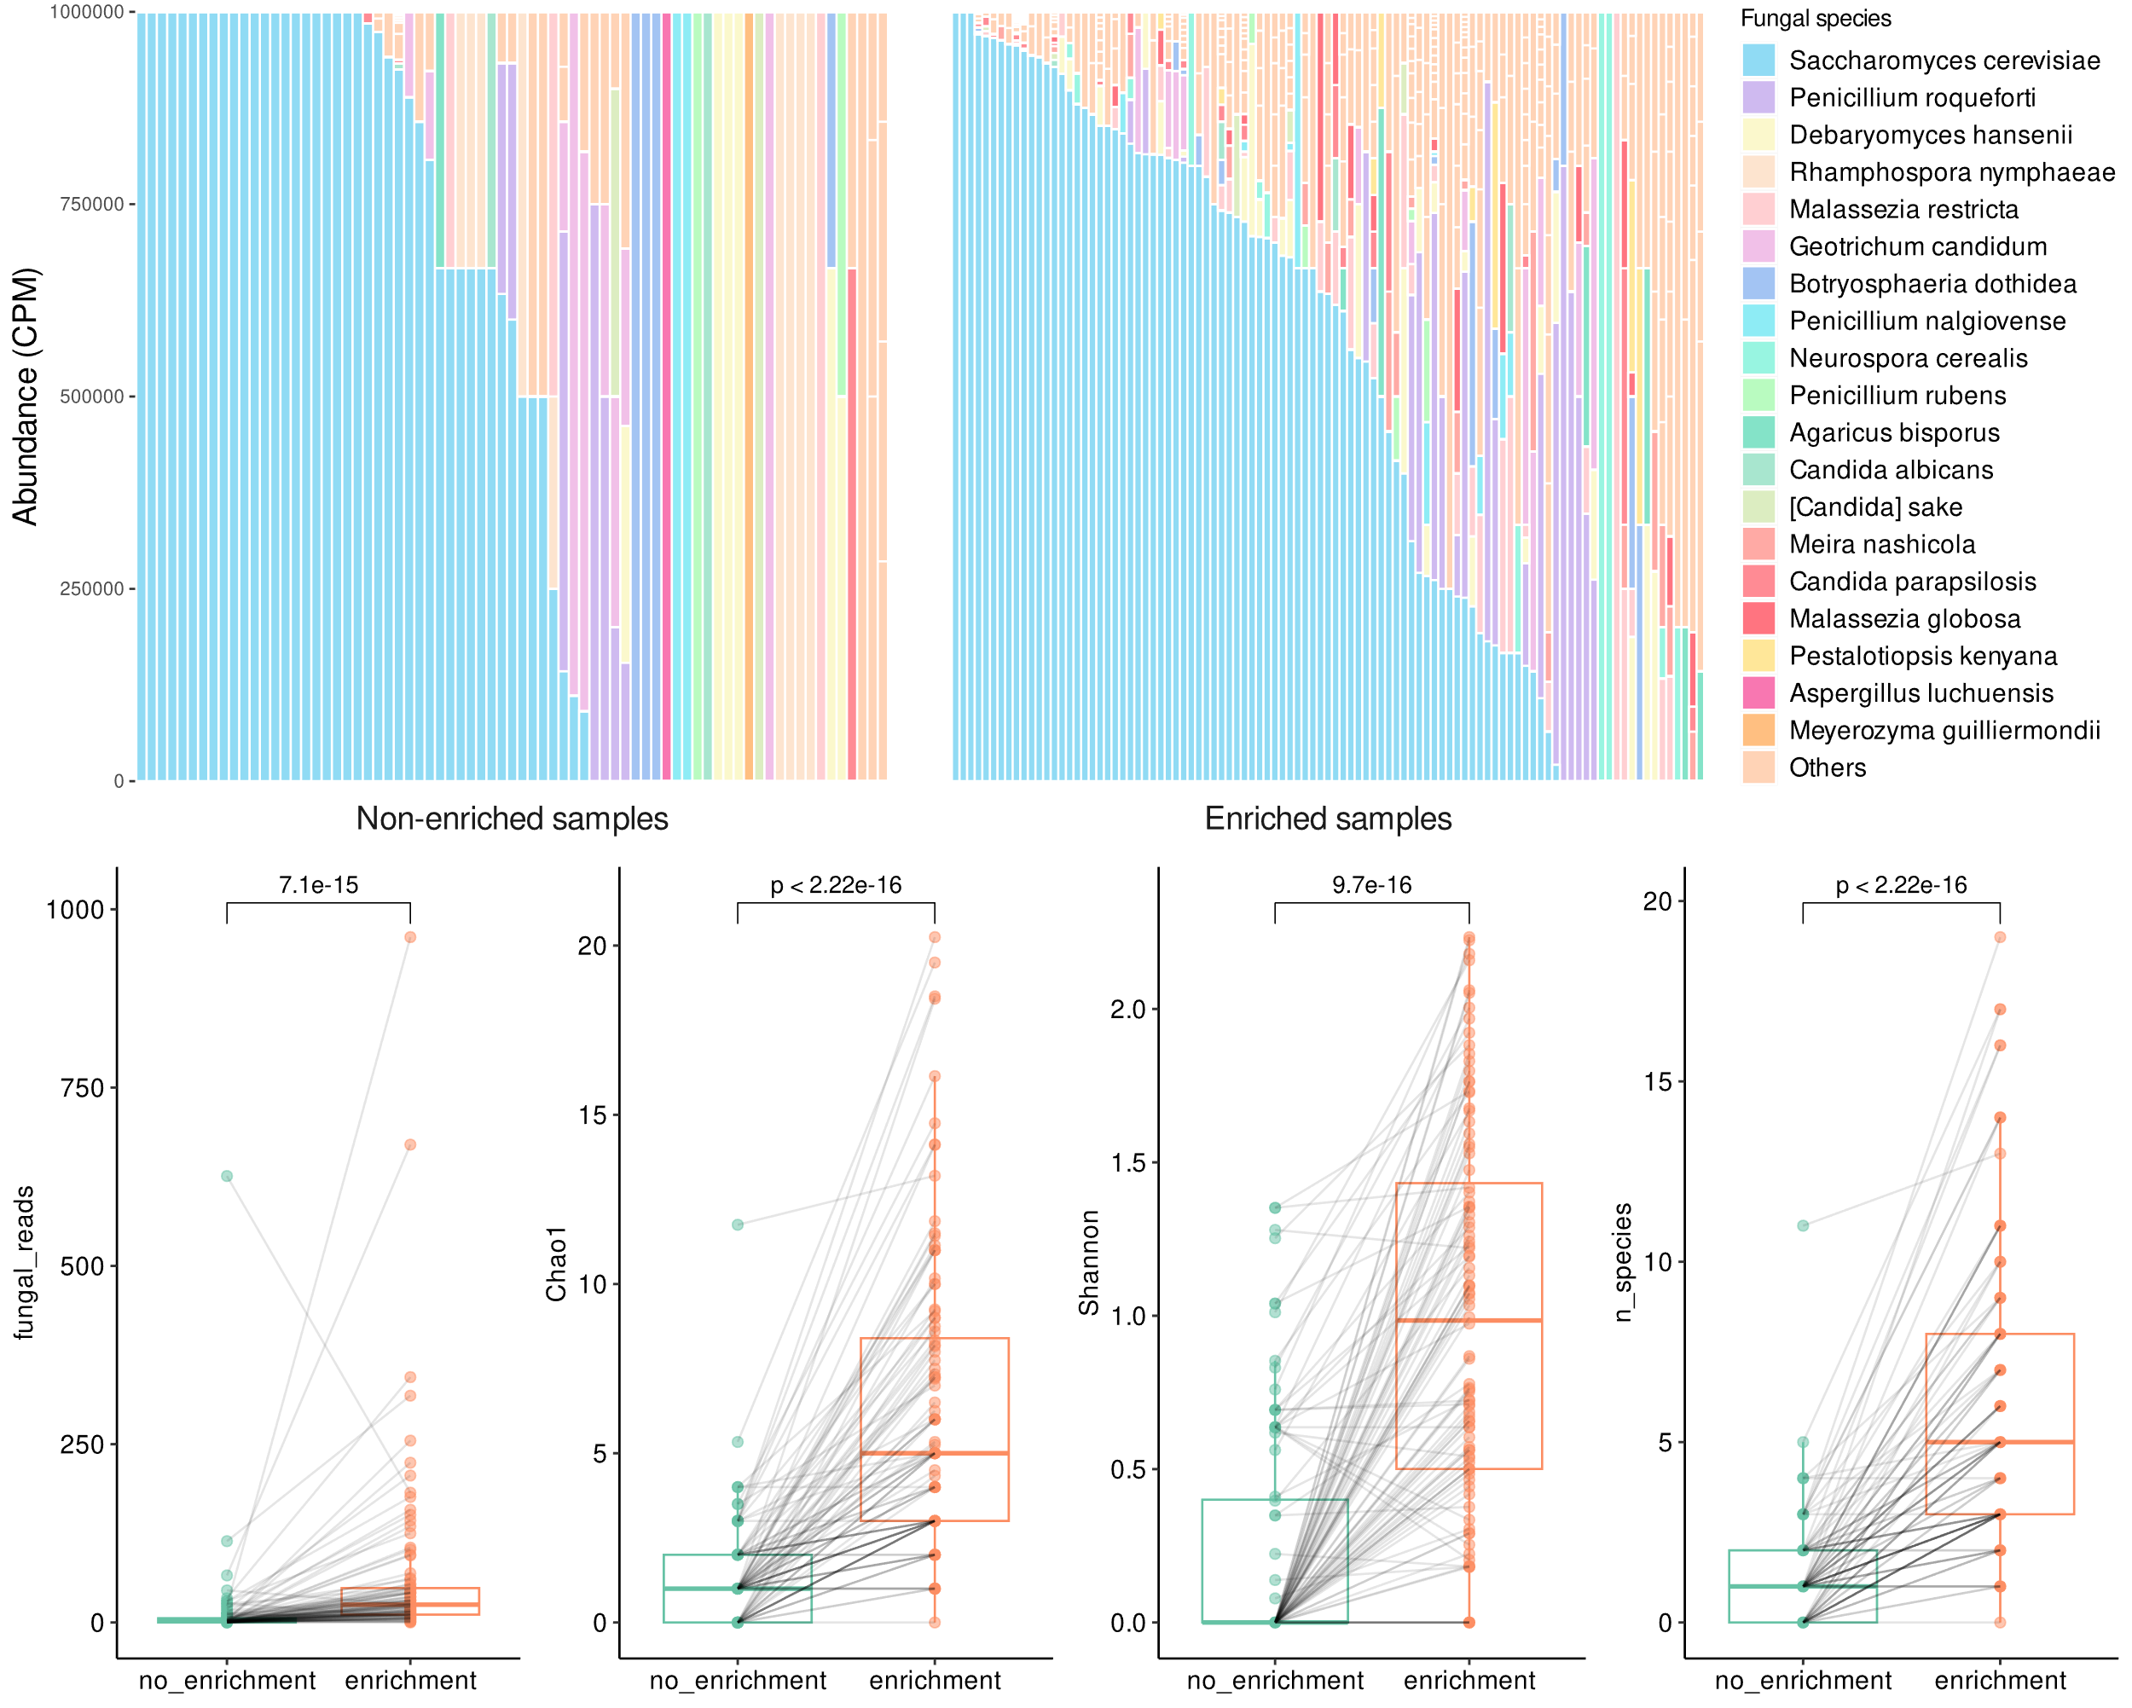
Figure S3. Fungal profiling comparison between enrichment and non-enrichment protocols (n=99). A) Distribution of mapped fungal reads per sample. B) Comparison of mapped fungal reads per sample between enrichment and non-enrichment protocols. Significance was tested with paired Wilcoxon test. C) Comparison of alpha diversity metrics (Chao1, Shannon and number of species) between enrichment and non-enrichment protocols. Significance was tested with paired Wilcoxon test.

