Supplementary Information

Supplementary Table S1. Soil chemical and physical properties.
Parameters |  | Results | Unit
Granulometry | Clay | 12
Granulometry | Loam | 28 | %
Granulometry | Sand | 60
pH |  | 8.36
Electric Conductivity (EC) 1/5 at 25°C |  | 0.19 | mS/cm
Total Limestone (CaCO₃) |  | 4.3 | %
Organic matter (OM) |  | 1.06 | %
Phosphorus (Olsen) (P2O₅) |  | 25 | mg/Kg
Exchangeable bases | K₂O | 140
Exchangeable bases | Na₂O | 123
Exchangeable bases | MgO | 384 | mg/Kg
Exchangeable bases | CaO | 8699
Oligoelements | Cu | 0.29
Oligoelements | Mn | 2.87
Oligoelements | Fe | 2.42 | mg/Kg
Oligoelements | Zn | 0.26

Supplementary Table S2. Fertilizer Doses and Sources.
 | Nutrient Doses
Unit | (Kg/Ha) |  | Mg/Pot
Application rate | 50% | 100% | 50% P | 100% P
Nitrogen (N) | 25 | 25 | 138.89 | 138.89
Phosphorus (P₂O₅) | 60 | 30 | 333.33 | 166.67
Potassium (K₂O) | 25 | 25 | 138.89 | 138.89
 | Sources
Ammonium phosphate NH₄H₂P0₄ (11-62-0) | 49.18 | 98.36 | 273.22 | 546.45
Potassium Nitrate, KNO₃ (13.7-0-46.2) | 54.11 | 54.11 | 300.63 | 300.63
Ammonium Nitrate, NH₄NO₃ (33.5-0-0) | 74.63 | 37.31 | 414.59 | 207.30

Supplementary Table S3. Effect of phosphorus and Rhizophagus irregularis inoculation on mycorrhizal root colonization and intensity of colonization.
 | Frequency of colonization |  | Intensity of Colonization
Source of Variation | F value | Pr(>F) | F value | Pr(>F)
AMF | 0.098 | 0.754 | 0.098 | 0.754
P | 5.090 | 0.027 | 3.419 | 0.069
AMF:P | 0.999 | 0.321 | 0.134 | 0.715

Supplementary Figure S1
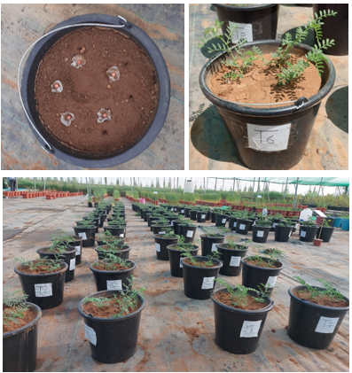
Supplementary figure 1. An illustration of the sowing technic (using filter paper) and the pots after thinning

Supplementary Figure S2
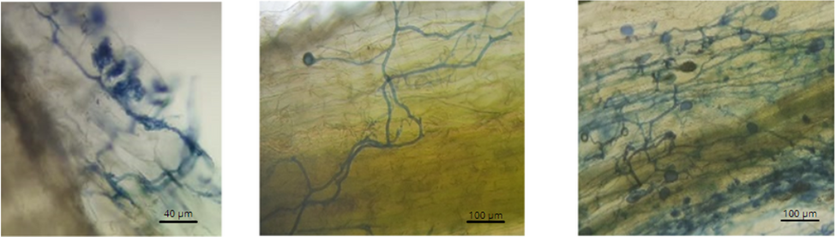
Supplementary Figure S2. Stained AMF inside chickpea roots visualized under an optical microscope showing Arbuscules, spores and external hyphae.

Supplementary Figure S3
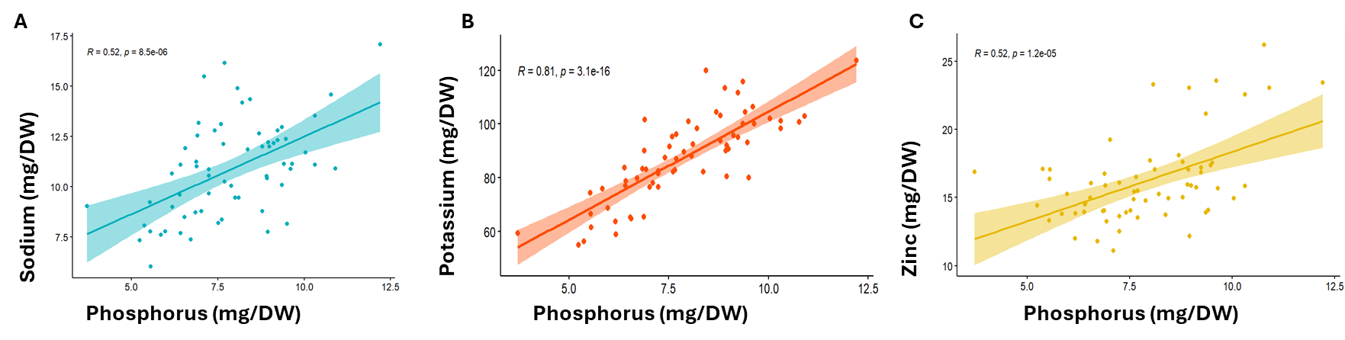
Supplementary Figure S3. correlation between chickpea phosphorus, sodium, and potassium content. Increasing P uptake by plant resulted in more a) Sodium (Na), b) potassium (K) and c) zinc uptake, however, zinc content correlated less with P.
Supplementary Figure S4.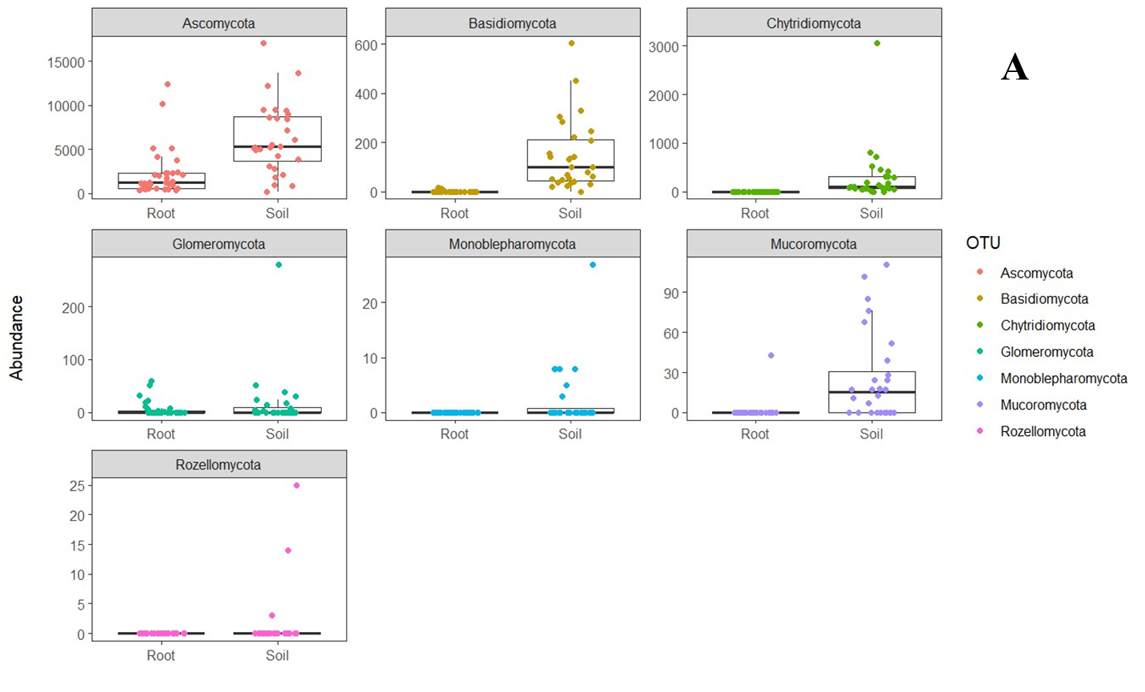
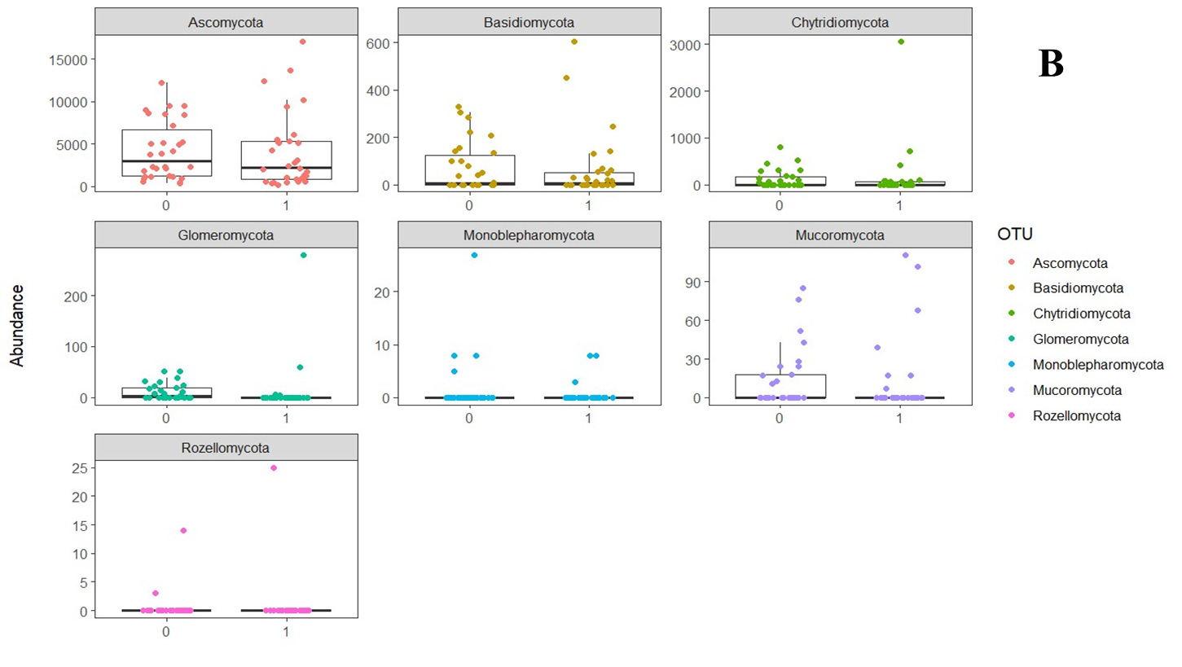
Supplementary Figure S4. ASV counts of chickpea rhizosphere and roots fungal taxa at phyla level. Ascomycota had the highest ASV counts in root and soil. The abundance of Basidiomycota, Chytridiomycota, Monoblepharomycota and Mucoromycota were far less in roots than soil where there were not many differences between the number of ASVs of Glomeromycota in root and soil). ASVs belonging to Basidiomycetes, Glomeromycota and Monoblepharomycota appear to decline in AMF-inoculated samples compared to non-inoculated control, whereas ASVs belonging to Ascomycetes, Mucoromycota appears to be enriched in AMF-inoculated samples b).
Supplementary Figure S5.
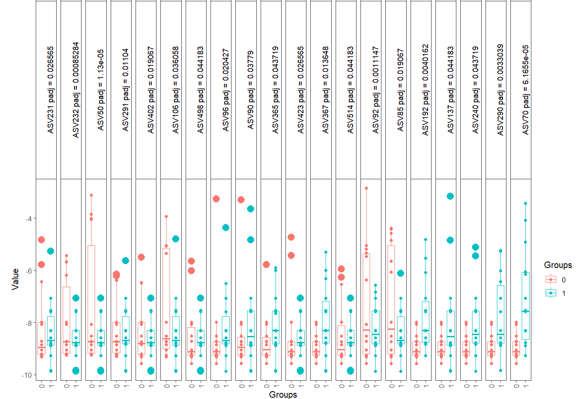
Supplementary Figure S5. Differentially abundant taxa in chickpea soil compartment of chickpea in response to AMF inoculation.

Supplementary Figure S6.
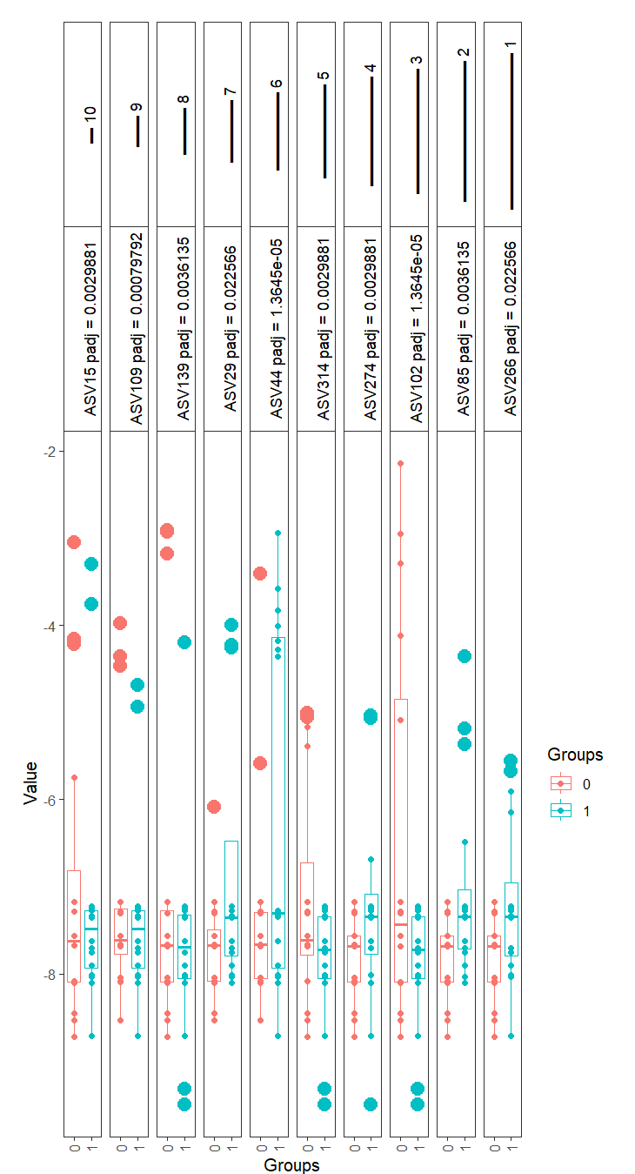
Supplementary Figure S6. Differentially abundant taxa in chickpea roots compartment of chickpea in response to AMF inoculation.

Supplementary Figure S7.
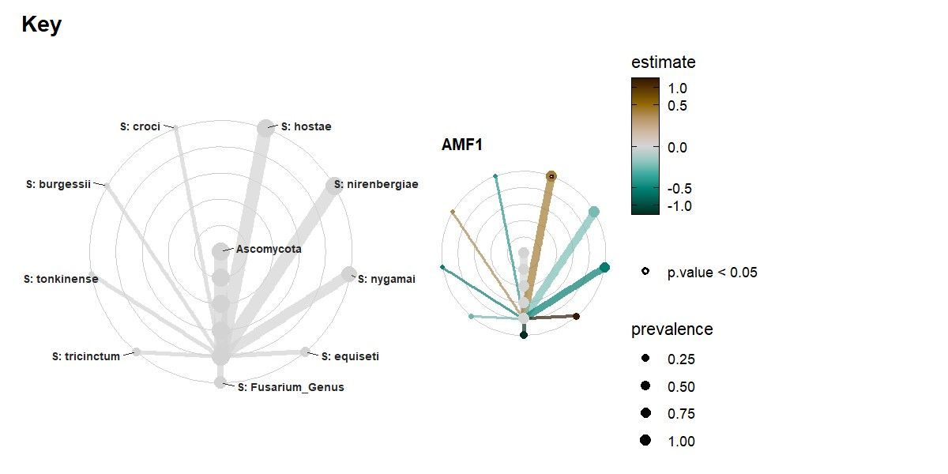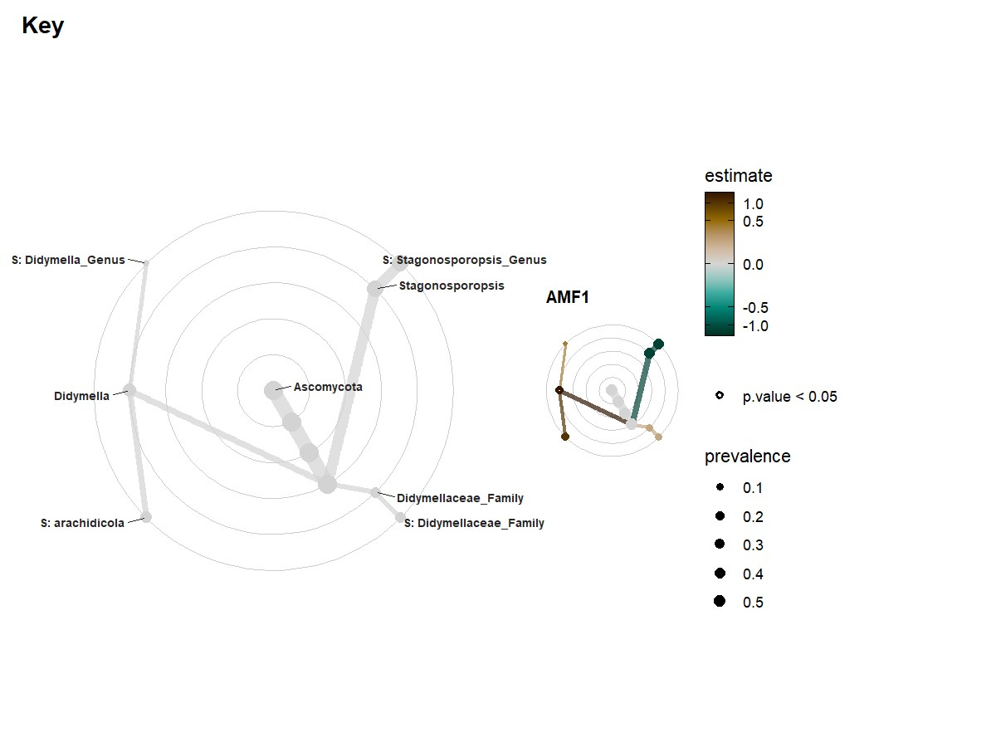
A
B

Supplementary Figure S7. Taxa tree model showing the effect of AMF on Fusarium (a) and Didymellaceae (b).

