Supplementary Information for:
Entanglement of Spin Transition and Elastic Interactions: Manipulating the Slow Spin Equilibrium by Guest-Mediated Fine-Tuning Elastic Frustration
Yuqiao Chai,¹ Yu-Ting Yang,^{1,2} Xing Li,² Bao Li,³* and Jin-Peng Xue²*

¹School of Material and Chemical Engineering, Ningbo University of Technology, Ningbo, Zhejiang, 315211, China.
²School of Materials Science and Chemical Engineering, Ningbo University, Ningbo, 315211, China
³Key Laboratory of Material Chemistry for Energy Conversion and Storage, School of Chemistry and Chemical Engineering, Huazhong University of Science and Technology, Wuhan, Hubei 430074, China
*Correspondence to: xuejinpeng@nbu.edu.cn (J.-P. Xue.); libao@hust.edu.cn (B. Li).

Table of Contents
General Experimental Section S4
Synthesis of ligand (1E,2E)-3-phenyl-N-(4H-1,2,4-triazol-4-yl)prop-2-en-1-imine S4
Assignation of the guest molecules types in 1·3H₂O·3/2CH₃OH S4
Figure S1 | The asymmetric unit of 1·3H₂O·3/2CH₃OH. S5
Figure S2 | The asymmetric unit with Q peaks in the pore of framework S5
Figure S3 | Building units of the title 2D coordination polymer S6
Figure S4 | Pore structure and supramolecular packing S6
Figure S5 | Distribution of H₂O and CH₃OH at different temperatures S7
Figure S6 | The inferred instability of the framework in pure CH₃OH S7
Figure S7 | The full PXRD patterns during guest exchange S8
Figure S8 | T-dependent χ_{M}T values with various H₂O-CH₃OH ratios. S8
Figure S9 | T-dependent χ_{M}T values with 5:5 H₂O-CH₃OH ratio S9
Figure S10 | T-dependent χ_{M}T values with 10:0 H₂O-CH₃OH ratio S9
Figure S11 | The enlarged view of the χ_{M}T with various H₂O-CH₃OH ratios S10
Figure S12 | T-dependent unit-cell volume S10
Figure S13 | T vs χ_{M}T of 10:0 D₂O-CH₃OH ratio and local enlarged view S11
Figure S14 | T vs χ_{M}T of 5:5 H₂O-D₂O ratio and local enlarged view S11
Figure S15 | T vs χ_{M}T of D₂O, H₂O, 5:5 H₂O-D₂O, 8:2 H₂O(D₂O)-CH₃OH ratios. S12
Figure S16 | T vs χ_{M}T of 8:2 D₂O-CH₃OH ratio and local enlarged view S12
Figure S17 | Plot of the guest dependence of γ_{HS} S13
Figure S18 | T vs χ_{M}T values of 8:2 H₂O-CH₃OH ratio starting at 250 K S13
Figure S19 | The enlarged view of the interval of 140−220 (a) and 60−115 K (b) S14
Figure S20 | T vs χ_{M}T values of 8:2 H₂O-CH₃OH ratio starting at 300 K S14
Figure S21 | The enlarged view of the interval of 140−220 (a) and 60−115 K (b) S15
Figure S22 | T vs χ_{M}T values of 10:0 H₂O-CH₃OH ratio starting at 250 K S15
Figure S23 | The enlarged view of the interval of 140−220 (a) and 60−115 K (b) S16
Figure S24 | T vs χ_{M}T values of 10:0 H₂O-CH₃OH ratio starting at 300 K S16
Figure S25 | The enlarged view of the interval of 140−220 (a) and 60−115 K (b) S17
Figure S26 | T vs χ_{M}T values of 2:8 H₂O-CH₃OH ratio starting at 250 and 300 K S17
Figure S27 | T vs χ_{M}T values of 2:8 H₂O-CH₃OH ratio starting at 395 K S18
Figure S28 | T vs χ_{M}T values of rehydrated sample starting at 250 K S18
Figure S29 | The temperature-scan rate vs γ_{HS} for rehydrated sample S19
Table S1 | Crystal data and structural refinements S20
Table S2 | Selected bond lengths and angles at different temperatures S21
Table S3 | Selected structural parameters at different temperatures S22
References S22

General Experimental Section:
Synthesis of ligand (1E,2E)-3-phenyl-N-(4H-1,2,4-triazol-4-yl)prop-2-en-1-imine (prentrz). The ligand prentrz was synthesized by a modified literature procedure^{1,2}.
Assignation of the guest molecules types in the guest-saturated state. Single-crystal X-ray diffraction (SC-XRD) data are utilized to determine the number and type of solvent molecules within the channel-type pore. To eliminate this potential interference, SC-XRD data of the guest-saturated state (1·3H₂O·3/2CH₃OH) at 150 K is compared with previously published SC-XRD data of the stable state in air (1·9/2H₂O) at 150 K (Figure S2). The Q peak in close proximity to the uncoordinated nitrogen atoms of the prentrz ligand is unambiguously assigned as a water molecule (O1).
The residual four Q peaks with heights of 2.5, 5.61, 6.14, and 7.7 were observed in the pore of the framework structure in 1·9/2H₂O. These Q peaks, being relatively far from each other, can more reasonably be assigned as water molecules. The relatively high heights of Q peaks may be attributed to a network of hydrogen bonding interactions formed between water guest molecules.
For 1·3H₂O·3/2CH₃OH, excluding the Q peak identified as O1, the pore is dominated by residual six Q peaks with heights of 2.36, 2.38, 2.87, 3.72, 5.16, and 5.94. The Q peaks located in the middle region of the pore are relatively close to each other, which can be recognized as methanol molecules, or water molecules by means of confinement operation. Given that the SC-XRD data of 1·3H₂O·3/2CH₃OH are collected in the immersed mixed solution, the Q peaks here are preferred to be assigned as methanol molecules. The relatively low heights of the Q peaks may be due to the presence of methanol molecules disrupting the hydrogen bonding network originally formed by the water molecules, resulting in a weakening of the Q peak heights.

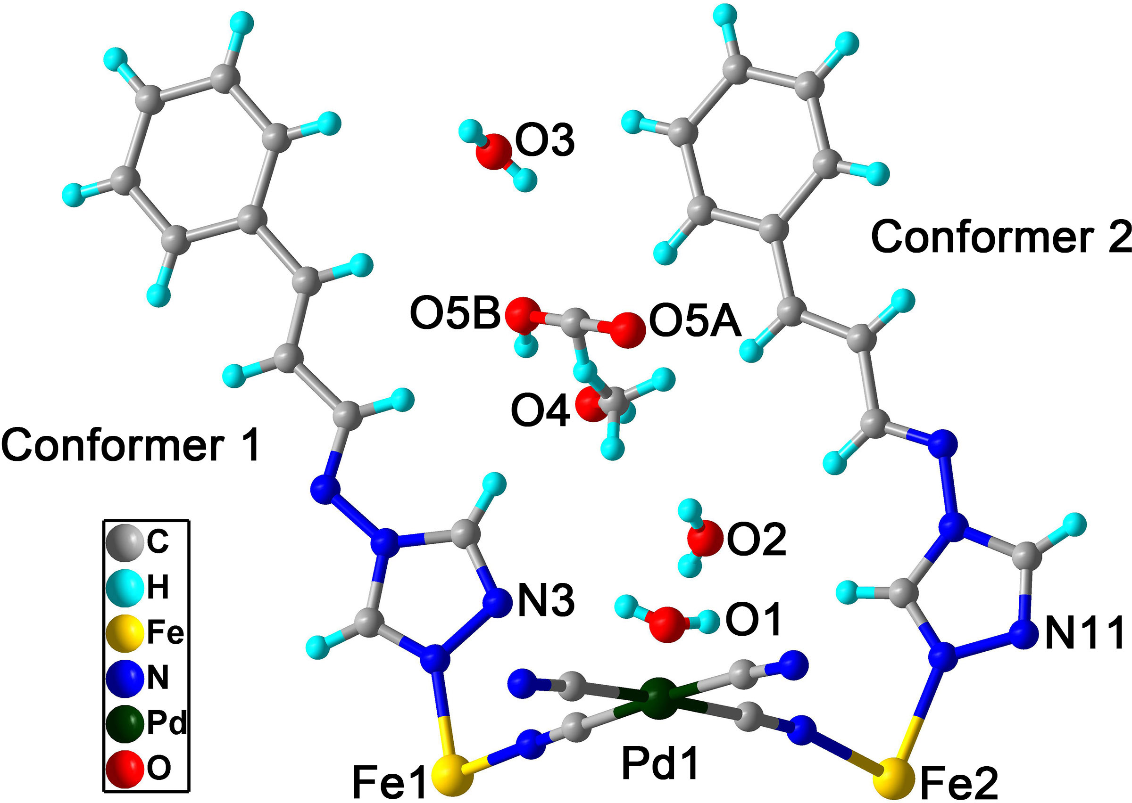
Figure S1. The asymmetric unit of 1·3H₂O·3/2CH₃OH.

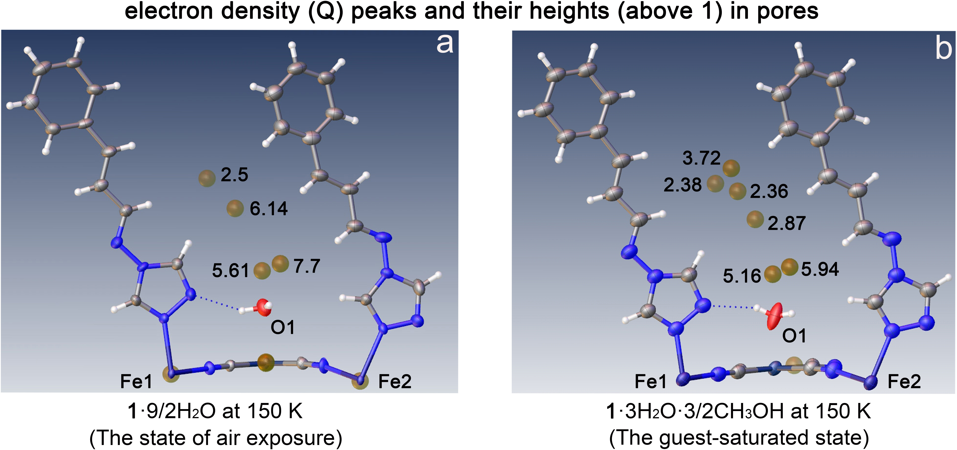
Figure S2. The asymmetric unit of the stable state in air (1·9/2H₂O, left) and the guest-saturated state (1·3H₂O·3/2CH₃OH, right) at 150 K. The Q peaks in the pore of the framework remain unassigned, except for a notable Q peak associated with O1, which has been identified as H₂O. The other Q peaks have not been assigned.
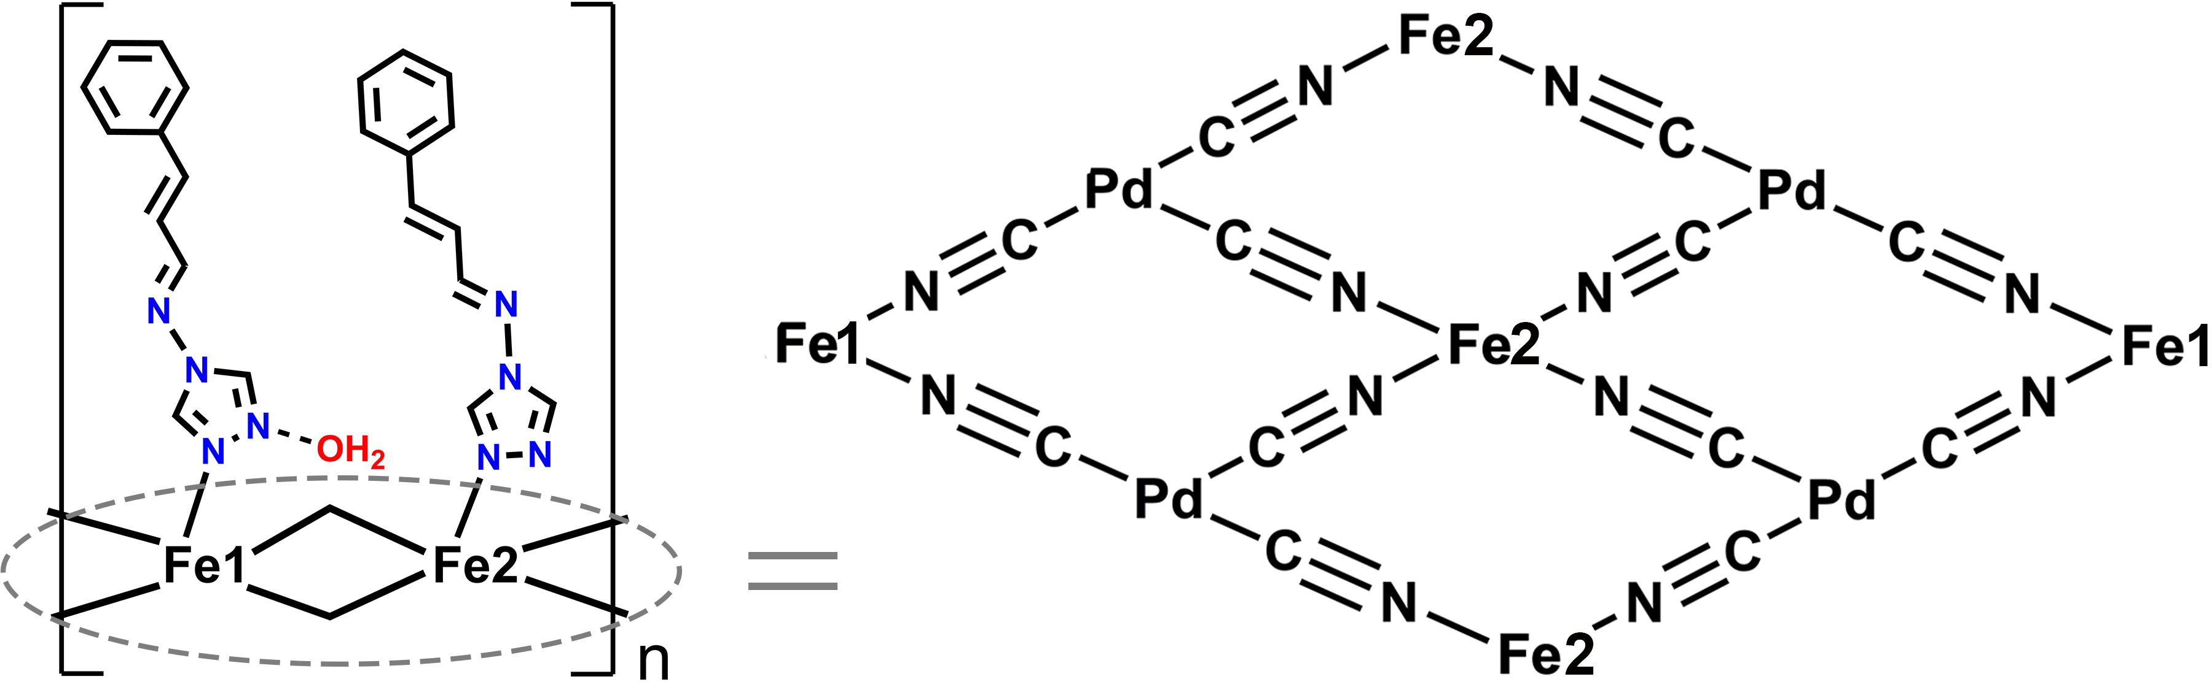
Figure S3. Building units of the title 2D coordination polymer.

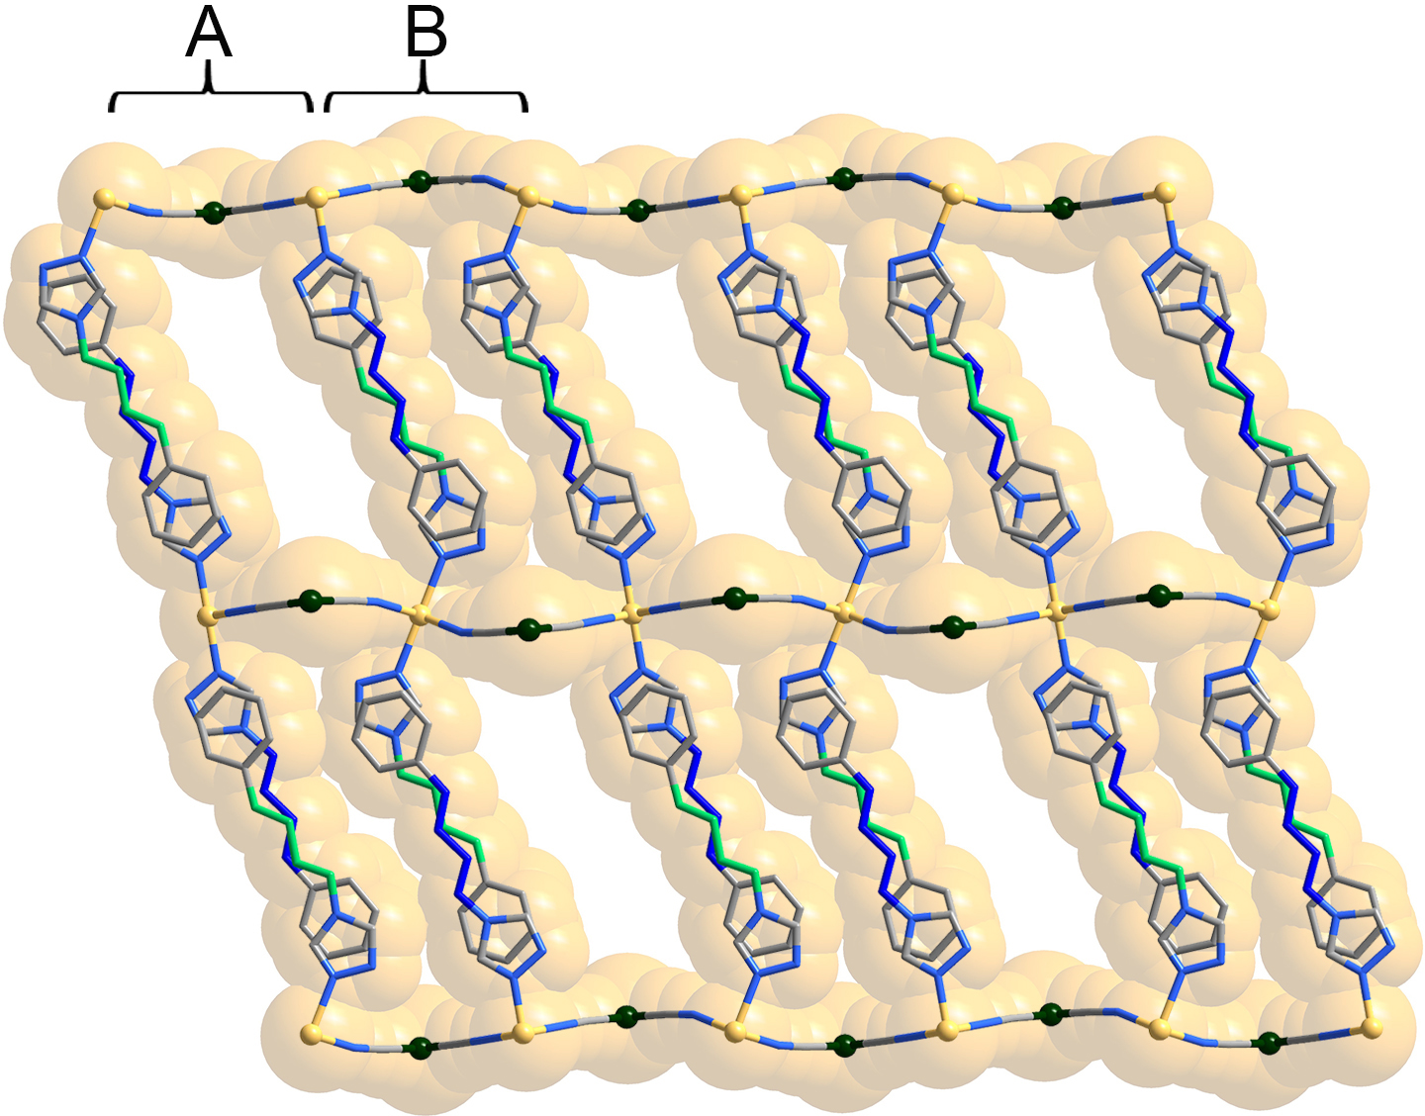
Figure S4. Pore structure and supramolecular packing of 1·3H₂O·3/2CH₃OH.

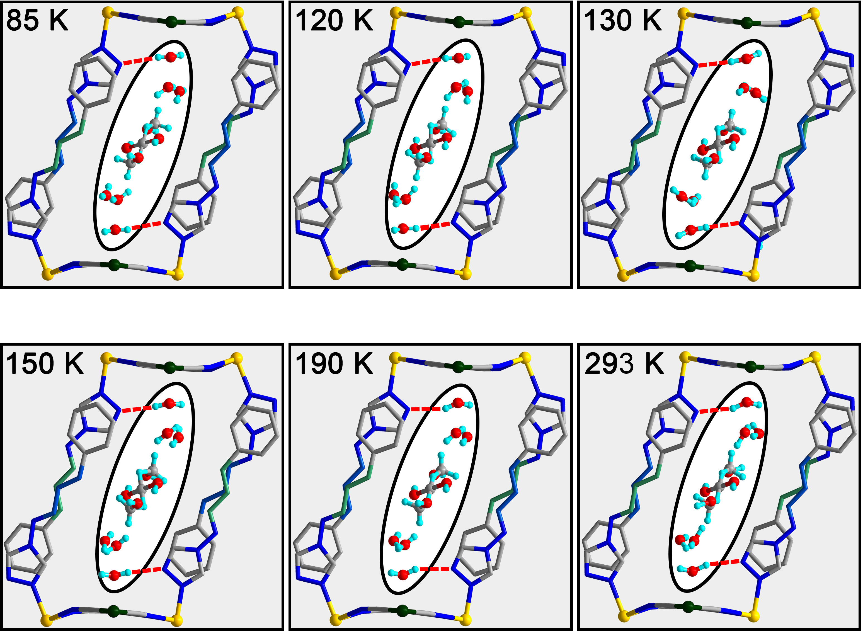
Figure S5. Distribution of H₂O and CH₃OH in 1·3H₂O·3/2CH₃OH at 85, 120, 130, 150, 190, and 293 K.
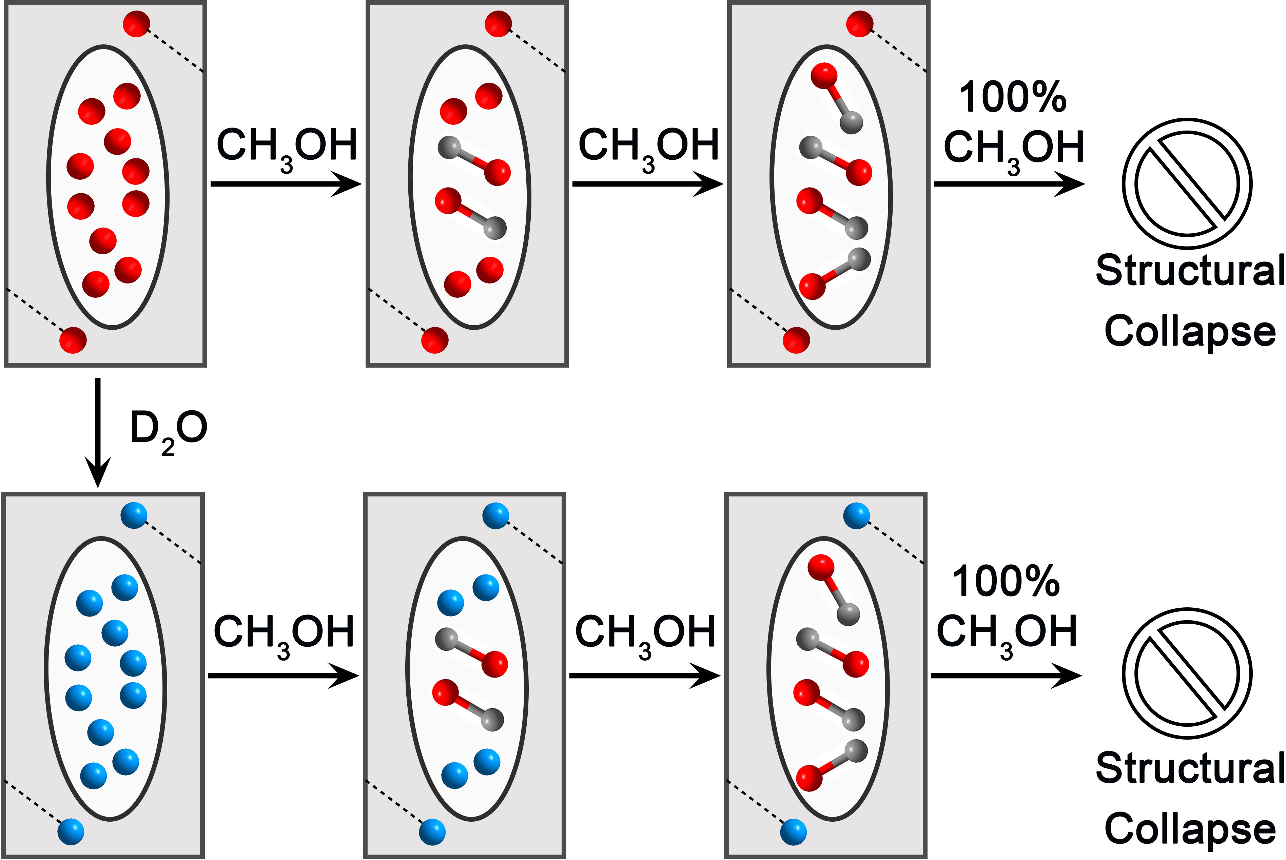
Figure S6. The hypothesized distribution of guest-saturated samples following exchange with CH₃OH, H₂O, and D₂O, and the inferred instability of the framework in pure CH₃OH.
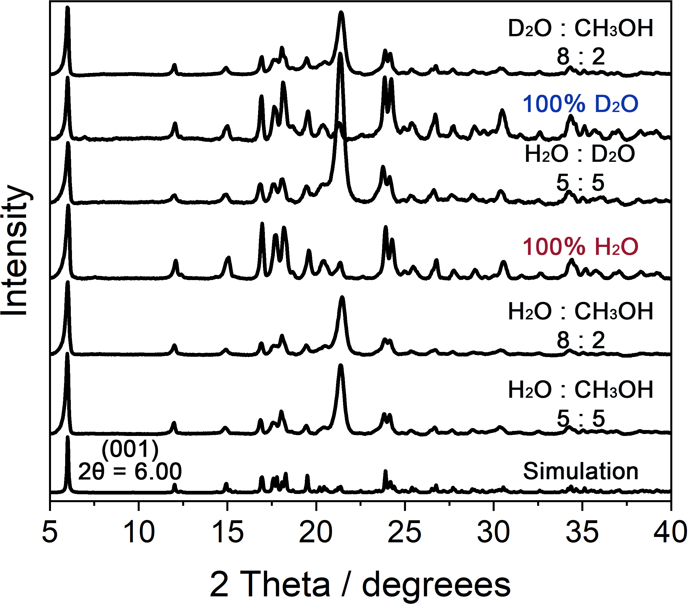
Figure S7. The full PXRD patterns of the guest-saturated samples during the guest-exchange process.

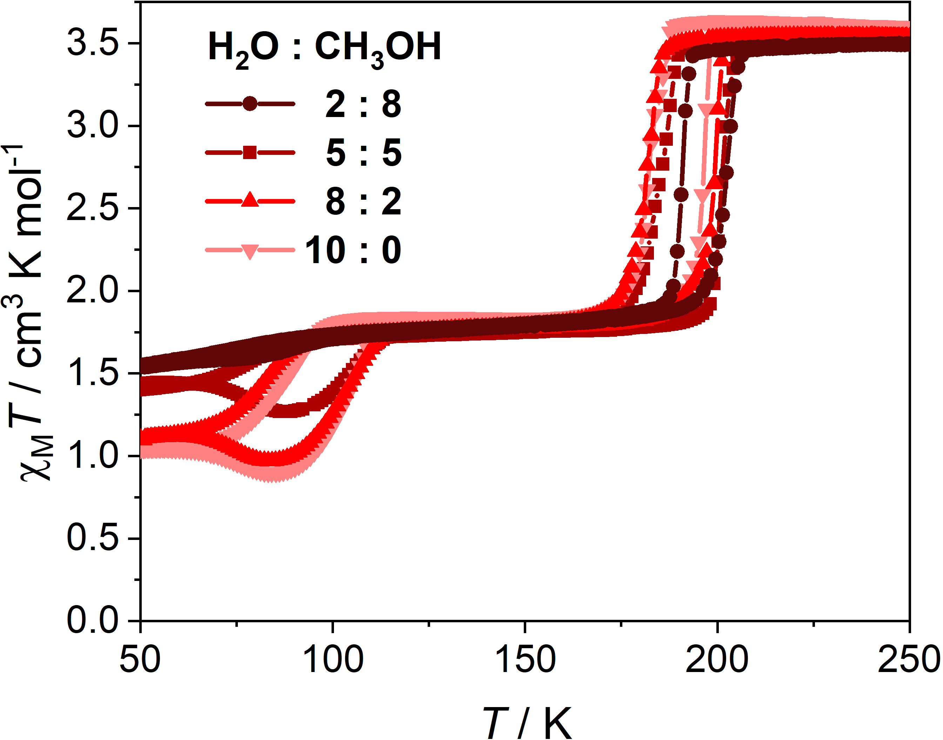
Figure S8. Temperature-dependent χ_{M}T values of the guest-saturated samples with various H₂O-CH₃OH ratios.
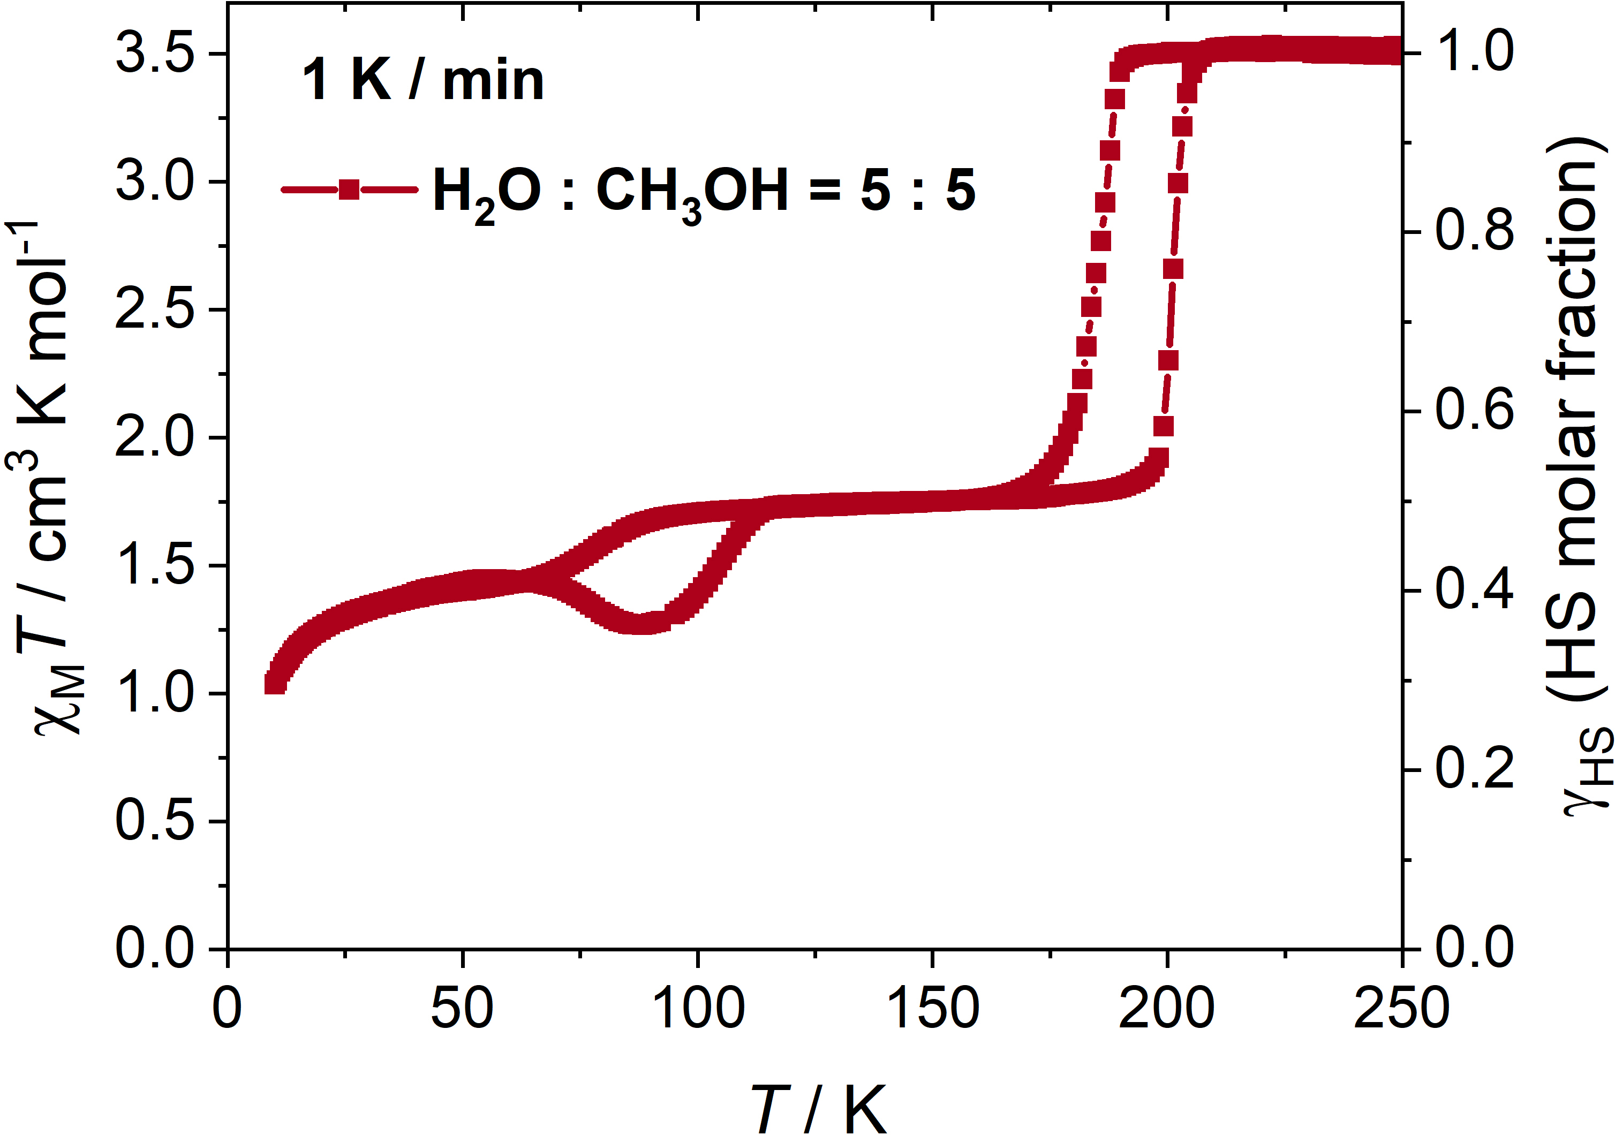
Figure S9. Temperature-dependent χ_{M}T values of the guest-saturated samples with 5:5 H₂O-CH₃OH ratio at 1 K min⁻¹ (2 K to 250 K).

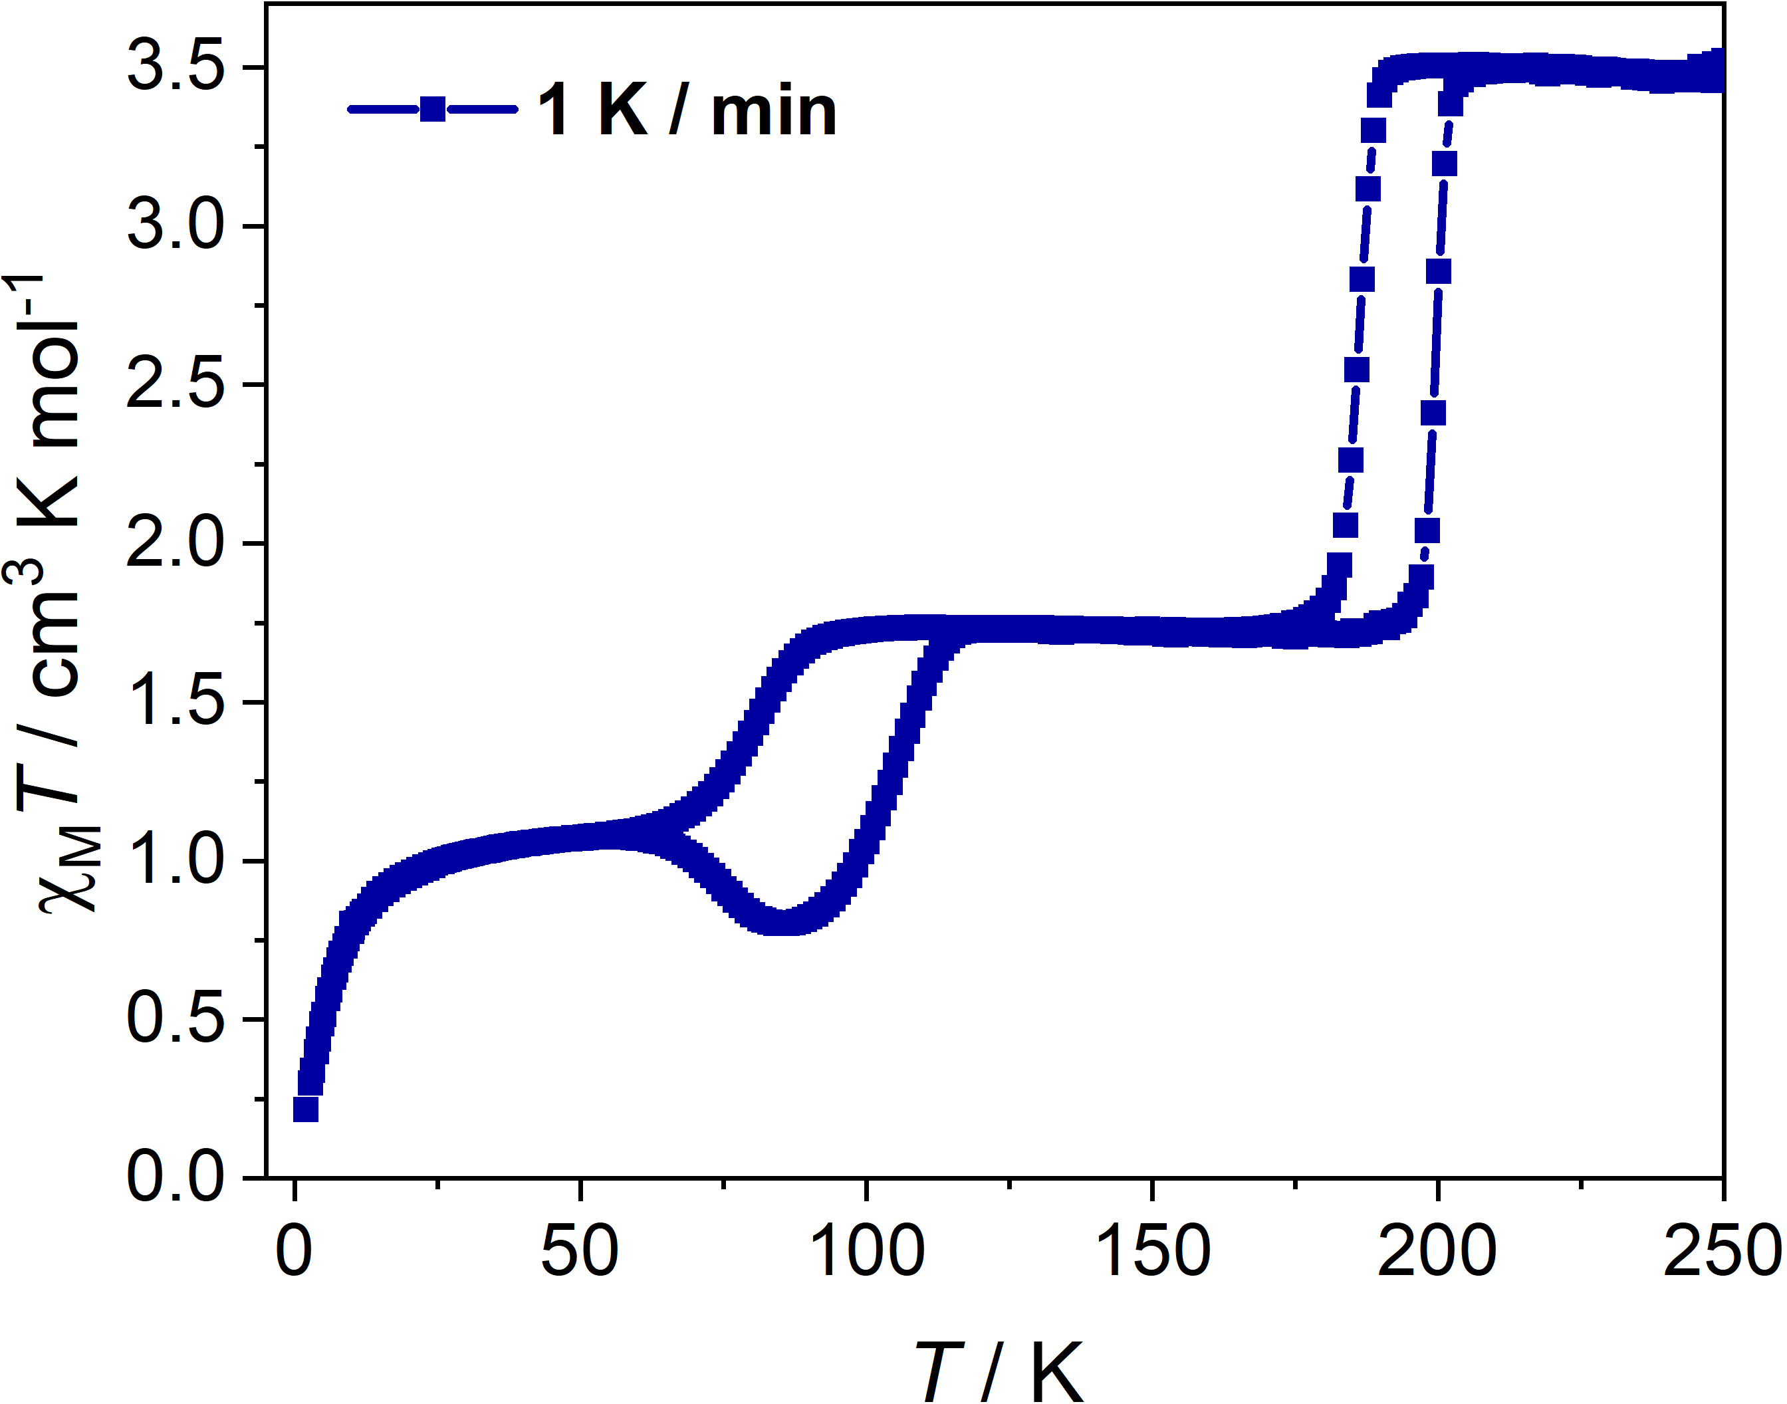
Figure S10 Temperature-dependent χ_{M}T values of the guest-saturated samples with 10:0 H₂O-CH₃OH ratio at 1 K min⁻¹ (2 K to 250 K).
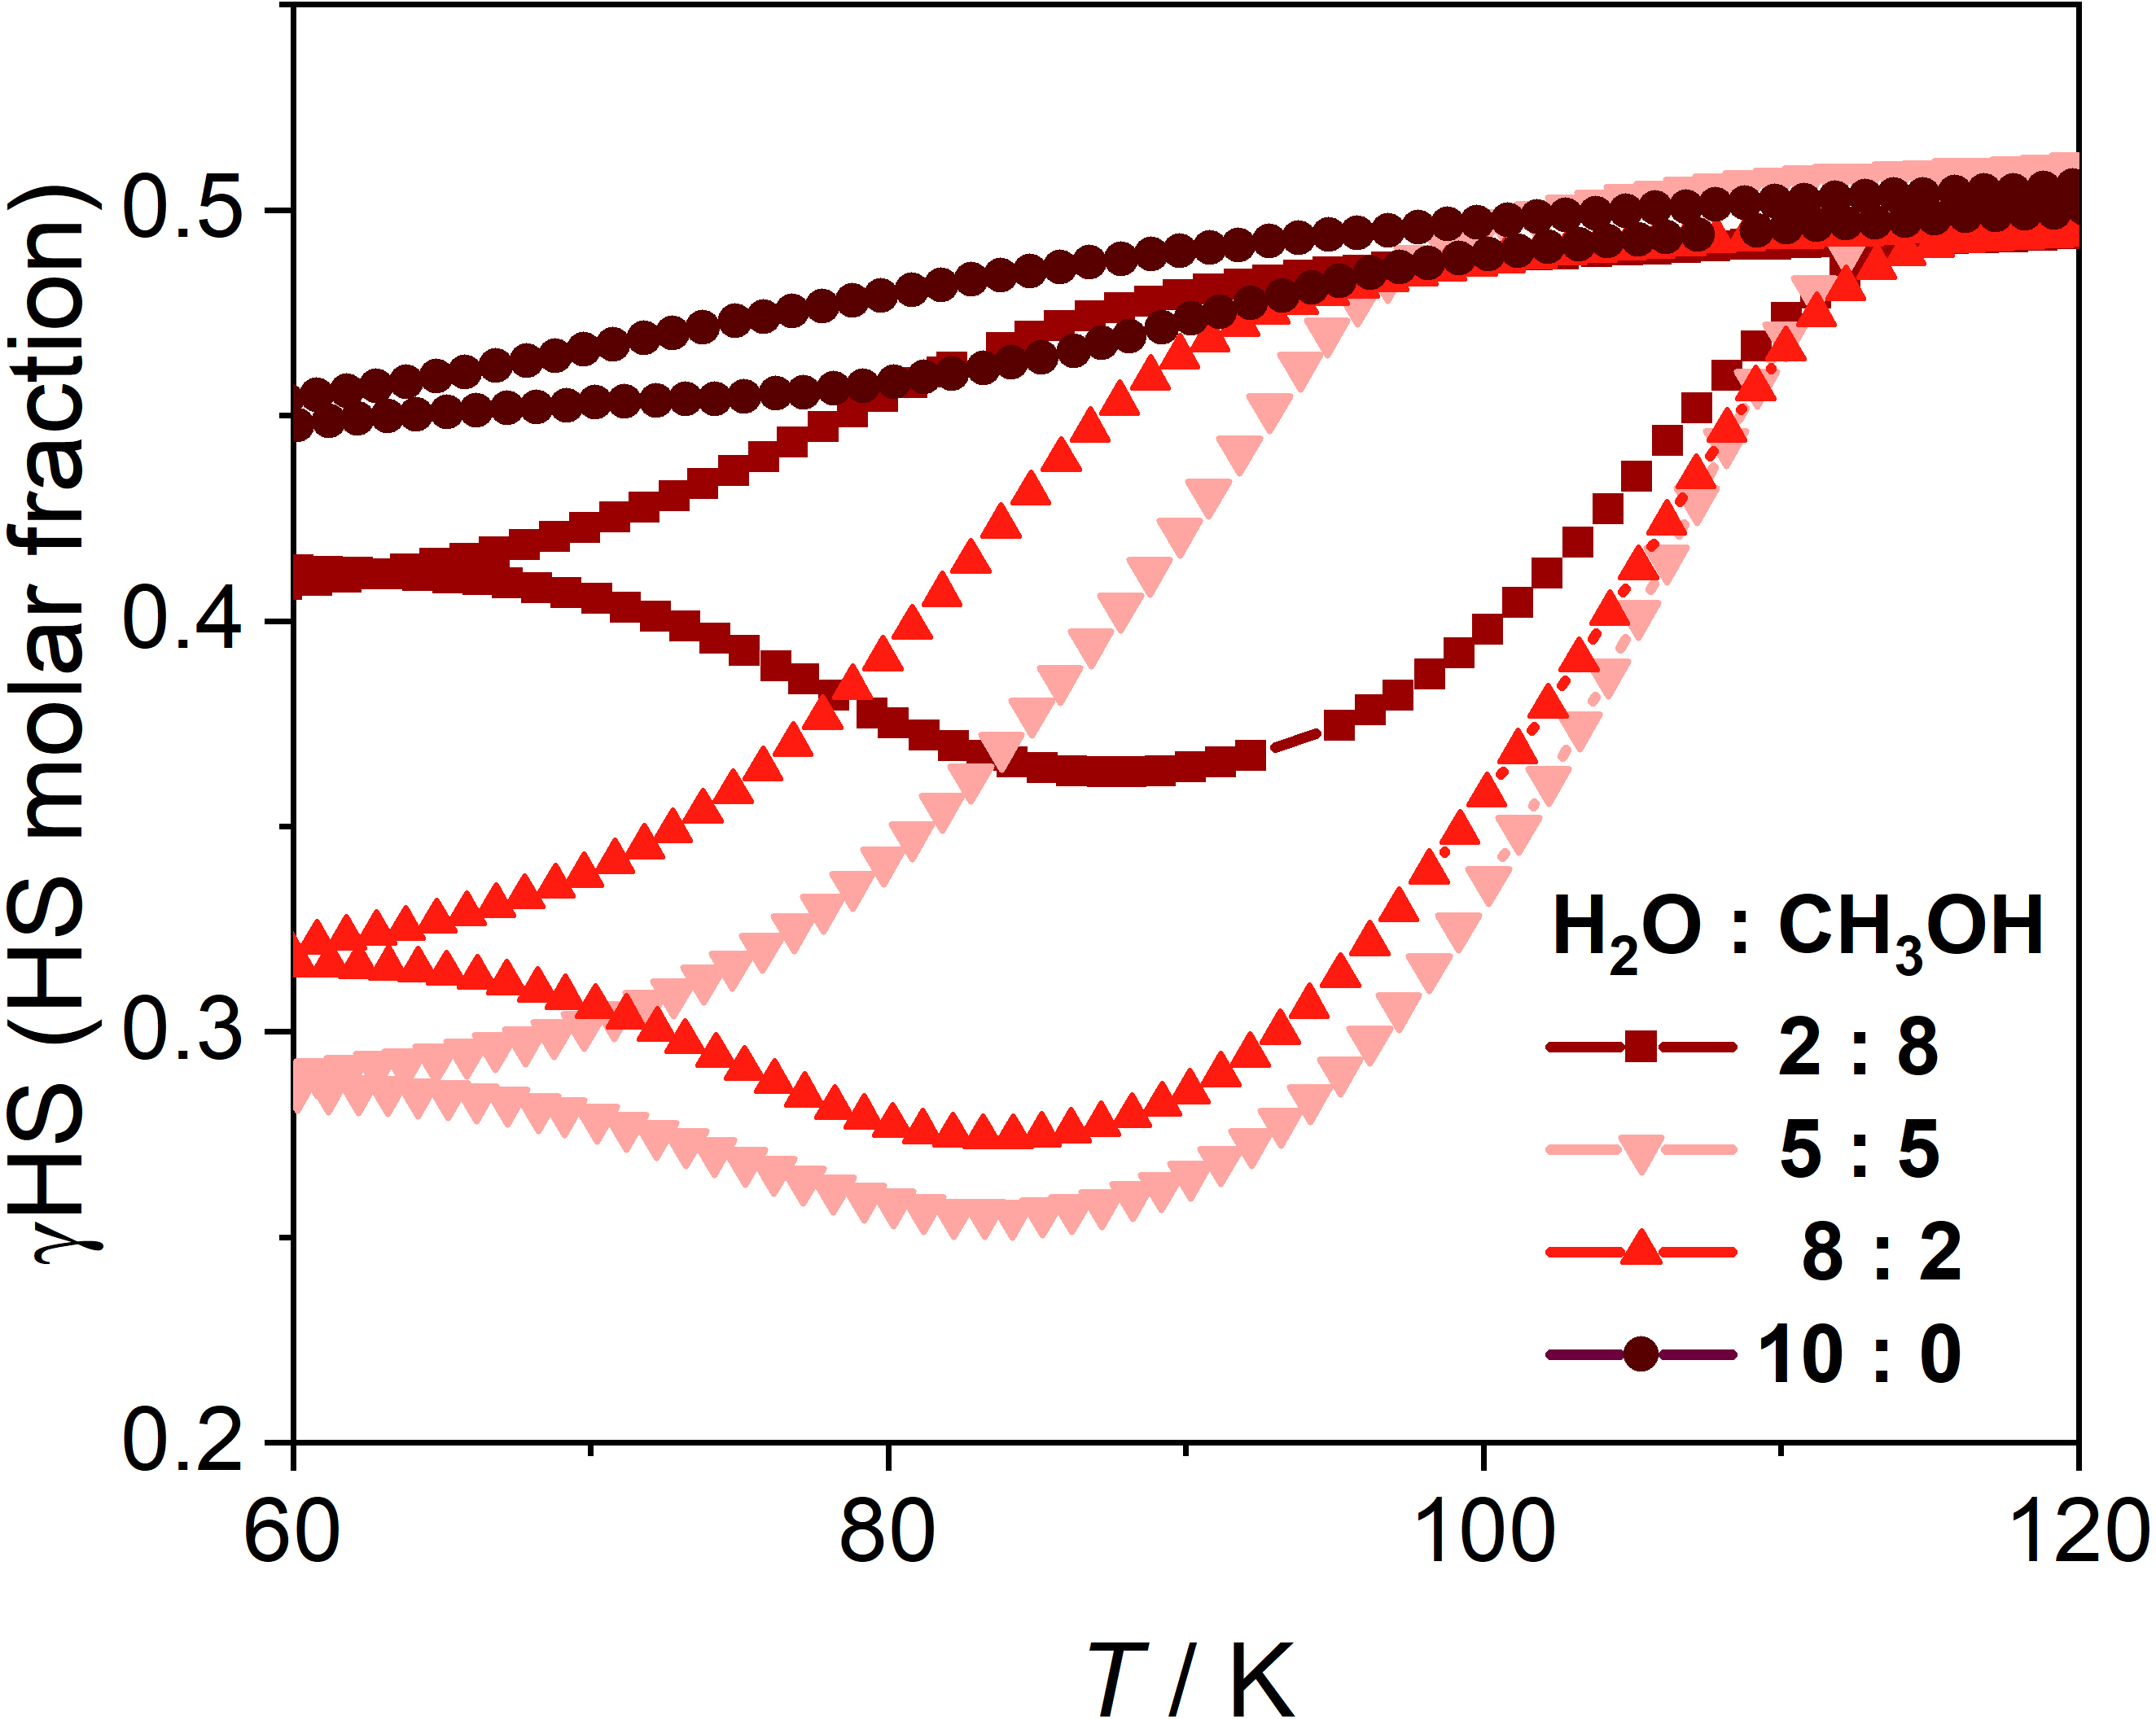
Figure S11. The enlarged view of the χ_{M}T of the guest-saturated samples with various H₂O-CH₃OH ratios product in the interval of 60−120 K.

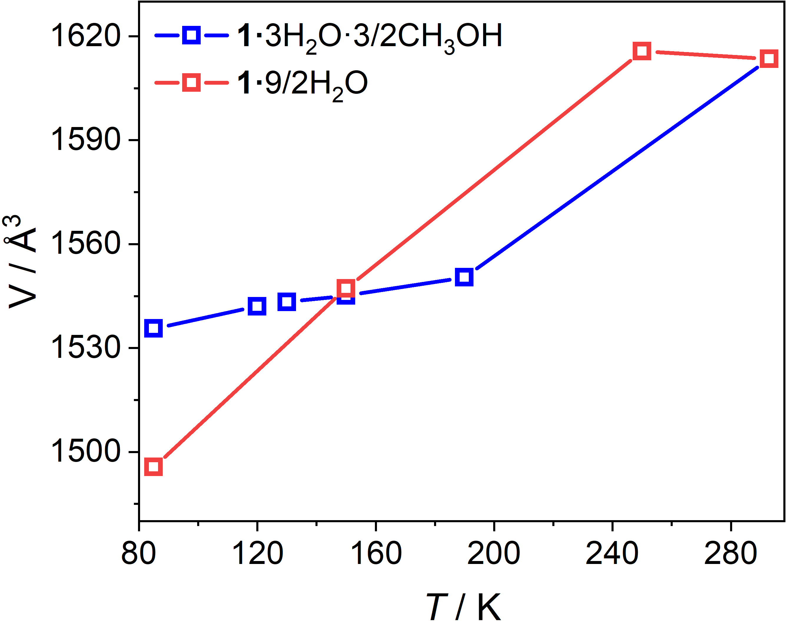
Figure S12. Temperature-dependent unit-cell volume of 1·9/2H₂O and 1·3H₂O·3/2CH₃OH.
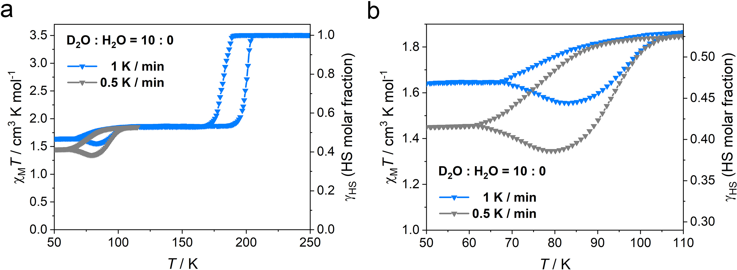
Figure S13. a, Temperature-dependent χ_{M}T values of the guest-saturated samples with 10:0 D₂O-CH₃OH ratio at 1 and 0.5 K min⁻¹. b, The enlarged view of the χ_{M}T product in the interval of 50−110 K.

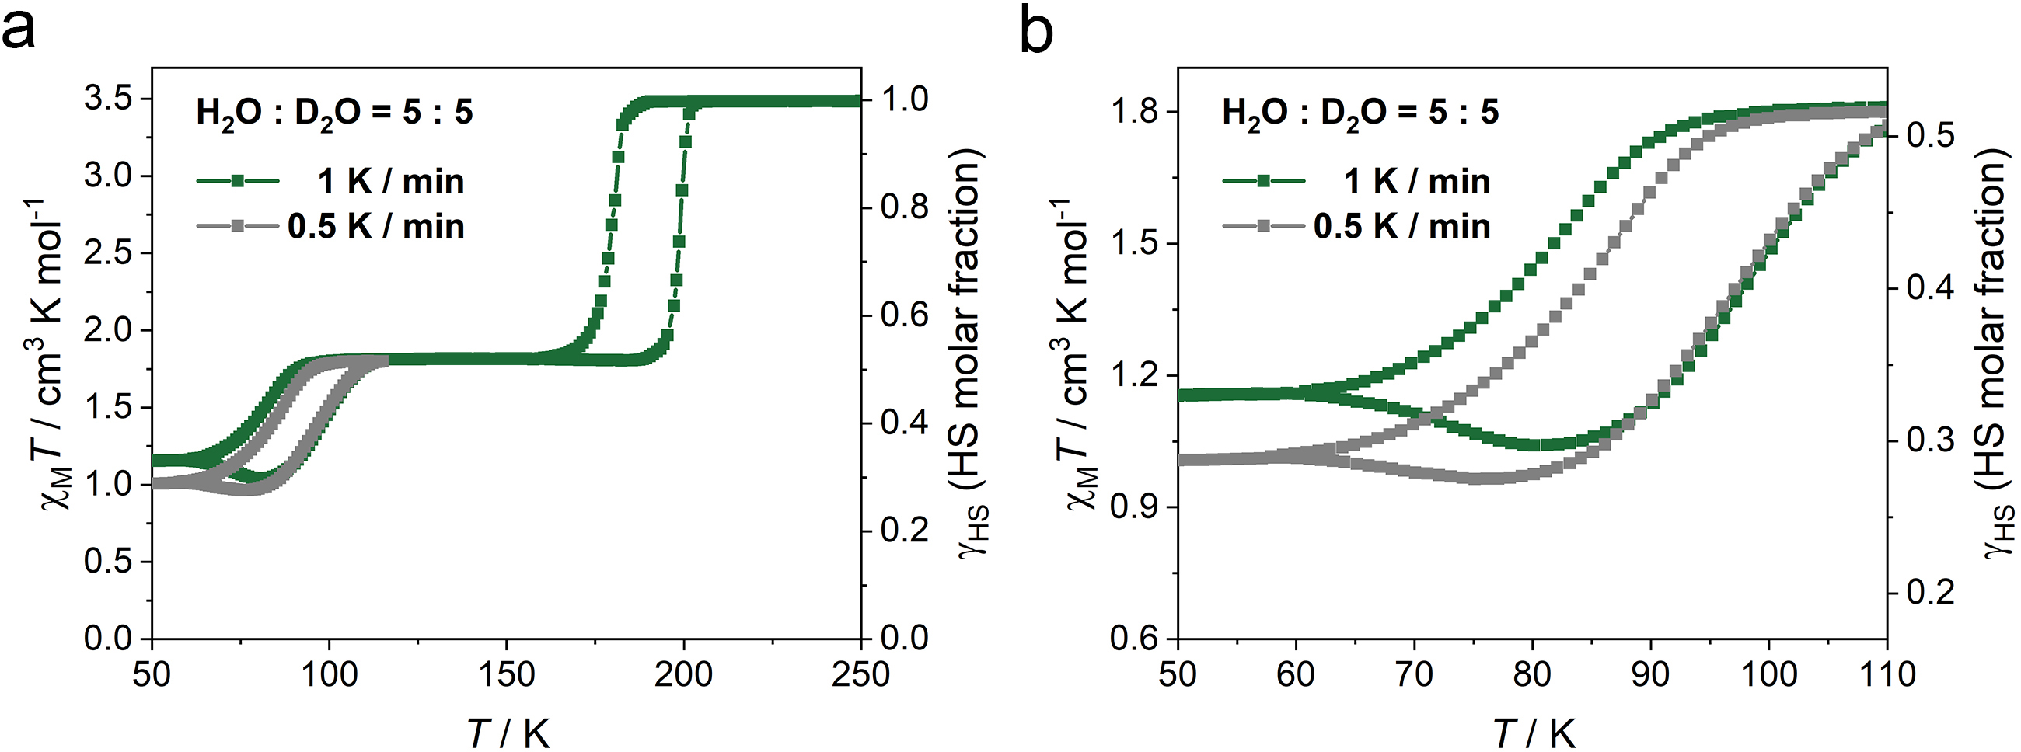
Figure S14. a, Temperature-dependent χ_{M}T values of the guest-saturated samples with 5:5 H₂O-D₂O ratio at 1 and 0.5 K min⁻¹. b, The enlarged view of the χ_{M}T product in the interval of 50−110 K.

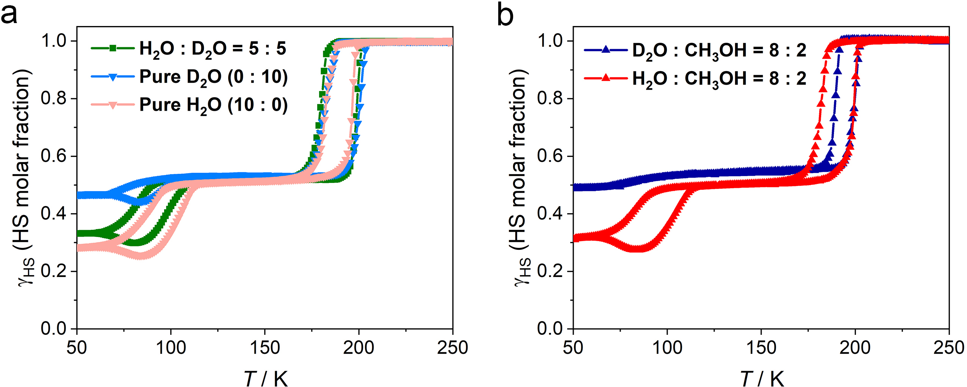
Figure S15. a, Temperature-dependent χ_{M}T values of the guest-saturated samples with pure D₂O, pure H₂O and 5:5 H₂O-D₂O ratio at 1 K min⁻¹. b, Temperature-dependent χ_{M}T values of the guest-saturated samples with 8:2 H₂O-CH₃OH and D₂O-CH₃OH ratios at 1 K min⁻¹.

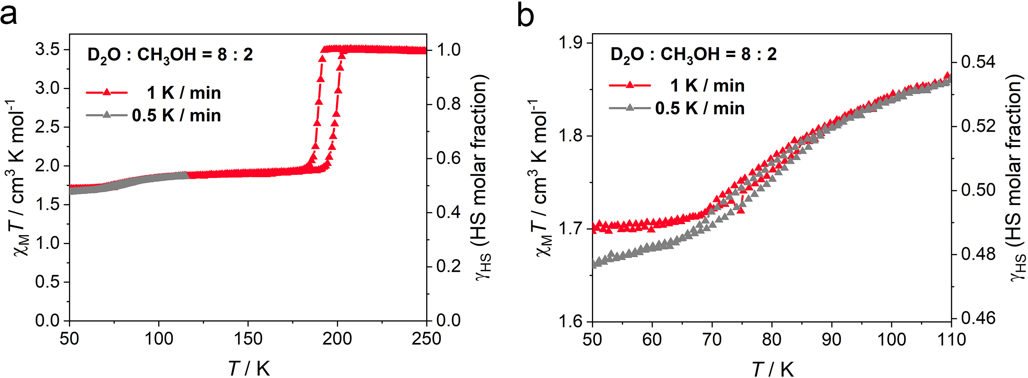
Figure S16. a, Temperature-dependent χ_{M}T values of the guest-saturated samples with 8:2 D₂O-CH₃OH ratio at 1 and 0.5 K min⁻¹. b, The enlarged view of the χ_{M}T product in the interval of 50−110 K.
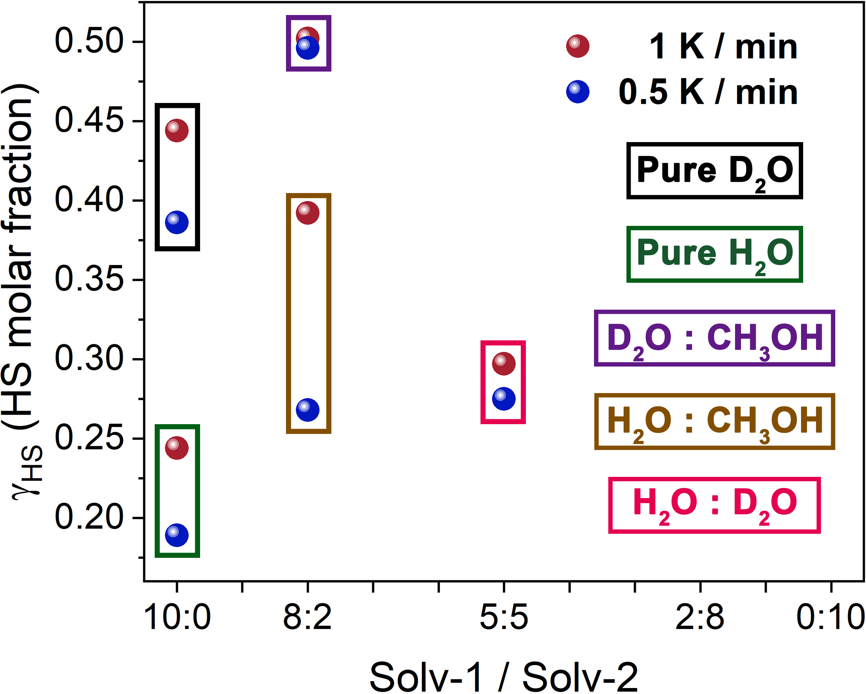
Figure S17. Plot of the guest dependence of the HS Fe^{II} molar fraction (γ_{HS}). The Solv-1/Solv-2 values on the x-axis represent the proportion of the mixed solvents described in the Figures S8-11 and S13-S16.

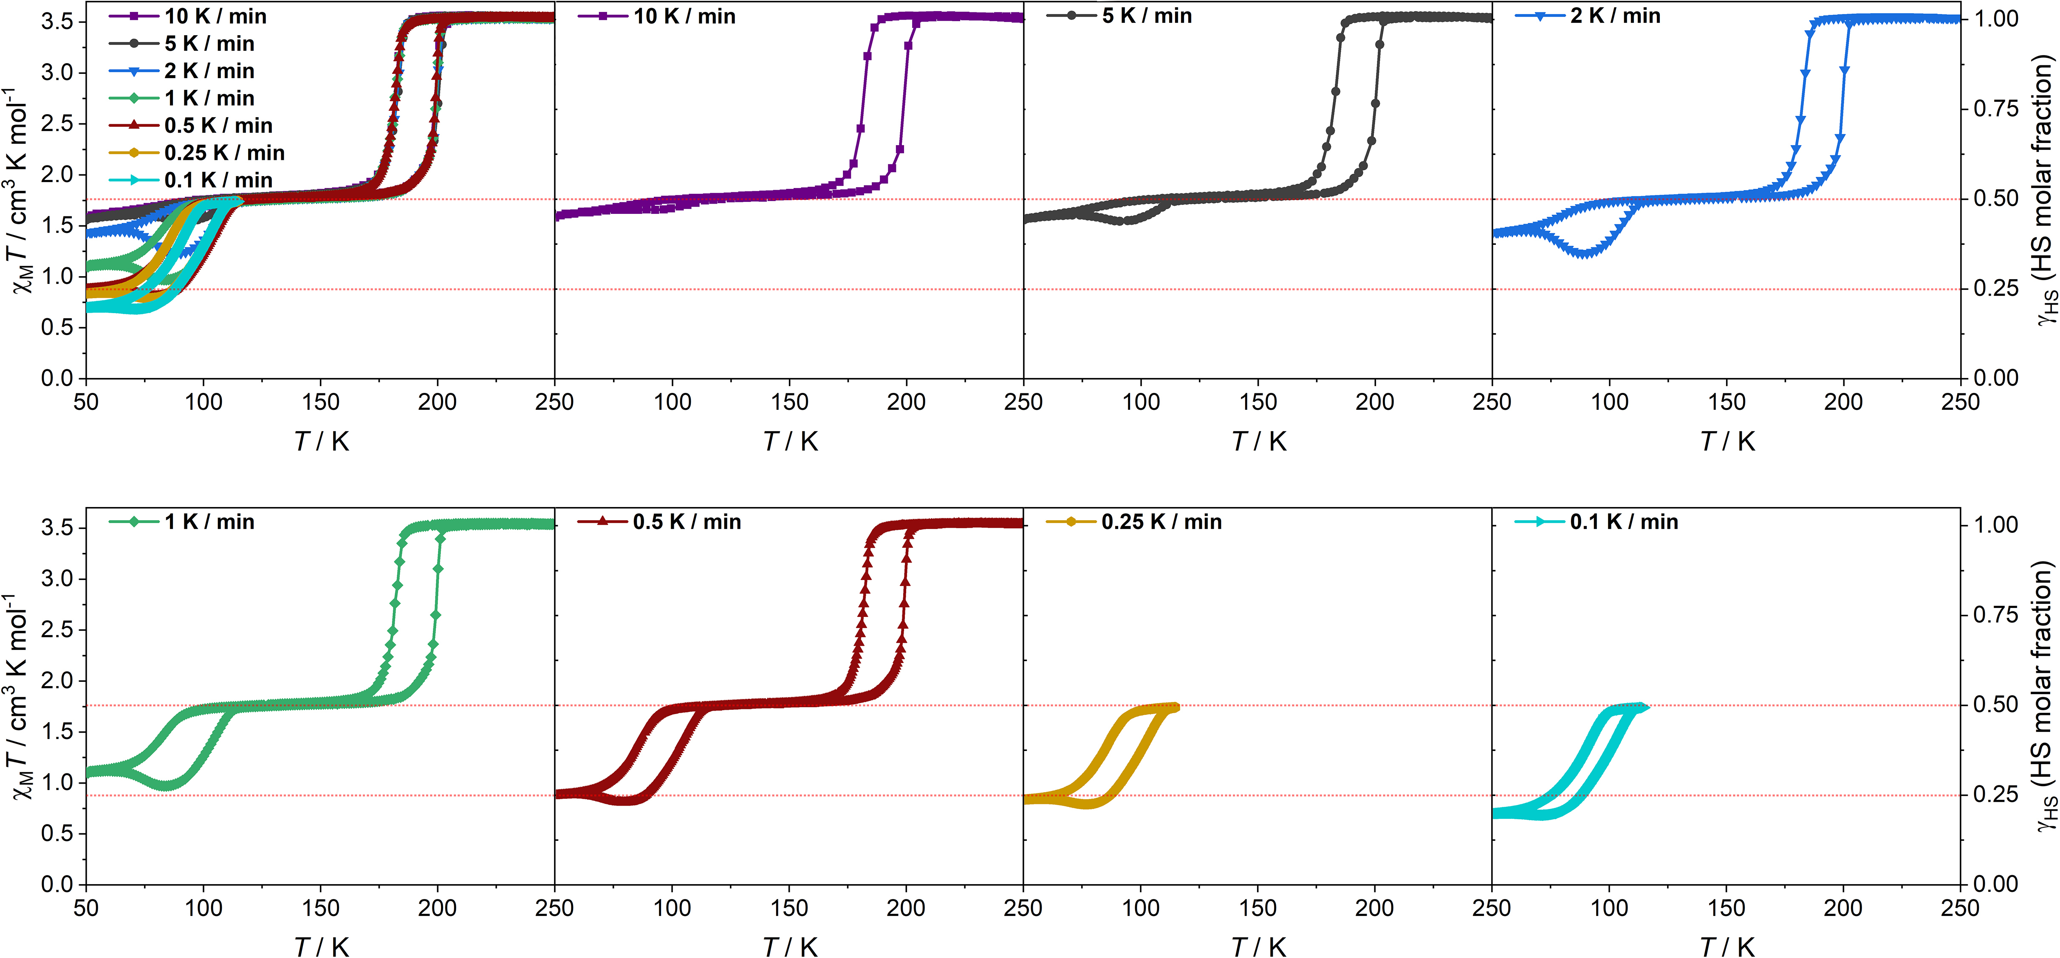
Figure S18. Temperature-dependent χ_{M}T values of the guest-saturated samples with 8:2 H₂O-CH₃OH ratio at an ambient temperature of 250 K.
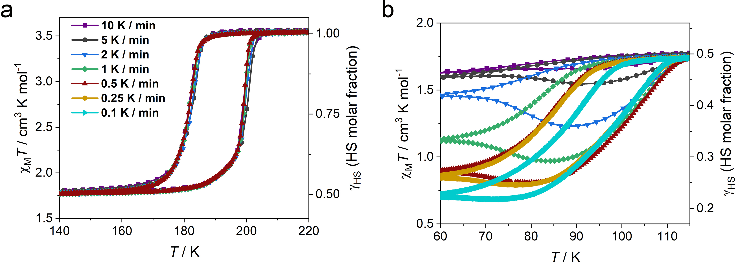
Figure S19. The enlarged view of the χ_{M}T of the guest-saturated sample with maintaining 8:2 H₂O-CH₃OH ratio product in the interval of 140−220 (a) and 60−115 K (b).

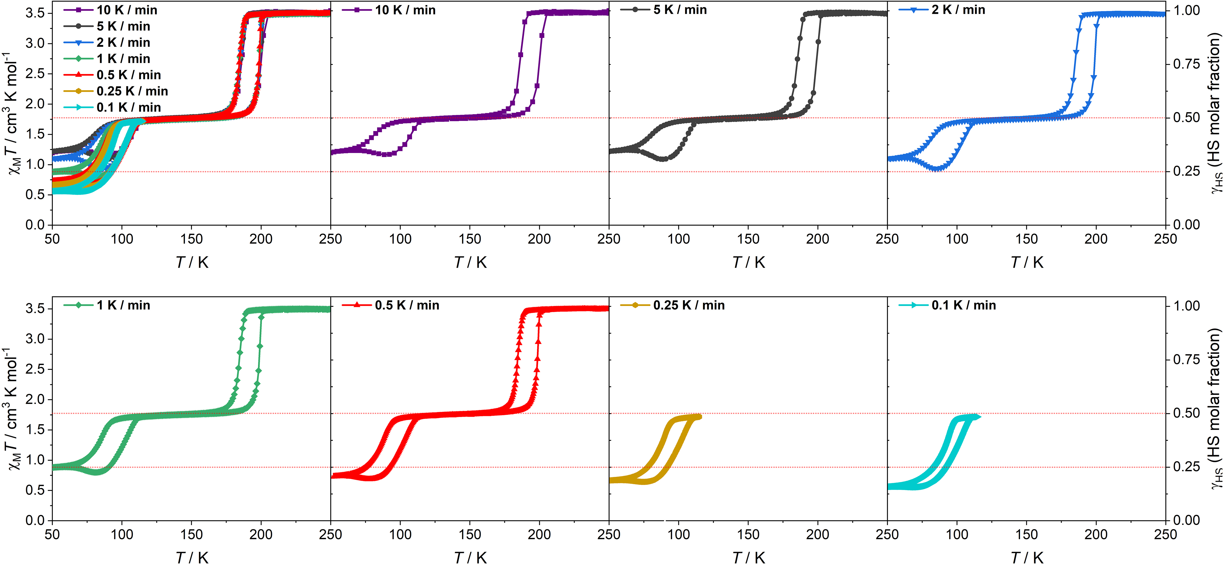
Figure S20. Temperature-dependent χ_{M}T values of the guest-saturated sample with 8:2 H₂O-CH₃OH ratio after in-situ heating at 300 K for 10 min.
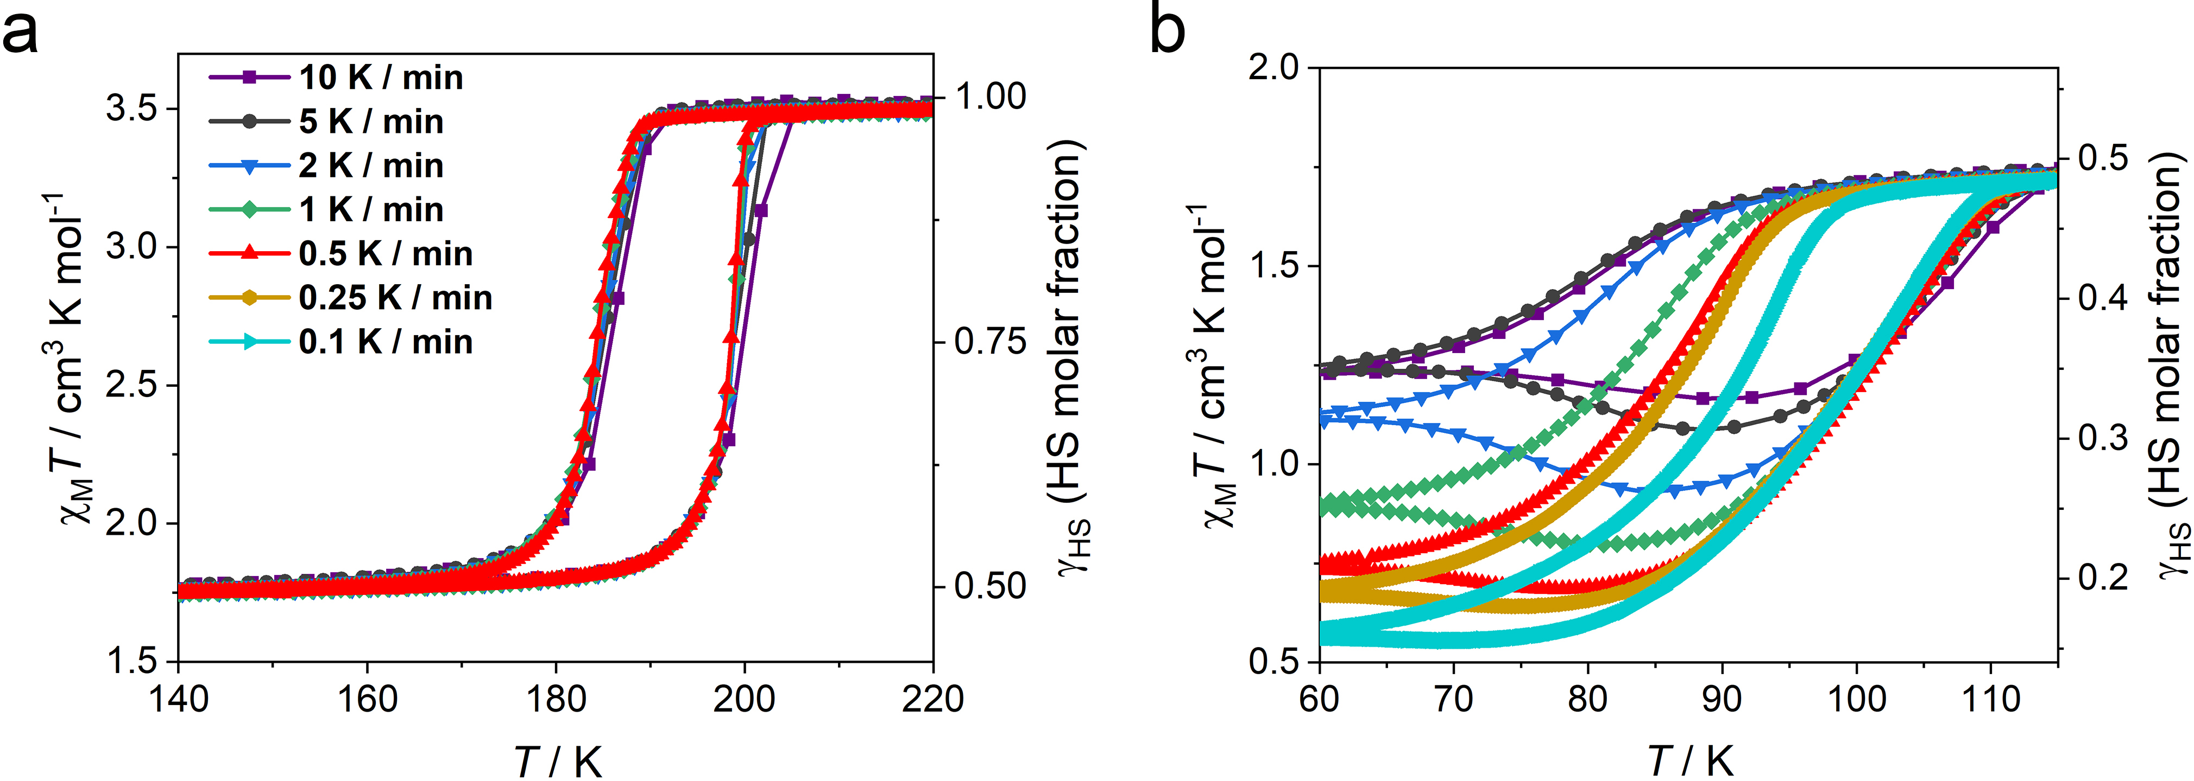
Figure S21. The enlarged view of the χ_{M}T of the guest-saturated sample with partial guest losing 8:2 H₂O-CH₃OH ratio product in the interval of 140−220 (a) and 60−115 K (b).

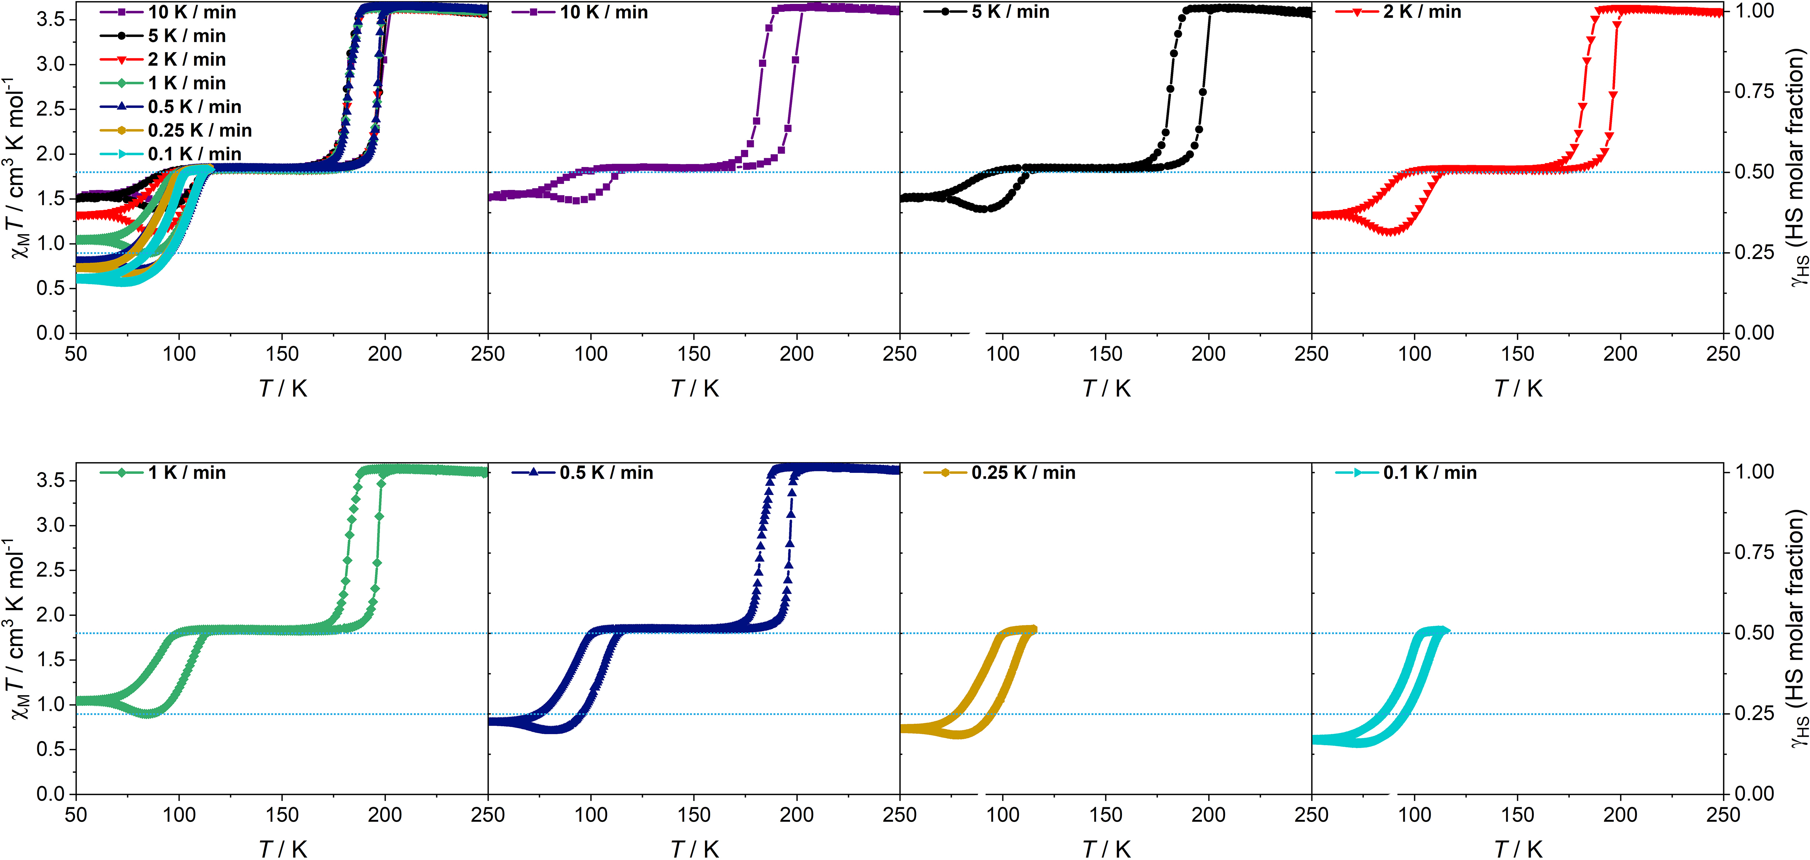
Figure S22. Temperature-dependent χ_{M}T values of the guest-saturated sample with 10:0 H₂O-CH₃OH ratio at an ambient temperature of 250 K.
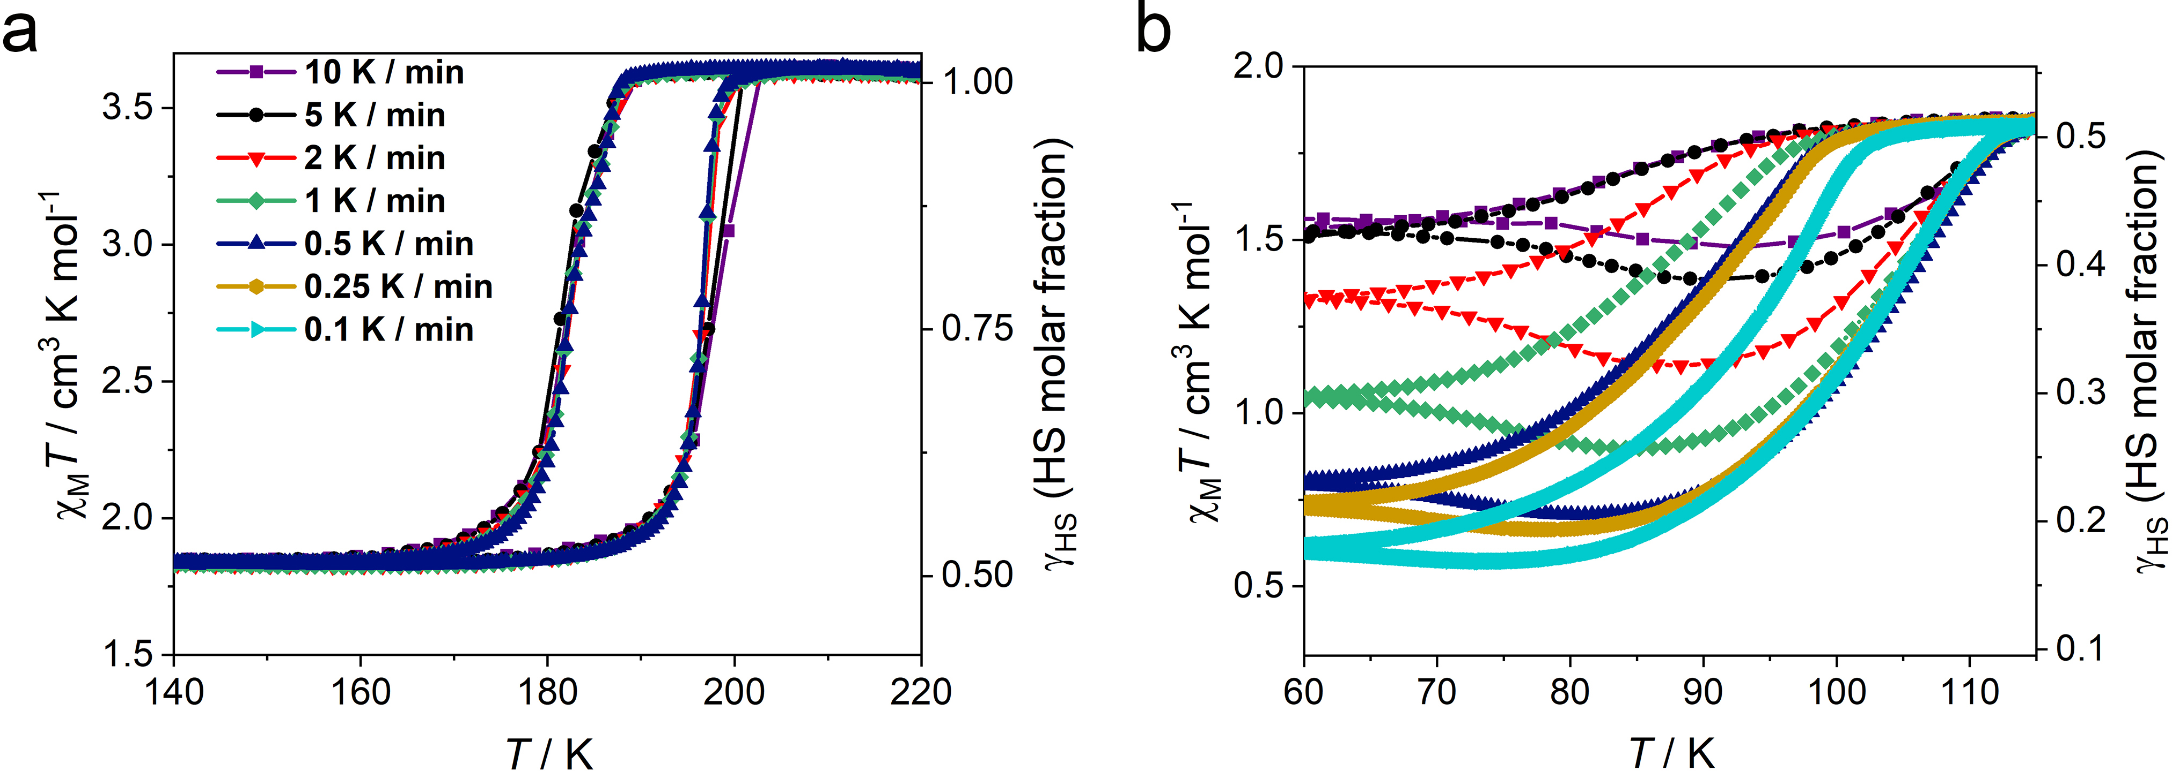
Figure S23. The enlarged view of the χ_{M}T of the guest-saturated sample with maintaining 10:0 H₂O-CH₃OH ratio product in the interval of 140−220 (a) and 60−115 K (b).

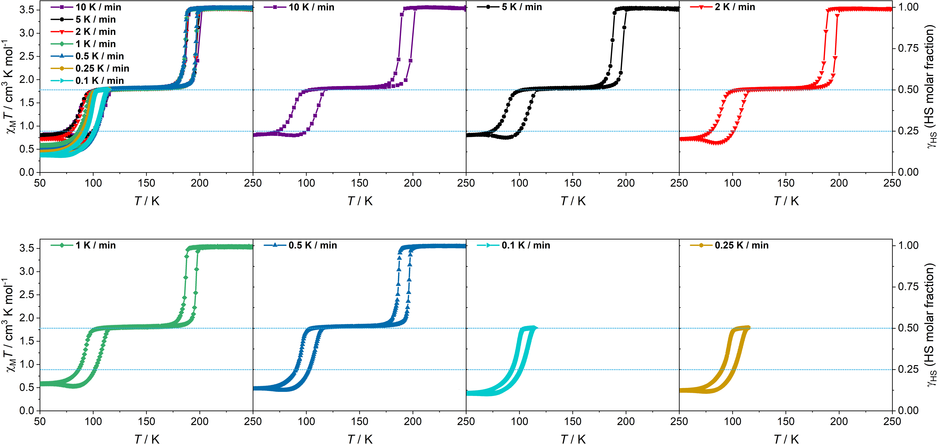
Figure S24. Temperature-dependent χ_{M}T values of the guest-saturated sample with 10:0 H₂O-CH₃OH ratio after in-situ heating at 300 K for 10 min.
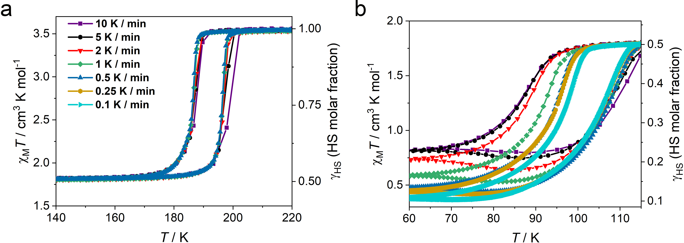
Figure S25. The enlarged view of the χ_{M}T of the guest-saturated sample with partial guest losing 10:0 H₂O-CH₃OH ratio product in the interval of 140−220 (a) and 60−115 K (b).

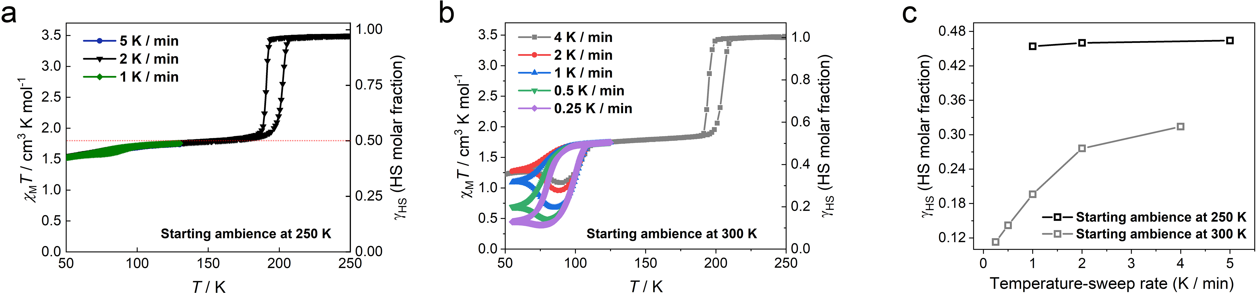
Figure S26. Temperature-dependent χ_{M}T values of the guest-saturated samples with 2:8 H₂O-CH₃OH ratio. The fresh sample was measured at an ambient temperature of 250 K to start the cooling-warming cycles (1, 2, 5 K min⁻¹, a). Then the sample was warmed up to 300 K and held for 10 min, followed by cooling down to 250 K to measure in the cooling-warming cycles (0.25, 0.5, 1, 2, 4 K min⁻¹, b). c, The temperature-sweep rate vs HS Fe^{II} molar fraction (γ_{HS}) for the sample with 2:8 H₂O-CH₃OH ratio starting different ambiences.
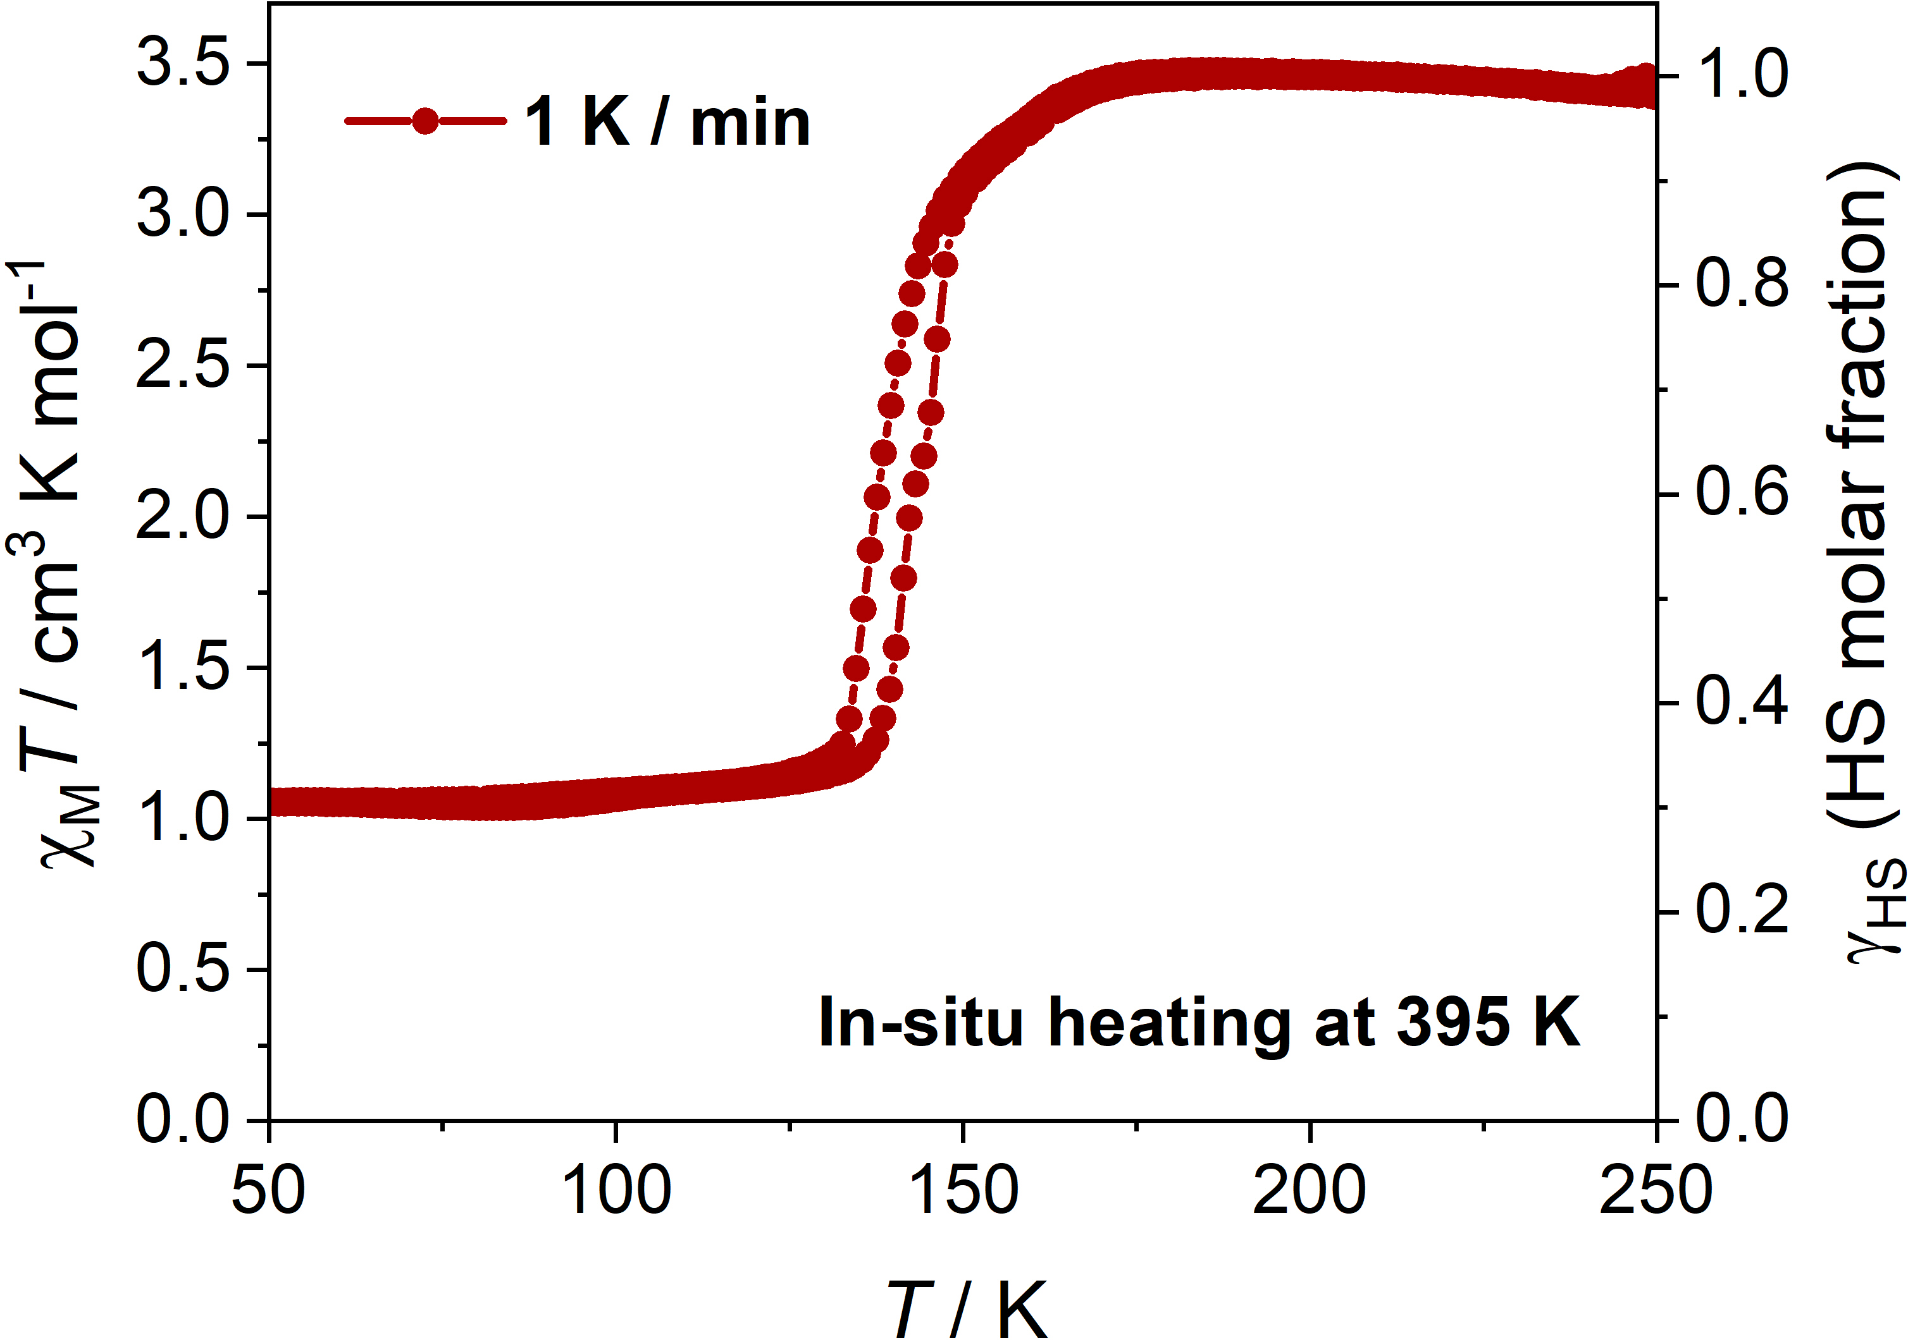
Figure S27. Temperature-dependent χ_{M}T and γ_{HS} values of the guest-saturated samples with the 2:8 H₂O-CH₃OH ratio under in situ heating at 395 K for 1 hour (the fourth cooling-warming cycle).

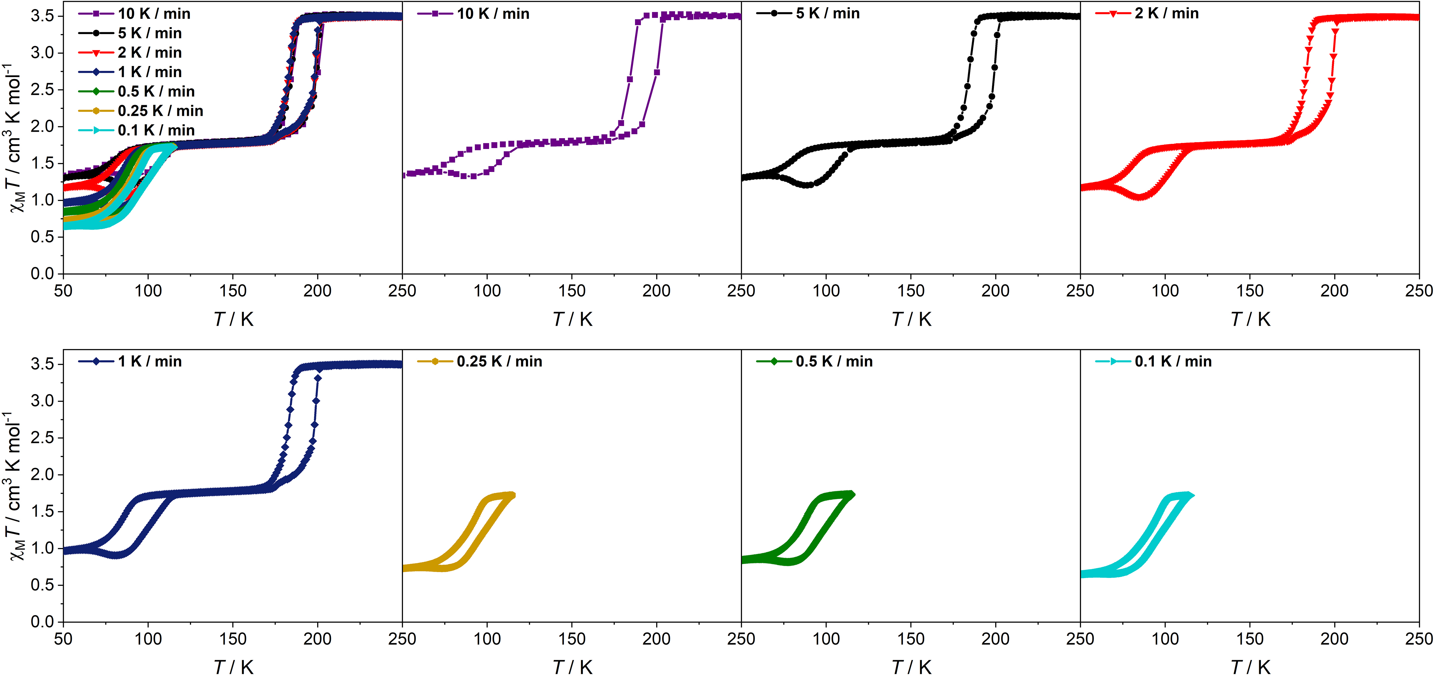
Figure S28. Temperature-dependent χ_{M}T values of rehydrated sample after heating at 395 K under various scan rates.
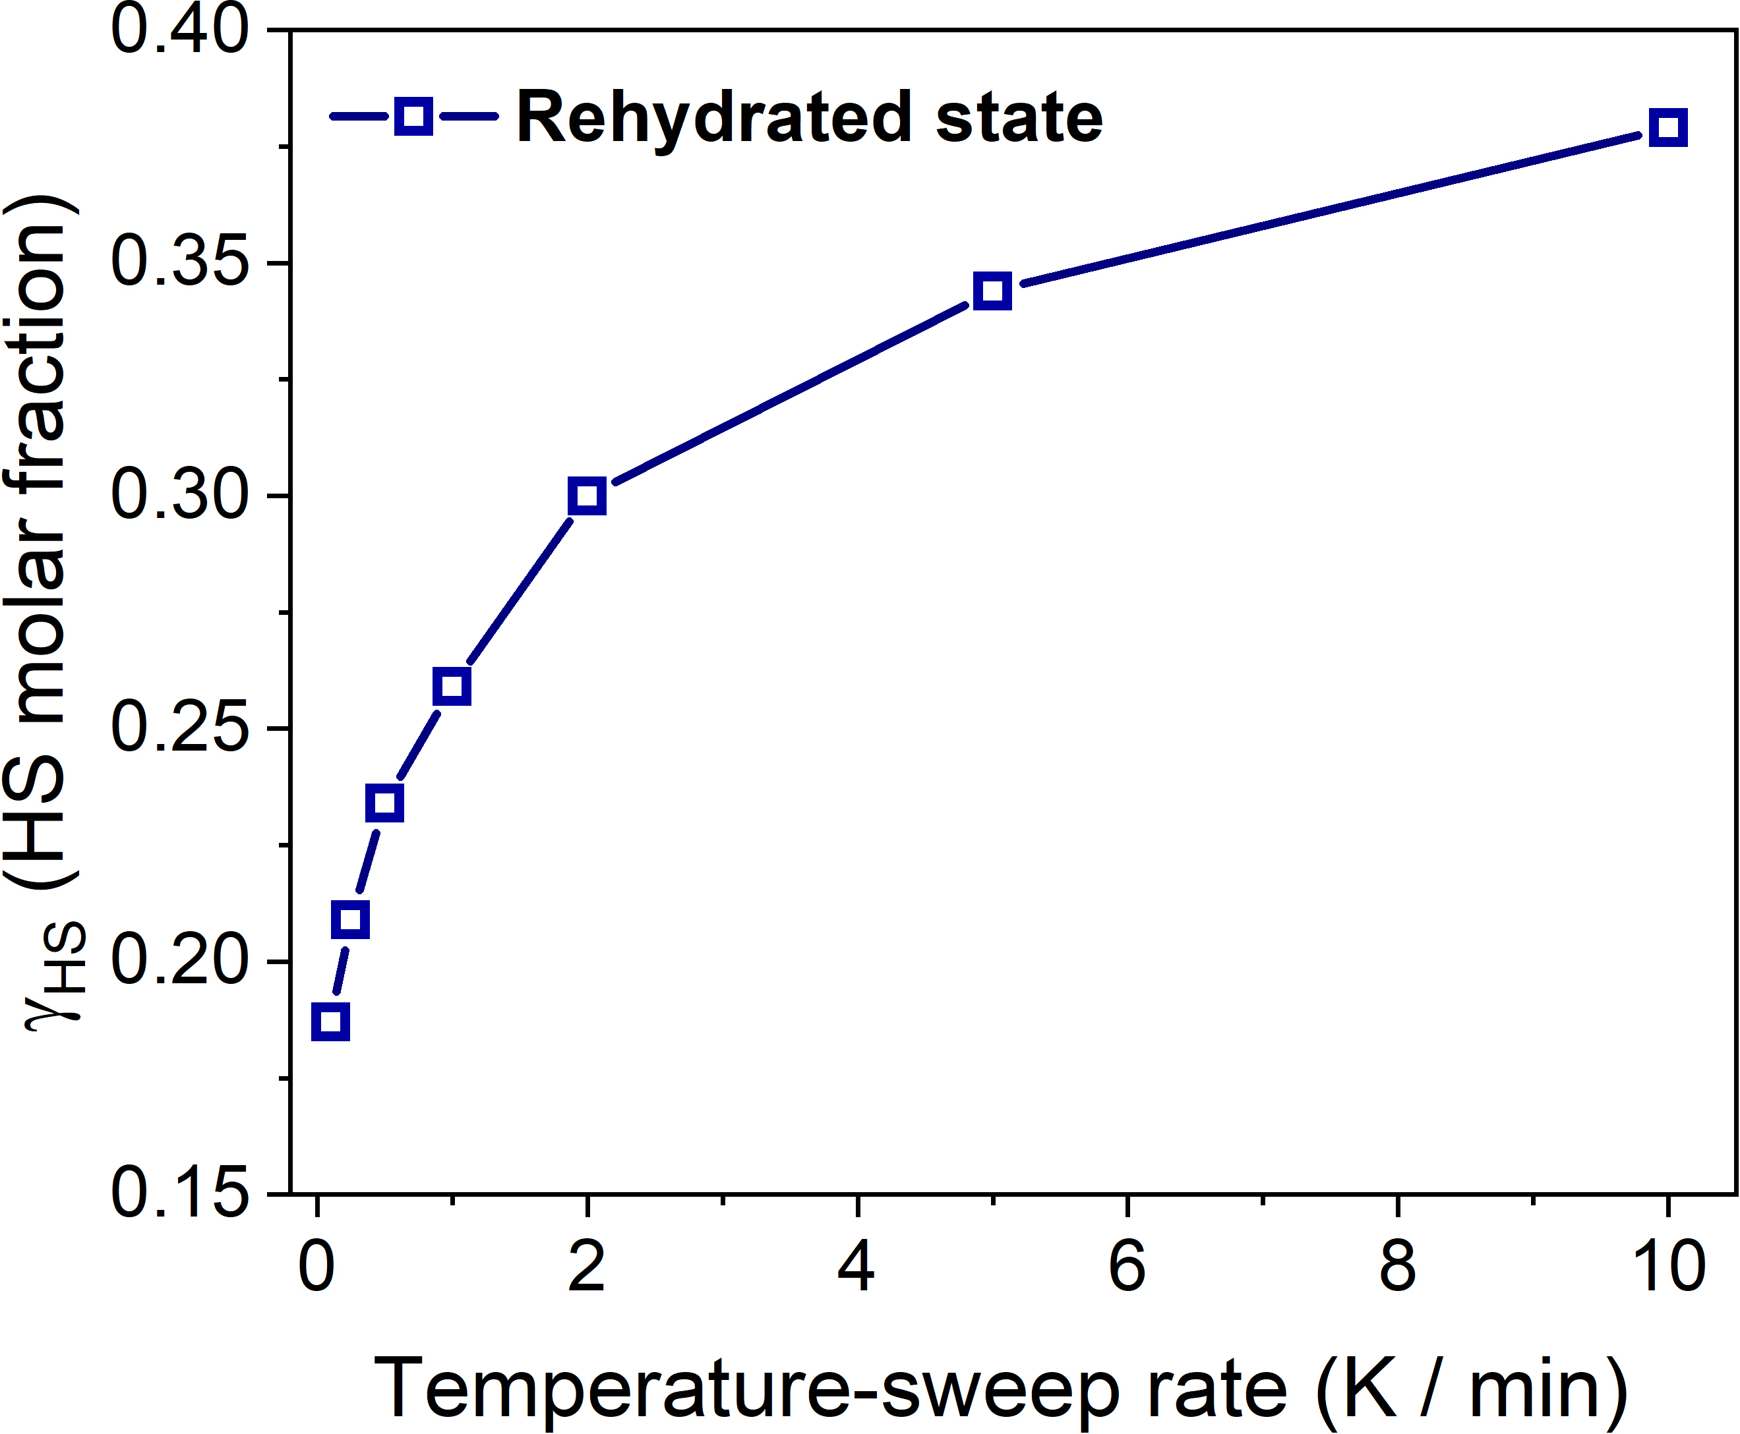
Figure S29. The temperature-sweep rate vs HS Fe^{II} molar fraction (γ_{HS}) for rehydrated sample after heating at 395 K starting at an ambient temperature of 250 K.

Table S1. Crystal data and structural refinements for 1·3H₂O·3/2CH₃OH.
1·3H₂O·3/2CH₃OH
Temperature/K | 293 | 190 | 150 | 130 | 120 | 85
Formula | C_{27.5} H_{30.5} Fe N₁₂ O_{4.5} Pd
Mr/g mol⁻¹ | 763.39
Crystal size/mm | 0.05×0.08×0.03
Wavelength/Å | 0.77484
Space group | P$\overline{1}$ | P$\overline{1}$ | P$\overline{1}$ | P$\overline{1}$ | P$\overline{1}$ | P$\overline{1}$
Crystal color | yellow | red | red | red | red | red
Crystal system | triclinic | triclinic | triclinic | triclinic | triclinic | triclinic
a/Å | 7.4570(15) | 7.2880(15) | 7.2770(15) | 7.2810(15) | 7.2780(15) | 7.2600(15)
b/Å | 14.711(3) | 14.504(3) | 14.509(3) | 14.499(3) | 14.500(3) | 14.476(3)
c/Å | 15.442(3) | 15.422(3) | 15.381(3) | 15.355(3) | 15.347(3) | 15.344(3)
α/° | 104.19(3) | 104.70(3) | 104.67(3) | 104.60(3) | 104.59(3) | 104.57(3)
β/° | 99.92(3) | 100.07(3) | 99.99(3) | 99.89(3) | 99.88(3) | 99.87(3)
γ/° | 90.28(3) | 90.33(3) | 90.32(3) | 90.32(3) | 90.32(3) | 90.32(3)
Volume/Å³ | 1613.5(6) | 1550.4(6) | 1545.1(6) | 1543.3(6) | 1542.0(6) | 1535.6(6)
Z | 2 | 2 | 2 | 2 | 2 | 2
D_{c} / g cm^{–3} | 1.571 | 1.635 | 1.641 | 1.643 | 1.644 | 1.651
μ / mm^{–1} | 1.062 | 1.105 | 1.109 | 1.110 | 1.111 | 1.116
F(000) | 775.0 | 775.0 | 775.0 | 775.0 | 775.0 | 775.0
θ range/° | 2.864 to 50.052 | 2.776 to 50.054 | 2.782 to 50.044 | 2.906 to 50.044 | 2.906 to 50.054 | 2.91 to 50.054
Data/restraints/parameters | 5202/422/424 | 5053/721/424 | 4992/25/424 | 4930/403/424 | 4910/25/424 | 3590/375/400
Goodness-of-fit on F² | 1.070 | 1.034 | 1.038 | 1.029 | 1.033 | 1.370
Reflections collected | 10053 | 9820 | 9540 | 9249 | 9169 | 5359
R₁ [I ≥ 2σ(I)] | 0.0675 | 0.0692 | 0.0699 | 0.0745 | 0.0761 | 0.1307
wR₂ [all data] | 0.1997 | 0.1962 | 0.2012 | 0.2148 | 0.2183 | 0.3547
Largest diff. peak and hole/e.Å⁻³ | 1.89/-1.41 | 1.99/-1.71 | 1.96/-1.66 | 2.34/-2.05 | 2.20/-1.98 | 4.47/-1.92

Table S2. Selected bond lengths and angles for 1·3H₂O·3/2CH₃OH at different temperatures.
 | 293 K | 190 K | 150 K | 130 K | 120 K | 85 K
Fe1−N4 | 2.161(6) | 1.981(5) | 1.967(5) | 1.965(6) | 1.972(6) | 1.986(12)
Fe1−N5 | 2.156(5) | 1.947(5) | 1.952(6) | 1.946(6) | 1.946(6) | 1.966(14)
Fe1−N6 | 2.152(5) | 1.950(5) | 1.950(5) | 1.942(6) | 1.949(6) | 1.943(14)
Fe2−N7 | 2.148(5) | 2.146(5) | 2.149(6) | 2.151(6) | 2.152(6) | 2.130(14)
Fe2−N8 | 2.177(5) | 2.161(5) | 2.159(6) | 2.157(6) | 2.168(6) | 2.121(14)
Fe2−N12 | 2.187(5) | 2.179(5) | 2.175(5) | 2.177(5) | 2.178(6) | 2.164(12)
N5¹−Fe1−N4¹ | 90.4(2) | 90.3(2) | 89.9(2) | 90.2(2) | 90.2(2) | 91.4(5)
N5¹−Fe1−N4 | 89.6(2) | 89.7(2) | 90.1(2) | 89.8(2) | 89.8(2) | 88.6(5)
N5−Fe1−N4¹ | 89.6(2) | 89.7(2) | 90.1(2) | 89.8(2) | 89.8(2) | 88.6(5)
N5−Fe1−N4 | 90.4(2) | 90.3(2) | 89.9(2) | 90.2(2) | 90.2(2) | 91.4(5)
N6²−Fe1−N4 | 88.0(2) | 91.2(2) | 88.9(2) | 91.3(2) | 88.9(2) | 91.4(5)
N6³−Fe1−N4 | 92.0(2) | 88.8(2) | 91.1(2) | 88.7(2) | 91.1(2) | 88.6(5)
N6²−Fe1−N4¹ | 92.0(2) | 88.8(2) | 91.1(2) | 88.7(2) | 91.1(2) | 88.6(5)
N6³−Fe1−N4¹ | 88.0(2) | 91.2(2) | 88.9(2) | 91.3(2) | 88.9(2) | 91.4(5)
N6²−Fe1−N5 | 89.6(2) | 89.8(2) | 89.9(2) | 90.1(2) | 90.0(2) | 89.7(5)
N6³−Fe1−N5 | 90.4(2) | 90.2(2) | 90.1(2) | 89.9(2) | 90.0(2) | 90.3(5)
N6³−Fe1−N5¹ | 89.6(2) | 89.8(2) | 89.9(2) | 90.1(2) | 90.0(2) | 89.7(5)
N6²−Fe1−N5¹ | 90.4(2) | 90.2(2) | 90.1(2) | 89.9(2) | 90.0(2) | 90.3(5)
Symmetry codes: ¹ – x, 1 – y, – z; ² –1 + x, + y, + z; ³ 1 – x, 1 – y, – z.

Table S3. Selected structural parameters for 1·3H₂O·3/2CH₃OH at different temperatures.
Compound | 1·3H₂O·3/2CH₃OH
Parameter | 293 K | 190 K | 150 K | 130 K | 120 K | 85 K
<Fe1−N>^{[a]}/Å | 2.156(5) | 1.959(5) | 1.956(5) | 1.951(6) | 1.956(6) | 1.965(13)
<Fe2−N>^{[a]}/Å | 2.170(5) | 2.162(5) | 2.161(5) | 2.162(6) | 2.166(6) | 2.138(13)
∑Fe1^{[b]} | 11.2(2) | 6.8(2) | 5.2(2) | 6.4(2) | 5.2(2) | 12.4(5)
∑Fe2^{[b]} | 5.6(3) | 11.72(8) | 12.0(2) | 13.6(2) | 13.2(2) | 14.4(5)
d_{N−O}^{[c]} | 2.904(4) | 2.817(3) | 2.822(3) | 2.824(4) | 2.821(3) | 2.850(3)
[a] The average Fe–N bond lengths (Å);
[b] Octahedral distortion parameters (°);
[c] The distance of hydrogen bonds between uncoordinated nitrogen atom of 1,2,4-triazole in the prentrz ligand and oxygen atom of adjacent H₂O molecule.

References
- Scott, H. S., Ross, T. M., Moubaraki, B., Murray, K. S. & Neville, S. M. (2013). Spin crossover in polymeric materials using schiff base functionalized triazole ligands. Eur. J. Inorg. Chem. 803-812.
- Xue, J-P., Hu, Y., Zhao, B., Liu, Z-K., Xie, J., Yao, Z-S. & Tao J. (2022). A spin-crossover framework endowed with pore-adjustable behavior by slow structural dynamics. Nat. Commun., 13, 3510.

