Supplementary Materials
Supplementary Methods
Treatments
Eligible patients received chemotherapy consisting of intravenous oxaliplatin 130 mg/m² on day 1, followed by oral capecitabine 1000 mg/m² twice daily for days 1-14 (XELOX), every three weeks. This regimen (XELOX) was administered in combination with either sintilimab (3 mg/kg for body weight <60 kg, 200 mg for ≥60 kg) in the sintilimab plus chemotherapy group, or a matching placebo in the placebo plus chemotherapy group. Both treatments were given intravenously every three weeks. Treatment continued until disease progression as assessed by the investigator using RECIST guidelines (version 1.1), nontolerable side effects, initiation of another anti-cancer therapy, patient withdrawal of consent, or fulfillment of other discontinuation criteria outlined in the protocol. Additionally, for patients in both groups who completed the initial 6 cycles of combination therapy, maintenance therapy with either sintilimab or placebo plus capecitabine (at the same dosage used in combination treatment) could be continued for up to a maximum of 2 years.
Assessments
Previous medical history, physical examination, Body Mass Index (BMI), ECOG PS, Electrocardiogram (ECG), complete blood count and chemistry, urinary and stool test, thyroid function test, gastroscopy with biopsy, and pathological evaluation were obtained or performed for each patient before treatment. Radiological evaluation by Positron Emission Tomography (PET) scans , Computed Tomography (CT) and/or Magnetic Resonance Imaging (MRI) was done for baseline tumor assessment according to RECIST v1.1, then every 6 weeks from randomization for 48 weeks and afterwards every 12 weeks. Events were reported as adverse events (AEs) from the first dose to 90 days after treatment discontinuation. The investigator assessed the incidence of treatment-related adverse events (TRAEs) to any drug and immune-mediated AEs. Survival follow-up was done every 60 days after the safety follow-up visit.

Supplementary Results
Efficacy
By the cutoff date of June 20, 2021, an interim survival analysis was performed with a median follow-up period of 13.3 months (IQR 6.9-24.6). A total of 36 progression-free survival events were observed. Twenty-seven (77.1%) of the 35 patients in the sintilimab group and 19 (100%) of the 19 patients in the placebo group had discontinued study treatment. The most common reason for discontinuation was disease progression, affecting 23 (65.7%) of patients in the sintilimab group and 16 (84.2%) of patients in the placebo group.
The best overall tumor response is shown in Supplementary Table 2. Among all randomized patients, one patient (2.9%) in the immunotherapy group achieved a complete response, while none did so in the placebo group. In the sintilimab group, the objective response rate was 42.9% (n=15), compared to 26.3% (n=5) in the placebo group, while the corresponding DCR was 88.6% (n=31) and 78.9% (n=15), respectively (Supplementary Table 1). Waterfall plots showing tumor shrinkage from baseline in target lesions are shown in Supplementary Figure 1.
In the final analysis of survival, the median progression-free survival was 7.07 months (95% CI, 5.38-8.76) with sintilimab plus XELOX and 4.23 months (95% CI, 3.06-5.40) with placebo plus XELOX in the overall population (Supplementary Figure 2A). Overall survival was also improved in the sintilimab group, with a median OS of 15.63 months (95% CI: 9.26-22.00) compared to 12.03 months (95% CI: 4.92-19.14) in the placebo group, representing a 3.6-month improvement and a 54% reduction in the risk of death (HR 0.46 [95% CI: 0.22-0.95]) (Figure 2D). Collectively, these results demonstrate promising efficacy, with encouraging survival benefits in the first-line immunotherapy setting.
Safety Profile
The frequency of AEs reported in patients treated with sintilimab plus XELOX or placebo plus XELOX is detailed in Supplementary Table 3. All grades of AEs were reported in 34 (97.1%) of 35 patients in the sintilimab group and 19 (100%) of 19 in the placebo group. The most common grade 3 or higher AE was decreased platelet count, occurring in 25.7% (n=9/35) of patients in the sintilimab group and 42.1% (n=8/19) of patients in the placebo group. Decreased neutrophil count was observed in 8 (22.9%) patients and 4 (21.1%) patients in the sintilimab and the placebo groups, respectively. Treatment-related serious adverse events of any grade occurred in 11 (31.4%) patients in the sintilimab group (including 6 [17.1%] with grade 3 or higher AEs) and in 2 (10.5%) patients in the placebo group (both with grade 3 or higher AEs). The most common SAE was decreased platelet count. Of the two deaths in the sintilimab group, one was attributed to sintilimab and chemotherapy, and the other was unrelated to treatment.

Supplementary Figure 1 Treatment response (n = 30)
Supplementary Figure 1 Treatment response (n = 30)

Supplementary Figure 2

Supplementary Figure 2 Kaplan-Meier plot of progression-free survival and overall survival for sintilimab plus chemotherapy and placebo plus chemotherapy

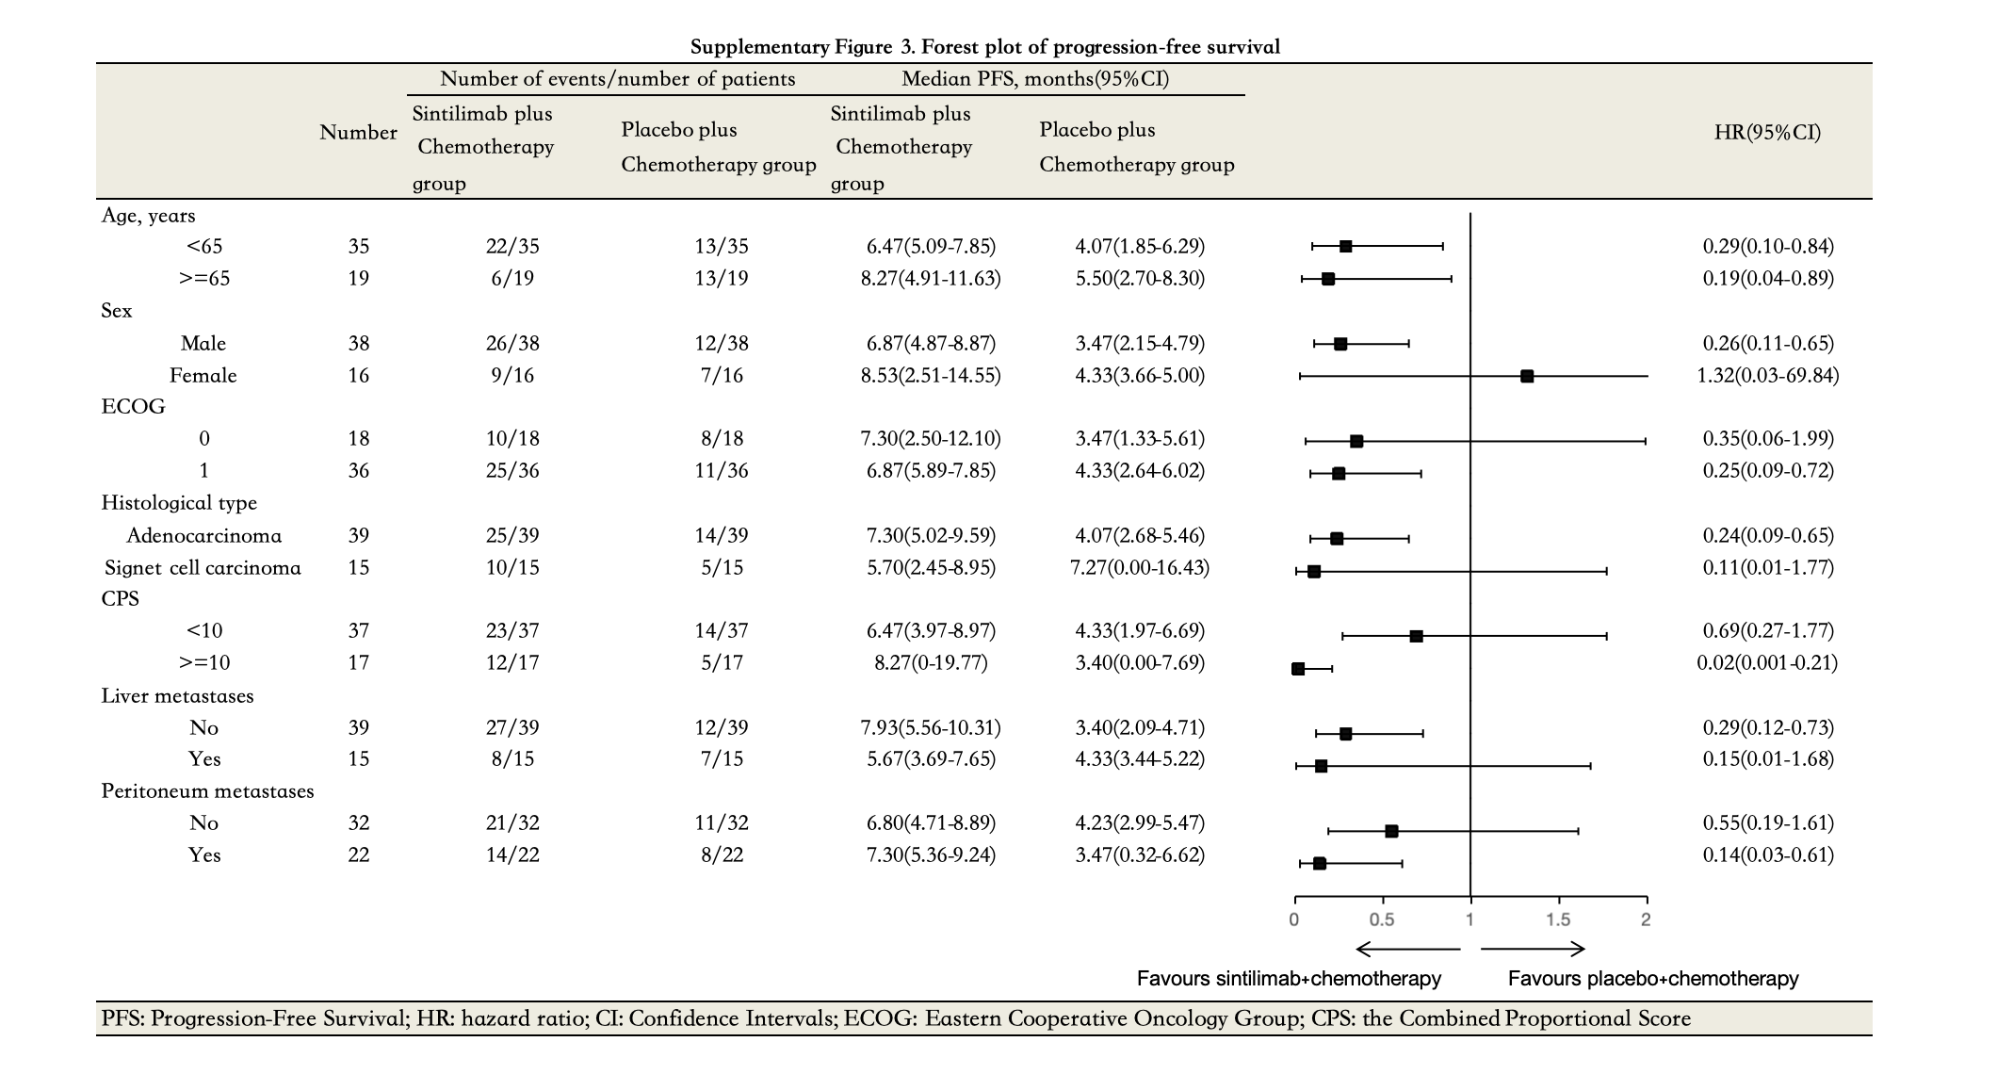
Supplementary Figure 3
Supplementary Figure 3 Forest plot of progression-free survival.

Supplementary Figure 4

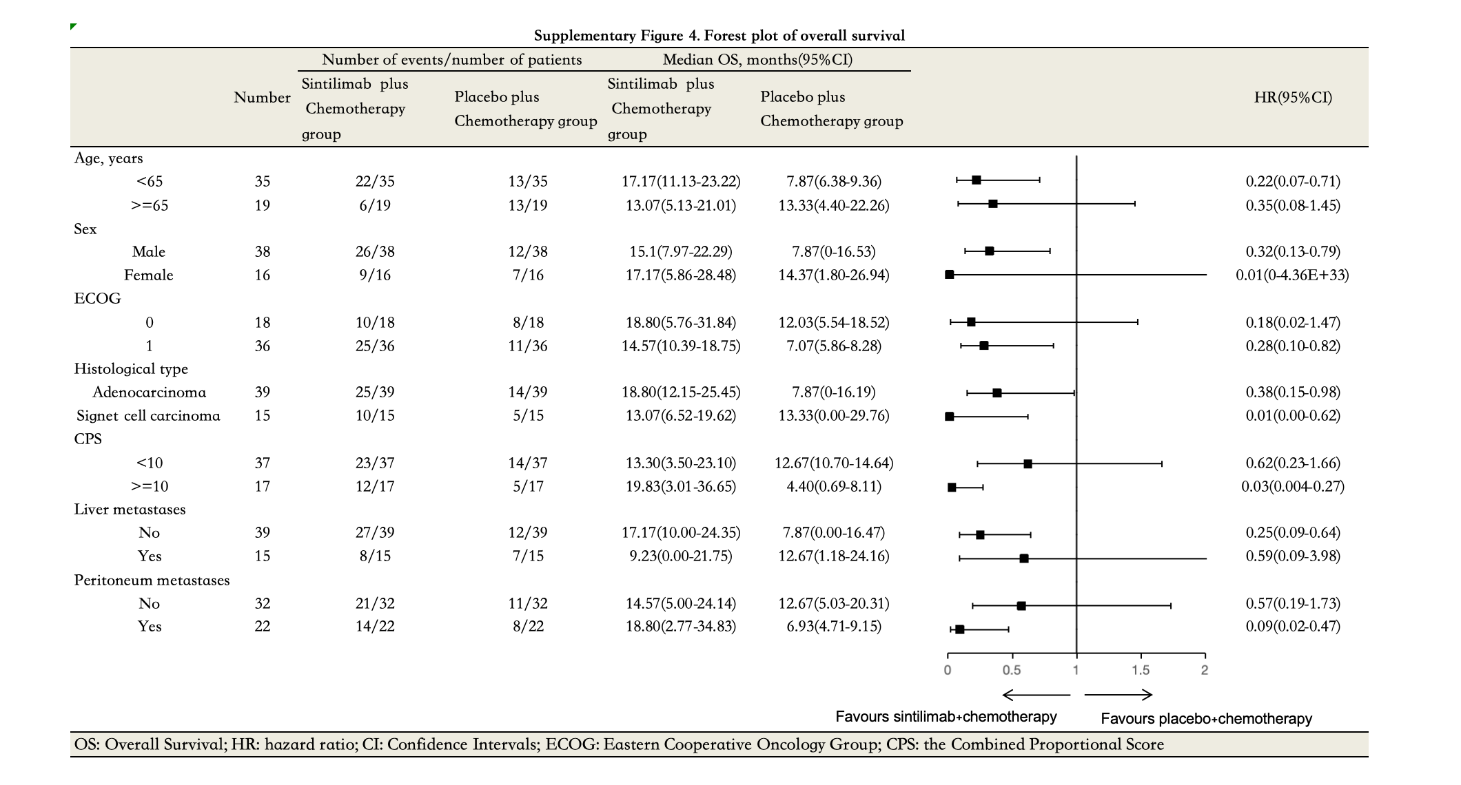
Supplementary Figure 4 Forest plot of overall survival.

Supplementary Table 1. Tumor responses
Category | Sintilimab +chemotherapy(N=35) |  | Placebo+chemotherapy(N=19)
Category | n | (95%CI) | n | (95%CI)a
Objective response rate (CR + PR) | 15(42.9%) |  | 5(26.3%)
Disease control rate (CR + PR + SD) | 31(88.6%) |  | 15(78.9%)
Best overall response, n (%)
Complete response (CR) | 1(2.9%) |  | 0(0.0%)
Partial response (PR) | 14(40.0%) |  | 5(26.3%)
Stable disease (SD) | 16(45.7%) |  | 10(52.6%)
Progressive disease (PD) | 0(0.0%) |  | 0(0.0%)
Not Avaliable (NA) | 4(11.4%) |  | 4(21.1%)
Progression-free survival, months, median | 7.07 | 5.38-8.76 | 4.23 | 3.06-5.40
Overall survival, months, median | 15.63 | 9.26-22.00 | 12.03 | 4.92-19.14
aThe confidence intervals were estimated by the Clopper-Pearson exact method.
Note: Data cut-off: July 20, 2020.

Supplementary Table 2. Summary of treatment-related adverse events in all patients
 | Sintilimab +chemotherapy(N=35) |  | Placebo+chemotherapy(N=19)
 | Any grade | Grade ≥3 | Any grade | Grade ≥3
All adverse eventsa | 34(97.1%) | 22(62.9%) | 19(100.0%) | 12(63.2%)
Serious events | 11(31.4%) | 6(17.1%) | 2(10.5%) | 2(10.5%)
Treatment-related adverse eventsb
Neutrophil count decreased | 26(74.3%) | 8(22.9%) | 10(52.6%) | 4(21.1%)
White blood cell count decreased | 26(74.3%) | 4(11.4%) | 10(52.6%) | 2(10.5%)
Platelet count decreased | 22(62.9%) | 9(25.7%) | 10(52.6%) | 8(42.1%)
Vomiting | 19(54.3%) | 0(0.0%) | 10(52.6%) | 1(5.3%)
Anemia | 12(34.3%) | 6(17.1%) | 9(47.4%) | 4(21.1%)
Diarrhea | 9(25.7%) | 0(0.0%) | 1(5.3%) | o
Abdominal pain | 7(20.0%) | 0(0.0%) | 4(21.1%) | 0(0.0%)
Weight decreased | 7(20.0%) | 1(2.9%) | 2(10.5%) | 1(5.3%)
Fever | 6(17.1%) | 0(0.0%) | 2(10.5%) | 0(0.0%)
Abdominal distension | 6(17.1%) | 0(0.0%) | 2(10.5%) | 0(0.0%)
Rash | 6(17.1%) | 0(0.0%) | 1(5.3%) | 0(0.0%)
Nausea | 5(14.3%) | 1(2.9%) | 2(10.5%) | 0(0.0%)
Palmar-plantar erythrodysesthesia syndrome | 6(17.1%) | 2(5.7%) | 1(5.3%) | 0(0.0%)
Fatigue | 5(14.3%) | 0(0.0%) | 6(31.6%) | 0(0.0%)
Peripheral sensory neuropathy | 5(14.3%) | 0(0.0%) | 0(0.0%) | 0(0.0%)
Oedema peripheral | 5(14.3%) | 0(0.0%) | 1(5.3%) | 0(0.0%)
Cough | 5(14.3%) | 0(0.0%) | 1(5.3%) | 0(0.0%)
Insomnia | 4(11.4%) | 0(0.0%) | 0(0.0%) | 0(0.0%)
Anaphylaxis | 4(11.4%) | 0(0.0%) | 0(0.0%) | 0(0.0%)
Hypokalemia | 4(11.4%) | 0(0.0%) | 1(5.3%) | 0(0.0%)
Lymphocyte count decreased | 4(11.4%) | 0(0.0%) | 0(0.0%) | 0(0.0%)
Data are n (%). Events include those occurring from the first date of study treatment to the date of initiating the subsequent therapy or 28 days after the last dose of study treatment, whichever occurred first.
aAdverse events were classified according to Medical Dictionary for Regulatory Activities and graded according to the National Cancer Institute Common Terminology Criteria for Adverse Events, version 5.0 (range, 1-5 [1, mild; 2, moderate; 3, severe; 4, life-threatening; and 5, death]).
bThe all-grade events reported here occurred in ≥15% of patients in either treatment group.

