A comparative encapsulation behaviour analysis and biological studies of C-alkyl calix[4]resorcinarenes-4-hydroxybenzoic acid inclusion complexes
Kasi Sathiyaseelan¹ and Albert Antony Muthu Prabhu²*
¹Research Scholar, Register Number: 19212022031004, Research Department of Chemistry, Aditanar College of Arts and Science, Tiruchendur – 628217. Affiliated to Manonmaniam Sundaranar University, Abishekapatti, Tirunelveli, Tamilnadu – 627 012, India.
^{2*}Department of PG Chemistry, Aditanar College of Arts and Science, Tiruchendur – 628217, Tamilnadu, India
Corresponding author: antonyphdchem@yahoo.com

Electronic Supplementary Informations

Fig. S1 A jobs plot for aqueous state inclusion complexes

Fig. S2 The phase solubility diagram of an aqueous phase inclusion complexes

Fig. S3 A proposed structure of inclusion complex formation between 4HBA and C4RAs: Orientation A and Orientation B

Structure | HOMO
LUMO | ESP
Fig. S4 Molecular modeling structures of compound 3a in gas phase DFT B3LYP 3-21G method

Structure | HOMO
LUMO | ESP
Fig. S5. Molecular modeling structures of compound 3b in gas phase DFT B3LYP 3-21G method

Structure | HOMO
LUMO | ESP
Fig. S6 Molecular modeling structures of compound 3c in gas phase DFT B3LYP 3-21G method

Structure | HOMO
LUMO | ESP
Fig. S7 Molecular modeling structures of compound 3d in gas phase DFT B3LYP 3-21G method

Fig. S8 A plot of % TAC vs Concentration of 4HBA (4), C4RAs (3a-3d) and their inclusion complexes (5a-5d)

Escherchia coli | Klebsiella pneumoniaei | Streptococus pneumoniae | Staphylococcus aureus | Pseudomonas aeruginose
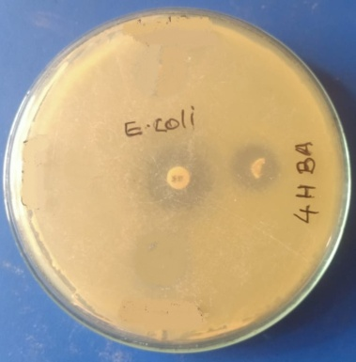 | 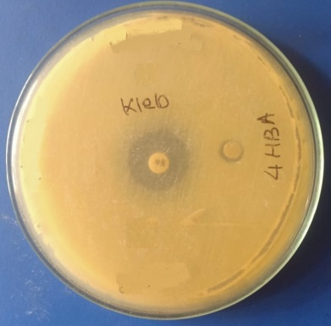 | 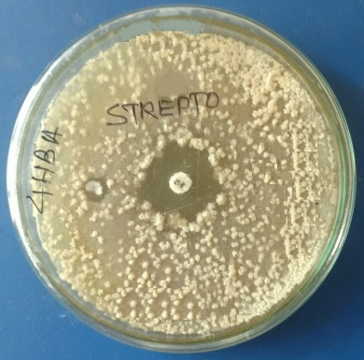 | 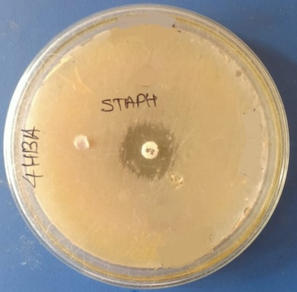 | 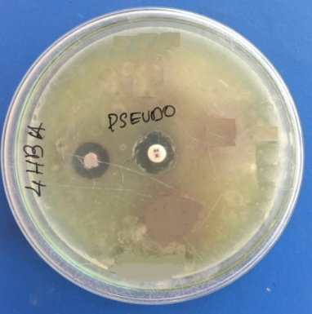
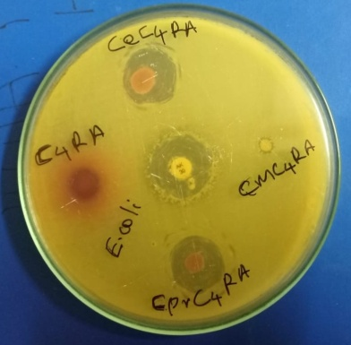 | 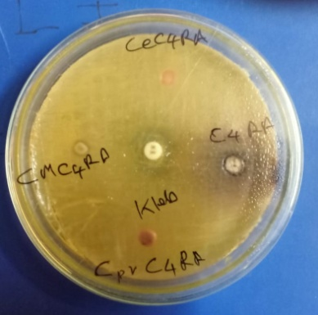 | 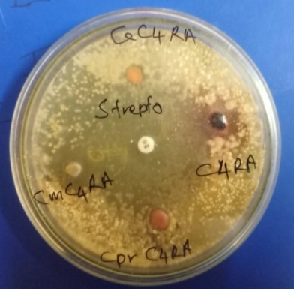 | 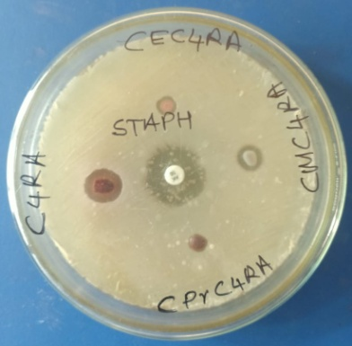 | 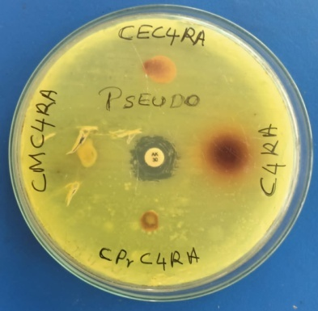
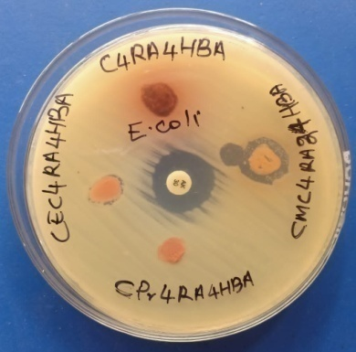 | 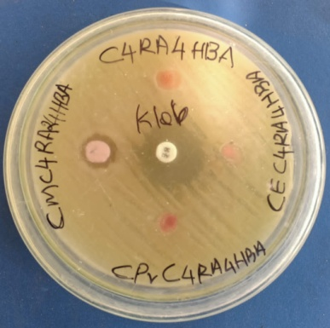 | 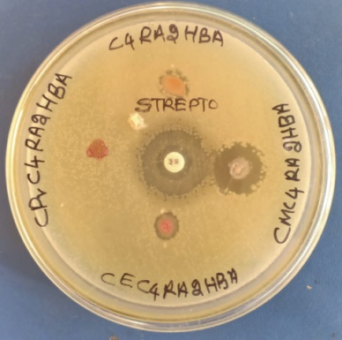 | 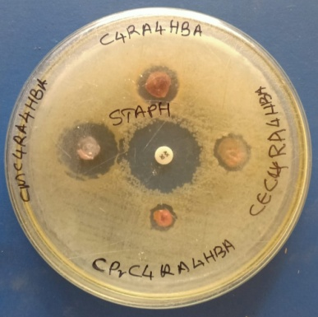 | 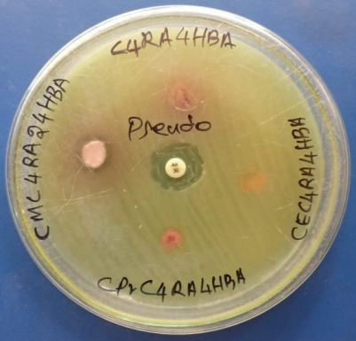
Fig. S9 Kirby-bauer antibacterial activity for 4HBA (4), C4RAs (3a-3d) and their inclusion complexes (5a-5d)
Tables

Table S1 The colour of appearance, yield and % yield of inclusion complexes
Parameters | 5a | 5b | 5c | 5d
Weight (mg) | 122 mg 3a | 136 mg 3b | 170 mg 3c | 164 mg 3d
Weight (mg) | 38 mg C2 | 38 mg C2 | 38 mg C2 | 38 mg 4
Colour | Red | Yellow | Green | Brown
Yield (mg) | 140 mg | 121 mg | 176 mg | 185 mg
% Yield | 89.74 | 70.67 | 95.39 | 81.94

Table S2 The solubility analysis for 10 mg of inclusion complexes with different solvents
Solvents | 4 | 3a | 3b | 3c | 3d | 5a | 5b | 5c | 5d
Water | P | P | P | P | P | P | P | P | P
Methanol | S | S | S | S | S | S | S | S | S
Ethanol | S | S | S | S | S | S | S | S | S
Ethanediol | S | S | S | S | S | S | S | S | S
Dichloromethane | P | P | P | P | P | P | P | P | P
Dichloroethane | P | P | P | P | P | P | P | P | P
Acetone | S | S | S | S | S | S | S | S | S
Dimethyl sulphoxide | S | S | S | S | S | S | S | S | S
N,N-dimethyl formamide | S | S | S | S | S | S | S | S | S
Acetonitrile | S | S | S | S | S | S | S | S | S
Ethyl acetate | S | S | S | S | S | S | S | S | S
Dioxane | S | S | S | S | S | S | S | S | S
Chloroform | P | P | P | P | P | P | P | P | P
Diethyl ether | S | S | S | S | S | S | S | S | S
Diphenyl ether | S | I | I | I | I | P | P | P | P
Tetrahydrofuran | S | P | P | P | P | I | I | I | I
Toluene | I | P | P | P | P | I | I | I | I
Cyclohexane | I | P | P | P | P | I | I | I | I
S – Soluble; P – Partially soluble and I – Insoluble

Table S3 Jobs plot data for equal molar concentrations of 4HBA (4) with C4RAs
Vol. 4HBA (mL) | Vol.  C4RAs (mL) | [4HBA]  (µM) | [C4RAs] (µM) | R | ΔA x R (Corrected absorbance)
 |  |  |  |  | 5a | 5b | 5c | 5d
0 | 10 | 0 | 100 | 0.0 | 0.0000 | 0.0000 | 0.0000 | 0.0000
1 | 9 | 10 | 90 | 0.1 | 0.0873 | 0.1069 | 0.0775 | 0.0885
2 | 8 | 20 | 80 | 0.2 | 0.1504 | 0.1890 | 0.1386 | 0.1176
3 | 7 | 30 | 70 | 0.3 | 0.2082 | 0.2493 | 0.1815 | 0.1590
4 | 6 | 40 | 60 | 0.4 | 0.2376 | 0.2792 | 0.2044 | 0.1996
5 | 5 | 50 | 50 | 0.5 | 0.2417 | 0.2965 | 0.2165 | 0.2090
6 | 4 | 60 | 40 | 0.6 | 0.2109 | 0.2838 | 0.2064 | 0.1788
7 | 3 | 70 | 30 | 0.7 | 0.1869 | 0.2506 | 0.1995 | 0.1442
8 | 2 | 80 | 20 | 0.8 | 0.1376 | 0.1960 | 0.1512 | 0.1357
9 | 1 | 90 | 10 | 0.9 | 0.0720 | 0.1269 | 0.1359 | 0.0972
10 | 0 | 100 | 0 | 1.0 | 0.0000 | 0.0000 | 0.0000 | 0.0000

Table S4 Phase solubility analysis of aqueous state inclusion complexes
Parameters | 5a | 5b | 5c | 5d
Slope (m) | 0.72 | 0.56 | 0.45 | 0.54
Intrinsic solubility (μM) | 6.72 | 6.92 | 6.49 | 7.59
R² | 0.98 | 0.97 | 0.95 | 0.94
Stability constant ( 10⁵ M⁻¹) | 3.91 | 1.82 | 1.28 | 3.86
Complexation efficiency (CE) | 2.63 | 1.26 | 0.83 | 0.29
Type of phase diagram | A_{L} | A_{L} | A_{N} | A_{N}

Table S5 Assignments of FTIR stretching and bending vibrations of compound 4, C4RAs and their inclusion complexes
Functional groups | Mode | Wavenumber (cm⁻¹)
Functional groups | Mode | 4 | 3a | 3b | 3c | 3d | 5a | 5b | 5c | 5d
hydroxyl group (-OH) | O-H (s) | 3385.42 | 3271.27 | 3363.66 | 3348.78 | 3301.54 | 3391.20 | 3366.14 | 3250.43 | 3289.96
hydroxyl group (-OH) | O-H (b) | 1384.63 | 1388.75 | 1381.03 | 1381.03 | 1377.89 | 1387.14 | 1385.60 | 1374.03 | 1315.21
hydroxyl group (-OH) | C-O (s) | 1290.18  1242.89  1166.72  1086.18 | 1296.16  1219.01  1157.29  1072.42 | 1273.02  1203.56  1111.00  1041.56 | 1281.47  1203.36  1149.37  1057.76 | 1290.14  1156.12  1199.51  1078.98 | 1290.14  1243.86  1167.68  1084.76 | 1277.60  1241.93  1166.72  1094.40 | 1289.18  1242.89  1169.61  1092.47 | 1294.96  1227.46  1159.97  1071.26
carbonyl group (-C=O) | C=O (s) | 1674.87 | - | - | - | - | 1675.83 | 1689.33 | 1679.69 | 1698.01
alkyl or aryl group (-R, -Ar) | C-H (s) | 3140.50  2946.10  2820.52 | 2952.52 | 2970.38 | 2959.23  2929.34  2871.49 | 2952.48  2865.70 | 3019.97  2924.76  2820.51 | 2966.62  2932.14  2876.33 | 2956.33  2929.34  2870.52 | 2965.01  2934.16  2871.48
alkyl or aryl group (-R, -Ar) | C=C (s) | 1607.38  1509.02 | 1612.48  1512.19 | 1612.49  1512.19 | 1614.13  1506.12 | 1613.16  1507.10 | 1608.34  1509.99 | 1607.40  1512.88 | 1609.30  1510.95 | 1610.25  1505.16
alkyl or aryl group (-R, -Ar) | C-H (b) | 1421.28 | 1450.47 | 1427.32 | 1434.78 | 1435.74 | 1447.32 | 1426.10 | 1447.31 | 1444.42

Table S6 Apart the change in stretching frequency values of compound 4 before and after complexation process
Parameters | 5a |  |  | 5b |  |  | 5c |  |  | 5d
Parameters | O-H (s) | C=O (s) | C=C (s) | O-H (s) | C=O (s) | C=C (s) | O-H (s) | C=O (s) | C=C (s) | O-H (s) | C=O (s) | C=C (s)
Complex | 3391.20 | 1675.83 | 1608.34  1509.99 | 3366.14 | 1689.33 | 1607.40  1512.88 | 3250.43 | 1679.69 | 1609.30  1510.95 | 3289.96 | 1698.01 | 1610.25  1505.16
Compound (4) | 3385.42 | 1674.87 | 1607.38  1509.02 | 3385.42 | 1674.87 | 1607.38  1509.02 | 3385.42 | 1674.87 | 1607.38  1509.02 | 3385.42 | 1674.87 | 1607.38  1509.02
Shift | -5.78 | +0.96 | +0.96  +0.97 | -19.28 | +14.46 | +0.03  +3.86 | -134.99 | +4.82 | +1.92  +1.93 | -95.46 | +23.14 | +2.87  -3.86

Table S7 Apart¹H-NMR chemical shift values of 4HBA (4), C4RAs (3a-3d) and their inclusion complexes
Portion | Functional group | Protons | ¹H-NMR chemical shift
Portion | Functional group | Protons | 4 | 3a | 3b | 3c | 3d | 5a | 5b | 5c | 5d
C4RAs  (3a-3d) | methine bridge | m | - | 3.428 | 4.449 | 4.096 | 4.223 | 3.430 | 4.451 | 4.089 | 4.224
C4RAs  (3a-3d) | aromatic ring | n | - | 6.252  6.291  6.538 | 6.150 | 6.154 | 6.142 | 6.223  6.289  6.538 | 6.150 | 6.150 | 6.149
C4RAs  (3a-3d) | aromatic ring | o | - | 6.035  6.056  6.652 | 6.760 | 7.219 | 7.235 | 6.040  6.060  6.648 | 6.751 | 7.215 | 7.223
C4RAs  (3a-3d) | hydroxyl group | p | - | 8.803  8.844  9.029 | 8.540 | 8.962 | 8.936 | 8.818  8.866  9.059 | 8.580 | 8.969 | 8.966
C4RAs  (3a-3d) | alkyl group on methine bridge | a | - | - | 1.284 | 0.793 | 0.902 | - | 1.290 | 0.787 | 0.880
C4RAs  (3a-3d) | alkyl group on methine bridge | b | - | - | - | 2.095 | 1.192 | - | - | 2.082 | 1.177
C4RAs  (3a-3d) | alkyl group on methine bridge | c | - | - | - | - | 2.080 | - | - | - | 2.078
4 | aryl group | 2/6 | 7.780 | - | - | - | - | 7.779 | 7.780 | 7.778 | 7.784
4 | aryl group | 3/5 | 6.836 | - | - | - | - | 6.837 | 6.838 | 6.838 | 6.839
4 | hydroxyl group | 7 | 10.310 | - | - | - | - | 10.264 | 10.289 | 10.280 | 10.300
4 | carboxylic acid group | 8 | 12.413 | - | - | - | - | 12.468 | 12.553 | 12.462 | 12.450

Table S8 The¹³C-NMR chemical shift values of 4HBA (4), C4RAs (3a-3d) and their inclusion complexes
Portion | Functional group | Carbon | ¹³C-NMR chemical shift
Portion | Functional group | Carbon | 4 | 3a | 3b | 3c | 3d | 5a | 5b | 5c | 5d
 | methine bridge | m | - | 28.49 | 29.04 | 35.62 | 36.18 | 28.56 | 22.01 | 35.75 | 37.28
 | aryl group | n | - | 118.75 | 123.56 | 123.52 | 123.66 | 118.50 | 123.57 | 123.46 | 123.65
 | aryl group | o | - | 152.56 | 152.35 | 152.03 | 152.05 | 153.21 | 152.38 | 151.98 | 151.98
 | aryl group | p | - | 102.57 | 102.57 | 102.72 | 102.80 | 102.40 | 102.46 | 102.67 | 102.70
 | aryl group | q | - | 130.24 | 125.77 | 125.49 | 125.50 | 130.11 | 125.85 | 125.59 | 125.48
 | alkyl group substitution | a | - | - | 22.09 | 13.09 | 14.38 | - | 22.08 | 13.09 | 14.42
 | alkyl group substitution | b | - | - | - | 27.21 | 21.15 | - | - | 27.22 | 21.09
 | alkyl group substitution | c | - | - | - | - | 33.03 | - | - | - | 31.19
4 | Aryl group | 1 | 121.69 | - | - | - | - | 121.83 | 121.77 | 121.86 | 121.71
4 | Aryl group | 2/6 | 132.13 | - | - | - | - | 131.82 | 131.13 | 131.99 | 132.00
4 | Aryl group | 3/5 | 115.53 | - | - | - | - | 115.44 | 115.48 | 115.46 | 115.52
4 | Aryl group | 4 | 161.85 | - | - | - | - | 162.08 | 162.08 | 162.12 | 162.04
4 | Carboxylic acid | 8 | 167.74 | - | - | - | - | 167.64 | 167.50 | 167.71 | 167.61

Table S9 Apart ¹H-NMR and ¹³C-NMR chemical shift values of 4HBA before and after complexation of inclusion complexes
Functional group |  | ¹H-NMR chemical shift values |  |  |  | ¹³C-NMR chemical shift values
Functional group |  | 5a | 5b | 5c | 5d | 5a | 5b | 5c | 5d
aryl group | 1 | - | - | - | - | +0.140 | +0.120 | +0.170 | +0.02
aryl group | 2/6 | -0.001 | +0.000 | -0.002 | +0.004 | -0.310 | -1.000 | -0.140 | -0.130
aryl group | 3/5 | +0.001 | +0.002 | +0.002 | +0.003 | -0.090 | -0.050 | -0.070 | -0.010
aryl group | 4 | - | - | - | - | +0.230 | +0.230 | +0.270 | +0.190
hydroxyl group | 7 | -0.046 | -0.021 | -0.030 | -0.010 | - | - | - | -
carboxylic acid group | 8 | +0.055 | +0.140 | +0.049 | +0.037 | -0.100 | -0.240 | -0.030 | -0.130

Table S10 Powder X-ray diffraction data of 4HBA (4), C4RAs (3a-3d) and their inclusion complexes (5a-5d)
Compound (or) Inclusion complex | 2 Theta (deg) | Nature of crystallinity | Crystalline size (nm)
4 | 17.59, 24.45 & 29.80 | Crystalline | 16.19
3a | 12.23, 19.50 & 23.76 | Crystalline | 2.10
3b | 20.98 & 26.91 | Crystalline | 18.89
3c | 13.49 & 20.10 | Crystalline | 14.92
3d | 18.20 & 20.22 | Crystalline | 15.02
5a | 16.18, 25.60 & 28.99 | Semi-crystalline | 17.80
5b | 13.25, 21.29 & 24.20 | Semi-crystalline | 7.68
5c | 16.87 & 20.47 | Semi-crystalline | 13.88
5d | 16.45, 19.54 & 29.45 | Semi-crystalline | 17.78

