Supporting Information for
Sea urchin-like sulfur-doped Ni(OH)₂ as an efficient electrocatalyst for oxygen evolution reaction
Fang Wu,^{∗a,b} Jin-Long Ge,^{a,b} Yujun Zhu,^{∗c} Yuhong Jiao^{a,b} Zhong Wu^{a,b} Chao Feng,^{a,b} Yupei Zhao,^{d} Qiu Li^{a,b}

ªSchool of Material and Chemical Engineering, Bengbu University, Bengbu, Anhui 233030, China. E-mail: bbcwuf@163.com
^{b}Silicon Based New Materials Engineering Research Center of Anhui Province, Bengbu University, Bengbu, Anhui 233030, China. E-mail: bbcwuf@163.com
^{c}Department of Pharmacy and Biomedical Engineering, Clinical College of Anhui Medical University, Hefei 230000, China E-mail: zyj8119@sina.com
^{d}School of Petrochemical Engineering, Changzhou University, Changzhou 213164, China

E-mail address: bbcwuf@163.com (Fang Wu), zyj8119@sina.com (Yujun Zhu)

Fig. S1 SEM-EDX spectrum of S-Ni(OH)₂-30 min.

Fig. S2 Overall XPS spectrum of S-Ni(OH)₂-30 min.

Fig. S3 CV curves of (a) Ni(OH)₂, (b) S-Ni(OH)₂-5 s, (c) S-Ni(OH)₂-5 min, (d) S-Ni(OH)₂-30 min, (e) S-Ni(OH)₂-1.5 h and (f) S-Ni(OH)₂-12 h at different scan rates in the potential range of -0.05–0.05 V vs Hg/HgO.

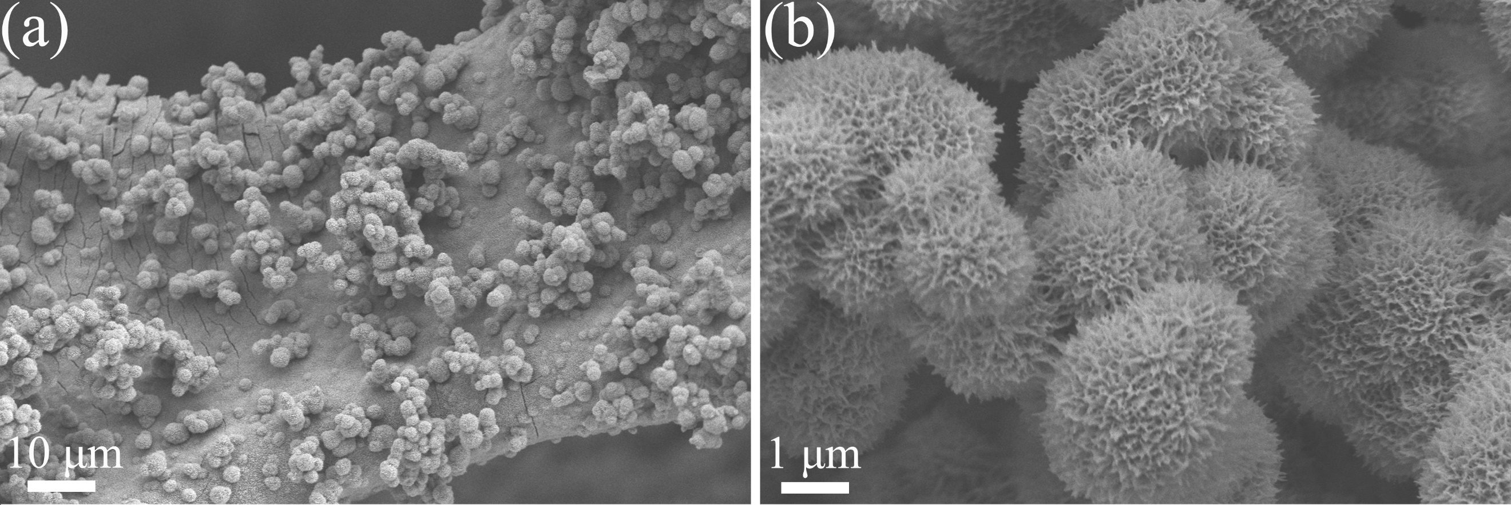
Fig. S4 SEM images of S-Ni(OH)₂-30 min after stability test.

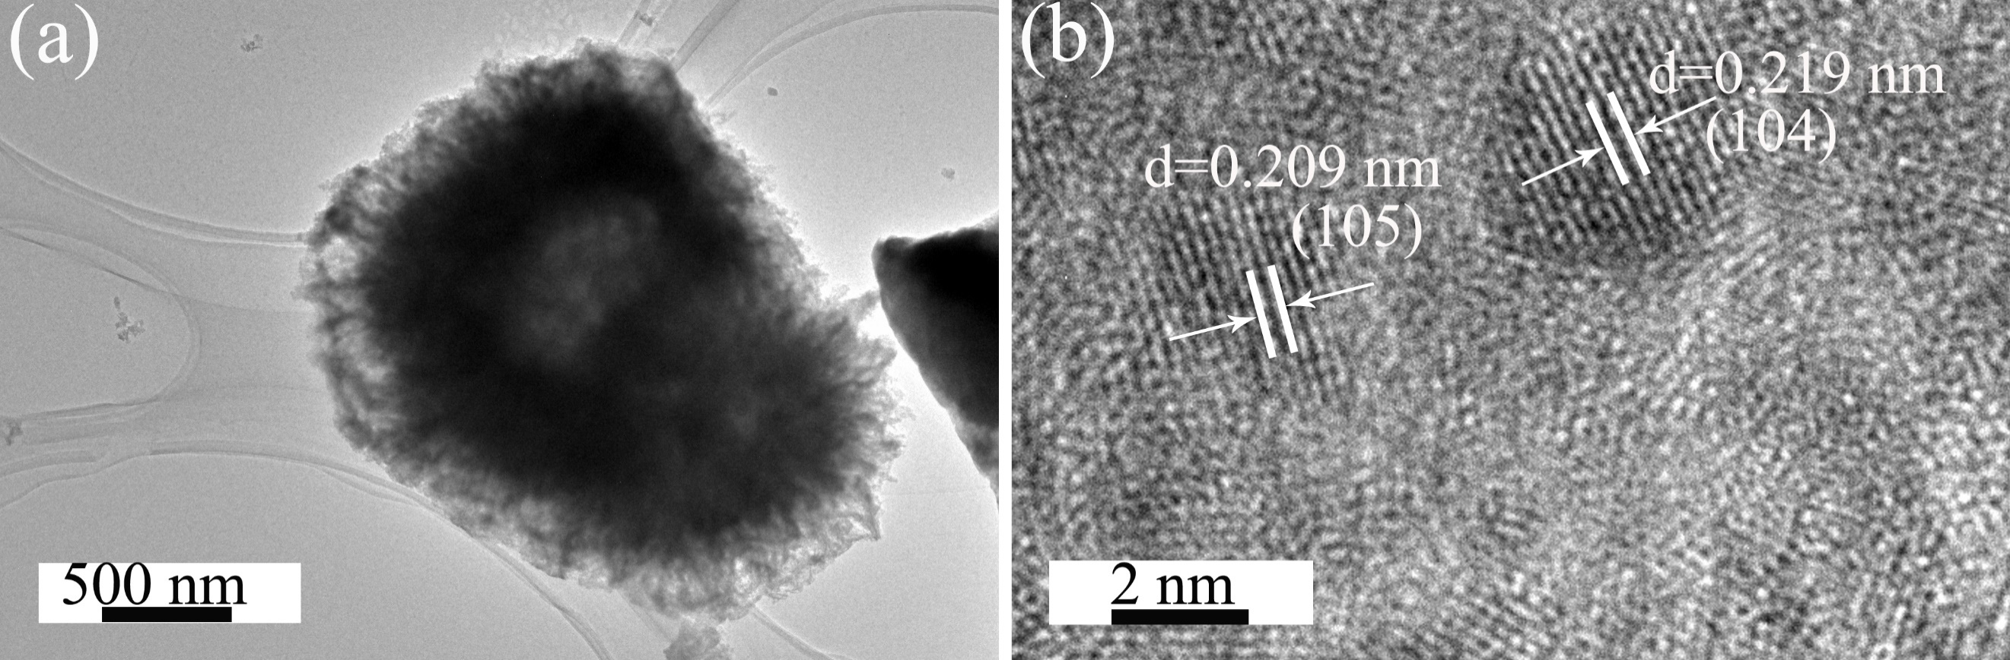
Fig. S5 (a) TEM and (b) HRTEM images of S-Ni(OH)₂-30 min after stability test.

Fig. S6 (a) XRD pattern, High-resolution XPS spectra of (b) Ni 2p, (c) O 1s and (d) S 2p of S-Ni(OH)₂-30 min after stability test.

Fig. S7 Raman spectrum of S-Ni(OH)₂-30 min after stability test.

