Supporting information for

Design, synthesis and antitumor activity evaluation of Benzimidazole derivatives with potent HDAC inhibitory activity

Jiantao Ping ^{a,b}, Hongrui Chu ^{a,b}, Yisheng Zhao ^{a,b*} , Chen Chen^{c*}

ª Shandong Analysis and Test Center, Qilu University of Technology (Shandong Academy of Sciences), Jinan 250013, PR China;
^{b} School of Pharmaceutical Sciences, Qilu University of Technology (Shandong Academy of Sciences), Jinan 250353, PR China;
^{c} Shandong Chengchuang Blue Sea Pharmaceutical Technology Co., Ltd. Jinan 250013, PR China;

*Address correspondence to this author: Yisheng Zhao, yisheng_zhao@qlu.edu.cn ; Chen Chen，chenlwchen@163.com

¹H NMR Spectra for 5a
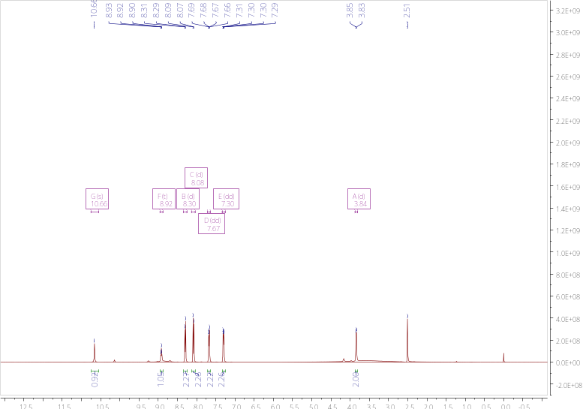
¹³C NMR Spectra for 5a
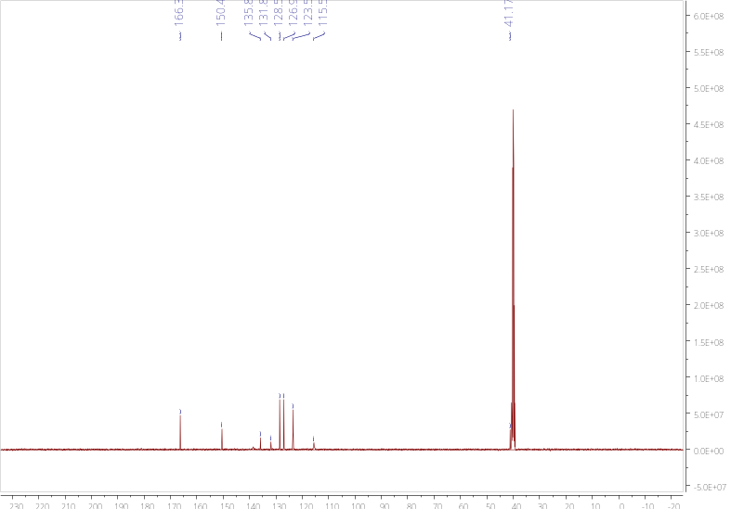
HRMS for 5a
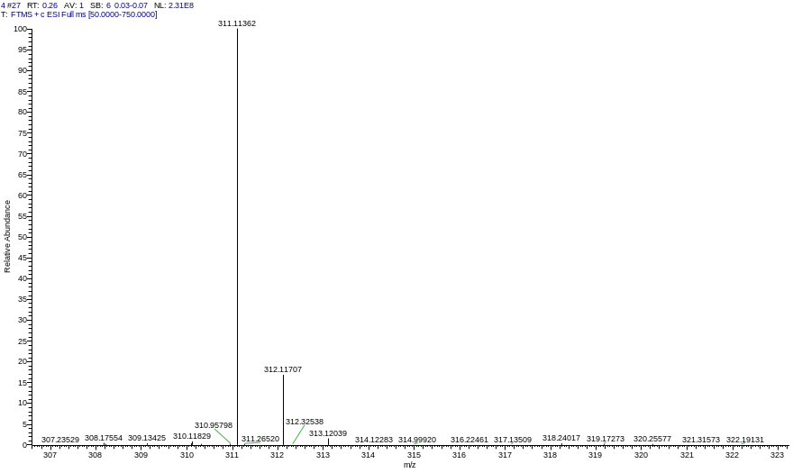
¹H NMR Spectra for 5b
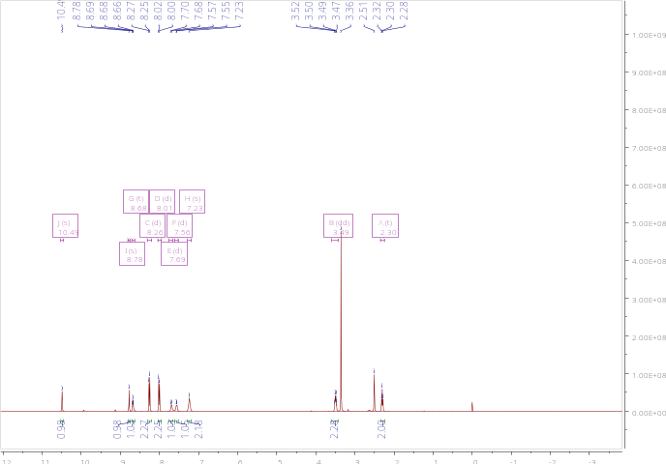
¹³C NMR Spectra for 5b
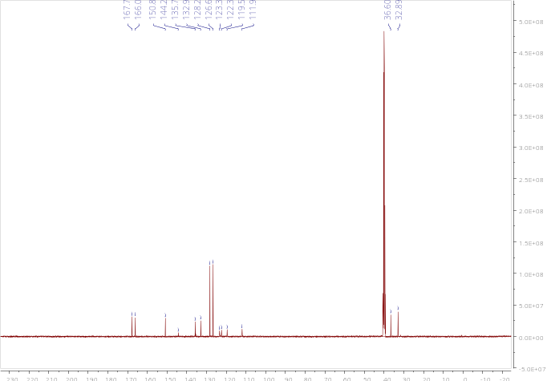
HRMS for 5b
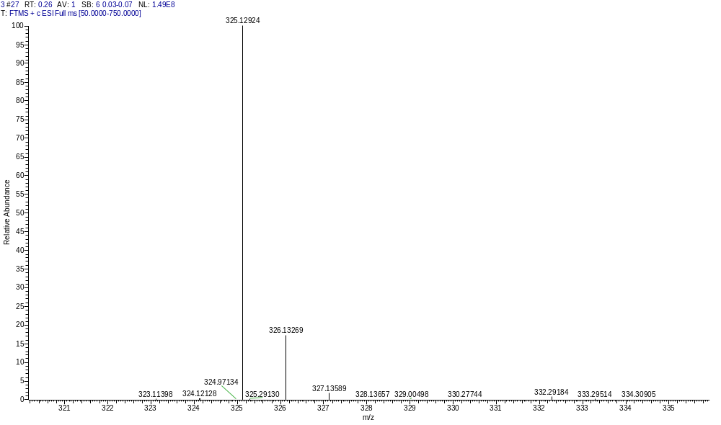

¹H NMR Spectra for 5c
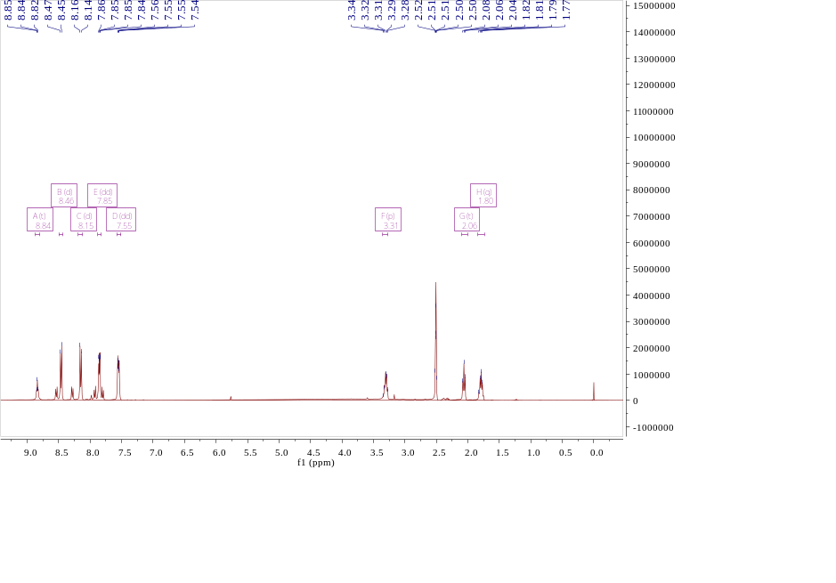
¹³C NMR Spectra for 5c
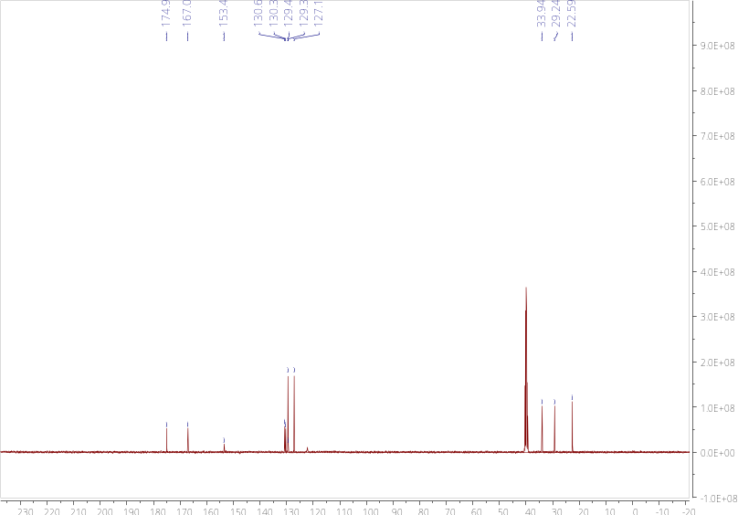
HRMS for 5c
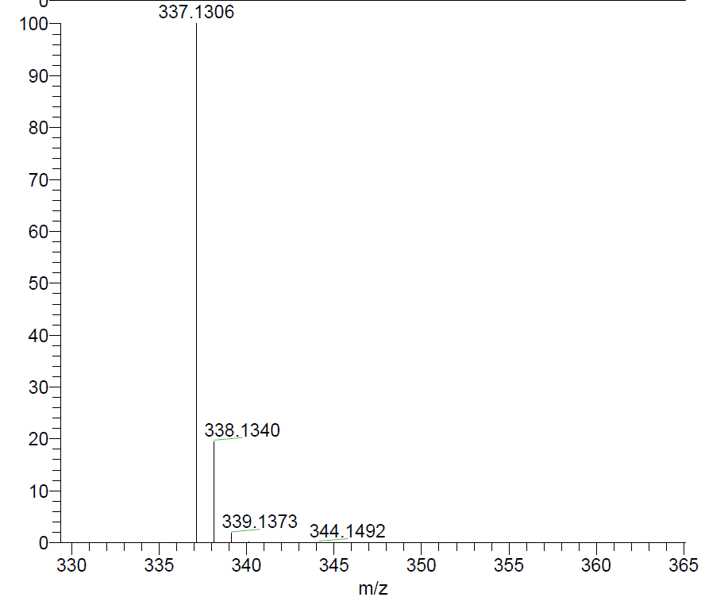
¹H NMR Spectra for 5d
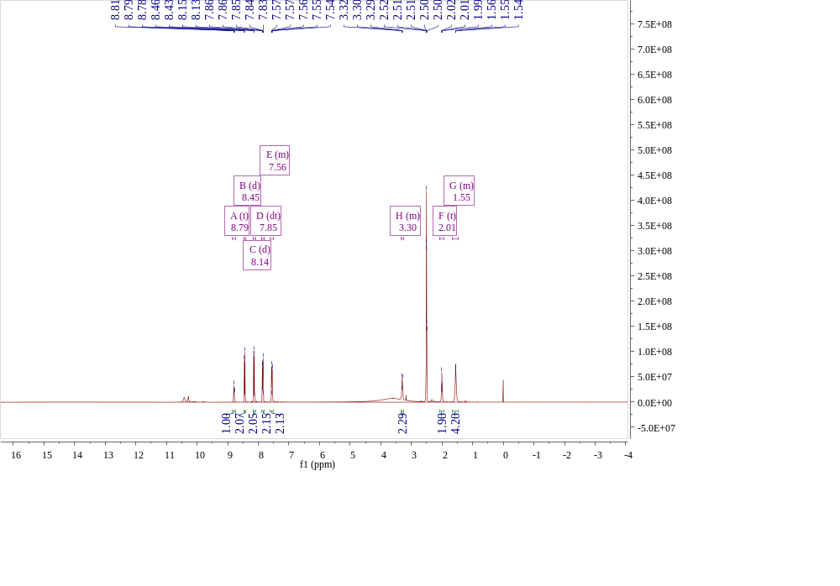
¹³C NMR Spectra for 5d
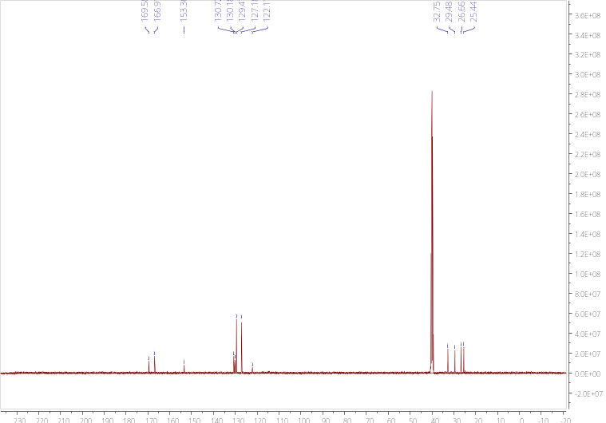
HRMS for 5d
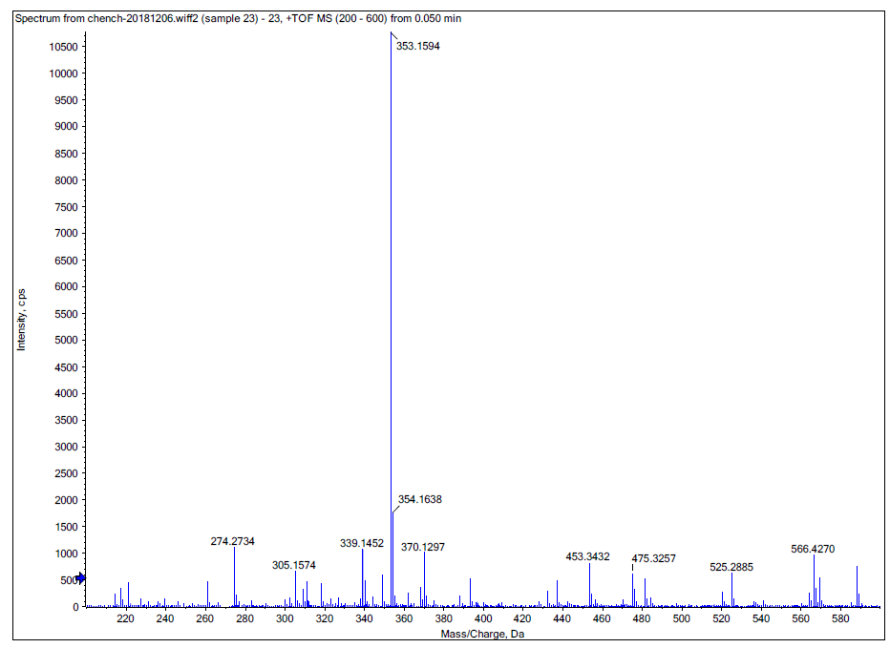
¹H NMR Spectra for 5e
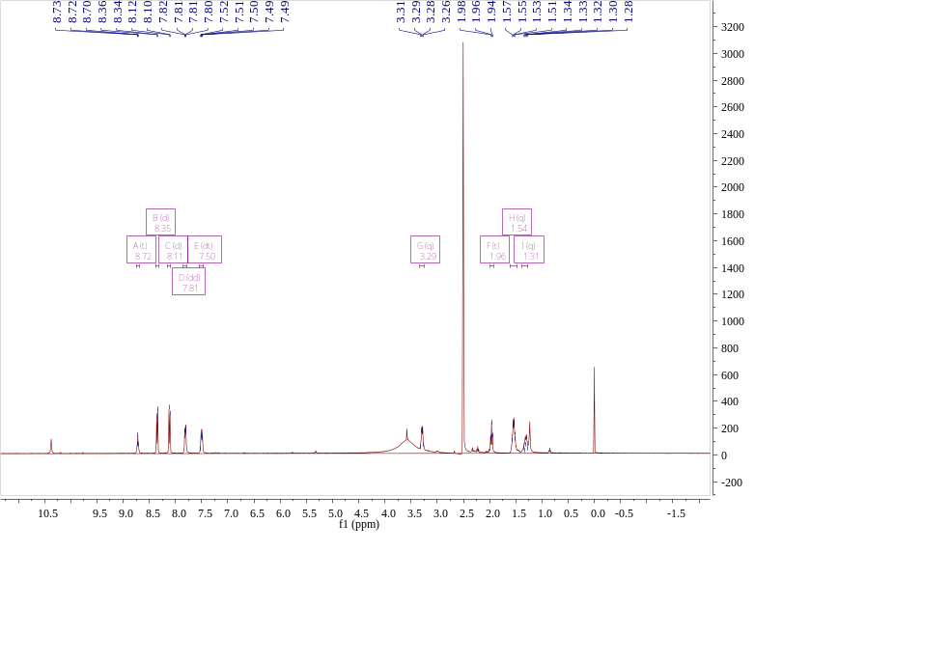
¹³C NMR Spectra for 5e
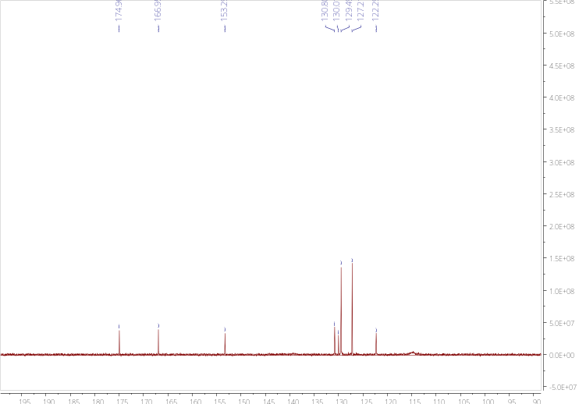
HRMS for 5e
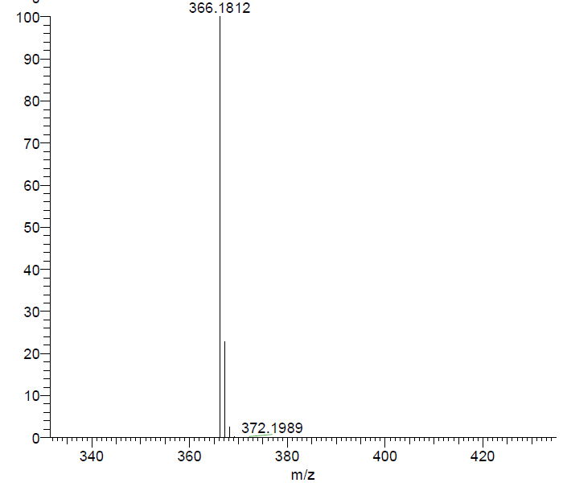
¹H NMR Spectra for 5f
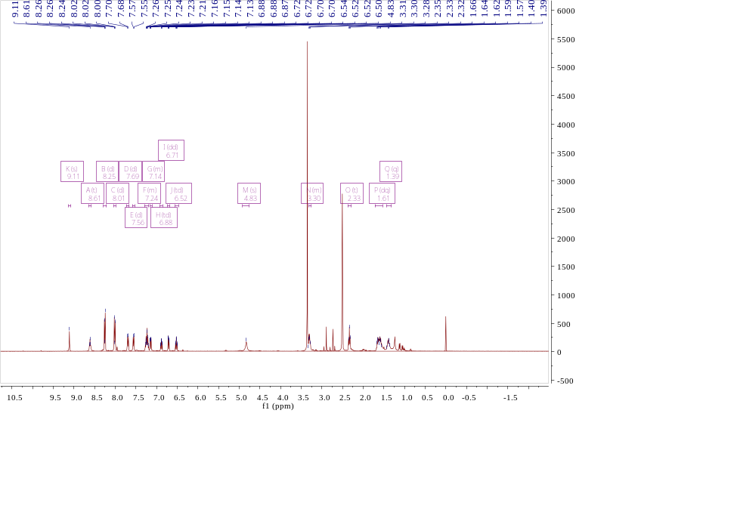
¹³C NMR Spectra for 5f
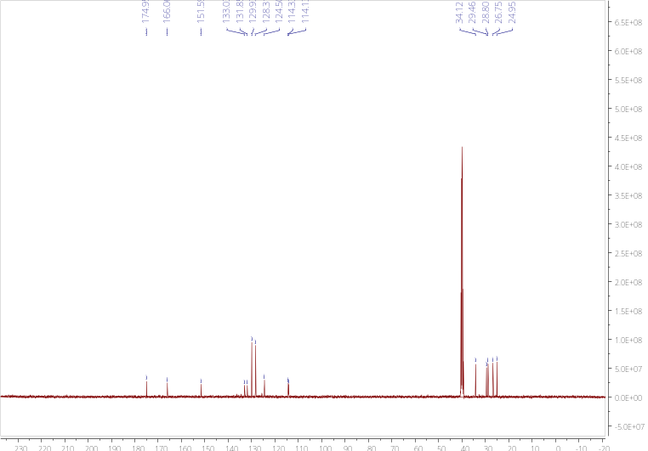
HRMS for 5f
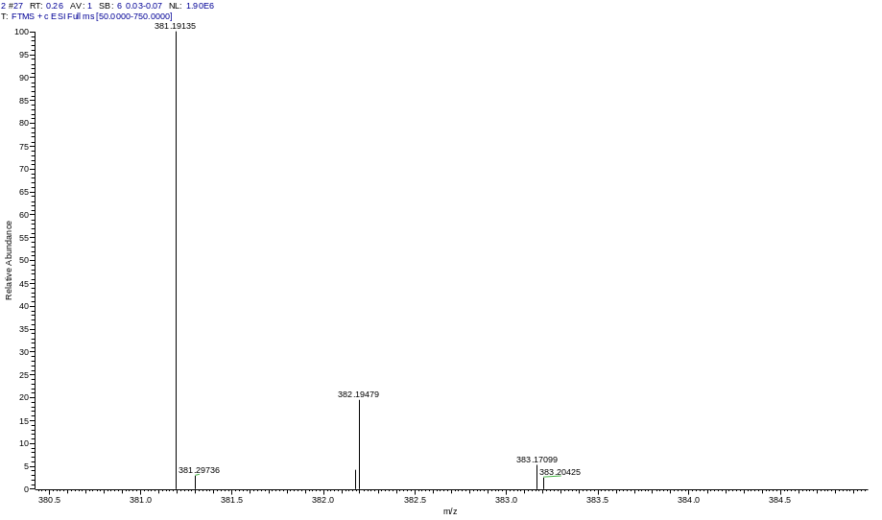
¹H NMR Spectra for 8a
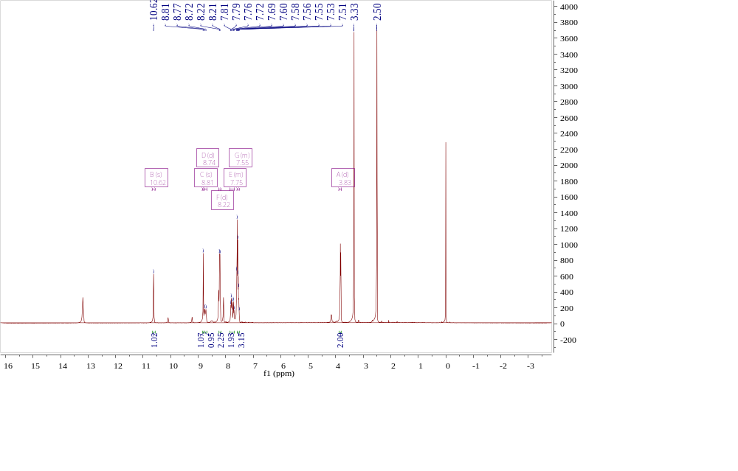
¹³C NMR Spectra for 8a
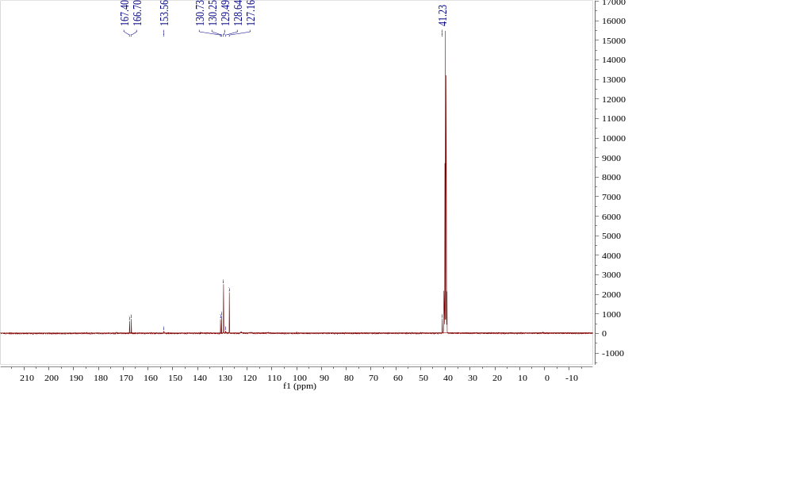
HRMS for 8a
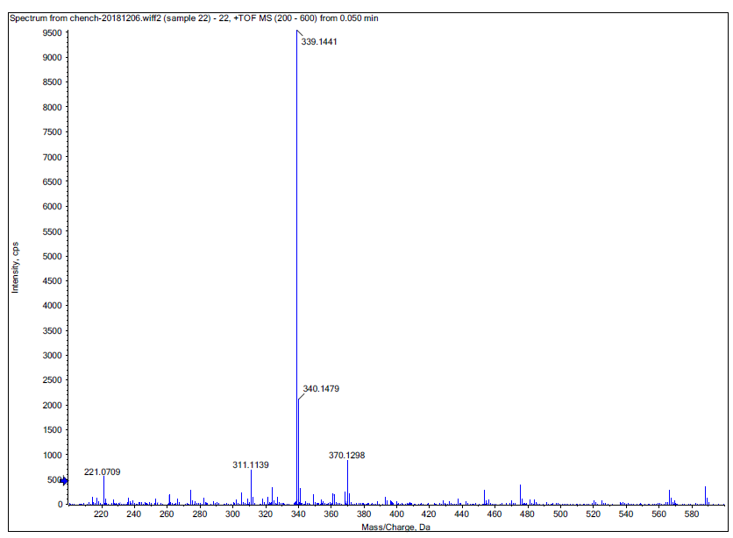
¹H NMR Spectra for 8b
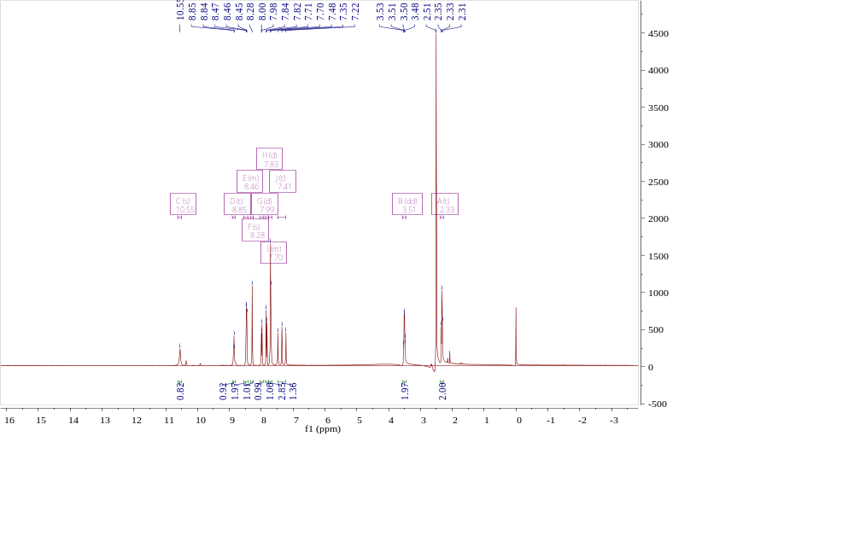
¹³C NMR Spectra for 8b
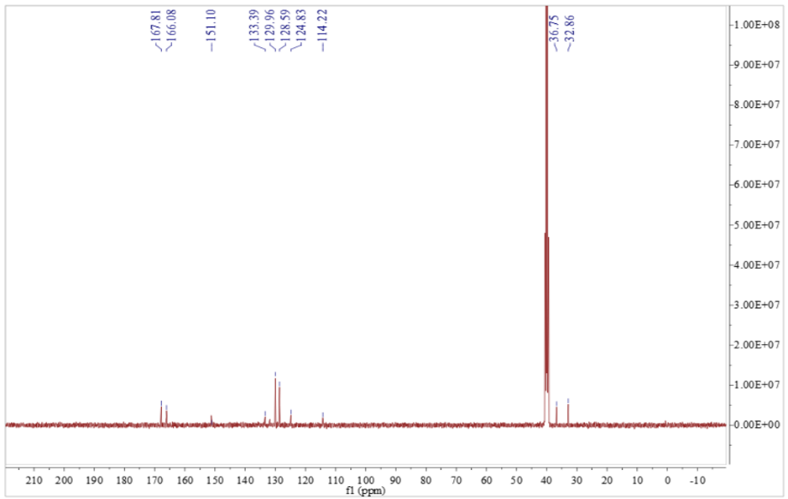
HRMS for 8b
¹H NMR Spectra for 8c
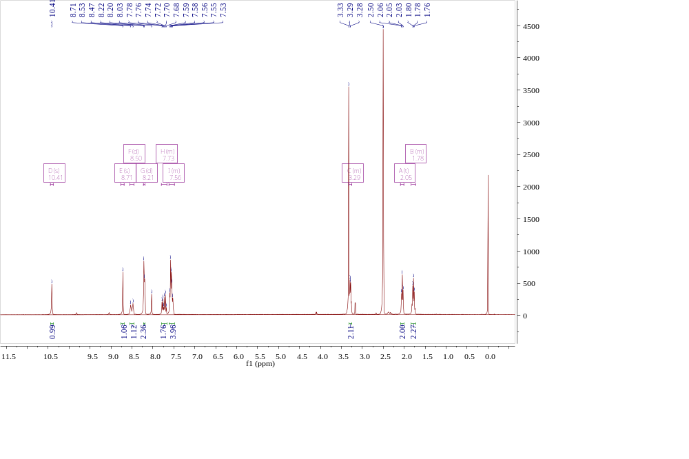
¹³C NMR Spectra for 8c
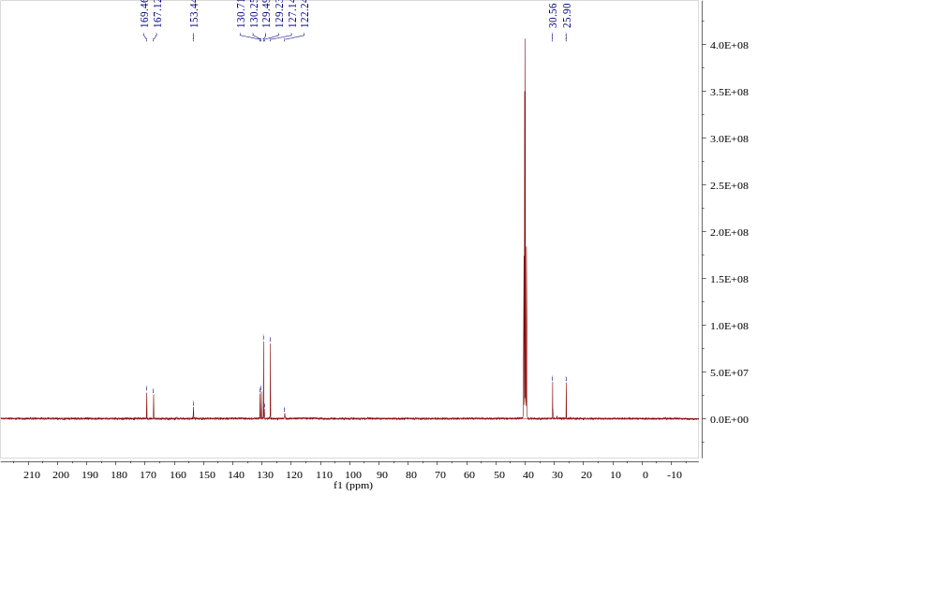
HRMS for 8c
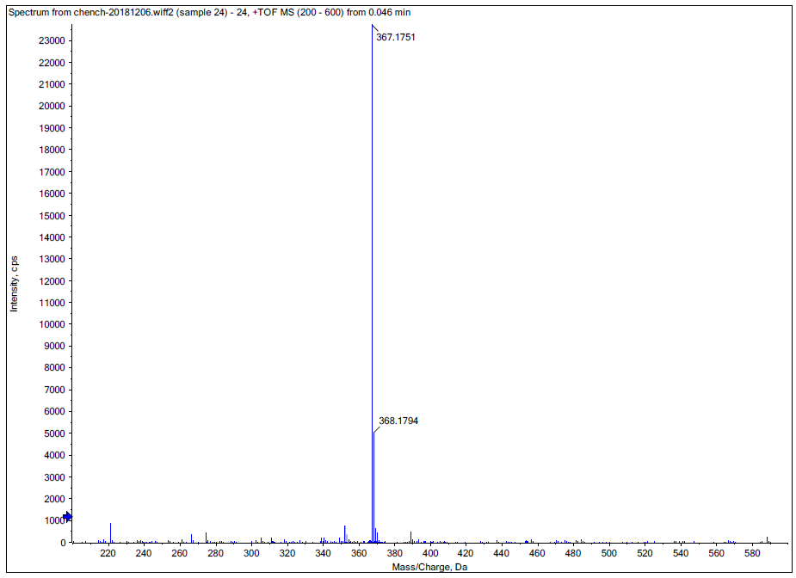
¹H NMR Spectra for 8d
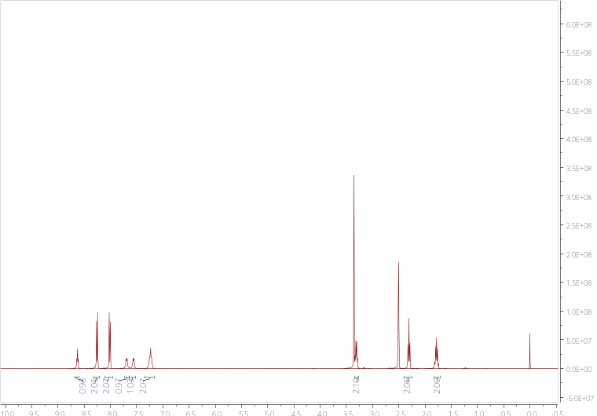
¹³C NMR Spectra for 8d
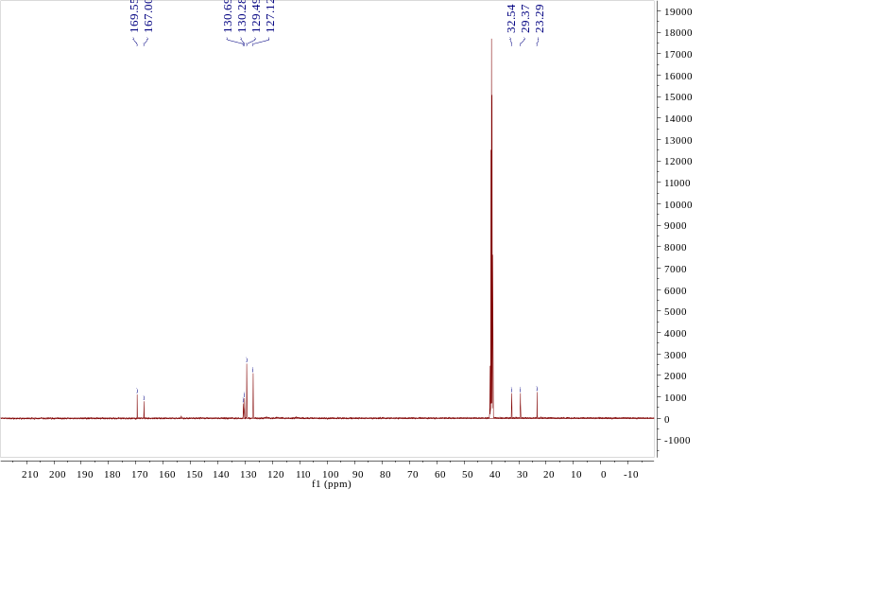
HRMS for 8d
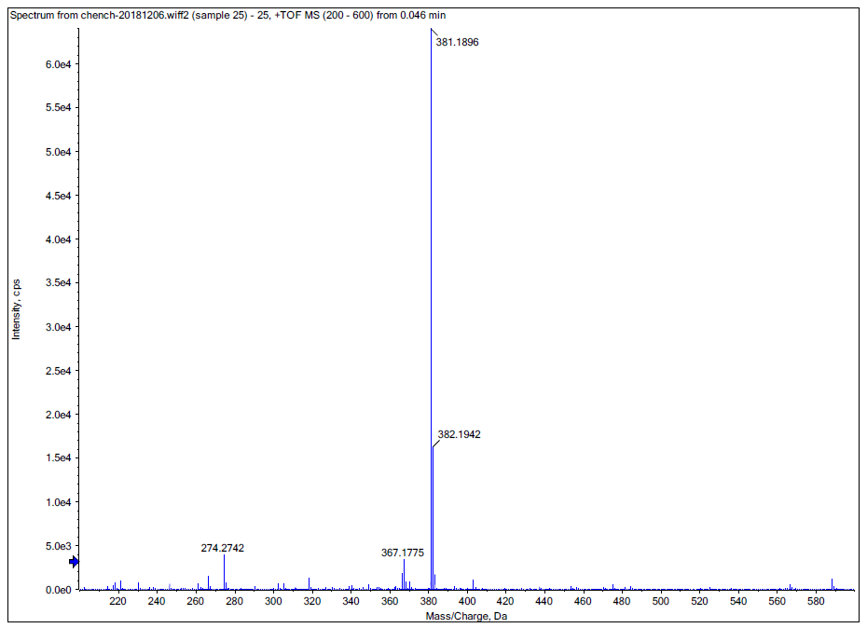

¹H NMR Spectra for 8e
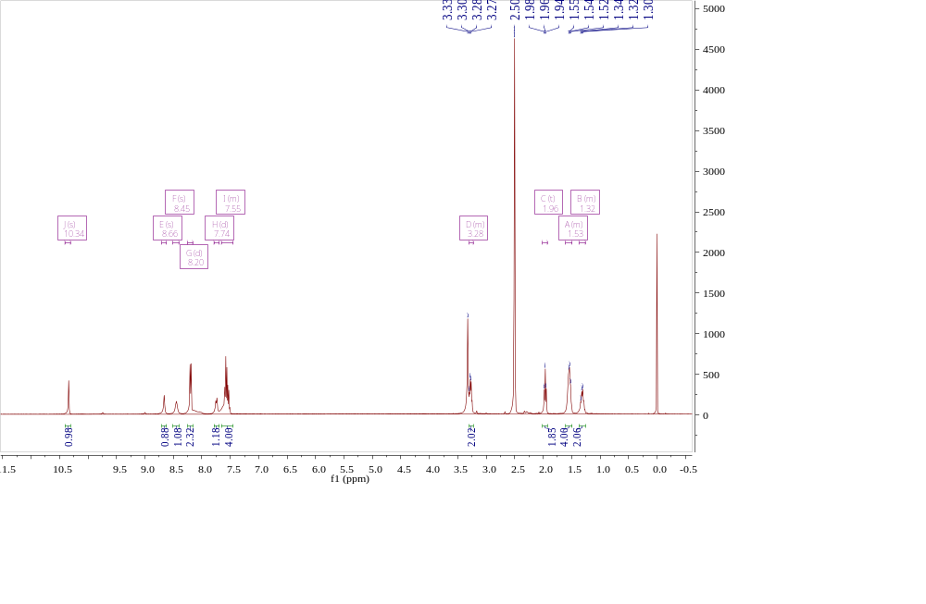
¹³C NMR Spectra for 8e
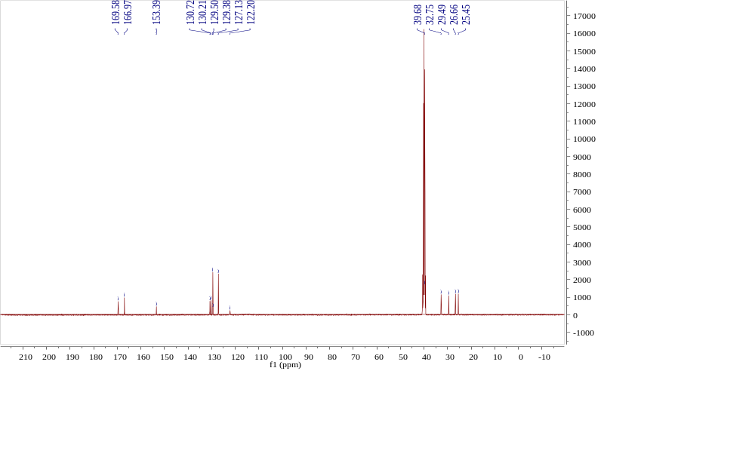
HRMS for 8e
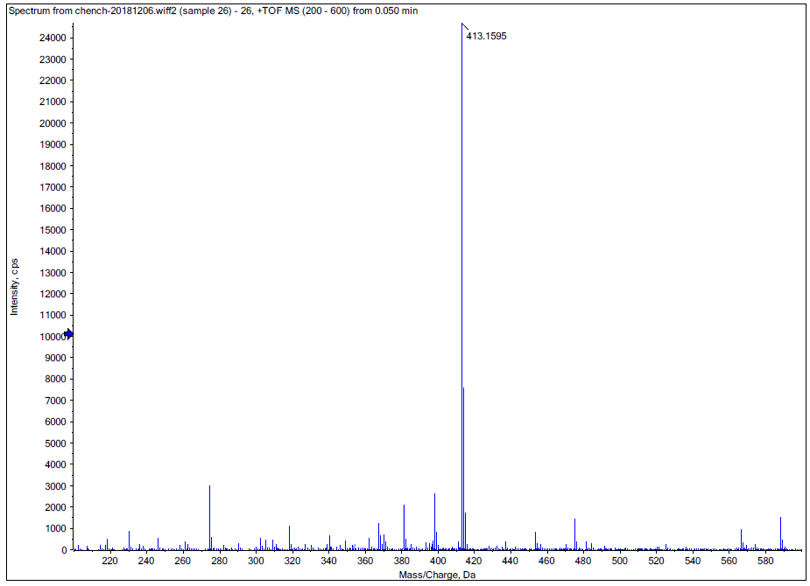
¹H NMR Spectra for 8f
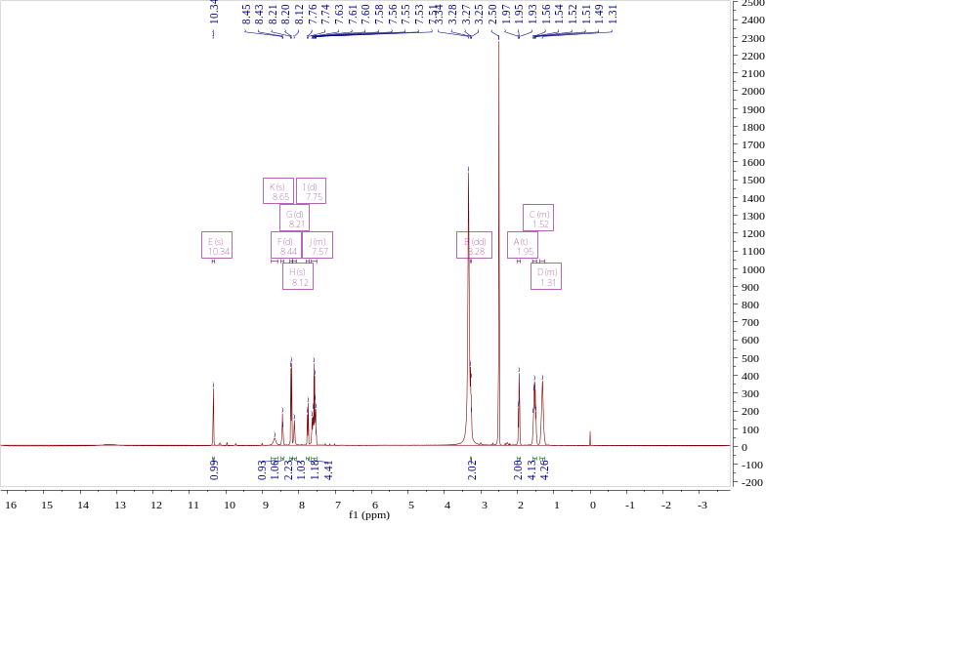
¹³C NMR Spectra for 8f
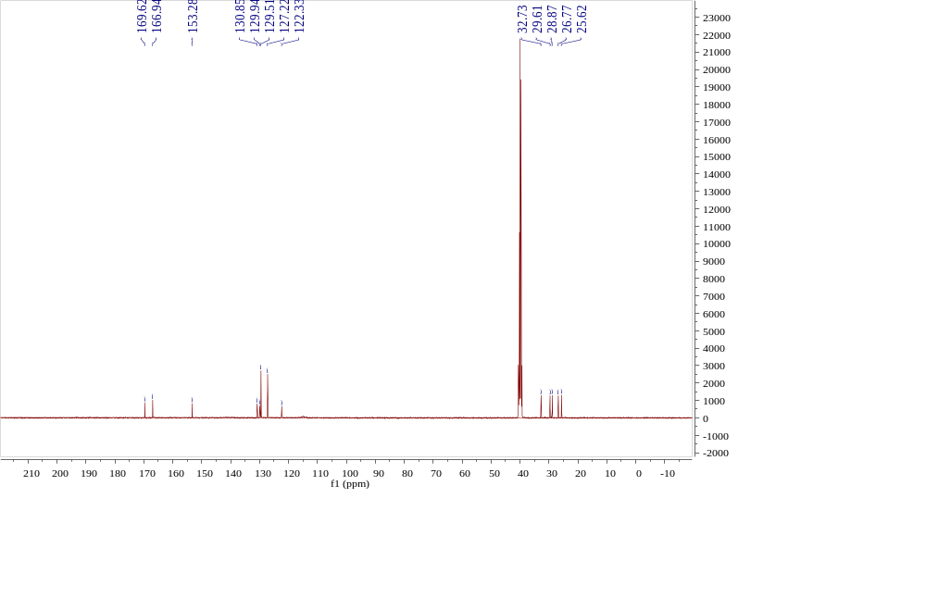
HRMS for 8f
