Supplemental Information:

Appendix S1. Protocol for Traditional 96-well ELISA for HPV E7 oncoprotein.
- 100 μL of the capture antibody was plated. An anti-HPV18 E7 monoclonal capture antibody (MBS310529, MyBioSource, San Diego, CA) was diluted to 5 μg/mL in 1X ELISA coating buffer (Biolegend, San Diego, CA), and incubated overnight at 4°C.
- The next day, the plate was washed with 300 μL PBST three times, and 300 μL of blocking solution which consisted of 3% bovine serum albumin (BSA) (Sigma-Aldrich Inc, St. Louis, MO) in PBS was added for 2 hours at room temperature on an orbital shaker.
- After blocking, the plate was washed with 300 μL PBST three times, and 100 μL of each sample was added in triplicate to the plate and incubated for 1 hour at room temperature on an orbital shaker.
- The plate was washed again with 300 μL PBST three times. Then, 100 μL of biotinylated detection antibody at 2 μg/mL was added to each well and incubated at room temperature on an orbital shaker for 1 hour.
- The unconjugated IgG detection antibody (anti-HPV E7 detection antibody, Ab100953, Abcam, Cambridge, MA) was biotinylated with 20mM biotin using the EZ-Link™ Sulfo-NHS-Biotin biotinylation kit (Thermo Fisher Scientific, Waltham, MA). Unbound biotin was removed by running the antibody solution three times through desalting Zeba columns (Thermo Fisher Scientific, Waltham, MA), and the concentration was determined using a bicinchoninic acid (BCA) protein assay kit (Thermo Fisher Scientific, Waltham, MA).
- After detection antibody incubation, the plate was washed with 300 μL PBST four times. Next, 100 μL of the secondary antibody, 0.1 μg/mL (1:10,000) of streptavidin poly-HRP80 (Fitzgerald, Acton, MA), was incubated at room temperature on an orbital shaker for 1 hour.
- Before the final colorimetric detection, all wells were washed with 300 μL PBST six times. Then, 50 μL of room temperature 1-Step Ultra TMB (3,3',5,5'-tetramethylbenzidine) ELISA Substrate (Thermo Fisher Scientific, Waltham, MA) was added to the plates, incubated for 15 minutes at room temperature, and stopped with 50 μL H₂SO₄ (2N).
- Any air bubbles were removed from the plate, and the absorbance of the wells at 450 nm was read using a plate reader (Tecan, Zürich, Switzerland).
- Two-tailed t-test were performed between each concentration to determine whether differences in absorbance were significant.

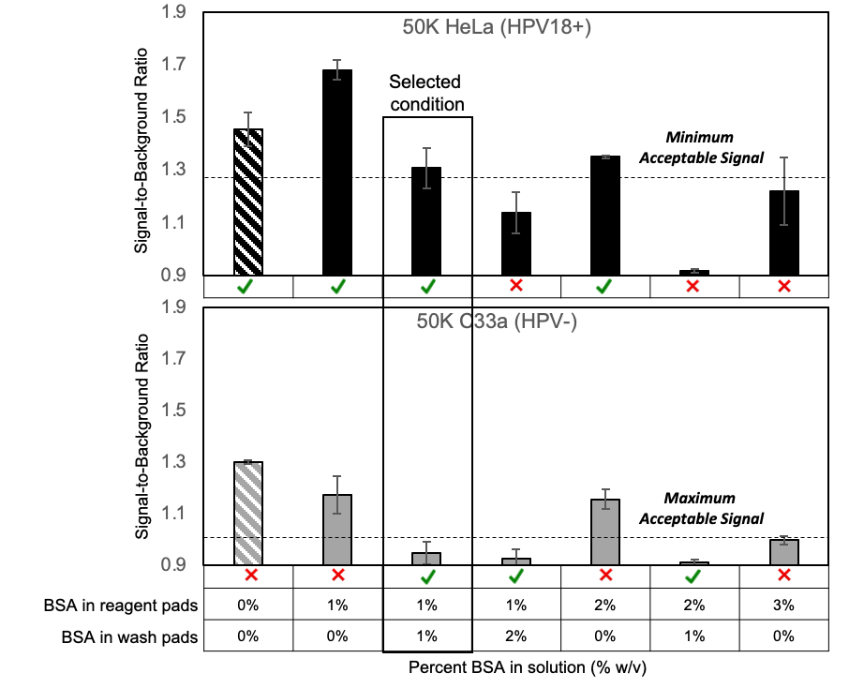
Figure S1. Glass fiber additives. Reduction of false positives in HPV E7 paper assay with BSA. To reduce non-specific binding in the HPV E7 paper assay, varying concentrations of BSA were added into the reagent and wash pads. HeLa (HPV18) and C33A (HPV negative) cells were lysed with xTractor buffer and tested in duplicate for each condition. Adding 1% BSA in both reagent and wash pads reduced non-specific binding, so that the C33A signal-to-background ratio was below 1. Increasing BSA concentration in the reagent or wash pads beyond 1% decreased the positive HeLa signal. Minimum acceptable signal= average baseline HeLa signal ± three standard deviations.
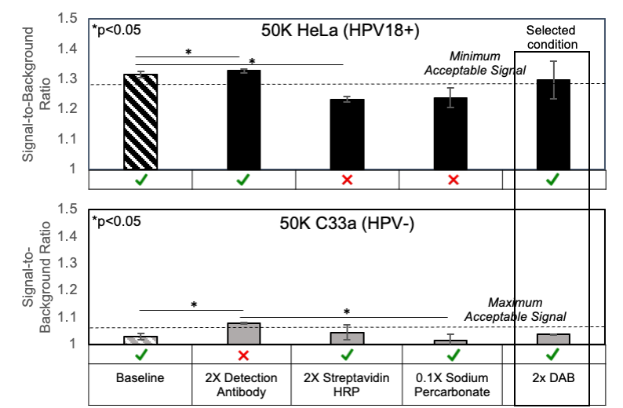
Figure S2. Reagent optimization in paper. Reagents for the HPV E7 paper assay were optimized by assessing the signal-to-background ratios of positive (HeLa; HPV18) and negative (C33A; HPV negative) cellular samples with increasing concentrations of detection antibody, streptavidin HRP, diaminobenzidine (DAB), and sodium percarbonate. Increasing the concentration of streptavidin HRP reduced the positive (HeLa) signal, compared to the baseline and increased detection antibody conditions (p<0.05), and increasing the concentration of detection antibody increased the negative (C33A) signal compared to the baseline and increased DAB conditions. Minimum acceptable signal= average baseline HeLa signal ± three standard deviations; Maximum acceptable signal= average baseline C33A signal ± three standard deviations.

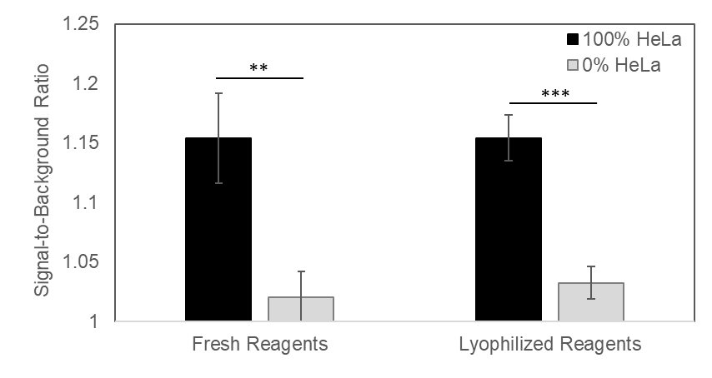
Figure S3. Lyophilization. Positive (HeLa) and negative (C33A) samples were tested with freshly prepared and lyophilized reagents (n=3). There was a significant difference between the positive and negative controls for both fresh (p<0.01) and lyophilized reagents (p<0.005). There were no significant differences in either positive (HeLa) signal or negative (C33A) signal between freshly prepared reagents and lyophilized reagents. ** p<0.01; *** p<0.005

Sample | High-Risk HPV DNA Test Result | Pathology | HPV E7 Result from Paper Assay
1027 | Negative | <CIN2 | Negative
1046 | Negative | <CIN2 | Negative
1141 | Negative | <CIN2 | Negative
220 | Negative | <CIN2 | Negative
396 | Negative | <CIN2 | Negative
648 | Negative | <CIN2 | Negative
81 | Negative | <CIN2 | Negative
737 | Negative | <CIN2 | Negative
1052 | 18+, hrHPV+ | <CIN2 | Positive
1371 | hrHPV+ | <CIN2 | Negative
580 | 16+ | <CIN2 | Negative
1083 | 16+ | CIN2+ | Positive
1122 | 16+ | CIN2+ | Positive
1136 | 16+ | CIN2+ | Positive
1196 | 16+, hrHPV+ | CIN2+ | Positive
1321 | 16+ | CIN2+ | Positive
560 | 16+ | CIN2+ | Positive
765 | 16+ | CIN2+ | Negative
946 | 16+ | CIN2+ | Positive

Table S1. Description of clinical samples, including hrHPV status as determined by careHPV or genotyped by AmpFire, histopathology, and E7 assay result.

Component |  | Cost
Sample Collection and Preparation | xTractor Buffer | $ 0.21
Sample Collection and Preparation | Cervical Brush | $ 0.19
Sample Collection and Preparation | Tubes and Pipettes | $ 0.14
HPV E7 Paper Assay | Antibodies | $ 0.26
HPV E7 Paper Assay | Paper and Plastic | $ 0.34
HPV E7 Paper Assay | Other Reagents | $ 0.33
All Sample Collection and Preparation |  | $ 0.54
All HPV E7 Paper Assay |  | $ 0.92
Total Cost |  | $ 1.46

Table S2. HPV E7 paper test cost. Small-scale cost estimations of sample collection and preparation materials as well as the HPV E7 paper test are shown.

