Supplementary Information

‘Urolithin A mitigates behavioral and synaptic deficits associated with epilepsy” by Mishra et al., 2025

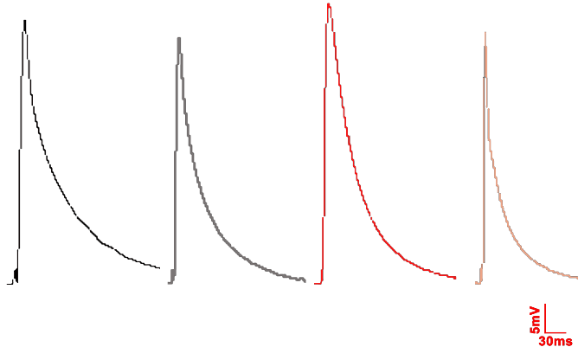
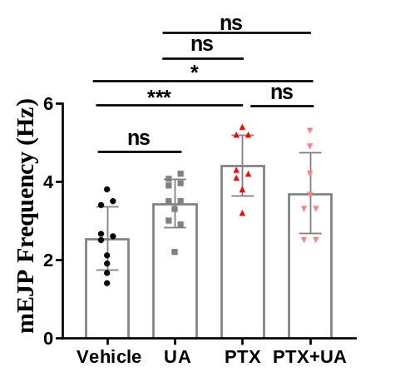
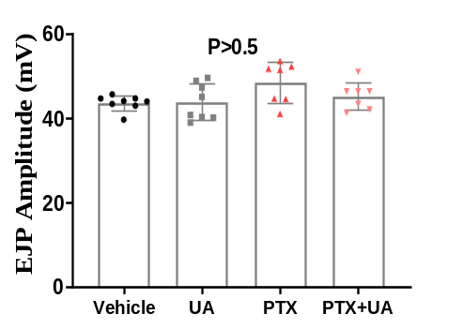
a
b
c

Supplementary Figure 1: Sub-acute administration of UA in a chemoconvulsive Drosophila (PTX) model induces no significant changes in the frequency of mEJP and the amplitude of EJPs.
- Note the increased frequency in the PTX treatment group, whereas UA administration did not show alterations in the PTX-induced increased frequency. n=number of recorded NMJs, N=number of larvae. n= 9, 10, 9, 7 for Vehicle, UA, PTX, and PTX+UA, respectively. N=4-5 for all the treatment groups. ns=non-significant. one-way ANOVA with Tukey post-hoc correction. b) Representative traces of EJPs for all the treatment groups. c) Quantification for EJPs, n= 8, 8, 7, 7 for Vehicle, UA, PTX, and PTX+UA, respectively. N=4-5 for all the treatment groups. ns=non-significant. one-way ANOVA with Tukey post-hoc correction. p = F (3, 26) = 2.6. *p < 0.5, **p < 0.05, ***p < 0.001.

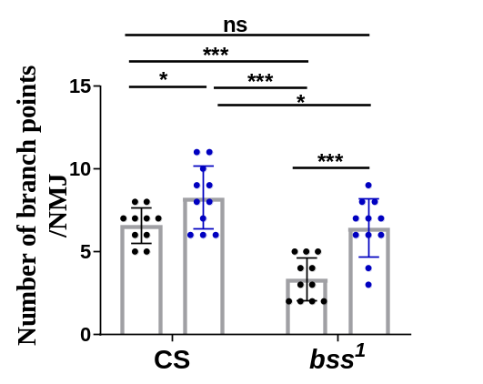
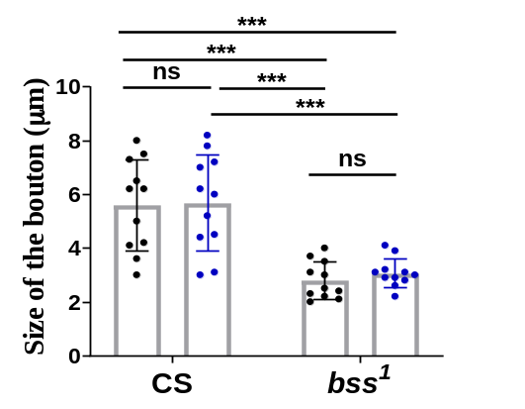
a
b

Supplementary Figure 2: UA’s chronic administration ameliorates the decreased branch points in genetic mutant bss¹ but no significant changes in the size of the boutons
- Quantification of UA’s induced amelioration in the synaptic defects related to the number of synaptic branches. Note that, in the healthy context, UA administration increased the number of synaptic branches. b) Quantification of the size of the boutons, Error bars represent SD. n=number of imaged NMJs, N=number of larvae. n= 10-11, N=6 for all treatment groups. ns=non-significant. two-way ANOVA with Bonferroni post-hoc correction for a) p<0.001, treatment factor F (1, 39) = 28.48, p<0.001, genotype factor F (1, 39) =25.30, and b) p=0.65, treatment factor F (1, 40) = 0.2101, p<0.001, genotype factor F (1, 39) =46.64. *p < 0.5, **p < 0.05, ***p < 0.001.

b
a
Vehicle

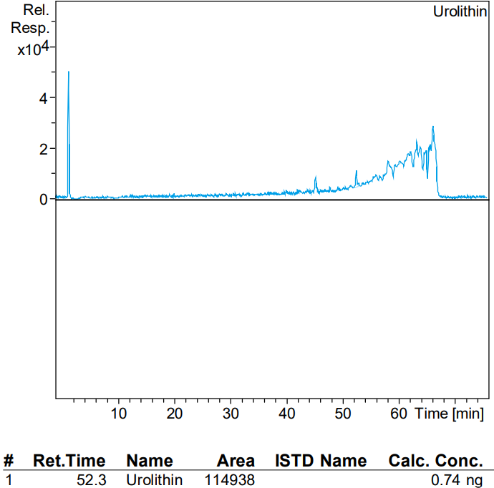
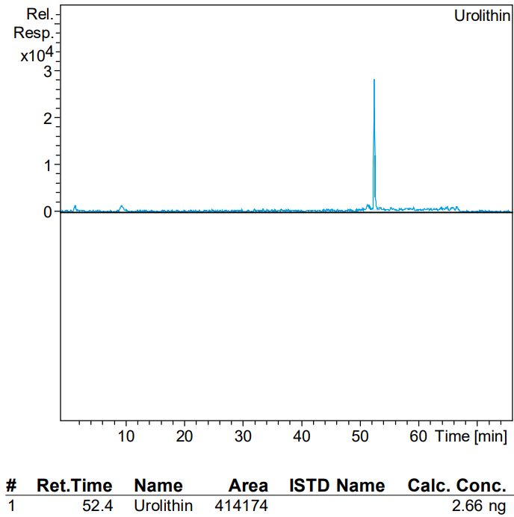
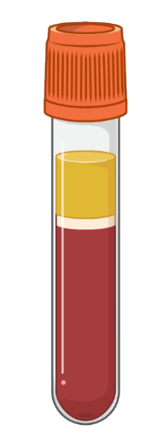
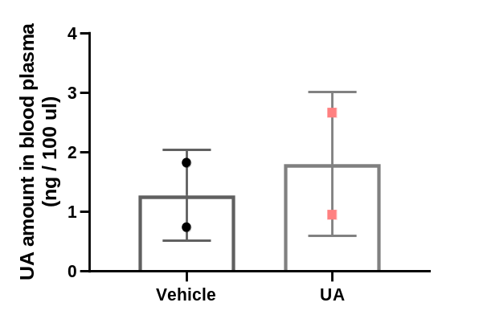
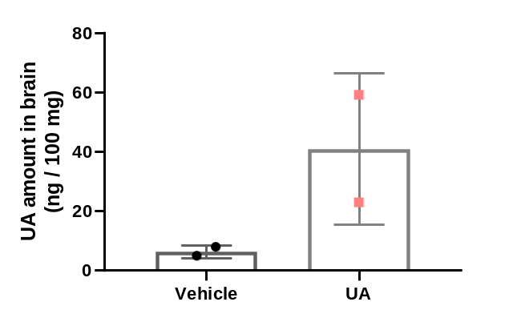
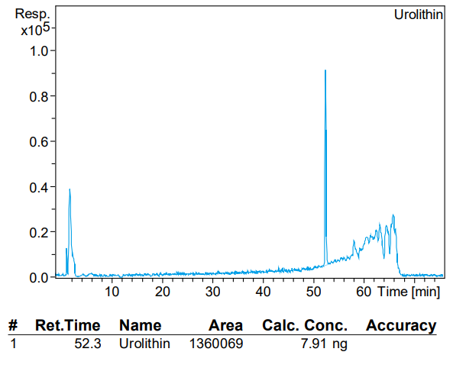

d
c
Vehicle
UA

e

Supplementary Figure 3: UA acutely crosses BBB and is present in the pure non-conjugated form, whereas it exists in the non-conjugated form in blood plasma
- Represent the chromatogram as a function of retention time (X-axis) and m/z ratio (m/z 228.7 marked in red arrows for UA) to the relative abundance (Y-axis), total output from LCMS/MS in brain sample from the animal gavaged with the vehicle. b) Concentration of UA/ 100mg of brain tissue detected after 1 hour of oral intake of Vehicle/UA. Note the significant increase in the concentration of UA after oral gavage with UA. c) and d) Represent the chromatogram as a function of retention time (X-axis) and m/z ratio (m/z 228.7 marked in red arrows for UA) to the relative abundance (Y-axis), total output from LCMS/MS in blood samples. e) Concentration of UA in blood plasma detected after 1 hour of oral intake of Vehicle/UA. Note the no overt differences in the concentration of UA in the blood plasma after oral gavage with UA. N=number of animals. N=2 for CMC-saline and UA (100)-saline, respectively. Error bars represent SD.

Supplementary Figure 4: UA exerts no acute effects on the epileptiform activity induced by 4AP-0mg in hippocampal slices.
- Regular firing subicular neurons showing voltage response to a step depolarization of 200 pA for 500 ms (current-clamp protocol shown with voltage response). b) Representative recording of voltage response of a subicular neuron in whole-cell current-clamp gap-free mode when perfused with 4AP-0Mg, and in the presence of UA (50 µm). c) Dot plot with instantaneous spike frequency vs. time plotted. d) Summary plot of mean spike frequency. n=number of slices. Ns=non-significant. two-tailed t-test. *p < 0.05, **p < 0.005, ***p < 0.001, Error bars represent SEM.

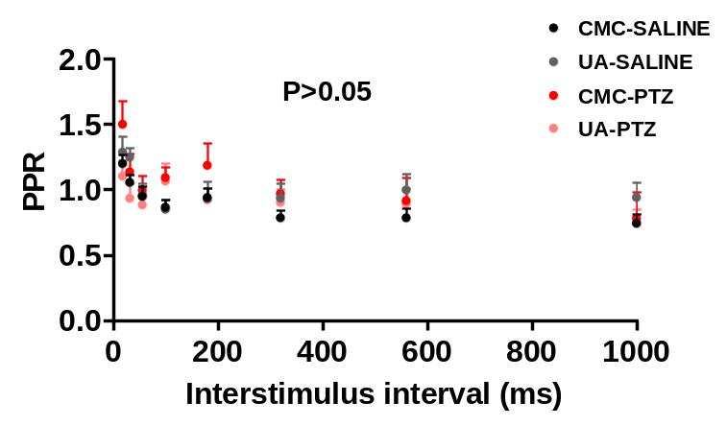
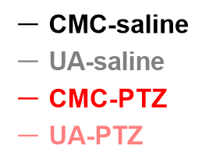
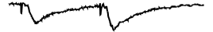
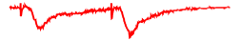
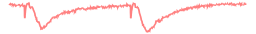
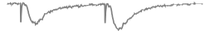
1 mV
100 ms
a
b

Supplementary Figure 5: Both UA and PTZ exert no alterations in the Paired-Pulse Ratio (PPR) at Schaffer collateral synapses
- Representative traces of paired-pulse responses for all the treatment groups. b) Summary plots of PPR against interstimulus interval of the delivery of action potentials. n= number of slices, N= number of animals. n= 9, 8, 9, 15 for CMC-saline, UA (100)-saline, CMC-PTZ, and UA (100)-PTZ, respectively. N=5-6 for all the treatment groups. ns=non-significant. two-way ANOVA with Bonferroni post-hoc correction, p=0.83, treatment factor f (7, 304) = 6.594; p=0.02 context (healthy/epileptic) factor f (3, 304) = 3.224. *p < 0.5, **p < 0.05, ***p < 0.001 with respect to CMC-saline group. Error bars represent SEM.

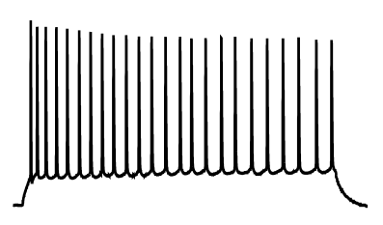
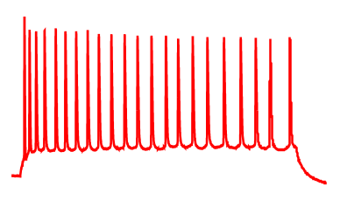
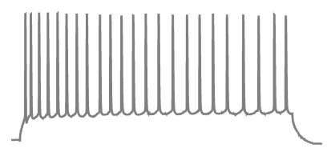
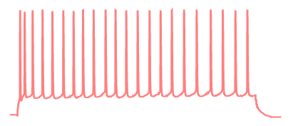
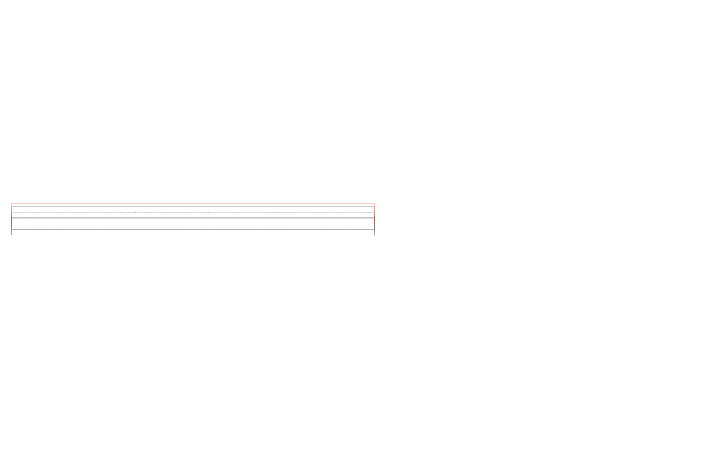
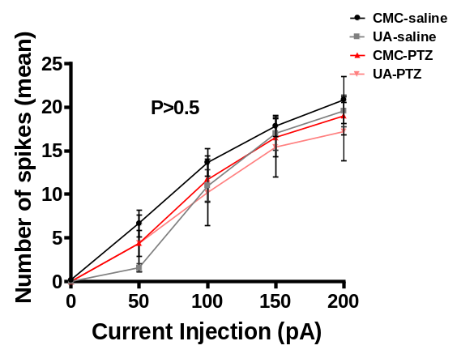
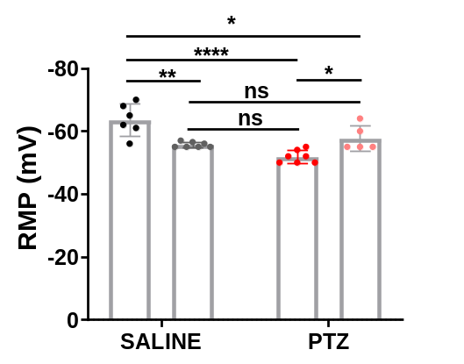
50 mV
200 ms
200 pA
-50 pA
a

b
c

Figure 6: UA increases the PTZ-induced increased Resting Membrane Potential (RMP) in CA1 pyramidal neurons
- Representative voltage response traces for 9-step hyperpolarizing and depolarizing currents from -50 pA to 200 pA. Spikes voltage-response spikes generated in CA1 neurons following a current injection of 200 pA (marked in red) b) Summary plot represents no significant changes of AP spikes frequency across the treatment groups c) Summary plot for RMP values projected a decrease in UA alone and PTZ group whereas, in the context of co-treatment with PTZ, UA mitigates the deficits of RMP. n= number of slices, N= number of animals. n= 9, 8, 9, 15 for CMC-saline, UA (100)-saline, CMC-PTZ, and UA (100)-PTZ, respectively. N=5-6 for all the treatment groups. *p < 0.5, **p < 0.05, ***p < 0.001, two-way ANOVA with Bonferroni post-hoc correction. Error bars represent SEM.

d
b
sIPSCs
sIPSCs
sEPSCs
sEPSCs
a
b
c
f

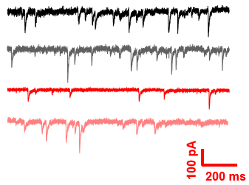
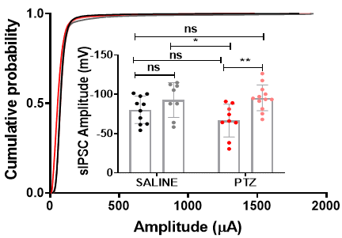
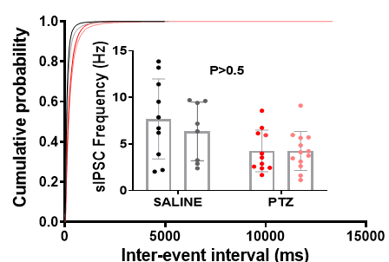
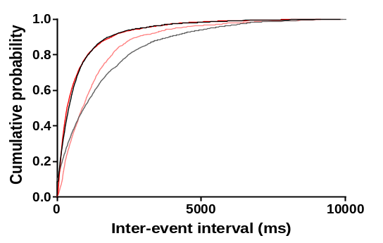
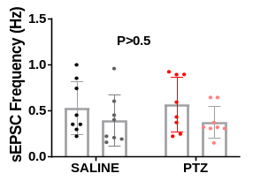
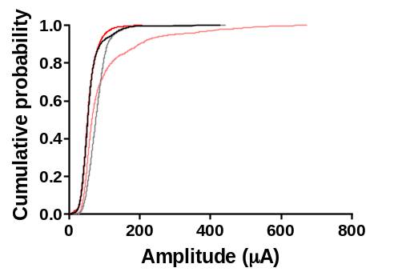
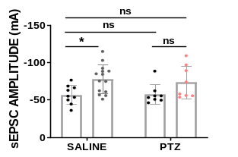
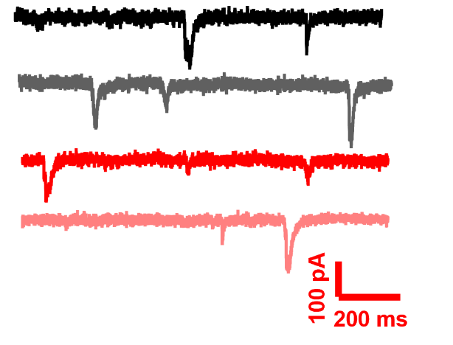

e

Figure 7: UA potentiates the spontaneous inhibitory transmission at an amplitude level but exerts no effects on the spontaneous excitatory transmission
- Representative traces of spontaneous Inhibitory post-synaptic currents for all the treatment groups. b) Cumulative probability for inter-stimulus intervals between fraction events with inset of quantitative histograms plotted for the frequency and c) for amplitude, respectively, of sIPSCs. d) Representative traces of spontaneous Excitatory post-synaptic currents for all the treatment groups. e) Cumulative probability for inter-stimulus intervals between fraction events with inset of quantitative histograms plotted for the frequency and f) for amplitude, respectively, of sEPSCs. For quantifications, n= number of cells, N= number of animals. (d-e) CMC-saline n= 9 N=5, UA (100)-saline n=8 N=4, CMC-PTZ n=11 N=7, and UA (100)-PTZ n=13 N=6. ns=non-significant. (g-h) CMC-saline n= 8 N=4, UA (100)-saline n=10 N=5, CMC-PTZ n= 9 N=4, and UA (100)-PTZ n=9 N=5. ns=non-significant. For cumulative plots of fraction events, multiple two K-S tests, with p>0.0,5 significance calculations. For inset bar graphs, two-way ANOVA with Bonferroni post hoc correction, *p < 0.5, **p < 0.05, ***p < 0.001. Error bars represent SEM.

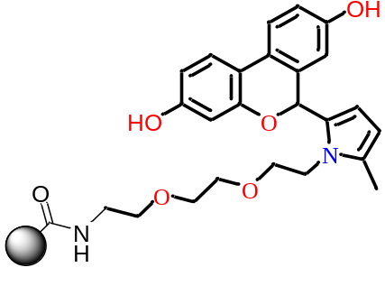

a
b
UA
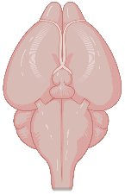
Mouse brain
lysate

Linker
Bead

Beads + Linker
Synthesis of scaffold

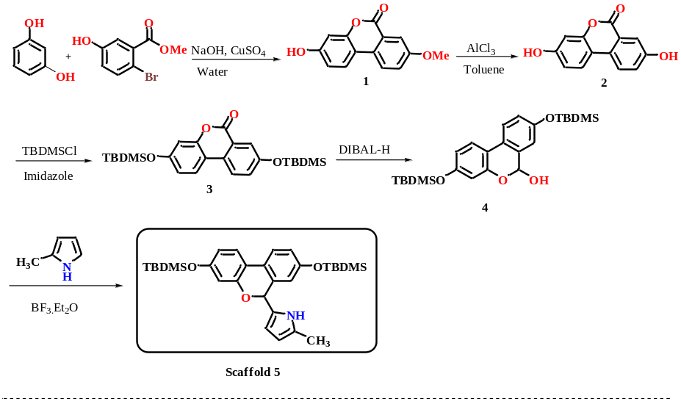

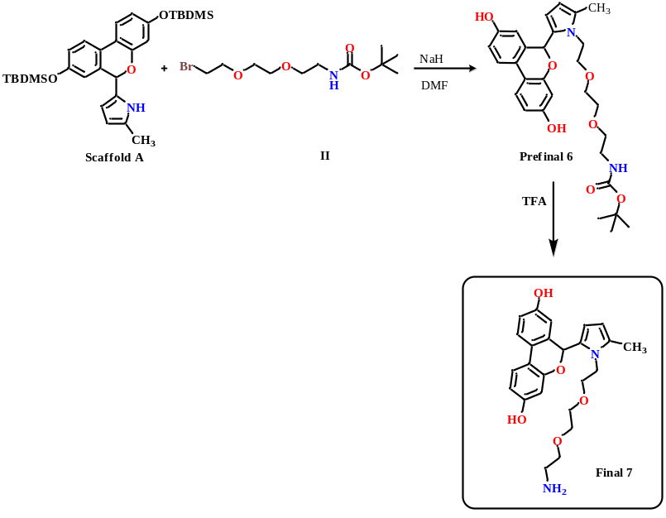

Synthesis of linker
Synthesis of the probe
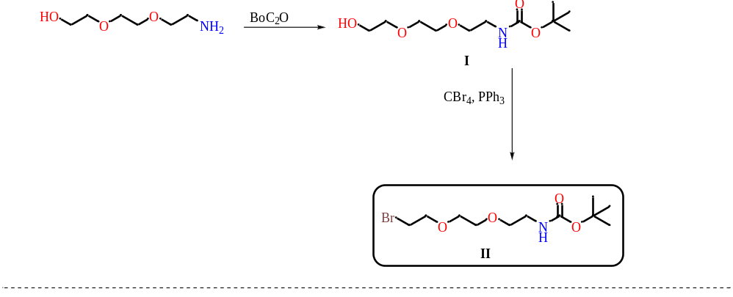

Synthesis of the probe

Figure 8: Series of chemical reactions to synthesize the UA-attached probe for affinity purification a) Chemical structure of the probe with encircled regions marking the bead, linker, and UA’s attachment through ester group b) The steps have been detailed in the Materials and Methods section.

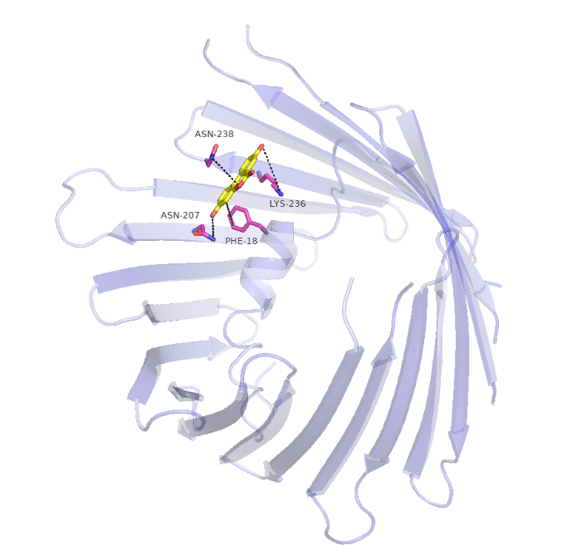
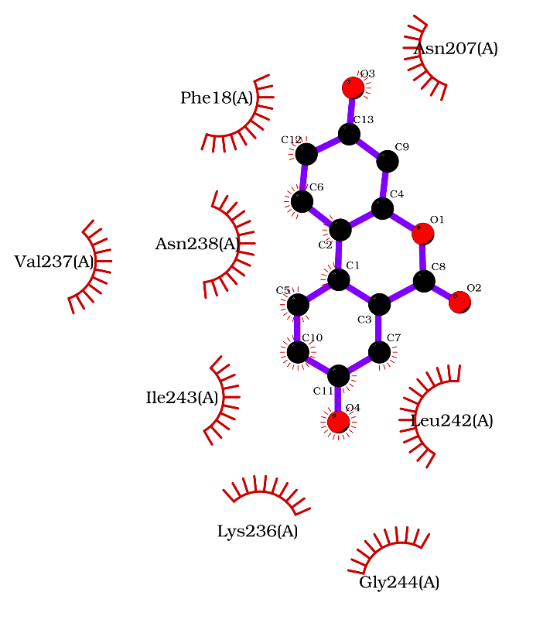
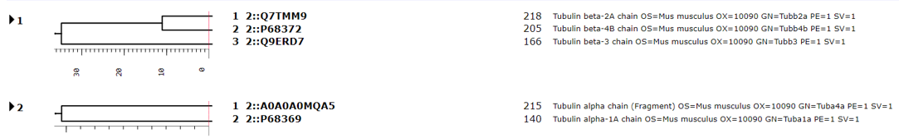

a

c
b

Figure 9: Proteomics identification of the complex of tubulin dimer and VDAC1 as a direct binding interactor of UA
- First and second boxes represent MASCOT search results depicting the interacting residues as tubulin dimer and VDAC1, respectively. b) Represents the docking pose of human VDAC1 (teal color) with minimum binding energy confirmation. Urolithin-A is shown in yellow color. Interactors (in proximity) marked with sticks in magenta color. The electronegative oxygen and nitrogen atoms in Urolithin-A and protein residues are shown in red and blue, respectively. Dotted lines indicate interacting residues involved in plausible hydrophobic interactions between Urolithin-A and human VDAC residues.
0 sec
Path tracks
a
5 sec

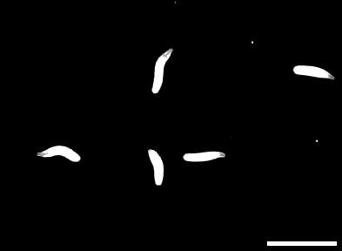
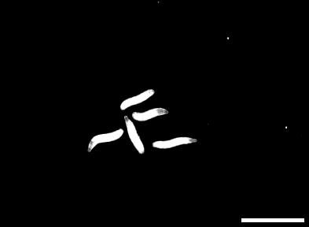
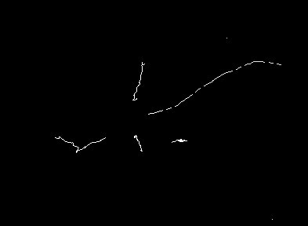
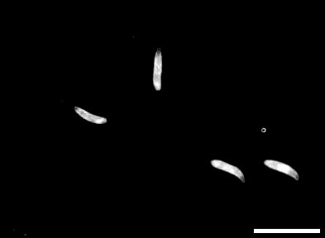
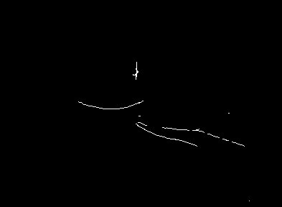
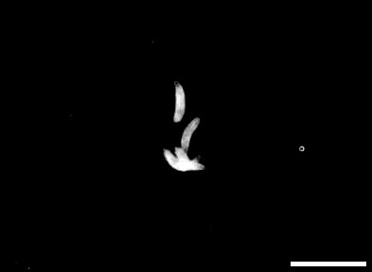
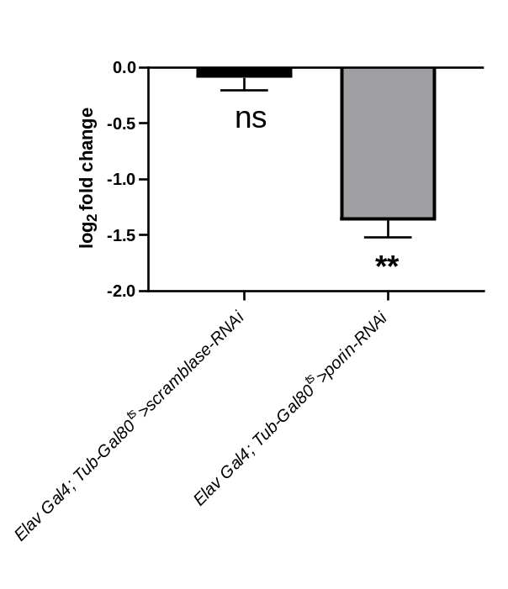
Elav Gal4; Tub-Gal80ts > scramblase
RNAi (PTX+UA)
Elav Gal4; Tub-Gal80ts > porin RNAi
(vehicle)

b

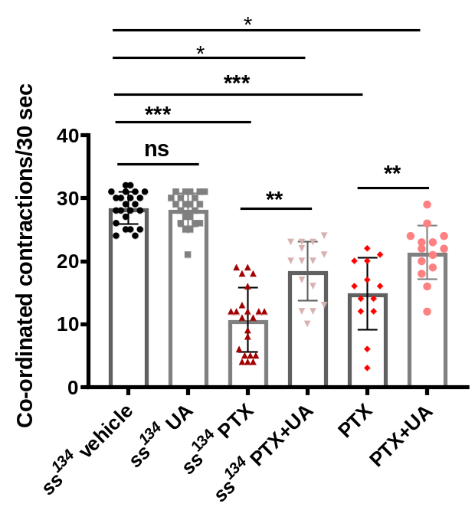

Figure 10: Brain-specific knockdown of VDAC1 phenocopies the sub-acute anti-epileptic effects of UA
- Representative still shots at 0 and 5 seconds with respective path tracks from videos recorded for peristaltic contractions in the larvae. The scale bar represents 80 pixels. Error bars represent SD. n= total number of larvae, N=biological replicates. Elav Gal4; Tub-Gal80^{ts}>scramblase-RNAi (vehicle) n=10, N=3; Elav Gal4; (PTX+UA) n=15, N=3. b) Quantification represents the improvement induced by UA in the locomotory defects of the ss¹³⁴ and PTX larvae by increasing the coordinated peristaltic contractions. Each dot represents the average of 3 technical replicates from each larva. Error bars: SD. n= total number of larvae, N=biological replicates. Vehicle n=23, UA n=22, ss¹³⁴ (PTX) n=21, ss134 (PTX+UA) n=23, PTX n=13, and PTX+UA n=14. N=3. ns=non-significant. one-way ANOVA with Tukey post-hoc correction, p<0.001, F (4, 280) =1.706, *p < 0.05, **p < 0.005, ***p < 0.001. c) qRT expression levels of VDAC1 knockdown. For quantification, *p < 0.5, **p < 0.05, ***p < 0.001, one-way ANOVA with Tukey post-hoc correction.
Table 1: List of the Drosophila stocks used in the study
Genotype | Stock Number/Source | Description
Canton-S | BS#1 | Control for all the fly experiments (Unless stated otherwise)
para^{bss1} | NCBS_CCAMP | Bang-sensitive mutant with GOF of the paralytic (Nav)
ss¹³⁴ | A kind gift from Prof. Jan | Protein null for Spineless (AhR)
Rdl^{MD-RR} | BS#35492 | Fly line with mutant GABA(A) receptor conferring resistance towards PTX
elav-GAL4; +; + | BS#458 | Drives the downstream gene in a pan-neuronal fashion
+; porin^{RNAi}; + | BS# 29572 | GAL4 inducible RNA interference against porin (VDAC1)

Material and Methods
Mouse experiments:
Preparation of acute hippocampal slices
Following a cervical dislocation, the mice’s brain were quickly removed and immersed in the ice-cold cutting solution (<4˚C) containing (in mM): 189 Sucrose (Sigma Aldrich, #S9378), 3 KCl (Sigma Aldrich, #P5405), 10 D-Glucose (Sigma Aldrich, #G8270), 26 NaHCO3 (Sigma Aldrich, #S5761), 10 MgSO₄.7H₂0 (Sigma Aldrich, #M2773), 1.25 NaH₂PO₄ (Sigma Aldrich, #S8282), and CaCl₂ (Sigma Aldrich, #21115). The cortex containing the hippocampus was dissected and immediately glued to the cutting stage of the vibratome (Leica, #VT1200S), and 350 µm thick slices were obtained. All the slices were maintained at 37˚C in a water bath (Thermo Fischer Scientific, #2842) for recovery of about 50-60 minutes in a slice chamber containing aCSF containing (in mM): 124 NaCl, 3 KCl, 10 D- Glucose, 24 NaHCO_{3,} 1 MgSO₄.7H₂0, 1.25 NaH₂PO_{4,} and 2 CaCl₂ bubbled with carbogen gas (95% 0₂ and 5%CO_{2,} #specgas). Subsequently, for stable baseline electrophysiological response, slices were kept at RT and were transferred to the submerged nylon mesh chamber bubbled with warm (34^{ο}C) and carbogenated aCSF at the flow rate of 2-3ml/min.
Extracellular recordings and whole-cell patch clamp recordings
Detailed methods are provided in the supplemental file. Hippocampal circuitries were identified using an upright microscope (Slicescope pro 6000 Scientific). A concentric borosilicate glass electrode (CBARC75, FHC, USA) was used to stimulate the Schaffer collateral pathway. The field Excitatory Post Synaptic Potentials (fEPSPs) were recorded from the hippocampus's stratum radiatum region of CA1 with a 3-5 MΩ resistance glass pipette (Harvard apparatus, #30–0044/GC120 F-10) filled with aCSF. To a stabilized stimulation frequency of 0.05 Hz, recorded signals were amplified (Molecular Devices, #Axon Multiclamp 700B amplifier) and digitized (Molecular Devices, # Axon Digidata 1440A). Then the current strength was set at a value that elicits 30-40% of the maximal response for the input-output (I/O) curve and for the experiments. A stimulation range of 20-40 ms and intensity with an increment of 20 µA per sweep from 0-300 µA was used for studying input-output curves. Paired pulse ratio (PPR) was checked by eliciting two pulses with interstimulus intervals ranging from 18-1000 ms, delivered every 10 s. PPR was calculated by dividing the slope of the second fEPSP by that of the first fEPSP. All signals were acquired, and the data analysis was performed on Clampfit 10.7.
Borosilicate glass electrodes of 6–8 MΩ resistance were used to record spontaneous postsynaptic currents (sPSC), and miniature postsynaptic currents (mPSCs). For recording excitatory transmission at spontaneous and miniature levels, intracellular electrodes were filled with an internal solution containing (mM): 130 potassium gluconate, 20 KCl (Sigma Aldrich, #P5405), 10 HEPES free acid (OmniPur Merck Millipore, #5310), 0.2 EGTA (OmniPur Merck Millipore, #4100), 0.3 mM GTP-Na salt, 4 mM ATP g whereas, for recording inhibitory transmission, electrodes were filled with cesium chloride (CsCl) internal solution containing (mM): 120 CsCl (Sigma Aldrich, #289329), 10 HEPES free acid, 10 EGTA, 5 QX314-Br, 4 ATP disodium salt, 0.3 mM GTP disodium salt, 4 mM MgCl₂; osmolality adjusted to 280–310 mOsm. sPSCs and mPSCs were measured by holding the cell in voltage-clamp mode at −70 mV. 10 µM bicuculline (Tocris, #0131) and 10 µM CNQX (Tocris, #1045) + 100 µM AP5 (Tocris, #3693) were used for bathing the cells to record sEPSC and sIPSC, respectively. Further, mEPSCs and mIPSCs were recorded in the presence of 1 µM TTX and the above-mentioned antagonists.
Lysate preparation: Hippocampal lysates were prepared from the Wild Type (WT) mice of all the treatment groups. Homogenization was done in radioimmunoprecipitation assay (RIPA) buffer containing 150 mM NaCl (Sigma, #S6191), 50Mm Tris-Cl (Thermo Fischer Scientific, #15965), HCL (Merck Millipore, #324502), 0.10% SDS (Bio-Rad, #1610302), 0.10% Triton-X (HI Media, #RM845), 2% phosphatase inhibitor cocktails (Sigma Aldrich, #P2850-cocktail1, #P5726-cocktail 2, #P0044-cocktail 3) and 10% protease inhibitor cocktail (Roche, #1183617001) in 7 ml Dounce Homogenizer (Sigma, #D9063).

Rat experiments:
Epileptiform firing model of acute rat hippocampal slices
Acute hippocampal slice preparation: The brain was carefully removed and quickly dissected in oxygenated sucrose-based artificial cerebrospinal fluid at 4˚C in sucrose-ACSF (mM): 230 sucrose, 3 MgCl₂.6H₂O, 1.25 NaH₂PO₄, 2.5 KCl, 2 CaCl₂.2H₂O, 25 NaHCO₃, 10 glucose, 2 sodium pyruvate), equilibrated with 5% CO₂ and 95% O_{2;} pH 7.4, 310-320 mosmol l⁻¹. Horizontal hippocampal slices of thickness 300 µm were prepared at 4˚C using a Leica-VT 1000S vibratome. Slices were transferred to an incubation chamber for 15 min. at 35˚C in oxygenated ACSF, whose composition was (mM): 125 NaCl, 2.5 KCl, 1.25 NaH₂PO_{4,} 1 MgCl₂.6H₂O, 2 CaCl₂.2H₂O, 25 NaHCO₃, 25 glucose, equilibrated with 95% O₂ and 5% CO_{2;} pH 7.4, 310-310 mosmol l⁻¹. After 15 minutes, the incubation chamber was maintained at room temperature (typically 24 ± 1˚C) with 95% O₂ and 5% CO_{2.} Before electrophysiological recordings, the slices were allowed to stabilize for 45 minutes at room temperature.
Electrophysiology and data analysis: Borosilicate glass electrodes were filled with an internal solution whose composition was (in mM): K- gluconate 135, KCl 10, EGTA 0.2, Hepes 10, Mg-ATP 5, Na-GTP 0.5, Na-phosphocreatine 10 (pH 7.3, 290–300 mosmol l⁻¹). The cells were approached using a micromanipulator (Patchstar, Scientifica) mounted onto an upright slice platform (Scientifica). The brain slice was shifted to an open bath chamber (Warner Instruments, #RC-21BRW) fitted onto a stage adapter. During the experimental recordings, the slices were continuously superfused with carbogen saturated ACSF (in mM): NaCl 125, KCl 2.5, NaH₂PO₄ 1.25, NaHCO₃ 26, MgCl₂.6H₂O 1, CaCl₂.2H₂O 2, glucose 25, pH 7.4. The slice was bathed in oxygenated artificial cerebrospinal fluid (ACSF) circulating through the chamber at 3-4 ml min⁻¹ via a Masterflex C/L peristaltic pump (Harvard Apparatus). The temperature of the ACSF within the open chamber was maintained at 30-34°C by a temperature controller (Warner Instruments, # TC-324B) connected to the stage adapter, and all electrophysiological recordings were done in the above conditions. Neurons were visualized using an upright microscope (Olympus BX-61WI) with differential interference contrast optics. The signals were amplified using Multiclamp700B (Axon Instruments, Molecular Devices Corporation) and digitized using Digidata 1440A (Molecular Devices). Data were acquired using pClamp 10 at a sampling frequency of 40 kHz and low pass filtered at 5 kHz. We used 100 µM 4aminopyridinese (Sigma-Aldrich, #99504-24-5) with zero Mg²⁺ ACSF to induce epileptiform activity. All the electrophysiological recordings are in current-clamp gap-free mode and were analyzed using Clamp fit 10.4 (Molecular Device) and Sigma Plot 10.0 (Systat Software Inc.). The instantaneous spike frequency was calculated by computing for each time (t) the inverse of the interspike interval using Clamp fit and Sigma plot software. The mean firing frequency was estimated for the defined time of 5 min for 4AP-0 Mg and with UA.

RNA isolation and cDNA synthesis
Chloroform was added (0.2 ml for every 1 ml of Trizol) to the homogenised solution and centrifuged at 12,000 RCF. The aqueous phase (containing RNA) was transferred carefully into a fresh Eppendorf tube without touching the interface and dense layer (containing DNA and proteins). Subsequently, isopropanol was added to the aqueous phase and washed using 70% ethanol. The pellet was resuspended in RNase -free, autoclaved water, and RNA were quantified using Nanodrop1000. For the qualitative estimation, RNA was run on a 1% agarose gel to check for the defined bands of ribosomal RNAs. 1 μg of RNA sample was taken for converting into cDNA using a first-strand cDNA kit following the manufacturer′s protocol (Thermo Fischer Scientific). To confirm the cDNA synthesis, semi-quantitative PCR was run with all the samples using the primer for constitutive gene ribosomal protein 49 (rp49).

Synthesis of UA affinity probe
Synthesis of 3-Hydroxy-8-methoxy-6H-benzo[c]chromen-6-one: Urolithin A was synthesized using a reported procedure with modification [7]. A mixture of Resorcinol (5.5 g, 49 mmol), 2-bromo-5-methoxybenzoic acid (5.6 g, 24 mmol), and NaOH (2.2 g, 55 mmol) in water (25 ml) was heated to reflux for 30 minutes. After adding CuSO4 (5%, 15 ml, 4.6 mmol)), the reaction mixture was refluxed for 30 min. The product precipitated as a brown solid and was filtered and washed multiple times with water and methanol. Thus, the product was taken to the next step without further purification.
Synthesis of 3,8-Dihydroxy-6H-benzo[c]chromen-6-one: A solution of 3-Hydroxy-8-methoxy-6H-benzo[c]chromen-6-one (1) (5 g, 20 mmol)) in Toluene (50 ml) was added to AlCl₃ (13.73 g, 102 mmol). The reaction mixture was heated at 90 °C overnight. Thin layer chromatography (TLC) monitored the progress of the reaction; after the complete consumption of reactants, water (30 ml) was added and filtered in Whatman filter paper (25 µM). The crude was purified by column chromatography on silica gel (10% ethyl acetate in hexane) to give beige color solid. Yield 2.5g, (53%); ¹H NMR (400 MHz, DMSO-d₆): δ (ppm). 10.18 (s, 1H), 10.11 (s, 1H), 8.09 (d, J = 4 Hz, 1H), 8.00 (d, J = 4 Hz, 1H), 7.49 (d, J = 4 Hz, 1H), 7.30 (dd, J₁ = 4 Hz, J₂ = 8 Hz, 1H), 6.80 (q, J = 4 Hz, 1H), 6.71 (d, J = 4 Hz, 1H); HRMS calculated for C₁₃H₉O₄ (M+H) 229.0501, found 229.0501.
Synthesis of 3,8-Bis((tert-butyldimethylsilyl) oxy)-6H-benzo[c]chromen-6-one: A solution of Urolithin-A (2.25 g,9.8 mmol) in DMF (50 ml) were added TBDMS-Cl (8.88 g, 58 mmol) and imidazole (4.17 g, 61 mmol) at 0°C. The reaction mixture was stirred at room temperature for 16 h. After completion of the reaction judged by TLC, the reaction mixture was extracted with ethyl acetate, followed by a water wash. The crude product was subjected to column chromatography on silica gel (60-120 mesh) to obtain 3 brown liquids. Yield: 2g, (44%). ¹H NMR (400 MHz, DMSO-d₆⁾: δ (ppm). 8.21 (d, J = 12 Hz, 1H), 8.13 (d, J = 8 Hz, 1H), 7.54 (d, J = 2.8 Hz, 1H), 7.42 (dd, J₁ = 4 Hz J₂ = 8 Hz, 1H), 6.89 (dd, J₁ = 4 Hz, J₂ = 8 Hz, 1H), 6.85 (s, 1H), 0.95 (d, J = 4 Hz, 18H), 0.23 (s, 12H); HRMS calculated for C₂₅H₃₆O₄Si₂H (M+H) 457.2230, found 457.2229.
Synthesis of 3,8-Bis((tert-butyldimethylsilyl) oxy)-6H-benzo[c]chromen-6-ol 4: To a solution of 3,8-Bis((tert-butyldimethylsilyl) oxy)-6H-benzo[c]chromen-6-one (0.75 g, 1.6 mmol) and 25 ml toluene, DIBAL-H (0.985 ml, 0.98 mmol) was added dropwise at -78 °C, and the mixture was stirred at the same temperature for 3 h. The reaction mixture was quenched with Methanol, followed by Rochelle's salt, and extracted with Dichloromethane (DCM). The crude product was purified by column chromatography on silica gel (8% Ethyl acetate in hexane) to give a white solid. Yield: 0.60 g, (79%). ¹H NMR (400 MHz, DMSO-d₆): δ (ppm). 7.68 (t, J = 8 Hz, 2H), 7.26 (d, J = 5.6 Hz, 1H), 6.91 (d, J = 2.4 Hz, 1H), 6.89 (d, J = 2.4 Hz, 1H), 6.81 ( d, J = 4 Hz, 1H), 6.56 (d, J = 2.4 Hz, 1H), 6.54 (d, J = 2.4 Hz, 1H), 6.43 (d, J = 2.4 Hz, 1H), 0.94 (d, J = 4 Hz, 18H), 0.19 (s, 12H) ; HRMS calculated for C₂₅H₃₈O₄SI₂ (M+) 458.2309 Found 458.2308.
Synthesis of 2-(3,8-Bis((tert-butyldimethylsilyl) oxy)-6H-benzo[c]chromen-6-yl)-5-methyl-1H-pyrrole: To a solution of 2-(3,8-Bis((tert-butyldimethylsilyl) oxy)-6H-benzo[c]chromen-6-yl)-5-methyl-1H-pyrrole (0.50 g, 1 mmol) in Dry DCM (30ml) was treated 2-methyl pyrrole (0.441 g, 5 mmol), BF₃. Et₂O (0.232 g, 1.6 mmol) dropwise at -50 °C and continued stirring for 1 h. The reaction was quenched with Saturated NaHCO_{3,} extracted with DCM, washed with brine solution, and dried over Na₂SO₄. The crude product was purified by column chromatography (10% Ethyl acetate in hexane) to give a brown oil. Yield: 0.20 g, (38%). ¹H NMR (400 MHz, DMSO-d₆): δ (ppm). 7.91 (s, 1H), 7.51 (t , J₁ = 8 Hz, 2H), 6.85 (q, J₁ = 4 Hz, 1H, 6.52 (q, J₁ = 4 Hz, J₂ = 4 Hz, 1H), 6.46 (m, 2H ), 6.09 (s, 1H), 5.99 (s, 1H), 5.58 (s, 1H), 2.22 (s, 3H), 0.97 (d, J = 6.4 Hz, 18H), 0.21 (s, 6H), 0.17 (s, 6H); HRMS calculated for C₃₀H₄₃NO₃Si₂H(M+H) 522.2860 found 522.2861.
Synthesis of Tert-butyl (2-(2-(2-hydroxyethoxy) ethoxy) ethyl) carbamate (I): 2-(2-(2-aminoethoxy) ethoxy) ethan-1-ol (3g, 20 mmol) was dissolved in 30 mL of dry DCM. It was cooled to 0 °C, and Boc anhydride (5 g, 22 mmol) was added dropwise under stirring conditions. The reaction mixture was warmed to room temperature, and the stirring was continued for 16 h. The progress of the reaction was monitored by TLC. After the complete consumption of materials, the product was extracted with DCM, and dried over Na₂SO₄. All the organic volatiles are removed under reduced pressure gave crude product. The crude product was purified by column chromatography on silica gel (50% Ethyl acetate in hexane) to give a colorless oil. Yield: 2.2g, (44%). ¹H NMR (400 MHz, DMSO-d₆): δ (ppm). 3.75 (t, J = 4 Hz, 2H), 3.67 - 3.61 (m, 6H), 3.57 (m, 2H), 3.32 (t, J = 4 Hz, 2H), 1.46 (s, 9H); HRMS calculated for C₁₁H₂₃NO₅ (M+Na) 272.1474, found 272.1472.
Synthesis of Tert-butyl (2-(2-(2-bromoethoxy) ethoxy) ethyl) carbamate (II): To a solution of Tert-butyl (2-(2-(2-hydroxyethoxy) ethoxy) ethyl) carbamate (I) (2 g, 8 mmol) in Tetrahydrofuran (20 ml), were added PPh₃ (3.35 g, 15 mmol) and CBr₄ (4.24 g ,12 mmol) slowly at room temperature. The reaction mixture was stirred at room temperature overnight. The progress of the reaction was monitored by TLC. After the complete consumption of materials, the reaction mixture was filtered through a celite bed to remove triphenylphosphine oxide. Then the crude product was subjected to column chromatography on silica gel (80% Ethyl acetate in hexane) to get colorless oil. Yield: 1.5 g, (60%). ¹H NMR (400 MHz, DMSO-d₆): δ (ppm). 6.69 (s, 1H), 3.70 (J = 8 Hz, 2H), 3.58 - 3.49 (m, 6H), 3.36 (t, J₁= 8 Hz, 2H), 3.04 (d, J = 8 Hz, 2H), 1.36 (s, 9H); HRMS calculated for C₁₁H₂₂BrNNO₄ (M+Na) 334.0630, found 334.0620.

Synthesis of Tert-butyl (2-(2-(2-(2-(3,8-dihydroxy-6H-benzo[c]chromen-6-yl)-5-methyl-1H-pyrrol-1-yl) ethoxy) ethoxy) ethyl) carbamate 6: To a stirred suspension of sodium hydride (0.13 g, 5.74mmol)) (60% suspension in oil) in anhydrous DMF (ml), at 0°C, DMF solution of 2-(3,8-Bis((tert-butyldimethylsilyl) oxy)-6H-benzo[c]chromen-6-yl)-5-methyl-1H-pyrrole(5) (0.20 g, 0.3 mmol) was added slowly under stirring conditions, and the resultant reaction mixture was stirred at RT for 30 min. To the reaction mixture, Tert-butyl (2-(2-(2-bromoethoxy) ethoxy) ethyl) carbamate (II) (0.143 g, 0.4 mmol) was added slowly, and the stirring was continued for 2 h at RT. The progress of the reaction was monitored by TLC, and after the complete consumption of reactants, the reaction was quenched with water. All soluble organics are extracted with ethyl acetate; the combined ethyl acetate solutions are stored over sodium sulfate. The crude product was subjected to column chromatography on silica gel using (10% ethyl acetate in hexane) as an eluent to give a brown sticky liquid. Yield: 70mg (44%). 1H NMR (400 MHz, DMSO-d6): δ (ppm). 10.75 (s, 1H), 9.48 (s, 1H), 7.64 - 7.57 (m, 2H), 6.75 (d, J = 4 Hz, 1H), 6.59 (s, 1H), 6.45 - 6.41 (m, 2H), 6.28 (d, J = 1.6 Hz, 1H), 6.04 (d, J = 16 Hz, 1H), 5.53 (d, J = 16 Hz, 2H), 5.44 (s, 1H), 4.04 (s, 2H), 3.71 (s, 2H), 3.57 - 3.50 (m, 6H), 3.05 (d, J = 4 Hz, 2H), 2.14 (d, J = 4 Hz, 3H), 1.36 (s, 9H); HRMS calculated for C29H36N2NaO7 (M + Na) 547.2420 found 547.2419.

Synthesis of 6-(1-(2-(2-(2-aminoethoxy) ethoxy) ethyl)-5-methyl-1H-pyrrol-2-yl)-6H-benzo[c]chromene-3,8-diol 7: To a solution of Tert-butyl (2-(2-(2-(2-(3,8-dihydroxy-6H-benzo[c]chromen-6-yl)-5-methyl-1H-pyrrol-1-yl) ethoxy) ethoxy) ethyl carbamate (6) (0.070 g, 0.1 mmol) in DCM (1ml) was added dropwise TFA (1ml) and the reaction mixture was allowed to stir at room temperature for 6 h. The progress of the reaction was monitored by TLC. After the complete consumption of reactants, all the volatiles were removed under reduced pressure and three times co-evaporated with DCM to obtain the product. ¹H NMR (400 MHz, DMSO-d₆): δ (ppm): ¹H NMR (400 MHz, DMSO-d₆): δ (ppm). Solubility is so poor with no recognizable signals; HRMS calculated for C₂₄H₂₈N₂O₅H (M+) 424.1998 found 424.2001.

