Supplementary Information

‘Urolithin A mitigates behavioral and synaptic deficits associated with epilepsy through VDAC-1 inhibition: A novel treatment approach’ by Mishra et al., 2024

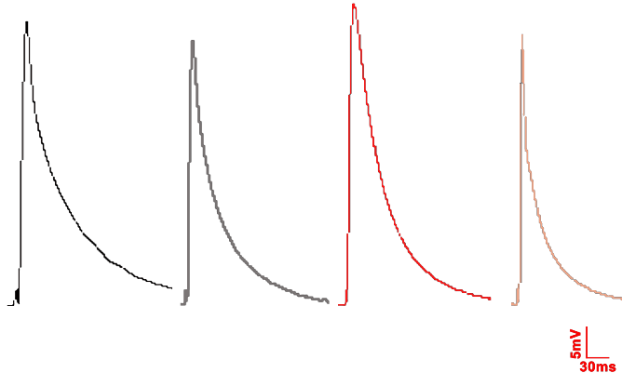
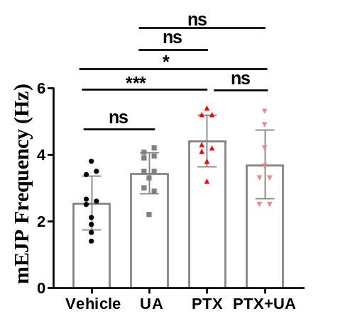
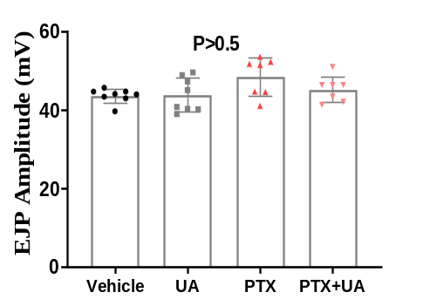
a
b
c

Supplementary Figure 1: Sub-acute administration of UA in a chemoconvulsive Drosophila (PTX) model induces no significant changes in the frequency of mEJP and the amplitude of EJPs.
- Note the increased frequency in the PTX treatment group, whereas UA administration did not show alterations in the PTX-induced increased frequency. n=number of recorded NMJs, N=number of larvae. n= 9, 10, 9, 7 for Vehicle, UA, PTX, and PTX+UA, respectively. N=4-5 for all the treatment groups. ns=non-significant. one-way ANOVA with Tukey post-hoc correction. b) Representative traces of EJPs for all the treatment groups. c) Quantification for EJPs, n= 8, 8, 7, 7 for Vehicle, UA, PTX, and PTX+UA, respectively. N=4-5 for all the treatment groups. ns=non-significant. one-way ANOVA with Tukey post-hoc correction. p = F (3, 26) = 2.6. *p < 0.5, **p < 0.05, ***p < 0.001.

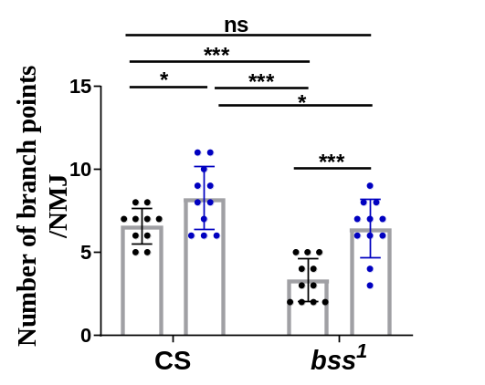
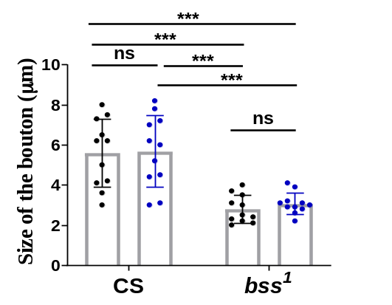
a
b

Supplementary Figure 2: UA’s chronic administration ameliorates the decreased branch points in genetic mutant bss¹ but no significant changes in the size of the boutons
- Quantification of UA’s induced amelioration in the synaptic defects related to the number of synaptic branches. Note that, in the healthy context, UA administration increased the number of synaptic branches. b) Quantification of the size of the boutons, Error bars represent SD. n=number of imaged NMJs, N=number of larvae. n= 10-11, N=6 for all treatment groups. ns=non-significant. two-way ANOVA with Bonferroni post-hoc correction for a) p<0.001, treatment factor F (1, 39) = 28.48, p<0.001, genotype factor F (1, 39) =25.30, and b) p=0.65, treatment factor F (1, 40) = 0.2101, p<0.001, genotype factor F (1, 39) =46.64. *p < 0.5, **p < 0.05, ***p < 0.001.

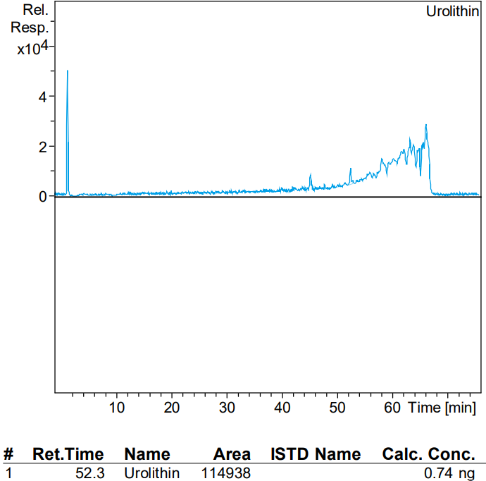
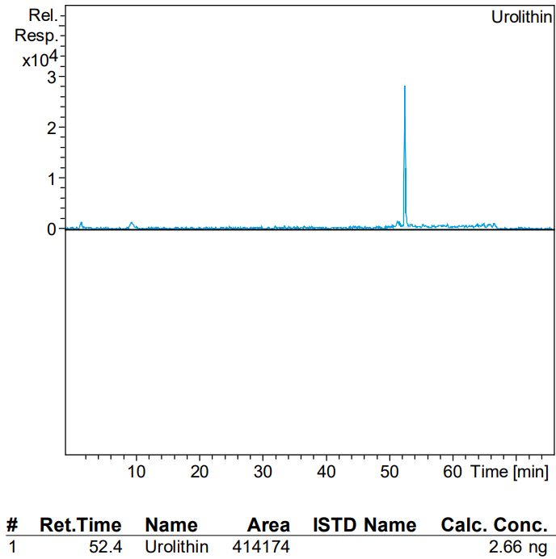
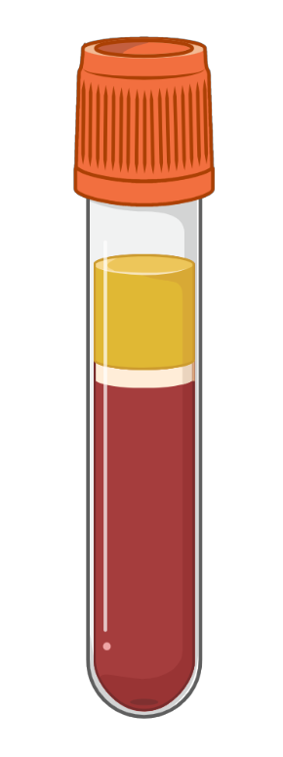
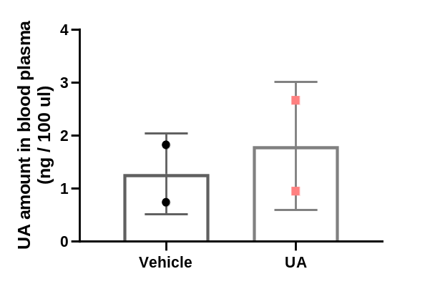
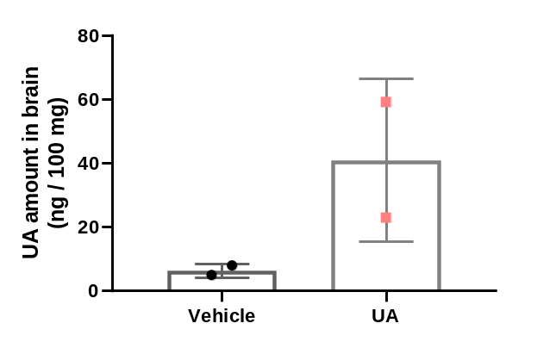

Vehicle
UA
a
b
c
d

Supplementary Figure 3: UA acutely crosses BBB and is present in the pure non-conjugated form, whereas it exists in the non-conjugated form in blood plasma
- Concentration of UA/ 100mg of brain tissue detected after 1 hour of oral intake of Vehicle/UA. Note the significant increase in the concentration of UA after oral gavage with UA. b) and c) Represent the chromatogram as a function of retention time (X-axis) and m/z ratio (m/z 228.7 marked in red arrows for UA) to the relative abundance (Y-axis), total output from LCMS/MS in blood samples. d) Concentration of UA in blood plasma detected after 1 hour of oral intake of Vehicle/UA. Note the no overt differences in the concentration of UA in the blood plasma after oral gavage with UA. N=number of animals. N=2 for CMC-saline and UA (100)-saline, respectively. Error bars represent SD.

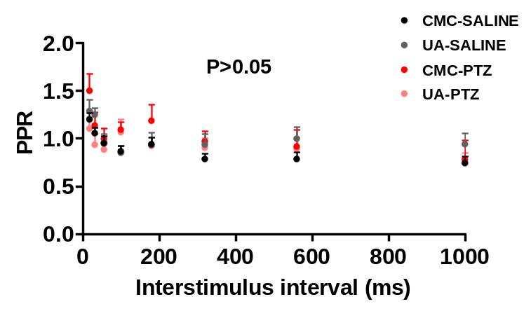
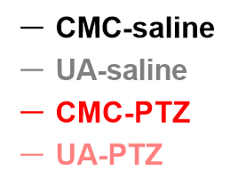
1 mV
100 ms
a
b
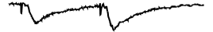
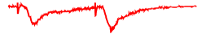
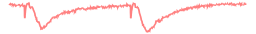
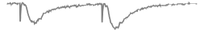

Supplementary Figure 4: Both UA and PTZ exert no alterations in the Paired-Pulse Ratio (PPR) at Schaffer collateral synapses
- Representative traces of paired-pulse responses for all the treatment groups. b) Summary plots of PPR against interstimulus interval of the delivery of action potentials. n= number of slices, N= number of animals. n= 9, 8, 9, 15 for CMC-saline, UA (100)-saline, CMC-PTZ, and UA (100)-PTZ, respectively. N=5-6 for all the treatment groups. ns=non-significant. two-way ANOVA with Bonferroni post-hoc correction, p=0.83, treatment factor f (7, 304) = 6.594; p=0.02 context (healthy/epileptic) factor f (3, 304) = 3.224. *p < 0.5, **p < 0.05, ***p < 0.001 with respect to CMC-saline group. Error bars represent SEM.

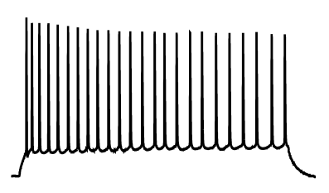
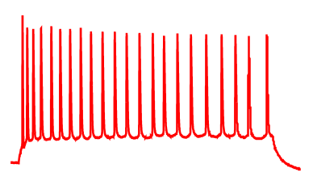
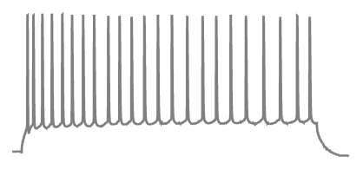
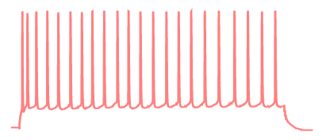
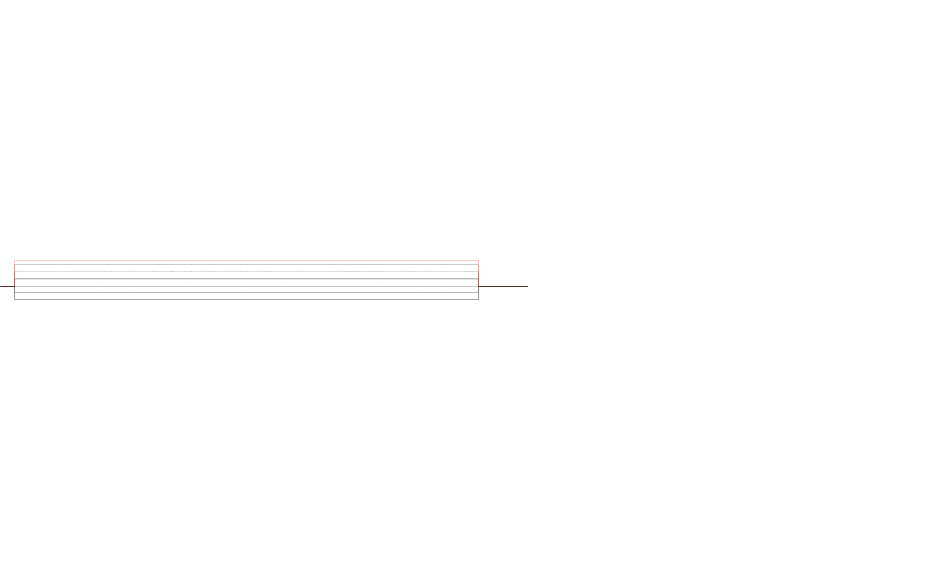
50 mV
200 ms
200 pA
-50 pA
a

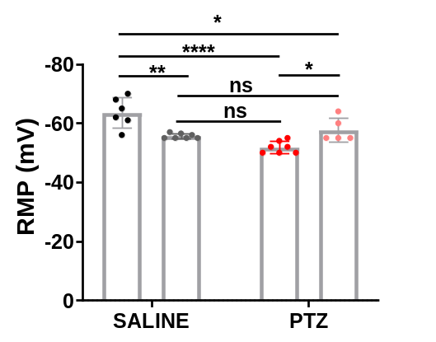
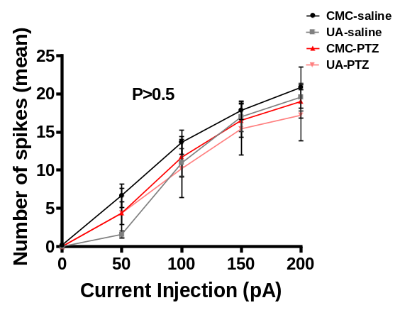
b
c

Figure 5: UA increases the PTZ-induced increased Resting Membrane Potential (RMP) in CA1 pyramidal neurons
- Representative voltage response traces for 9-step hyperpolarizing and depolarizing currents from -50 pA to 200 pA. Spikes voltage-response spikes generated in CA1 neurons following a current injection of 200 pA (marked in red) B) Summary plot represents no significant changes of AP spikes frequency across the treatment groups C) Summary plot for RMP values projected a decrease in UA alone and PTZ group whereas, in the context of co-treatment with PTZ, UA mitigates the deficits of RMP. n= number of slices, N= number of animals. n= 9, 8, 9, 15 for CMC-saline, UA (100)-saline, CMC-PTZ, and UA (100)-PTZ, respectively. N=5-6 for all the treatment groups. *p < 0.5, **p < 0.05, ***p < 0.001, two-way ANOVA with Bonferroni post-hoc correction. Error bars represent SEM.

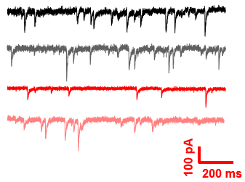
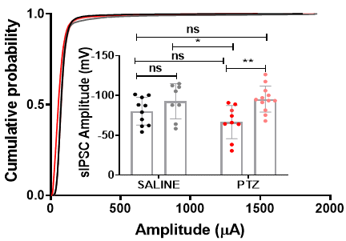
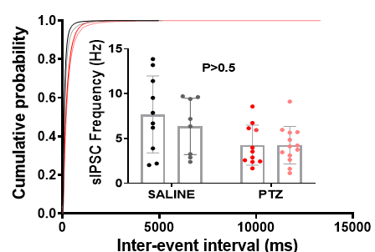
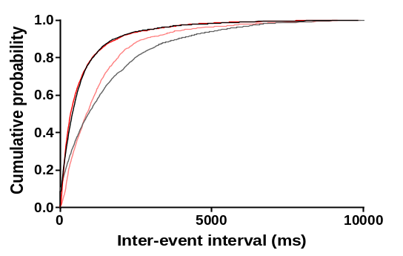
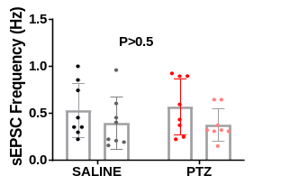
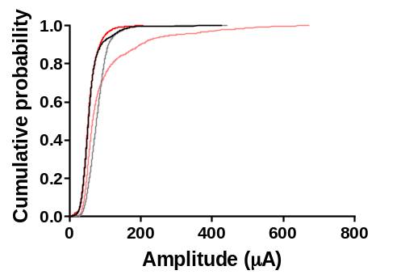
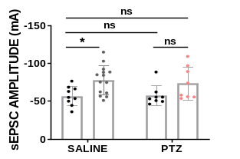
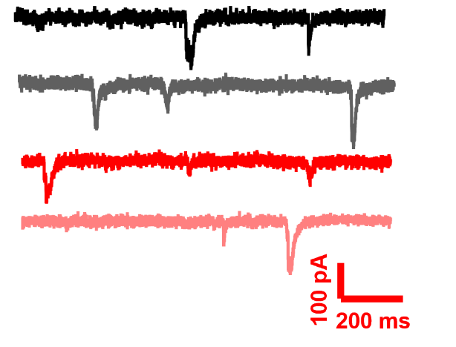
d
b
sIPSCs
sIPSCs
sEPSCs
sEPSCs
a
b
c
f

e

Figure 6: UA potentiates the spontaneous inhibitory transmission at an amplitude level but exerts no effects on the spontaneous excitatory transmission
- Representative traces of spontaneous Inhibitory post-synaptic currents for all the treatment groups. b) Cumulative probability for inter-stimulus intervals between fraction events with inset of quantitative histograms plotted for the frequency and c) for amplitude, respectively, of sIPSCs. d) Representative traces of spontaneous Excitatory post-synaptic currents for all the treatment groups. e) Cumulative probability for inter-stimulus intervals between fraction events with inset of quantitative histograms plotted for the frequency and f) for amplitude, respectively, of sEPSCs. For quantifications, n= number of cells, N= number of animals. (d-e) CMC-saline n= 9 N=5, UA (100)-saline n=8 N=4, CMC-PTZ n=11 N=7, and UA (100)-PTZ n=13 N=6. ns=non-significant. (g-h) CMC-saline n= 8 N=4, UA (100)-saline n=10 N=5, CMC-PTZ n= 9 N=4, and UA (100)-PTZ n=9 N=5. ns=non-significant. For cumulative plots of fraction events, multiple two K-S tests, with p>0.0,5 significance calculations. For inset bar graphs, two-way ANOVA with Bonferroni post hoc correction, *p < 0.5, **p < 0.05, ***p < 0.001. Error bars represent SEM.
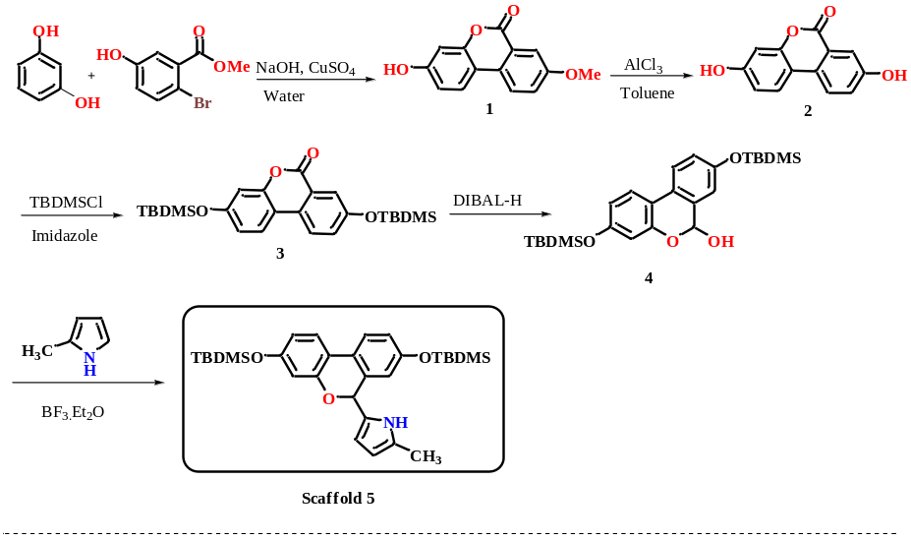
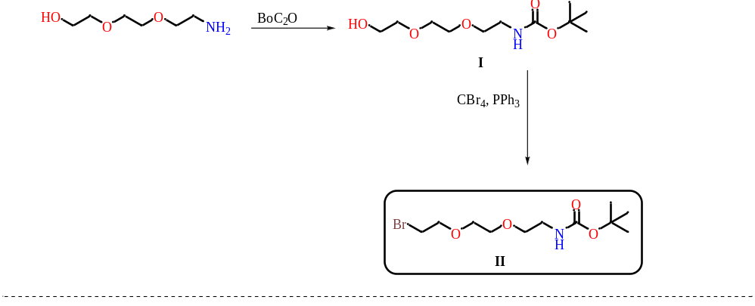
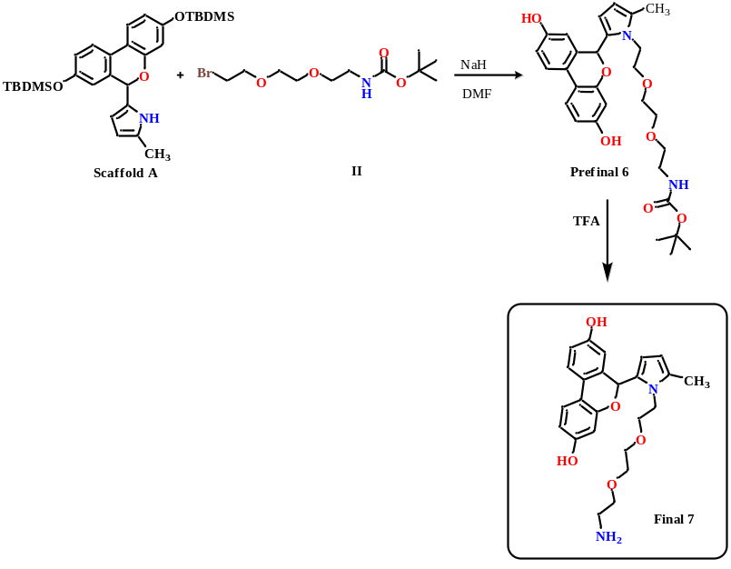
Synthesis of scaffold
Synthesis of linker
Synthesis of the probe

Figure 7: Series of chemical reactions to synthesize the UA-attached probe for affinity purification

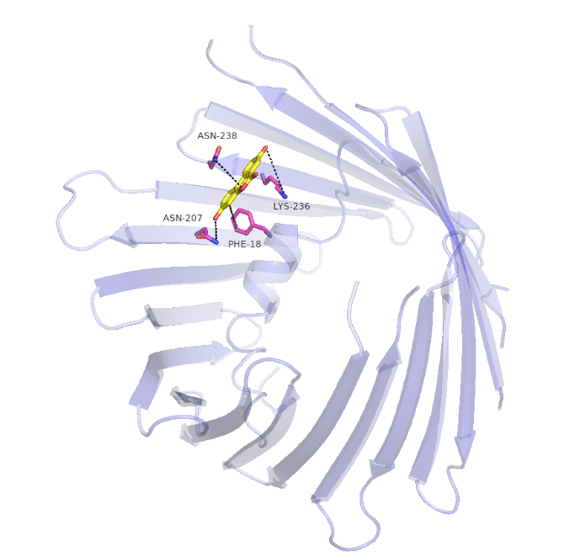
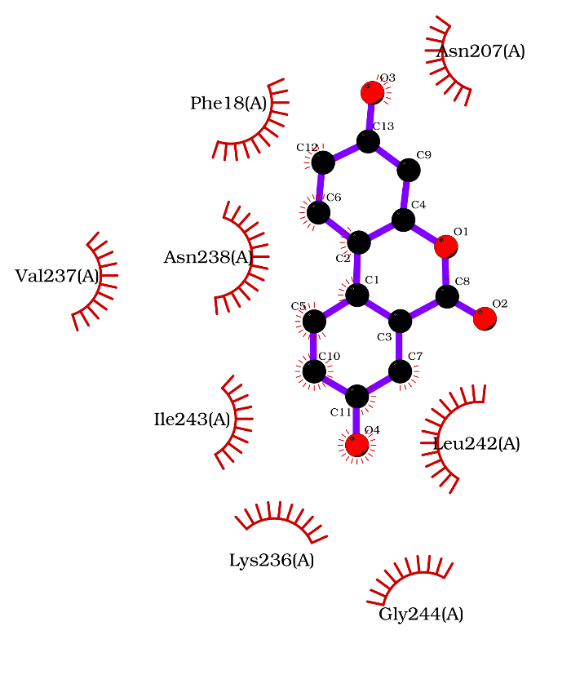
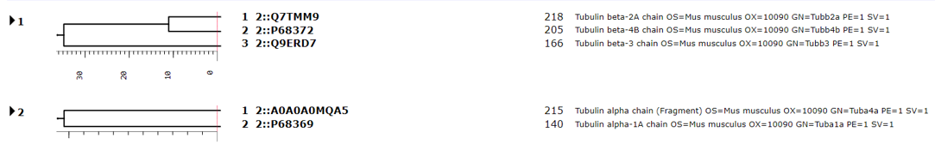

a
b
c

Figure 8: Proteomics identification of the complex of tubulin dimer and VDAC1 as a direct binding interactor of UA
- First and second boxes represent MASCOT search results depicting the interacting residues as tubulin dimer and VDAC1, respectively. b) Represents the docking pose of human VDAC1 (teal color) with minimum binding energy confirmation. Urolithin-A is shown in yellow color. Interactors (in proximity) marked with sticks in magenta color. The electronegative oxygen and nitrogen atoms in Urolithin-A and protein residues are shown in red and blue, respectively. Dotted lines indicate interacting residues involved in plausible hydrophobic interactions between Urolithin-A and human VDAC residues.
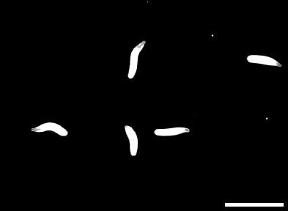
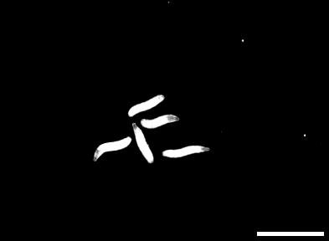
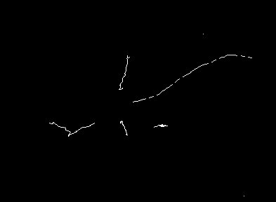
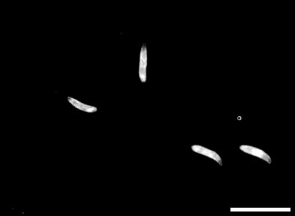
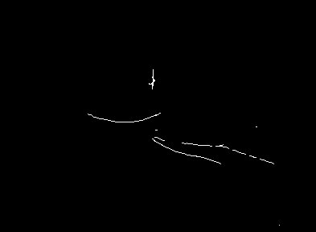
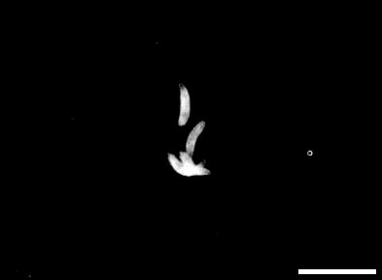
Elav Gal4; Tub-Gal80ts > scramblase
RNAi (PTX+UA)
Elav Gal4; Tub-Gal80ts > porin RNAi
(vehicle)
0 sec
Path tracks
a
b
5 sec

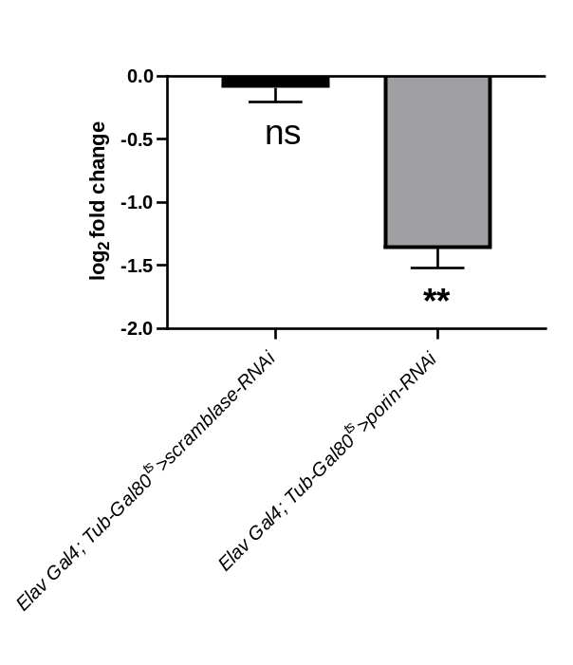

Figure 9: Brain-specific knockdown of VDAC1 phenocopies the sub-acute anti-epileptic effects of UA
- Representative still shots at 0 and 5 seconds with respective path tracks from videos recorded for peristaltic contractions in the larvae. The scale bar represents 80 pixels. Error bars represent SD. n= total number of larvae, N=biological replicates. Elav Gal4; Tub-Gal80^{ts}>scramblase-RNAi (vehicle) n=10, N=3; Elav Gal4; (PTX+UA) n=15, N=3. b) qRT expression levels of VDAC1 knockdown. For quantification, *p < 0.5, **p < 0.05, ***p < 0.001, one-way ANOVA with Tukey post-hoc correction.
Table 1:
Genotype | Stock Number/Source | Description
Canton-S | BS#1 | Control for all the fly experiments (Unless stated otherwise)
para^{bss1} | NCBS_CCAMP | Bang-sensitive mutant with GOF of the paralytic (Nav)
ss¹³⁴ | A kind gift from Prof. Jan | Protein null for Spineless (AhR)
Rdl^{MD-RR} | BS#35492 | Fly line with mutant GABA(A) receptor conferring resistance towards PTX
elav-GAL4; +; + | BS#458 | Drives the downstream gene in a pan-neuronal fashion
+; porin^{RNAi}; + | BS# 29572 | GAL4 inducible RNA interference against porin (VDAC1)

