Figure 1. ¹H NMR proton spectrum of compound 3,8-Dihydroxy-6H-benzo[c]chromen-6-one
Figure 2. ¹H NMR proton spectrum of compound 3,8-Bis((tert-butyldimethylsilyl) oxy)-6H-benzo[c]chromen-6-one
Figure 3. ¹H NMR proton spectrum of compound 3,8-Bis((tert-butyldimethylsilyl) oxy)-6H-benzo[c]chromen-6-ol.

Figure 4. ¹H NMR proton spectrum of compound 2-(3,8-Bis((tert-butyldimethylsilyl) oxy)-6H-benzo[c]chromen-6-yl)-5-methyl-1H-pyrrole.
Figure 5. ¹H NMR proton spectrum of compound Tert-butyl (2-(2-(2-hydroxyethoxy) ethoxy) ethyl) carbamate
Figure 6. ¹H NMR proton spectrum of compound Tert-butyl (2-(2-(2-bromoethoxy) ethoxy) ethyl) carbamate.
Figure 7. ¹H NMR proton spectrum of compound Tert-butyl (2-(2-(2-(2-(3,8-dihydroxy-6H-benzo[c]chromen-6-yl)-5-methyl-1H-pyrrol-1-yl) ethoxy) ethoxy) ethyl carbamate.

Figure 8. ¹H NMR proton spectrum of compound 6-(1-(2-(2-(2-aminoethoxy) ethoxy) ethyl)-5-methyl-1H-pyrrol-2-yl)-6H-benzo[c]chromene-3,8-diol.
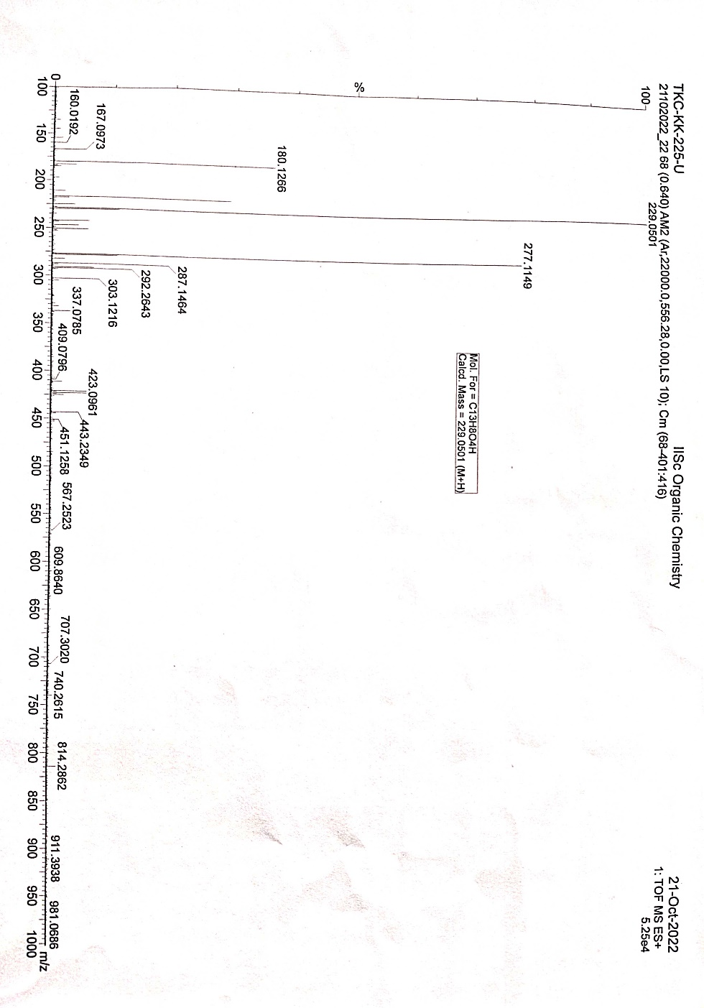
Figure 9: HRMS of compound 3,8-Dihydroxy-6H-benzo[c]chromen-6-one.
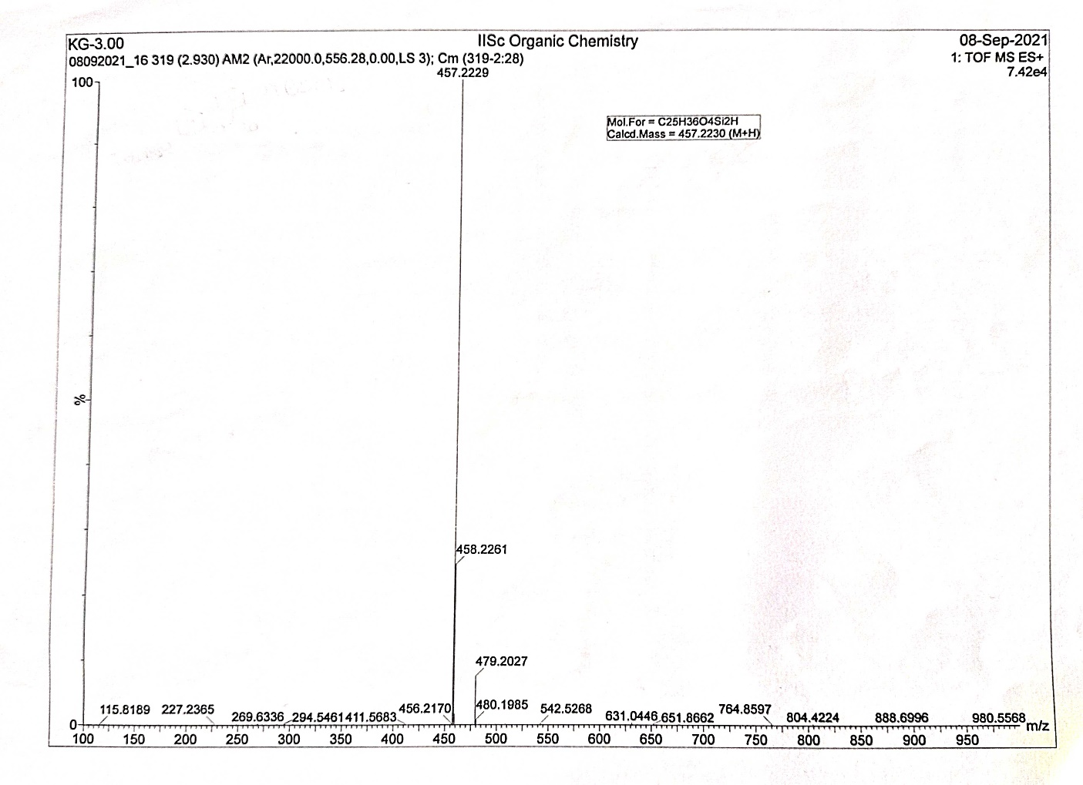
Figure 10. HRMS of compound 3,8-Bis((tert-butyldimethylsilyl) oxy)-6H-benzo[c]chromen-6-one.
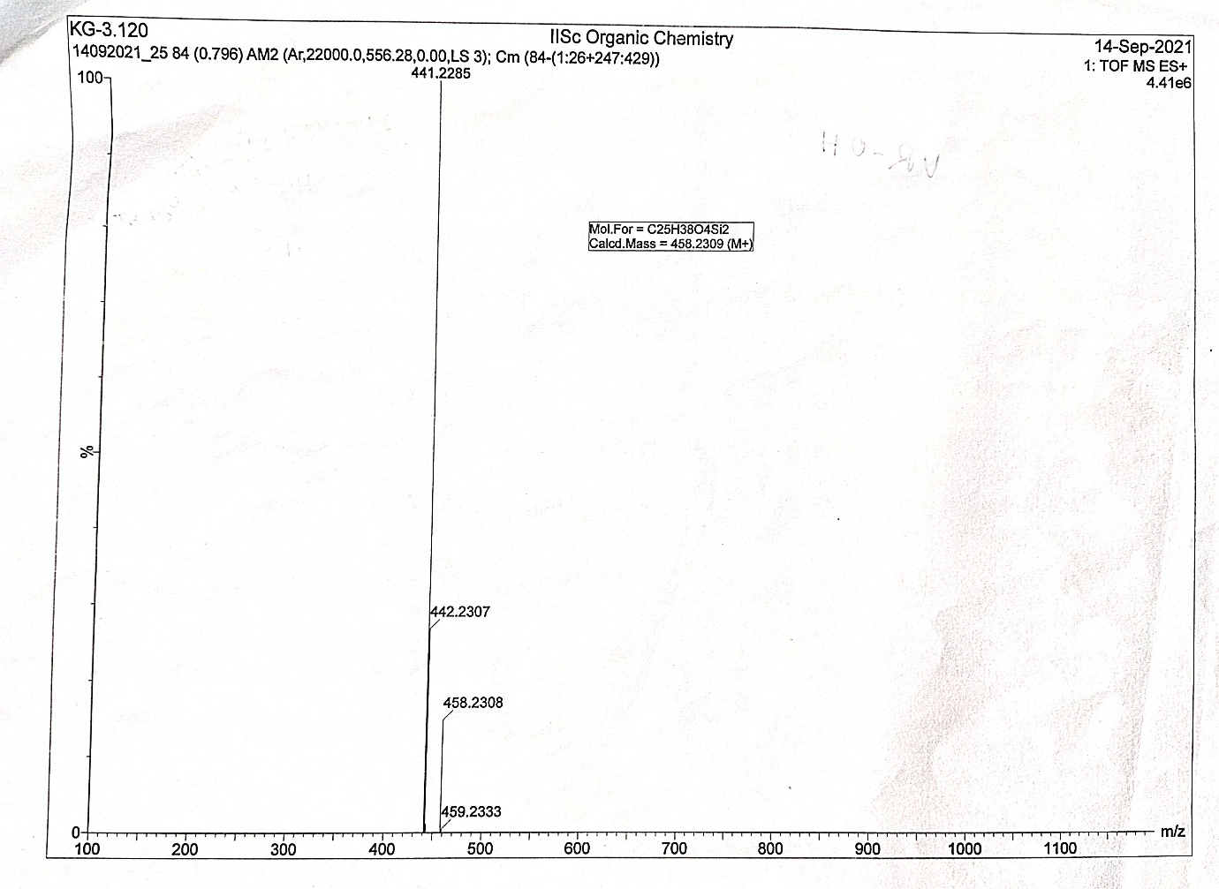
Figure 11. HRMS of compound 3,8-Bis((tert-butyldimethylsilyl) oxy)-6H-benzo[c]chromen-6-ol
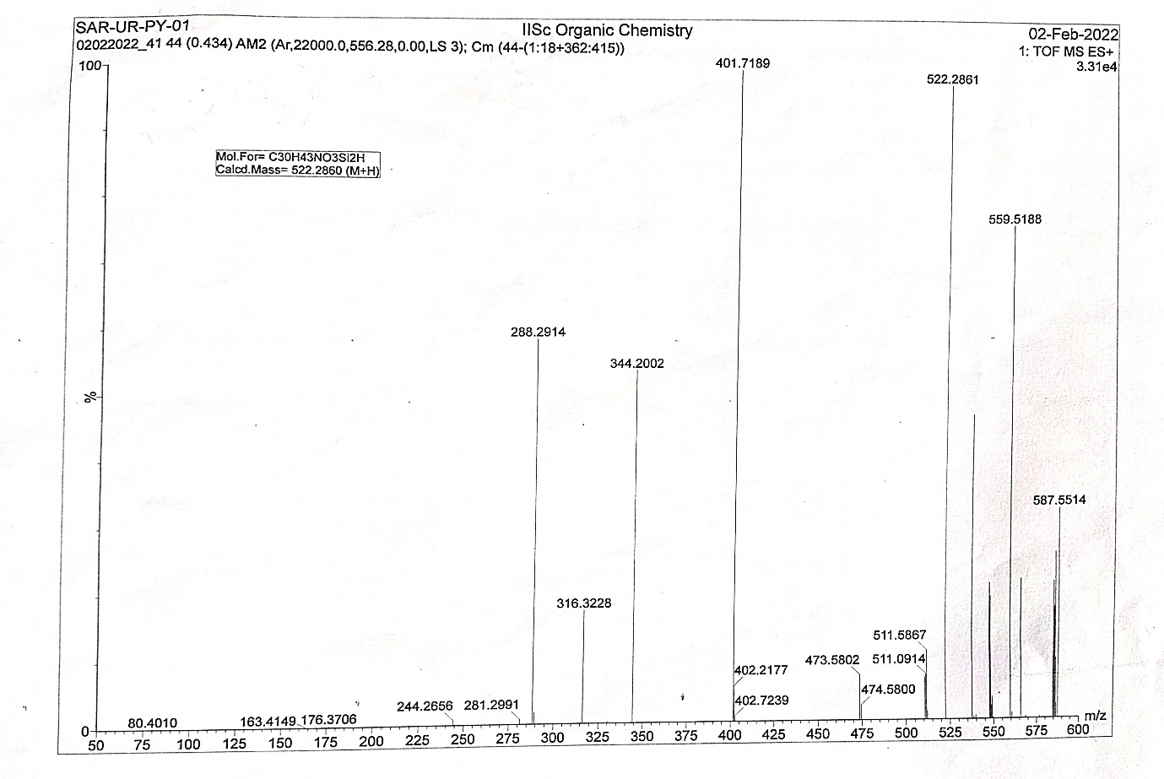
Figure 12. HRMS of compound 2-(3,8-Bis((tert-butyldimethylsilyl) oxy)-6H-benzo[c]chromen-6-yl)-5-methyl-1H-pyrrole
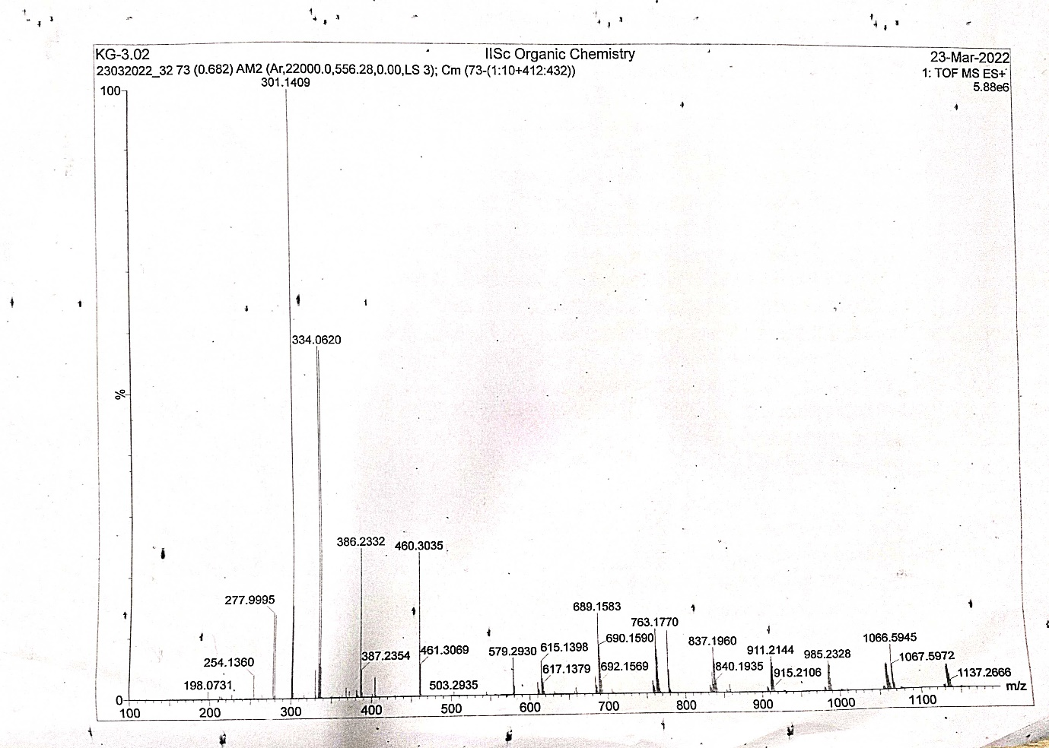
Figure 12: HRMS of compound Tert-butyl (2-(2-(2-bromoethoxy) ethoxy) ethyl) carbamate.
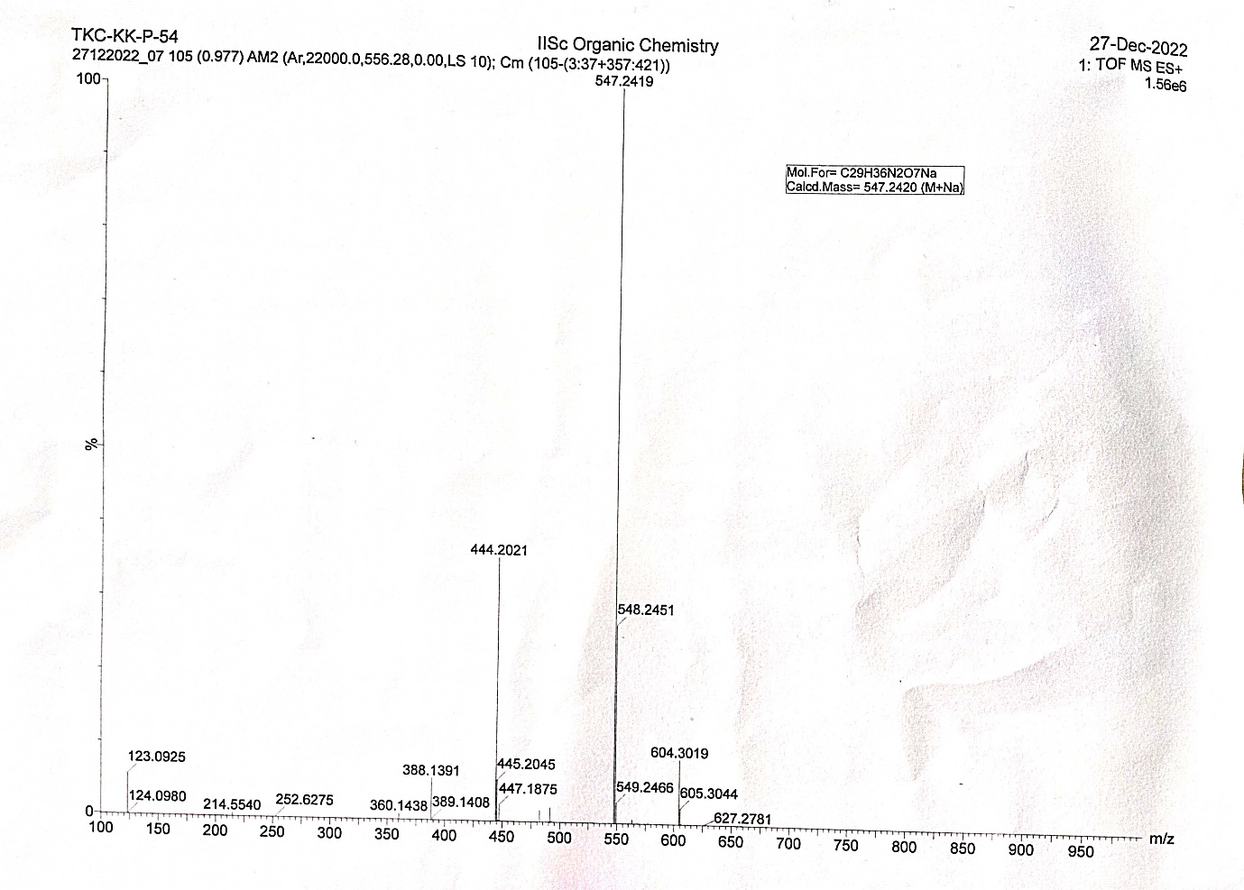
Figure 13: HRMS of compound Tert-butyl (2-(2-(2-(2-(3,8-dihydroxy-6H-benzo[c]chromen-6-yl)-5-methyl-1H-pyrrol-1-yl) ethoxy) ethoxy) ethyl carbamate.
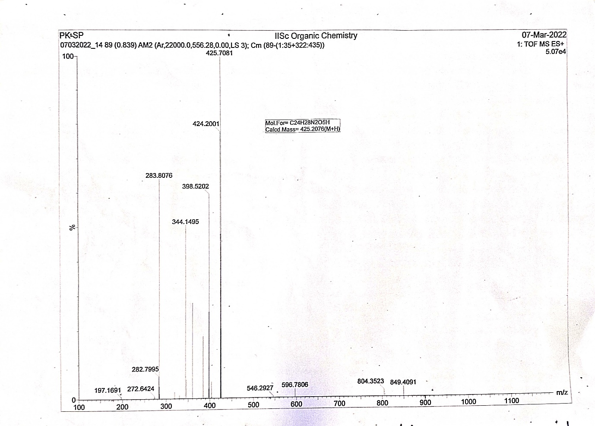
Figure 14: HRMS of compound 6-(1-(2-(2-(2-aminoethoxy) ethoxy) ethyl)-5-methyl-1H-pyrrol-2-yl)-6H-benzo[c]chromene-3,8-diol

