Supporting information for

Electrifying Industrial Hydrogen Peroxide Production via
Interfacial Molecular Mediation
Dawei Xi^{1,3,}*, Yuheng Wu^{1,3}, Yuli Li², Richard Y. Liu², Michael J. Aziz^{1,}*
1 Harvard John A. Paulson School of Engineering and Applied Sciences, Cambridge, MA, USA.
2 Department of Chemistry and Chemical Biology, Harvard University, Cambridge, MA, USA
3 These authors contributed equally: Dawei Xi and Yuheng Wu
* E-mail: daweixi@fas.harvard.edu; maziz@harvard.edu

Table of Contents

Supplementary figures
S1: Determination of the concentration of DPPEAQ and H₂DPPEAQ using Ultraviolet–visible spectroscopy (UV-Vis)…………………………………………………………………..………....4
S2: Determination of the concentration of EtAQ in 3Tol/2Dec (volume ratio of toluene : 1-dencanol = 3 : 2) using UV-Vis spectrophotometry………………………………………………....…….....6
S3: Determination of the solubility of DPPEAQ in 3Tol/2Dec and EtAQ in phosphate buffer……7
S4: The schematic of the kinetics test device……………………………………………………….8
S5: The temporal variation of the UV-Vis spectrum of H₂DPPEAQ/DPPEAQ solution during ANIHAT kinetics tests……………………………………………………………………………..9
S6: Determination of the SOC of DPPEAQ using UV-Vis spectrophotometry…………………..10
S7: Fitting of the kinetic rate constants of ANIHAT based on reversible second-order reaction model…………………………………………………………………………………………...…12
S8: Proposed mechanisms of ANIHAT…………………………………………………………...14
S9: Calculated potential energy surfaces of ANIHAT……………………………………………15
S10: The key intermediates of ANIHAT………………………………………………………….16
S11: The energy difference of EtAQ reduction in toluene and 1-decanol………………………...18
S12: The reaction rate test of the ANIHAT between H₂DPPEAQ and EtAQ under vigorous stirring…………………………………………………………………………………………….19
S13: The illustration of the tandem reactor for the continuous production of H₂O₂ using e-AO method………………………………………………………………………………………….…21
S14: The liquid chromatography-mass spectrometry (LC-MS) of the DPPEAQ electrolyte after the long-term cell cycling test………………………………………………………………………...23
S15: The LC-MS of the EtAQ solution cycled with DPPEAQ electrolyte after the long-term cell cycling test………………………………………………………………………………………...25
S16: The deprotonation of H₂EtAQ at pH = 14…………………………………………………...27
S17: The area-normalized Nyquist plot of the cell recorded after the continuous production of H₂O₂ using e-AO method………………………………………………………………………………..28
S18: The full cell voltage (V₁) monitored throughout the continuous production of H₂O₂ using e-AO method………………………………………………………………………………………..28
S19: The color change of EtAQ during ANIHAT and AO processes…………………………….29
S20: The low reactivity of H₂EtAQ with the H₂O₂ product……………………………………....29
S21: The polarization behavior of “anode + membrane”…………………………………………31
S22: The parasitic hydrogen evolution reaction (HER) side reaction………………………….…32
S23: The polarization performance (half-cell) and the Coulombic efficiency of D2PEAQ (pH = 7) under different current densities…………………………………………………………………..33
S24: The reaction rate test of the ANIHAT between H₂D2PEAQ and EtAQ under vigorous stirring…………………………………………………………………………………………….34
S25: Techno-economic analysis (TEA)…………………………………………………………..35

Supplementary tables
S1: The solubility of DPPEAQ and EtAQ in phosphate buffer solution (pH = 7) and 3Tol/2Dec…38
S2: Performance comparison of currently reported H₂O₂ synthesis methods…………………….38

Supplementary data
S1: XYZ coordinates of the optimized DFT structures and corresponding energies……………..40

References………………………...……………………………………………………………...77

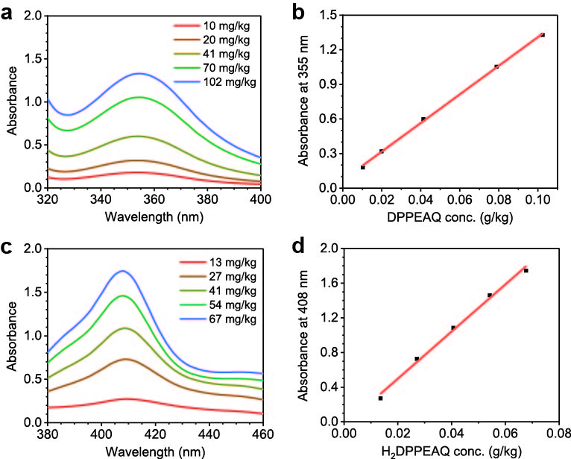
Supplementary Fig. S1 | Determination of the concentration of DPPEAQ and H₂DPPEAQ using Ultraviolet–visible spectroscopy (UV-Vis). a, The UV-Vis spectra and b, the concentration-absorbance curve of DPPEAQ solutions with a series of standard concentrations. The calibration curve showed a good linear relation of absorbance with DPPEAQ concentration (y = 12.4021 x + 0.0691, R² = 0.9996). c, The UV-Vis spectra and d, the concentration-absorbance curve of H₂DPPEAQ solutions with a series of standard concentrations. 3Tol/2Dec was used as the solvent. The calibration curve showed a good linear relation of absorbance with H₂DPPEAQ concentration (y = 27.1822 x − 0.0463, R² = 0.9970).

The UV-Vis spectrophotometry was measured based on Beer–Lambert law (Equation S2).
$\log_{10}(I_{R}/I_{s})=A=εlc$ (S2)
where
I_{R}: the intensity of transmitted light through a reference sample consisting of pure solvent.
I_{S}: the intensity of light transmitted through a sample.
A: absorbance.
ε: absorptivity.
l: the optical path length within the sample solution.
c: the molar concentration of the solute in the sample.

We employed linear fitting to analyze the absorbance-concentration data.
1 mol L⁻¹ KOH was used as the solvent to fully deprotonate DPPEAQ and H₂DPPEAQ, otherwise the peak of the testing species would shift at different pH within the range of 7 to 12. For all future DPPEAQ/H₂DPPEAQ dilution operations, we used 1 mol L⁻¹ KOH as the diluent to assure the reproducibility of the results. The absorbance at a certain wavelength with various concentrations (black dots) was linearly fitted (red line) to determine the linear region of the absorbance-concentration relationship.

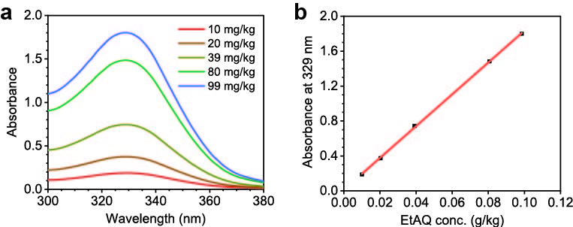
Supplementary Fig. S2 | Determination of the concentration of EtAQ in 3Tol/2Dec (volume ratio of toluene : 1-dencanol = 3 : 2) using UV-Vis spectrophotometry. a, The UV-Vis spectra and b, the concentration-absorbance curve of EtAQ solutions with a series of standard concentrations. The calibration curve showed a good linear relation of absorbance with EtAQ concentration (y = 18.2227 x + 0.0118, R² = 0.9998).

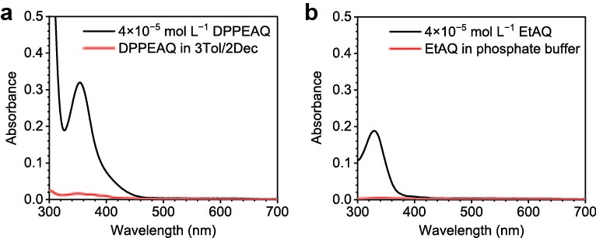
Supplementary Fig. S3 | Determination of the solubility of DPPEAQ in 3Tol/2Dec and EtAQ in phosphate buffer. The UV-Vis spectra of a, DPPEAQ-saturated 3Tol/2Dec and b, EtAQ-saturated phosphate buffer (pH = 7). The concentration of DPPEAQ and EtAQ were estimated based on the linear relationships between absorbance and concentration.
The solubility of DPPEAQ in 3Tol/2Dec was determined through UV-Vis spectrophotometry. Approximately 10 mg DPPEAQ (sodium salt form) were added to 1 mL 3Tol/2Dec, followed by vigorous agitation. The suspension was then centrifuged, and the clear solution was sampled for characterization. The UV-Vis measurement was conducted on the nonaqueous phase, revealing that the intensity of the peak of the spectra was at the noise level and far lower than the concentration range used for the calibration. To estimate the concentration of DPPEAQ in the nonaqueous phase, we recalibrated the concentration-absorbance curve of DPPEAQ, forcing the intercept to zero. The solubility of DPPEAQ in 3Tol/2Dec was determined to be lower than 2 μmol L⁻¹.
The solubility of EtAQ in water was determined by adding approximately 10 mg of EtAQ to 1 mL of 0.33 mol L⁻¹ phosphate buffer (pH = 7), followed by vigorous agitation and centrifuging as described above. The clear solution was sampled for UV-Vis spectrophotometry. Following the same procedure, the solubility of EtAQ in the phosphate buffer was determined to be lower than 0.01 μmol L⁻¹. The results show that EtAQ has low solubility in the aqueous phase and DPPEAQ has low solubility in the nonaqueous phase, indicating a low crossover of molecules between phases.
The solubility of 1-decanol in water is lower than 40 mg L⁻¹ at 20°C. The solubility of toluene in water is lower than 0.54 g L⁻¹ at 20°C. For lower solubility of nonaqueous solvents in water, common solvents in t-AO methods can be used (mixture of heavy aromatic molecules, tris (2-ethylhexyl) phosphate, and di-n-pentyl phthalate)¹.

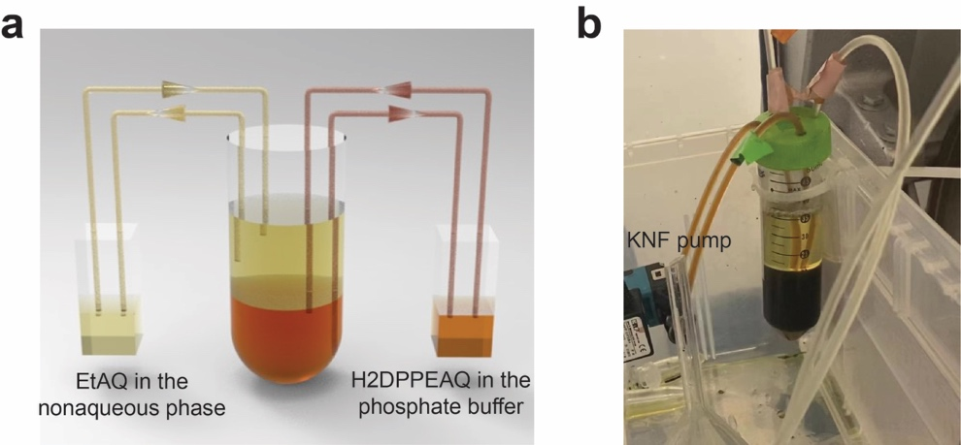
Supplementary Fig. S4 | The schematic of the kinetics test device. a, The apparatus layout and b, the digital photo of our device for ANIHAT kinetics measurement with pumps circulating the solutions.
The kinetics measurements were conducted in the apparatus shown in Supplementary Fig. S4a. Initially, 20 mL 0.05 mol L⁻¹ H₂DPPEAQ in the phosphate buffer (pH = 7) was added to a 50 mL centrifuge tube. Two KNF pumps were attached into the centrifuge tube, one of them extended below the aqueous phase, ensuring the continuous circulation of the DPPEAQ solution. This facilitated the mass transport of DPPEAQ/H₂DPPEAQ between the bulk solution and the aqueous-nonaqueous interface. The other pump was located above the nonaqueous phase, near the surface of DPPEAQ solution, which would later circulate the nonaqueous phase once EtAQ solution was added, facilitating the mass transport of EtAQ/H₂EtAQ between the bulk solution and the aqueous-nonaqueous interface. When kinetics test started, 20 mL of 0.05 mol L⁻¹ EtAQ solution was gently added to the top of the aqueous phase with a funnel, submerging the tubes above the DPPEAQ solution. At regular intervals, the DPPEAQ and the EtAQ solutions were sampled for UV-Vis measurement. The kinetics test continued until two consecutive UV-Vis spectra showed no obvious distinction, indicating the reaction had reached equilibrium.
As shown in Supplementary Fig. S4b, during the test, the circulation of solutions had minimal interference with the interface between the aqueous and the nonaqueous phases. The interface remained stable, maintaining a well-defined contact area between these two phases.

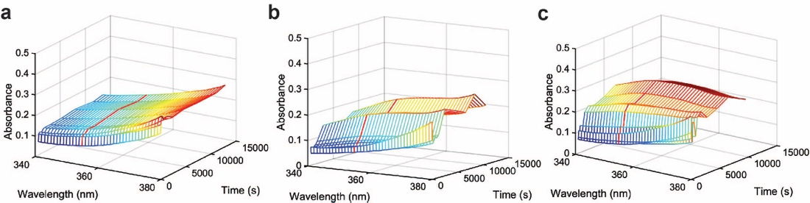
Supplementary Fig. S5 | The temporal variation of the UV-Vis spectrum of H₂DPPEAQ/DPPEAQ solution during ANIHAT kinetics tests. Nonaqueous solvent compositions of a, 4Tol/1Dec, b, 3Tol/2Dec and c, 2Tol/3Dec were used during the kinetics tests. The red line represents the temporal variation of the absorbance at 355 nm.

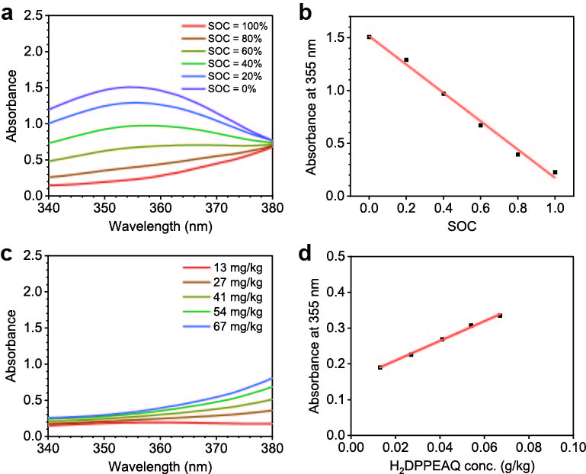
Supplementary Fig. S6 | Determination of the SOC of DPPEAQ using UV-Vis spectrophotometry. a, The UV-Vis spectra and b, the SOC-absorbance curve of 0.24 mmol L⁻¹ DPPEAQ with a series of SOC of 0%, 20%, 40%, 60%, 80%, and 100%. 1 mol L⁻¹ KOH was used as the diluent . The calibration curve showed a good linear relation of absorbance with the SOC of DPPEAQ (y = 1.3414 x + 0.1729, R² = 0.9966). c, The UV-Vis spectra and b, the concentration-absorbance curve of H₂DPPEAQ solutions with a series of standard concentrations. The calibration curve showed a good linear relation of absorbance with H₂DPPEAQ concentration (y = 2.7496 x + 0.1544, R² = 0.9982).
To calibrate the SOC-absorbance curve, we first dissolved a certain amount of DPPEAQ in a specified amount of phosphate buffer (pH = 7). Subsequently, we sampled half of the DPPEAQ solution and electrochemically reduced it with a constant voltage method until the current drop to lower than 0.2 mA cm⁻², ensuring more than 98% of the DPPEAQ was converted to H₂DPPEAQ (based on theoretical capacity). Afterwards, we mixed the DPPEAQ and H₂DPPEAQ solutions with specific proportions to obtain DPPEAQ solutions with 0%, 20%, 40%, 60%, 80%, and 100% SOCs. The DPPEAQ solutions were then diluted with 1 mol L⁻¹ KOH to the detection range and measured by a UV-Vis spectrometer. The absorbances at the wavelength of 355 nm (black dots) were linearly fitted (red line) and employed to calculate the SOC at a specific analytic concentration of DPPEAQ (Supplementary Fig. S6).
To verify that the linear relationship between absorbance and SOC exists at any specific DPPEAQ analytical concentration, we calibrated the absorbance-concentration curves of DPPEAQ and H₂DPPEAQ at 355 nm (Supplementary Fig. S1a, S6c). Both absorbance of DPPEAQ and H₂DPPEAQ at 355 nm demonstrate good linear relationships with their concentrations, validating the feasibility of using Equation S3, S4 at any specific DPPEAQ analytical concentration.

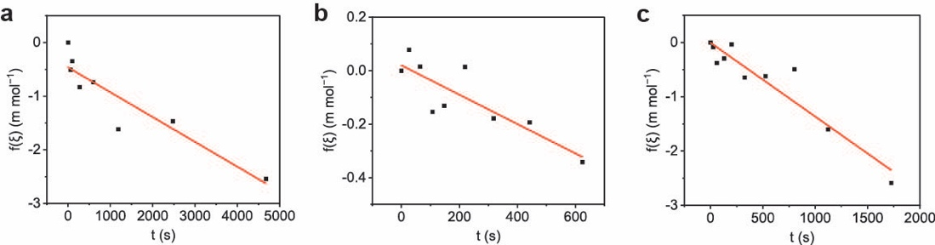
Supplementary Fig. S7 | Fitting of the kinetic rate constants of ANIHAT based on reversible second-order reaction model. The linear fits for the k₁ and k₋₁ of ANIHAT from the kinetics tests using the nonaqueous solvents of a, 4Tol/1Dec, b, 3Tol/2Dec, and c, 2Tol/3Dec. Here, $f(ξ)=ln\left|\frac{1+\frac{1-K_{eq}}{\sqrt{K_{eq}}}⋅\left(ξ-\frac{1}{1-K_{eq}}\right)}{1-\frac{1-K_{eq}}{\sqrt{K_{eq}}}⋅\left(ξ-\frac{1}{1-K_{eq}}\right)}\right|-ln\left|\frac{1-\sqrt{K_{eq}}}{1+\sqrt{K_{eq}}}\right|$.
The kinetic equation of ANIHAT was derived under the hypothesis that this reaction is an apparent second-order reaction (Equation S3, S4). The initial concentration of H₂DPPEAQ and EtAQ were both approximately 0.05 mol L⁻¹; the initial concentration of DPPEAQ and H₂EtAQ were both nearly 0.
$H_{2}DPPEAQ\left(aq\right)+EtAQ\left(nonaq\right)⇌DPPEAQ\left(aq\right)+H_{2}EtAQ\left(nonaq\right)$ (S3)
$-c_{0}\frac{dξ}{dt}=k_{1}⋅A⋅c_{0}^{2}⋅ξ^{2}-k_{-1}⋅A⋅c_{0}^{2}⋅{(1-ξ)}^{2}$ (S4)
Where:
c₀: the original concentration of H₂DPPEAQ and EtAQ.
ξ: extent of reaction.
A: contact area of aqueous and nonaqueous phase.
After conducting definite integral, the relationship between time and the extent of the reaction could be expressed as follows.
$-2\sqrt{k_{1}^{'}k_{-1}^{'}}⋅t=ln\left|\frac{1+\frac{1-K_{eq}}{\sqrt{K_{eq}}}⋅\left(ξ-\frac{1}{1-K_{eq}}\right)}{1-\frac{1-K_{eq}}{\sqrt{K_{eq}}}⋅\left(ξ-\frac{1}{1-K_{eq}}\right)}\right|-ln\left|\frac{1-\sqrt{K_{eq}}}{1+\sqrt{K_{eq}}}\right|$ (S5)
where $k_{1}^{'}=c_{0}·A·k_{1}$, $k_{-1}^{'}=c_{0}·A·k_{-1}$.
Linear regression was employed to fit the k₁ and k₋₁ in the second-order kinetic equation of ANIHAT (Equation S5)). The K_{eq} was first determined according to the final sample from the DPPEAQ solution. Then we calculated the f(ξ) of each sample based on its SOC, and plotted it as a function of reaction time. A linear regression analysis was subsequently performed, and the outcome slope was designated as $-2\sqrt{k_{1}^{'}k_{-1}^{'}}$. Given the relationship k₁’/k₋₁’=K_{eq}, where K_{eq} is a known value, k₁’ and k₂’, as well as k₁ and k₂ were accordingly determined. We utilized the derived values of k₁ and k₋₁ to construct the mole fraction-time curves for ANIHAT, which exhibited a strong match with the experimental data.

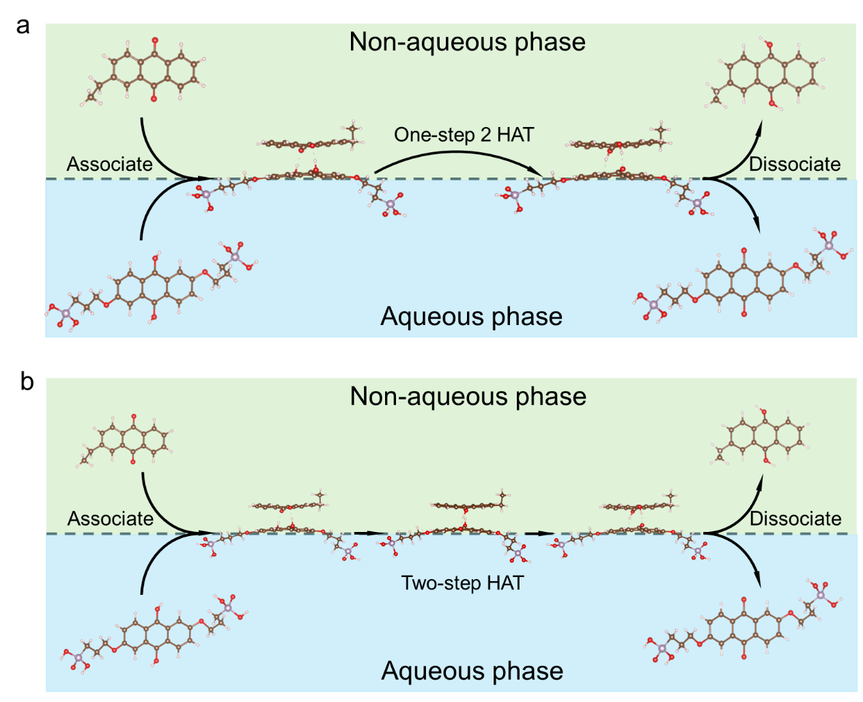
Supplementary Fig. S8 | Proposed mechanisms of ANIHAT. a, The one-step HAT mechanism. b, The two-step HAT mechanism. The color code of atoms: C: brown; O: red; phosphor: purple; and H: white.
ANIHAT is a spontaneous non-Faradaic process taking place at the interface of two immiscible phases. During ANIHAT, H₂DPPEAQ and EtAQ first migrate to the interface and combine to form a quinhydrone-like adduct^{24, 26}, H₂DPPEAQ-EtAQ. It is hypothesized that the hydrophobic aromatic rings of DPPEAQ enter the nonaqueous phase during the formation of the adduct, leaving the hydrophilic phosphate terminal group in the aqueous phase. The two hydrogen atoms attached to H₂DPPEAQ are then transferred to EtAQ, forming DPPEAQ-H₂EtAQ, which then dissociates and releases DPPEAQ and H₂EtAQ to their corresponding bulk solutions. The transfer of protons happens along with the transfer of electrons³⁸. This proton-coupled electron transfer is equivalent to the transfer of two hydrogen atoms. The transfer of two hydrogens can happen with one step (one-step HAT mechanism, Supplementary Fig. S8a), or through two separate steps (two step HAT mechanism, with one hydrogen transferred first, then the second, Supplementary Fig. S8b).

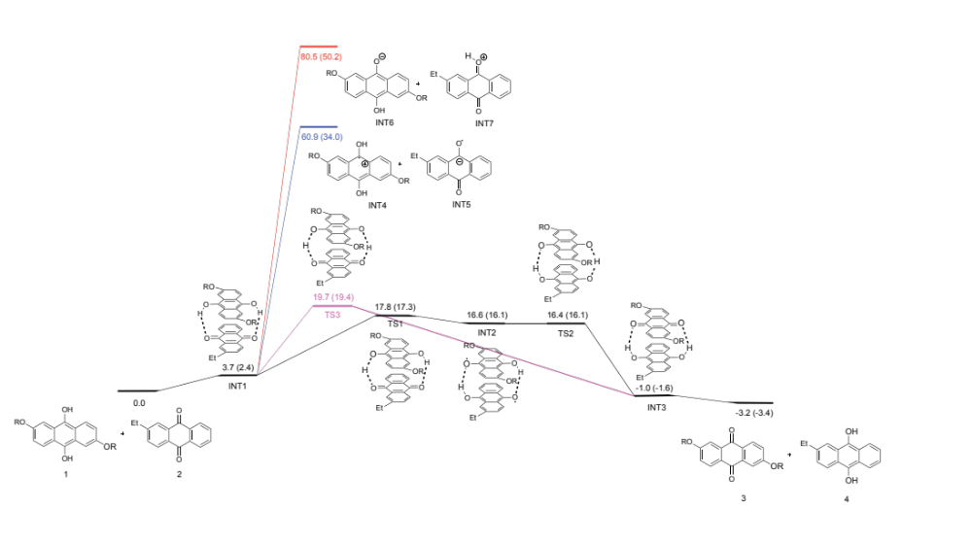
Supplementary Fig. S9 | Calculated potential energy surfaces of ANIHAT.
ANIHAT is a multi-step process that involves the concerted transfer of two protons and two electrons. Here, we used calculations to show that the transfer of the proton and the electron is concerted rather than sequential. We conducted quantum chemistry computations using Gaussian 16 package. The energy changes in toluene and 1-decanol are both calculated, with the energy in toluene shown outside parentheses and the energy in 1-decanol shown within parentheses. As shown in the calculated potential energy surface of ANIHAT (Supplementary Fig. S9), the HAT mechanisms (black and pink), in which electron and proton are transferred simultaneously, have remarkably lower energy barriers compared to those of sequential electron-proton transfer (blue and red). Furthermore, between two possible HAT mechanisms, stepwise HAT of two hydrogens (black) exhibits lower energy barrier than one step HAT of two hydrogens (pink). In the stepwise HAT pathway, the first hydrogen atom transfer is the rate determining step followed by a more facile second hydrogen atom transfer. The polarity of the nonaqueous solvent can affect the kinetics of ANIHAT by lowering the energy barrier of the transition states, as shown by the energy results in parentheses (1-decanol as solvent).
Calculations were performed with Gaussian 16 package⁴⁷. Geometry optimizations and frequency calculations were performed at the M06-2X/Def2-SVP^{48, 49} level of theory with the default convergence criteria. Single-point energy calculations were performed at the M06-2X/Def2-TZVP-SMD(Toluene) and M06-2X/Def2-TZVP-SMD(1-Decanol) level^{49, 50}. Frequency outcomes were examined to confirm stationary points as minima (no imaginary frequencies) or transition states (only one imaginary frequency). Paton’s GoodVibes⁵¹ was used to correct entropy and enthalpy by Grimme’s quasi-harmonic approximation⁵² and Head-Gordon’s method⁴⁶. All energy is in kcal/mol unless otherwise indicated. The XYZ coordinates of the optimized DFT structures and corresponding energies are shown in Supplementary Data S1.

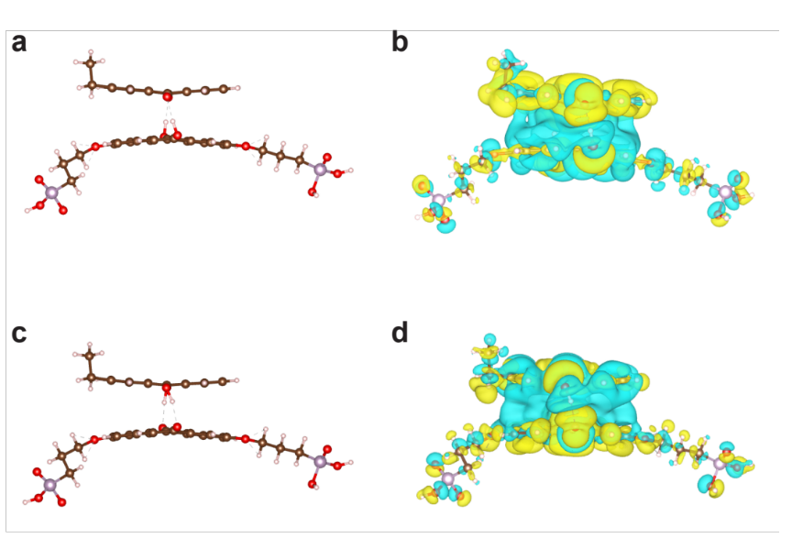
Supplementary Fig. S10 | The key intermediates of ANIHAT. a, The optimized structural geometry of H₂DPPEAQ-EtAQ adduct. b, The charge density difference plot of the H₂DPPEAQ-EtAQ adduct. c, The optimized structural geometry of the DPPEAQ- H₂EtAQ adduct. d, The charge density difference plot of the DPPEAQ-H₂EtAQ adduct. The light green and yellow color present the charge accumulation and depletion, respectively. The color code of atoms: C: brown; O: red; phosphor: purple; and H: white.
A quinhydrone-like adduct of DPPEAQ and EtAQ is considered the key intermediate of ANIHAT. To assess the electronic structure of the adduct, we performed DFT simulations to calculate the charge density difference of the adducts before (and after) HAT compared to H₂DPPEAQ and EtAQ (DPPEAQ and H₂EtAQ) alone. As shown in Supplementary Fig. S10, the adducts reveals strong π–π stacking interactions between the aromatic rings of DPPEAQ and EtAQ, and the hydrogen atoms to be transferred form hydrogen bonds with the oxygens in the carbonyl group of the oxidized form AQ. The π–π stacking and hydrogen bonds stabilize the key intermediate of ANIHAT, allowing the facile hydrogenation of AQs in the nonaqueous phase under ambient conditions, without the need for any heterogeneous catalysts or phase transfer catalysts.
The calculations were performed with the Perdew-Burke-Ernzerhof functional, using the Vienna ab initio simulation package (VASP). The van der Waals interactions were described using DFT-D3 method. Plane-wave cutoff of 450 eV was set and spin-polarization was included. The k-point sampling in the Brillouin zone was implemented using Monkhorst-Pack scheme with grid 1×1×1 for the geometry optimization and charge density calculation. All the atoms were allowed to relax until the force on each ion was smaller than 0.02 eV Å⁻¹.

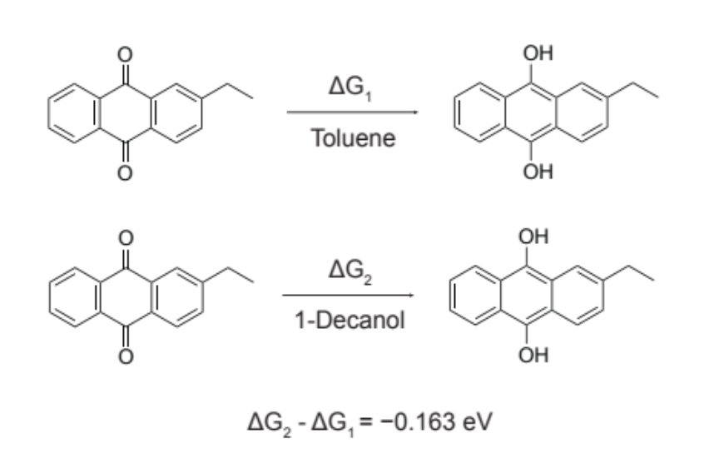
Supplementary Fig. S11 | The Gibbs free energy change of EtAQ reduction in toluene and 1-decanol.
To validate that the polarity of the nonaqueous phase solvent can influence the thermodynamics of ANIHAT, we compared the Gibbs free energy change (ΔG) of EtAQ hydrogenation in toluene and 1-decanol. The ΔG of EtAQ hydrogenation in 1-decanol was 0.163 eV more negative than in toluene. The ΔG difference could be attributed to the solvation of EtAQ and H₂EtAQ. Solvents with higher polarity deliver greater solvation energy for H₂EtAQ, whereas solvents with lower polarity exhibit greater solvation energy for EtAQ. The energy calculations were performed using the same method as described in Supplementary Fig. S9.

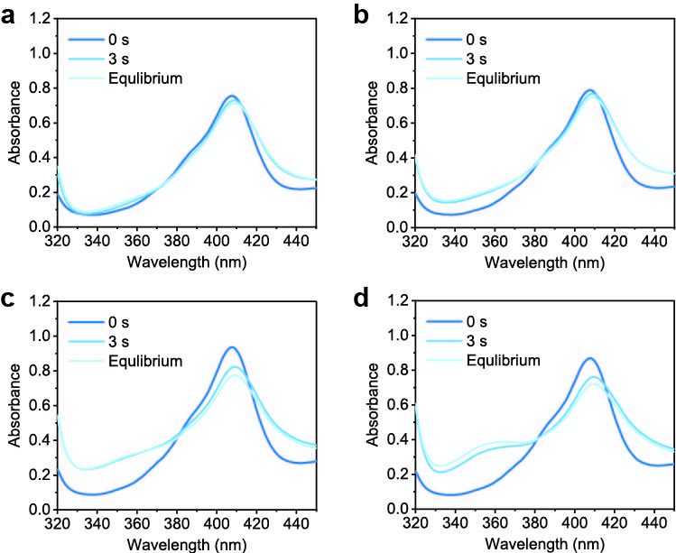
Supplementary Fig. S12 | The reaction rate test of the ANIHAT between H₂DPPEAQ and EtAQ under vigorous stirring. The temporal variations of the UV-Vis spectrum of DPPEAQ during the reaction rate test, conducted under vigorous stirring using the nonaqueous solvents of a, 5Tol/0Dec, b, 4Tol/1Dec, c, 3Tol/2Dec, and d, 2Tol/3Dec.
The reaction rate of the ANIHAT process under operation conditions possesses great practical significance. Since ANIHAT is the potential rate determining step in the e-AO process flow, its reaction rate compatibility with the EChem process is critical to the high yield rate continuous production of H₂O₂ using the e-AO method. To increase the reaction rate of ANIHAT, we conducted the reaction under vigorous stirring, with a substantially increased interfacial area, as the reaction rate of interfacial reactions is proportional to the contact area between phases.
During the reaction rate test, the aqueous phase containing 0.05 mol L⁻¹ DPPEAQ in 0.33 mol L⁻¹ phosphate buffer (pH = 7) was electrochemically reduced under constant voltage in a nitrogen glovebox until more than 98% of the oxidative specie was converted to its reduced form (the spectra were labeled as 0 s). Afterwards, 2.5 mL of the aqueous phase was transferred to a tube with 2.5 mL 0.05 mol L⁻¹ EtAQ, followed by 3 s of vigorous stirring. The emulsion was let stand for 1 min, allowing the majority of the aqueous and the nonaqueous phase to be separated. 0.1 mL of the aqueous and the nonaqueous phase were sampled and the aqueous sample was collected for UV-Vis test (the spectra were labeled as 3 s). The same procedures were repeated until the UV-Vis spectra of two consecutive tests showed no obvious distinction (the spectra were labeled as Equilibrium). According to the UV-Vis results (Supplementary Fig. S12), the ANIHAT between EtAQ and H₂DPPEAQ was nearly entirely achieved within the first 3 s of stirring. Therefore, ANIHAT, with an increased interfacial area under sufficient stirring, is capable of matching high current densities in EChem step, demonstrating great practicability in the continuous production of H₂O₂.

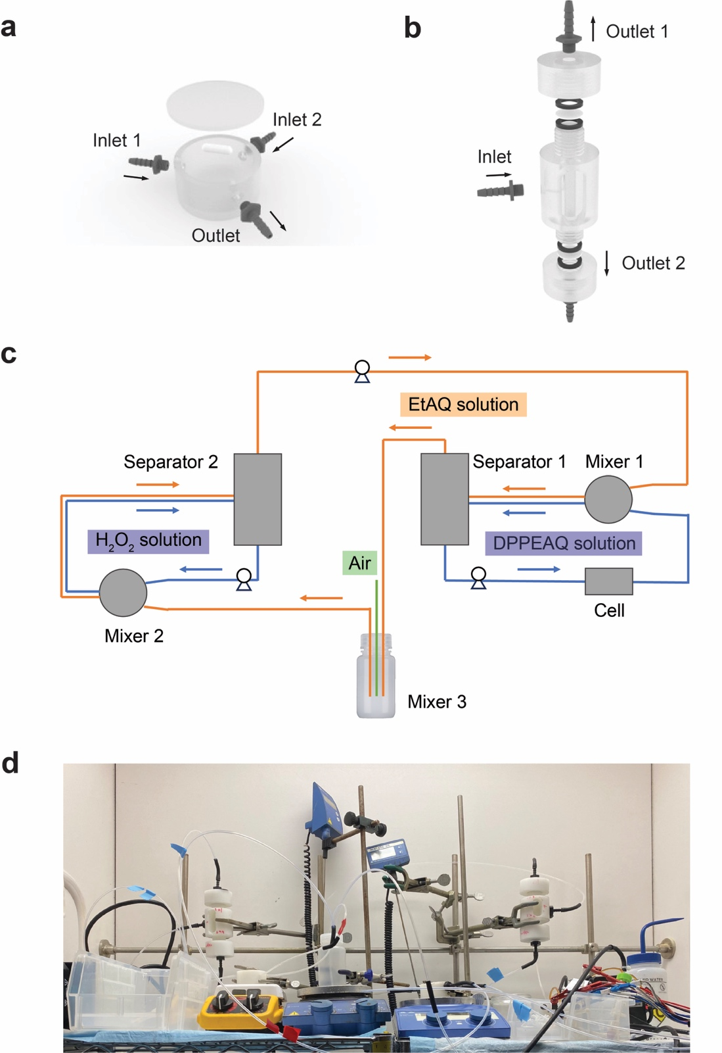
Supplementary Fig. S13 | The illustration of the tandem reactor for the continuous production of H₂O₂ using e-AO method. The design of a, the mixer, b, the separator, and c, the phase circulation layout of the tandem reactor for continuous H₂O₂ production through e-AO method. d, The digital picture of the tandem reactor.
Customized mixers and separators were employed to facilitate efficient mass transport at the boundary between distinct phases (Supplementary Fig. S13). The aqueous and nonaqueous phases can be respectively pumped into the mixers through inlet 1 and inlet 2 and sufficiently agitated by a magnetic stirrer. The resulting emulsion was then transported to a subsequent separator, where it separates into two distinct layers by gravity. The stratified aqueous and nonaqueous phases then exited the separator from the bottom and the top outlets respectively and processed to the next reaction cycle. Hydrophilic and hydrophobic microfiltration membranes can be applied to further promote phase separation. Settlers or centrifugation equipment would also be helpful for effective phase separation¹⁷.
In the continuous production of H₂O₂, three peristaltic pumps were used to circulate the DPPEAQ solution, the EtAQ solution, and the DI water, respectively. Prior to the electrolysis, 10 mL of 0.1 mol L⁻¹ buffered DPPEAQ and 18 mL of DI water were first added to separator 1 and separator 2 respectively, and pumped through their corresponding volumes with all the mixers’ nonaqueous phase inlet sealed off. Subsequently, 50 mL of 0.5 mol L⁻¹ EtAQ in 3Tol/2Dec was added to mixer 3. The inlet of the nonaqueous phase was opened and the EtAQ solution was pumped through every mixer and separator sequentially, exhausting all the gas inside the tandem reactor. This allowed each phase to have its own flow rate, without causing interruptions to the others.
During the continuous production of H₂O₂ using the tandem reactor, the amount of O₂ bubbling in mixer 3 was strictly controlled. Because O₂ displays moderate solubility in the nonaqueous phase, it must be purged out before the nonaqueous phase encounters the aqueous phase, to avoid reacting with H₂DPPEAQ. Otherwise, residual O₂ in the nonaqueous phase undergoes reduction in the aqueous electrolyte in Mixer 1, producing water or hydrogen peroxide that cannot be collected, penalizing overall Faradaic efficiency of H₂O₂. It was estimated that every 1 mL 3Tol/2Dec could dissolve 5 μmol O₂, leading to 2 C Faradaic efficiency loss. Therefore, the air flow applied in the AO chamber was carefully controlled, avoiding excessive O₂ dissolution in the nonaqueous phase, yet sufficient to oxidize most of the H₂EtAQ. After O₂ bubbling, the potentially unreacted oxygen was purged by N₂ after leaving separator 2 and before entering mixer 1.

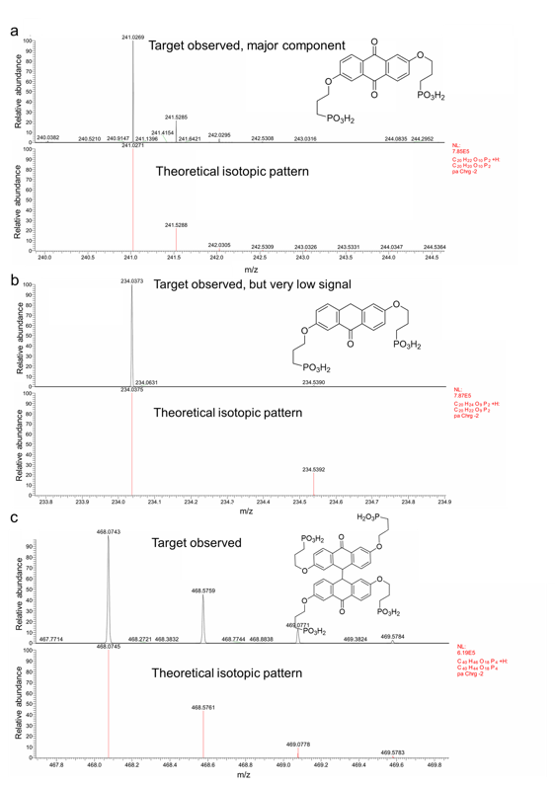
Supplementary Fig. S14 | The liquid chromatography-mass spectrometry (LC-MS) of the DPPEAQ electrolyte after the long-term cell cycling test. a, The target and its theoretical mass spectra of DPPEAQ. b, The target and its theoretical mass spectra of the corresponding anthrone decomposed from DPPEAQ. c, The target and its theoretical mass spectra of the corresponding dimer formed from DPPEAQ.
After the long-term cell cycling test of DPPEAQ (0.1 mol L⁻¹, buffered by 0.33 mol L⁻¹ phosphate (pH = 7), capacity limiting side) against ferro/ferricyanide (0.08 mol L⁻¹ ferrocyanide, 0.02 mol L⁻¹ ferricyanide, buffered by 0.33 mol L⁻¹ phosphate (pH = 7), capacity unlimiting side) for approximately 8 days, we sampled the electrolyte for the LC-MS analysis. Water and acetonitrile were used as mobile phase solvents.
Supplementary Fig. S14a shows the mass spectra of DPPEAQ in the sample (top) and the theoretical isotopic pattern (bottom). DPPEAQ was the major component in the electrolyte. Supplementary Fig. S14b shows the mass spectra of the corresponding anthrone decomposed from DPPEAQ (chemical structure drawn at top right) in the sample (top) and the theoretical isotopic pattern (bottom). Only weak signals were identified, indicating that the corresponding anthrone formed during the cycling test, but was not the major decomposition product. Supplementary Fig. S14c shows the mass spectra of the corresponding dimer formed from DPPEAQ (chemical structure drawn at top right) in the sample (top) and the theoretical isotopic pattern (bottom). The result indicates that the corresponding dimer was the major degradation product. The fade rate of DPPEAQ in our test at pH 7 was higher than the reported value at pH 12²¹. This is because the higher pH can suppress the formation of anthrones and dimerization⁵³. The anthrones and dimers formed from DPPEAQ degradation can be recovered chemically or electrochemically^{27, 28}.

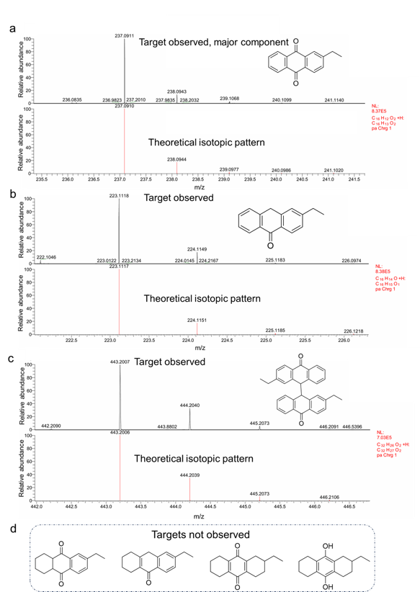
Supplementary Fig. S15 | The LC-MS of the EtAQ solution cycled with DPPEAQ electrolyte after the long-term cell cycling test. a, The target and its theoretical mass spectra of EtAQ. b, The target and its theoretical mass spectra of the corresponding anthrone decomposed from EtAQ. c, The target and its theoretical mass spectra of the corresponding dimer formed from EtAQ. d, The chemical structures of the possible molecules that formed from the over-reduction of EtAQ during ANIHAT, but were not observed after the long-term cell cycling test.
After cell cycling of DPPEAQ (0.1 mol L⁻¹, buffered by 0.33 mol L⁻¹ phosphate (pH = 7), capacity limiting side) adding EtAQ (0.1 mol L⁻¹ in 3Tol/2Dec, nonaqueous phase floating above the DPPEAQ electrolyte) against ferro/ferricyanide (0.08 mol L⁻¹ ferrocyanide, 0.02 mol L⁻¹ ferricyanide, buffered by 0.33 mol L⁻¹ phosphate (pH = 7), capacity unlimiting side) for approximately 3 days, we sampled the nonaqueous EtAQ solution for the LC-MS analysis. Water and acetonitrile were used as mobile phase solvents.
Supplementary Fig. S15a shows the mass spectra of EtAQ in the sample (top) and the theoretical isotopic pattern (bottom). EtAQ was the major component in the solution. Supplementary Fig. S15b shows the mass spectra of the corresponding anthrone decomposed from EtAQ (chemical structure drawn at top right) in the sample (top) and the theoretical isotopic pattern (bottom). Supplementary Fig. S15c shows the mass spectra of the corresponding dimer formed from DPPEAQ (chemical structure drawn at top right) in the sample (top) and the theoretical isotopic pattern (bottom). The results indicate that the corresponding anthrone and dimer were the major degradation product. The anthrones and dimers formed from the decomposition of EtAQ can be recovered thermochemically (reacting with O₂ at high temperature, catalyzed by alkaline metal oxides) or photochemically (reacting with H₂O₂ or O₂ under light). Structures drawn in Supplementary Fig. S15d are the possible molecules formed from EtAQ degradation due to the over-reduction of EtAQ in the ANIHAT process. These targets were not found or were too weak to be detected in the sample, indicating that ANIHAT intrinsically shows minimal over-reduction side reaction, such as the formation naphthoquinones or benzoquinones, the common degradation products in t-AO process. Technically, the naphthoquinones or benzoquinones formed from the over-reduction of EtAQ can hardly be recovered.

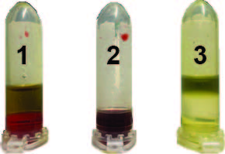
Supplementary Fig. S16 | The deprotonation of H₂EtAQ at pH = 14.
Keeping the pH of the buffer solution of DPPEAQ near neutral is crucial to achieving highly stable, long-term production of H₂O₂, because H₂EtAQ starts to deprotonate when the pH of the aqueous phase ramps up to ~12. The formed EtAQ²⁻ anions can dissolve in the aqueous phase, which might precipitate in the cathode chamber and block the flow channel.
After the addition of 0.5 mL 1 mol L⁻¹ KOH to 0.5 mL hydrogenated EtAQ solution in a nitrogen glovebox, a portion of the H₂EtAQ in the nonaqueous phase partly deprotonated, forming EtAQ²⁻ anions (tube 1). The phase at the bottom was colorless pure water before EtAQ anions dissolved, but turned red afterwards, since EtAQ²⁻ was soluble in aqueous phase and the EtAQ²⁻ extracted to the aqueous phase revealed a red color. Afterwards, the aqueous phase (at the bottom) in tube 1 were transferred to tube 2.0.5 mL 3Tol/2Dec and a sufficient amount of phosphate buffer solution were added to tube 2. The EtAQ²⁻ got fully protonated and was extracted back to the nonaqueous phase (tube 3), leaving a colorless aqueous phase. Therefore, we used protons as charge carriers in our electrochemical cells and the phosphate buffer for the DPPEAQ to keep a relative stable near neutral pH for the DPPEAQ electrolyte.

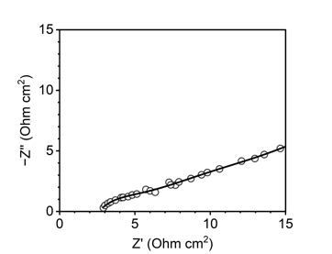
Supplementary Fig. S17 | The area-normalized Nyquist plot of the cell recorded after the continuous production of H₂O₂ using e-AO method. The cell exhibited a low area-specific ohmic resistance of ~2.8 Ω cm².

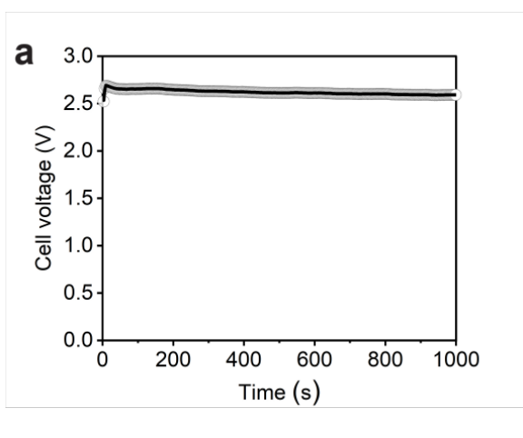
Supplementary Fig. S18 | The full cell voltage (V₁) monitored throughout the continuous production of H₂O₂ using e-AO method.

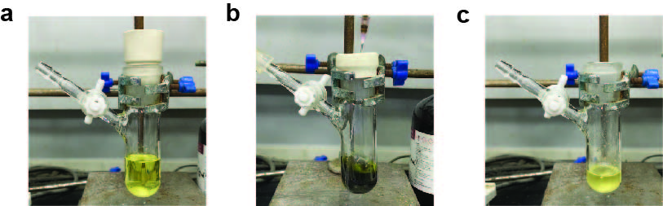
Supplementary Fig. S19 | The color change of EtAQ during ANIHAT and AO processes. The pictures of EtAQ solution a, before hydrogenation, b, after hydrogenation, and c, after auto-oxidation.
The EtAQ solution shows apparent color changes during the hydrogenation and auto-oxidation process. Originally, the color of EtAQ solution was light yellow (Supplementary Fig. S19a), whereas it turns brown or dark green (depending on the SOC and the solvent composition, Supplementary Fig. S19b), after hydrogenation. After thorough auto-oxidation of H₂EtAQ under vigorous stirring in air, the EtAQ solution becomes yellow, but not a clear solution anymore (Supplementary Fig. S19c), indicating the presence of the H₂O₂ product. The solution became clear again after extraction with water.

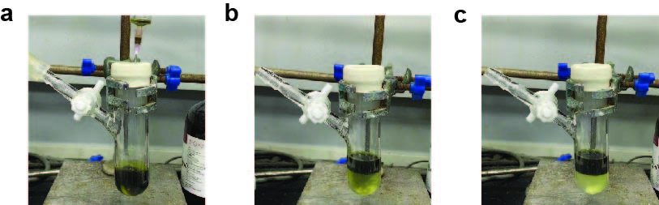
Supplementary Fig. S20 | The low reactivity of H₂EtAQ with the H₂O₂ product. a, The picture of H₂EtAQ solution before the addition of 30 wt.% H₂O₂. b, The picture of H₂EtAQ solution after the addition of 30 wt.% H₂O₂. The mixture was stirred at 800 rpm for 5 min. c, The picture of sufficiently agitated mixture of H₂EtAQ and H₂O₂ after letting stand for 1 min.
H₂EtAQ exhibits low reactivity with the H₂O₂ product, so that the H₂O₂ will not oxidize H₂EtAQ during the auto-oxidation process, avoiding the 4 e⁻ reduction process of O₂. The 4 e⁻ reduction of O₂ to H₂O would penalize the overall Faradaic efficiency of hydrogen peroxide production. To verify the sluggish kinetics of the reaction between H₂O₂ and H₂EtAQ, we added 5 mL 30 wt.% H₂O₂ to 5 mL 0.5 mol L⁻¹ H₂EtAQ in a sealed container, under the protection of argon gas (Supplementary Fig. S20a). We then stirred them on at 800 rpm for 5 min (Supplementary Fig. S20b). Rested for 1 min, the H₂EtAQ remained largely unreacted (Supplementary Fig. S20c). Technically, most of the H₂EtAQ remained unreacted even under the presence of 30% hydrogen peroxide for 1 day. However, adding H₂O₂ into H₂DPPEAQ will cause immediate oxidation of H₂DPPEAQ into DPPEAQ.
Oxygen has a moderate solubility in the nonaqueous solvent. If not controlling the amount of air bubbled into the nonaqueous phase or not fully purging out the remained oxygen or not fully extracting the generated hydrogen peroxide out of the nonaqueous phase, oxygen or hydrogen peroxide in the nonaqueous phase (after separator 2) will touch the aqueous solvent with H₂DPPEAQ inside (in mixer 1), oxidizing the H₂DPPEAQ without producing collectable hydrogen peroxide, causing severe Faradaic efficiency loss.
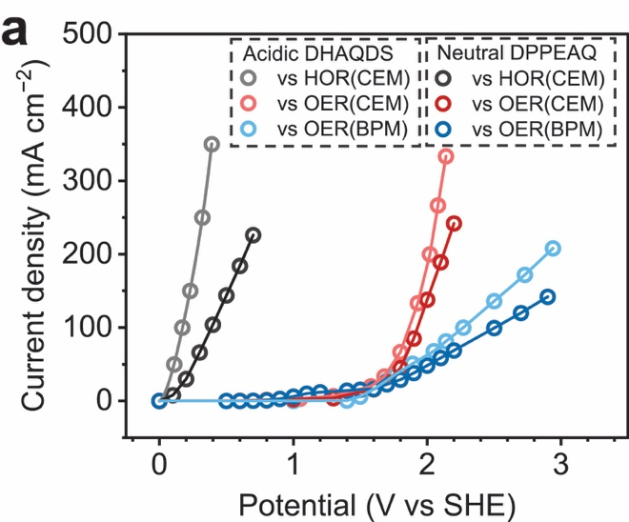
Supplementary Fig. S21 | The polarization behavior of “anode + membrane”.
The engineering of the anode reaction and membrane is crucial for the realization of high energy efficiency in H₂O₂ production. To evaluate the energy efficiency of the anode and membrane part, we measured the polarization behavior of anode + membrane.
During tests, the cell was monitored with two voltameters, one recording the full cell voltage (full cell voltage V₁, positive), another connecting the working electrode and a reference electrode inserted in aqueous AQ (cathode voltage V₂, labeled as a more negative current and more negative voltage when V₁ and cell current is higher). V₂ were referenced to Ag/AgCl reference electrode, and transferred to standard hydrogen electrode (SHE) by calculating.
The polarization of the counter electrode adding membrane was evaluated against 0.1 M buffered DPPEAQ (pH = 7) or 0.25 M DHAQDS (pH = 0), by recording the current through the cell and calculating V₁+V₂ (Supplementary Fig. S21). The polarization of the counter electrode adding membrane is generally worse when working against a pH-neutral cathode, compared with working against an acidic cathode, because pH gradient and ion polarization resistance existing in the former condition, increasing the voltage drop across the membrane.

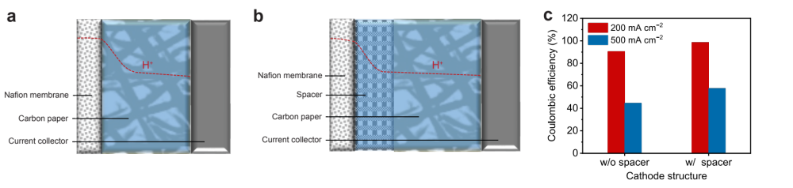
Supplementary Fig. S22 | The parasitic hydrogen evolution reaction (HER) side reaction. The pH profile of the cathode chamber a, without spacer (w/o spacer) and b, with spacer (w/ spacer). c, the Coulombic efficiencies of EChem process before and after the introduction of spacers.
Hydrogen evolution reaction (0 V vs. RHE) is the major side reaction of the EChem process, penalizing the Coulombic efficiency. The migration of H⁺ from the Nafion membrane into the aqueous electrolyte results in locally low pH near the membrane, which might lead to the precipitation of DPPEAQ. In Supplementary Fig. S22a, the red line indicates the roughly estimated log(c(H⁺)) profile in the cathode chamber. Therefore, the DPPEAQ electrochemical hydrogenation (− 0.4 V vs. SHE, at pH 7) pathway is blocked and HER becomes dominant, especially at higher current densities. Adding a non-conductive spacer (porous plastic paper) between the Nafion membrane and the carbon paper will create enough space for protons migrated from the Nafion to be neutralized by the phosphate buffer in the electrolyte, avoiding the locally low pH reaching the conductive carbon paper (Supplementary Fig. S22b). Supplementary Fig. S22c reveals that with the addition of a ~ 0.2 mm spacer layer, the Coulombic efficiency of DPPEAQ (0.1 mol L⁻¹, buffered by 0.33 mol L⁻¹ phosphate (pH = 7), capacity limiting side, HOR as the counter reaction) electrochemical hydrogenation increased substantially. To facilitate the mass transport of H⁺ between the Nafion membrane and the carbon paper and increase the mass transport of DPPEAQ, the flow rate of the DPPEAQ solution should be increased. With a lower flow rate, mass transport limitation of DPPEAQ will result in larger partial current into the HER.

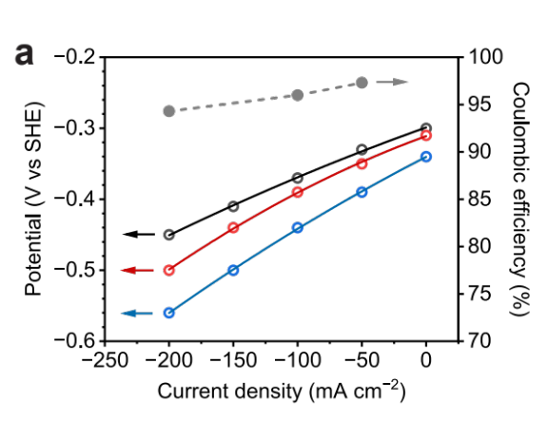
Supplementary Fig. S23 | The polarization performance (half-cell) and the Coulombic efficiency of D2PEAQ (pH = 7) under different current densities.

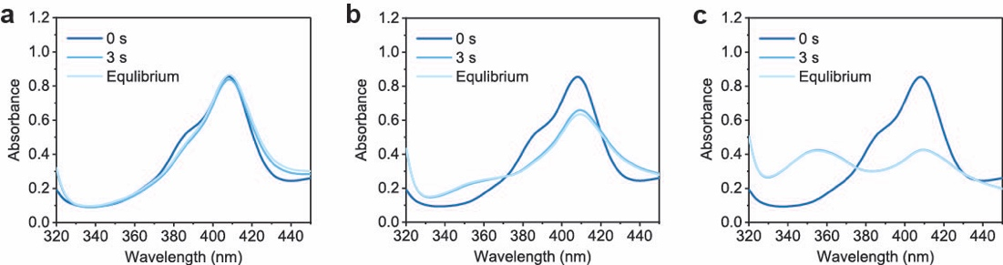
Supplementary Fig. S24 | The reaction rate test of the ANIHAT between H₂D2PEAQ and EtAQ under vigorous stirring. The temporal variations of the UV-Vis spectrum of D2PEAQ during the reaction rate test. The reaction rate test was conducted under vigorous stirring using the nonaqueous solvents of a, 5Tol/0Dec, b, 4Tol/1Dec, and c, 3Tol/2Dec.
Under the same polarity of the nonaqueous solvent, H₂D2PEAQ transfers more charges – protons than H2PPEAQ to the EtAQ due to the lower redox potential of D2PEAQ/H₂D2PEAQ than DPPEAQ/H₂DPPEAQ^{21, 35}. The reaction rate under vigorous stirring is fast. The reaction almost react equilibrium in 3 s.

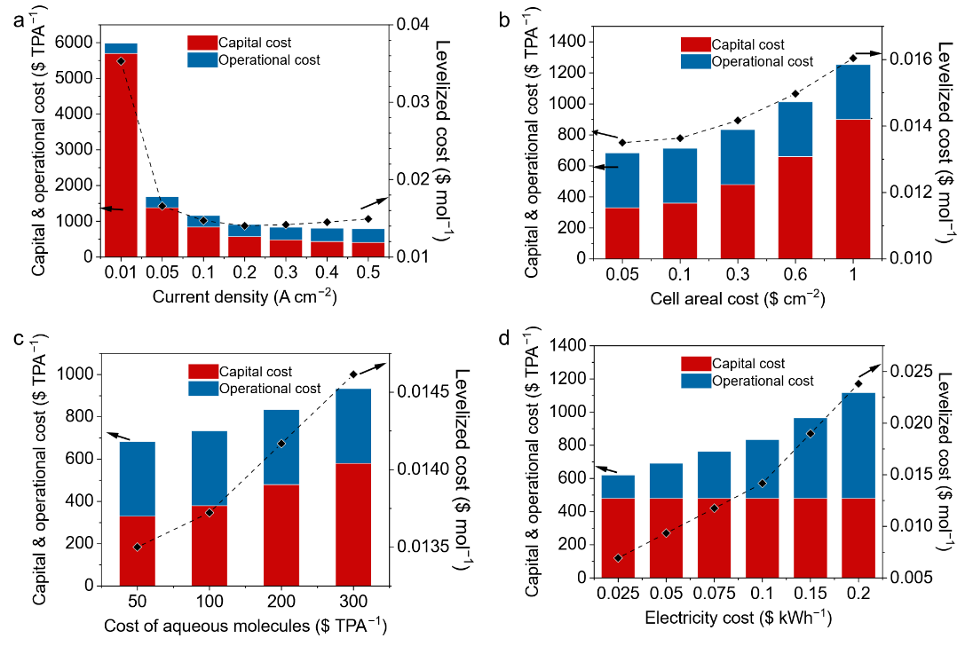
Supplementary Fig. S25 | Techno-economic analysis (TEA). The operational cost, capital cost, and levelized cost of e-AO method at different a, current densities, b, cell areal costs, c, aqueous AQ costs, and d, electricity costs. The default value of current density, cell areal cost, aqueous AQ cost, and electricity cost were set to be 0.3 A cm⁻², 0.3 $ cm⁻², 200 $ TPA⁻², 0.1 kWh cm⁻², respectively. In each plot, only one parameter was set as the variable; other parameters were set as constants.
In this section, we further study the capital cost, operational cost and levelized cost of a hypothetical hydrogen peroxide production system using e-AO. These costs depend on the cost of several components of the e-AO system.
As shown in Supplementary Fig. S25a, with higher current density, the capital cost decreases due to smaller electrochemical cells required. But operational cost increases due to higher voltage used to drive the reaction. As a result, the levelized cost decreases then increase with a higher current density. A low current density smaller than 0.05 A cm⁻² is not acceptable because the high capital cost.
As shown in Supplementary Fig. S25b, higher areal cost of electrochemical cells will increase the capital cost. Supplementary Fig. S25c shows that higher cost of anthraquinones will also increase the capital cost. These two factors have minor influence on the levelized cost of produced hydrogen peroxide.
Supplementary Fig. S25d shows that higher cost of electricity will increase the operational cost and significantly increase the levelized cost of produced hydrogen peroxide. Cheap, green electricity is crucial to make e-AO commercially attractive.
The detailed techno -economic analysis is shown as follows⁵⁴.
Input values for economic analyses of a e-AO system are as follows for a 10 year project:
M is the molecular weight of hydrogen peroxide in g mol⁻¹, equaling 34.
F is the Faradaic constant in C mol⁻¹, equaling 96485.
n is the number of electrons transferred during oxygen reduction, equaling 2.
t is the time of a year in s, equaling 365*24*3600.
m is the mass of produced hydrogen peroxide per year (counted as pure) in grams, equaling 1000000 when producing 1 tonne per year.
I is the current density of the cell in A cm⁻², with a default value assumed as 0.3.
V is the voltage of the cell in V, which is calculated using: $V=1.5+0.1I$, assuming a linear relationship between the current density and the voltage.
Cost_{cell areal} is the areal cost of the cell in $ cm⁻², with a default value assumed as 0.3.
Area is the area of the cell for the production of 1 tonne (1000000 g) hydrogen peroxide per annual (TPA) in cm², where $Area=\frac{m*n*F}{M*I*t}$.
Cost_{cell} is the capital cost of the electrochemical cell in $ TPA⁻¹, where ${Cost}_{cell}={Cost}_{cell areal}*Area$.
Cost_{aq} is the capital cost of aqueous molecules in $ TPA⁻¹, with a default value assumed as 200.
Cost_{naq} is the capital cost of nonaqueous molecules in $ TPA⁻¹, assumed as 50.
Cost_{nsol} is the capital cost of nonaqueous solvent in $ TPA⁻¹, assumed as 50.
Cost_{other} is the capital cost of other equipment in $ TPA⁻¹, assumed as 300.
Cost_{capital} is the capital cost of the whole system in $ TPA⁻¹, where ${Cost}_{capital}={Cost}_{cell}+{Cost}_{aqaq}+{Cost}_{naq}+{Cost}_{nsol}+{Cost}_{other}$.
Cost_{electricity} is the cost of electricity in $ kWh⁻¹, with a default value assumed as 0.1.
Cost_{e} is the cost of electricity during the system operation in $ TPA⁻¹, where ${Cost}_{e}=\frac{m*n*F*V*{Cost}_{electricity}}{M*1000*3600}$.
Cost_{nsolopex} is the operational cost of nonaqueous solvent in $ TPA⁻¹, assumed as 20.
Cost_{otheropex} is the operational cost of other maintenance in $ TPA⁻¹, assumed as 50.
Cost_{opex} is the operational cost of the whole system during operation in $ TPA⁻¹, where ${Cost}_{opex}={Cost}_{e}+{Cost}_{nsolopex}+{Cost}_{otheropex}$.
Capital cost is assumed to happen in and only in the first year, without production of any product. Operational cost happens in every following years, producing 1 tonne hydrogen peroxide annually.
r is the discount rate, whose value is set as 0.05, for a ten year project.
Cost_{H2O2} is the levelized cost of produced hydrogen peroxide (counted as molecule), in $ mol⁻¹.
NPV is the cumulative net product value of the produced hydrogen peroxide.
$$NPV=-{Cost}_{capital}+\sum_{year=2}^{year=10}{({\frac{{Cost}_{H2O2}*m}{M}-Cost}_{opex}){(1-r)}^{year}}$$
Cost_{H2O2} is resolved by setting $NPV=0$.
The capital cost of e-AO method is strongly correlated to the current density of H₂O₂ production and the areal cost of the cell, whereas the operational cost is mainly subject to the cost of electricity.

Supplementary Table S1 | The solubility of DPPEAQ and EtAQ in phosphate buffer solution (pH = 7) and 3Tol/2Dec.
Solute | Solubility in phosphate buffer | Solubility in 3Tol /2Dec
DPPEAQ | > 0.1 mol L⁻¹ | < 2 μmol L⁻¹
EtAQ | < 0.01 μmol L⁻¹ | 0.5 mol L⁻¹

DPPEAQ has high solubility in phosphate buffer but extremely low solubility in 3Tol/2Dec (Table S1). On the other hand, EtAQ has nearly no solubility in phosphate buffer, but shows good solubility in 3Tol/2Dec. The huge solubility difference of AQs in the aqueous and the nonaqueous phases restricted the crossover of AQs across phases, avoiding the loss of AQs and the contamination of the H₂O₂ product.

Supplementary Table S2 | Performance comparison of currently reported H₂O₂ synthesis methods.
Method | Purity | Yield rate  (mmol cm⁻² h⁻¹) | Yield rate  (mol kg_{cat}⁻² h⁻¹) | Faradaic efficiency or selectivity  (%) | Stability  (h) | H₂O₂ conc.  (mmol L⁻¹) | Comments and reference
Direct (CB, B doped carbon, using two-membrane cell) | Pure | > 6 | 3660 | 98 | > 100 | > 100 | Wang et al, showed high yield rate, high purity, high efficiency, and high energy efficiency of electrochemical direct H₂O₂ synthesis with tunable concentration using a two-membrane three-chamber cell. However, Faradaic efficiency of this method declines when the product going to higher concentration.^{12, 14}
Direct (CB, B doped carbon, using two-membrane cell) | Pure | > 2 | 2560 | > 90 | > 100 | 1941
Direct (Au-Pd/TiO₂) | Impure | / | 180 | 80 ~ 96 | > 4 | / | Hutchings et al, showed direct synthesis of H₂O₂ using oxygen and hydrogen gas with high selectivity, but uses alcohols as solvents.⁴
Direct (Pd-Sn/SiO₂) | Pure | / | 50 | 95 | / | / | Hutchings et al, showed direct synthesis of H₂O₂ using oxygen and hydrogen gas with high selectivity in aqueous phase.⁷
Direct (decorated carbon, with fuel cell) | Impure/pure | 1.73 | / | 93 | 2 | 2058 | Yamanaka et al, used a fuel cell system to electrochemically generate H₂O₂ through a gas diffusion electrode. The product can be pure, but will result in a lower Faradaic efficiency and current density. ^{9, 10}
Direct (Pd membrane) | Pure | 0.018 | / | 9.6 | / | 3.6 | Berlinguette et al, directly reduced gas phase oxygen into H₂O₂ with Pd membrane, but the method features low Faradaic efficiency and limited concentration of produced H₂O₂.¹¹
Indirect (two phase flow) | Impure | 1 | / | ~ 80 | / | 220 | Tissot et al, reported the very beginning exploration of e-AO by mixing nonaqueous solutions with aqueous electrolytes mechanically, but the H₂O₂ product has electrolyte impurities.¹⁸
Indirect (AQDS) | Pure | ~ 0.015 | / | ~ 85 | > 7 | 33 | Surendranath et al, used one molecule shuttling between the aqueous and nonaqueous phase as a phase transfer catalyst. Achieve high Faradaic efficiency with no electrolyte contaminants. Limiting solubility of the same molecule in both aqueous phase and nonaqueous phase leads to a low limiting current density due to mass transport limitation.¹⁷
Indirect (AQ-PANI) | Impure | 0.43 | 450 | 95.83 | / | / | Kim et al, bonded AQ to the electrode as catalysts to mediate the 2e ORR in the aqueous electrolyte, but has limited concentration of produced H₂O₂ and impure product. ⁶
Indirect (Pd membrane) | Pure | 1.0 | / | 80 | / | 147 | Berlinguette et al, hydrogenated nonaqueous AQ by electricity, but Pd membrane has high capital cost and HER side reaction, as well as over-reduction.¹⁹
Indirect (DPPEAQ, EtAQ…) | Pure | ~2 | / | 77 | > 75 | 3200 | This work uses two different molecules as a pair to electrify the nonaqueous chemistry though interfacial reactions.
Indirect (DPPEAQ, EtAQ…) | pure | ~4 | / | 87 | > 75 | 900

Supplementary Data S1 | XYZ coordinates of the optimized DFT structures and corresponding energies.

Structure 1
E(toluene)[M06-2X/Def2-TZVP, SMD(toluene)] = -997.640337 a.u.
E(1-Decanol)[M06-2X/Def2-TZVP, SMD(1-Decanol)] = -997.641846 a.u.
Gcorr[M06-2X/Def2-SVP] = 0.277723 a.u.
G = E(toluene) + Gcorr= -997.362614 a.u.
G = E(1-Decanol) + Gcorr= -997.364123 a.u.

C 3.45945400 1.38404500 -0.01052700
C 2.16613200 1.82596000 -0.00892300
C 1.06356200 0.91935500 -0.00503800
C 1.33703600 -0.49129300 -0.00420900
C 2.69820800 -0.92052700 -0.00009900
C 3.73434100 -0.02064300 -0.00490900
C -0.25801400 1.39269200 0.00008300
C 0.25801500 -1.39259800 -0.00263200
C -1.06354400 -0.91928000 0.00264900
C -1.33704600 0.49138700 0.00288500
C -2.69826500 0.92053200 0.00093600
H -2.98035000 1.97516300 -0.00977000
C -3.73435800 0.02061400 0.00520400
C -3.45942400 -1.38407800 0.00834200
C -2.16609400 -1.82593000 0.00566100
H 4.27328400 2.10712000 -0.01385400
H 1.94952800 2.89379200 -0.01046800
H 2.98006500 -1.97517300 0.01397200
H -4.27323100 -2.10718200 0.01093900
H -1.94942500 -2.89375000 0.00572100
O -4.99086700 0.52412500 0.00344200
O 4.99082700 -0.52418100 -0.00087700
C -6.09283400 -0.35728600 -0.00023800
H -6.06059100 -1.00779800 0.89154700
H -6.05377600 -1.00867900 -0.89110900
C 6.09281700 0.35719800 0.00366200
H 6.06219900 1.00659500 -0.88899200
H 6.05218400 1.00970500 0.89364700
O -0.43164900 2.73882300 0.00033200
H -1.36832800 2.94785300 0.06325400
O 0.43184700 -2.73874400 -0.00384000
H 1.36783600 -2.94755000 -0.07716100
C -7.35143600 0.48136400 -0.00531100
H -8.24078600 -0.16257300 -0.00816300
H -7.38314900 1.12376500 0.88466200
H -7.37665300 1.12277400 -0.89620000
C 7.35137700 -0.48149000 0.01200800
H 8.24074500 0.16241800 0.01561500
H 7.37499700 -1.12178200 0.90374300
H 7.38463400 -1.12501000 -0.87710100

Structure 2
E(toluene)[M06-2X/Def2-TZVP, SMD(toluene)] = -767.392096 a.u.
E(1-Decanol)[M06-2X/Def2-TZVP, SMD(1-Decanol)] = -767.387396 a.u.
Gcorr[M06-2X/Def2-SVP] = 0.197402 a.u.
G = E(toluene) + Gcorr= -767.194694 a.u.
G = E(1-Decanol) + Gcorr= -767.189994 a.u.

C -3.03957300 -0.01203000 -0.31974400
C -1.94559500 -0.87839800 -0.27624400
C -0.64425900 -0.38569300 -0.16945400
C -0.42151500 0.99754500 -0.10202900
C -1.51051800 1.87162100 -0.14333500
C -2.80172300 1.36955900 -0.25028600
C 0.49110300 -1.35915700 -0.13260700
C 0.95576700 1.56283100 0.01066100
C 2.09205600 0.58944900 0.05098200
C 1.87192500 -0.79467600 -0.01728900
C 2.95584400 -1.67500300 0.02221800
H 2.75320500 -2.74523400 -0.03305200
C 4.25090200 -1.17786000 0.12938900
C 4.47014700 0.20122400 0.19776700
C 3.39436200 1.08272000 0.15862400
H -2.08127000 -1.96090500 -0.32883400
H -1.31457900 2.94340200 -0.09263600
H -3.64937700 2.05835200 -0.28555200
H 5.09698700 -1.86584500 0.16005900
H 5.48707300 0.58711100 0.28180200
H 3.53350500 2.16324300 0.20970000
C -4.44827700 -0.54628700 -0.37773900
H -5.07219400 0.13679900 -0.97377900
H -4.44813100 -1.51571400 -0.89727100
C -5.05257900 -0.70929800 1.01985200
H -5.07756500 0.25420200 1.54912300
H -6.07907100 -1.09695900 0.96330400
H -4.45349500 -1.40615700 1.62313000
O 0.30179800 -2.55270400 -0.19208100
O 1.14776600 2.75625600 0.06950800

Structure INT1
E(toluene)[M06-2X/Def2-TZVP, SMD(toluene)] = -1765.055046 a.u.
E(1-Decanol)[M06-2X/Def2-TZVP, SMD(1-Decanol)] = -1765.053785 a.u.
Gcorr[M06-2X/Def2-SVP] = 0.50357 a.u.
G = E(toluene) + Gcorr= -1764.551476 a.u.
G = E(1-Decanol) + Gcorr= -1764.550215 a.u.

C 3.74291900 -1.26361800 -1.36254200
C 2.47705800 -1.23585900 -1.88475400
C 1.32878600 -1.34762900 -1.04848100
C 1.52875300 -1.49871200 0.36411200
C 2.85229200 -1.50833000 0.88391400
C 3.93594800 -1.38143400 0.04807200
C 0.03076500 -1.22977500 -1.57529300
C 0.40638200 -1.55720200 1.21393500
C -0.89250500 -1.57843900 0.67284100
C -1.08921800 -1.38815900 -0.73860400
C -2.41609000 -1.33285400 -1.25470400
H -2.58034200 -1.17893000 -2.32084700
C -3.50155600 -1.46222200 -0.42474300
C -3.30897900 -1.70965200 0.97337400
C -2.04620200 -1.76199700 1.49433100
H 4.59841200 -1.17733300 -2.03154700
H 2.31813500 -1.12962100 -2.95784500
H 3.00829700 -1.59945200 1.95801100
H -4.16390200 -1.85587100 1.63171300
H -1.90845900 -1.95346400 2.55924900
O -4.72982400 -1.34747200 -0.98368100
O 5.16538600 -1.33824200 0.62191300
C -5.87570200 -1.53455200 -0.18412600
H -5.88291700 -0.80142400 0.64277500
H -5.86558700 -2.54416900 0.26369100
C 6.31241800 -1.42948300 -0.19431000
H 6.24449000 -2.32144100 -0.84185700
H 6.38513100 -0.54527700 -0.85351500
C 7.51877700 -1.51311300 0.71433500
H 7.44575000 -2.39743200 1.36092400
H 7.57515400 -0.62197300 1.35371200
O -0.12206600 -0.96262900 -2.90093900
H -0.54707200 -0.08942800 -2.98896800
O 0.61034800 -1.57970500 2.55535300
H 0.02818700 -0.92203100 2.97585400
C 2.72355200 1.88821500 -0.30084600
C 1.50524800 1.89867100 -0.97918800
C 0.29975800 1.73530300 -0.29108000
C 0.31266300 1.54923600 1.10211500
C 1.52852000 1.54643500 1.79041600
C 2.71667700 1.71536400 1.09394300
C -0.97861600 1.70485800 -1.04888800
C -0.94421400 1.28622100 1.84843500
C -2.22652200 1.54922500 1.13542200
C -2.24355800 1.73685700 -0.25501100
C -3.45974400 1.89900100 -0.92106600
H -3.44673300 2.01265500 -2.00555400
C -4.65028200 1.89787500 -0.20090100
C -4.63212500 1.72321300 1.18646400
C -3.42412100 1.53614900 1.85232600
H 1.47057000 2.00809700 -2.06571600
H 1.52113800 1.38033100 2.86833000
H 3.66865500 1.68757900 1.63014700
H -5.60007400 2.02913700 -0.72173900
H -5.56795200 1.72672000 1.74815400
H -3.38192400 1.36710800 2.92914400
C 4.02965400 2.08659600 -1.02610700
H 4.78089100 1.41333000 -0.58169200
H 3.91055100 1.78109000 -2.07613100
C 4.51826100 3.53522900 -0.95070200
H 4.65672200 3.84786200 0.09447800
H 5.47662100 3.65717600 -1.47437700
H 3.78668900 4.21629800 -1.40840200
O -1.00787500 1.66286700 -2.26757200
O -0.93401300 0.85294700 2.98832900
H 8.44113200 -1.58164500 0.12249700
C -7.08787900 -1.35355800 -1.07043900
H -7.06968100 -2.08195100 -1.89182500
H -8.01124400 -1.49400500 -0.49302800
H -7.09297600 -0.34522300 -1.50637200

Structure TS1
E(toluene)[M06-2X/Def2-TZVP, SMD(toluene)] = -1765.055046 a.u.
E(1-Decanol)[M06-2X/Def2-TZVP, SMD(1-Decanol)] = -1765.053785 a.u.
Gcorr[M06-2X/Def2-SVP] = 0.50357 a.u.
G = E(toluene) + Gcorr= -1764.551476 a.u.
G = E(1-Decanol) + Gcorr= -1764.550215 a.u.

C 3.74291900 -1.26361800 -1.36254200
C 2.47705800 -1.23585900 -1.88475400
C 1.32878600 -1.34762900 -1.04848100
C 1.52875300 -1.49871200 0.36411200
C 2.85229200 -1.50833000 0.88391400
C 3.93594800 -1.38143400 0.04807200
C 0.03076500 -1.22977500 -1.57529300
C 0.40638200 -1.55720200 1.21393500
C -0.89250500 -1.57843900 0.67284100
C -1.08921800 -1.38815900 -0.73860400
C -2.41609000 -1.33285400 -1.25470400
H -2.58034200 -1.17893000 -2.32084700
C -3.50155600 -1.46222200 -0.42474300
C -3.30897900 -1.70965200 0.97337400
C -2.04620200 -1.76199700 1.49433100
H 4.59841200 -1.17733300 -2.03154700
H 2.31813500 -1.12962100 -2.95784500
H 3.00829700 -1.59945200 1.95801100
H -4.16390200 -1.85587100 1.63171300
H -1.90845900 -1.95346400 2.55924900
O -4.72982400 -1.34747200 -0.98368100
O 5.16538600 -1.33824200 0.62191300
C -5.87570200 -1.53455200 -0.18412600
H -5.88291700 -0.80142400 0.64277500
H -5.86558700 -2.54416900 0.26369100
C 6.31241800 -1.42948300 -0.19431000
H 6.24449000 -2.32144100 -0.84185700
H 6.38513100 -0.54527700 -0.85351500
C 7.51877700 -1.51311300 0.71433500
H 7.44575000 -2.39743200 1.36092400
H 7.57515400 -0.62197300 1.35371200
O -0.12206600 -0.96262900 -2.90093900
H -0.54707200 -0.08942800 -2.98896800
O 0.61034800 -1.57970500 2.55535300
H 0.02818700 -0.92203100 2.97585400
C 2.72355200 1.88821500 -0.30084600
C 1.50524800 1.89867100 -0.97918800
C 0.29975800 1.73530300 -0.29108000
C 0.31266300 1.54923600 1.10211500
C 1.52852000 1.54643500 1.79041600
C 2.71667700 1.71536400 1.09394300
C -0.97861600 1.70485800 -1.04888800
C -0.94421400 1.28622100 1.84843500
C -2.22652200 1.54922500 1.13542200
C -2.24355800 1.73685700 -0.25501100
C -3.45974400 1.89900100 -0.92106600
H -3.44673300 2.01265500 -2.00555400
C -4.65028200 1.89787500 -0.20090100
C -4.63212500 1.72321300 1.18646400
C -3.42412100 1.53614900 1.85232600
H 1.47057000 2.00809700 -2.06571600
H 1.52113800 1.38033100 2.86833000
H 3.66865500 1.68757900 1.63014700
H -5.60007400 2.02913700 -0.72173900
H -5.56795200 1.72672000 1.74815400
H -3.38192400 1.36710800 2.92914400
C 4.02965400 2.08659600 -1.02610700
H 4.78089100 1.41333000 -0.58169200
H 3.91055100 1.78109000 -2.07613100
C 4.51826100 3.53522900 -0.95070200
H 4.65672200 3.84786200 0.09447800
H 5.47662100 3.65717600 -1.47437700
H 3.78668900 4.21629800 -1.40840200
O -1.00787500 1.66286700 -2.26757200
O -0.93401300 0.85294700 2.98832900
H 8.44113200 -1.58164500 0.12249700
C -7.08787900 -1.35355800 -1.07043900
H -7.06968100 -2.08195100 -1.89182500
H -8.01124400 -1.49400500 -0.49302800
H -7.09297600 -0.34522300 -1.50637200

Structure TS1
E(toluene)[M06-2X/Def2-TZVP, SMD(toluene)] = -1765.02935 a.u.
E(1-Decanol)[M06-2X/Def2-TZVP, SMD(1-Decanol)] = -1765.026917 a.u.
Gcorr[M06-2X/Def2-SVP] = 0.500408 a.u.
G = E(toluene) + Gcorr= -1764.528942 a.u.
G = E(1-Decanol) + Gcorr= -1764.526509 a.u.

C 3.71209000 -1.39698000 -1.19080700
C 2.42824200 -1.38634900 -1.70558000
C 1.30596300 -1.33288100 -0.86339900
C 1.50676000 -1.26014000 0.54415000
C 2.81444500 -1.23010800 1.06028800
C 3.90805800 -1.30729300 0.20614700
C -0.01924200 -1.23380000 -1.42970500
C 0.37012600 -1.14595300 1.40805000
C -0.93471300 -1.32306600 0.88616800
C -1.14323900 -1.35911600 -0.52853600
C -2.44875900 -1.47876900 -1.04136100
H -2.60437900 -1.49298600 -2.12005000
C -3.53546600 -1.54879600 -0.18894300
C -3.33330300 -1.54554800 1.22252000
C -2.06660900 -1.43409600 1.73834900
H 4.56239800 -1.45874500 -1.86872800
H 2.25535300 -1.42331000 -2.78207500
H 2.97721100 -1.15223900 2.13449500
H -4.17911900 -1.63103100 1.90251600
H -1.91849300 -1.43192500 2.81886100
O -4.75663200 -1.62760500 -0.75409400
O 5.13093900 -1.26935100 0.77968800
C -5.90251500 -1.68012500 0.06983400
H -5.92195800 -0.80091000 0.73775800
H -5.87003900 -2.58442800 0.70297400
C 6.26998100 -1.56923500 -0.00355000
H 6.13650000 -2.55286600 -0.48695000
H 6.38902800 -0.81564100 -0.80184100
C 7.47186700 -1.56764600 0.91352300
H 7.34303600 -2.31134800 1.71079900
H 7.59522500 -0.57993300 1.37770900
O -0.18794000 -1.00435500 -2.67369700
H -0.65490700 0.21375000 -2.75463500
O 0.58127100 -0.90731600 2.70319700
H -0.01104400 -0.17471000 3.00832500
C 2.67789500 1.97648600 -0.71342100
C 1.45502200 1.80586700 -1.34294400
C 0.25543000 1.70028800 -0.60600100
C 0.31183600 1.76204300 0.81157700
C 1.54987300 1.93942600 1.44566900
C 2.71046400 2.04008500 0.70045600
C -1.00439100 1.48813900 -1.27116600
C -0.90583500 1.61349400 1.62064100
C -2.19161800 1.72395200 0.90553100
C -2.23165400 1.63468400 -0.50449900
C -3.47730800 1.61364400 -1.15510700
H -3.49249800 1.51211300 -2.24036800
C -4.64987800 1.72450100 -0.42103200
C -4.60465500 1.83802700 0.97603400
C -3.38141800 1.81974500 1.63468200
H 1.39818300 1.74114700 -2.43222400
H 1.57220900 1.98063400 2.53554200
H 3.66233300 2.17093200 1.21572800
H -5.61228100 1.72018200 -0.93595100
H -5.53081400 1.93075100 1.54608300
H -3.31369900 1.86976000 2.72238300
C 3.93713700 2.09722500 -1.54604500
H 3.89956700 1.31971500 -2.32493000
H 3.90830100 3.06018400 -2.08289100
C 5.24415300 1.98781200 -0.77013800
H 5.27038100 1.07229200 -0.15918400
H 6.10082900 1.97129800 -1.45821200
H 5.38464200 2.84154300 -0.09153700
O -1.07611700 1.22597400 -2.53832900
O -0.86294100 1.37316700 2.83267500
H 8.38257200 -1.80738200 0.34908200
C -7.11535900 -1.69894500 -0.83290200
H -7.07897100 -2.57001800 -1.50032700
H -8.03613300 -1.74831400 -0.23684000
H -7.14237100 -0.79206300 -1.45193900

Structure INT2
E(toluene)[M06-2X/Def2-TZVP, SMD(toluene)] = -1765.03255 a.u.
E(1-Decanol)[M06-2X/Def2-TZVP, SMD(1-Decanol)] = -1765.030144 a.u.
Gcorr[M06-2X/Def2-SVP] = 0.501712 a.u.
G = E(toluene) + Gcorr= -1764.530838 a.u.
G = E(1-Decanol) + Gcorr= -1764.528432 a.u.

C 3.87315000 -0.92980600 -1.46180800
C 2.60604300 -0.67299200 -1.95497600
C 1.45504800 -0.99227900 -1.20642200
C 1.62510200 -1.55264100 0.08772300
C 2.90261200 -1.78651000 0.59019700
C 4.03055600 -1.49009300 -0.17556500
C 0.14699800 -0.67972400 -1.69043600
C 0.45723800 -1.76754100 0.95935200
C -0.85873800 -1.68683600 0.32406100
C -1.01009500 -1.13521300 -0.98064900
C -2.29941700 -1.01283400 -1.53398800
H -2.44537100 -0.58616100 -2.52620600
C -3.41640900 -1.41277000 -0.81238400
C -3.26406700 -1.97898300 0.47649700
C -2.00038000 -2.10411700 1.02370400
H 4.74075500 -0.68332200 -2.07214200
H 2.47672500 -0.21985100 -2.93818300
H 3.01948100 -2.18680000 1.59741500
H -4.13094700 -2.30904700 1.04587500
H -1.86531700 -2.52025000 2.02337600
O -4.61196500 -1.23158400 -1.40574500
O 5.22779400 -1.75103700 0.38525300
C -5.78981900 -1.57388200 -0.70570900
H -5.81672000 -1.03721000 0.25899100
H -5.79710500 -2.65707800 -0.49038800
C 6.40592300 -1.46218800 -0.33756900
H 6.40775600 -2.02097800 -1.28994800
H 6.44024900 -0.38523500 -0.58275600
C 7.58483200 -1.85756200 0.52253000
H 7.54022600 -2.92900400 0.75790200
H 7.57345500 -1.29532700 1.46556000
O 0.04184200 0.02430700 -2.81572000
H -0.59383500 0.77639900 -2.68751500
O 0.59262300 -1.95635000 2.17813500
C 2.53435300 2.14030600 -0.16707800
C 1.26396600 2.25364200 -0.70894200
C 0.12610600 1.83610200 0.00280200
C 0.27062100 1.28969200 1.30828300
C 1.57359200 1.18209600 1.85831000
C 2.66875800 1.59909200 1.13672800
C -1.19482000 1.91244800 -0.62899300
C -0.87883700 0.84178900 2.02393300
C -2.19309400 1.15626600 1.54362500
C -2.35718200 1.69290800 0.24168500
C -3.64723700 1.91577100 -0.26251600
H -3.73764400 2.29575500 -1.28089700
C -4.75996000 1.64705900 0.51736800
C -4.60061200 1.12114700 1.81355800
C -3.33887000 0.86251800 2.31633800
H 1.11692000 2.65373300 -1.71486600
H 1.69648800 0.75929700 2.85627800
H 3.66751600 1.50408900 1.57097300
H -5.76090200 1.83696300 0.12584900
H -5.48024000 0.90801300 2.42400100
H -3.20034000 0.43266900 3.30833300
C 3.75442200 2.62343000 -0.90768100
H 4.57601900 1.90638500 -0.74583000
H 3.54550500 2.62761400 -1.98824700
C 4.19146000 4.01936500 -0.45602200
H 4.41501500 4.02997300 0.62077700
H 5.09051100 4.34866400 -0.99571100
H 3.39232500 4.75209000 -0.63687000
O -1.33088400 2.10913500 -1.84756900
O -0.77405900 0.13793500 3.14955000
H 8.52689900 -1.64973900 -0.00159800
C -6.96664100 -1.18624200 -1.57218700
H -6.92212100 -1.71424200 -2.53389200
H -7.91077500 -1.44056100 -1.07265800
H -6.95045400 -0.10610500 -1.77118300
H -0.14449800 -0.61850600 3.01971400

Structure TS2
E(toluene)[M06-2X/Def2-TZVP, SMD(toluene)] = -1765.031284 a.u.
E(1-Decanol)[M06-2X/Def2-TZVP, SMD(1-Decanol)] = -1765.028607 a.u.
Gcorr[M06-2X/Def2-SVP] = 0.500166 a.u.
G = E(toluene) + Gcorr= -1764.531118 a.u.
G = E(1-Decanol) + Gcorr= -1764.528441 a.u.

C 3.78720900 -0.96607800 -1.48995900
C 2.51393700 -0.66974200 -1.95433400
C 1.37585200 -0.96199700 -1.18559100
C 1.55394000 -1.53260500 0.09984700
C 2.82973500 -1.80324900 0.57744000
C 3.95306900 -1.53360200 -0.21210300
C 0.05860400 -0.61178900 -1.65484200
C 0.39039800 -1.73827300 0.98899400
C -0.93345100 -1.64436900 0.36608100
C -1.09391600 -1.09234700 -0.93471000
C -2.38104900 -0.98111600 -1.48958400
H -2.52106000 -0.55078700 -2.48106400
C -3.49399800 -1.38834600 -0.76571800
C -3.33397700 -1.94861200 0.52525600
C -2.06870100 -2.06991900 1.06993200
H 4.64836100 -0.74213600 -2.11764600
H 2.37293600 -0.20926500 -2.93282300
H 2.95664400 -2.21263500 1.57977500
H -4.19772700 -2.28405000 1.09644000
H -1.92909700 -2.48769400 2.06820100
O -4.69275500 -1.22151100 -1.35684300
O 5.14953100 -1.83214000 0.32622300
C -5.86633200 -1.55203200 -0.64441800
H -5.88696400 -0.99955900 0.31167300
H -5.87316000 -2.63144800 -0.41073800
C 6.32421600 -1.57284600 -0.41488500
H 6.29405100 -2.12817800 -1.36866700
H 6.38266100 -0.49638600 -0.65681300
C 7.50530700 -2.00341400 0.42479800
H 7.43539100 -3.07403300 0.65765900
H 7.52505700 -1.44406900 1.36937800
O -0.06433200 0.09848300 -2.74143500
H -0.61642100 0.99384000 -2.53526000
O 0.53943800 -1.94896400 2.19845600
C 2.63834400 2.09272800 -0.14894300
C 1.38635000 2.21351700 -0.71450300
C 0.22184900 1.81943100 -0.01563800
C 0.34047000 1.29685700 1.30806300
C 1.63851600 1.18570100 1.88347400
C 2.74612700 1.57207600 1.17428500
C -1.07334100 1.90787900 -0.65656800
C -0.81772000 0.87748800 2.00861800
C -2.11619100 1.19522900 1.49675400
C -2.24645400 1.71483600 0.18113400
C -3.52794900 1.94003600 -0.35221900
H -3.59542600 2.30826100 -1.37650300
C -4.65685200 1.69250700 0.40816800
C -4.52990200 1.18774800 1.71751900
C -3.28187200 0.92663700 2.25025500
H 1.26354500 2.60418100 -1.72715300
H 1.73623900 0.78787400 2.89439000
H 3.73702300 1.47859200 1.62651100
H -5.64781100 1.88337200 -0.00767000
H -5.42404400 0.99456200 2.31339700
H -3.16738000 0.51591700 3.25341800
C 3.88194700 2.54564300 -0.86881700
H 4.66940300 1.78629500 -0.72732000
H 3.67924800 2.59500500 -1.94935500
C 4.38205100 3.90331300 -0.36897500
H 4.59724100 3.86962300 0.70908800
H 5.30059800 4.20574200 -0.89131100
H 3.62044700 4.67883100 -0.53179200
O -1.18924400 2.10179200 -1.90321800
O -0.73939900 0.21150200 3.16340000
H 8.44387900 -1.81972100 -0.11432700
C -7.04857100 -1.17964000 -1.51025300
H -7.00962700 -1.72494700 -2.46248900
H -7.98952000 -1.42520200 -1.00048000
H -7.03411400 -0.10337200 -1.72893000
H -0.14214100 -0.57180500 3.05638100

Structure INT3
E(toluene)[M06-2X/Def2-TZVP, SMD(toluene)] = -1765.062133 a.u.
E(1-Decanol)[M06-2X/Def2-TZVP, SMD(1-Decanol)] = -1765.059913 a.u.
Gcorr[M06-2X/Def2-SVP] = 0.503297 a.u.
G = E(toluene) + Gcorr= -1764.558836 a.u.
G = E(1-Decanol) + Gcorr= -1764.556616 a.u.

C 3.89393200 -1.18495900 -1.38328600
C 2.62263200 -0.97917000 -1.91027700
C 1.48559000 -1.14242700 -1.12128000
C 1.63571500 -1.49820400 0.23206200
C 2.89773100 -1.68834900 0.77255300
C 4.03681000 -1.53691700 -0.03105100
C 0.14871100 -0.86213300 -1.69532400
C 0.44272300 -1.59741800 1.12844000
C -0.88493000 -1.61266100 0.47640900
C -1.03545000 -1.26451000 -0.88169000
C -2.29418300 -1.22881300 -1.46377800
H -2.41080800 -0.93194600 -2.50625600
C -3.42966100 -1.53159100 -0.69984800
C -3.28552300 -1.88983200 0.65175300
C -2.02067300 -1.91907300 1.22612700
H 4.76539700 -1.05851500 -2.02356600
H 2.49152200 -0.67759500 -2.95069600
H 3.00833000 -1.93373000 1.82883400
H -4.15532500 -2.12291700 1.26295800
H -1.89689500 -2.16359500 2.28245400
O -4.60995800 -1.45064900 -1.33154300
O 5.22003700 -1.73344000 0.57313000
C -5.79950200 -1.68398300 -0.60246100
H -5.82973800 -1.01437900 0.27433400
H -5.81116100 -2.72556100 -0.23553900
C 6.41187300 -1.56841000 -0.17017000
H 6.41731000 -2.26780100 -1.02431800
H 6.45628600 -0.54227600 -0.57640100
C 7.57538000 -1.83579200 0.75695300
H 7.51805200 -2.85778700 1.15389300
H 7.55843600 -1.13425900 1.60130600
O 0.02175600 -0.31145200 -2.77692500
H -0.88037900 1.42326800 -2.54801300
O 0.57433500 -1.64999900 2.34048000
C 2.50220800 2.10280300 -0.45372700
C 1.23634200 2.15046600 -0.97367900
C 0.08449500 1.85416000 -0.17675000
C 0.26943500 1.51017200 1.20598500
C 1.60255800 1.47330800 1.72668100
C 2.67206400 1.75647900 0.92793800
C -1.21215000 1.86948700 -0.72035900
C -0.84323500 1.20038600 2.00638000
C -2.14640500 1.35372100 1.49546600
C -2.33217400 1.68375700 0.11291400
C -3.66050100 1.75482600 -0.40720700
H -3.78327100 1.98868800 -1.46458500
C -4.74000400 1.54189100 0.40783600
C -4.55540300 1.22389000 1.78508000
C -3.29518700 1.12177500 2.31103800
H 1.08700600 2.42282900 -2.02069900
H 1.74464500 1.21765400 2.77739500
H 3.68348800 1.72104300 1.34189900
H -5.75108700 1.61750400 0.00228200
H -5.42698800 1.06106400 2.42211300
H -3.13355300 0.87024800 3.35920400
C 3.71417200 2.45889600 -1.27628100
H 4.50520100 1.71389100 -1.08601900
H 3.46279500 2.38747600 -2.34549100
C 4.24271300 3.85957200 -0.95784200
H 4.50412200 3.94797200 0.10686200
H 5.13927800 4.09178500 -1.54991000
H 3.47793100 4.61828400 -1.17558700
O -1.41912500 2.06324900 -2.04841200
O -0.68938000 0.74850700 3.27908800
H 8.52537100 -1.71862800 0.21937100
C -6.96420600 -1.41816400 -1.52834800
H -6.91349600 -2.07661400 -2.40556800
H -7.91442600 -1.59573000 -1.00778900
H -6.94001200 -0.37657300 -1.87602800
H -0.13472900 -0.05262700 3.25546700

Structure 3
E(toluene)[M06-2X/Def2-TZVP, SMD(toluene)] = -996.455128 a.u.
E(1-Decanol)[M06-2X/Def2-TZVP, SMD(1-Decanol)] = -996.45095 a.u.
Gcorr[M06-2X/Def2-SVP] = 0.257101 a.u.
G = E(toluene) + Gcorr= -996.198027 a.u.
G = E(1-Decanol) + Gcorr= -996.193849 a.u.

C 3.49749200 -1.38140900 -0.00004600
C 2.18070500 -1.83072100 -0.00000100
C 1.11454000 -0.93203800 0.00003200
C 1.38525500 0.44926900 0.00003000
C 2.69423700 0.90828000 -0.00000500
C 3.76075000 -0.00182100 -0.00005000
C -0.27640700 -1.45979200 0.00006600
C 0.27640700 1.45979300 0.00008000
C -1.11454000 0.93203900 0.00002700
C -1.38525500 -0.44926800 0.00001000
C -2.69423700 -0.90827900 -0.00004200
H -2.89334000 -1.97999900 -0.00003800
C -3.76075000 0.00182200 -0.00008900
C -3.49749200 1.38141000 -0.00006800
C -2.18070500 1.83072200 -0.00000800
H 4.31026700 -2.10566600 -0.00008100
H 1.95317000 -2.89768700 0.00001000
H 2.89334000 1.98000000 0.00000700
H -4.31026600 2.10566800 -0.00010400
H -1.95317000 2.89768800 0.00001400
O -4.99498200 -0.52764500 -0.00016000
O 4.99498200 0.52764500 -0.00010000
C -6.11673800 0.33326900 -0.00001300
H -6.08586300 0.98386200 -0.89153000
H -6.08569000 0.98377800 0.89155800
C 6.11673600 -0.33327100 -0.00003100
H 6.08573100 -0.98380400 0.89152400
H 6.08581600 -0.98384000 -0.89156300
O -0.50993700 -2.64781700 0.00014200
O 0.50993800 2.64781800 0.00013400
C 7.35933700 0.52754400 0.00000800
H 7.37729100 1.16936900 0.89056200
H 8.25871200 -0.10209000 0.00005600
H 7.37736700 1.16933800 -0.89056700
C -7.35933700 -0.52754800 0.00006300
H -7.37724800 -1.16939700 0.89060200
H -8.25871300 0.10208400 0.00017000
H -7.37740800 -1.16932000 -0.89052800

Structure 4
E(toluene)[M06-2X/Def2-TZVP, SMD(toluene)] = -768.583368 a.u.
E(1-Decanol)[M06-2X/Def2-TZVP, SMD(1-Decanol)] = -768.584664 a.u.
Gcorr[M06-2X/Def2-SVP] = 0.219048 a.u.
G = E(toluene) + Gcorr= -768.36432 a.u.
G = E(1-Decanol) + Gcorr= -768.365616 a.u.

C -3.01172400 -0.09300800 -0.30465100
C -1.93487400 -0.93869000 -0.26591000
C -0.59881200 -0.44133400 -0.15518800
C -0.38754800 0.97251500 -0.09350200
C -1.52628000 1.83682800 -0.13065500
C -2.78595000 1.32048900 -0.23034000
C 0.50227900 -1.31310000 -0.09928600
C 0.91802000 1.48463000 -0.00966300
C 2.02246500 0.61735800 0.02195500
C 1.80753300 -0.80732600 0.01337700
C 2.94975100 -1.66504600 0.12973200
H 2.81179200 -2.74634100 0.19956300
C 4.21810100 -1.16222700 0.18999200
C 4.43421400 0.24623400 0.13248000
C 3.37108400 1.09995400 0.05448900
H -2.07513000 -2.01903800 -0.32022600
H -1.35861500 2.91230100 -0.08232000
H -3.64652700 1.99358700 -0.26238700
H 5.06979900 -1.83682500 0.28423800
H 5.45142700 0.63894700 0.15002900
H 3.56656400 2.17279000 -0.00957600
C -4.42639400 -0.60978100 -0.37830100
H -4.97334900 -0.05582800 -1.15850700
H -4.41193900 -1.66466800 -0.68913600
C -5.16481900 -0.47247100 0.95544400
H -5.19868600 0.57738200 1.28176800
H -6.19883200 -0.83669400 0.87658400
H -4.65373600 -1.04787000 1.74027900
O 0.24146800 -2.64609200 -0.14363100
O 1.05276100 2.83558800 0.02519200
H 1.02706800 -3.12423900 -0.42693500
H 1.91406400 3.07037200 0.38430100

Structure TS3
E(toluene)[M06-2X/Def2-TZVP, SMD(toluene)] = -1765.028272 a.u.
E(1-Decanol)[M06-2X/Def2-TZVP, SMD(1-Decanol)] = -1765.025678 a.u.
Gcorr[M06-2X/Def2-SVP] = 0.502424 a.u.
G = E(toluene) + Gcorr= -1764.525848 a.u.
G = E(1-Decanol) + Gcorr= -1764.523254 a.u.

C 3.66558000 -1.49722700 -1.12539600
C 2.37909100 -1.49777800 -1.64410900
C 1.26159500 -1.36693200 -0.81228000
C 1.46126700 -1.20154600 0.58508300
C 2.76312600 -1.16008600 1.10338900
C 3.86069900 -1.31744100 0.25873100
C -0.06934300 -1.28993500 -1.39354600
C 0.31944600 -1.02142000 1.44555800
C -0.98569700 -1.23944200 0.93084000
C -1.19610700 -1.35367200 -0.47768900
C -2.49893300 -1.50837100 -0.98066100
H -2.65523400 -1.58356000 -2.05670800
C -3.58419900 -1.53380400 -0.12184800
C -3.37965700 -1.45663900 1.28709600
C -2.11208200 -1.31306600 1.79274000
H 4.51466500 -1.62300800 -1.79584100
H 2.20692500 -1.60458800 -2.71611600
H 2.92361000 -1.01655900 2.17129400
H -4.22383600 -1.51081000 1.97222500
H -1.95669300 -1.25024800 2.87034600
O -4.80510100 -1.64872500 -0.67824400
O 5.07997200 -1.26917100 0.83710700
C -5.95137900 -1.64428400 0.14790400
H -5.96502200 -0.72571400 0.76049100
H -5.92358900 -2.50841300 0.83489900
C 6.21729800 -1.62918700 0.07662800
H 6.07426200 -2.64054500 -0.34265300
H 6.34319000 -0.92950000 -0.76827600
C 7.41826900 -1.57937300 0.99336900
H 7.28126600 -2.26742900 1.83784300
H 7.55176800 -0.56438600 1.39127000
O -0.23547700 -1.15567300 -2.63744400
H -0.66539400 0.18489100 -2.80071500
O 0.52290100 -0.71817100 2.71592700
H -0.03705800 0.08988400 2.96634100
C 2.73806900 1.90955300 -0.79488500
C 1.51914200 1.72470300 -1.41777100
C 0.31161500 1.65833200 -0.67898000
C 0.36899000 1.77346100 0.73862600
C 1.61125800 1.97616800 1.36637400
C 2.76948300 2.03504300 0.62030100
C -0.94164200 1.43093700 -1.32761200
C -0.84422800 1.67384400 1.54841000
C -2.12452200 1.76355400 0.83514200
C -2.16481700 1.61255300 -0.57207200
C -3.41351100 1.57355900 -1.21859500
H -3.43253300 1.42862800 -2.29877600
C -4.58388100 1.72812000 -0.48893000
C -4.53719600 1.90513100 0.90172400
C -3.31389900 1.90399000 1.55942100
H 1.46313500 1.61866200 -2.50377000
H 1.63228800 2.06978000 2.45293500
H 3.72172200 2.18683000 1.12915300
H -5.54650600 1.71035000 -1.00327300
H -5.46197700 2.03308000 1.46710700
H -3.24444300 2.00384300 2.64357800
C 4.00259800 1.98363500 -1.62604000
H 3.96274600 1.17311300 -2.37051500
H 3.98597200 2.92238800 -2.20448500
C 5.30505800 1.89667300 -0.83915000
H 5.31762100 1.01152800 -0.18458100
H 6.16475200 1.83741400 -1.52110500
H 5.45240300 2.78024500 -0.20147900
O -1.01921500 1.16642100 -2.61020200
O -0.79896300 1.48316800 2.77893300
H 8.32673400 -1.86525700 0.44713800
C -7.16454900 -1.71183600 -0.75198000
H -7.13326800 -2.62272800 -1.36420900
H -8.08519800 -1.71921600 -0.15376000
H -7.18689100 -0.84475900 -1.42572800

Structure INT4
E(toluene)[M06-2X/Def2-TZVP, SMD(toluene)] = -997.448242 a.u.
E(1-Decanol)[M06-2X/Def2-TZVP, SMD(1-Decanol)] = -997.466376 a.u.
Gcorr[M06-2X/Def2-SVP] = 0.279012 a.u.
G = E(toluene) + Gcorr= -997.16923 a.u.
G = E(1-Decanol) + Gcorr= -997.187364 a.u.

C -3.46911700 -1.40170300 -0.00012300
C -2.16472500 -1.83940000 -0.00024700
C -1.08031100 -0.92928000 -0.00022700
C -1.35828400 0.47328200 -0.00015000
C -2.68948700 0.90634500 0.00002500
C -3.74749900 -0.00987100 0.00004500
C 0.25704300 -1.39439800 -0.00026200
C -0.25704500 1.39440200 -0.00028100
C 1.08031300 0.92928400 -0.00021200
C 1.35828400 -0.47327800 -0.00010700
C 2.68948700 -0.90633900 0.00012400
H 2.98046300 -1.95854200 0.00036700
C 3.74749600 0.00988000 0.00015800
C 3.46911800 1.40170900 -0.00004500
C 2.16472200 1.83940500 -0.00021300
H -4.27958600 -2.12806900 -0.00013800
H -1.94968400 -2.90783300 -0.00034800
H -2.98045900 1.95854800 0.00023000
H 4.27958500 2.12807700 -0.00003800
H 1.94968100 2.90783800 -0.00032700
O 4.96717900 -0.50295500 0.00041700
O -4.96718000 0.50295600 0.00023500
C 6.11301300 0.35305300 0.00026800
H 6.07723100 0.99619300 0.89462500
H 6.07716700 0.99596200 -0.89425200
C 7.34219000 -0.52269200 0.00034500
H 7.35928100 -1.16131700 0.89270600
H 7.35946200 -1.16128500 -0.89203300
C -6.11301200 -0.35306800 0.00029200
H -6.07730400 -0.99599200 -0.89422100
H -6.07706600 -0.99618300 0.89466000
C -7.34219200 0.52267200 0.00054400
H -7.35943500 1.16143400 -0.89171500
H -7.35931600 1.16112400 0.89302600
O 0.43393700 -2.70279800 -0.00039800
H 1.36742400 -2.95183900 -0.00086400
O -0.43393600 2.70280300 -0.00042700
H -1.36742300 2.95184500 -0.00083600
H -8.24368900 -0.10300500 0.00049300
H 8.24369200 0.10297900 0.00045500

Structure INT5
E(toluene)[M06-2X/Def2-TZVP, SMD(toluene)] = -767.485734 a.u.
E(1-Decanol)[M06-2X/Def2-TZVP, SMD(1-Decanol)] = -767.507262 a.u.
Gcorr[M06-2X/Def2-SVP] = 0.194713 a.u.
G = E(toluene) + Gcorr= -767.291021 a.u.
G = E(1-Decanol) + Gcorr= -767.312549 a.u.

C -3.01212700 -0.07266000 -0.31165400
C -1.91999400 -0.91721900 -0.26083900
C -0.59832800 -0.42534900 -0.15962300
C -0.38827900 0.97810200 -0.10611600
C -1.51113900 1.83496100 -0.15932000
C -2.78901800 1.32949100 -0.25864200
C 0.50812200 -1.38421200 -0.11479900
C 0.94817300 1.56851000 -0.00167800
C 2.05623900 0.60919400 0.04485500
C 1.84627800 -0.79540900 -0.00899000
C 2.96593100 -1.65693300 0.04070300
H 2.76349700 -2.72854300 -0.00346800
C 4.24721100 -1.15560100 0.14011900
C 4.45598300 0.24308700 0.19398200
C 3.37699700 1.10140700 0.14666100
H -2.03714400 -2.00325800 -0.30032200
H -1.31395900 2.90787000 -0.12205000
H -3.64639200 2.00872100 -0.30381300
H 5.10181500 -1.83554100 0.17727200
H 5.47108900 0.63968500 0.27267700
H 3.49562400 2.18572800 0.18537500
C -4.42285900 -0.60812300 -0.36807400
H -5.00757700 -0.03204500 -1.10530300
H -4.40202400 -1.64950900 -0.72432400
C -5.12617600 -0.54611400 0.99030300
H -5.15873300 0.48862500 1.36287300
H -6.15886900 -0.92384200 0.93331000
H -4.57706300 -1.14477600 1.73137000
O 0.32474900 -2.61505100 -0.16244300
O 1.13120800 2.79856200 0.04432600

Structure INT6
E(toluene)[M06-2X/Def2-TZVP, SMD(toluene)] = -997.130992 a.u.
E(1-Decanol)[M06-2X/Def2-TZVP, SMD(1-Decanol)] = -997.156037 a.u.
Gcorr[M06-2X/Def2-SVP] = 0.264309 a.u.
G = E(toluene) + Gcorr= -996.866683 a.u.
G = E(1-Decanol) + Gcorr= -996.891728 a.u.

C 3.47772600 1.34963300 -0.00287100
C 2.17685100 1.80863800 -0.00806600
C 1.06538800 0.91798500 -0.01354900
C 1.35475700 -0.48520100 -0.01153500
C 2.68818500 -0.92962600 -0.00869300
C 3.74559800 -0.04099800 -0.00431000
C -0.26747200 1.38139700 -0.02157900
C 0.28290900 -1.49297200 0.00007600
C -1.07465500 -0.94507500 0.00236500
C -1.32992900 0.47227700 -0.01863500
C -2.69459500 0.89997600 -0.02416200
H -2.93094900 1.96300800 -0.07265600
C -3.72835800 -0.00796700 0.00475200
C -3.47593400 -1.40683300 0.03495900
C -2.16059800 -1.83391900 0.02875900
H 4.29265200 2.07479000 -0.00043200
H 1.97202800 2.87989000 -0.01442500
H 2.86558100 -2.00611900 -0.00716300
H -4.28754600 -2.13206300 0.05858800
H -1.91190700 -2.89740000 0.04597100
O -4.99935700 0.51006100 -0.00253500
O 5.01934400 -0.56718000 -0.00070500
C -6.08439100 -0.37268700 -0.00562500
H -6.06535800 -1.01860100 0.89203100
H -6.04026100 -1.04191300 -0.88494400
C 6.09882000 0.31589400 -0.00485000
H 6.06527500 0.97419600 -0.89490600
H 6.06943100 0.97789700 0.88272200
O -0.51267700 2.75480100 -0.02796600
H -0.85463200 2.98807400 0.84360600
O 0.51849900 -2.70940600 0.01193300
C -7.35240000 0.45617400 -0.03362700
H -8.24175100 -0.18959000 -0.03635300
H -7.39314000 1.11295700 0.84626800
H -7.36956400 1.08858900 -0.93186000
C 7.37155700 -0.50665800 -0.00578400
H 8.25841300 0.14266600 -0.00864500
H 7.40397000 -1.14984000 0.88432300
H 7.40053800 -1.15297800 -0.89370600

Structure INT7
E(toluene)[M06-2X/Def2-TZVP, SMD(toluene)] = -767.771594 a.u.
E(1-Decanol)[M06-2X/Def2-TZVP, SMD(1-Decanol)] = -767.791572 a.u.
Gcorr[M06-2X/Def2-SVP] = 0.209199 a.u.
G = E(toluene) + Gcorr= -767.562395 a.u.
G = E(1-Decanol) + Gcorr= -767.582373 a.u.

C -3.04028000 -0.03391300 -0.31578000
C -1.93799600 -0.88744800 -0.26516500
C -0.63364200 -0.36875300 -0.16121400
C -0.42557800 1.02854700 -0.10386800
C -1.51937500 1.88004500 -0.15178100
C -2.80786200 1.35027100 -0.25570600
C 0.49949400 -1.25341600 -0.11745900
C 0.94821700 1.59990300 0.00458900
C 2.08818000 0.62425700 0.04966000
C 1.86247800 -0.77002400 -0.01052400
C 2.96004800 -1.64968300 0.03452800
H 2.84176400 -2.73565000 -0.00793600
C 4.25159400 -1.14938900 0.13713800
C 4.46255500 0.23103500 0.19596500
C 3.38272000 1.11568500 0.15226700
H -2.08518800 -1.96770700 -0.31069100
H -1.34732800 2.95653300 -0.10962100
H -3.66186100 2.03092900 -0.29659900
H 5.09760800 -1.83577600 0.17157200
H 5.47877300 0.61960200 0.27655600
H 3.52501300 2.19645500 0.19665600
C -4.44451300 -0.57401200 -0.37526400
H -5.04428500 0.06279900 -1.04194200
H -4.42966600 -1.57846500 -0.82154800
C -5.09058800 -0.62576200 1.01319100
H -5.13510600 0.37493400 1.46624600
H -6.11494900 -1.01379900 0.94562700
H -4.52037000 -1.27795700 1.68950900
O 0.23649200 -2.51810900 -0.17878800
O 1.14335500 2.78661100 0.05471100
H 1.02409900 -3.08397300 -0.14869200

References:

1. Hess, W. T., Hydrogen Peroxide. In Kirk-Othmer Encyclopedia of Chemical Technology, 2000.
2. Campos‐Martin, J. M.; Blanco‐Brieva, G.; Fierro, J. L., Hydrogen peroxide synthesis: an outlook beyond the anthraquinone process. Angewandte Chemie International Edition 2006, 45 (42), 6962-6984.
3. Perry, S. C.; Pangotra, D.; Vieira, L.; Csepei, L.-I.; Sieber, V.; Wang, L.; Ponce de León, C.; Walsh, F. C., Electrochemical synthesis of hydrogen peroxide from water and oxygen. Nat. Rev. Chem. 2019, 3 (7), 442-458.
4. Edwards, J. K.; Solsona, B.; N, E. N.; Carley, A. F.; Herzing, A. A.; Kiely, C. J.; Hutchings, G. J., Switching off hydrogen peroxide hydrogenation in the direct synthesis process. Science 2009, 323 (5917), 1037-1041.
5. Siahrostami, S.; Verdaguer-Casadevall, A.; Karamad, M.; Deiana, D.; Malacrida, P.; Wickman, B.; Escudero-Escribano, M.; Paoli, E. A.; Frydendal, R.; Hansen, T. W.; Chorkendorff, I.; Stephens, I. E.; Rossmeisl, J., Enabling direct H2O2 production through rational electrocatalyst design. Nat. Mater. 2013, 12 (12), 1137-43.
6. Zhu, Q.; Hinkle, M.; Kim, D. J.; Kim, J.-H., Modular hydrogen peroxide electrosynthesis cell with anthraquinone-modified polyaniline electrocatalyst. ACS ES&T Engineering 2020, 1 (3), 446-455.
7. Freakley, S. J.; He, Q.; Harrhy, J. H.; Lu, L.; Crole, D. A.; Morgan, D. J.; Ntainjua, E. N.; Edwards, J. K.; Carley, A. F.; Borisevich, A. Y.; Hutchings, G. J., Palladium-tin catalysts for the direct synthesis of H2O2 with high selectivity. Science 2016, 351 (6276), 965-968.
8. Zhang, X.; Xia, Y.; Xia, C.; Wang, H., Insights into practical-scale electrochemical H2O2 synthesis. Trends in Chemistry 2020, 2 (10), 942-953.
9. Yamanaka, I.; Onizawa, T.; Takenaka, S.; Otsuka, K., Direct and continuous production of hydrogen peroxide with 93% selectivity using a fuel‐cell system. Angew. Chem. 2003, 115 (31), 3781-3783.
10. Yamanaka, I.; Murayama, T., Neutral H2O2 synthesis by electrolysis of water and O2. Angew. Chem. 2008, 120 (10), 1926-1928.
11. Huang, A.; Delima, R. S.; Kim, Y.; Lees, E. W.; Parlane, F. G.; Dvorak, D. J.; Rooney, M. B.; Jansonius, R. P.; Fink, A. G.; Zhang, Z.; Berlinguette, C. P., Direct H2O2 synthesis, without H2 gas. J. Am. Chem. Soc. 2022, 144 (32), 14548-14554.
12. Xia, C.; Xia, Y.; Zhu, P.; Fan, L.; Wang, H., Direct electrosynthesis of pure aqueous H2O2 solutions up to 20% by weight using a solid electrolyte. Science 2019, 366 (6462), 226-231.
13. Zhang, X.; Zhao, X.; Zhu, P.; Adler, Z.; Wu, Z.-Y.; Liu, Y.; Wang, H., Electrochemical oxygen reduction to hydrogen peroxide at practical rates in strong acidic media. Nat. Commun. 2022, 13 (1), 2880.
14. Xia, Y.; Zhao, X.; Xia, C.; Wu, Z.-Y.; Zhu, P.; Kim, J. Y.; Bai, X.; Gao, G.; Hu, Y.; Zhong, J.; Wang, H., Highly active and selective oxygen reduction to H2O2 on boron-doped carbon for high production rates. Nat. Commun. 2021, 12 (1), 4225.
15. Preger, Y.; Gerken, J. B.; Biswas, S.; Anson, C. W.; Johnson, M. R.; Root, T. W.; Stahl, S. S., Quinone-mediated electrochemical O2 reduction accessing high power density with an off-electrode Co-N/C catalyst. Joule 2018, 2 (12), 2722-2731.
16. Twilton, J.; Johnson, M. R.; Sidana, V.; Franke, M. C.; Bottecchia, C.; Lehnherr, D.; Lévesque, F.; Knapp, S. M.; Wang, L.; Gerken, J. B.; Stahl, S. S., Quinone-mediated hydrogen anode for non-aqueous reductive electrosynthesis. Nature 2023, 623 (7985), 71-76.
17. Murray, A. T.; Voskian, S.; Schreier, M.; Hatton, T. A.; Surendranath, Y., Electrosynthesis of hydrogen peroxide by phase-transfer catalysis. Joule 2019, 3 (12), 2942-2954.
18. Huissoud, A.; Tissot, P., Electrochemical reduction of 2-ethyl-9, 10-anthraquinone (EAQ) and mediated formation of hydrogen peroxide in a two-phase medium Part II: Production of alkaline hydrogen peroxide by the intermediate electroreduction of EAQ in a flow-by porous electrode in two-phase liquid–liquid flow. J. Appl. Electrochem. 1999, 29, 17-25.
19. Fink, A. G.; Delima, R. S.; Rousseau, A. R.; Hunt, C.; LeSage, N. E.; Huang, A.; Stolar, M.; Berlinguette, C. P., Indirect H2O2 synthesis without H2. Nat. Commun. 2024, 15 (1), 766.
20. Tang, J.; Zhao, T.; Solanki, D.; Miao, X.; Zhou, W.; Hu, S., Selective hydrogen peroxide conversion tailored by surface, interface, and device engineering. Joule 2021, 5 (6), 1432-1461.
21. Ji, Y.; Goulet, M. A.; Pollack, D. A.; Kwabi, D. G.; Jin, S.; Porcellinis, D.; Kerr, E. F.; Gordon, R. G.; Aziz, M. J., A Phosphonate‐Functionalized Quinone Redox Flow Battery at Near‐Neutral pH with Record Capacity Retention Rate. Adv. Energy Mater. 2019, 9 (12).
22. Huskinson, B.; Marshak, M. P.; Suh, C.; Er, S.; Gerhardt, M. R.; Galvin, C. J.; Chen, X.; Aspuru-Guzik, A.; Gordon, R. G.; Aziz, M. J., A metal-free organic-inorganic aqueous flow battery. Nature 2014, 505 (7482), 195-8.
23. Fajt, V.; Kurc, L.; Červený, L., The effect of solvents on the rate of catalytic hydrogenation of 6‐ethyl‐1,2,3,4‐tetrahydroanthracene‐9,10‐dione. Int. J. Chem. Kinet. 2008, 40 (5), 240-252.
24. Patil, A.; Curtin, D.; Paul, I., Interconversion by hydrogen transfer of unsymmetrically substituted quinhydrones in the solid state. Crystal structure of the 1: 2 complex of 2, 5-dimethylquinone with hydroquinone. J. Am. Chem. Soc. 1984, 106 (14), 4010-4015.
25. Mercado, F. V.; Fernández, R. A.; Iglesias, R. A.; Dassie, S. A., Facilitated proton transfer reactions via water autoprotolysis across oil| water interfaces. Spectroelectrochemical analysis. Electrochim. Acta 2019, 299, 430-440.
26. Patil, A.; Curtin, D.; Paul, I., Solid-state formation of quinhydrones from their components. Use of solid-solid reactions to prepare compounds not accessible from solution. J. Am. Chem. Soc. 1984, 106 (2), 348-353.
27. Goulet, M. A.; Tong, L.; Pollack, D. A.; Tabor, D. P.; Odom, S. A.; Aspuru-Guzik, A.; Kwan, E. E.; Gordon, R. G.; Aziz, M. J., Extending the Lifetime of Organic Flow Batteries via Redox State Management. J. Am. Chem. Soc. 2019, 141 (20), 8014-8019.
28. Jing, Y.; Zhao, E. W.; Goulet, M. A.; Bahari, M.; Fell, E. M.; Jin, S.; Davoodi, A.; Jonsson, E.; Wu, M.; Grey, C. P.; Gordon, R. G.; Aziz, M. J., In situ electrochemical recomposition of decomposed redox-active species in aqueous organic flow batteries. Nat. Chem. 2022, 14 (10), 1103-1109.
29. Shang, H.; Zhou, H.; Zhang, W.; Zhang, K., Regeneration of working solution in the hydrogen peroxide production process. The Canadian Journal of Chemical Engineering 2011, 89 (5), 1296-1302.
30. Kwabi, D. G.; Lin, K.; Ji, Y.; Kerr, E. F.; Goulet, M.-A.; De Porcellinis, D.; Tabor, D. P.; Pollack, D. A.; Aspuru-Guzik, A.; Gordon, R. G.; Aziz, M. J., Alkaline Quinone Flow Battery with Long Lifetime at pH 12. Joule 2018, 2 (9), 1894-1906.
31. Lu, S.; Wang, L.; Wang, Y.; Mi, Z., Kinetic Model of Gas‐Liquid‐Liquid Reactive Extraction for Production of Hydrogen Peroxide. Chem. Eng. Technol. 2011, 34 (5), 823-830.
32. Li, T.; Lees, E. W.; Goldman, M.; Salvatore, D. A.; Weekes, D. M.; Berlinguette, C. P., Electrolytic conversion of bicarbonate into CO in a flow cell. Joule 2019, 3 (6), 1487-1497.
33. Wu, Z.-Y.; Chen, F.-Y.; Li, B.; Yu, S.-W.; Finfrock, Y. Z.; Meira, D. M.; Yan, Q.-Q.; Zhu, P.; Chen, M.-X.; Song, T.-W., Non-iridium-based electrocatalyst for durable acidic oxygen evolution reaction in proton exchange membrane water electrolysis. Nat. Mater. 2023, 22 (1), 100-108.
34. Oener, S. Z.; Foster, M. J.; Boettcher, S. W., Accelerating water dissociation in bipolar membranes and for electrocatalysis. Science 2020, 369 (6507), 1099-1103.
35. Kerr, E. F.; Tang, Z.; George, T. Y.; Jin, S.; Fell, E. M.; Amini, K.; Jing, Y.; Wu, M.; Gordon, R. G.; Aziz, M. J., High energy density aqueous flow battery utilizing extremely stable, branching-induced high-solubility anthraquinone near neutral pH. ACS Energy Lett. 2022, 8 (1), 600-607.
36. Kurc, L.; Páter, M.; Červený, L., Activity of basic catalysts in oxidation of 2-ethyl-5,6,7,8-tetrahydro-9,10-anthrahydroquinone. J. Mol. Catal. A: Chem. 2003, 202 (1-2), 327-332.
37. Osakai, T.; Okamoto, M.; Sugihara, T.; Nakatani, K., Bimolecular-reaction effect on the rate constant of electron transfer at the oil/water interface as studied by scanning electrochemical microscopy. J. Electroanal. Chem. 2009, 628 (1-2), 27-34.
38. Cukier, R. I.; Nocera, D. G., Proton-coupled electron transfer. Annu. Rev. Phys. Chem. 1998, 49 (1), 337-369.
39. Lewis, R. J.; Hutchings, G. J., Selective oxidation using In situ-generated hydrogen peroxide. Acc. Chem. Res. 2023, 57 (1), 106-119.
40. Chanda, A.; Fokin, V. V., Organic synthesis “on water”. Chem. Rev. 2009, 109 (2), 725-748.
41. Shang, H.; Chen, Y.; Guan, S.; Wang, Y.; Cao, J.; Wang, X.; Li, H.; Bian, Z., Scalable and selective gold recovery from end-of-life electronics. Nature Chemical Engineering 2024, 1 (2), 170-179.
42. Xu, Y.; Mao, Z.; Qu, R.; Wang, J.; Yu, J.; Luo, X.; Shi, M.; Mao, X.; Ding, J.; Liu, B., Electrochemical hydrogenation of oxidized contaminants for water purification without supporting electrolyte. Nature Water 2023, 1 (1), 95-103.
43. Willner, I., Photoinduced electron transfer across a water-oil boundary: A model for redox reaction separation. 1979.
44. Sherbo, R. S.; Delima, R. S.; Chiykowski, V. A.; MacLeod, B. P.; Berlinguette, C. P., Complete electron economy by pairing electrolysis with hydrogenation. Nat. Catal. 2018, 1 (7), 501-507.
45. Han, C.; Zenner, J.; Johny, J.; Kaeffer, N.; Bordet, A.; Leitner, W., Electrocatalytic hydrogenation of alkenes with Pd/carbon nanotubes at an oil–water interface. Nat. Catal. 2022, 5 (12), 1110-1119.
46. Li, Y.-P.; Gomes, J.; Mallikarjun Sharada, S.; Bell, A. T.; Head-Gordon, M., Improved force-field parameters for QM/MM simulations of the energies of adsorption for molecules in zeolites and a free rotor correction to the rigid rotor harmonic oscillator model for adsorption enthalpies. J. Phys. Chem. C 2015, 119 (4), 1840-1850.
47. Frisch, M.; Clemente, F., MJ Frisch, GW Trucks, HB Schlegel, GE Scuseria, MA Robb, JR Cheeseman, G. Scalmani, V. Barone, B. Mennucci, GA Petersson, H. Nakatsuji, M. Caricato, X. Li, HP Hratchian, AF Izmaylov, J. Bloino and G. Zhe, Gaussian 9.
48. Zhao, Y.; Truhlar, D. G., The M06 suite of density functionals for main group thermochemistry, thermochemical kinetics, noncovalent interactions, excited states, and transition elements: two new functionals and systematic testing of four M06-class functionals and 12 other functionals. Theor. Chem. Acc. 2008, 120, 215-241.
49. Weigend, F.; Ahlrichs, R., Balanced basis sets of split valence, triple zeta valence and quadruple zeta valence quality for H to Rn: Design and assessment of accuracy. Phys. Chem. Chem. Phys. 2005, 7 (18), 3297-3305.
50. Marenich, A. V.; Cramer, C. J.; Truhlar, D. G., Universal solvation model based on solute electron density and on a continuum model of the solvent defined by the bulk dielectric constant and atomic surface tensions. J. Phys. Chem. B 2009, 113 (18), 6378-6396.
51. Luchini, G.; Alegre-Requena, J.; Funes, I.; Rodríguez-Guerra, J.; Chen, J.; Paton, R., Bobbypaton/GoodVibes: GoodVibes v3. 0.0. Zenodo Switzerland: 2019.
52. Grimme, S., Supramolecular binding thermodynamics by dispersion‐corrected density functional theory. Chemistry–A European Journal 2012, 18 (32), 9955-9964.
53. Wu, M.; Bahari, M.; Jing, Y.; Amini, K.; Fell, E. M.; George, T. Y.; Gordon, R. G.; Aziz, M. J., Highly stable, low redox potential quinone for aqueous flow batteries. Batteries & Supercaps 2022, 5 (6), e202200009.
54. Xi, D.; Alfaraidi, A. M.; Gao, J.; Cochard, T.; Faria, L. C. I.; Yang, Z.; George, T. Y.; Wang, T.; Gordon, R. G.; Liu, R. Y.; Aziz, M. J., Mild pH-decoupling aqueous flow battery with practical pH recovery. Nat. Energy 2024.

