Supporting Information
Electrocatalyst for ethanol oxidation reaction based on isatin functionalized chitosan

Brenda Antunes Louriçal Paixãoª; Nathalia Biazotto Sá^{b}; Jardel Ramos da Encarnação^{c}, Joel dos Santos Batista^{c}, Letícia Oliveira Laierª; Eduardo Guilherme Cividini Neiva^{d}, Elson Almeida Souza^{c}; Rodrigo de Siqueira Meloª; Willian Tássio Gomes Novatoª; Ismael Casagrande Bellettini^{b}; José Wimo da Cruz Jr.^{b}, Paulo José Sousa Maia^{e}*
ªUniversidade Federal do Rio de Janeiro, 27930-560, Macaé, RJ, Brasil;
^{b}Universidade Federal de Santa Catarina, 89036-002, Blumenau, SC, Brasil;
^{c}Universidade Federal do Amazonas, 69100-000 Itacoatiara, AM, Brasil;
^{d}Universidade Regional de Blumenau, 89012-900 Blumenau, SC, Brasil;
^{e}Universidade Federal de São Carlos – Campus Sorocaba, 18052-780, Sorocaba, SP, Brasil.

*To whom correspondence should be addressed:
Paulo José Sousa Maia (geqbio@gmail.com; paulojdesm@gmail.com)

Figure S1. ¹H Nuclear Magnetic Resonance (NMR) spectrum of (a) pure chitosan and (b) the CIS polymeric Schiff base. Solvent: D₂O/TFA.
Figure S2. FT-IR spectrum (4000-500 cm⁻¹) of chitosan and CIS.
Figure S3. UV-Vis absorption spectrum of CIS in a 1% (v/v) H₂O/HCl solution.
Figure S4. (A, B) TG curves and (C, D) DTG curves of (a) chitosan, (b) CIS (film), and (c) isatin in an (A, C) air atmosphere and (B, D) nitrogen atmosphere. Heating rate of 10 °C min⁻¹. Gas flow rate of 20 mL min⁻¹.

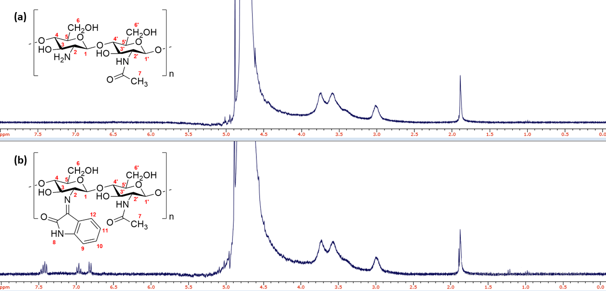
Figure S1. ¹H Nuclear Magnetic Resonance (NMR) spectrum of (a) pure chitosan and (b) the CIS polymeric Schiff base. Solvent: D₂O/TFA.

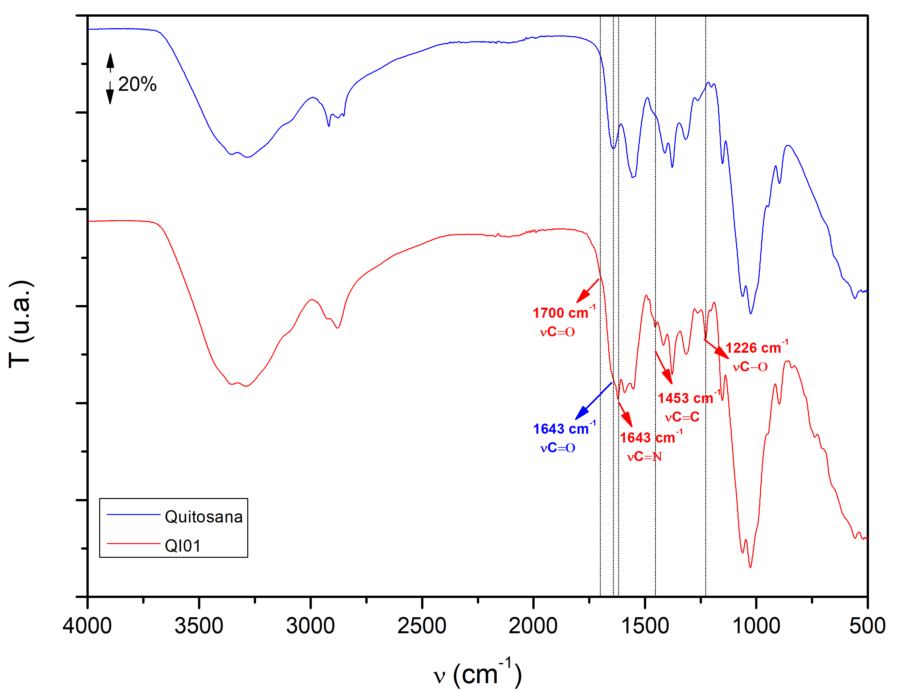
Figure S2. FT-IR spectrum (4000-500 cm⁻¹) of chitosan and CIS.

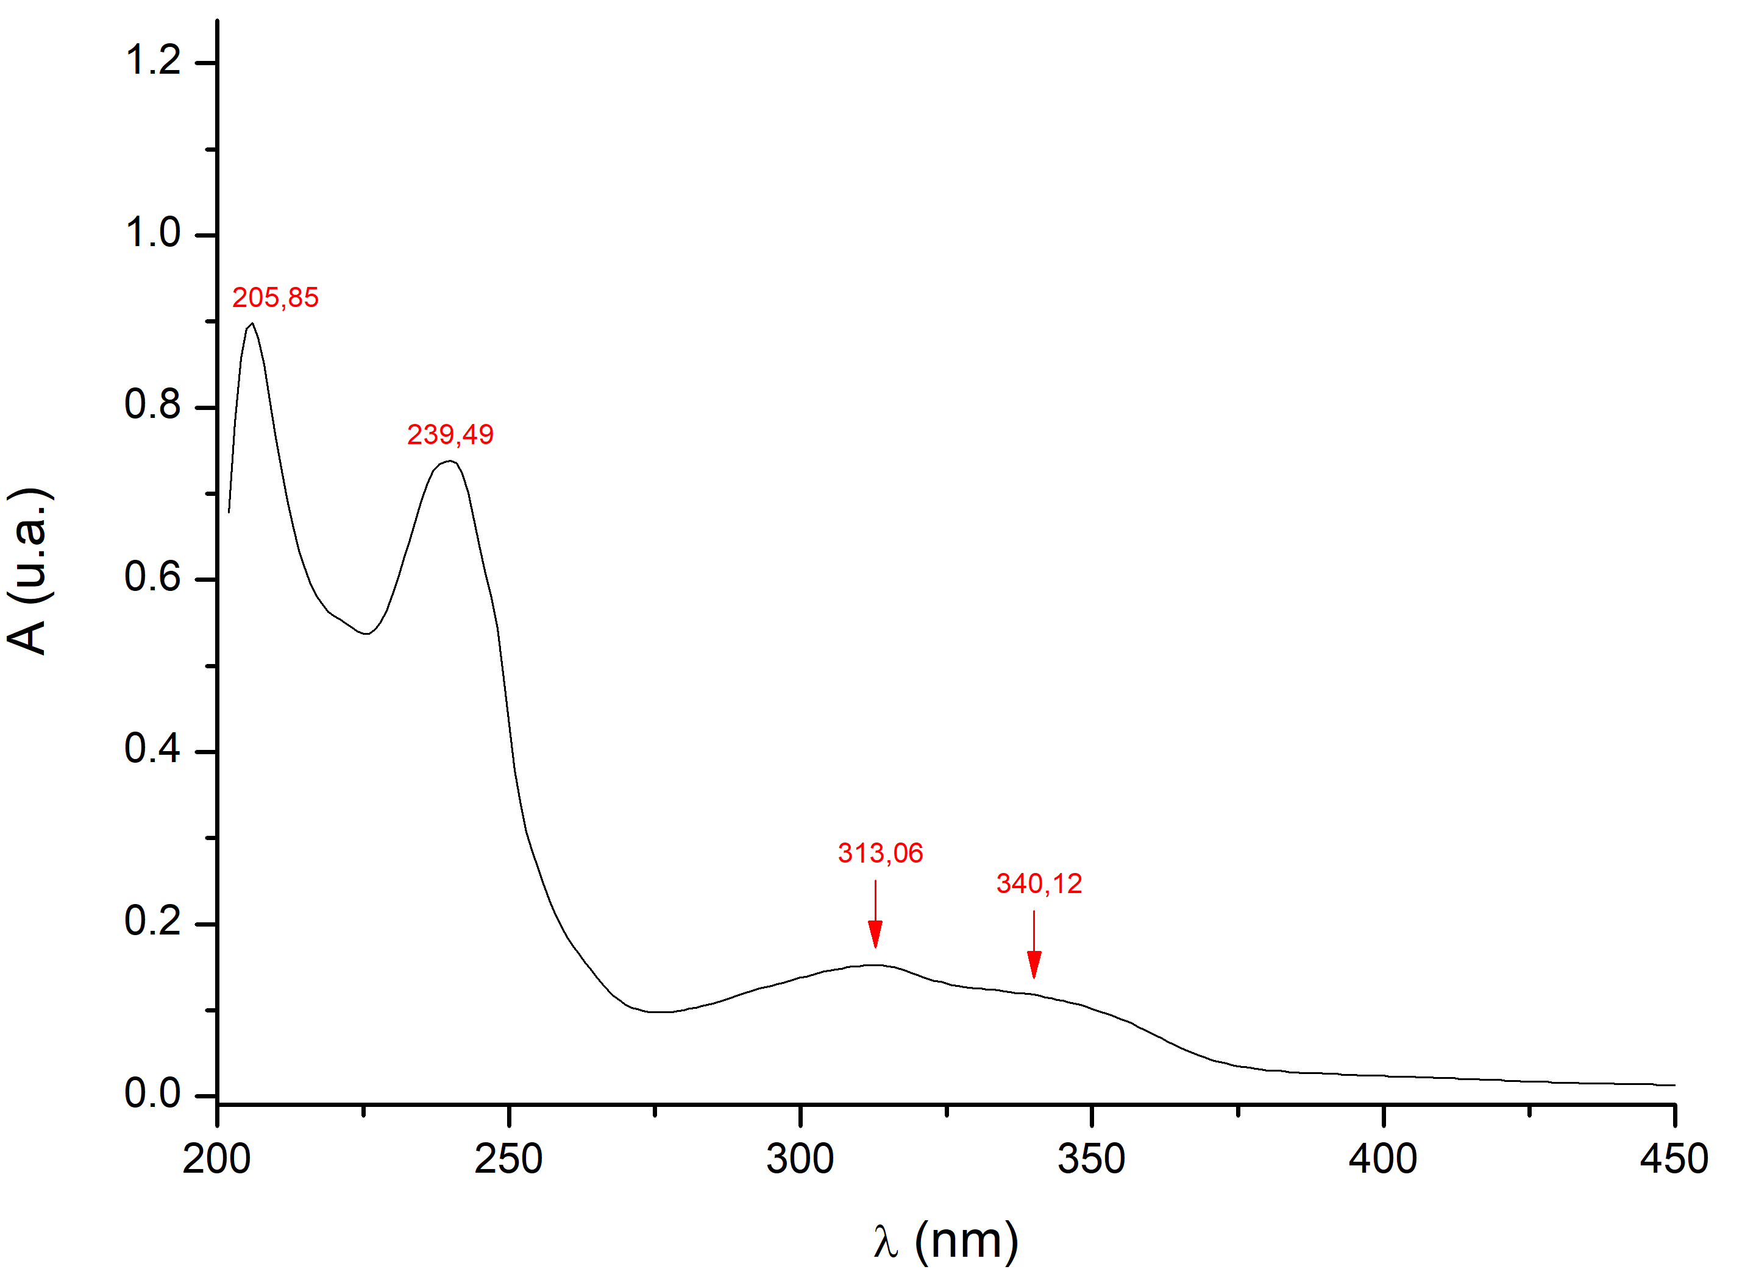
Figure S3. UV-Vis absorption spectrum of CIS in a 1% (v/v) H₂O/HCl solution.

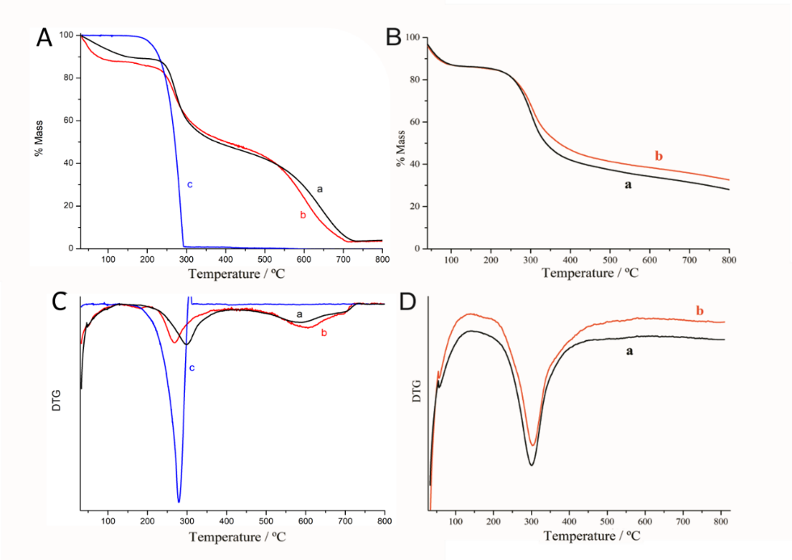
Figure S4. (A, B) TG curves and (C, D) DTG curves of (a) chitosan, (b) CIS (film), and (c) isatin in an (A, C) air atmosphere and (B, D) nitrogen atmosphere. Heating rate of 10 °C min⁻¹. Gas flow rate of 20 mL min⁻¹.

