Table 1. K_{d} values (μM)^{a,b} of 1, 8a-f, 11, 15a-c ,16a-c, 19, 22, 25, 28, 29, and 32.
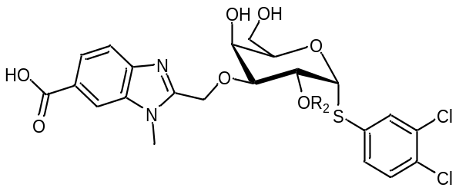
 | K_{d} values (µM)
Compound | R₂ | Gal-8N | Gal-3 (selectivity ratio^{c}) | Gal-1 (selectivity ratio^{c}) | Gal-8C (selectivity ratio^{c})
1¹³ | -H | 1.8 ± 0.10 | 5.0 ± 1.1  (2.8) | 130 ± 11  (72) | 760 ± 160  (422)
8a | 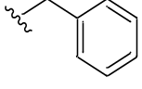 | 1.5 ± 0.13 | 3.7 ± 0.50  (2.5) | 14 ± 0.82  (9.4) | 320 ± 12  (213)
8b | 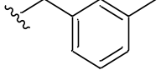 | 2.1 ± 0.10 | 8.2 ± 0.70  (3.9) | 19 ± 0.67  (9) | 303 ± 19  (144)
8c | 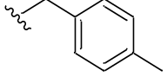 | 2.1 ± 0.15 | 5.9 ± 0.60  (2.8) | 16 ± 0.75  (7.6) | 256 ± 24  (122)
8d | 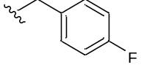 | 1.6 ± 0.060 | 4.2 ± 0.60  (2.6) | 14 ± 1.2  (8.8) | 301 ± 28  (188)
8e | 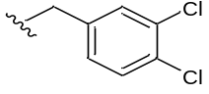 | 4.3 ± 0.40 | 12 ± 3.0  (2.8) | 20 ± 0.84  (4.7) | 577 ± 4  (134)
8f | 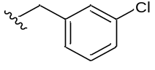 | 1.8 ± 0.18 | 5.8 ± 0.70  (3.2) | 15 ± 1.3  (8.3) | 225 ± 37  (125)
11 | 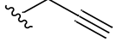 | 0.80 ± 0.090 | 1.4 ± 0.20  (1.75) | 10 ± 0.71  (12.5) | 390 ± 14  (488)
15a | 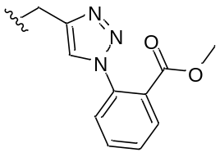 | 3.5 ± 0.37 | 4.7 ± 1.0  (1.3) | 69 ± 9.5  (19.7) | 355 ± 57  (101)
15b | 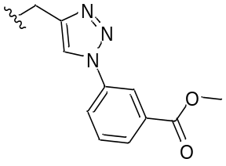 | 4.5 ± 0.24 | 22 ± 5.5  (4.9) | 104 ± 7.4  (23) | 568 ± 23  (126)
15c | 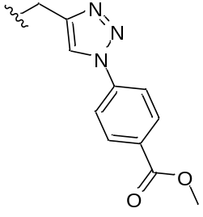 | 4.1 ± 0.33 | 23 ± 4.9  (5.6) | 99 ± 3.1  (24) | 350 ± 60  (85)
16a | 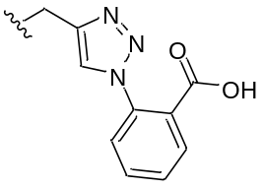 | 0.46 ± 0.030 | 1.2 ± 0.20  (2.6) | 26 ± 1.1  (57) | 159 ± 4  (346)
16b | 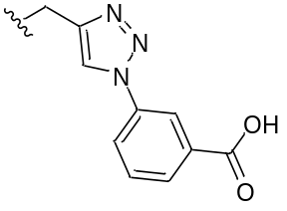 | 0.65 ± 0.050 | 2.9 ± 0.40  (4.5) | 37 ± 1.1  (57) | 100 ± 2  (154)
16c | 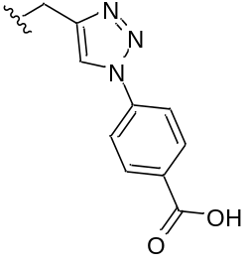 | 1.1 ± 0.070 | 6.2 ± 1.1  (5.6) | 45 ± 0.80  (41) | 201 ± 37  (183)
19 | 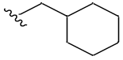 | 4.1 ± 0.61 | 21 ± 1.5  (5.1) | 76 ± 15  (18.5) | 662 ± 27  (161)
22 | 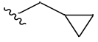 | 1.0 ± 0.060 | 5.7 ± 1.3  (5.7) | 12 ± 1.0  (12) | 374 ± 38  (374)
25 | 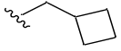 | 1.6 ± 0.070 | 9.4 ± 1.9  (5.9) | 16 ± 0.50  (10) | 383 ± 21  (239)
29 | 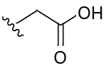 | 0.50 ± 0.030 | 3.3 ± 0.20  (6.6) | 49 ± 3.6  (98) | 449 ± 39  (898)
32 | -CH₃ | 1.3 ± 0.050 | 4.5 ± 0.70  (3.5) | 16 ± 0.80  (12.3) | 358 ± 29  (275)
ª Results represent the mean ± SEM of n = 4 to 8.^{b} K_{d} was determined by competitive fluorescence polarisation assay. ^{c} Ratio between affinity for Gal-8N vs. galectin of choice: K_{d} (Gal-X)/K_{d} (Gal-8N).

