Supplement Figure 1. Radiographic parameters.
Supplement Figure2
Longitudinal change in C27SVA, Cervical LL, and T1slope between farmers and non-farmers over study period in a propensity score matched cohort.
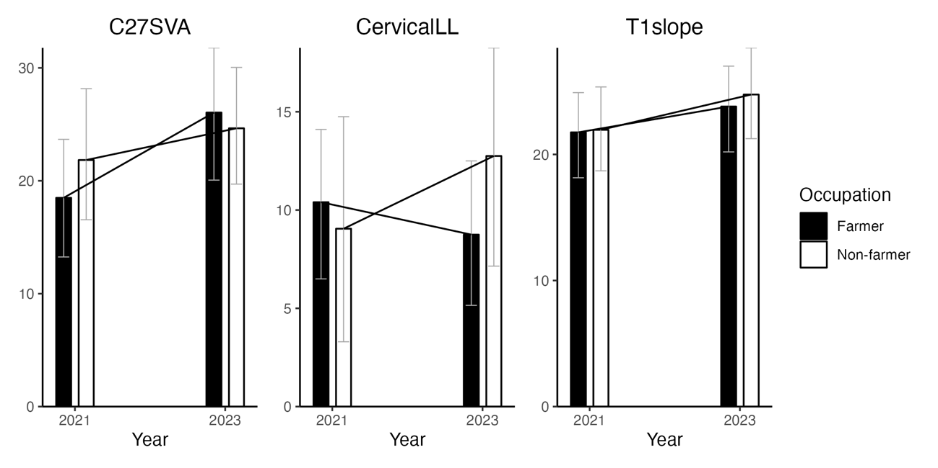
Age and sex were balanced by a 1:1 propensity score matching. The variables are explained as follows: C27SVA; C2-7 Sagittal Vertical Axis, Cervical LL; Cervical Lordosis, and T1slope; T1 Slope.

Longitudinal change in SVA, TK, and LL between farmers and non-farmers over study period in a propensity score matched cohort.
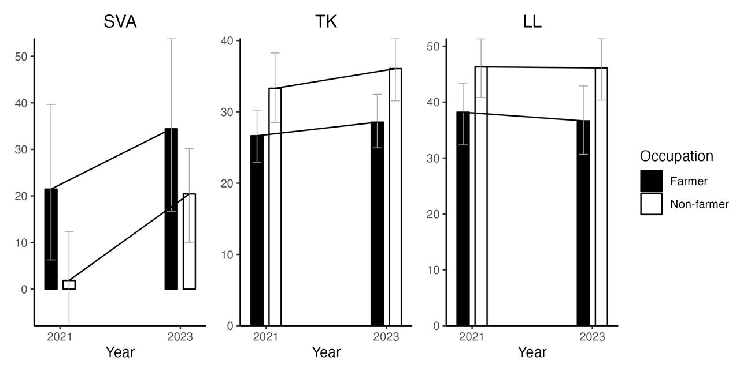
Age and sex were balanced by a 1:1 propensity score matching. The variables are explained as follows: SVA; Sagittal Vertical Axis, TK; Thoracic Kyphosis, LL; Lumbar Lordosis

Longitudinal change in SS, and PT between farmers and non-farmers over study period in a propensity score matched cohort.
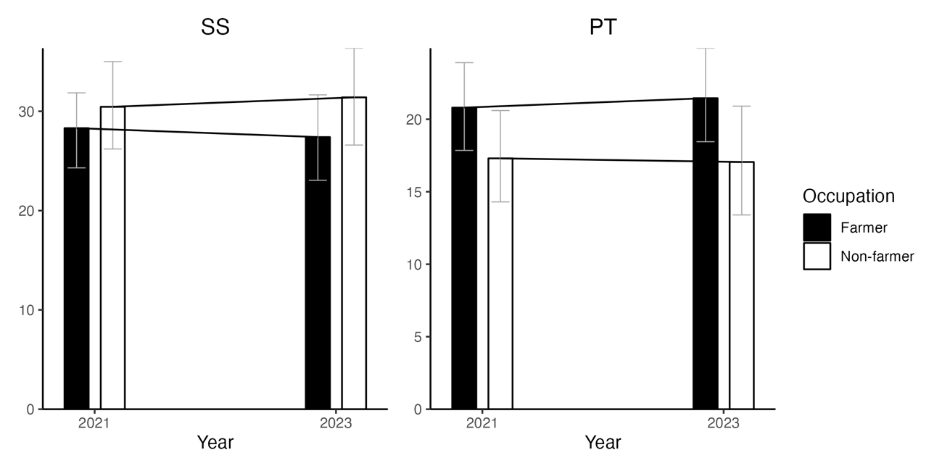
Age and sex were balanced by a 1:1 propensity score matching. The variables are explained as follows: SS; Sacral Slope, PT; Pelvic Tilt

Longitudinal change in EQ5D, ODI, and NDI between farmers and non-farmers over study period in a propensity score matched cohort.

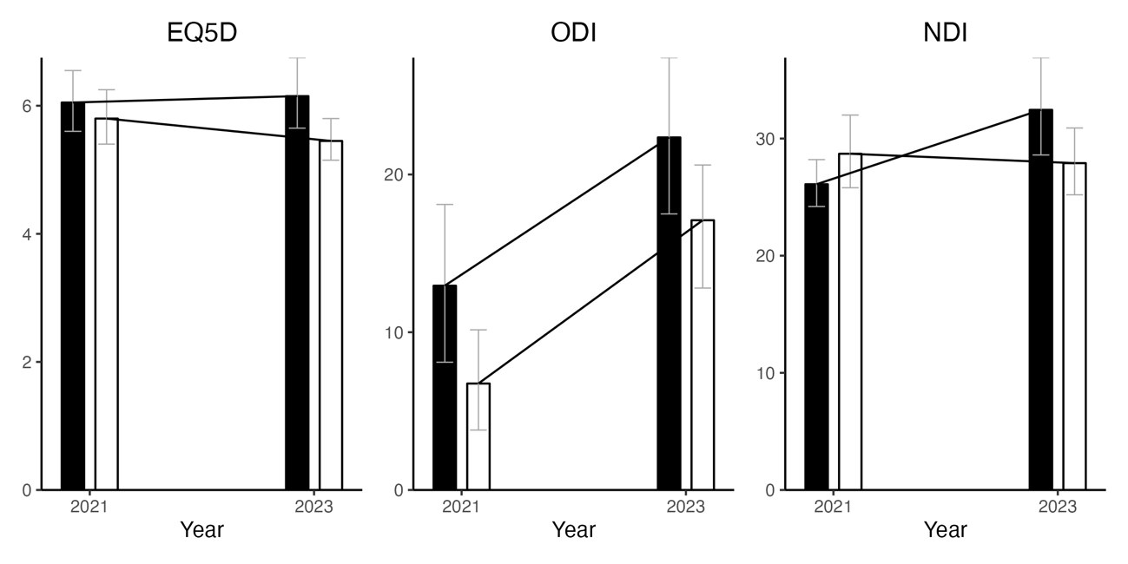
Age and sex were balanced by a 1:1 propensity score matching. The variables are explained as follows: EQ5D; Euro Qol 5 Dimensions 3-Level, NDI; Neck Disability Index, ODI; Oswestry Disability Index

