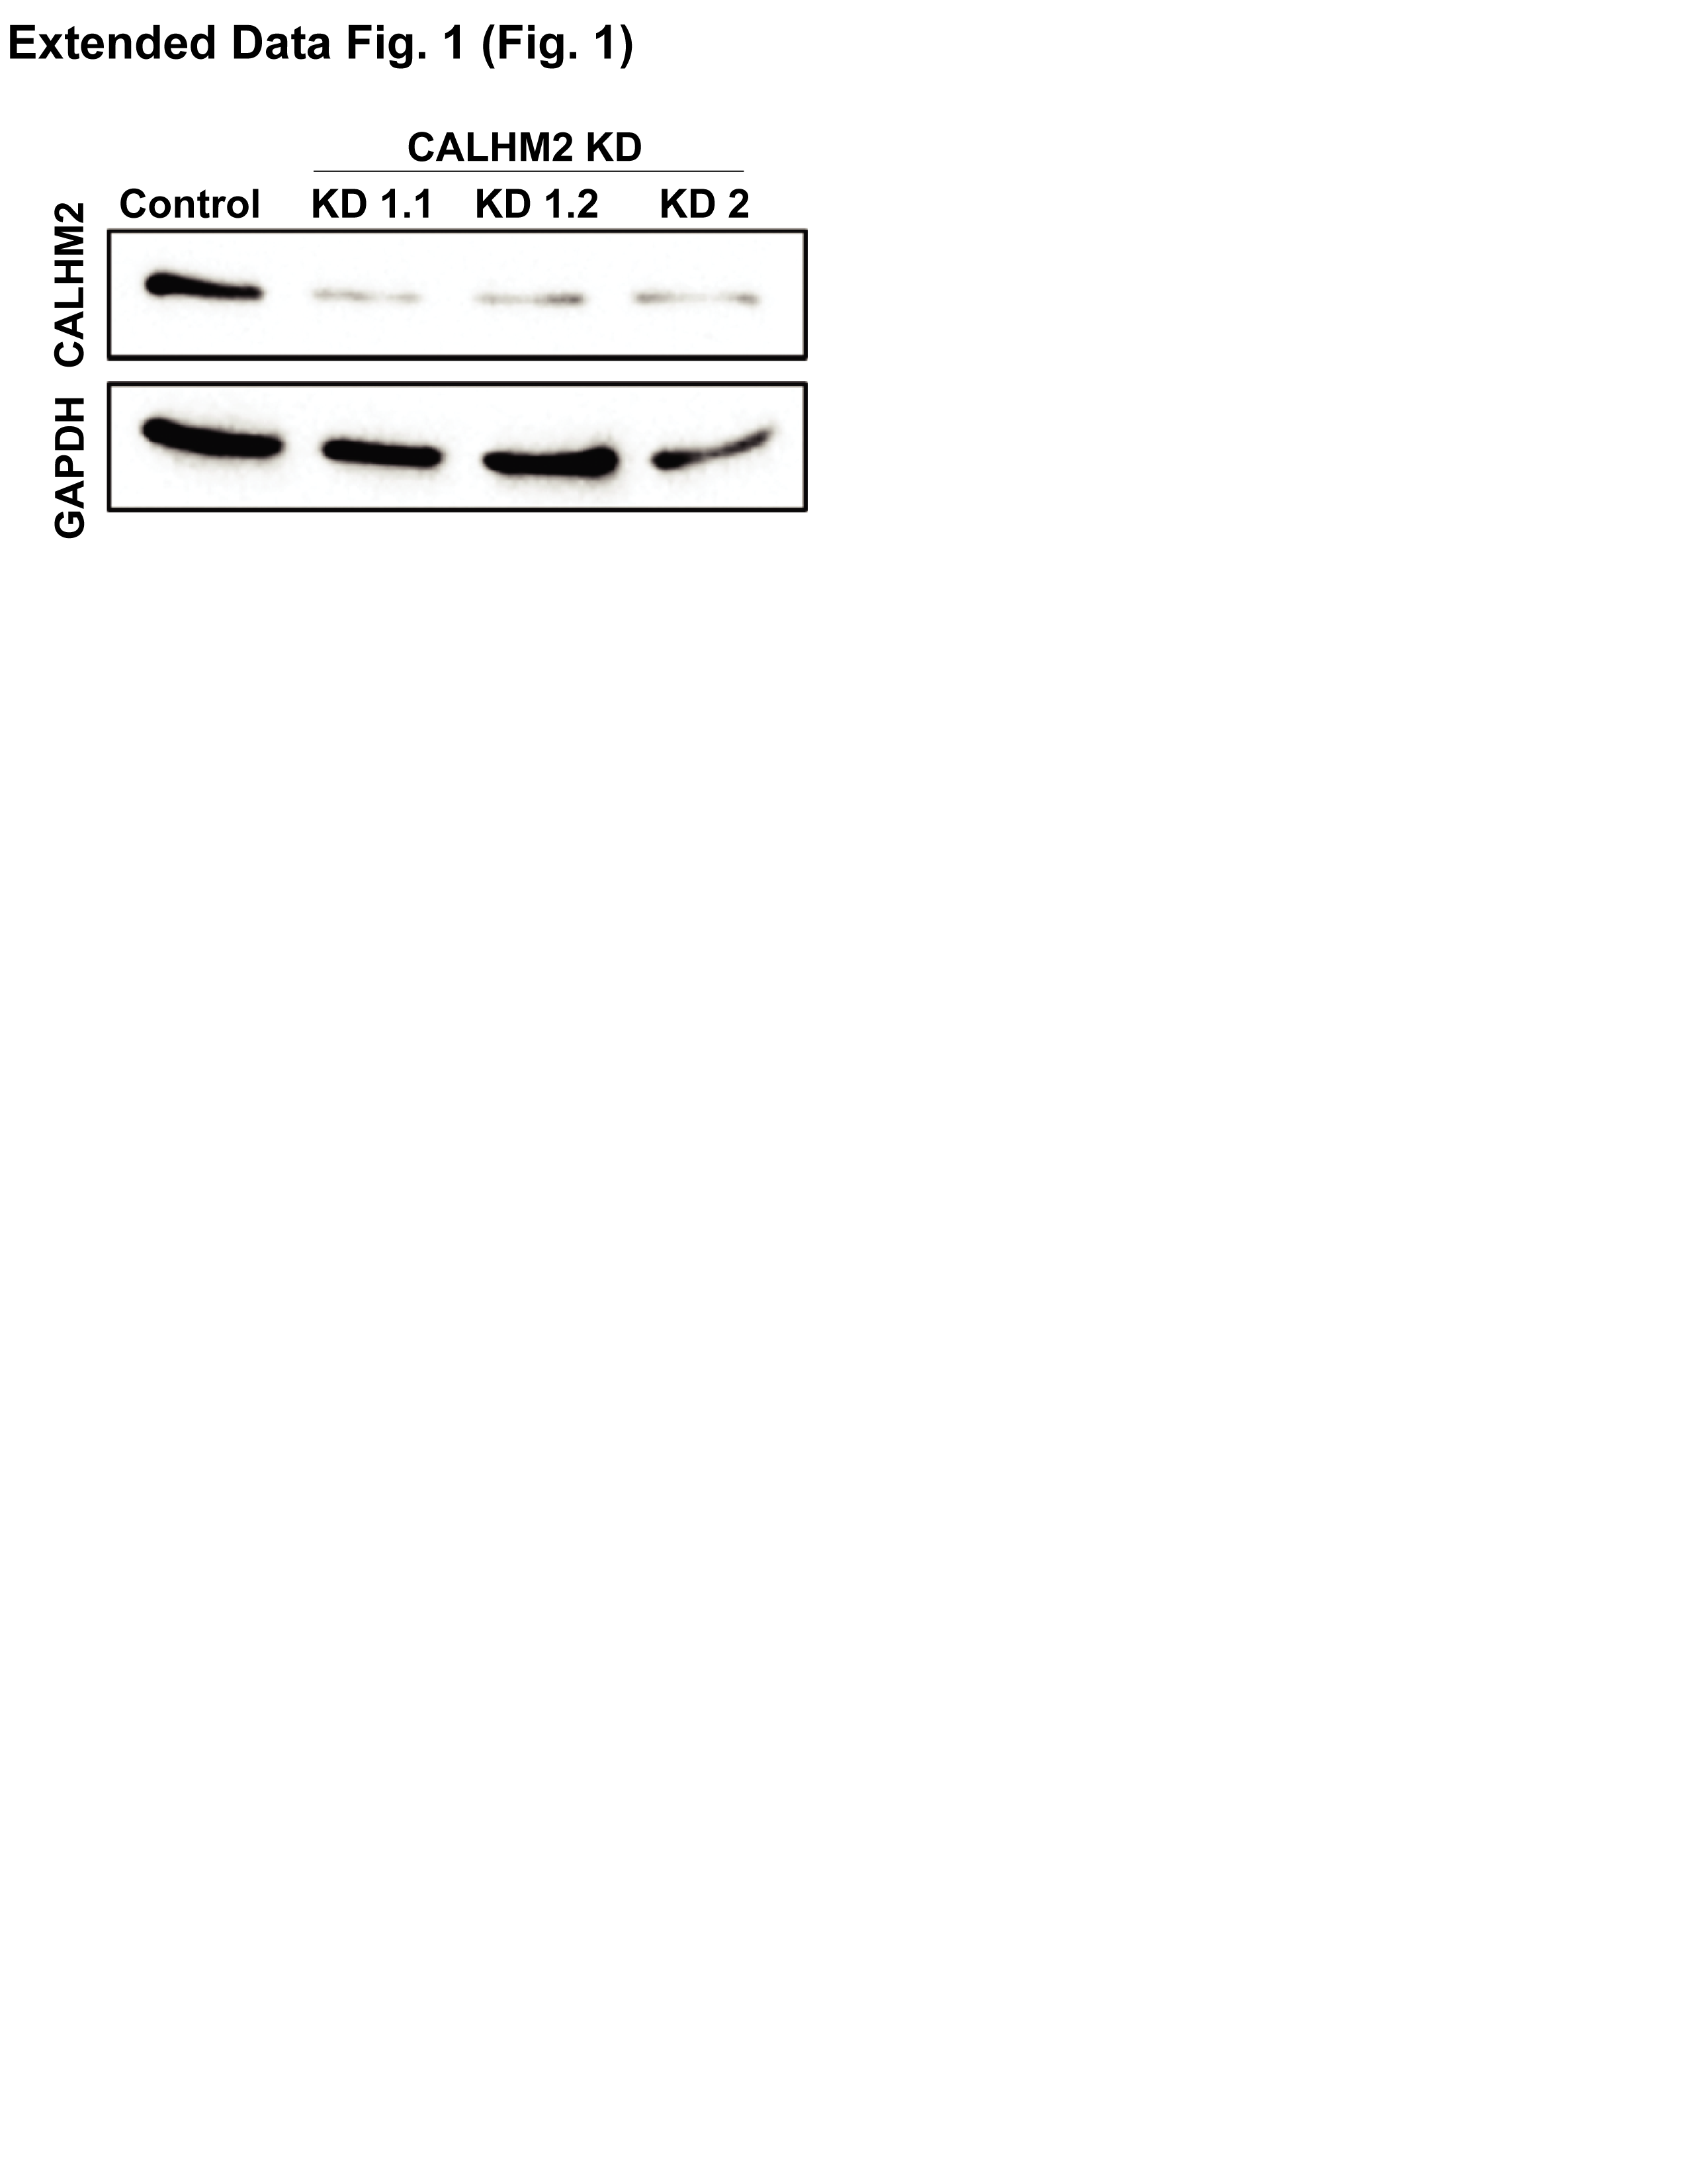

Extended Data Fig 1. Confirmation and analysis of CALHM2 knockdown in cell lines
Western blots of CALHM2 protein from total cell extracts from RPE cells for Cas9 only controls and for pLenti-Cas9-gRNA CALHM2 using two different gRNAs.

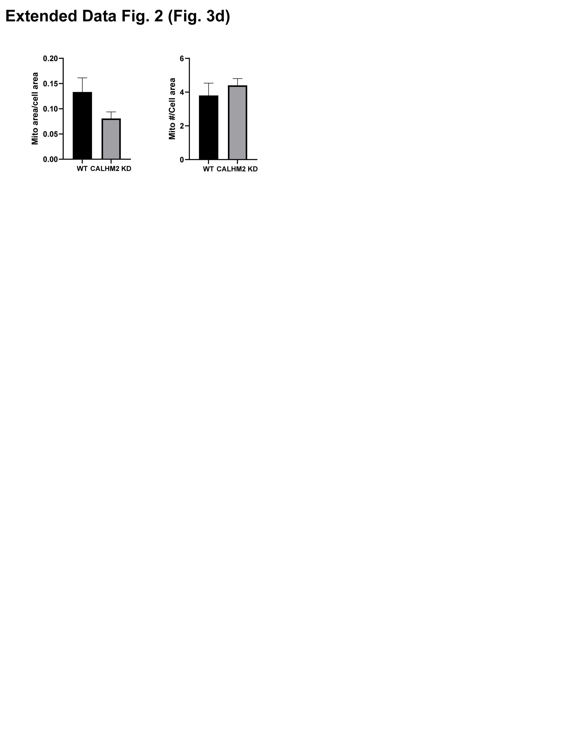
Extended Data Fig 2. Mitochondrial content does not differ in CALHM2 KD cells.
No change in mitochondrial area/cell area or mitochondrial number/cell area in CALHM2 KD cells compared to WT cells. n=5 micrographs for each.

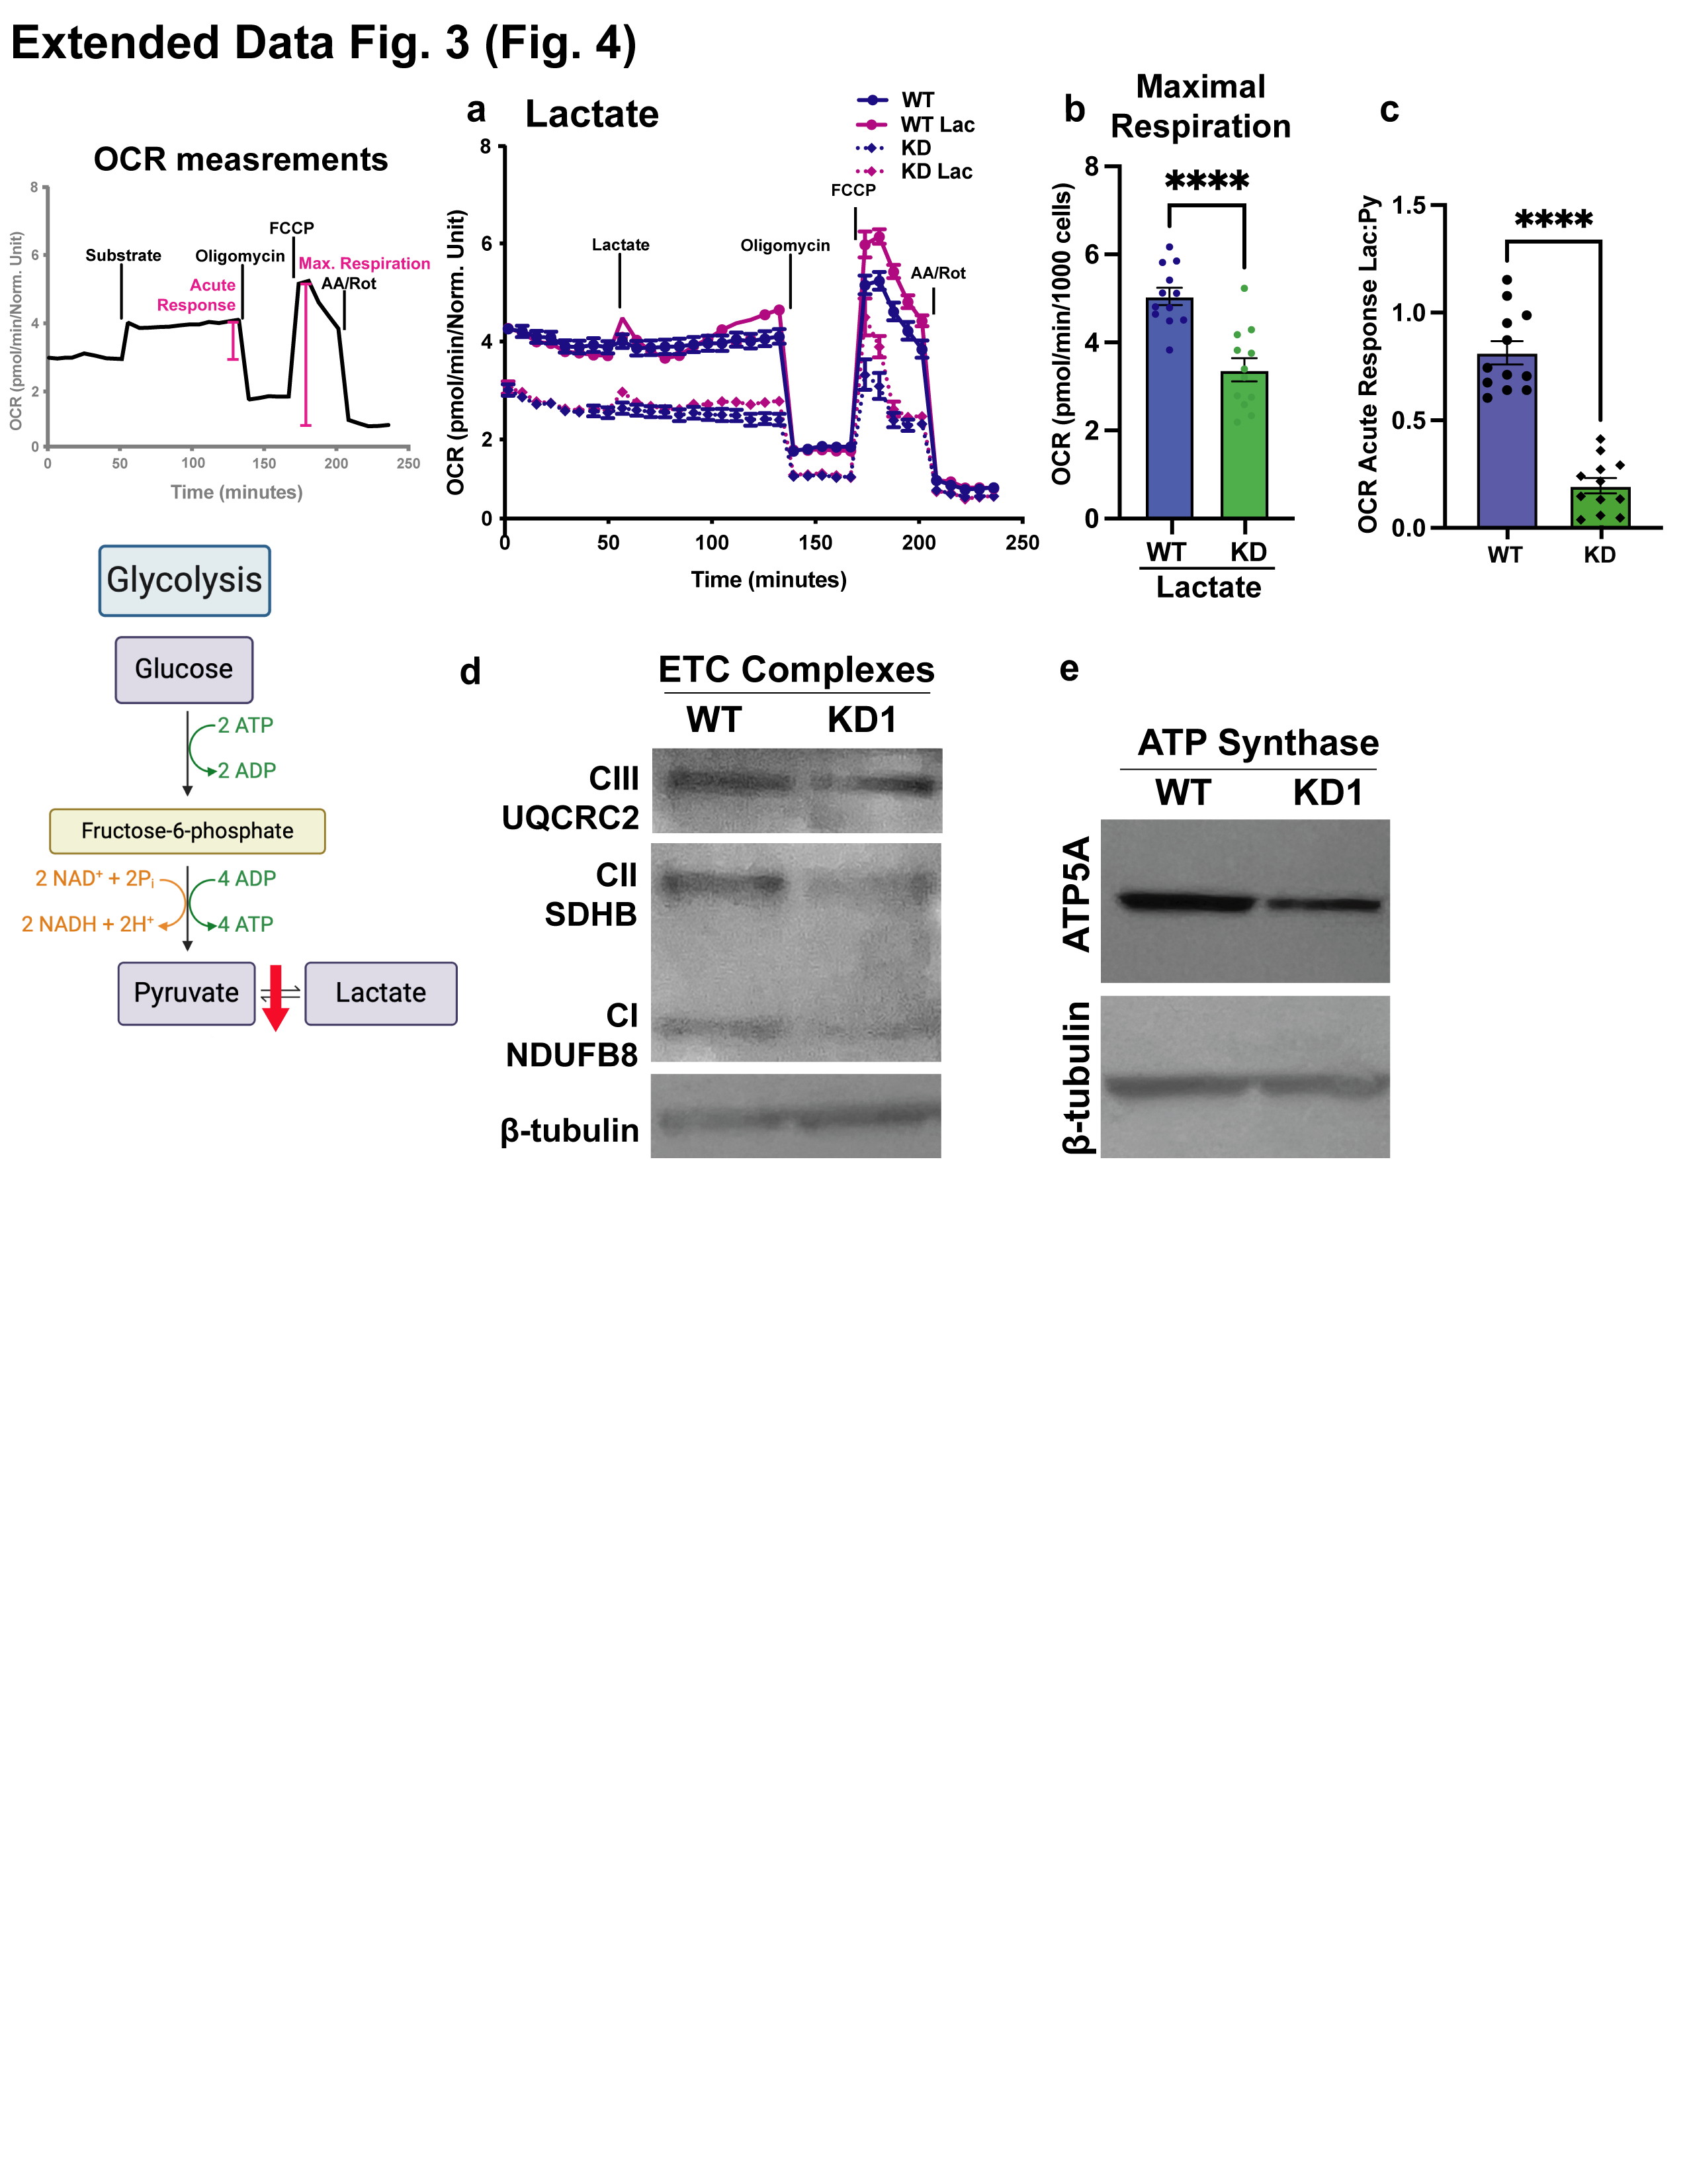
Extended Data Fig 3.
- OCR in RPE cells supplemented with 2mM glutamine. 5mM lactate, Oligomycin, FCCP and rotenone plus antimycin A were added at times indicated (n = 12).
- Quantification of maximal respiration (FCCP) with 2 mM glutamine and 5mM lactate (n = 12); p < 0.0001.
- Quantification of the acute response to lactate compared to the acute response to pyruvate indicating a deficiency in the activity of LDH or NADH/NAD⁺ (n = 12); p < 0.0001
- Representative western blot of electron transport chain subunits in WT and CALHM2 KD RPE cells (n = 3).
- Representative western blot of ATP Synthase subunit alpha in WT and CALHM2 KD RPE cells (n = 3).

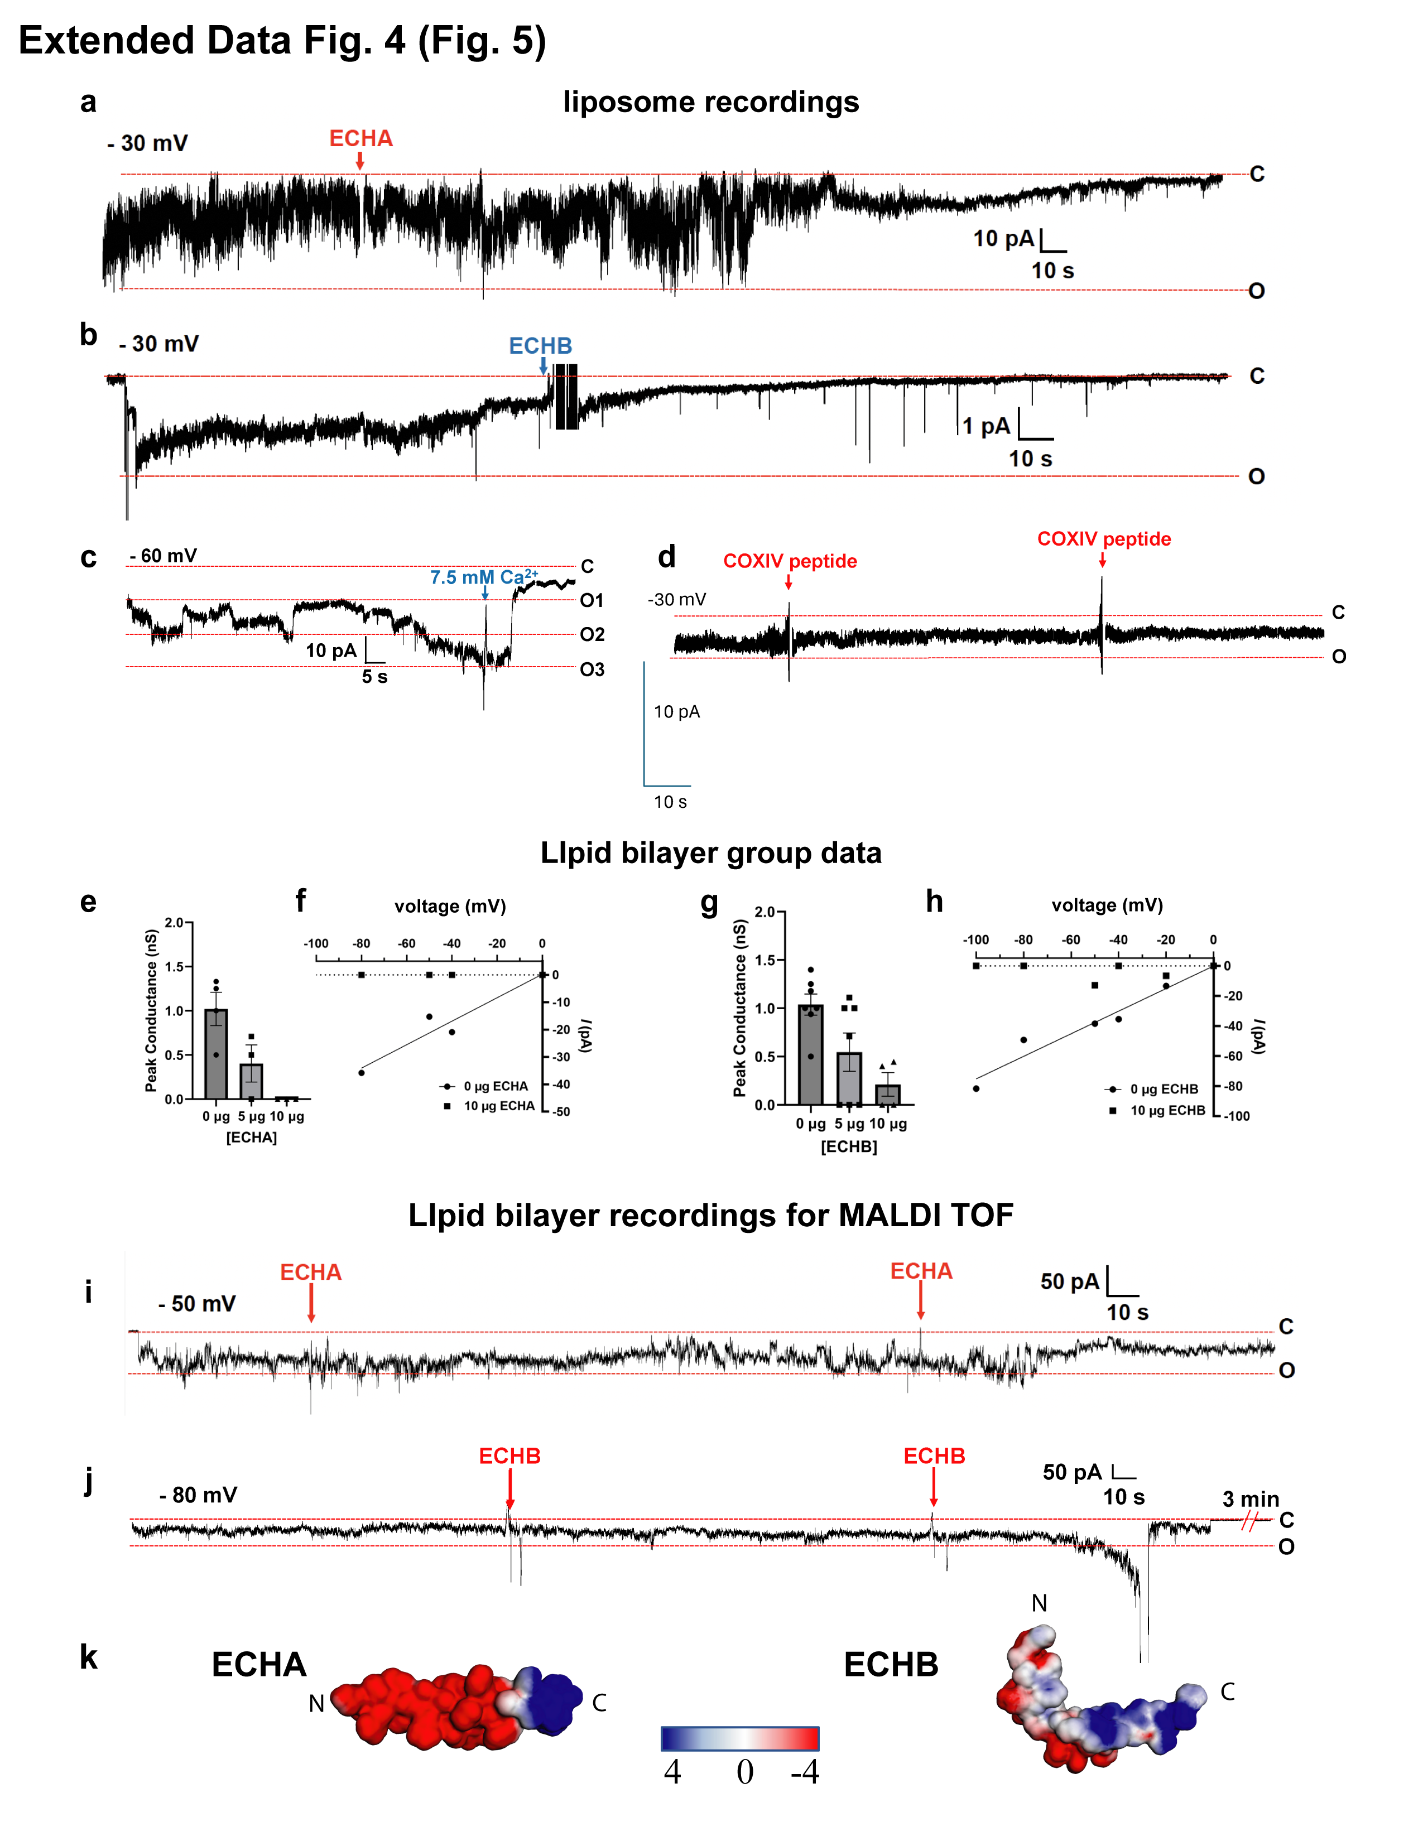
Extended Data Fig 4.
- CALHM2 was reconstituted into liposomes. Representative recording of currents upon the addition of ECHA peptide (5 µg/ml). Holding voltage and open and closed states are indicated.
- Representative recording of currents upon the addition of ECHB peptide (5 µg/ml).
- Representative recording of currents upon the addition of Ca²⁺ at the indicated concentration.
- Representative recording of currents upon the addition of control peptide (COXIV peptide 5 µg/ml)
- Concentration dependence of peak conductance upon the addition of ECHA peptide (at the indicated concentrations)
- Current voltage relationship before and after the addition of 10 µg/ml ECHA peptide
- Concentration dependence of peak conductance upon the addition of ECHB peptide (at the indicated concentrations)
- Current/voltage relationship before and after the addition of 10 µg/ml ECHB peptide.
- Representative recording of lipid bilayer reconstituted with CALHM2 protein. ECHA peptide (2.5 µg/ml) was added to the cis side of the bilayer at the indicated times.
- Representative recording of lipid bilayer reconstituted with CALHM2 protein. ECHB peptide (2.5 µg/ml) was added to the cis side of the bilayer at the indicated times.
- Electrostatic potential maps of ECHA and ECHB N-terminal peptides generated using APBS-PDB2PQR software. The models were generated by AlphaFold to show the electrostatic properties and 3D structures of the peptides. The N-terminal region of ECHA is more negatively charged compared with ECHB.

Extended Data: Table S1 –
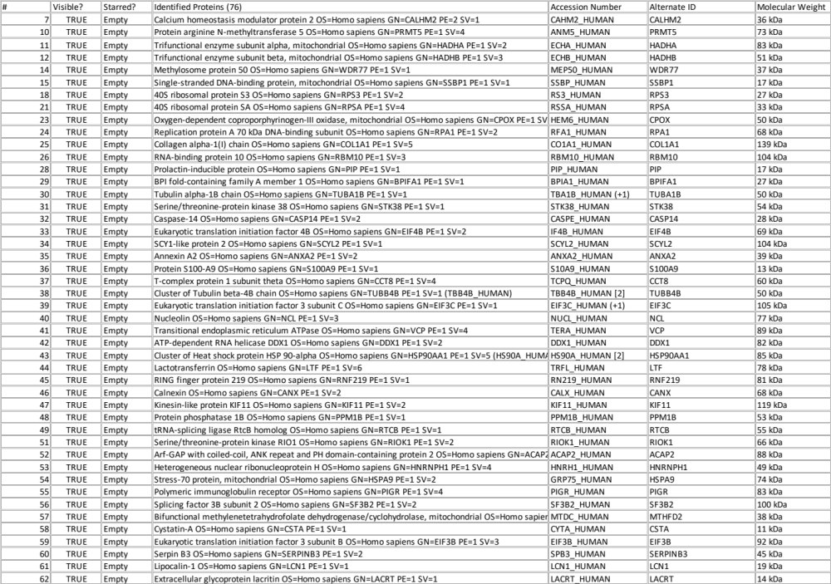
Extended Data: Table S2 - MRM transition pairs (Q₁/Q₃) for all metabolites studied.
studied.
Metabolite | Isotopologue | Q₁/Q₃
Citrate | M+0 | 191/111
Citrate | M+1 | 192/111
Citrate | M+1 | 192/112
Citrate | M+2 | 193/112
Citrate | M+2 | 193/113
Citrate | M+3 | 194/113
Citrate | M+3 | 194/114
Citrate | M+4 | 195/114
Citrate | M+4 | 195/115
Citrate | M+5 | 196/115
Citrate | M+5 | 196/116
Citrate | M+6 | 197/116
Succinate | M+0 | 117/73
Succinate | M+1 | 118/73
Succinate | M+1 | 118/74
Succinate | M+2 | 119/74
Succinate | M+2 | 119/75
Succinate | M+3 | 120/75
Succinate | M+3 | 120/76
Succinate | M+4 | 121/76
Malate | M+0 | 133/133
Malate | M+1 | 133/115
Malate | M+2 | 134/116
Malate | M+3 | 135/117
Malate | M+4 | 136/118
Malate | M+0 | 146/128
Malate | M+1 | 147/129
Malate | M+2 | 148/130
Malate | M+3 | 149/131
Malate | M+4 | 150/132
Malate | M+5 | 151/133
PEP | M+0 | 167/79
PEP | M+1 | 168/79
PEP | M+2 | 169/79
PEP | M+3 | 170/79

