Supplementary Section

Design of a silver-zinc nanozeolite-based antibiofilm wound dressing activity in an in vitro biofilm mode
Sarah Abdulaziz Alobaid¹, Sweta Shrestha², Morgan Tasseff¹, Bo Wang², Monique Van Hoek^{1,*}, Prabir K. Dutta ^{2,3,*}
¹School of Systems Biology, George Mason University, Manassas, VA, USA
²Zeovation Inc., Columbus, OH, US.
³Department of Chemistry, The Ohio State University, Columbus, OH, US.

Supplementary Figures
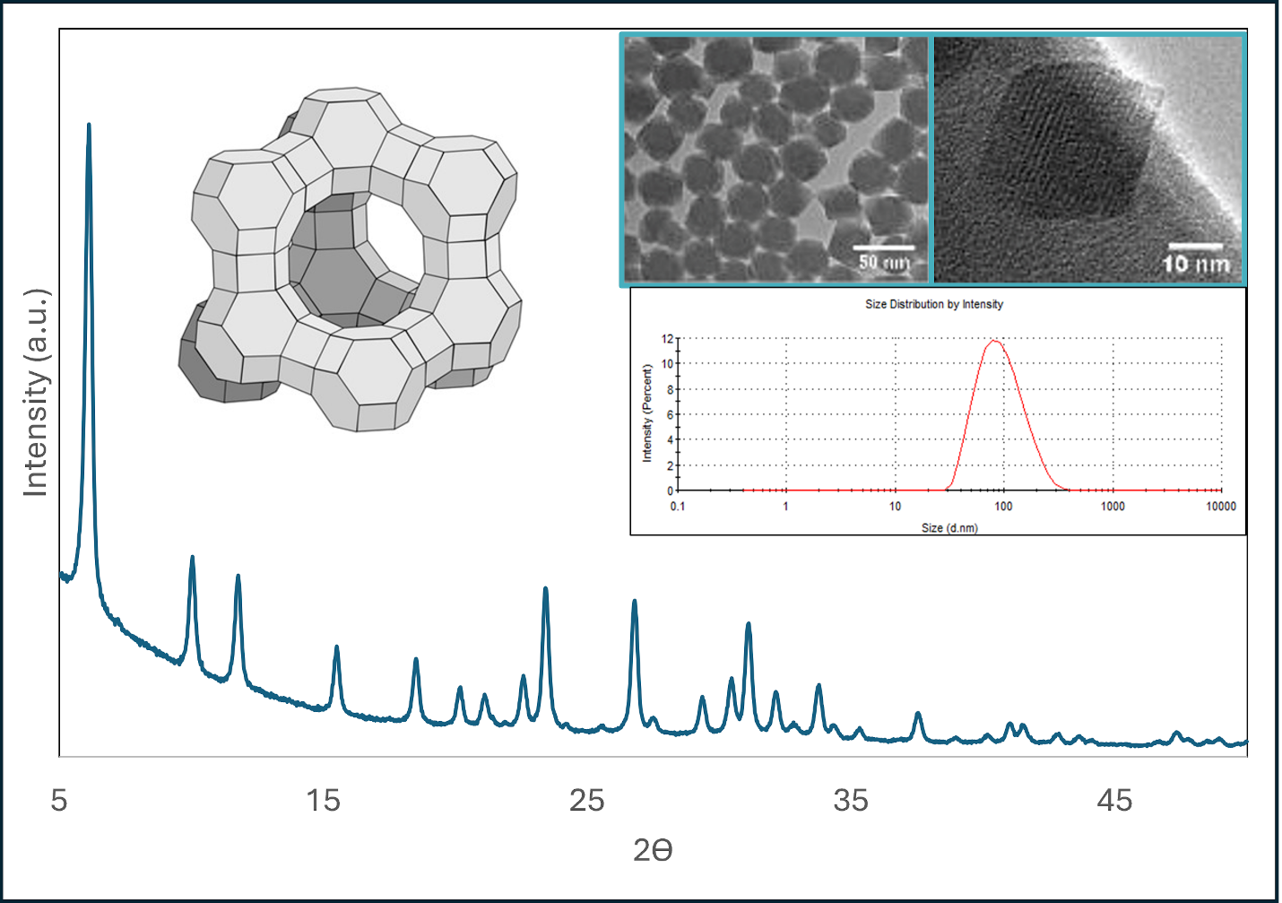
Figure 1S. Powder X-ray diffraction, HRTEM and dynamic light scattering of FAU30 used to make AM30. A schematic of the supercage of FAU30 is shown.
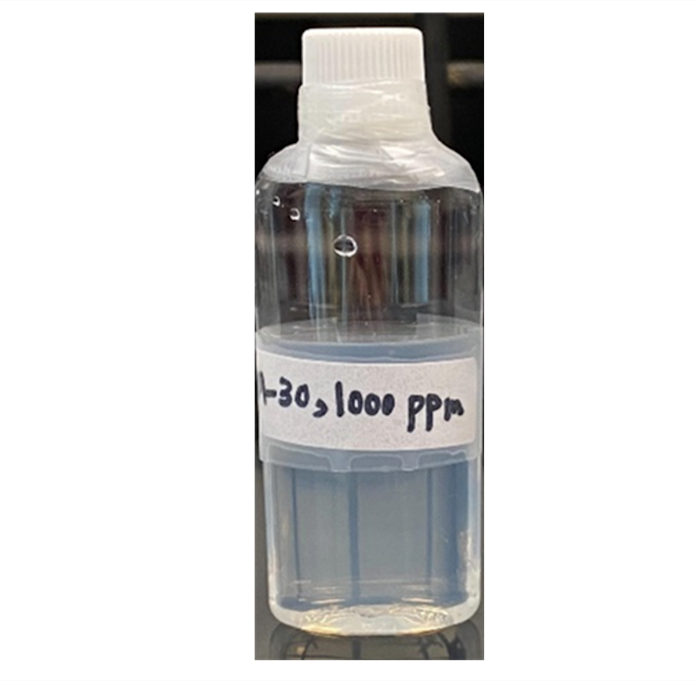

Figure 2S. 1000 ppm solution of AM30 indefinitely stable over time

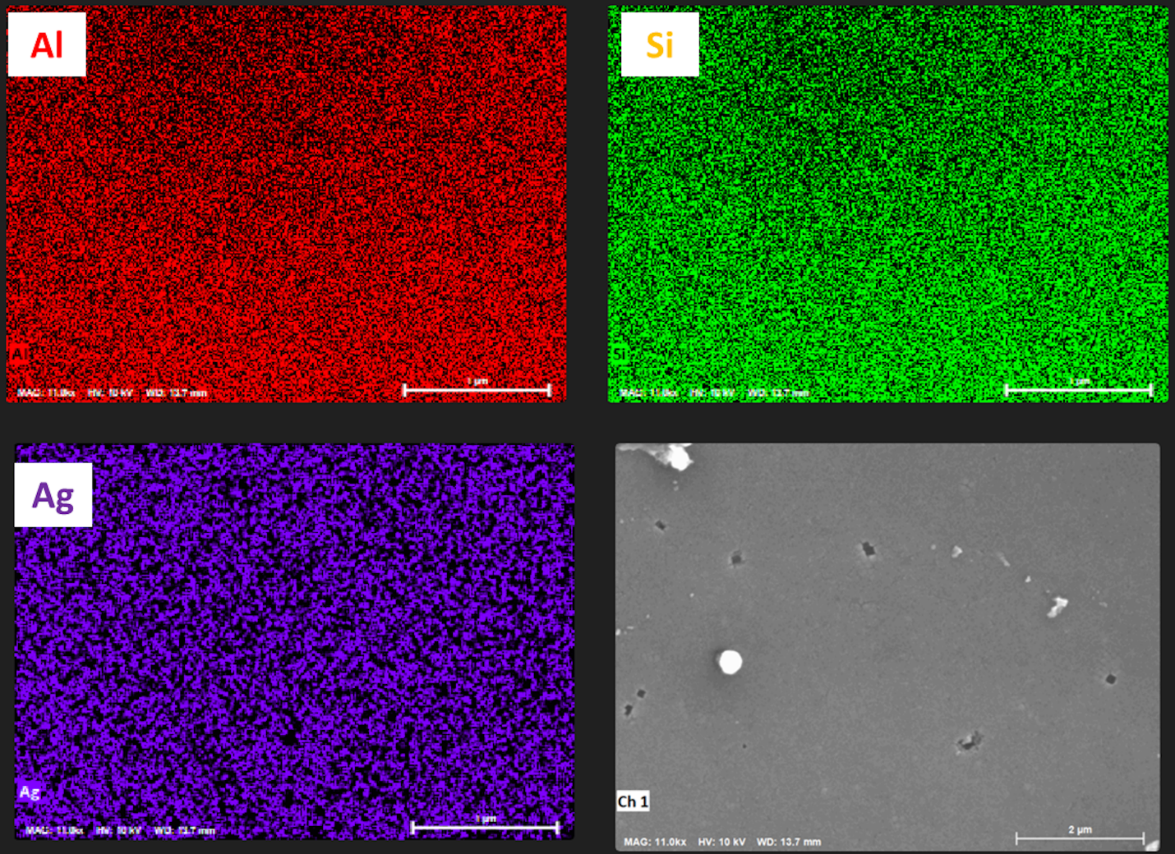
Figure 3S. Elemental map of the surface of ABF-XenoMEM by energy dispersive spectroscopy. Lower right-hand picture is the SEM of ABF-XenoMEM over which the elemental analysis was done.
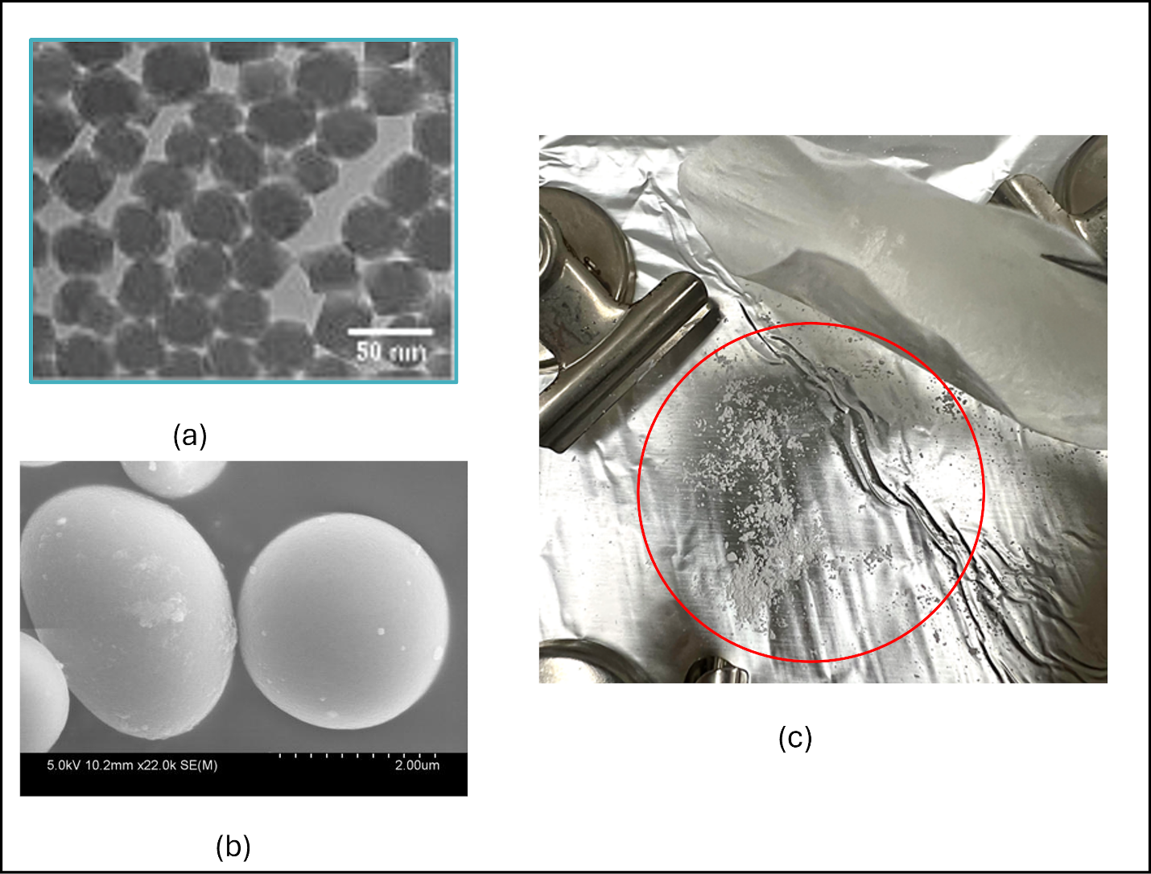
Figure 4S. (a) HRTEM of AM30 (b) SEM of AM30 after spray drying indicating the aggregation and increase in size (c) Photograph of XenoMEM coated with spray dried AM30 gently shaken, leading to the particles falling off from the membrane
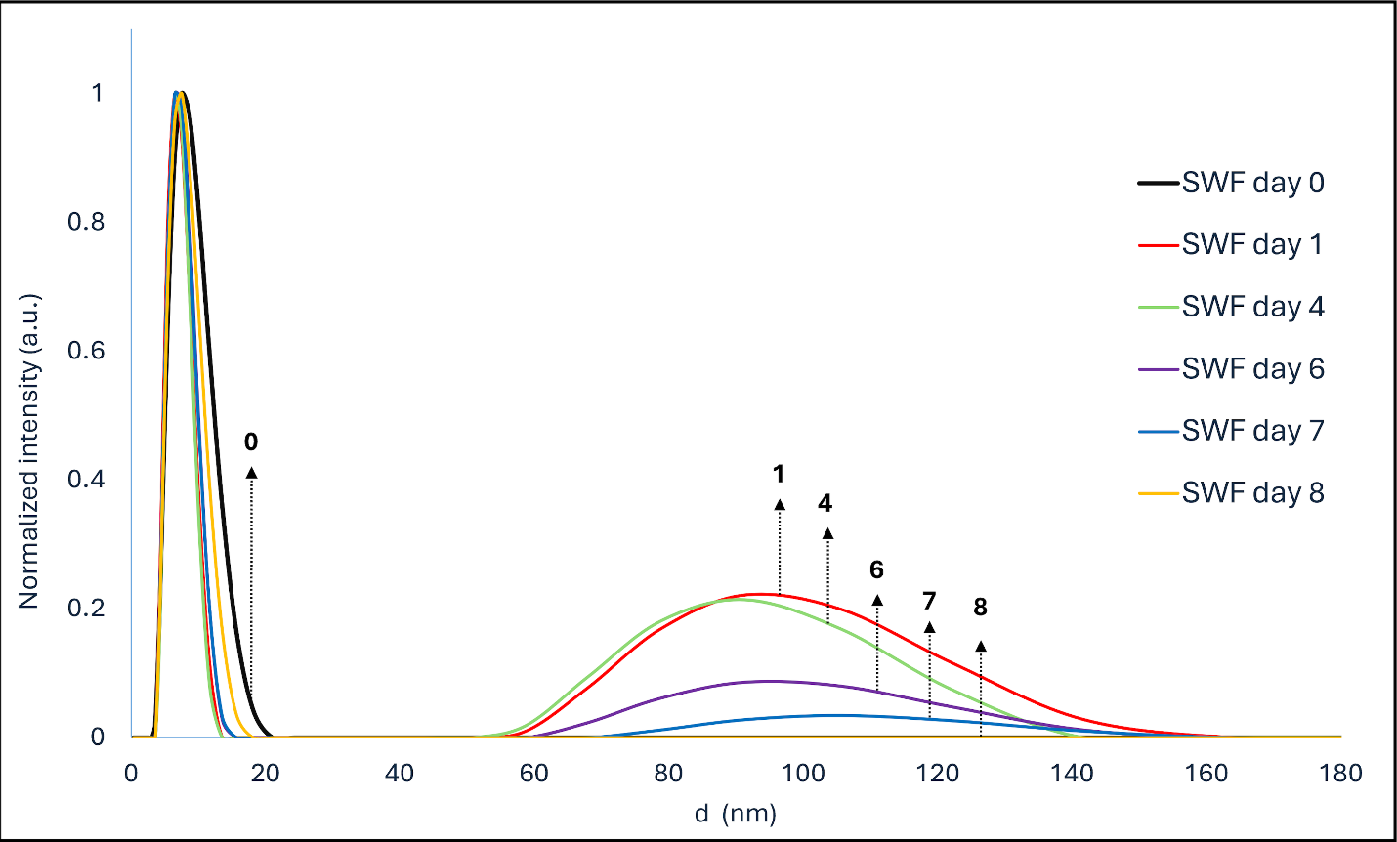
Figure 5S. Dynamic light scattering of SWF (simulated wound fluid) after static exposure to ABF-XenoMEM over time
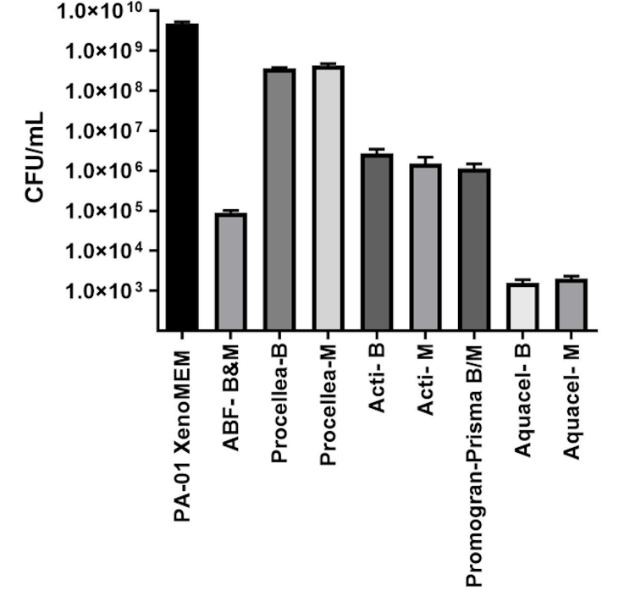
Figure 6S. Comparison of commercial wound dressings and ABF-XenoMEM for biofilm studies. PA01 biofilms were grown on cellulose membrane (M) for 48 h and exposed to ABF-XenoMEM, Procellera™, Acticoat™ 7, Promogran Prisma™ and Aquacel® Ag⁺ Extra™ for 24 h (B). The dressing and membrane were separated (except for ABF-XenoMEM and Prisma), and the bacteria on the dressings and membrane were extracted and the bacteria in the extracts were counted (CFU/ml). The data plots the bacteria in the extract observed on B and M separately.
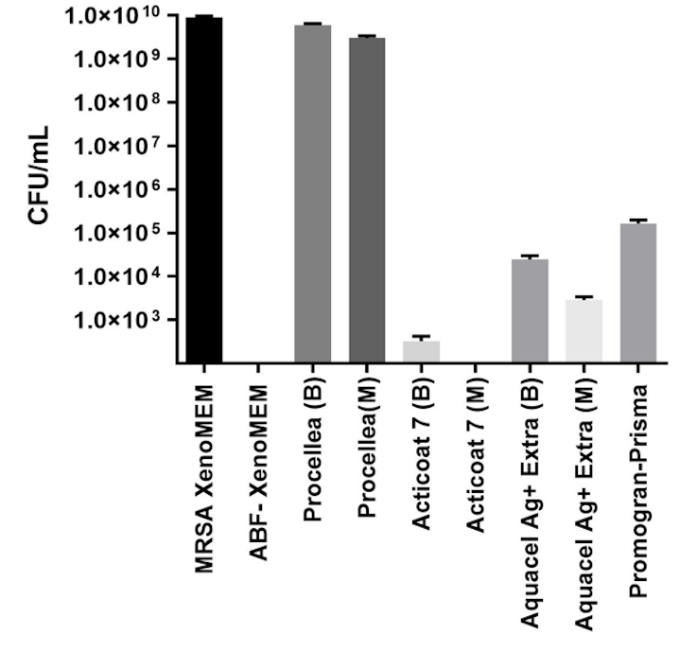
Figure 7S. Comparison of commercial wound dressings and ABF-XenoMEM for biofilm studies. MRSA biofilms were grown on cellulose membrane (M) for 48 h and exposed to ABF-XenoMEM, Procellera™, Acticoat™ 7, Promogran Prisma™ and Aquacel® Ag⁺ Extra™ for 24 h (B). The dressing and membrane were separated (except for ABF-XenoMEM and Prisma), and the bacteria on the dressings and membrane were extracted and the bacteria in the extracts were counted (CFU/ml). The data plots the bacteria in the extract observed on B and M separately.

