Appendix A. Supplementary data

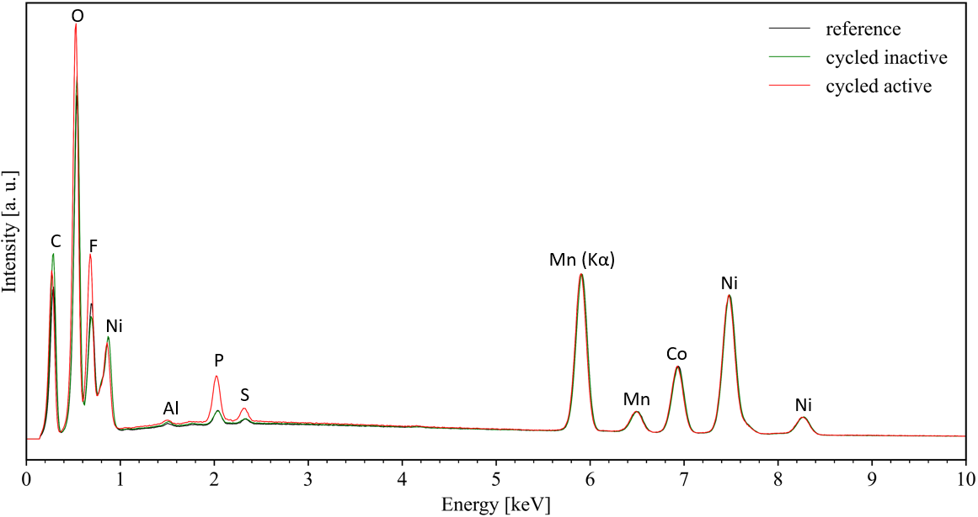

Fig. 1 Cathode surface EDS analysis, normalized to Mn K-alpha to see NMC ratio same
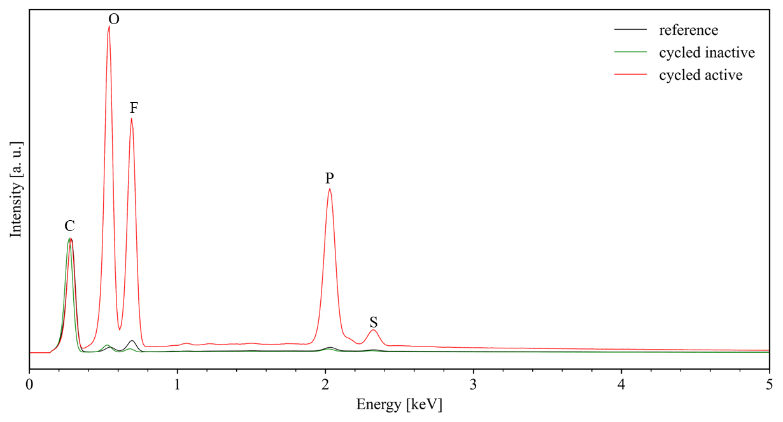

Fig. 2 Anode surface EDS analysis, normalized to peak C

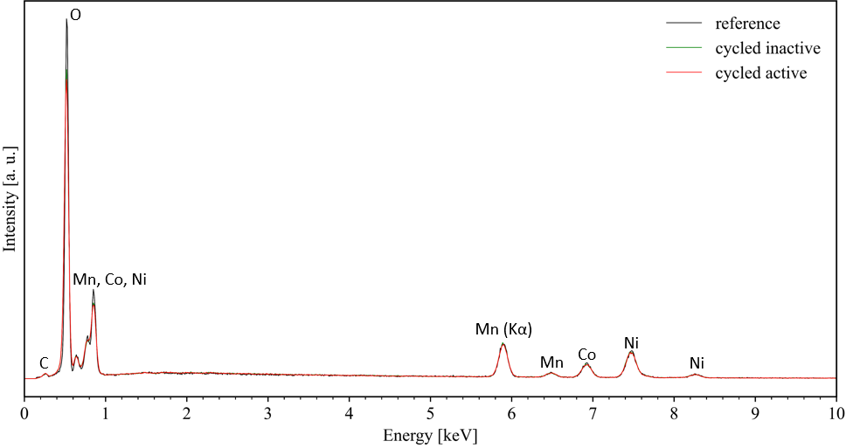

Fig. 3 Selected NMC grains EDS analysis, normalized to Mn K-alpha to see NMC ratio is the same

