Supporting Information

Bismuth Atom Tailoring of Indium Oxide Surface Frustrated Lewis Pairs Boosts Heterogeneous CO₂ Photocatalytic Hydrogenation

Tingjiang Yan,^{a,b}* Na Li,^{c}* Linlin Wang,ª Weiguang Ran,ª Paul N. Duchesne,^{b} Lili Wan,^{b} Nhat Truong Nguyen,^{b} Lu Wang,^{b} Meikun Xia,^{b} Geoffrey A. Ozin^{b}*
ª The Key Laboratory of Life-Organic Analysis, College of Chemistry and Chemical Engineering, Qufu Normal University, Qufu, Shandong 273165, P. R. China.
^{b} Materials Chemistry and Nanochemistry Research Group, Solar Fuels Cluster, Department of Chemistry, University of Toronto, 80 St. George Street, Toronto, Ontario M5S 3H6, Canada.
^{c} Qufu Normal University Library, Qufu Normal University, Qufu, Shandong 273165, P. R. China.

Corresponding Authors
*Email: tingjiangn@163.com, chessmantj@163.com, gozin@chem.utoronto.ca

Table S1. The molar contents of Bi in the series of Bi_{x}In_{2-x}O₃ nanocrystals determined by ICP-MS.
Catalyst | Molar content of Bi (%)
0.5% Bi_{x}In_{2-x}O₃ | 0.43
1.0% Bi_{x}In_{2-x}O₃ | 0.89
3.0% Bi_{x}In_{2-x}O₃ | 2.35
5.0% Bi_{x}In_{2-x}O₃ | 4.84

Table S2. Fitting results of Bi L₃-edge and In K-edge FT-EXAFS data.
Sample | Path | CN | R (Å²) | σ² (Å²) | ΔE₀ (eV)
Bi₂O₃ | Bi-O  Bi-O  Bi-Bi | 2.8(4)  2.7(4)  3.8(9) | 2.169(9)  2.52(3)  3.590(8) | 0.005(1)  0.022(9)  0.006(1) | 1.5(7)
1.0% Bi_{x}In_{2-x}O₃ | Bi-O  Bi-In | 5(1)  4(1) | 2.21(1)  3.42(1) | 0.016(4)  0.007(1) | -7(1)
5.0% Bi_{x}In_{2-x}O₃ | Bi-O  Bi-In | 4.4(6)  2.9(7) | 2.18(1)  3.42(1) | 0.014(3)  0.009(1) | -8.6(8)
In₂O₃ | In-O  In-In  In-In | 6.1(3)  4.9(6)  3.6(9) | 2.170(3)  3.359(3)  3.843(4) | 0.0061(9)  0.0031(6)  0.003(1) | -0.4(4)
CN = coordination numbers of Bi and In atoms; R = bond length; σ² = the Debye−Waller factor coefficient.

Table S3. The compared CO production rate of different catalysts for photocatalytic CO₂ hydrogenation.
Catalyst | Feeds (CO₂+H₂) | Light Source | T (°C) | CO rate (μmol⋅g⁻¹⋅h⁻¹) | Ref.
In₂O_{3-x}(OH)_{y} superstructures | 1:1 | 1000 W Hortilux Blue metal halide bulb | - | 1.2 | 1
Bi_{z}In_{2−z}O_{3−x}(OH)_{y} | 1:1 | 1000 W Hortilux Blue metal halide bulb | 150 | 1.32 | 2
Pd/Nb₂O₅ | 1:1 | 300 W Xe lamp | - | 1800 | 3
Pd@H_{y}WO_{3−x} | 1:1 | 300 W Xe lamp | 250 | 3000 | 4
Pt/NaTaO₃ | 1:1 | 300 W UV-enhanced Xe lamp | - | 139.1 | 5
Pd@SiNS | 1:1 | 300 W Xe lamp | 170 | 10 | 6
In₂O_{3-x}(OH)_{y}/Nb₂O₅ | 1:1 | 300 W Xe lamp | - | 1400 | 7
Bi_{x}In_{2-x}O₃ | 1:1 | 300 W Xe lamp | - | 8000 | This work

Table S4. Specific surface area of pristine In₂O₃ and Bi_{x}In_{2-x}O₃ nanocrystals.
Catalyst | Surface area (m² g⁻¹)
Pristine In₂O₃ | 33.5
0.5% Bi_{x}In_{2-x}O₃ | 33.8
1.0% Bi_{x}In_{2-x}O₃ | 34.2
3.0% Bi_{x}In_{2-x}O₃ | 34.0
5.0% Bi_{x}In_{2-x}O₃ | 32.5

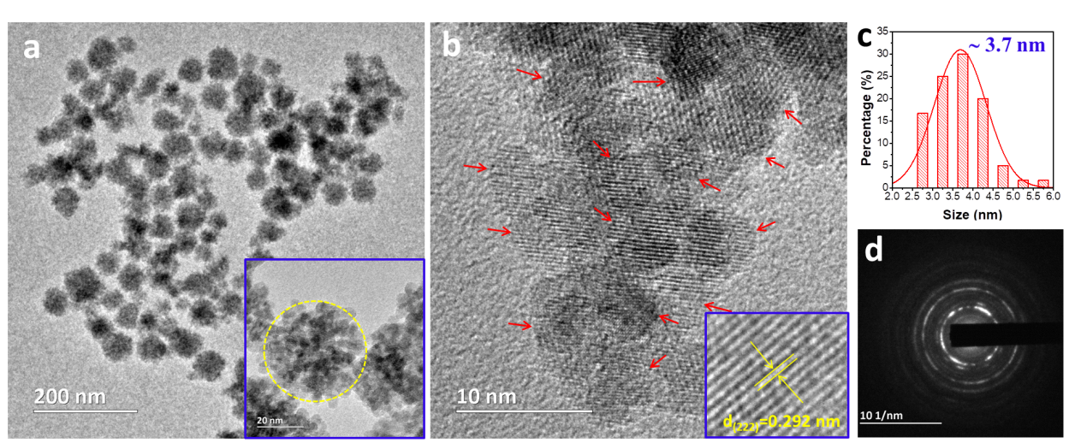
Fig. S1 (a) TEM, (b) HRTEM, (c) size distribution, and (d) SAED of pristine In₂O₃. The highlighted yellow ring in (a) shows one flower-like agglomerate. The red arrows in (b) represent the single nanocrystals, and the inset in (b) shows the lattice fringe with a spacing of 2.92 Å.

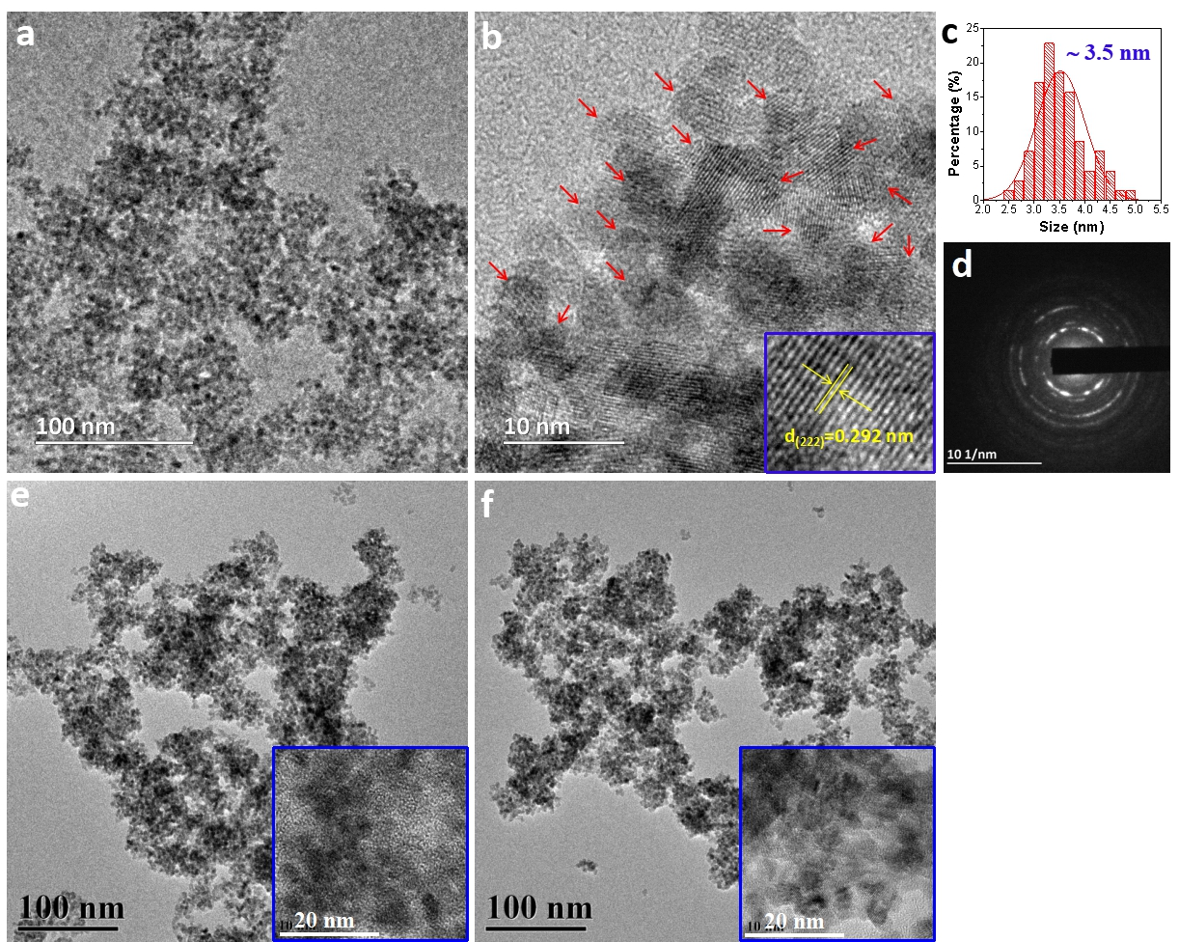
Fig. S2 (a) TEM, (b) HRTEM, (c) size distribution, and (d) SAED of 1.0% Bi_{x}In_{2-x}O₃ sample. (e) TEM and HRTEM of 3.0% Bi_{x}In_{2-x}O₃ sample. (f) TEM and HRTEM of 5.0% Bi_{x}In_{2-x}O₃ sample.

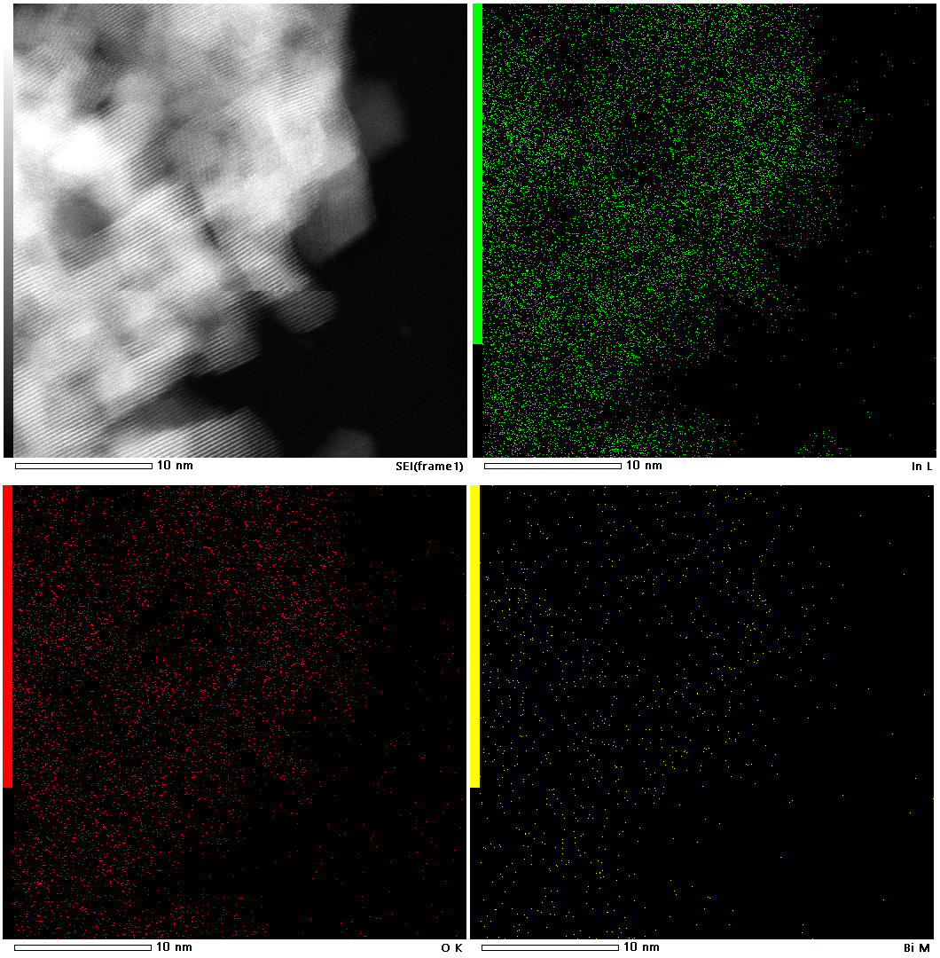
Fig. S3 Elemental mapping profiles of 1.0% Bi_{x}In_{2-x}O₃.

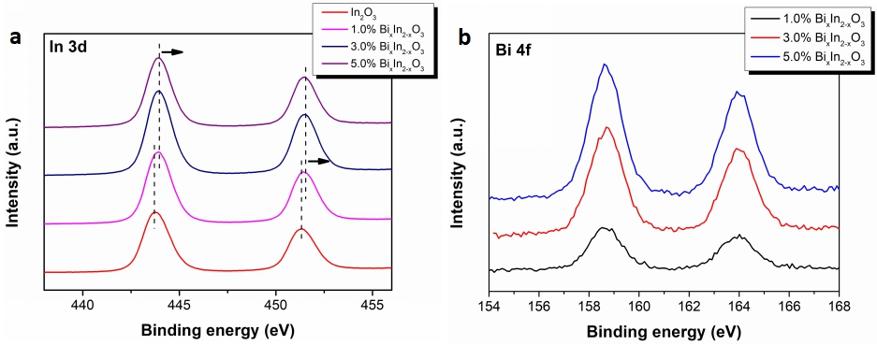
Fig. S4 (a) In 3d and (b) Bi 4f XPS spectra of pure In₂O₃ and Bi_{x}In_{2-x}O₃ nanocrystals.

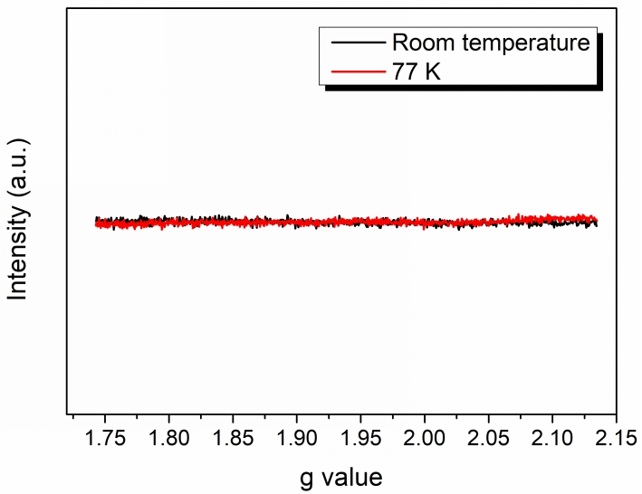
Fig. S5 EPR spectra of 1.0% Bi_{x}In_{2-x}O₃ nanocrystals recorded at room temperature and 77 K.

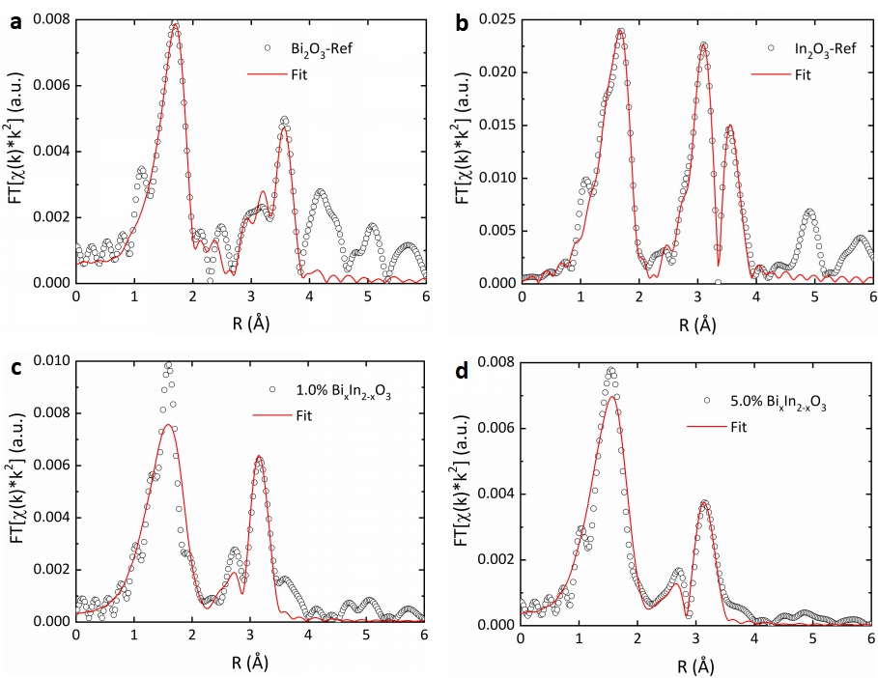
Fig. S6 Fitted Bi L₃-edge and In K-edge FT-EXAFS spectra from (a) Bi₂O₃ and (b) In₂O₃ reference materials, as well as (c) 1.0% and (d) 5.0% Bi_{x}In_{2-x}O₃ samples.

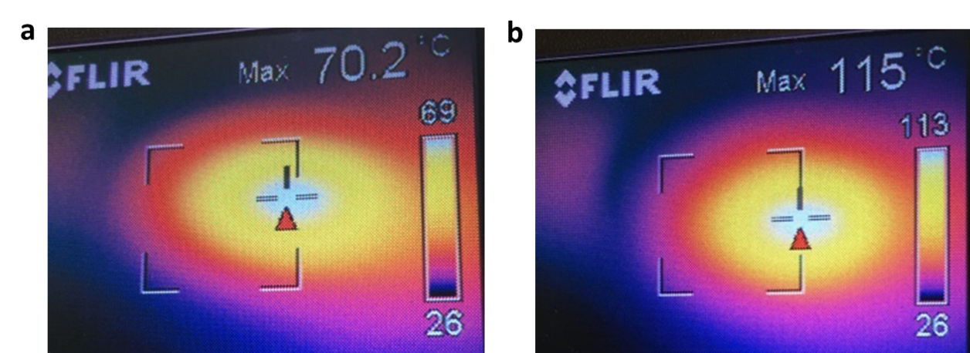
Fig. S7 The actual reaction temperature tested by IR camera on (a) pristine In₂O₃ and (b) 1.0% Bi_{x}In_{2-x}O₃ nanocrystals.

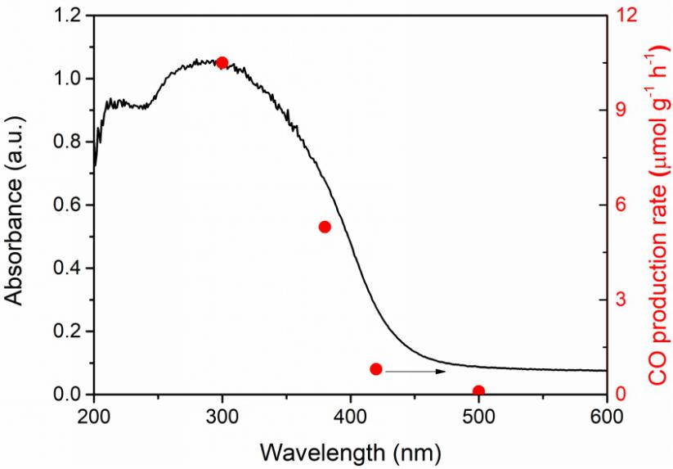
Fig. S8 CO production rate as a function of absorption cut-off filter wavelength for pure In₂O₃ sample.

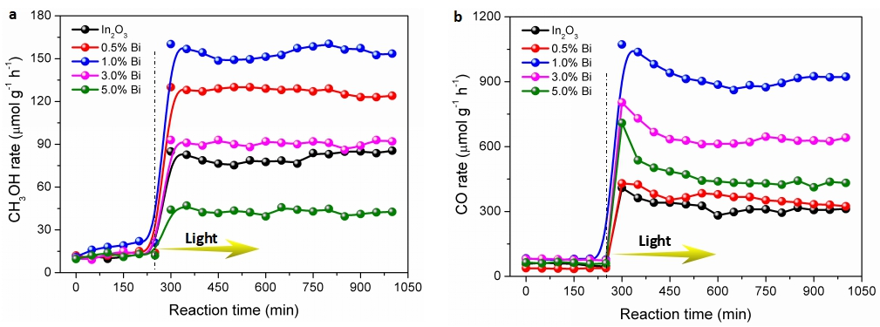
Fig. S9 (a) CH₃OH production and (b) CO production as function of reaction time on pristine In₂O₃ and Bi_{x}In_{2-x}O₃ nanocrystals in the flow reactor at 230 °C, with and without light irradiation.

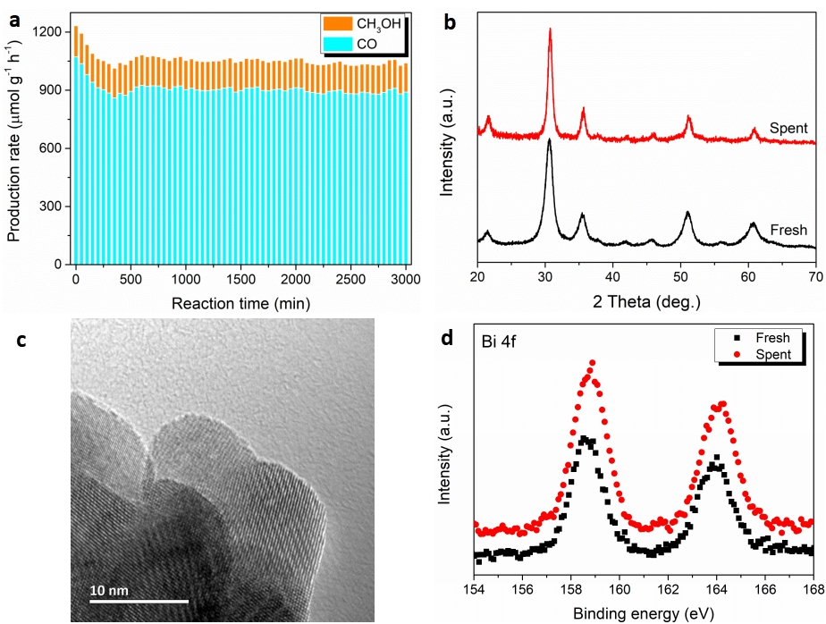
Fig. S10 (a) Plotted reaction rates demonstrating the long-term (50 h) catalytic stability of 1.0% Bi_{x}In_{2-x}O₃ nanocrystals during photocatalytic CO₂ hydrogenation. (b) XRD patterns, (c) TEM image, and (d) Bi 4f XPS spectra of fresh and spent (i.e., after 50 h stability testing) 1.0% Bi_{x}In_{2-x}O₃ nanocrystals.

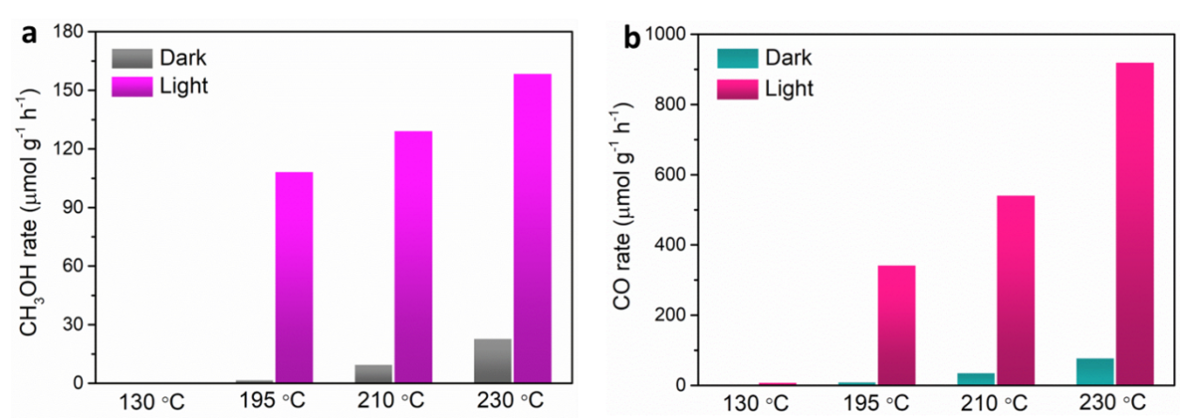
Fig. S11 (a) CH₃OH production rates and (b) CO production rates of the top-performing catalyst 1.0% Bi_{x}In_{2-x}O₃ as a function of reaction temperatures.

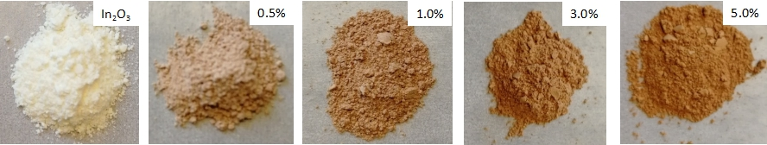
Fig. S12 The color of pure In₂O₃ and substituted Bi_{x}In_{2-x}O₃ nanocrystals.

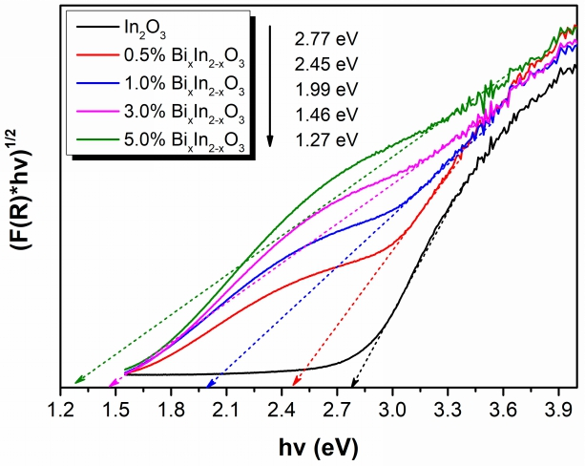
Fig. S13 Inferred band gaps of pristine In₂O₃ and various Bi_{x}In_{2-x}O₃ nanocrystals.

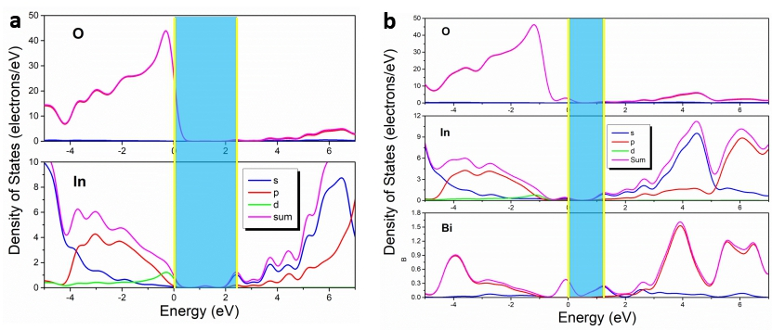
Fig. S14 Calculated DOS plots for (a) pristine In₂O₃ and (b) Bi_{x}In_{2-x}O₃ nanocrystals.

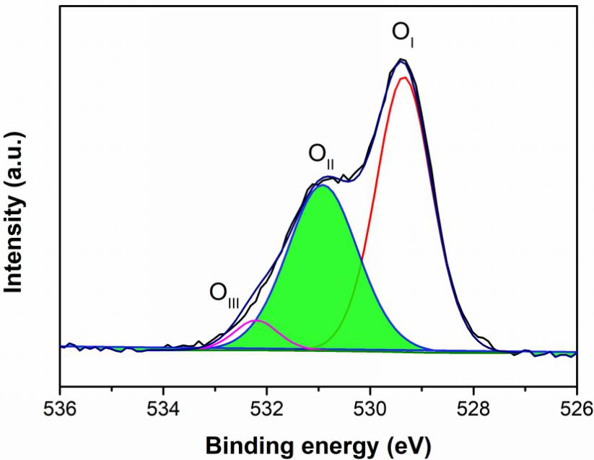
Fig. S15 High-resolution O 1s core-level XPS spectra of 1.0% Bi_{x}In_{2-x}O₃ nanocrystals. The O 1s core level XPS spectra could be fitted into three peaks at 529.3 eV, 530.9 eV, and 532.8 eV, which are assigned to oxides (O_{I}), oxygen vacancies (O_{II}), and hydroxyl groups (O_{III}), respectively.

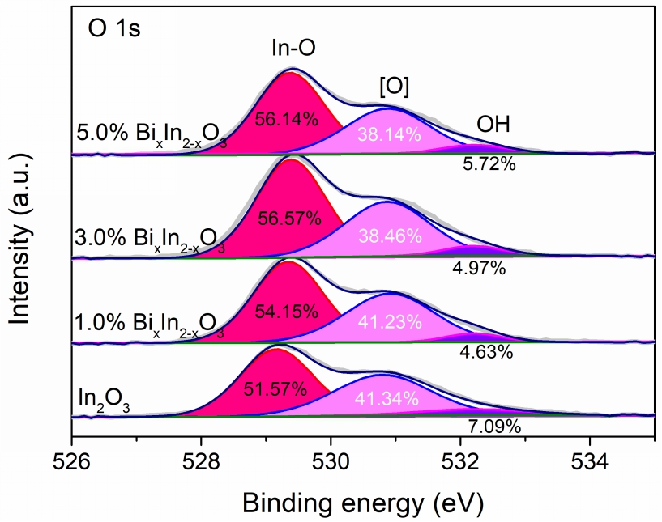
Fig. S16 High-resolution O 1s core-level XPS spectra of pure In₂O₃ and Bi_{x}In_{2-x}O₃ nanocrystals.

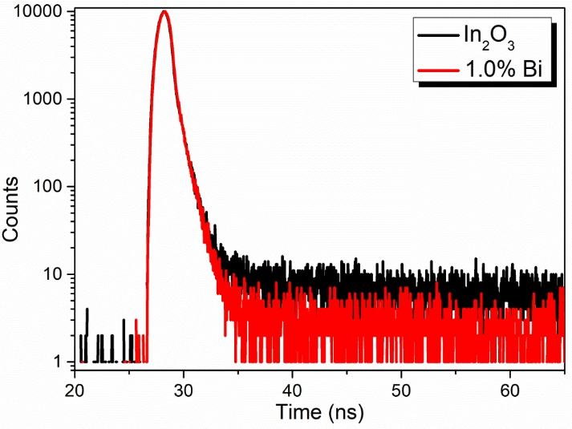
Fig. S17 Time-resolved PL spectra of pristine In₂O₃ and 1.0% Bi_{x}In_{2-x}O₃ nanocrystals.

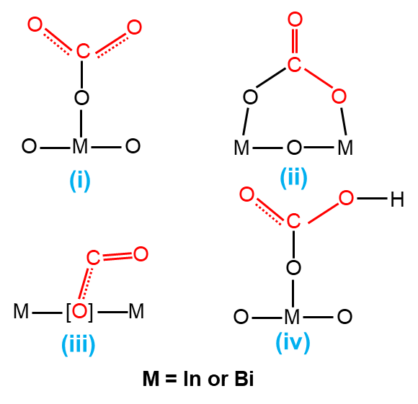
Fig. S18 Schematic of surface species contributing to the adsorption of CO₂ on Bi_{x}In_{2-x}O₃ nanocrystals, as exemplified by monodentate carbonate-like species (m-CO₃²⁻), bidentate carbonate-like species (b-CO₃²⁻), bent adsorbed species (CO₂^{δ-}), and bicarbonate-like species (HCO₃⁻).

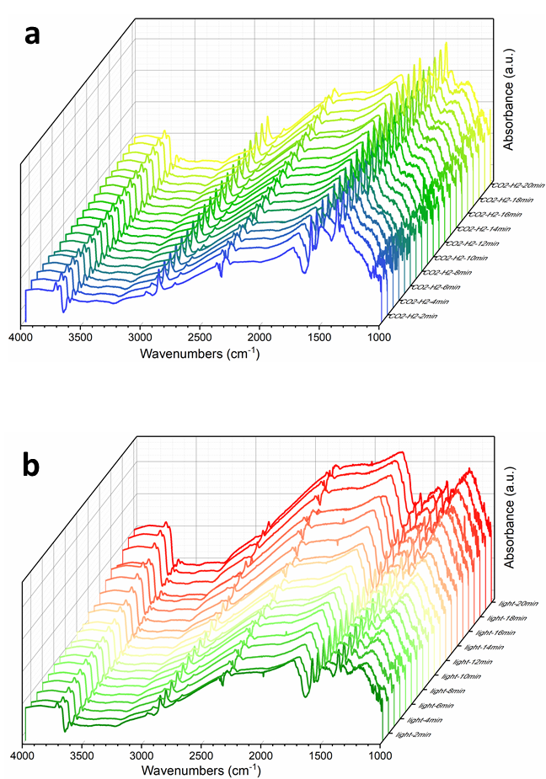
Fig. S19 In-situ DRIFTS spectra for CO₂ hydrogenation under (a) dark and (b) light conditions on 1.0% Bi_{x}In_{2-x}O₃.

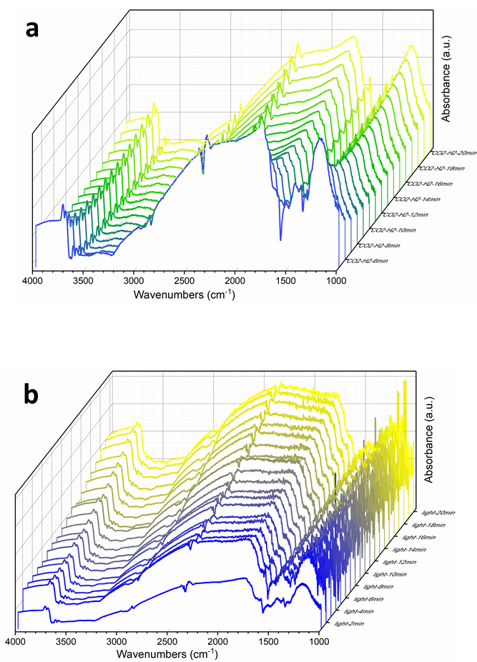
Fig. S20 In-situ DRIFTS spectra for CO₂ hydrogenation under (a) dark and (b) light conditions on pristine In₂O₃.

Note 1.
Calculation of turnover frequency (TOF)
TOF = number of produced molecues / (number of active sites * total reaction time)
NA = 6.022 x 10¹⁷ μmol⁻¹
Number of produced molecules per hour = CO rate (μmol h⁻¹m⁻²) x NA / total reaction time
Total reaction time = 1 h
Number of surface O atoms at exposed facet = 9.23 x 10¹⁸ m⁻²
- Pristine In₂O₃ rate: 35.6 μmol h⁻¹g⁻¹ 1.06 μmol h⁻¹m⁻² (accoring to the surface area: 33.5 m²g⁻¹)
The number of produced molecules per hour for pristine In₂O₃ is 6.38 x 10¹⁷ m⁻²h⁻¹
- 1.0% Bi_{x}In_{2-x}O₃ rate: 7959 μmol h⁻¹g⁻¹ 232.72 μmol h⁻¹m⁻² (accoring to the surface area: 34.2 m²g⁻¹)
The number of produced molecules per hour for 1.0% Bi_{x}In_{2-x}O₃ is 1.4 x 10²⁰ m⁻²h⁻¹

Model 1: Assume all [O] will be used for reaction
Number of active sites = number of [O] = 9.23 x 10¹⁸ m⁻² x [O] value obtained from XPS (41.34%) = 3.82 x 10¹⁸ m⁻²
TOF_{In2O3} = 6.38 x 10¹⁷ m⁻²h⁻¹ / 3.82 x 10¹⁸ m⁻² = 0.167 h⁻¹
Similarly, TOF_{1.0% BixIn2-xO3} = 36.8 h⁻¹.

Model 2: Assume only extrinsic [O] will be used for reaction
Number of active sites = number of extrinsic [O] = 9.23 x 10¹⁸ m⁻² x ([O] value obtained from XPS (41.34%) – intrinsic [O] of In₂O₃ (25%) ) = 1.51 x 10¹⁸ m⁻²
TOF_{In2O3} = 6.38 x 10¹⁷ m⁻²h⁻¹ / 1.51 x 10¹⁸ m⁻² = 0.42 h⁻¹
As a result, TOF_{1.0% BixIn2-xO3} = 93.6 h⁻¹.

References

- L. He, T. E. Wood, B. Wu, Y. C. Dong, L. B. Hoch, L. M. Reyes, D. Wang, C. Kubel, C. X. Qian, J. Jia, K. Liao, P. G. O'Brien, A. Sandhel, J. Y. Y. Loh, P. Szymanski, N. P. Kherani, T. C. Sum, C. A. Mims, G. A. Ozin, ACS Nano 2016, 10, 5578.
- Y. C. Dong, K. K.Ghuman, R. Popescu, P. N. Duchesne, W. J. Zhou, J. Y. Y. Loh, A. A. Jelle, J. Jia, D. Wang, X. K. Mu, G. A. Ozin, Adv. Sci. 2018, 5. 1700732.
- J. Jia, P. G. O’Brien, L. He, Q. Qiao, T. Fei, L. M. Reyes, T. E. Burrow, Y. C. Dong, K. Liao, M. Varela, S. J. Pennycook, M. Hmadeh, A. S. Helmy, N. P. Kherani, D. D. Perovic, G. A. Ozin, Adv. Sci. 2016, 3, 1600189.
- Y. F. Li, N. Soheilnia, M. Geriner, U. Ulmer, T. Wood, A. A. Jelle, Y. C. Dong, A. P. Y. Wong, J. Jia, G. A. Ozin, ACS Appl. Mater. Interfaces 2019, 11, 5610.
- M. Li, P. Li, K. Chang, T. Wang, L. Q. Liu, Q. Kang, S. X. Ouyang, J. H. Ye, Chem. Commun. 2015, 51, 7645.
- C. X. Qian, W. Sun, D. L. H. Hung, C. Y. Qiu, M. Makaremi, S. G. H. Kumar, L. L. Wan, M. Ghoussoub, T. E. Wood, M. K. Xia, A. A. Tountas, Y. F. Li, L. Wang, Y. C. Dong, I. Gourevich, C. V. Singh, G. A. Ozin, Nat. Catal. 2019, 2, 46-54.
- H. Wang, J. Jia, K. Butler, R. Song, G. Casillas, L. He, N. P. Kherani, D. D. Perovic, L. Q. Jing, A. Walsh, R. Dittmeyer, G. A. Ozin, Adv. Sci. 2019, 6, 1902170.

