Assessment of Model Convergence
There are several methods to check for convergence. Among them trace plot for monitoring convergence have been presented below.
Trace plots: This is the graph which could be plotted the iterations versus the generated values. In this graph convergence can be attained if all values are within a zone without strong periodicities (up and down periods). Therefore, the trace plots below are all straight line which did not show up and down periods. This is an indication that all posterior estimates were converged.
Figure 1 Trace plots for convergence of coefficients for Number of antenatal care visit of mother.
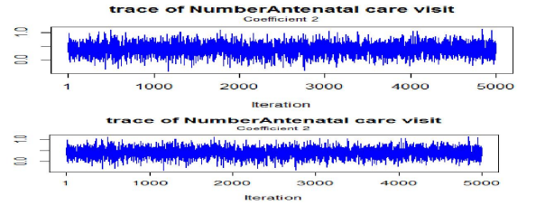
Figure 2 Trace plots for convergence of coefficients for delivery place of mother.
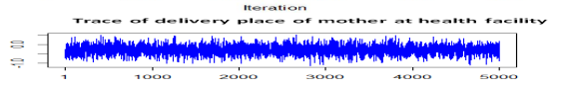
Figure 3 Trace plots for convergence of coefficients for mother wealth index.

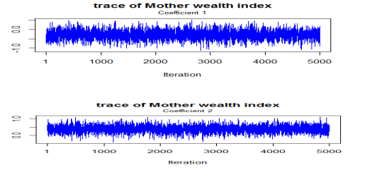
Figure 4 Trace plots for convergence of coefficients for marital status of mother.
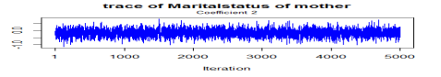
Figure 5 Trace plots for convergence of coefficients for birth order of mother.
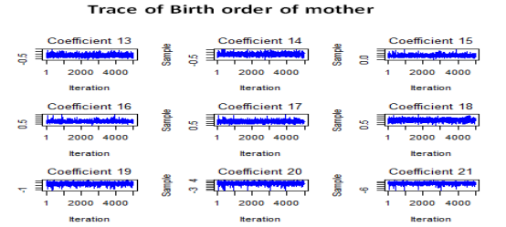
Figure 6 Trace plots for convergence of coefficients for age of mother.
