Revealing the Antioxidant Properties of Alkyl Gallates: A Novel Approach through Quantum Chemical Calculations and Molecular Docking
Nihat Karakuş
Department of Chemistry, Faculty of Science Sivas Cumhuriyet University, 58140 Sivas, Turkey

Support Files
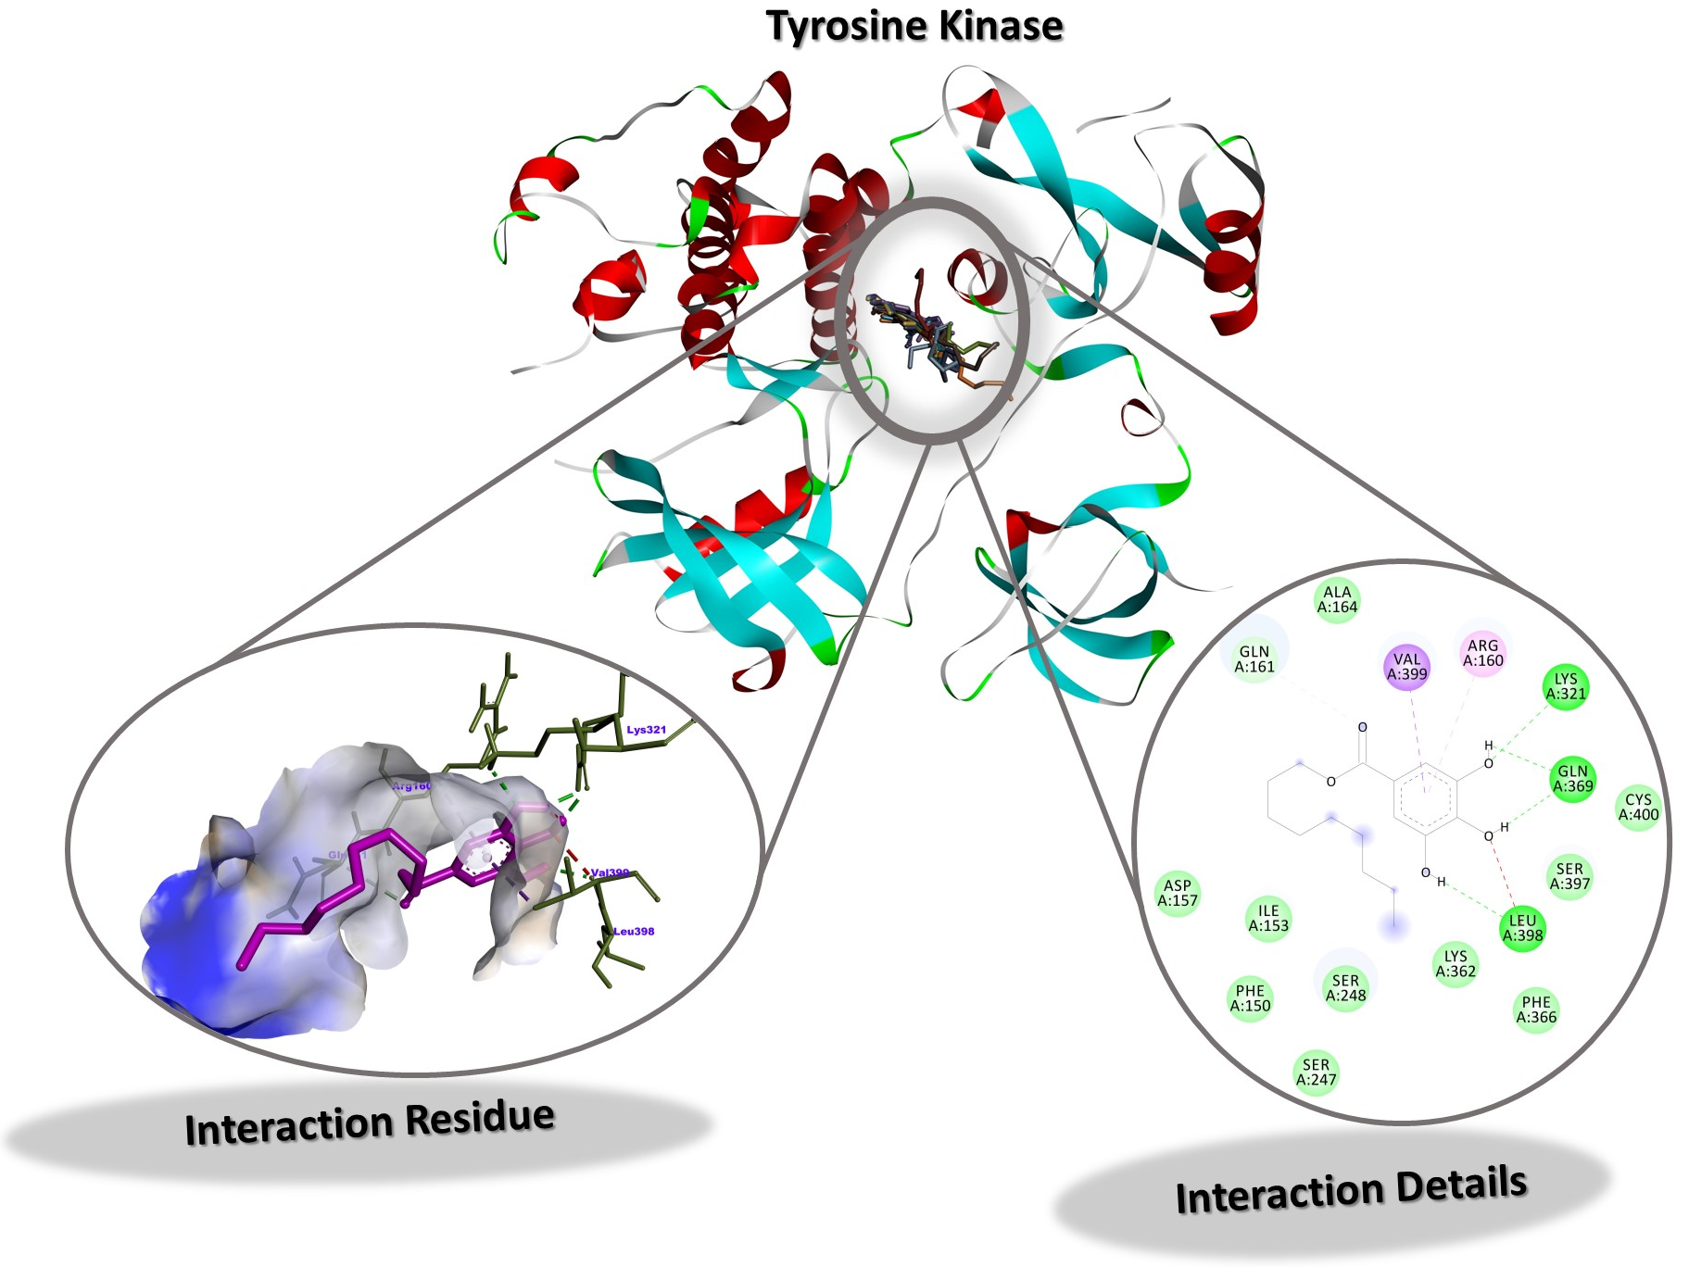
Figure S1. Interaction Residue and Interaction Details of DG against Tyrosine Kinase Hck

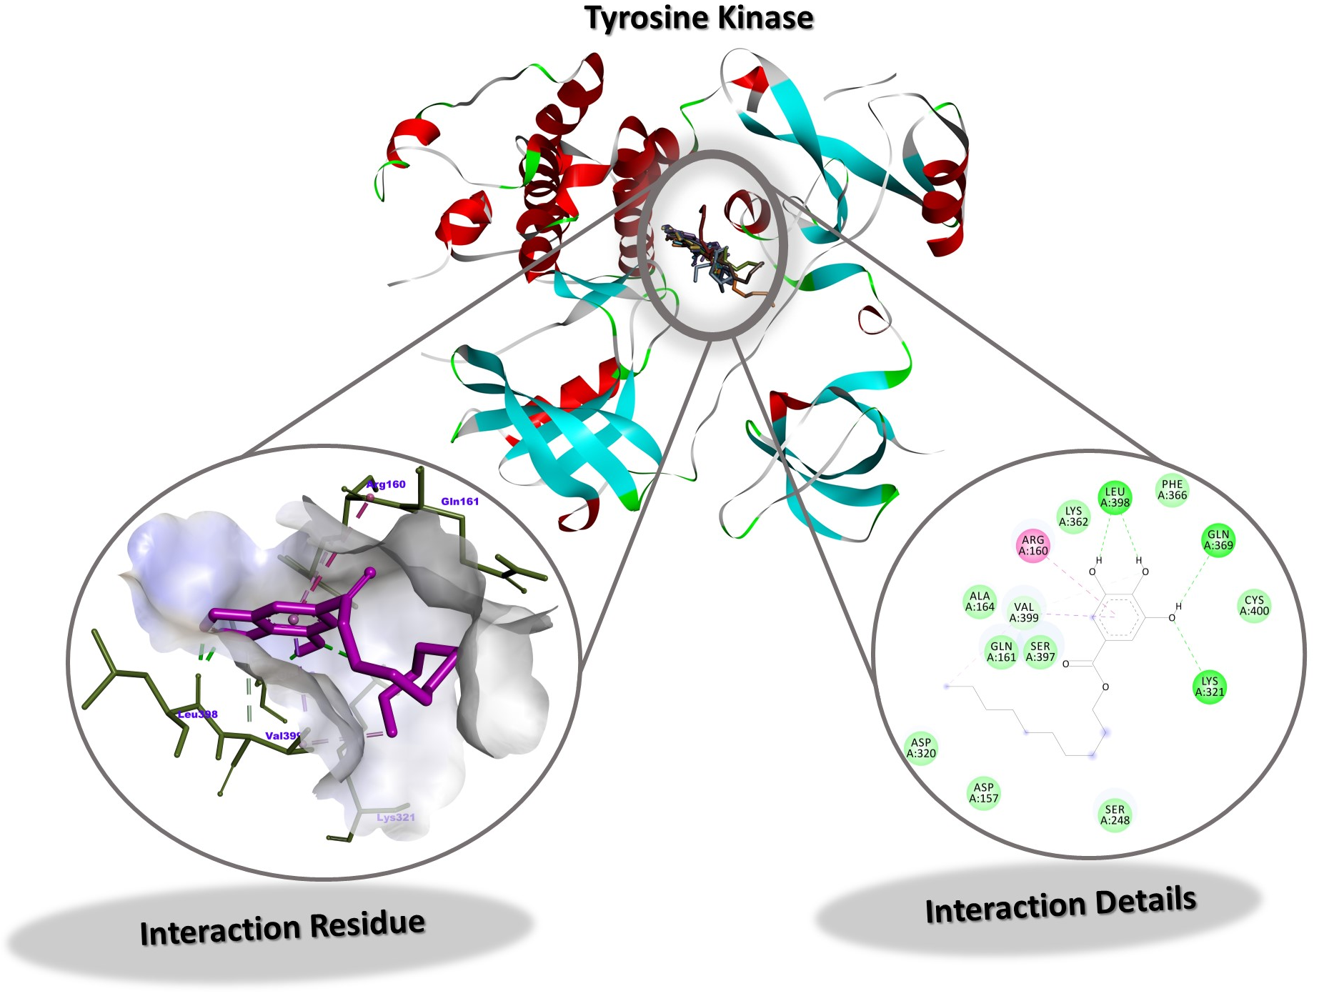
Figure S2. Interaction Residue and Interaction Details of DOG against Tyrosine Kinase Hck

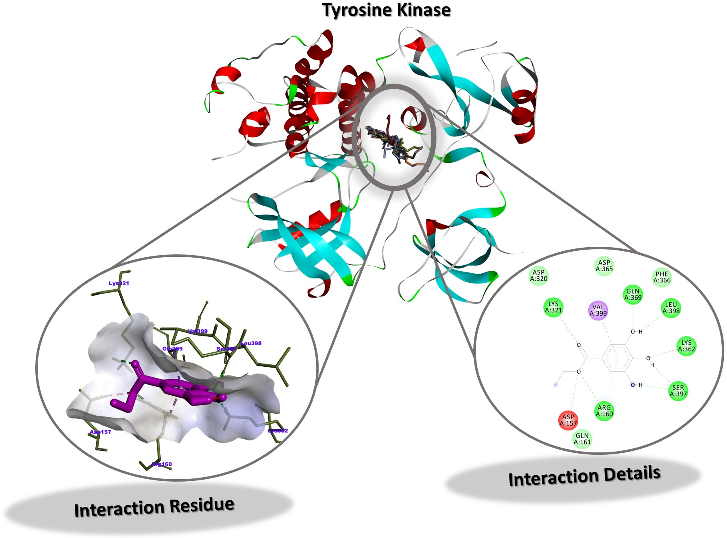
Figure S3. Interaction Residue and Interaction Details of EG against Tyrosine Kinase Hck
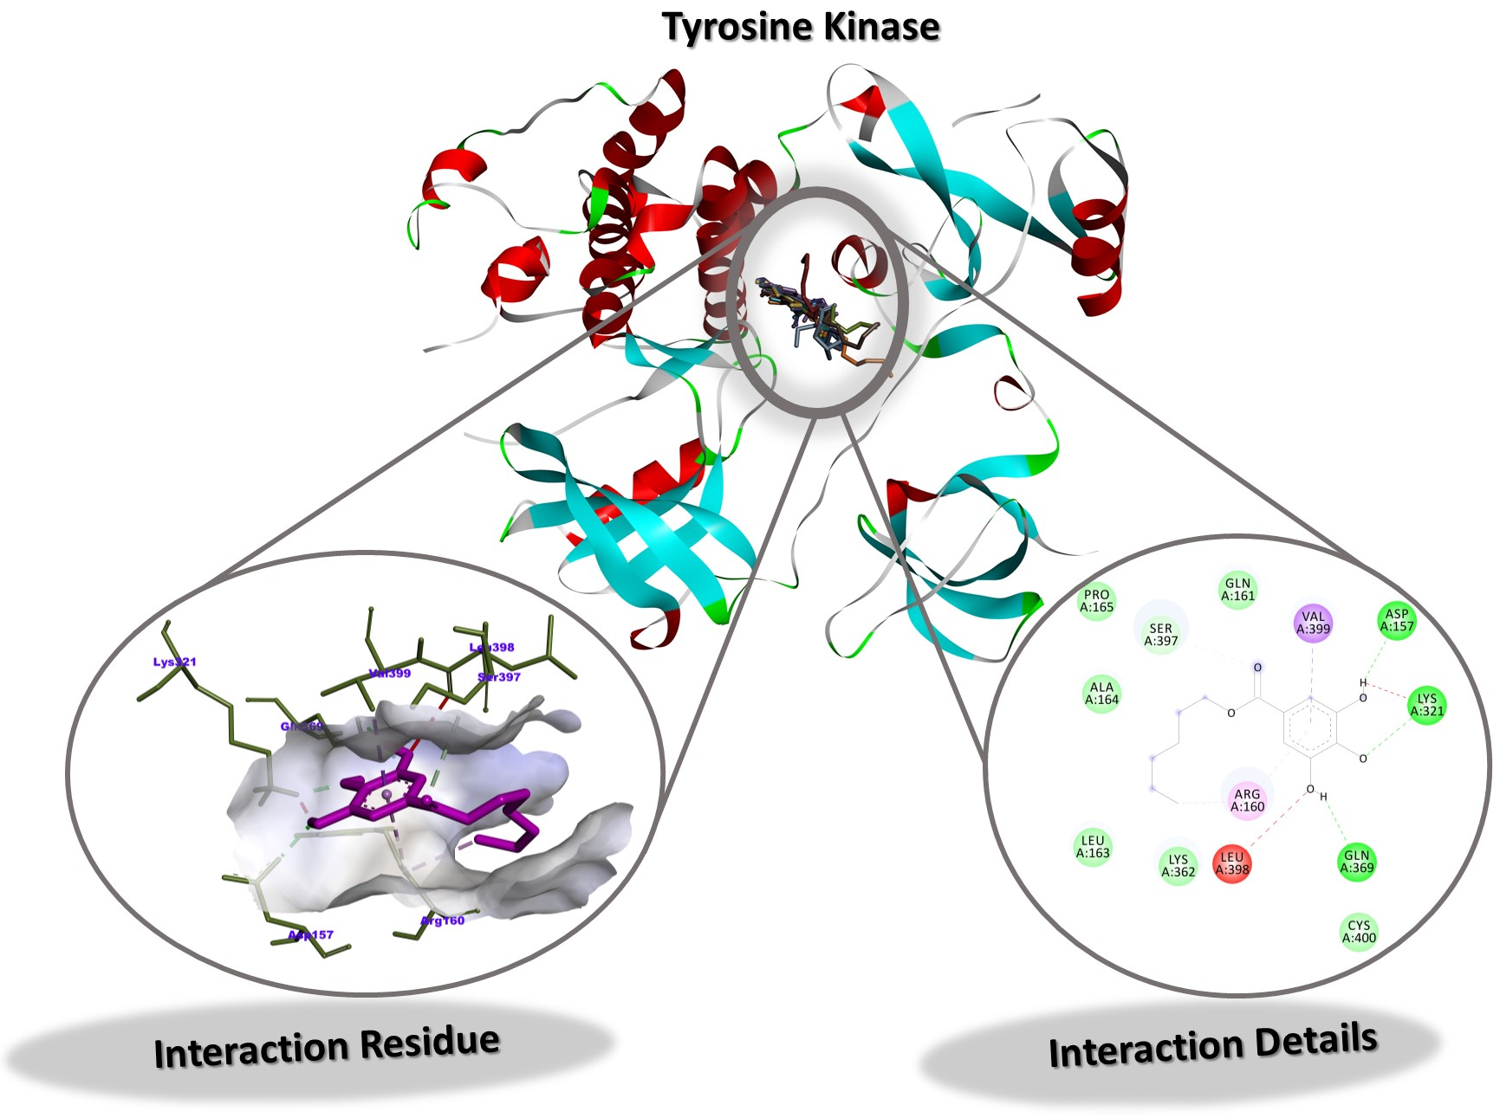
Figure S4. Interaction Residue and Interaction Details of HG against Tyrosine Kinase Hck

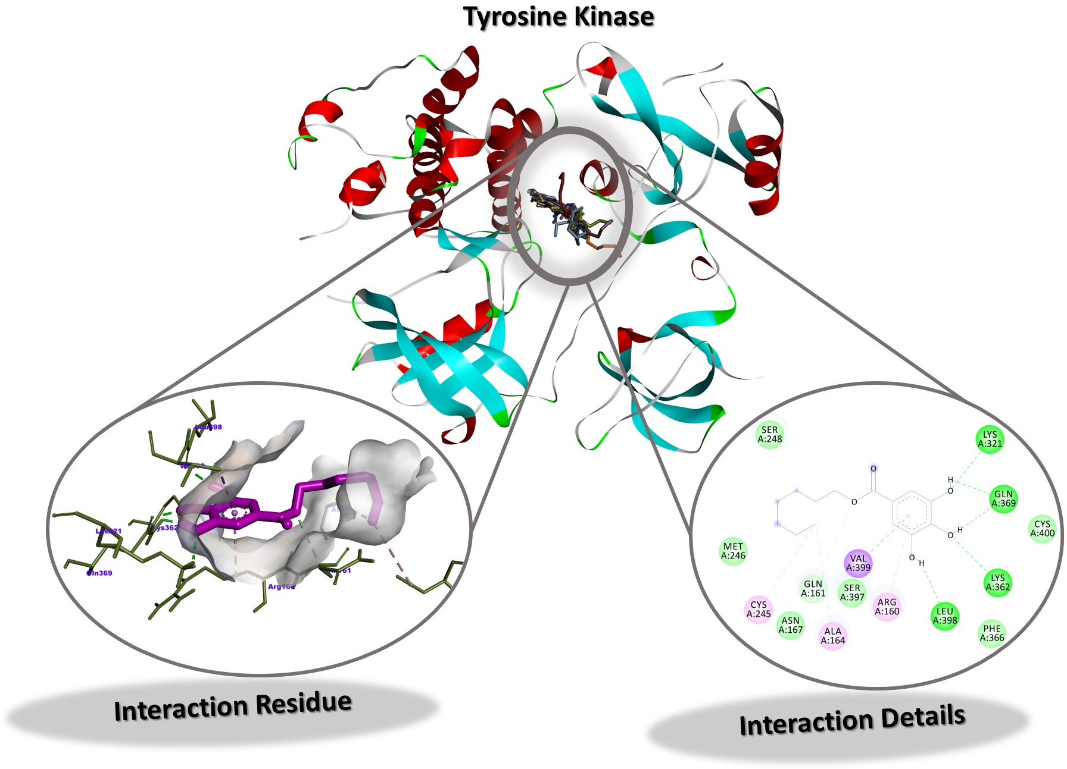
Figure S5. Interaction Residue and Interaction Details of HPG against Tyrosine Kinase Hck
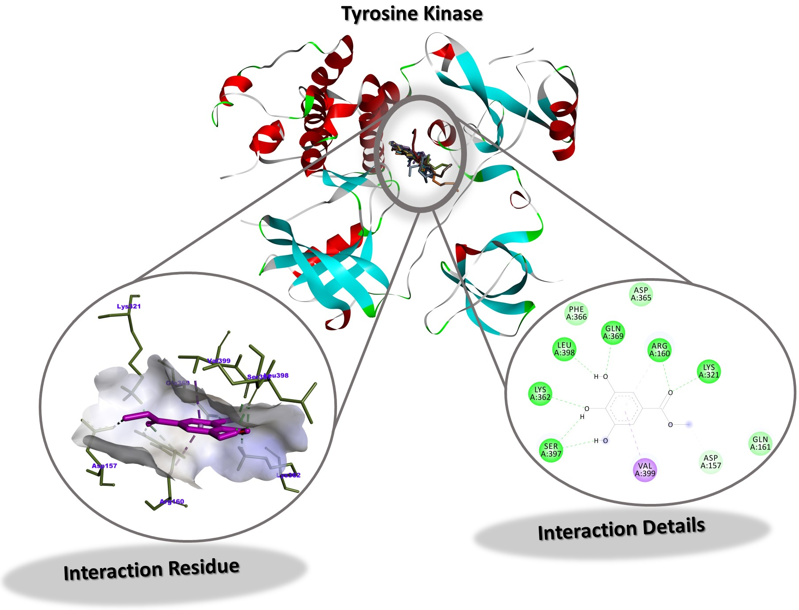
Figure S6. Interaction Residue and Interaction Details of MG against Tyrosine Kinase Hck

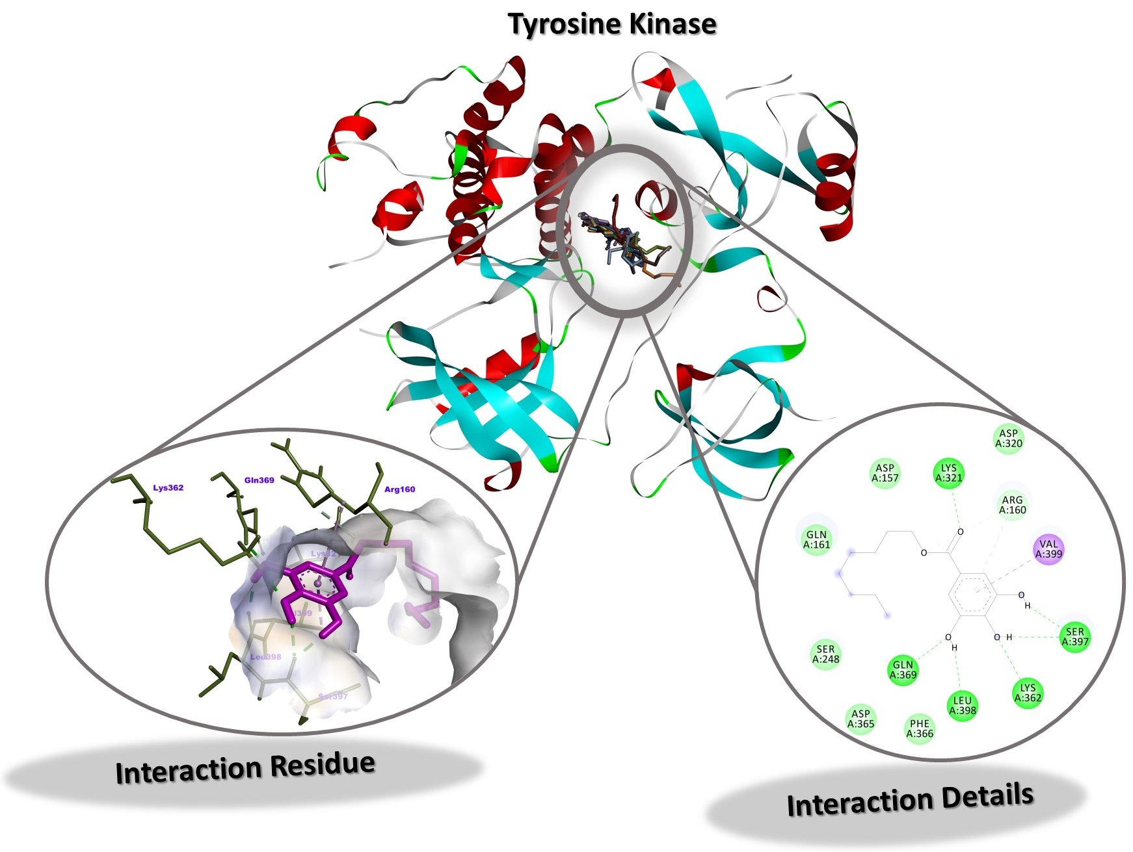
Figure S7. Interaction Residue and Interaction Details of OG against Tyrosine Kinase Hck
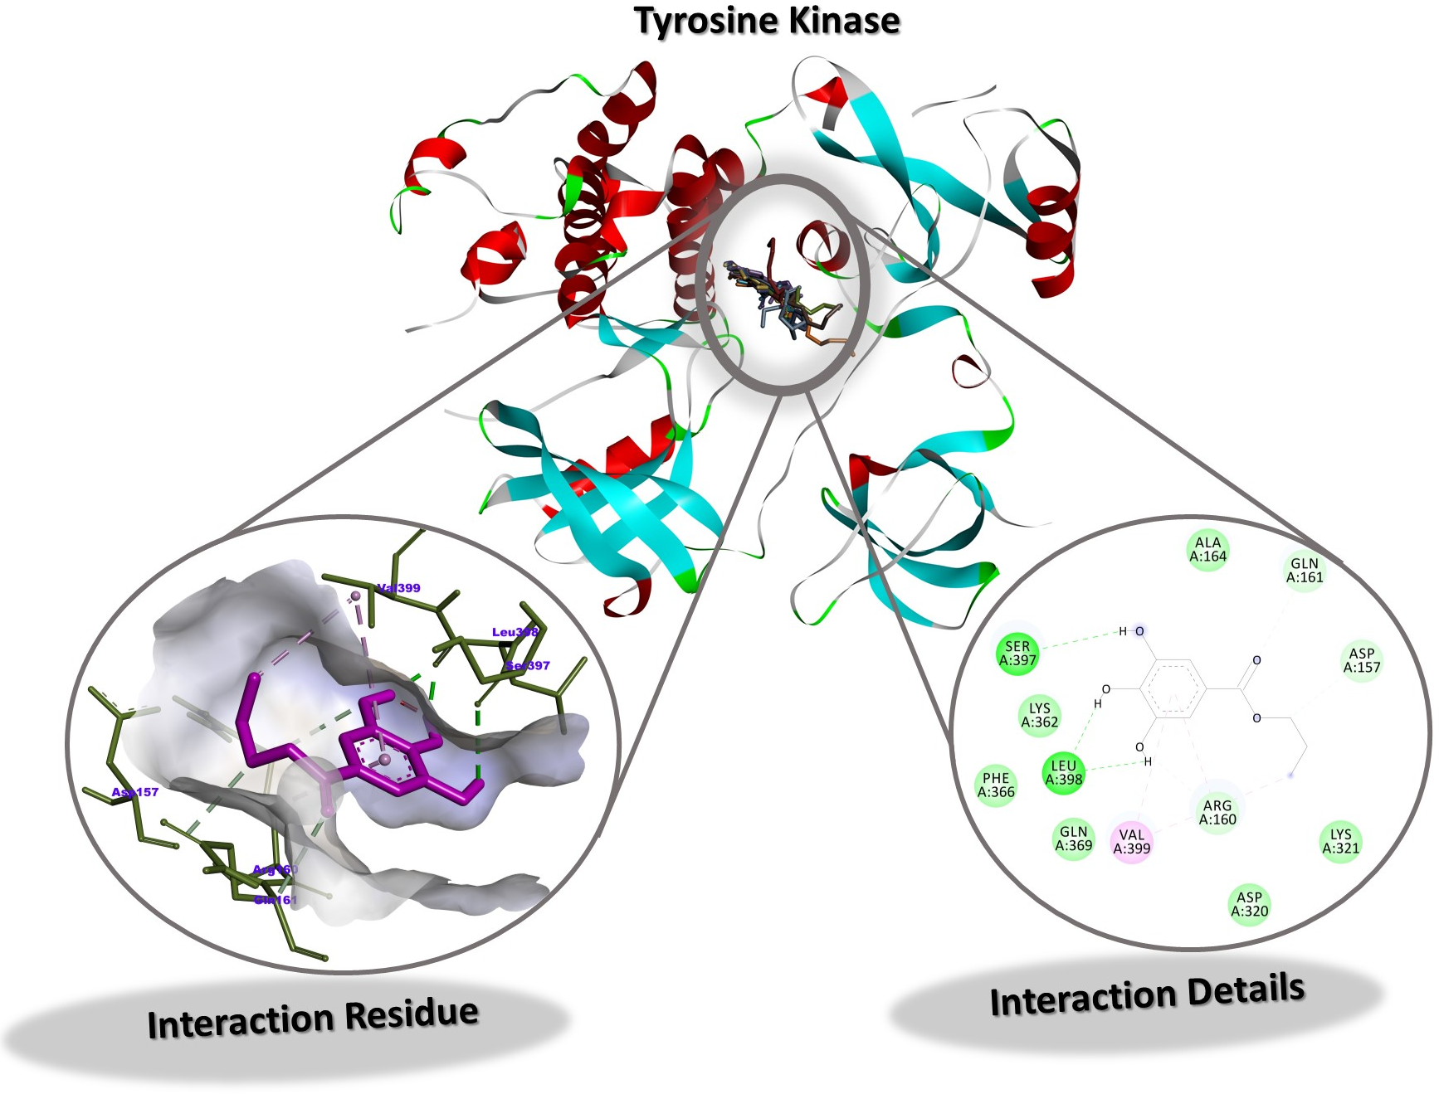
Figure S8. Interaction Residue and Interaction Details of PG against Tyrosine Kinase Hck

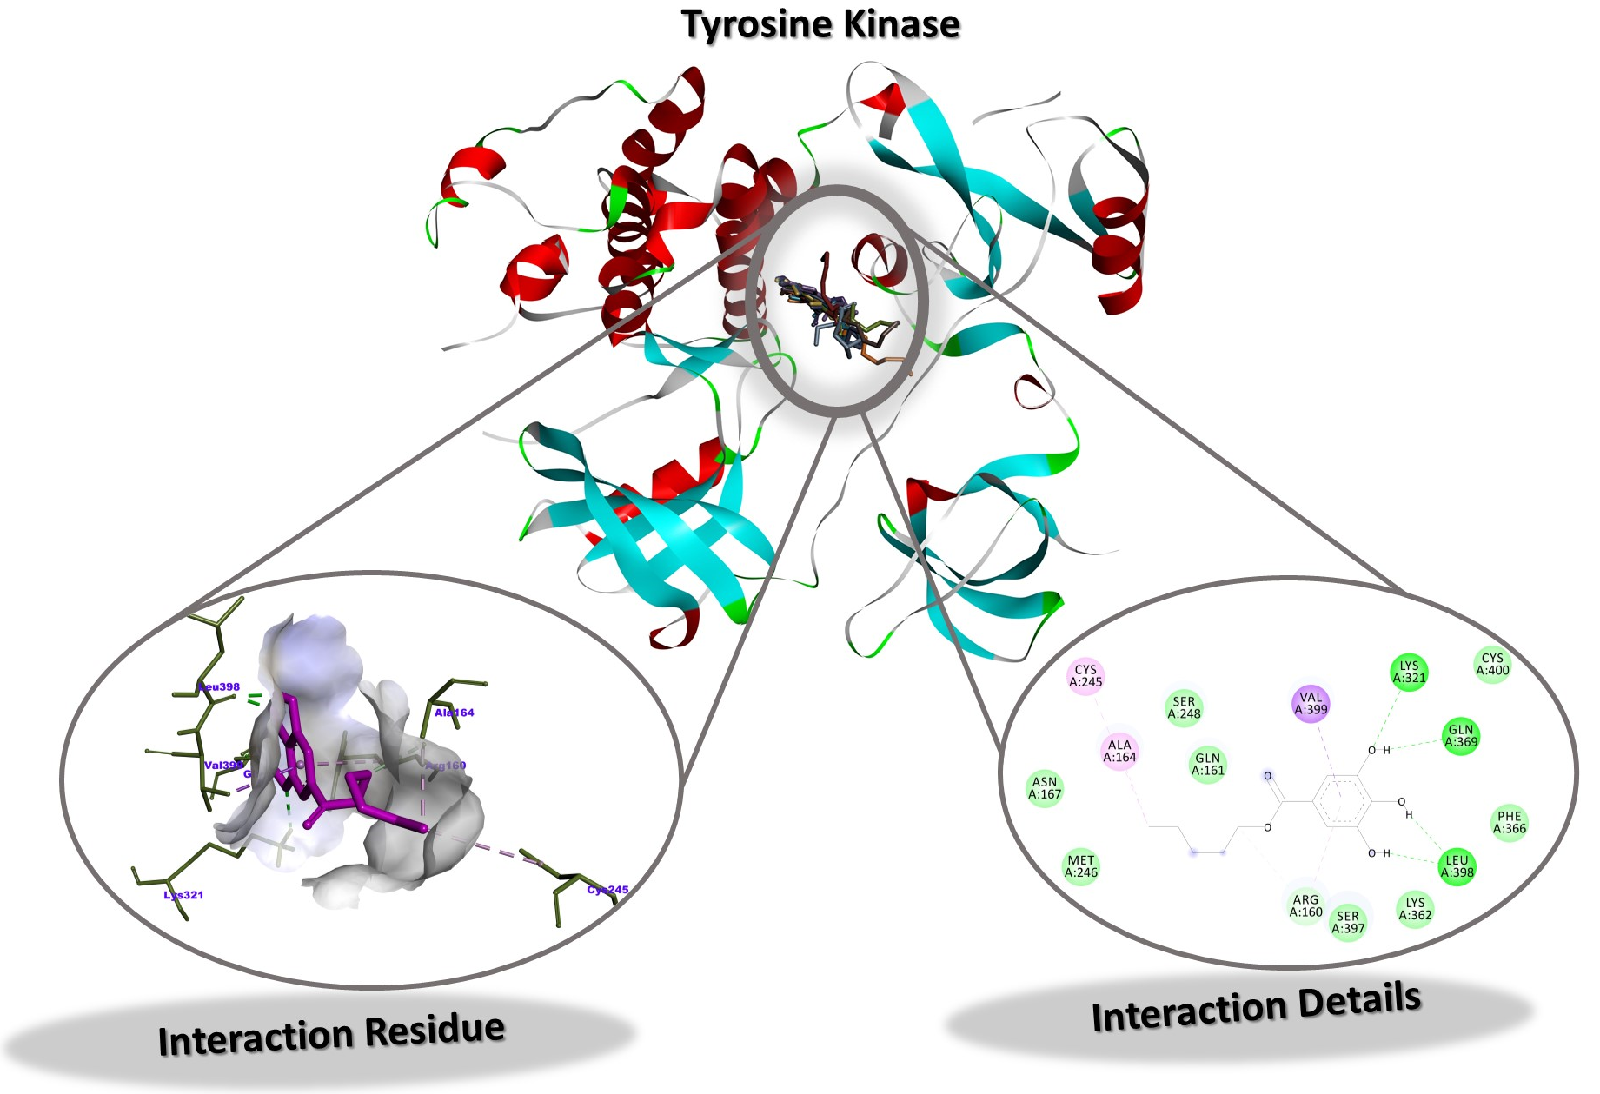
Figure S9. Interaction Residue and Interaction Details of PNG against Tyrosine Kinase Hck
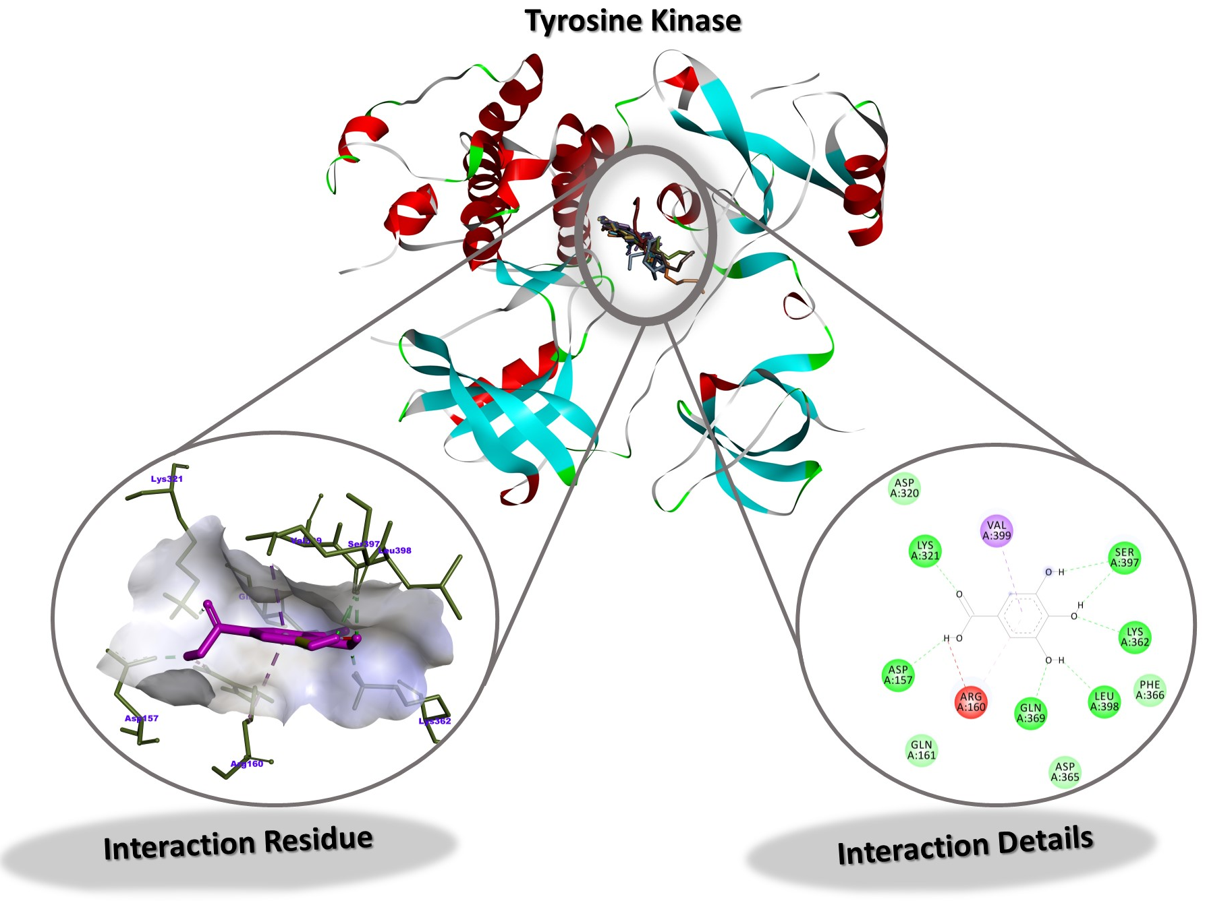
Figure S10. Interaction Residue and Interaction Details of GA against Tyrosine Kinase Hck

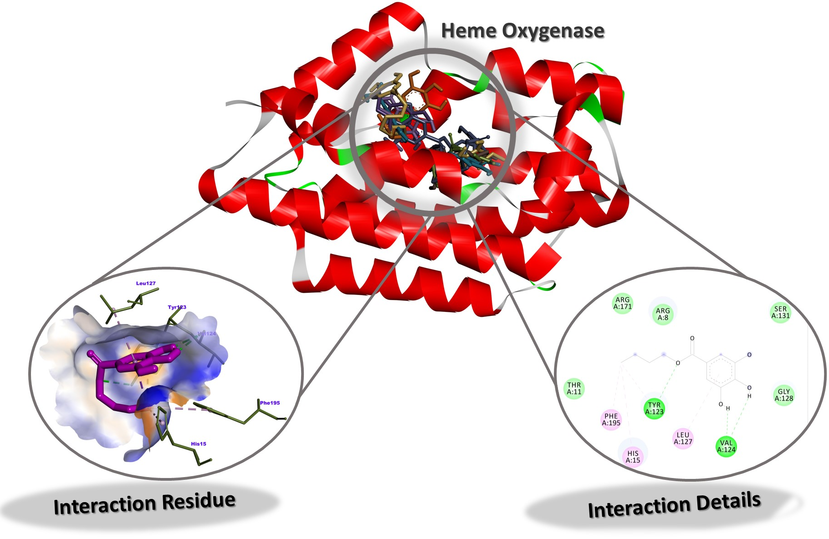
Figure S11. Interaction Residue and Interaction Details of BG against Heme Oxygenase
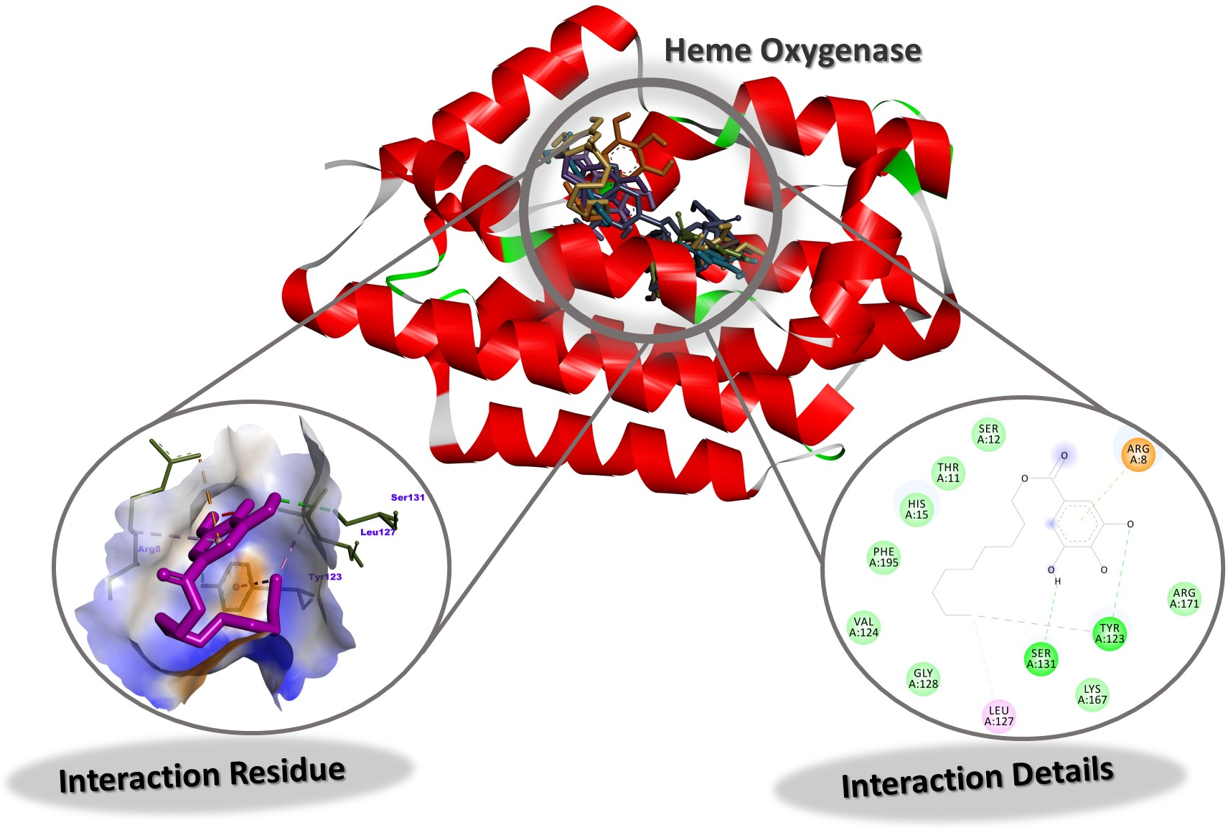
Figure S12. Interaction Residue and Interaction Details of DG against Heme Oxygenase

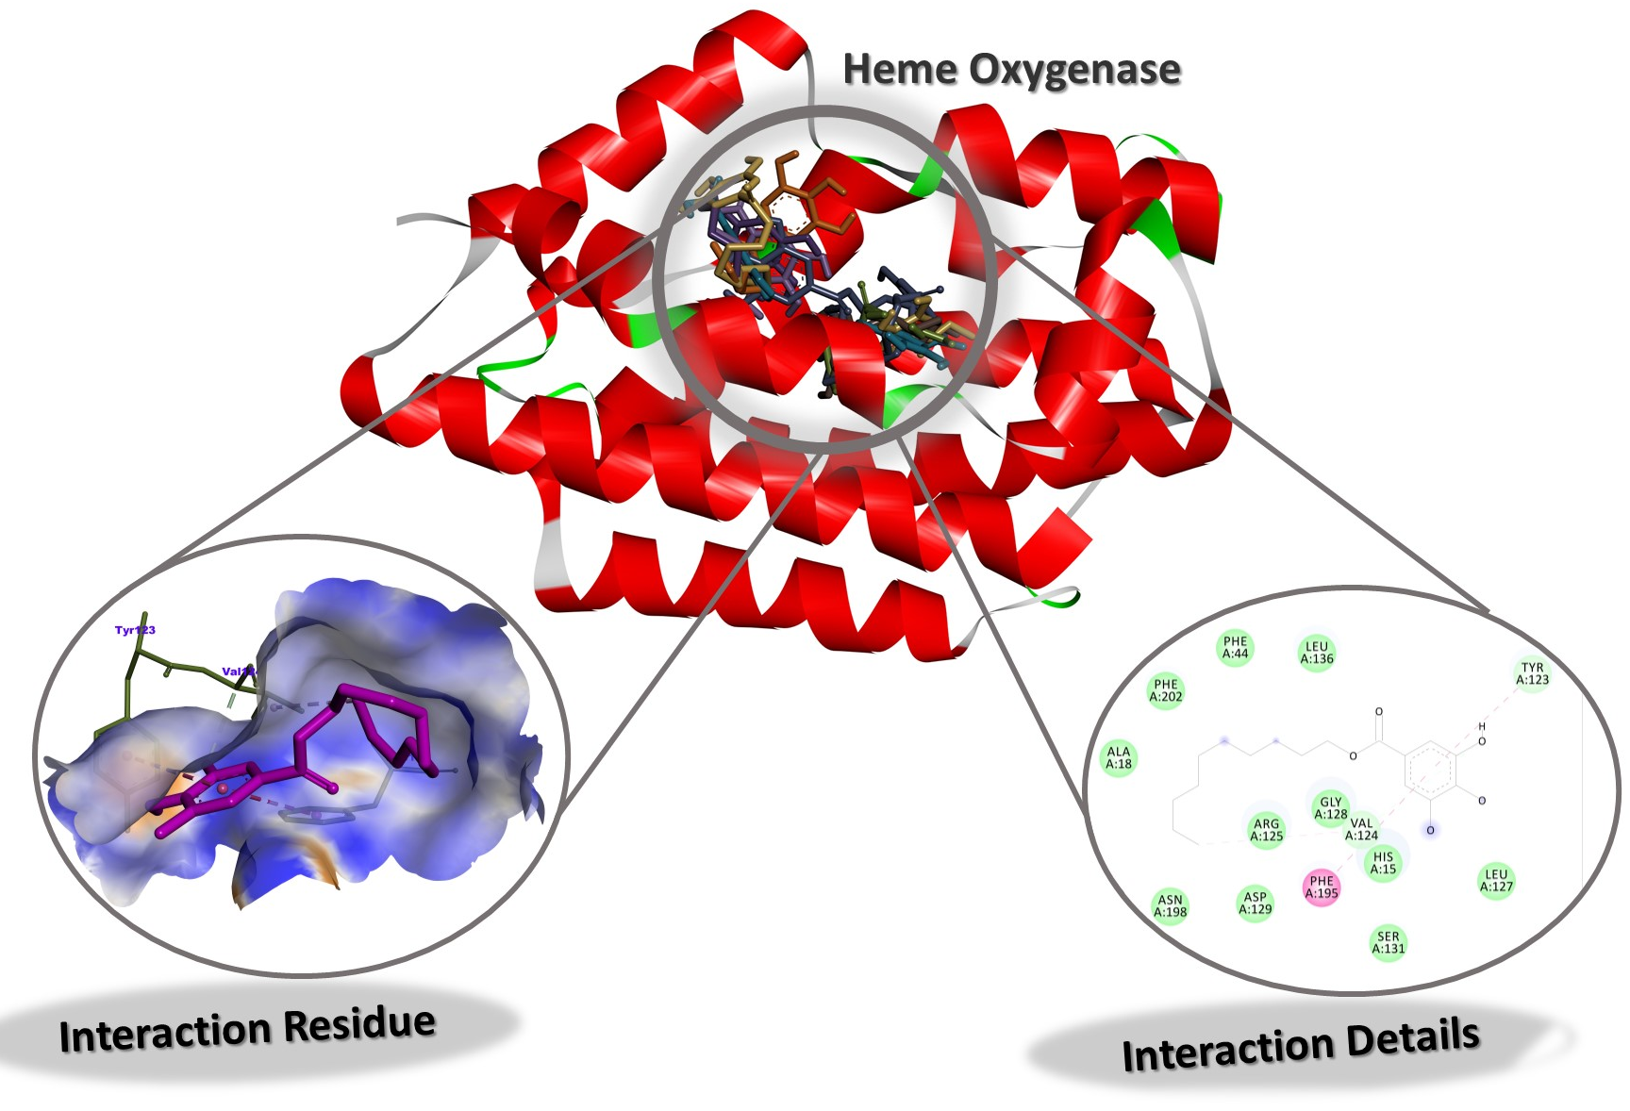
Figure S13. Interaction Residue and Interaction Details of DOG against Heme Oxygenase
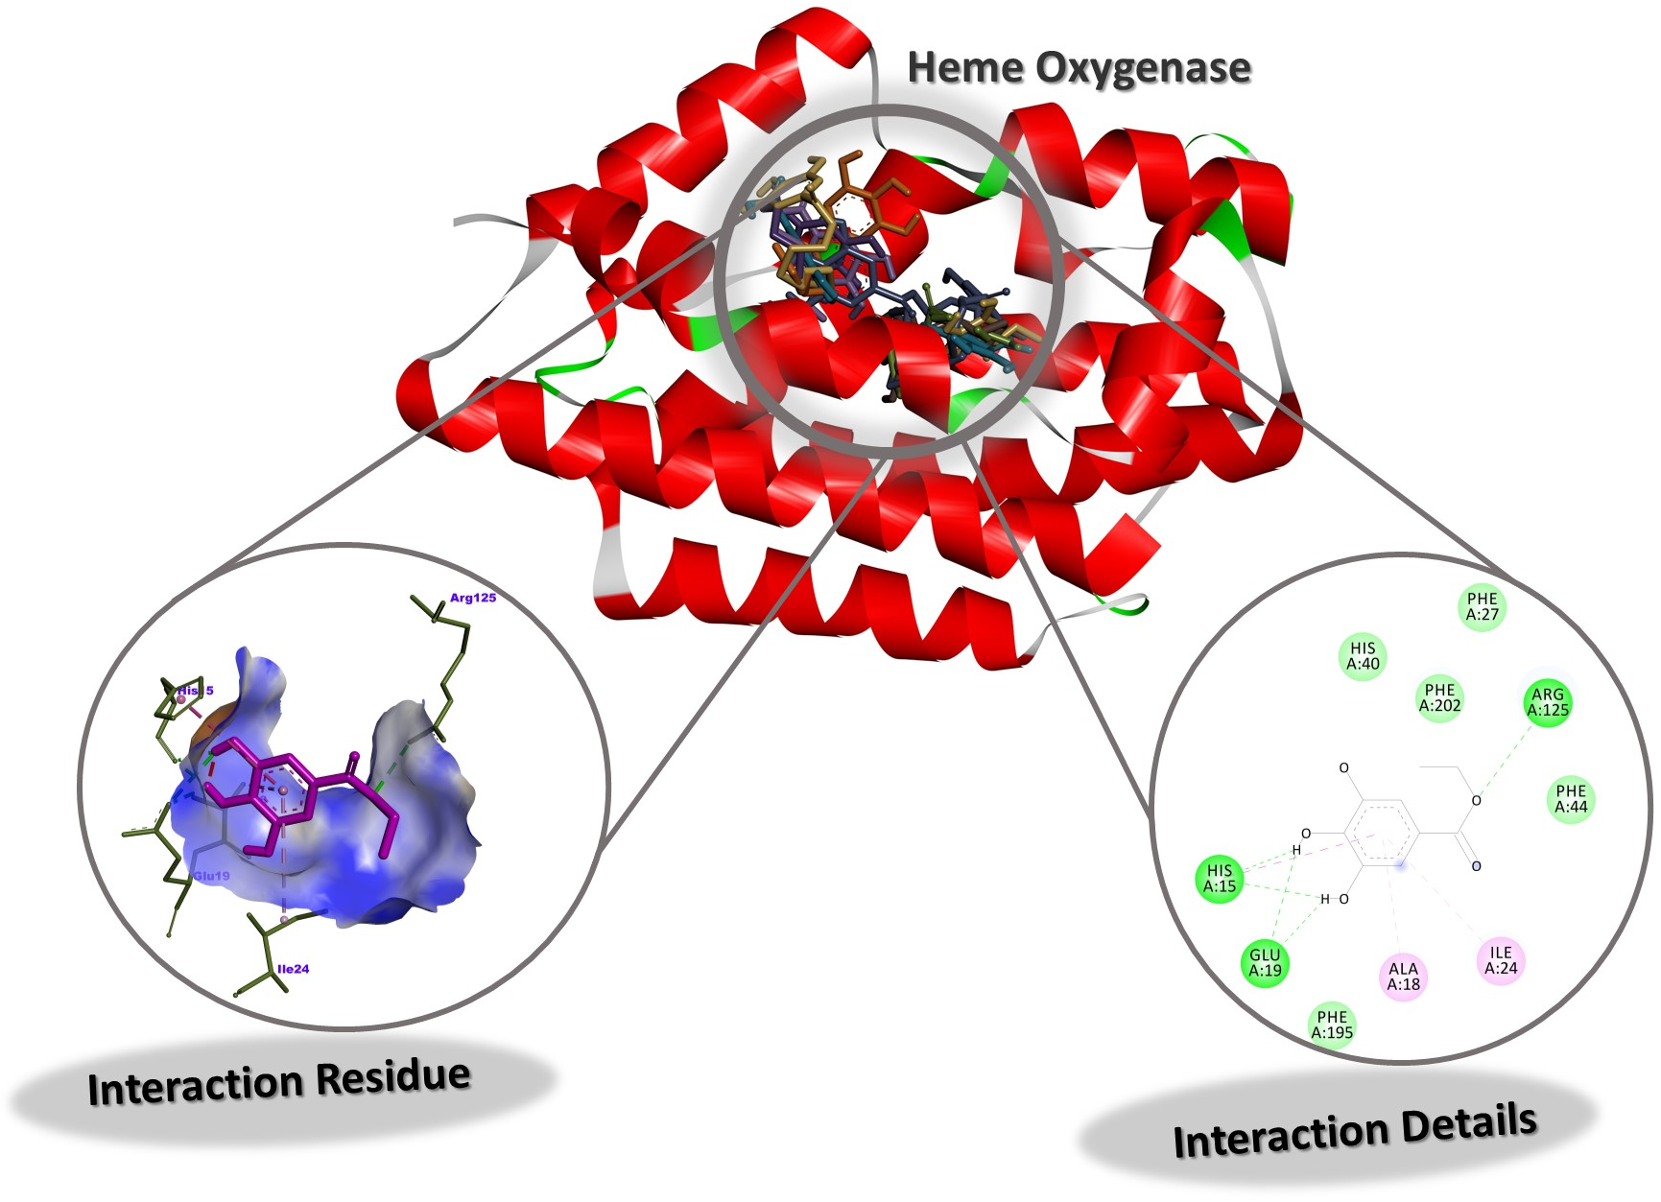
Figure S14. Interaction Residue and Interaction Details of EG against Heme Oxygenase

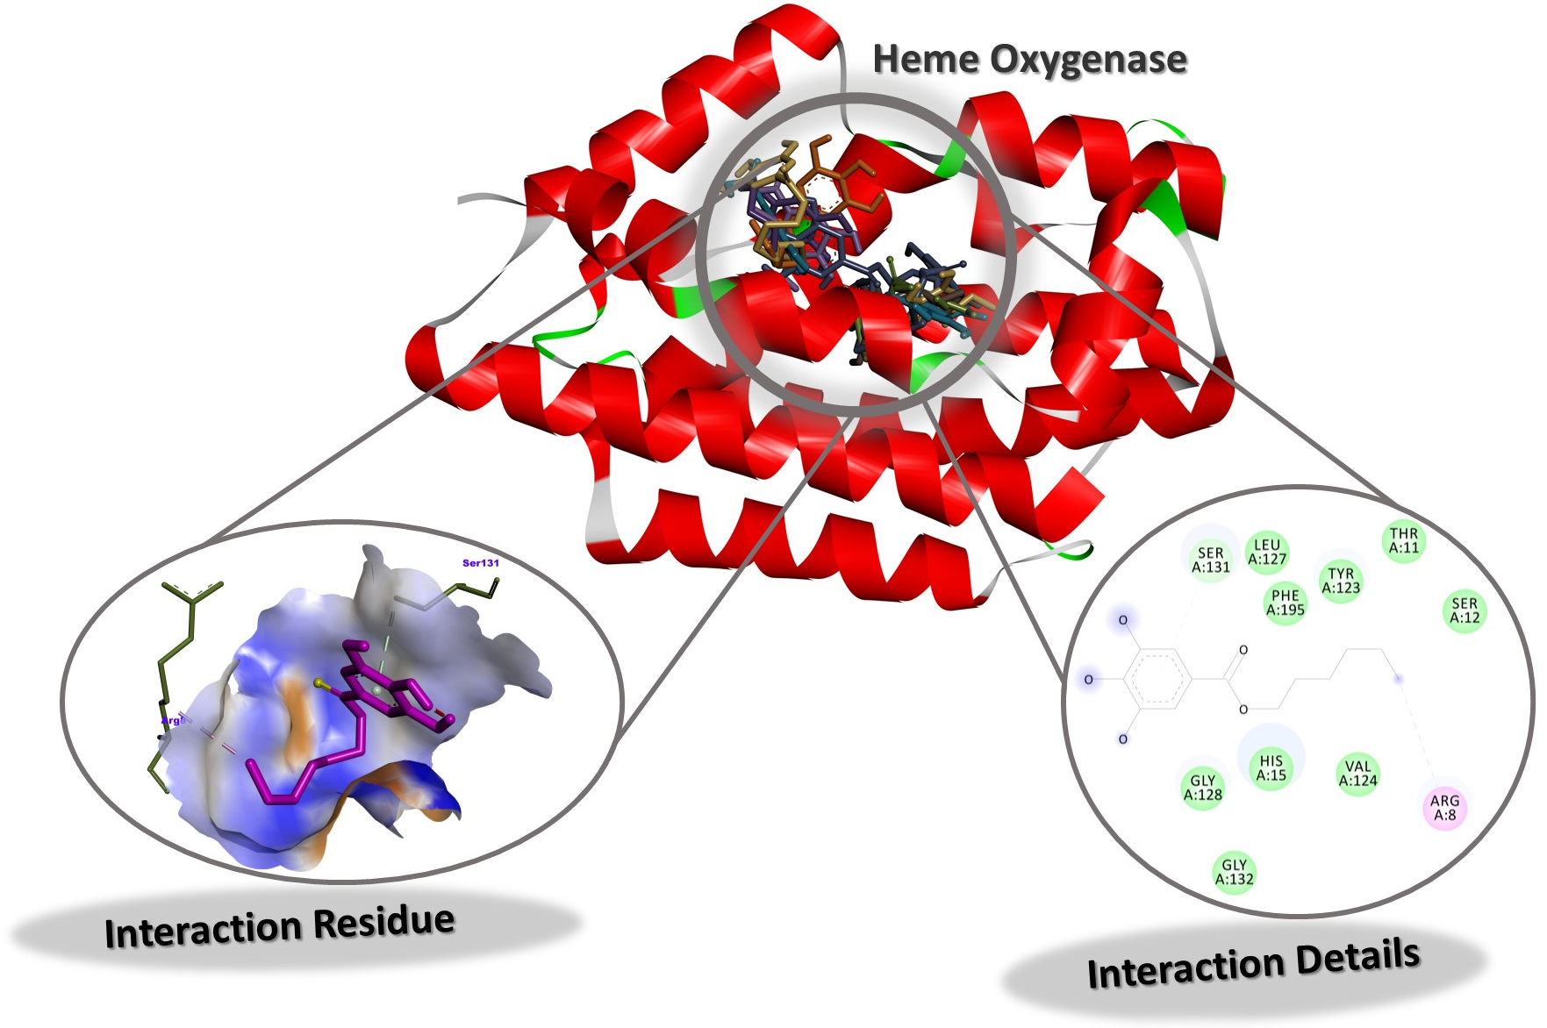
Figure S15. Interaction Residue and Interaction Details of HG against Heme Oxygenase
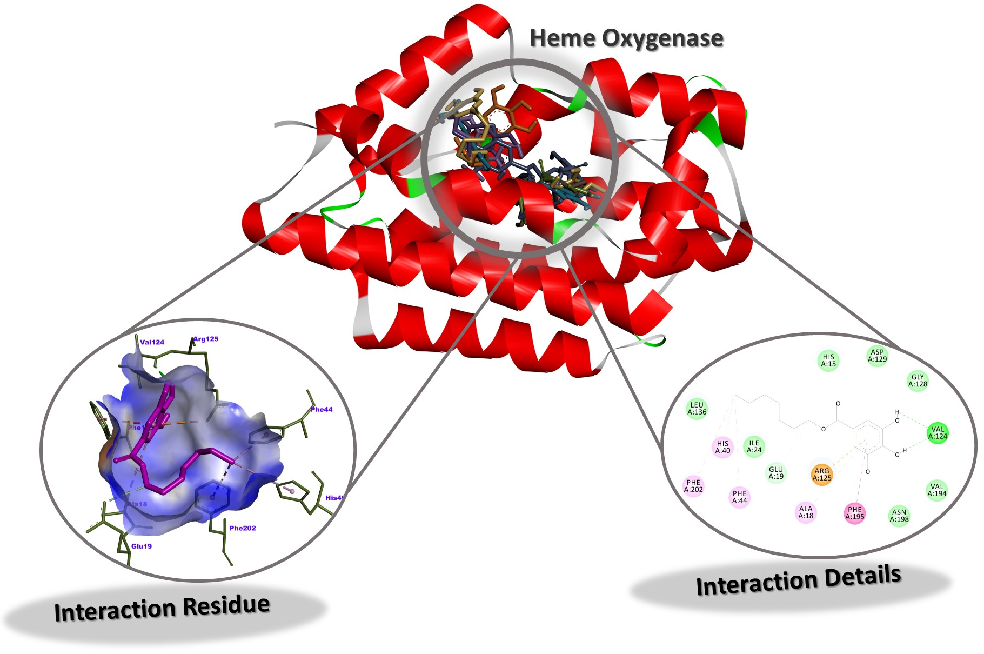
Figure S16. Interaction Residue and Interaction Details of HPG against Heme Oxygenase

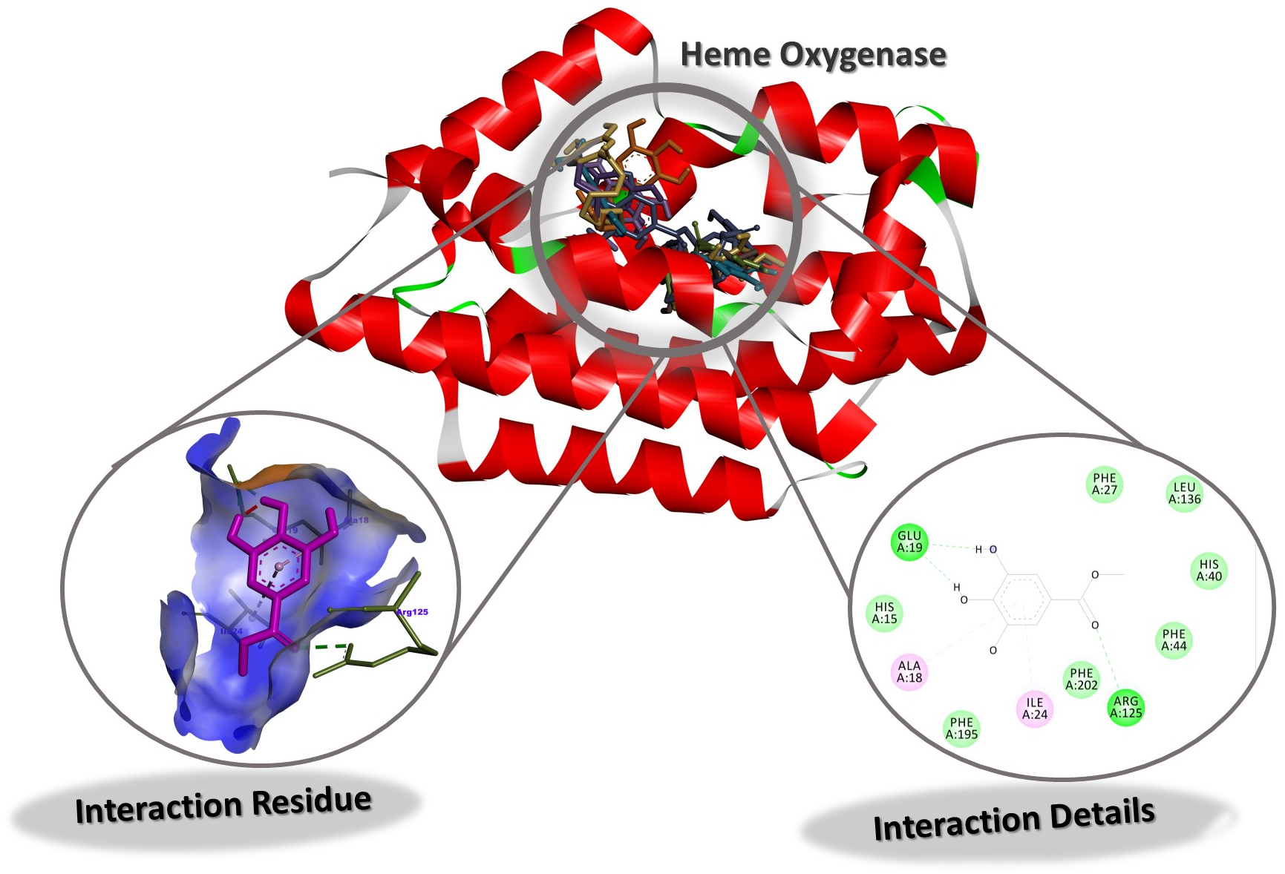
Figure S17. Interaction Residue and Interaction Details of MG against Heme Oxygenase
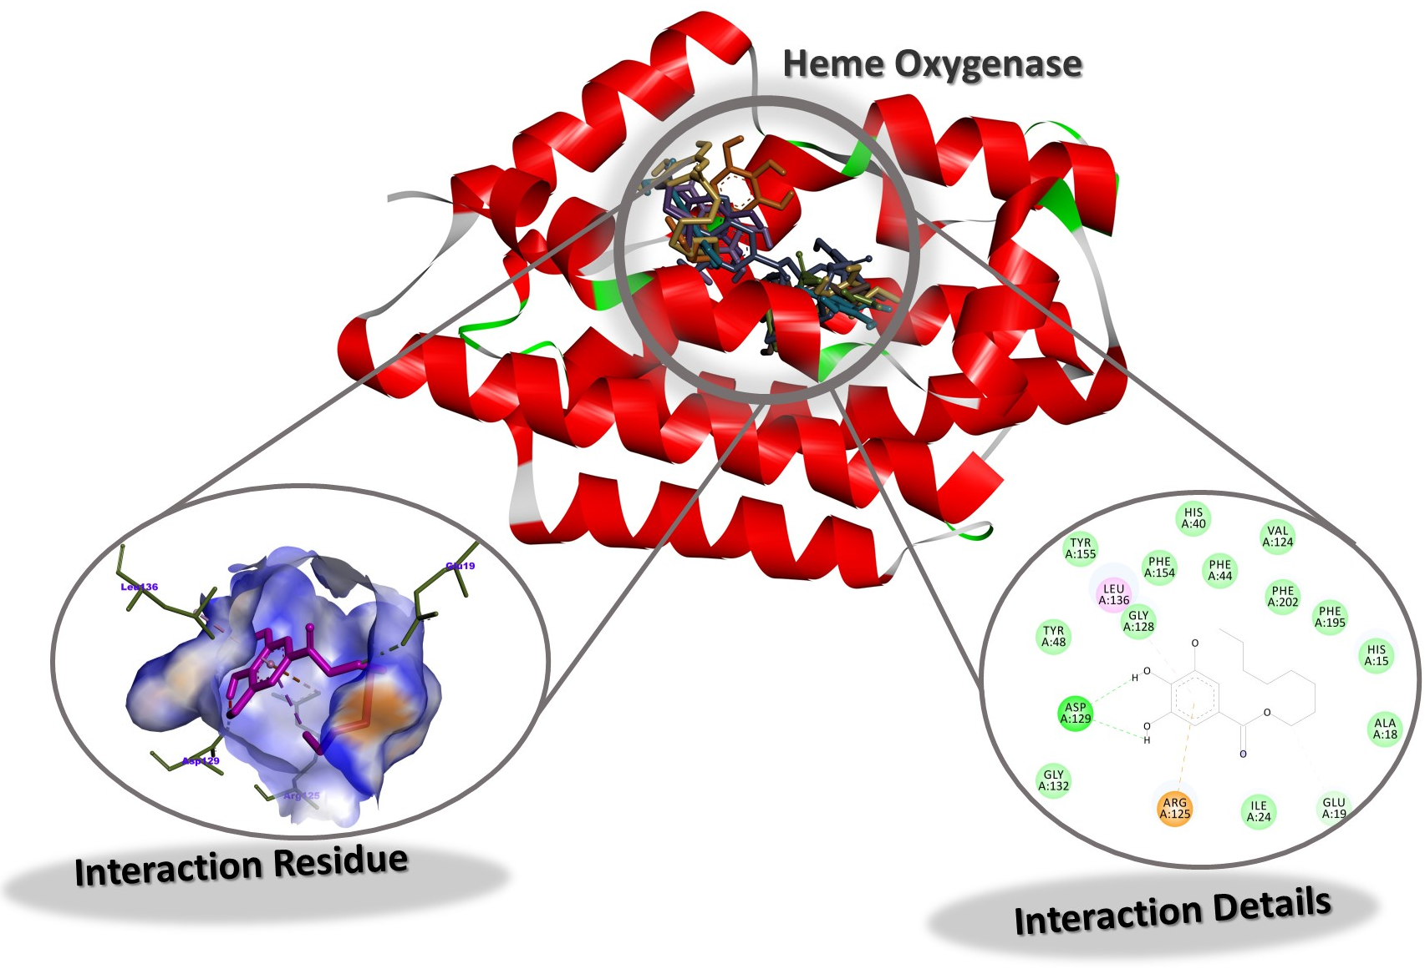
Figure S18. Interaction Residue and Interaction Details of OG against Heme Oxygenase

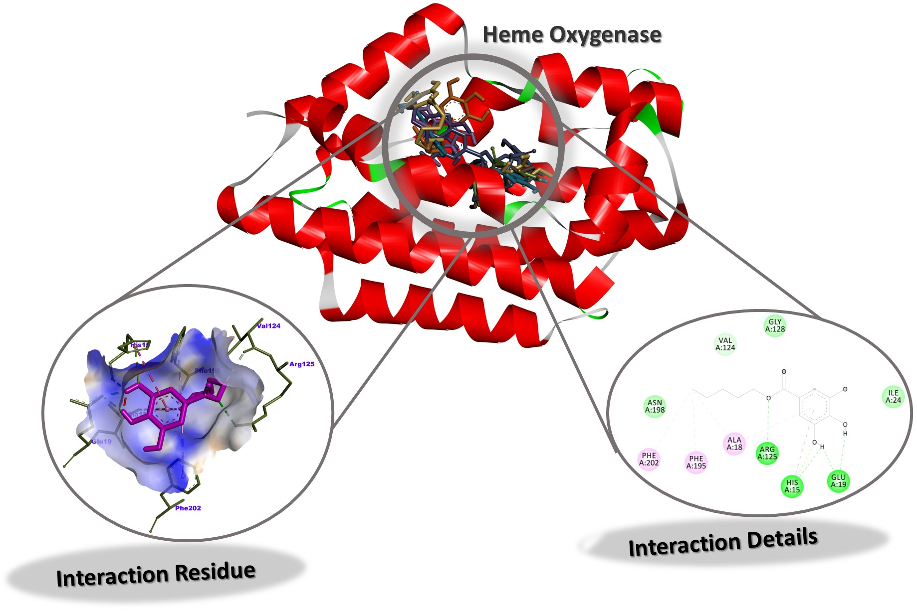
Figure S19. Interaction Residue and Interaction Details of PNG against Heme Oxygenase
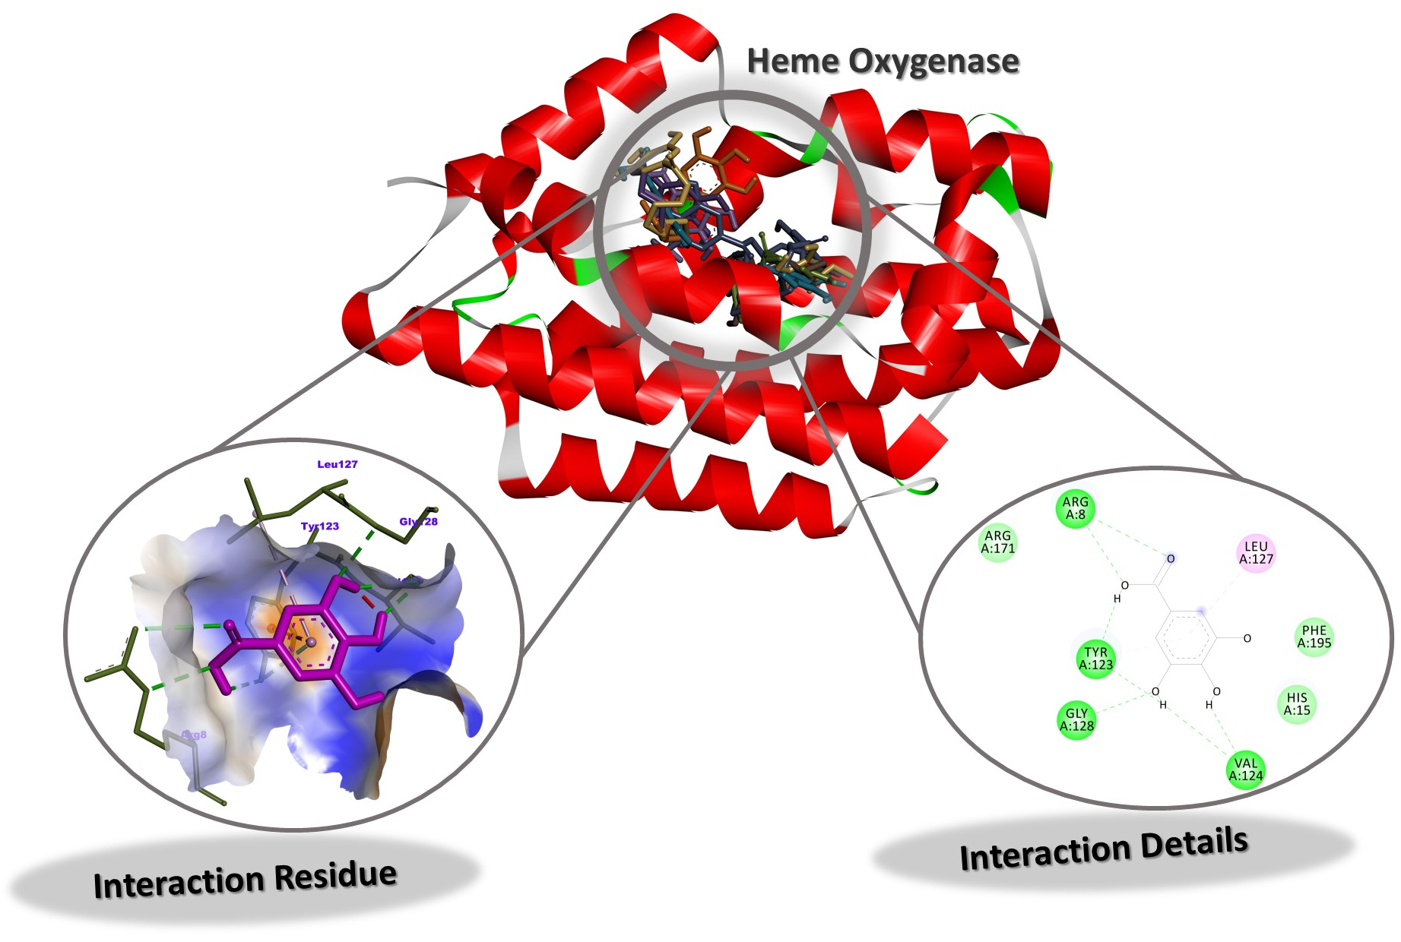
Figure S20. Interaction Residue and Interaction Details of GA against Heme Oxygenase

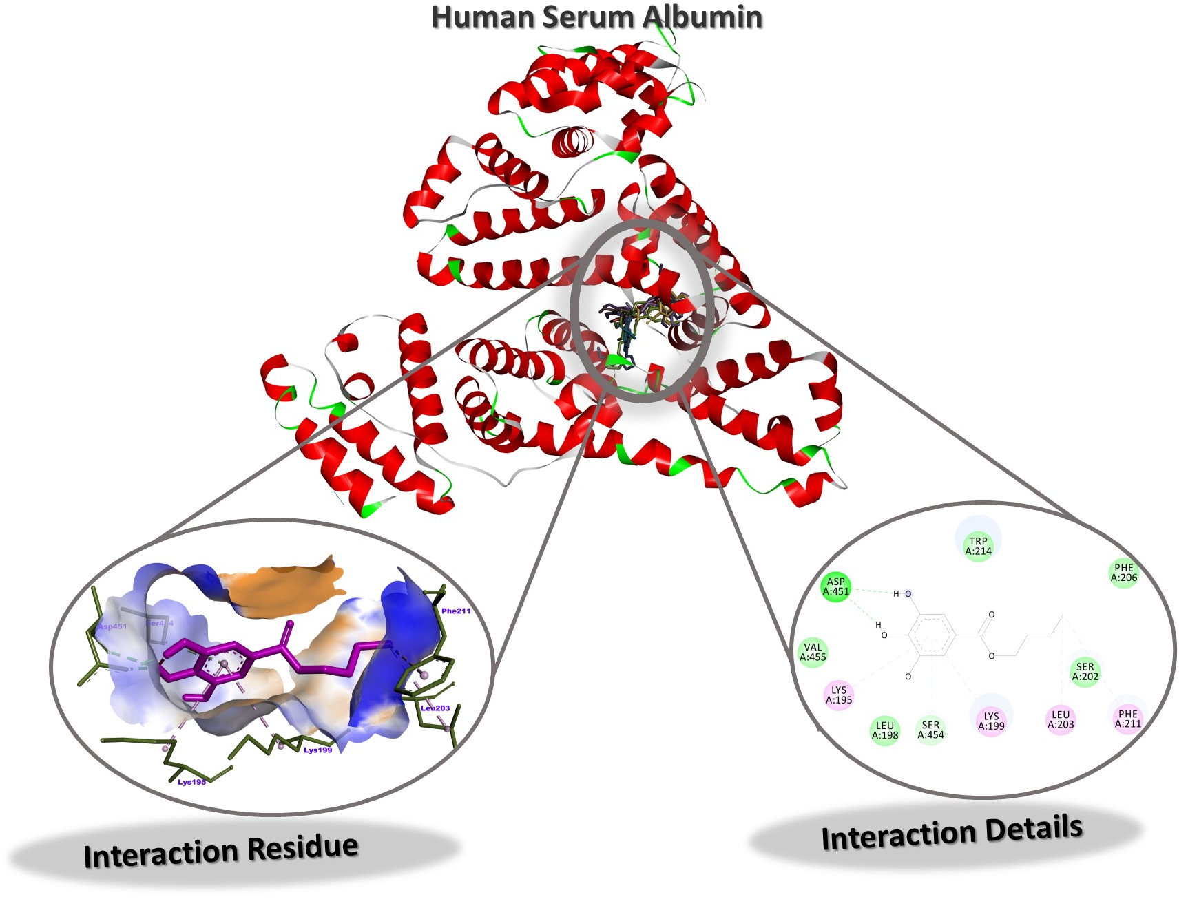
Figure S21. Interaction Residue and Interaction Details of BG against Human Serum Albumin
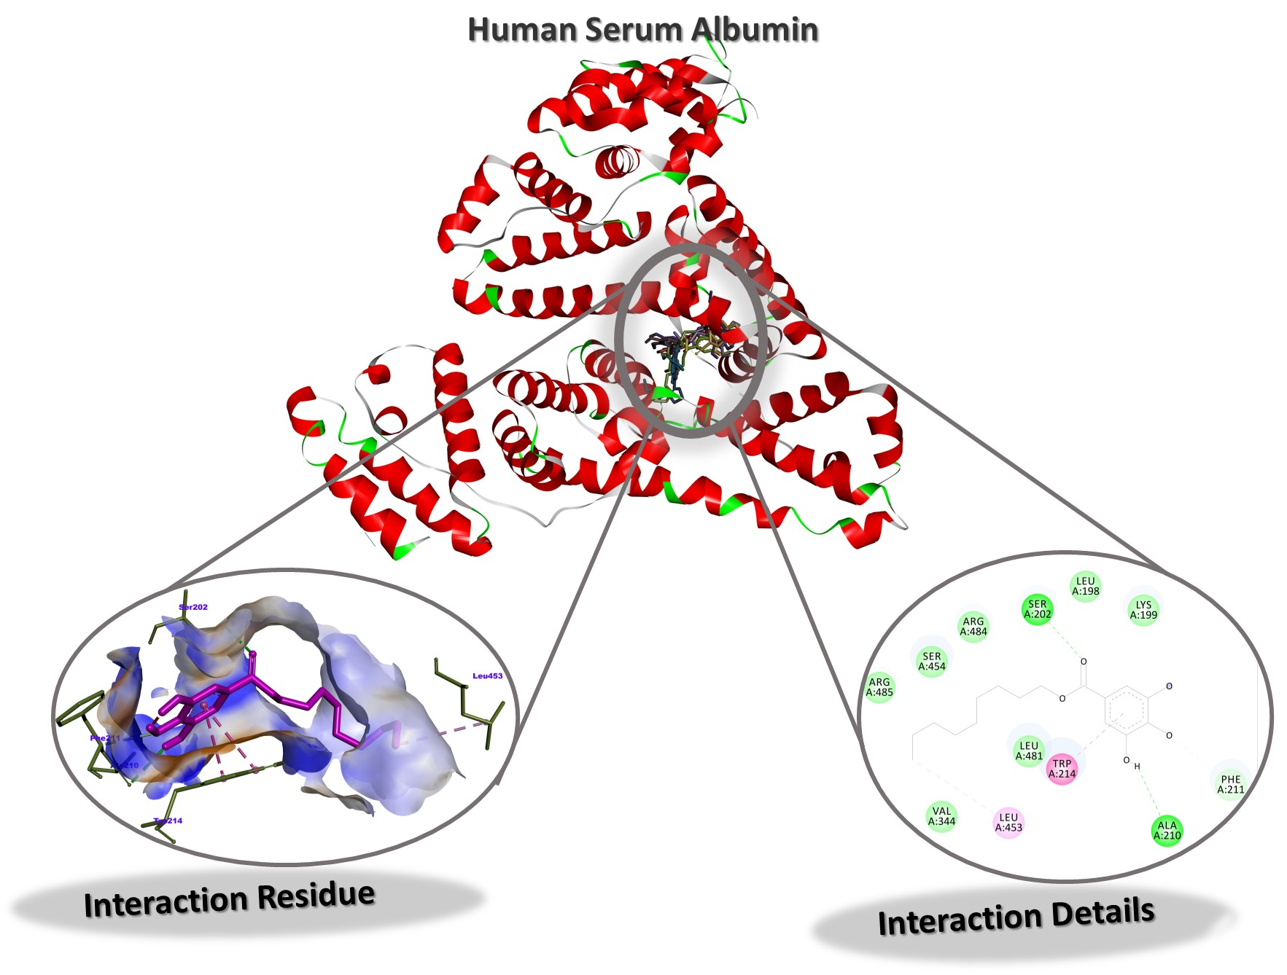
Figure S22. Interaction Residue and Interaction Details of DG against Human Serum Albumin

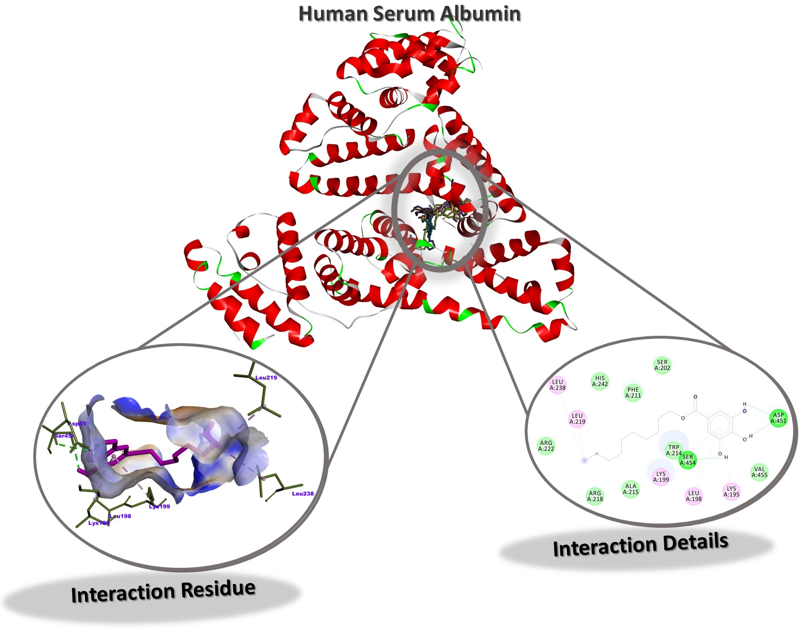
Figure S23. Interaction Residue and Interaction Details of DOG against Human Serum Albumin
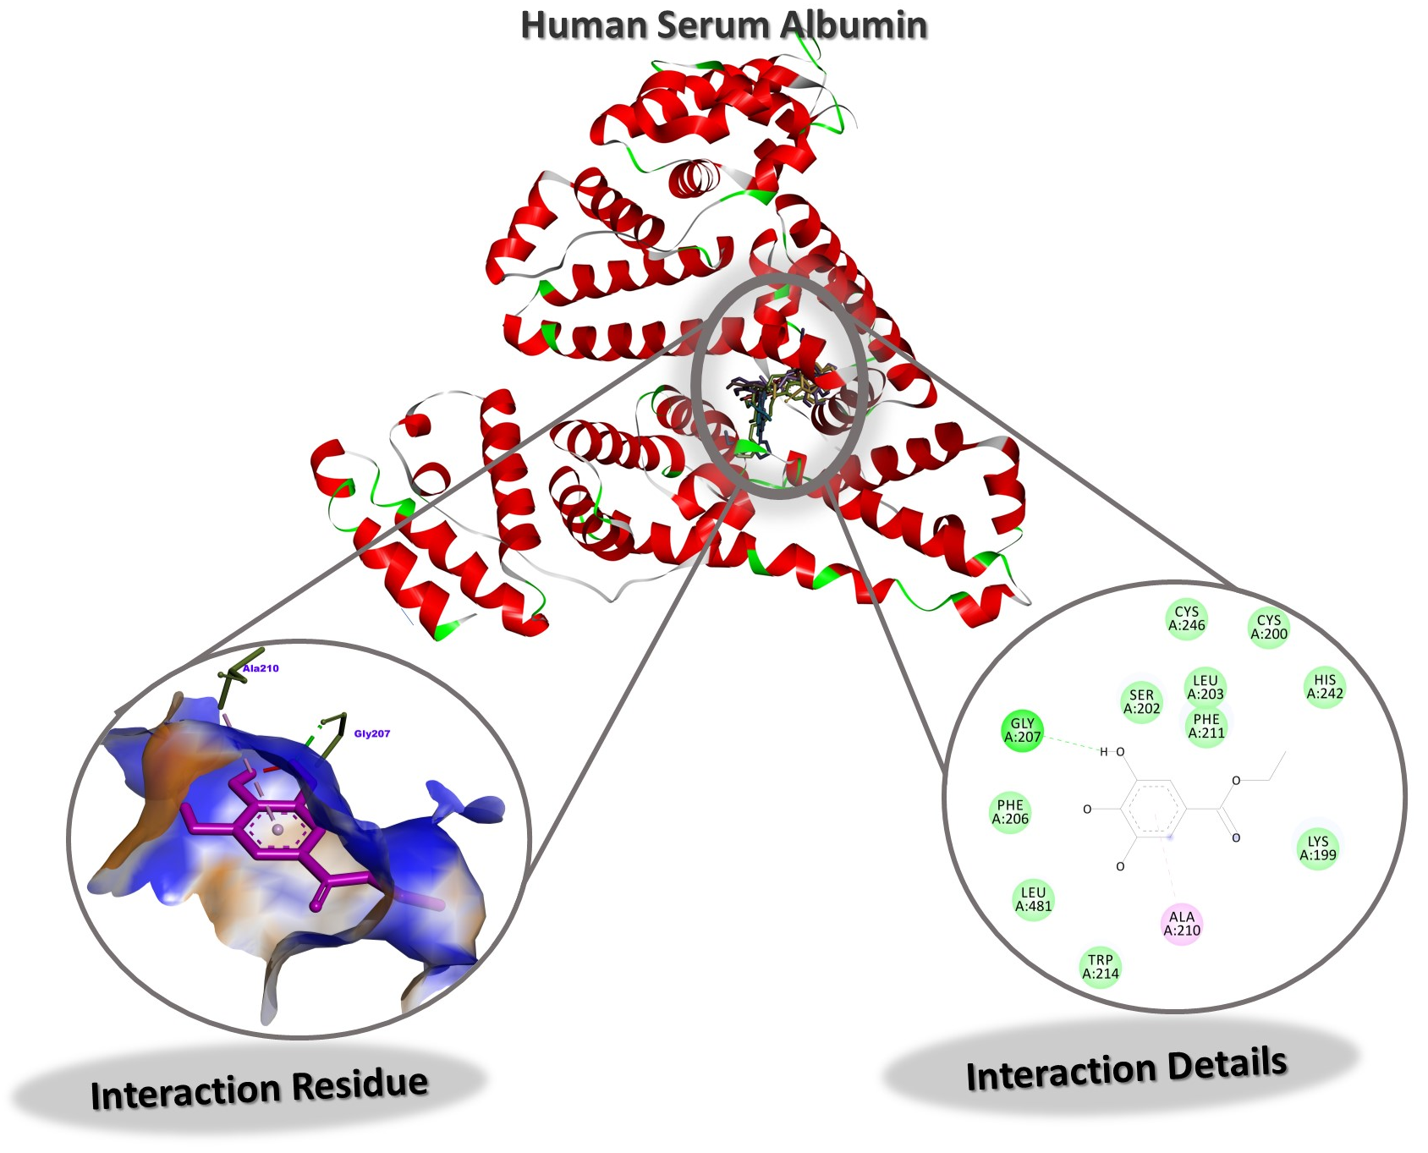
Figure S24. Interaction Residue and Interaction Details of EG against Human Serum Albumin

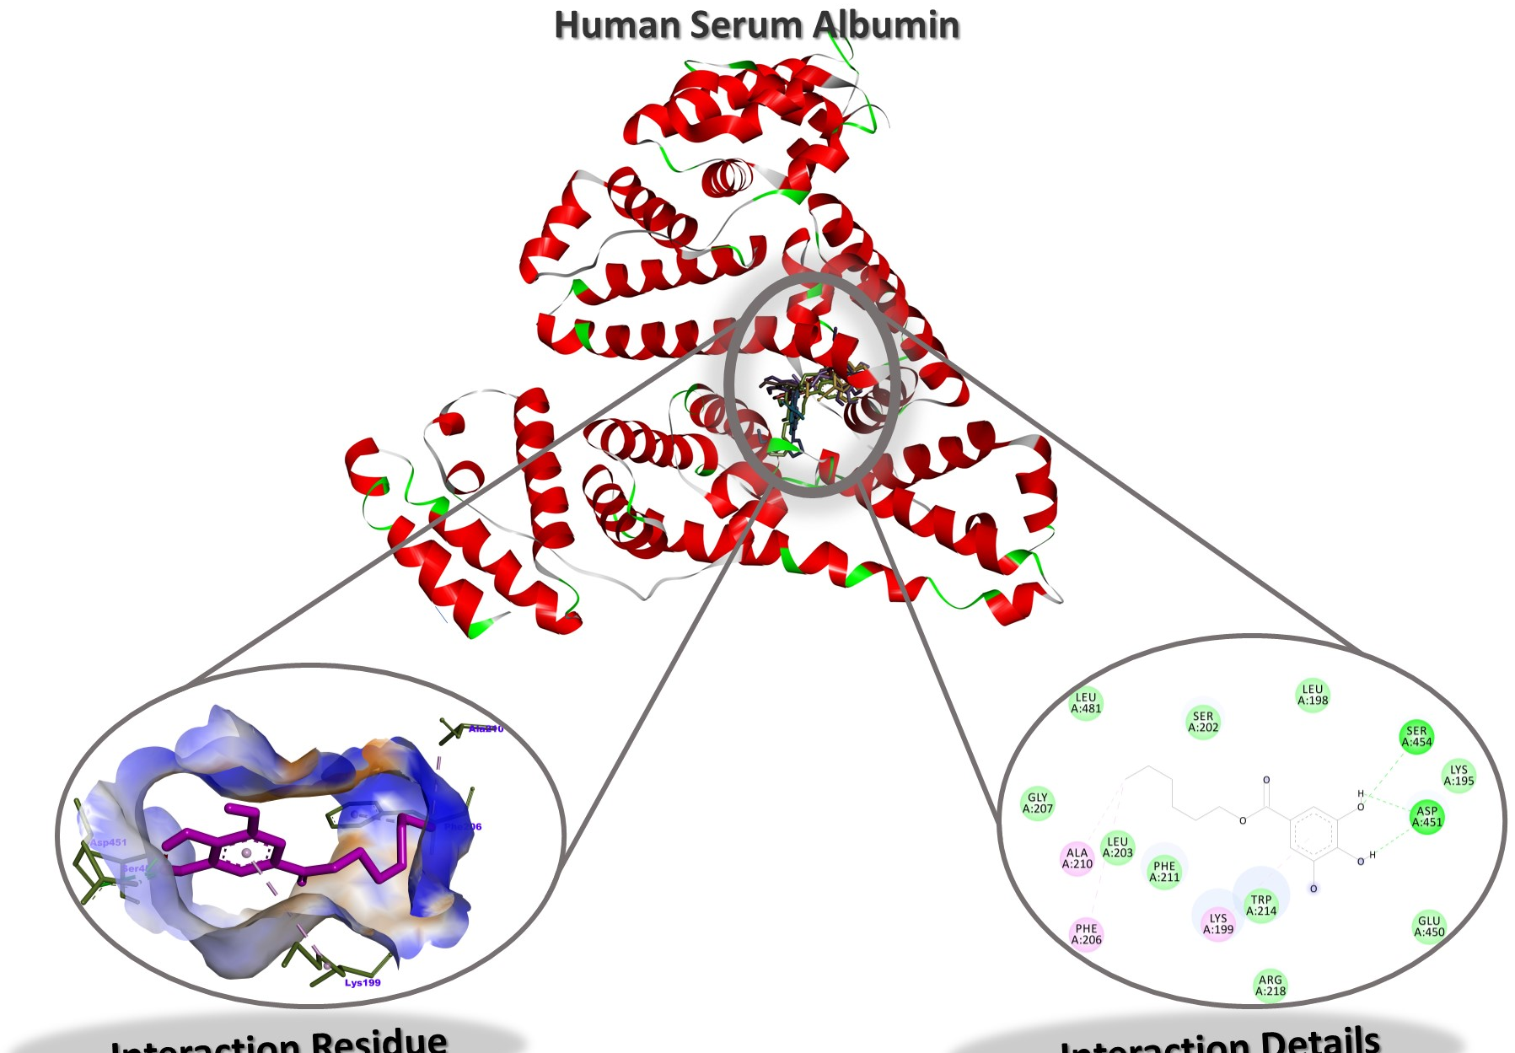
Figure S25. Interaction Residue and Interaction Details of HG against Human Serum Albumin
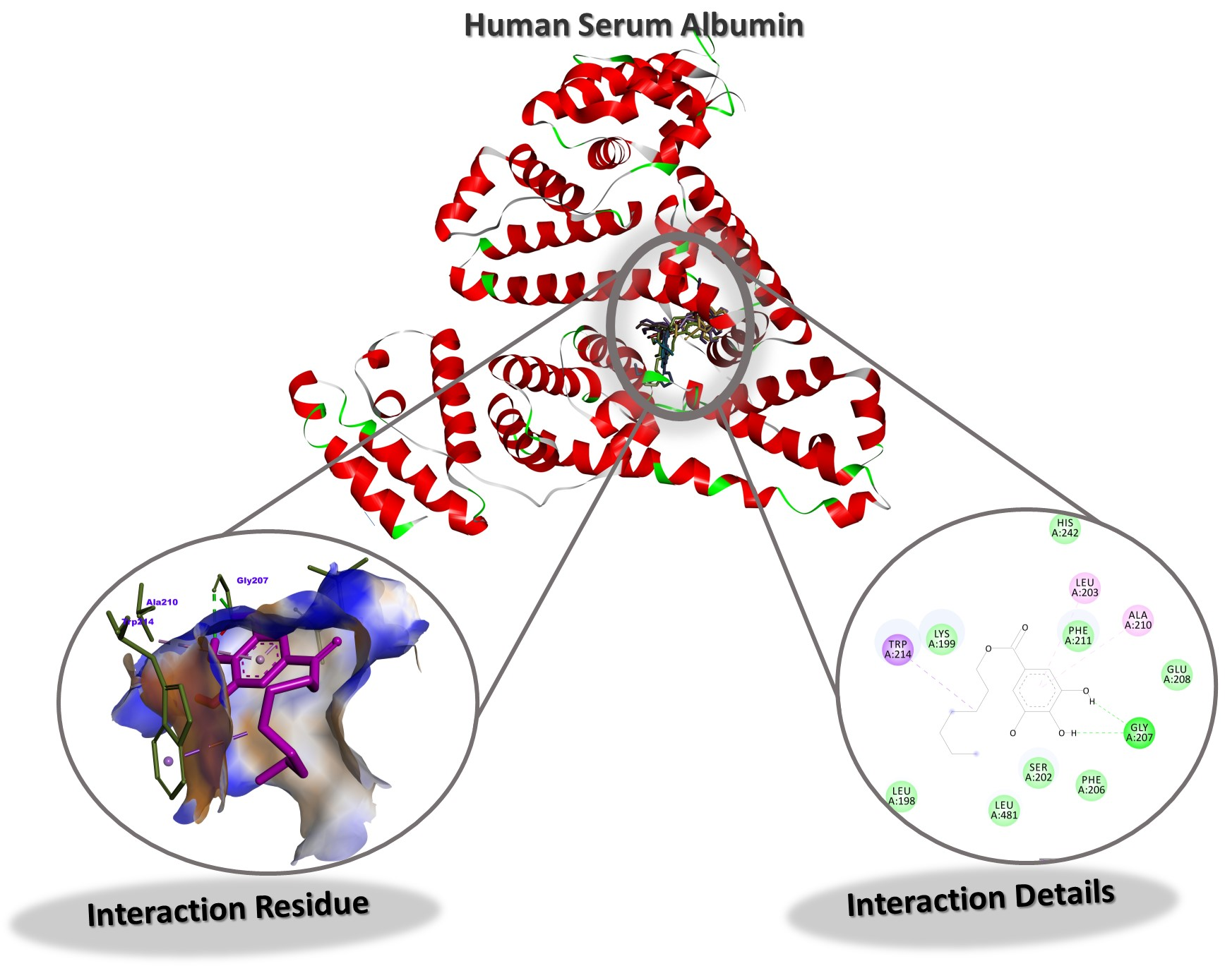
Figure S26. Interaction Residue and Interaction Details of HPG against Human Serum Albumin

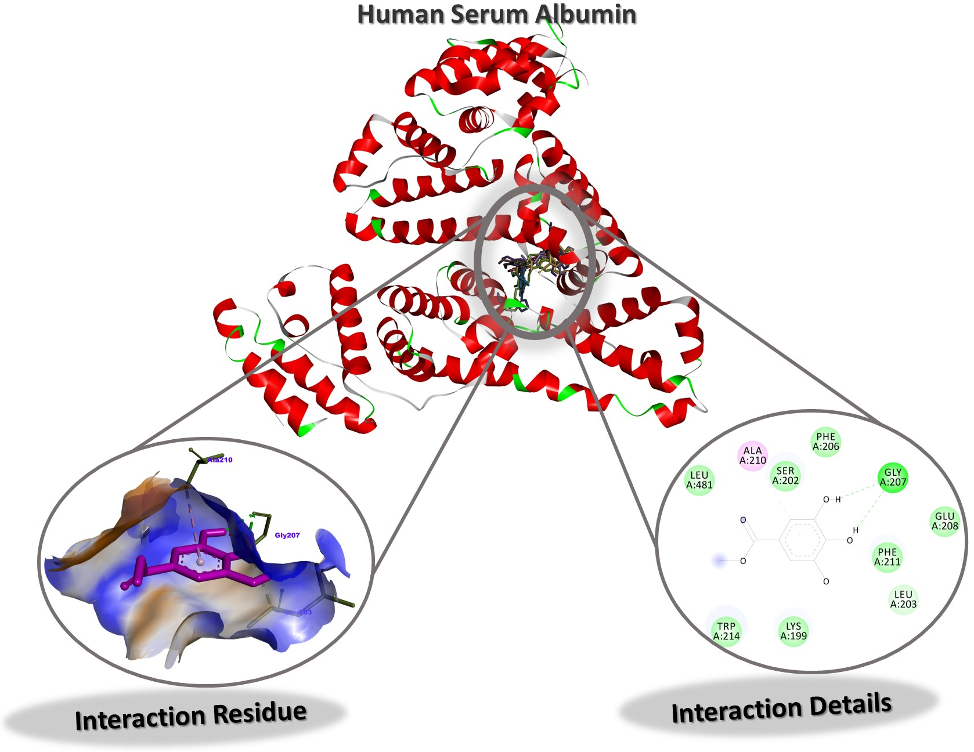
Figure S27. Interaction Residue and Interaction Details of MG against Human Serum Albumin
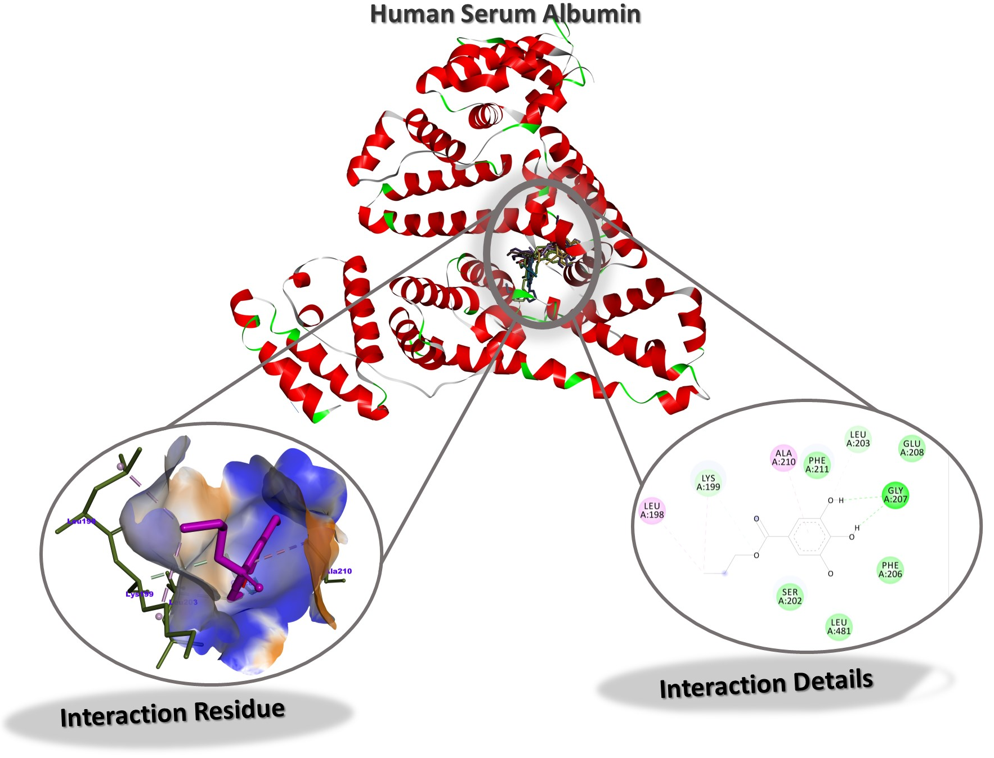
Figure S28. Interaction Residue and Interaction Details of PG against Human Serum Albumin

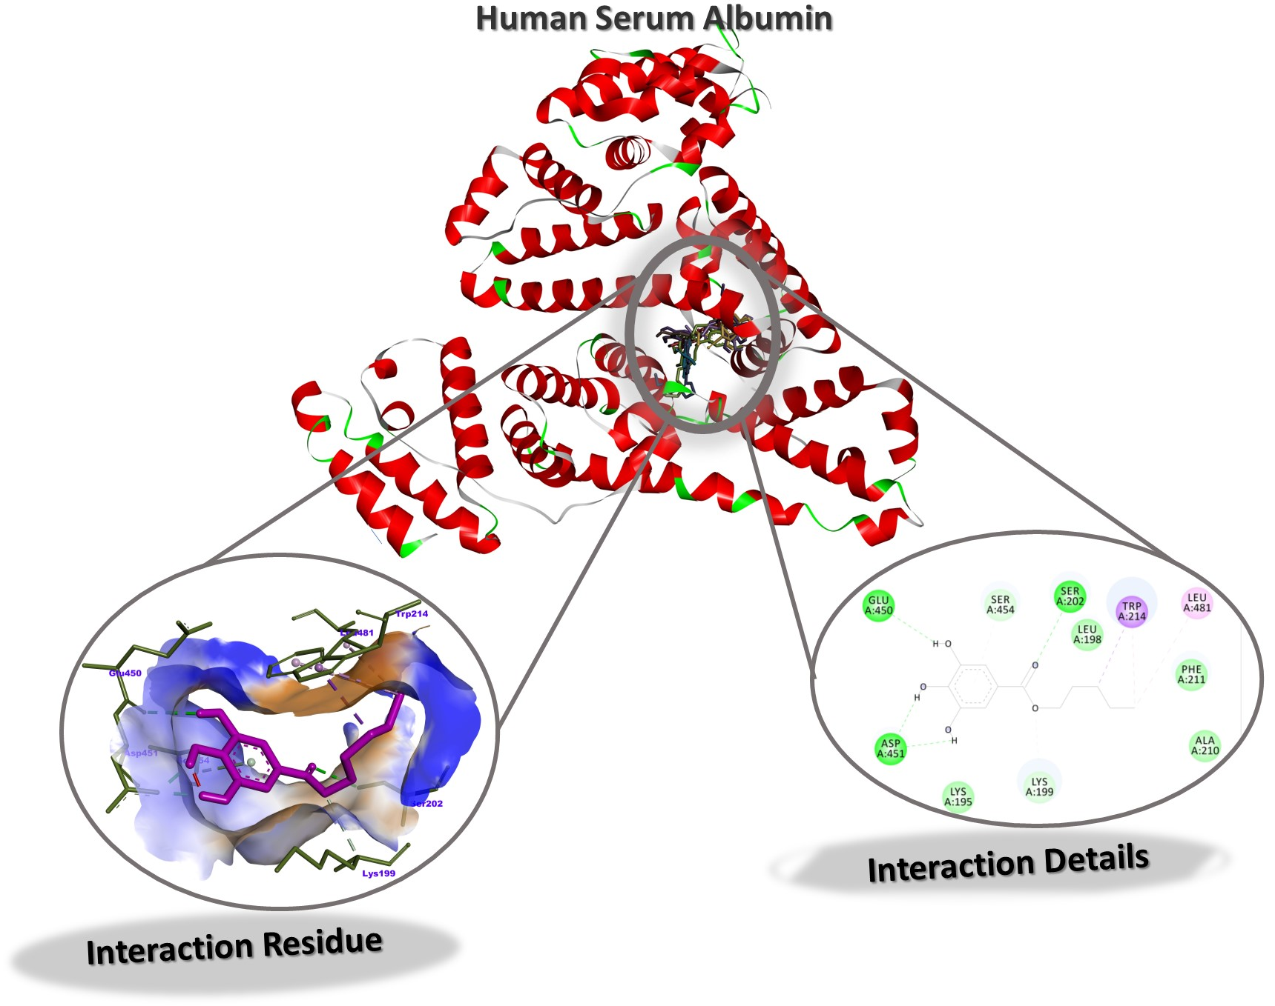
Figure S29. Interaction Residue and Interaction Details of PNG against Human Serum Albumin
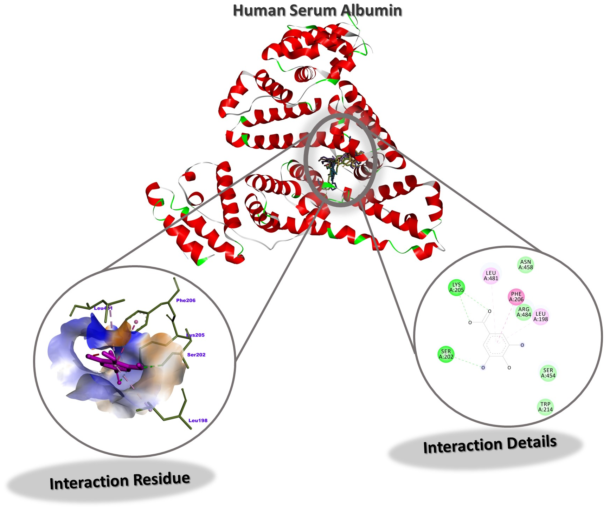
Figure S30. Interaction Residue and Interaction Details of GA against Human Serum Albumin

