SUPPLEMENTARY MATERIAL TO

Synthesis, Characterization, Computational Studies, Microbial Activity, Larvicidal Activity and Theoretical Biological Potential of various Imidazole Scaffolds.
CHARACTERIZATION DATA
1) (E)-ethyl 2-(4, 5-dihydro-1H-imidazol-2-yl)-3-phenylacrylate (6a): Yield 88%, m.p. 210 ºC; Colour: Yellow. IR: 3325.28 (-NH), 2900.94 (-CH) 1647.21(-C=O), 1558.48(C=C olefinic) cm⁻¹. ¹H NMR (500 MHz, DMSO-d6): 8.176 ∂ (S, 1H,- NH), 7.278-7.237 ∂ (m, -ArH), 5.875 ∂ (s, 1H, -CH), 4.352-4.394 ∂ (q, 2H, -CH₂), 1.394 -1.379 ∂ (t, 3H, -CH₃), 3.265-3.598 ∂ (d, H, -CH₂).
LC/MS (m/z) Anal. Calcd. for C₁₄H₁₆O₂N₂ is 244.12; found 244
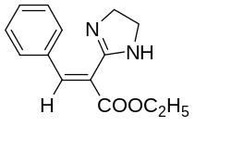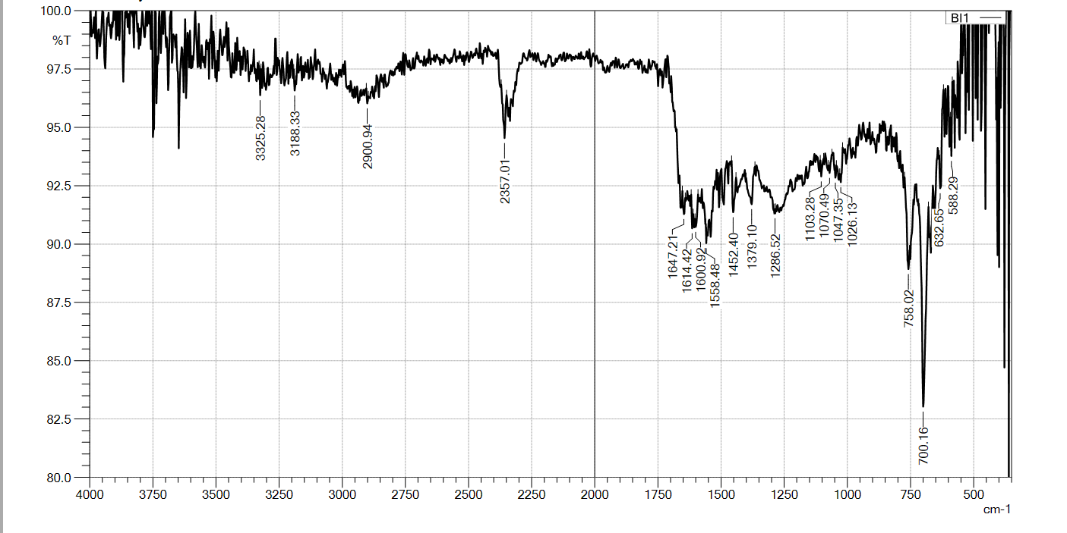

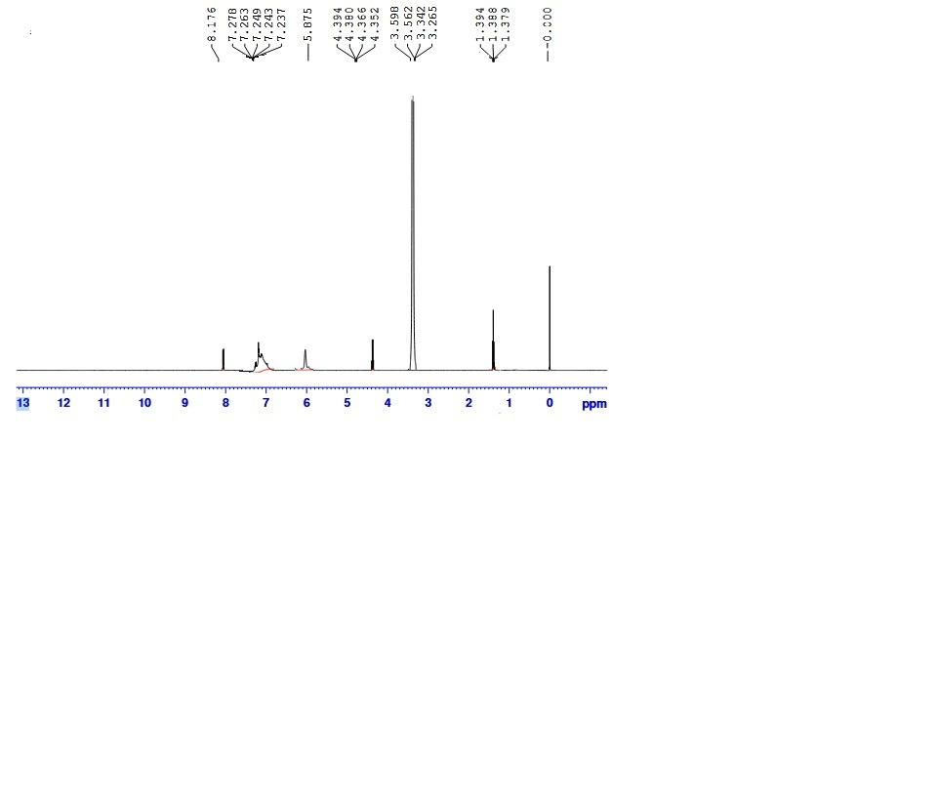

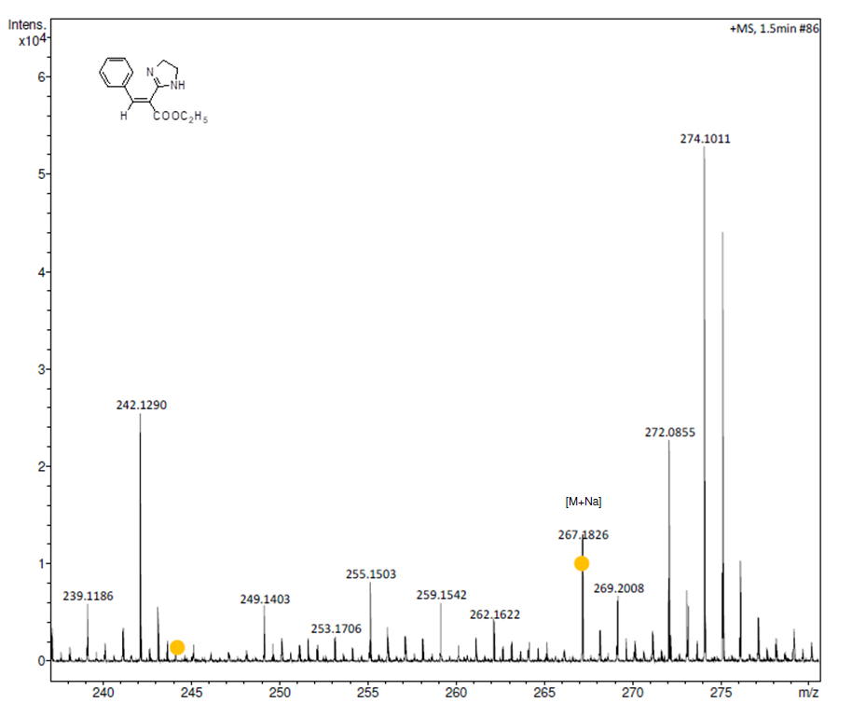

2) E)-ethyl 2-(4, 5-dihydro-1H-imidazol-2-yl)-3(4-methoxyphenyl) acrylate (6b): Yield 85%, m.p. 220 ⁰C; Colour: Dark Yellow. IR: 3342. 64 (-NH), 2981.95(-CH), 1653.00 (-C=O), 1508.33 (-C=C olefinic), 1029.99 (-OCH₂), 1018.41 (-OCH₃) cm⁻¹. ¹H NMR (500 MHz, DMSO-d6): 3.692 ∂ (S, 3H,- OCH₃), 7.167-7.185 ∂ (s, -ArH), 8.025-8.043 ∂ (s, -ArH), 5.544 ∂ (d, 1H, -CH), 2.501-2.5441 ∂ (d, 2H, -CH₂), 8.177 ∂ (d, 1H, NH), 4.348 -4.391 ∂ (q, 2H, -CH₂), 1.392-1.406 ∂ (t, 3H, -CH₃). LC/MS (m/z) Anal. Calcd. for C₁₅H₁₈O₃N₂ is 274.13; found 274.

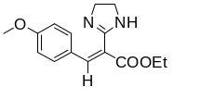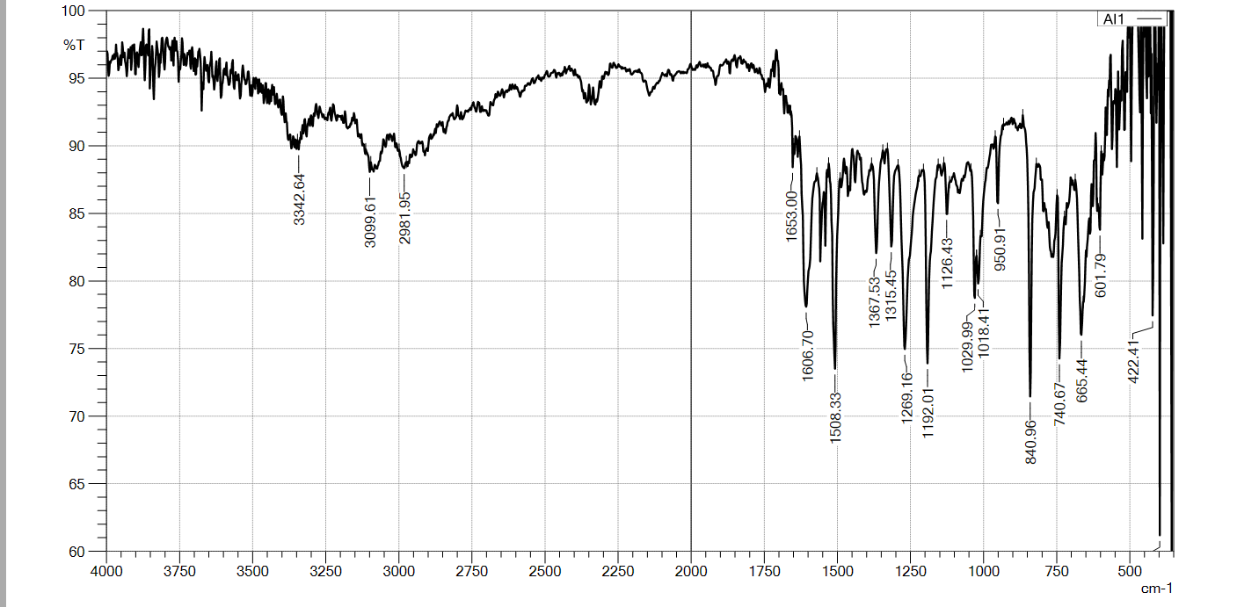

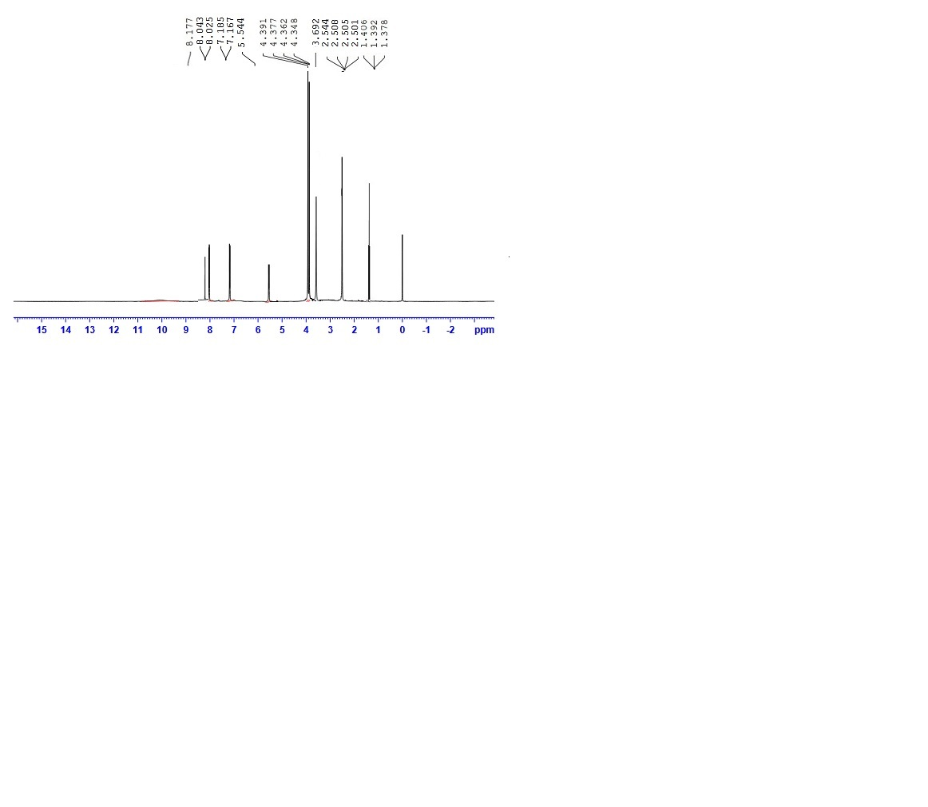

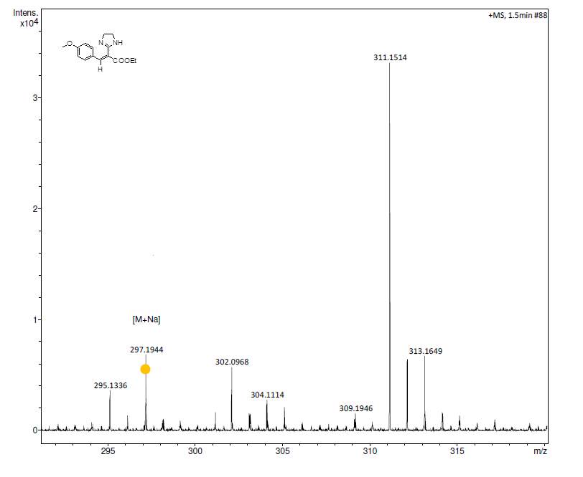

3) ethyl 2-(4, 5-dihydro-1H-imidazol-2-yl)-3-(2-hydroxyphenyl) acrylate (6c): Yield 87%, m.p. 158 ⁰C;Colour: Black. IR: 3600 (-OH), 3136.25 (NH), 2920.23 (-CH), 1645.28 (-C=O), 1539.28 (-C=C olefinic) cm⁻¹. LC/MS (m/z) Anal. Calcd. for C₁₅H₁₈O₃N₂ is 260.12; found 261.

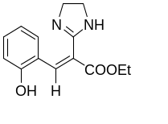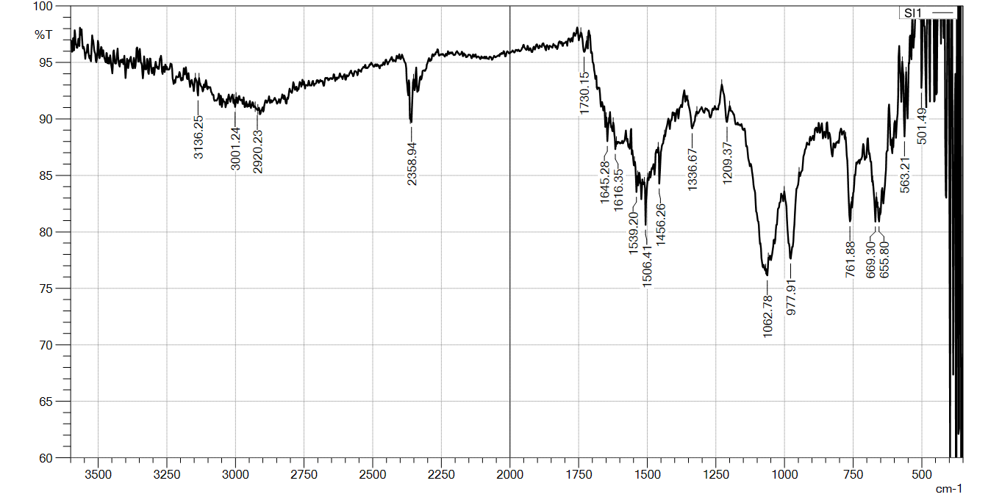

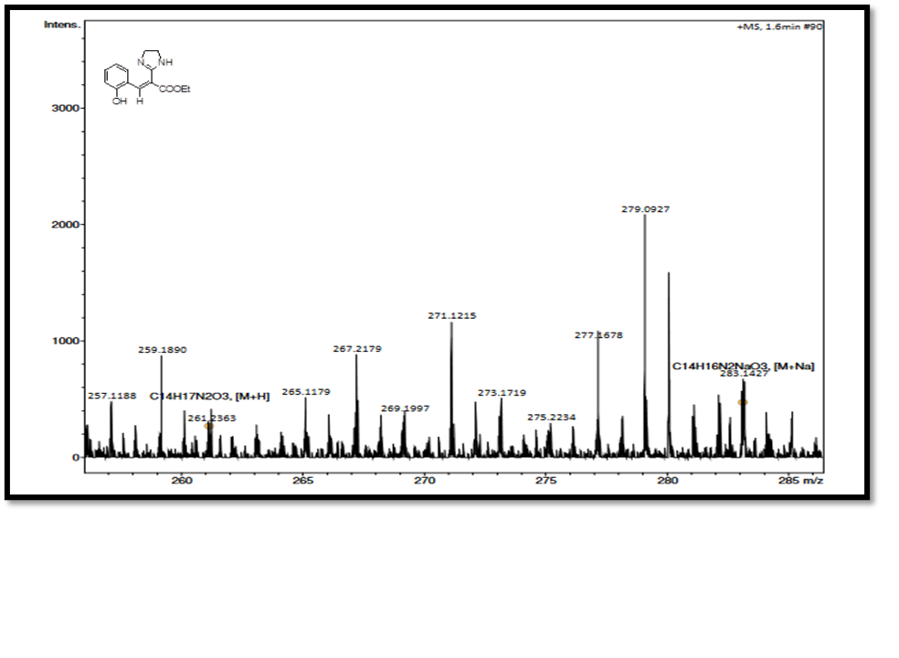
4) (2E,4E)-ethyl 2-(4,5-dihydro-1H-imidazol-2-yl)-5-phenylpenta-2,4-dienoate (6d): Yield 80%, m.p. 74 ⁰C; Colour: Orange. IR: 3230.77 (-NH), 2943.37 (-CH), 1653.00 (-C=O), 1525.69 (-C=C olefinic) cm-¹, ¹H NMR (500 MHz, DMSO-d6): 8.463 ∂ (S, 1H,- NH), 8.295 ∂ (m, 5H,-ArH), 7.160 ∂ (S, 1H,-CH), 5.915 ∂ (s, 1H, -CH), 6.744 ∂ (s, 1H, -CH), 3.199-3.305 ∂ (d, 2H, CH₂), 4.352-4.394 ∂ (q, 2H, -CH₂), 1.116-1.493 ∂ (t, 3H, -CH₃). LC/MS (m/z) Anal. Calcd. for C₁₆H₁₈O₂N₂ is 270.14; found 275
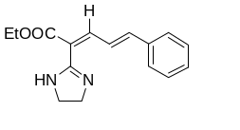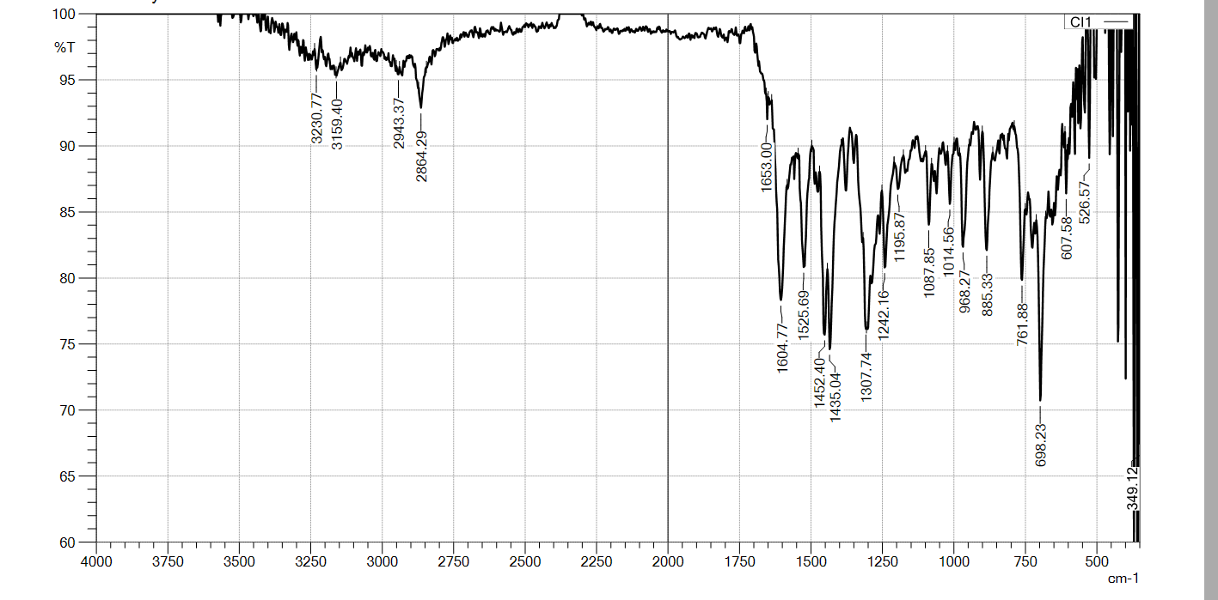

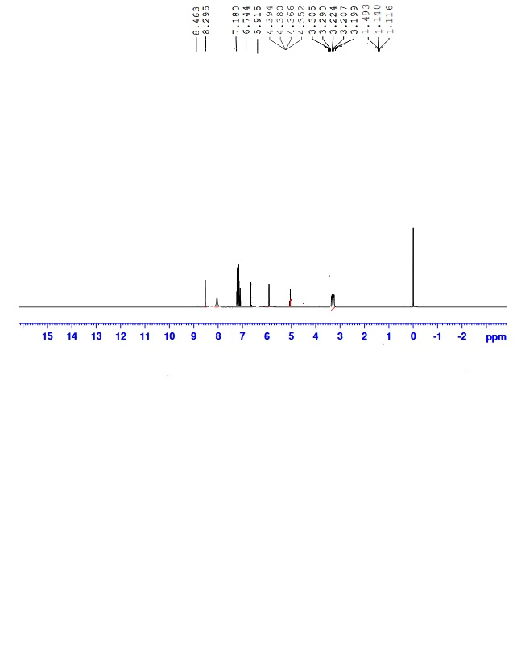

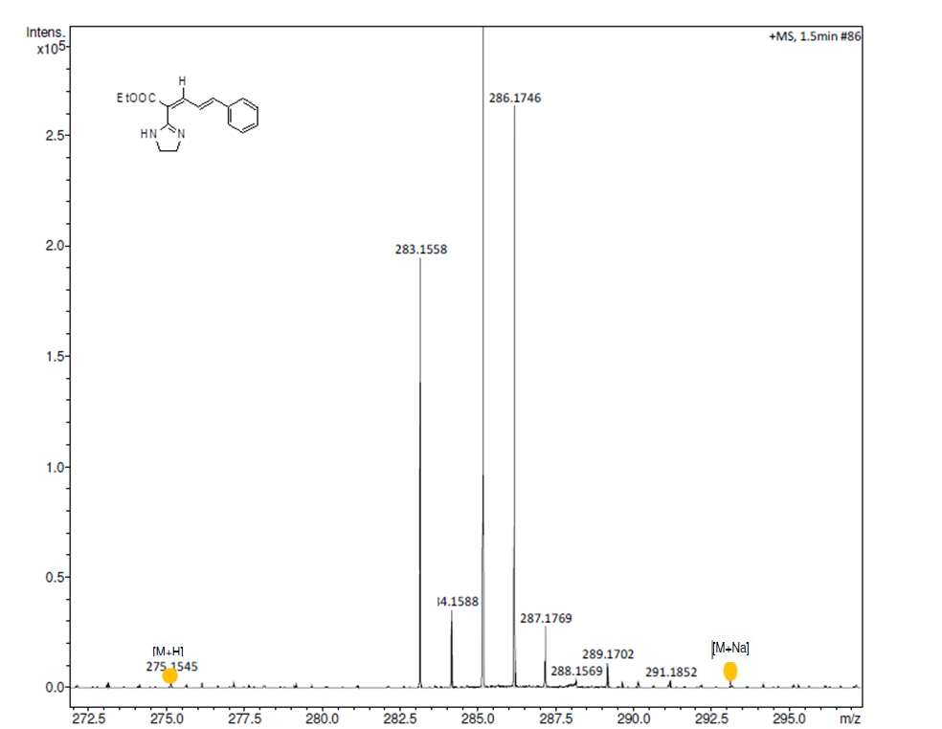

5) (E)-ethyl 2-(4, 5-dihydro-1H-imidazol-2-yl)-3-(4-nitrophenyl) acrylate (6e): Yield 78%, m.p. 194 ⁰C; Colour: Reddish. IR: 3221.12 (-NH), 2926.01 (-CH), 1649.14 (-C=O), 1502.55 (-NO₂) cm⁻¹. ¹H NMR (500 MHz, DMSO-d6): 8.747 ∂ (S, 1H, - NH), 2.362-2.504 ∂ (m, 2H, -CH₂), 7.887-7.941 ∂ (d, -ArH), 7.607-7.625 ∂ (d, -ArH), 4.886 ∂ (s, -CH), 4.360-4.604∂ (q, 2H, -CH₂) , 1.783-1.805 ∂ (t, 3H, -CH₃). LC/MS (m/z) Anal. Calcd. for C₁₄H₁₅O₄N₃ is 289.11; found 289.
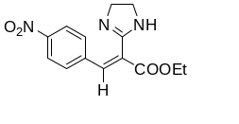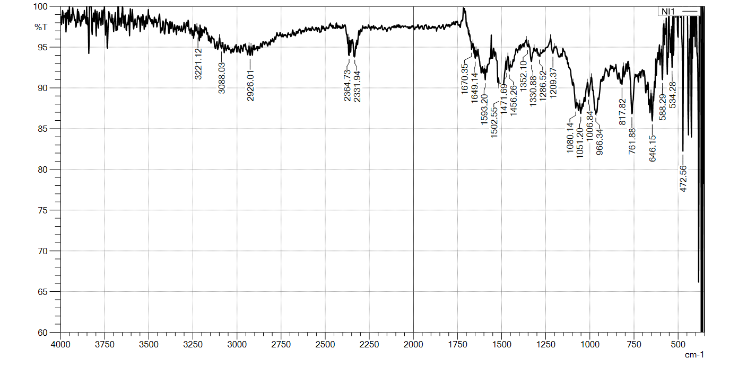

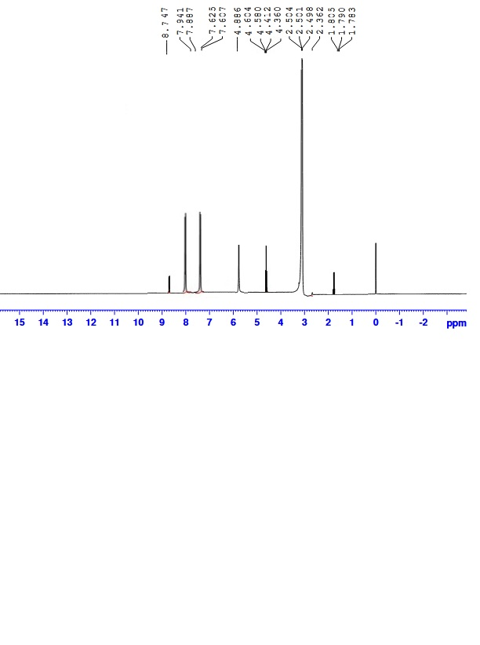

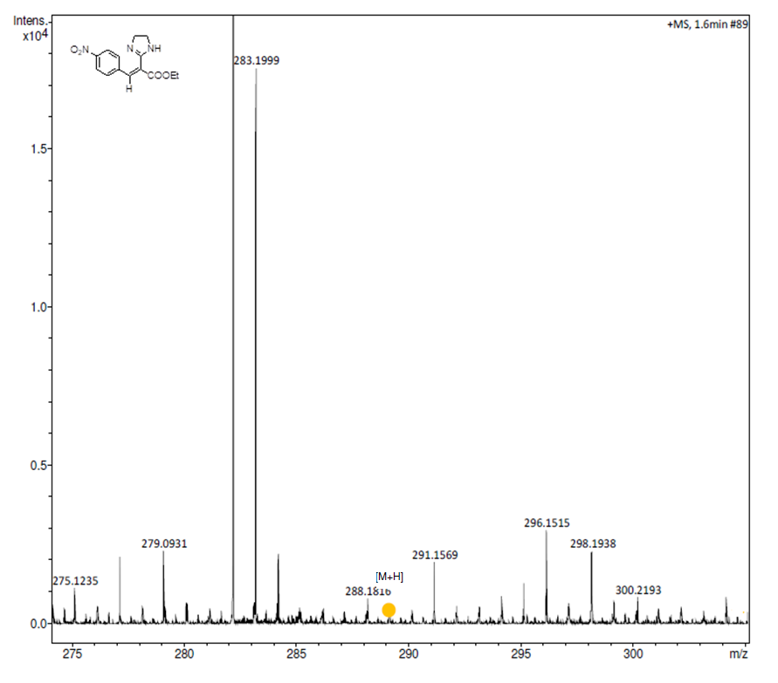

6) (E)-ethyl 3-(4-chlorophenyl)-2-(4, 5-dihydro-1H-imidazol-2-yl) acrylate (6f): Yield 90%, m.p. 218 ⁰C; Colour: Reddish. IR: 3230.77 (-NH), 2943.37 (-CH), 1620.00 (-C=O), 698.23 (-Cl) cm⁻¹. ¹H NMR (500 MHz, DMSO-d6): 8.722 ∂ (s, 1H, -NH), 2.628 -2.643 ∂ (m, 2H, -CH₂), 7.895-7.899 ∂ (d, 1H, -ArH), 7.582-7.585 ∂ (d, 1H, -ArH), 5.993 ∂ (S, 1H, -CH), 4.318- 4.965∂ (q, 2H, -CH₂), 1.432-1.439 ∂ (t, 3H, -CH₃). LC/MS (m/z) Anal. Calcd. for C₁₄H₁₅O₂N₂Cl is 278.08; found 278.

