Supplementary information for
Inhibition of TFF3 Synergizes with c-MET Inhibitors to Decrease the CSC-like Phenotype and Metastatic Burden in ER+HER2+ Mammary Carcinoma
Chuyu He^{1,7}, Xuejuan Wang^{1,7}, Yi-Shiou Chiou^{1,2}, Basappa Basappa³, Tao Zhu^{4,5,6}, Vijay Pandey^{1*} and Peter E. Lobie^{1, 4*}
¹ Institute of Biopharmaceutical and Health Engineering and Tsinghua Berkeley Shenzhen Institute, Tsinghua Shenzhen International Graduate School, Tsinghua University, Shenzhen 518055, People’s Republic of China.
²Master Degree Program in Toxicology, College of Pharmacy, Kaohsiung Medical University, Kaohsiung, 807, Taiwan.
³Laboratory of Chemical Biology, Department of Studies in Organic Chemistry, University of Mysore, Manasagangotri 570006 Mysore, India.
⁴Shenzhen Bay Laboratory, Shenzhen 518055 Guangdong, People’s Republic of China.
⁵Department of Oncology, The First Affiliated Hospital of USTC, Center for Advanced Interdisciplinary Science and Biomedicine of IHM, Division of Life Sciences and Medicine, University of Science and Technology of China, Hefei, Anhui 230027, People’s Republic of China.
⁶Hefei National Laboratory for Physical Sciences, University of Science and Technology of China, Hefei, Anhui 230027, People’s Republic of China.
⁷These authors contributed equally to this work.

* Correspondence: vijay.pandey@sz.tsinghua.edu.cn; pelobie@sz.tsinghua.edu.cn
Supplementary information 1
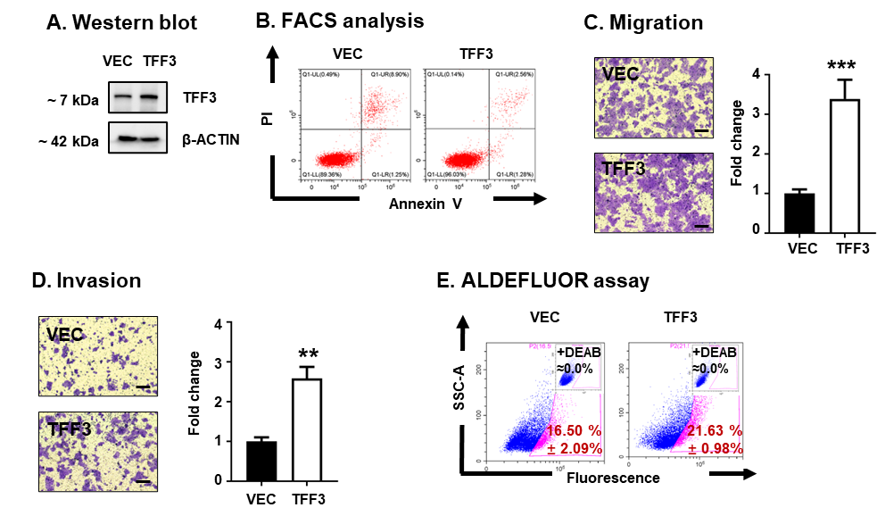
A. Western blot analysis was performed to determine the expression of TFF3 in MDA-MB-361-TFF3 (TFF3) and MDA-MB-361-VEC (VEC) cells.
B. The percentage of early apoptotic (Annexin-V-positive/PI negative) and late apoptotic (Annexin-V-positive/PI-positive) cells was plotted by flow cytometry in MDA-MB-361-TFF3 (TFF3) and MDA-MB-361-VEC (VEC) cells.
C. Cell migration assay. Scale bar, 50 μm. Data are expressed as mean ± SD (n = 3). Statistical significance is indicated as *P < 0.05, **P < 0.01, and ***P < 0.001.
D. Cell invasion assay. Scale bar, 50 μm. Data are expressed as mean ± SD (n = 3). Statistical significance is indicated as *P < 0.05, **P < 0.01, and ***P < 0.001.
E. ALDEFLUOR assay analysis of MDA-MB-361-TFF3 (TFF3) and MDA-MB-361-VEC (VEC) cells. The percentage of ALDH1-positive cells (in the pink box) was plotted by flow cytometry. Data are expressed as mean ± SD (n = 3). Statistical significance is indicated as *P < 0.05, **P < 0.01, and ***P < 0.001.

Supplementary information 2
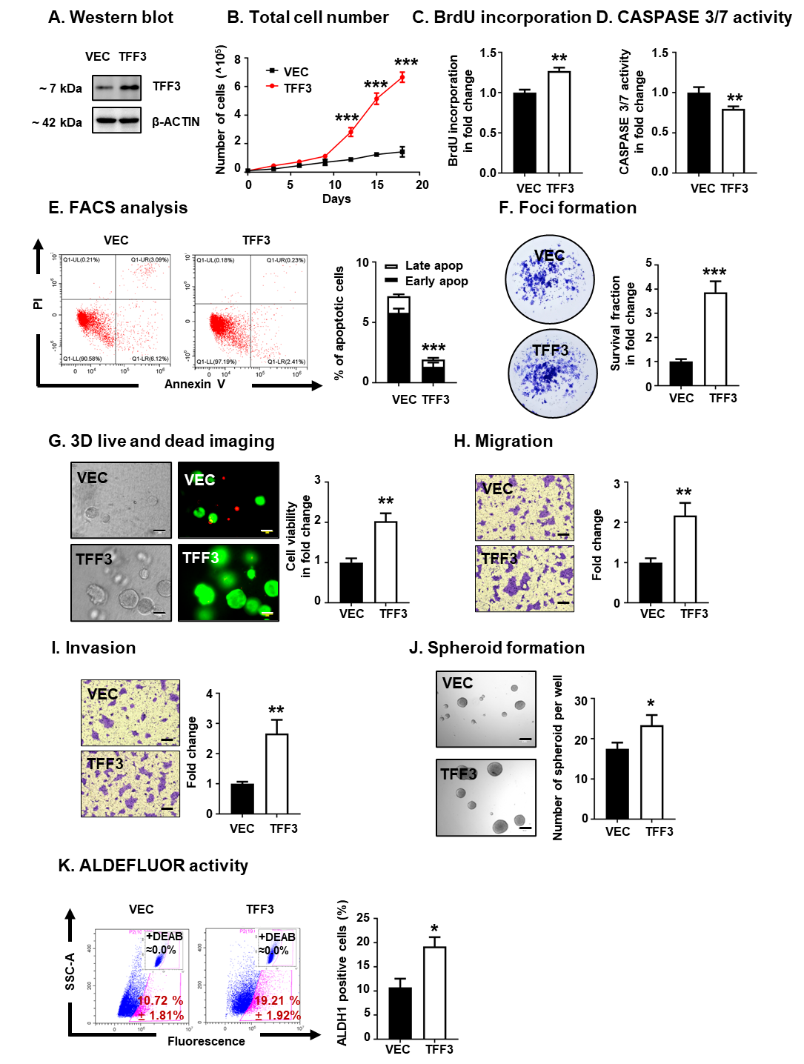
BT474 cells were stably transfected with pIRESneo3-TFF3 (designated BT474-TFF3 (TFF3)) or pIRESneo3-vector (BT474-VEC (VEC)).
A. Western blot analysis was performed to determine the expression of TFF3 in BT474-TFF3 (TFF3) and BT474-VEC (VEC) cells.
B. Total cell number counting. Data are expressed as mean ± SD (n = 3). Statistical significance is indicated as *P < 0.05, **P < 0.01, and ***P < 0.001.
C. BrdU incorporation assay after 12 hours of serum deprivation. Data are expressed as mean ± SD (n = 3). Statistical significance is indicated as *P < 0.05, **P < 0.01, and ***P < 0.001.
D. CASPASE 3/7 activity after 12 hours of serum deprivation. Data are expressed as mean ± SD (n = 3). Statistical significance is indicated as *P < 0.05, **P < 0.01, and ***P < 0.001.
E. Annexin-V/PI apoptotic cell death was determined after 12 hours of serum deprivation. The percentages of cells in early (Annexin-V-positive/PI negative) or late (Annexin-V-positive/PI-positive) apoptotic phase were analyzed and plotted by flow cytometry Data are expressed as mean ± SD (n = 3). Statistical significance is indicated as *P < 0.05, **P < 0.01, and ***P < 0.001.
F. Foci formation. BT474-TFF3 (TFF3) and BT474-VEC (VEC) cells were cultured in monolayer at low cell density for foci formation for 14 days. Foci were stained by crystal violet. Fold change of survival fraction was measured by eluting the crystal violet with methanol and detected absorbance at 595 nm. Data are expressed as mean ± SD (n = 3). Statistical significance is indicated as *P < 0.05, **P < 0.01, and ***P < 0.001.
G. Microscopic visualization of LIVE/DEADTM Cell Imaging kit-stained colonies after 12 days of cell culture in medium containing 2% FBS and 4% Matrigel. The bright-field images were on the left and the merged imaged of Live and Dead were on the right with red indicating dead colonies and green indicating live colonies. Scale bars, 100 μm. Fold change of cell viability of 3D colonies was determined by AlamarBlue. Data are expressed as mean ± SD (n = 3). Statistical significance is indicated as *P < 0.05, **P < 0.01, and ***P < 0.001.
H. Cell migration assay. Scale bar, 50 μm. Data are expressed as mean ± SD (n = 3). Statistical significance is indicated as *P < 0.05, **P < 0.01, and ***P < 0.001.
I. Cell invasion assay. Scale bar, 50 μm. Data are expressed as mean ± SD (n = 3). Statistical significance is indicated as *P < 0.05, **P < 0.01, and ***P < 0.001.
J. Spheroid formation assay. BT474-TFF3 (TFF3) and BT474-VEC (VEC) cells were seeded in ultralow attachment plates in and cultured in spheroid growth media for 12 days. Scale bar, 50 μm. The spheroids with diameters greater than 50 μm in each well were counted. Data are expressed as mean ± SD (n = 3). Statistical significance is indicated as *P < 0.05, **P < 0.01, and ***P < 0.001.
K. ALDEFLUOR activity after 12 hours of serum deprivation. The cells were then harvested and incubated with ALDEFLUOR substrate to define the ALDH1-positive population. DEAB was used to establish the baseline fluorescence. The percentage of ALDH1-positive cells (in the pink box) was plotted by flow cytometry. Data are expressed as mean ± SD (n = 3). Statistical significance is indicated as *P < 0.05, **P < 0.01, and ***P < 0.001.
Supplementary information 3
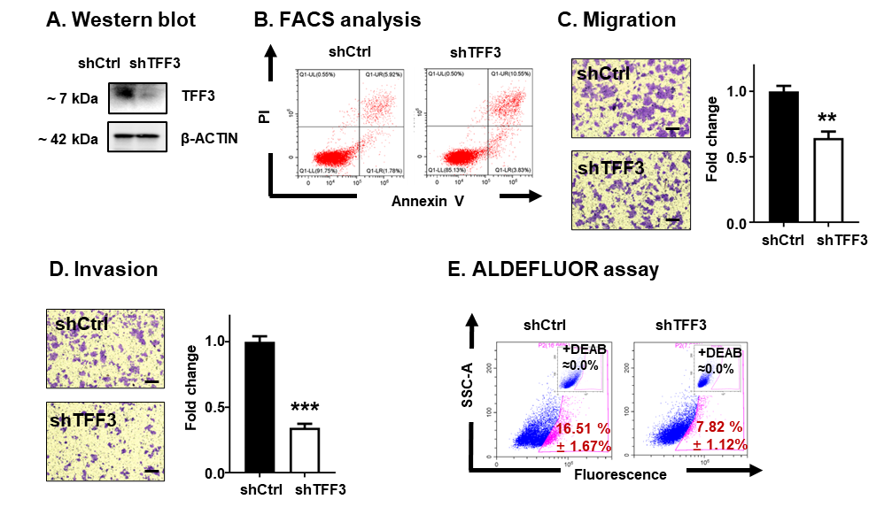
A. Western blot analysis was performed to determine the expression of TFF3 in MDA-MB-361-shCtrl (shCtrl) and MDA-MB-361-shTFF3 (shTFF3) cells.
B. The percentage of early apoptotic (Annexin-V-positive/PI negative) and late apoptotic (Annexin-V-positive/PI-positive) cells was plotted by flow cytometry in MDA-MB-361-shCtrl (shCtrl) and MDA-MB-361-shTFF3 (shTFF3) cells.
C. Cell migration assay. Scale bar, 50 μm. Data are expressed as mean ± SD (n = 3). Statistical significance is indicated as *P < 0.05, **P < 0.01, and ***P < 0.001.
D. Cell invasion assay. Scale bar, 50 μm. Data are expressed as mean ± SD (n = 3). Statistical significance is indicated as *P < 0.05, **P < 0.01, and ***P < 0.001.
E. ALDEFLUOR assay analysis of MDA-MB-361-shCtrl (shCtrl) and MDA-MB-361-shTFF3 (shTFF3) cells. The percentage of ALDH1-positive cells (in the pink box) was plotted by flow cytometry. Data are expressed as mean ± SD (n = 3). Statistical significance is indicated as *P < 0.05, **P < 0.01, and ***P < 0.001.

Supplementary information 4
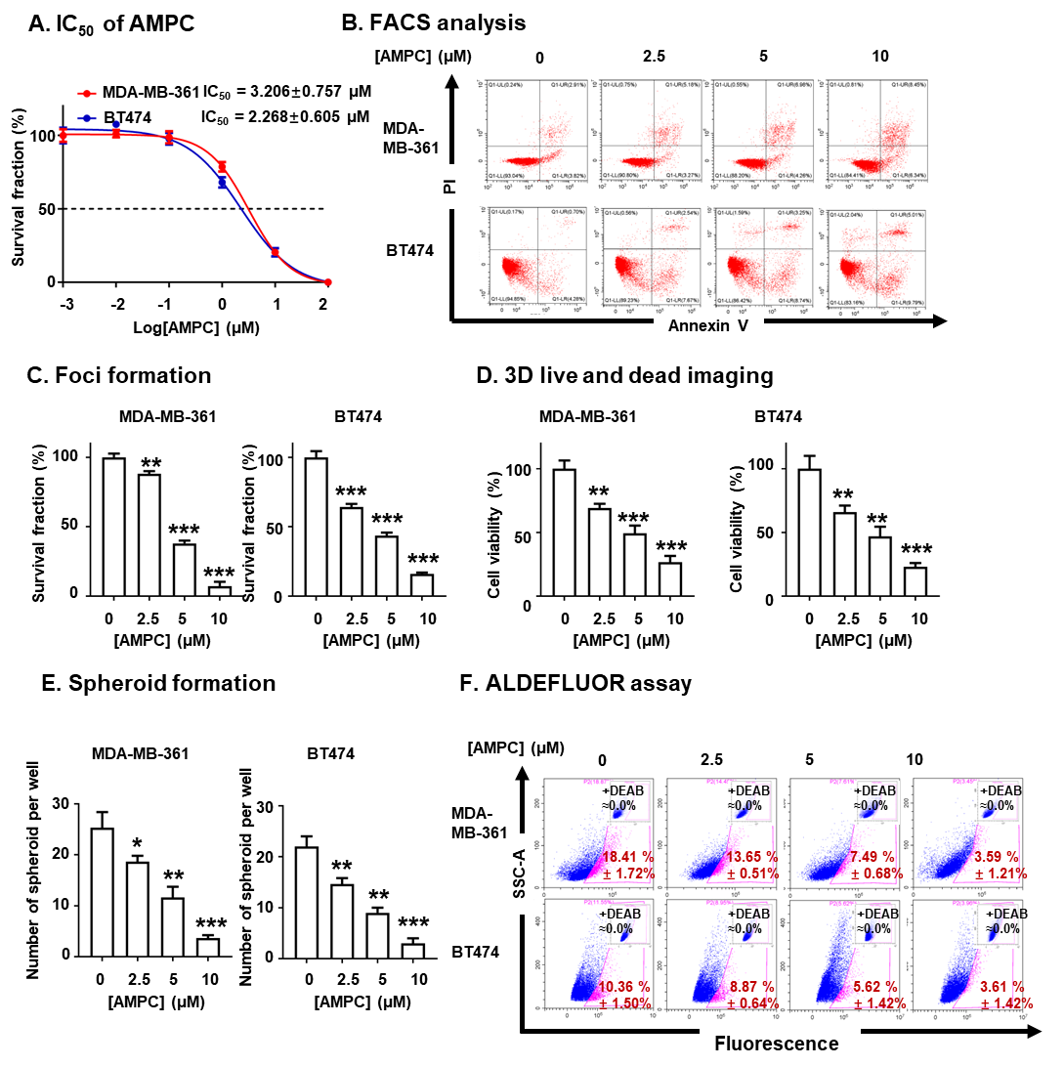
A. Effect of AMPC on the total cell number of ER+HER2+ MC cells was assessed using a total cell number counting assay after treatment with AMPC (0, 0.01, 0.1, 1, 10 or 100 µM) for 6 days. Inhibitory concentration 50% (IC₅₀) values of AMPC for MDA-MB-361 and BT474 cells are presented as IC₅₀ ± SD.
B. MDA-MB-361 and BT474 cells were treated with 0, 2.5, 5 or 10 µM AMPC for 2 days. The percentage of early apoptotic (Annexin-V positive/PI negative) and late apoptotic (Annexin-V positive/PI positive) cells was plotted by flow cytometry.
C. MDA-MB-361 and BT474 cells were treated with 0, 2.5, 5 or 10 µM AMPC in monolayer culture for 14 days. Foci were stained by crystal violet. Survival fraction was measured by eluting the crystal violet with methanol and determination of absorbance at 595 nm. Data are expressed as mean ± SD (n = 3). Statistical significance is indicated as *P < 0.05, **P < 0.01, and ***P < 0.001.
D. MDA-MB-361 and BT474 cells were treated with 0, 2.5, 5 or 10 µM AMPC in 3D-Matrigel culture for 12 days. Cell viability of 3D colonies was determined by AlamarBlue. Data are expressed as mean ± SD (n = 3). Statistical significance is indicated as *P < 0.05, **P < 0.01, and ***P < 0.001.
E. MDA-MB-361 and BT474 cells were cultured in ultralow attachment plates in spheroid growth media with 0, 2.5, 5 or 10 µM AMPC treatment for 12 days. The spheroids with diameters greater than 50 μm in each well were counted. Data are expressed as mean ± SD (n = 3). Statistical significance is indicated as *P < 0.05, **P < 0.01, and ***P < 0.001.
F. ALDEFLUOR assay analysis of MDA-MB-361 and BT474 cells were treated with 0, 2.5, 5 or 10 µM AMPC for 3 days. The percentage of ALDH1-positive cells (in the pink box) was plotted by flow cytometry. Data are expressed as mean ± SD (n = 3). Statistical significance is indicated as *P < 0.05, **P < 0.01, and ***P < 0.001.

Supplementary information 5
Product Name | Pathway | Target
Dacomitinib (PF299804, PF299) | Protein Tyrosine Kinase | EGFR
Gefitinib (ZD1839) | Protein Tyrosine Kinase | EGFR
Nintedanib (BIBF 1120) | Protein Tyrosine Kinase | FGFR, PDGFR, VEGFR
OSI-930 | Protein Tyrosine Kinase | c-KIT, CSF-1R, VEGFR
PHA-665752 | Protein Tyrosine Kinase | c-MET
SU11274 | Protein Tyrosine Kinase | c-MET
Vatalanib (PTK787) 2HCl | Protein Tyrosine Kinase | VEGFR
BIBR 1532 | DNA Damage | Telomerase
Cyclophosphamide Monohydrate | DNA Damage | DNA alkylator
Doxorubicin (Adriamycin) HCl | DNA Damage | Topoisomerase
Iniparib (BSI-201) | DNA Damage | PARP
Rucaparib (AG-014699, PF-01367338) phosphate | DNA Damage | PARP
Aminoglutethimide | Endocrinology & Hormones | Aromatase
Bicalutamide | Endocrinology & Hormones | Androgen Receptor
GW9508 | Endocrinology & Hormones | GPR
Hydrocortisone | Endocrinology & Hormones | Glucocorticoid Receptor
Letrozole | Endocrinology & Hormones | Aromatase
AMG-900 | Cell Cycle | Aurora Kinase
Barasertib (AZD1152-HQPA) | Cell Cycle | Aurora Kinase
Y-27632 2HCl | Cell Cycle | Autophagy, ROCK
Combretastatin A4 | Cytoskeletal Signaling | Microtubule Associated
Luminespib (AUY-922, NVP-AUY922) | Cytoskeletal Signaling | HSP (e.g. HSP90)
Paclitaxel | Cytoskeletal Signaling | Autophagy, Microtubule Associated
Belinostat (PXD101) | Epigenetics | HDAC
BIX 01294 | Epigenetics | Histone Methyltransferase
Sirtinol | Epigenetics | Sirtuin
2-Methoxyestradiol (2-MeOE2) | Angiogenesis | HIF
Saracatinib (AZD0530) | Angiogenesis | SRC
Obatoclax Mesylate (GX15-070) | Apoptosis | Autophagy, Bcl-2
YM155 (Sepantronium Bromide) | Apoptosis | Survivin
Silmitasertib (CX-4945) | Metabolism | Casein Kinase
Tipifarnib | Metabolism | Transferase
CH5132799 | PI3K/Akt/mTOR | PI3K
Idelalisib (CAL-101, GS-1101) | PI3K/Akt/mTOR | PI3K
Febuxostat | Immunology & Inflammation | ROS
Doramapimod (BIRB 796) | MAPK | p38 MAPK
Maraviroc | Microbiology | CCR
Valproic acid sodium salt (Sodium valproate) | Neuronal Signaling | GABA Receptor, HDAC, Autophagy
QNZ (EVP4593) | NF-κB | NF-κB, TNF-alpha
Ixazomib Citrate (MLN9708) | Proteases | Proteasome
The detailed information of the compounds showing synergistic effect with AMPC in both MDA-MB-361 and BT474 cells.

Supplementary information 6
A. c-MET inhibitors and the structure
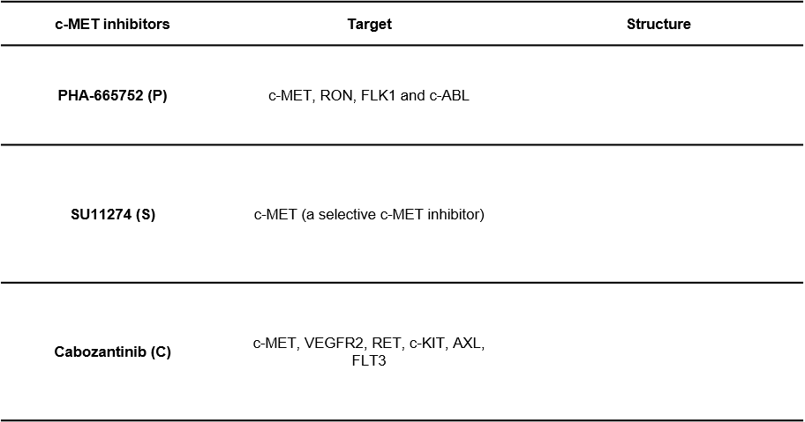

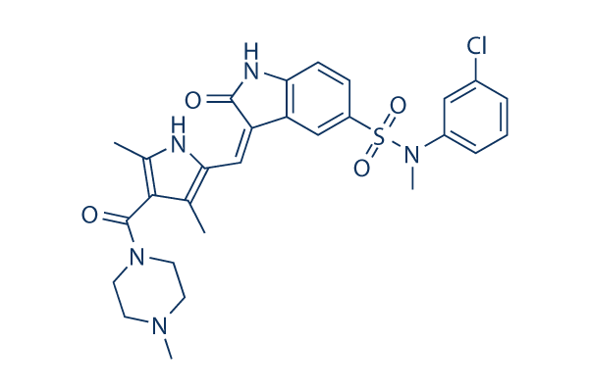

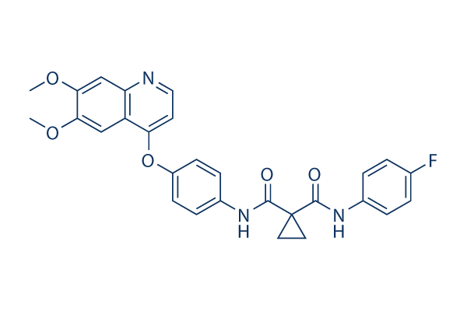

B. IC₅₀ of AMPC and c-MET inhibitors
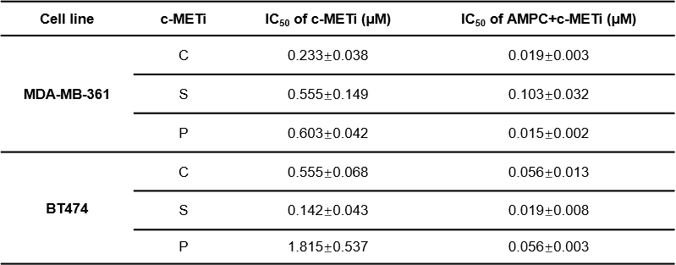

A. Targets and the structures of the c-METis.
B. The shift in IC₅₀ of Cabozantinib (C), SU11274 (S), or PHA-665752 (P) in MDA-MB-361 and BT474 cells after co-treatment with AMPC (2.5 μM) was conducted with total cell number assay. Data are represented as means ± SD (n = 3)

Supplementary information 7
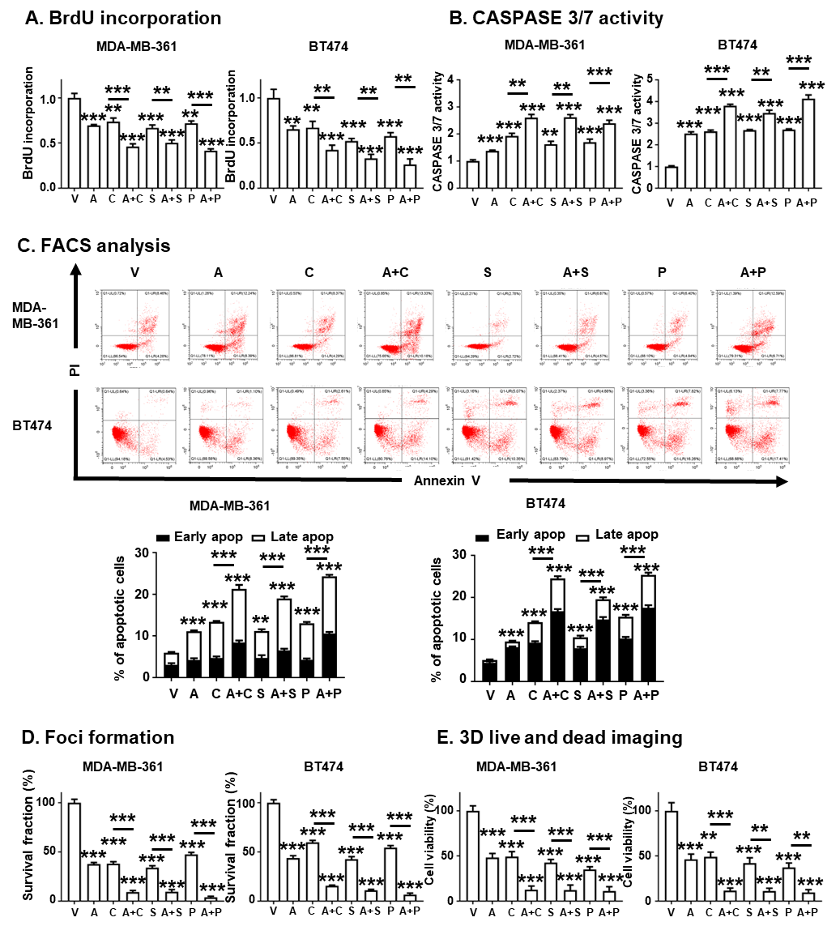
A. BrdU incorporation assays in MDA-MB-361 and BT474 cells were performed with the treatment of vehicle (V), 5 μM AMPC (A), 1 μM Cabozantinib (C), 1 μM SU11274 (S), 2 μM PHA-665752 (P) or the combination for 3 days. Data are expressed as mean ± SD (n = 3). Statistical significance is indicated as *P < 0.05, **P < 0.01, and ***P < 0.001.
B. CASPASE 3/7 activities were determined after 3 days of vehicle (V), 5 μM AMPC (A), 1 μM Cabozantinib (C), 1 μM SU11274 (S), 2 μM PHA-665752 (P) or the combination treatment. Data are expressed as mean ± SD (n = 3). Statistical significance is indicated as *P < 0.05, **P < 0.01, and ***P < 0.001.
C. Apoptotic cell death of MDA-MB-361 and BT474 cells was determined after 2 days of vehicle (V), 5 μM AMPC (A), 1 μM Cabozantinib (C), 1 μM SU11274 (S), 2 μM PHA-665752 (P) or the combination treatment using Annexin-V/PI. The percentage of early apoptotic (Annexin-V positive/PI negative) and late apoptotic (Annexin-V positive/PI positive) cells was plotted by flow cytometry and analyzed. Data are expressed as mean ± SD (n = 3). Statistical significance is indicated as *P < 0.05, **P < 0.01, and ***P < 0.001.
D. Foci formation. MDA-MB-361 and BT474 cells were treated with vehicle (V), 5 μM AMPC (A), 1 μM Cabozantinib (C), 1 μM SU11274 (S), 2 μM PHA-665752 (P) or the combination for foci formation for 14 days. Foci were stained by crystal violet. The survival fraction was measured by eluting the crystal violet with methanol and determination of absorbance at 595 nm. Data are expressed as mean ± SD (n = 3). Statistical significance is indicated as *P < 0.05, **P < 0.01, and ***P < 0.001.
E. MDA-MB-361 and BT474 cells were treated with vehicle (V), 5 μM AMPC (A), 1 μM Cabozantinib (C), 1 μM SU11274 (S), 2 μM PHA-665752 (P) or the combination in 3D-Matrigel culture for 12 days after 3 days of pre-culture. Cell viability of 3D colonies was determined by AlamarBlue. Data are expressed as mean ± SD (n = 3). Statistical significance is indicated as *P < 0.05, **P < 0.01, and ***P < 0.001.

Supplementary information 8
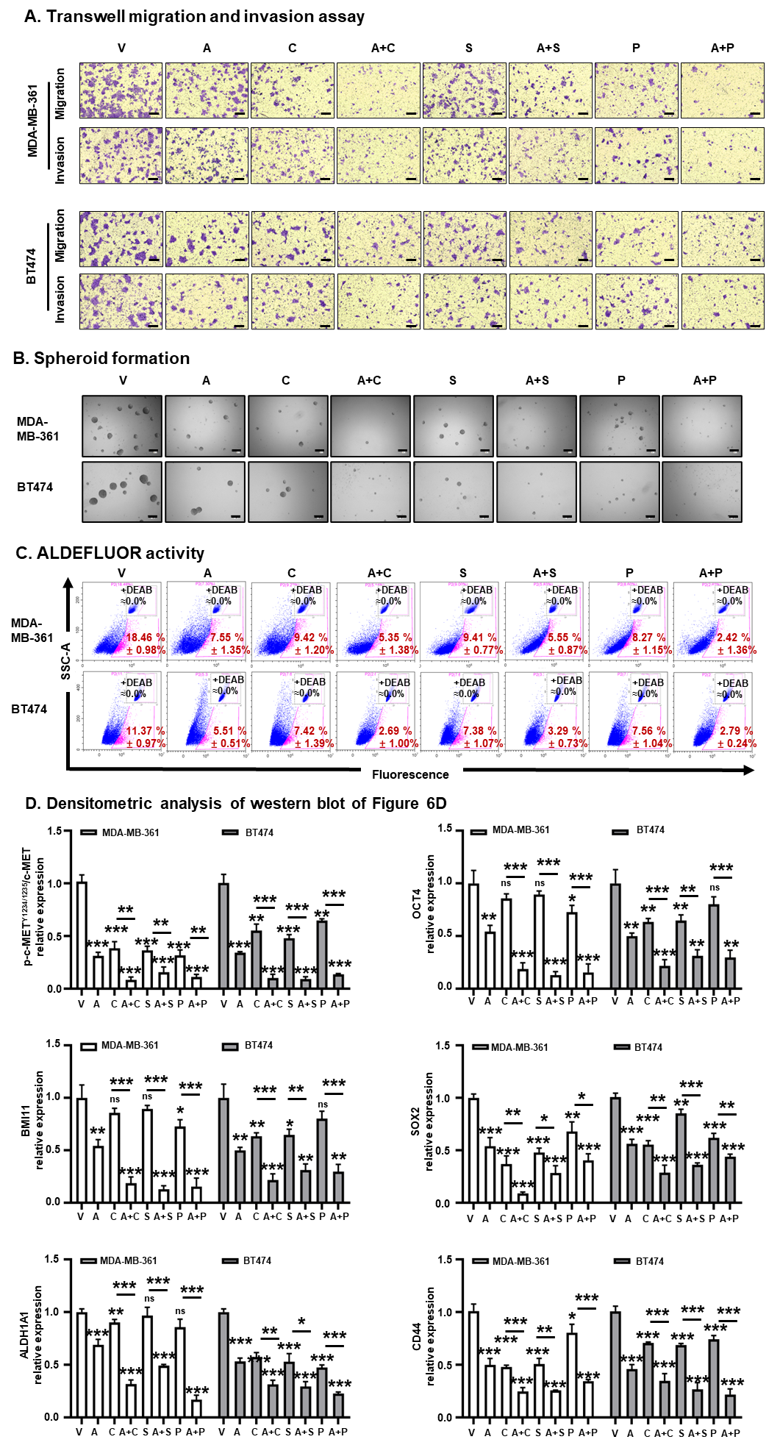

A. Cell migration and invasion assay were performed on MDA-MB-361 and BT474 cells treated with vehicle (V), 5 μM AMPC (A), 1 μM Cabozantinib (C), 1 μM SU11274 (S), 2 μM PHA-665752 (P) or the combination. Scale bar, 50 μm.
B. MDA-MB-361 and BT474 cells were seeded in ultralow attachment plates and cultured in spheroid growth media, and treated with vehicle (V), 5 μM AMPC (A), 1 μM Cabozantinib (C), 1 μM SU11274 (S), 2 μM PHA-665752 (P) or the combination for 12 days. Scale bar, 50 μm.
C. ALDEFLUOR assay analysis was measured on MDA-MB-361 and BT474 cells with the treatment of vehicle (V), 5 μM AMPC (A), 1 μM Cabozantinib (C), 1 μM SU11274 (S), 2 μM PHA-665752 (P) and the combination for 3 days. The percentage of ALDH1-positive cells (in the pink box) was plotted by flow cytometry. Data are expressed as mean ± SD (n = 3).
D. Densitometric analysis of western blots in Figure 6D was conducted by using ImageJ software. Data are expressed as mean ± SD (n = 3). Statistical significance is indicated as *P < 0.05, **P < 0.01, and ***P < 0.001.

Supplementary information 9
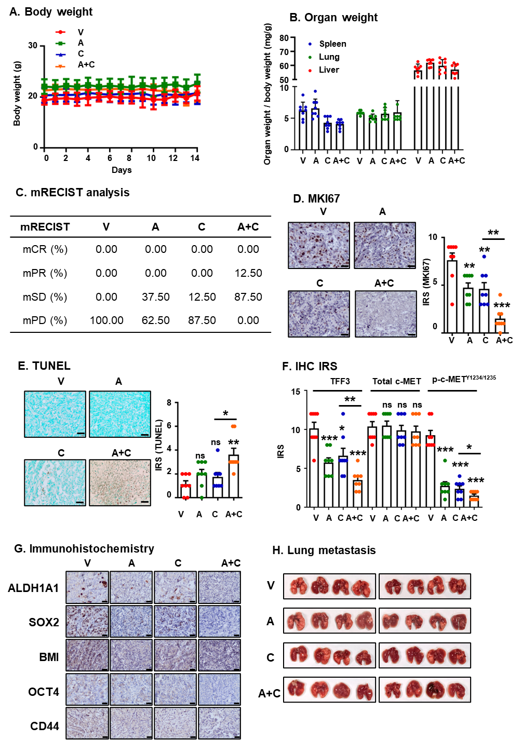
A. Body weights of mice were recorded during the treatment period. Data are expressed as mean ± SD (n = 8). Statistical significance is indicated as *P < 0.05, **P < 0.01, and ***P < 0.001.
B. Weights of resected organs was determined at the termination of the experiments. Data are expressed as mean ± SD (n = 8). Statistical significance is indicated as *P < 0.05, **P < 0.01, and ***P < 0.001.
C. The modified Response Evaluation Criteria in Solid Tumors (mRECIST) assessment was performed. CR: disappearance of any intertumoral arterial enhancement in all target lesions, PR: at least a 30% decrease in the sum of diameters of viable (enhancement in the arterial phase) target lesions, taking as reference the baseline sum of the diameters of target lesions, SD: Any cases that do not qualify for either partial response or progressive disease, PD: an increase of at least 20% in the sum of the diameters of viable (enhancing) target lesions, taking as reference the smallest sum of the diameters of viable (enhancing) target lesions recorded since treatment started.
D. IHC and IRS analysis on MKI67 were conducted in the indicated xenografts. Scale bar, 20 μm. Data are expressed as mean ± SD (n = 8). Statistical significance is indicated as *P < 0.05, **P < 0.01, and ***P < 0.001.
E. TUNEL and IRS analysis were performed in the indicated xenografts. Scale bar, 20 μm. Data are expressed as mean ± SD (n = 8). Statistical significance is indicated as *P < 0.05, **P < 0.01, and ***P < 0.001.
F. IRS score of TFF3, c-MET and c-MET phosphorylation at Y1234/1235 was assessed. Data are expressed as mean ± SD (n = 8). Statistical significance is indicated as *P < 0.05, **P < 0.01, and ***P < 0.001.
G. IHC staining for CSC markers in the indicated xenografts. Scale bar, 20 μm.
H. Photographs of lungs of mice after vehicle (V), AMPC (A), Cabozantinib (C) and AMPC + Cabozantinib (A+C) treatment.

Supplementary information 10
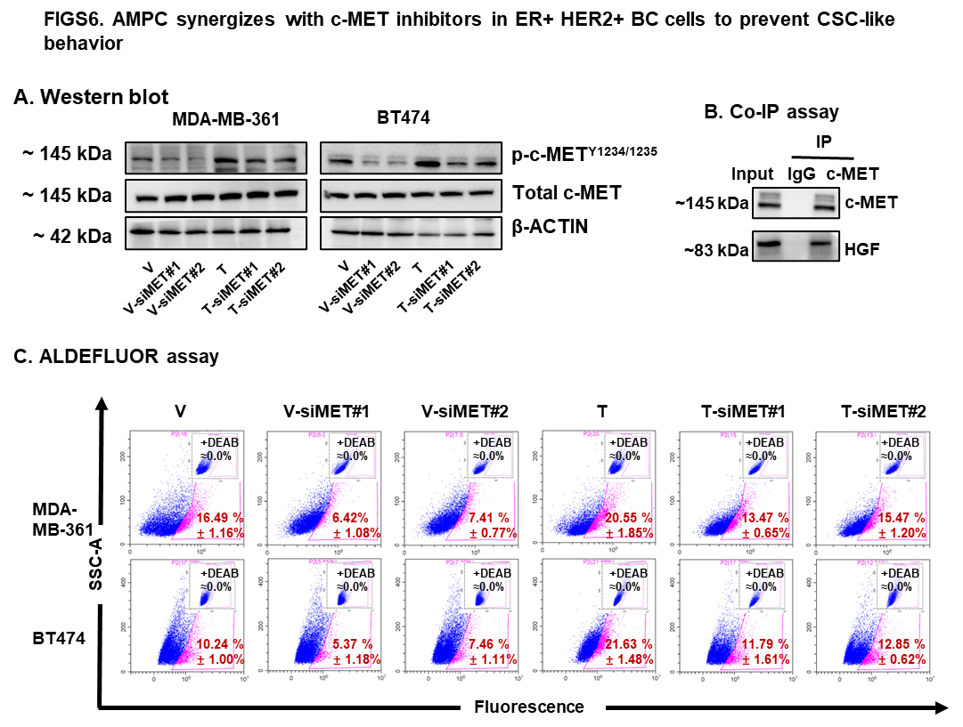
A. Western blot analysis was performed to assess the level of c-MET and c-MET phosphorylation at Y1234/1235 in MDA-MB-361 and BT474 cells transfected with scrambled siRNA, siMET#1 or siMET#2 plasmid. β-ACTIN was used as input control. The sizes of detected protein blots in kDa were shown on the left.
B. A potential c-MET/TFF3 interaction in MDA-MB-361 cells was investigated by immunoprecipitation (IP) and immunoblotting. HGF was used as the positive control.
C. ALDEFLUOR assay analysis of MDA-MB-361 and BT474 cells transfected with scrambled siRNA, siMET#1 and siMET#2. The percentage of ALDH1-positive cells (in the pink box) was plotted by flow cytometry. Data were expressed as mean ± SD (n=3). Statistical significance was indicated as *P < 0.05, **P < 0.01, and ***P < 0.001.

Supplementary information 11
Antibody | Vendor | Catalog | Application | Dilution
TFF3 | Abcam | ab108599 | WB/ IHC/ IF | 1:1000/1:200/1:200
MKI67 | Abcam | ab16667 | IHC | 1:500
β-ACTIN | Santa Cruz | sc-47778 | WB | 1:1000
Total MET | CST | 8198S | WB/ IHC | 1:1000/1:100
Phospho-MET Y1234/1235 | CST | 3077S | WB/ IHC | 1:1000/1:300
OCT4 | Abcam | ab181557 | WB/ IHC | 1:1000/1:300
BMI1 | CST | 6964 | WB/ IHC | 1:1000/1:250
ALDH1A1 | CST | 36671 | WB/ IHC | 1:1000/1:250
CD44 | Abcam | ab157107 | WB/ IHC | 1:1000/1:250
SOX2 | Abcam | ab97959 | WB/ IHC | 1:1000/1:100
hHPRT | Invitrogen | MA5-15274 | IHC | 1:200
Rabit IgG | CST | 7074 | WB | 1:3000
Mouse IgG | CST | 7076 | WB | 1:3000

Supplementary information for uncropped western blot images.
