Integrated ctDNA Methylation Profiling of P2RX1, CBFA2T3, and CERS4 as Pancreatic Ductal Adenocarcinoma Biomarkers: Identification and Mechanistic Insights

Materials and Methods
Cell transfection
Seed cells into a six-well plate and inspect them the following day. If the cell fusion rate exceeds 70%, proceed with the transfection process. Prepare two sets of eppendorf tubes, each containing 200 µL of Opti-MEM medium. To the top tubes, add 7.5 µL of LipofectamineTM 3000, mix thoroughly, and allow to incubate at room temperature for 5 min. In the bottom tubes, combine the overexpression plasmid with 5 µL of LipofectamineTM 3000, mix gently, and maintain sterility. Transfer the contents from the top tubes to the bottom ones, ensuring a complete mix, and let the mixture sit for an additional 15 min at room temperature. Replace the existing cell culture medium in the six-well plate with approximately 1.5 mL of fresh medium, then carefully add the mixed Eppendorf contents to the designated wells. Place the plate into a cell culture incubator. After 24 h, evaluate the transfection efficiency. Proceed to extract RNA 48 h post-transfection and proteins 72 h post-transfection to assess the level of overexpression.

Cell Infection
Prepare a lentiviral vector containing the target gene CERS4, and determine the MOI of the lentiviral vector based on MIA PaCa-2 cells. Add the lentiviral vector to the cell culture medium and gently mix to ensure even distribution of the virus. Then place the cells in a culture incubator and incubate at 37 °C and 5% CO₂ for 72 h before observing the infection efficiency under a fluorescence microscope. Add 2 µg/mL of puromycin and screen for stable cell lines after 48 h.

Cell derived xenograft
Feed six five-week-old BALB/c-nude female nude mice in an SPF level environment for one week to adapt to the environment. Randomly divide the nude mice into two groups (normal control group and overexpression group). Resuspend infected or uninfected MIA-PaCa2 cells (5 × 10⁶/100 µL/mouse) with matrix gel and inject them subcutaneously into the armpits of each group of mice. Measure the size of subcutaneous tumors in each group of nude mice every three days using a vernier caliper. One month later, the tumor was removed from euthanized mice for subsequent experiments

Immunofluorescence
Add approximately 100 μL of culture medium to the petri dish and culture the cells. Begin by gently washing the cells with 4°C PBS for three times. Then fix them with 4% formaldehyde for 20 min, followed by washing with PBS. Afterward, permeabilize with 0.5% Triton X-100, rinse, and let dry. Next, incubate with blocking solution for 30 min, remove it, and overnight incubate with diluted primary antibody at 4°C. Following antibody recovery, wash with PBST three times, each for 3 min, and add fluorescent secondary antibody in the dark for 1 h. Rinse again with PBST thrice, followed by DAPI staining for 10 min in the dark. Seal the slides with an anti-fade mounting medium, and observe and analyze the results under a fluorescence microscope.

Supplementary Table
Supplementary Table 1
 | Pancreatic ductal adenocarcinoma (N=60 cases)
Average age (range, years) | 67(42-83)
Gender (Male) | N=35
Average tumor size (range, cm) | 3.2(1.5-6)
Differentiation
well | N=1
moderate | N=45
poor | N=13
Undifferentiated | N=1
TNM stageª
Ⅰ A、B | N=29
Ⅱ A、B | N=13
Ⅲ | N=18
Lymph node metastasis | N=20
CA 19-9 level (U/ml)
Average | 1000.3
Median | 187.6
Highest | >12000
Lowest | <2
ªTNM stages were assessed in accordance with definitions found in the eighth edition of the TNM classification criteria.

Supplementary Figure

Supplementary Fig.1 Whole-genome methylation landscape of ctDNA from PDAC. (a) The average methylation level of the whole genome reflects the overall characteristics of the genome methylation profile (the distribution of methylated C bases in the genome includes three forms of DMRs, with methylation levels distributed in CG, CHG, and CHH, where H represents A, T, or C bases). (b) The distribution of 112,294 DMRs in various regions of genes, of which there are 6,226 DMRs in the promoter region, accounting for 5.54%. (c) For the methylation level of DMRs, the metilene software provides the average methylation level of differentially methylated regions to draw the distribution of methylation levels in violin boxplot. (d) Comparing the methylation levels of single-sample gene functional regions, the average methylation levels of CG sites in upstream2k, exon, intron, downstream2k, CGI, and CGI shore are plotted for each context. (e) Principal component analysis between patients with PDAC and healthy individuals. (f) At a sequencing depth of 5x, IGV can clearly display the methylation levels at specific locations on the chromosome.

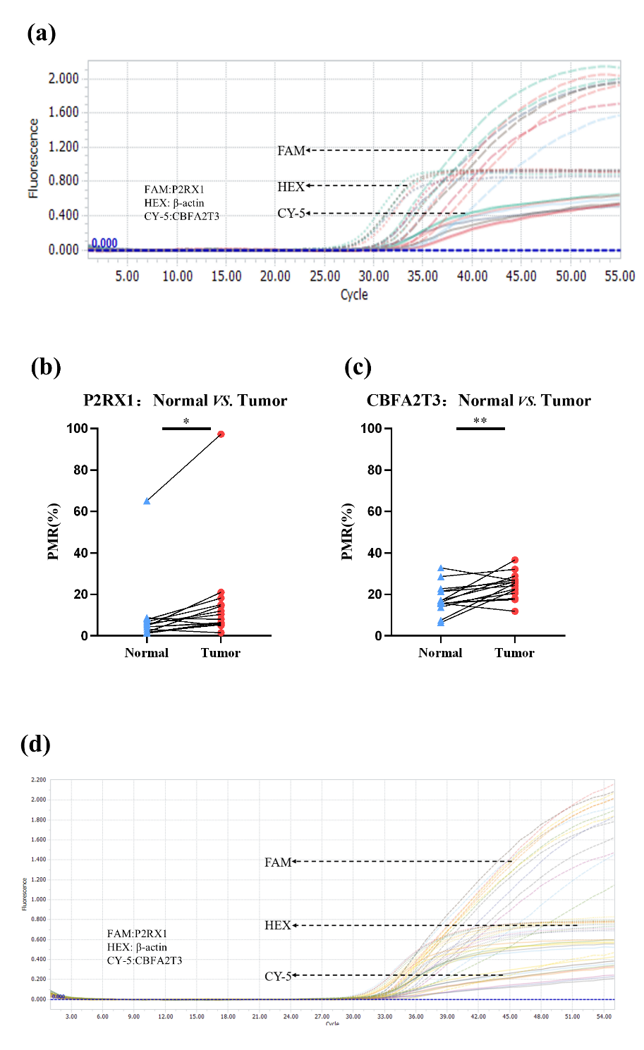
Supplementary Fig.2 Establishment of the M-QMSP system. (a) The illustrative diagram of the M-QMSP system in tissue. (b, c) Methylation status of P2RX1 and CBFA2T3 gene from 15 pairs of tissues. (d) The illustrative diagram of the M-QMSP system in plasma. b, c used paired t-test. P<0.05*, P<0.01**, P<0.001***, P<0.0001****.

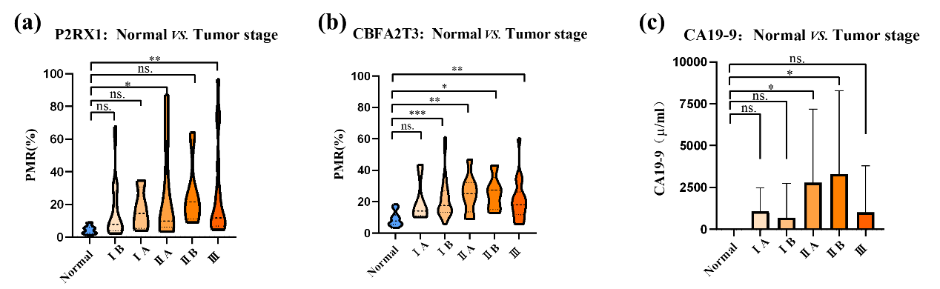
Supplementary Fig. 3 The association of CA19-9 levels and the P2CC model methylation status with clinical staging. P<0.05*, P<0.01**, P<0.001***.

Supplementary Fig.4 Transfection of CERS4 overexpression vectors into PANC-1 and MIA PaCa-2 cell lines. (a) microscopic images of MIA PaCa-2 cells transfection. (b、c) RT-qPCR and western blot detection of the efficiency of CERS4 overexpression in PANC-1 and MIA PaCa-2 cells. P<0.01**, P<0.0001****.

Supplementary Fig.5 Overexpression of CERS4 inhibits the growth of transplanted tumors in CDX mice. (a-c) RT-qPCR and western blot detection of infection efficiency of CERS4 overexpression lentiviral vector. (d) Subcutaneous tumor formation in nude mice. (e) Subcutaneous tumor growth curve in nude mice. (d) Tumor weight. P<0.01**, P<0.001***.

Supplementary Fig.6 Representative images of H&E staining and immunohistochemical staining of tumors.

Supplementary Fig.7 Immunofluorescence detection of CERS4 located in nucleus and membrane.

