Supporting Information
Synthesis of MnO₂@TiO₂ composite electrodes via hydrolysis and calcination for high stability zinc ions batteries
Jun Zhu ∗, Hongwei Shi, Chengcheng Liu, Wenzhu Ouyang, Yuling Liu, Xiaoling Li
Key Laboratory of Spin Electron and Nanomaterials of Anhui Higher Education Institutes, Suzhou University, Educational Park No. 1769 Xuefu Avenue, Suzhou 234000, P. R. China

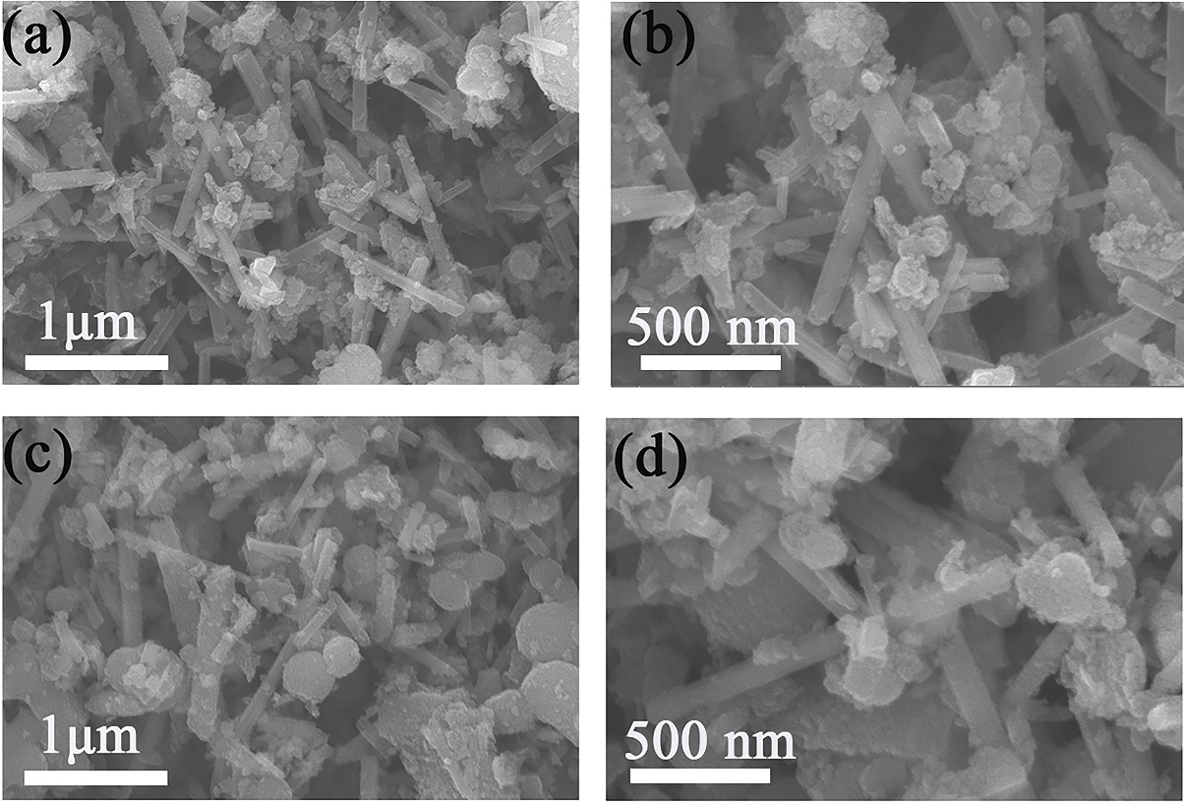
Figure S1. SEM images of (a, b) MnO₂@TiO₂-1 and (c, d) MnO₂@TiO₂-3.

Table S1. Comparison of electrochemical performance of MnO₂@TiO₂-2 anode with different manganese oxide anodes in recent years
Cathode | electric current (A g⁻¹) | Capacity  (mAh g⁻¹) | Retention/Cycles | Ref.
MnO₂@TiO₂-2 | 3 | 93.35 | 97.47 % /1500 | This work
MnO₂@V₂O₅ | 2 | 77.45 | 73 %/3000 | ¹
ε-MnO₂@C | 1 | 172 | 91 %/1700 | ²
α-MnO₂@LMO | 1 | 115 | 90 %/1500 | ³
KMO | 1 | 99.6 | 50.74 % /1400 | ⁴
Ag_{0.4}Mn₈O₁₆ | 1 | 110 | 50 %/800 | ⁵
α-MnO₂/super-P | 1 | 84.6 | 47 %/1000 | ⁶
α-MnO₂@DCDA | 3 | 102.6 | 62 %/1500 | ⁷

Figure S2. (a) Coin cell battery successfully lights up the electronic watch, (b) CV curves of MnO₂ at different scan rates, (c) Linear logarithmic plot between scan rate and peak current response value for MnO₂, (c) Contributions of capacitance control and diffusion control at different scan rates for MnO₂.

REFERENCES
(1) Shang, H.; Zhang, Z.; Liu, C.; Zhang, X.; Li, S.; Wen, Z.; Ji, S.; Sun, J., MnO2@ V2O5 microspheres as cathode materials for high performance aqueous rechargeable Zn-ion battery. Journal of Electroanalytical Chemistry 2021, 890, 115253.
(2) Zhao, W.; Kong, Q.; Wu, X.; An, X.; Zhang, J.; Liu, X.; Yao, W., ε-MnO2@ C cathode with high stability for aqueous zinc-ion batteries. Applied Surface Science 2022, 605, 154685.
(3) Li, H.; Zhou, X.; Liu, L.; Huang, D.; Zhang, W.; Zhang, S., Hierarchical α-MnO2@ LaxMn1-xO2-δ core–shell nanostructure cathode for high-performance aqueous Zn-ion batteries. Ionics 2024, 1-11.
(4) Yang, Q.; Chen, Y.; Yang, Y.; Xu, T.; Lin, Y.; Zhang, X.; Wang, J.; Liu, Y.-N.; Li, Y., Batch Synthesis of K-Doped α-MnO2 Nanorods as Cathode Materials for Aqueous Zinc-Ion Battery. Industrial & Engineering Chemistry Research 2023, 62 (41), 16757-16765.
(5) Fenta, F. W.; Olbasa, B. W.; Tsai, M.-C.; Temesgen, N. T.; Huang, W.-H.; Tekaligne, T. M.; Nikodimos, Y.; Wu, S.-h.; Su, W.-N.; Dai, H., Structural engineering of α-MnO2 cathode by Ag+ incorporation for high capacity aqueous zinc-ion batteries. Journal of Power Sources 2022, 548, 232010.
(6) Yang, C.; Wu, Q.; Cao, Y.; Gao, Y.; Li, A.; Liu, X.; Zhang, X.; Tian, Z.; Liu, R., α-MnO2/super-P with conductive carbon network for rechargeable aqueous Zinc ion batteries. Materials Letters 2021, 302, 130419.
(7) Lu, C.-h.; Du, D., Construction of dicyandiamide-coated manganese dioxide composite and its mechanism for improving zinc storage performance. Journal of Central South University 2024, 31 (5), 1443-1460.

∗ Corresponding author: szxyhsxyzj@163.com

